BLG 231E - Digital Circuits

Assignment 2

Name Surname: Seyfülmülük Kutluk
Student ID: 150180073
CRN: 11623

1. The truth table for a function y(A, B, C, D) is given below:

A
B
C
D
y
0
0

0

0

0

0
1
0

0

0

1

1
2
0

0

1

0

0
3
0

0

1

1

1
4
0

1

0

0

0
5
0

1

0

1

1
6
0

1

1

0

0
7
0

1

1

1

0
8
1

0

0

0

0
9
1

0

0

1

1
10
1

0

1

0

1
11
1

0

1

1

0
12
1

1

0

0

1
13
1

1

0

1

0
14
1

1

1

0

1
15
1

1

1

1

1

a. Write the expressions of y in the first and second canonical forms.

1st canonical form of y in SOP (ΣΠ) form:

y(A,B,C,D)=A’B’C’D + A’B’CD + A’BC’D + AB’C’D + AB’CD’ + ABC’D’ + ABCD’ +ABCD

2nd canonical form of y in POS (ΠΣ) form:

y(A,B,C,D)=ABCD + ABC’D + AB’CD + AB’C’D +AB’C’D’ + A’BCD +A’BC’D’ + A’B^CD’

b. Minimize the expression in the first canonical form using axioms and theorems of Boolean algebra.
Show all steps in your minimization and write the name of the axiom/theorem/property you use on the right-hand side of the expression at each step.

=A’B’C’D + A’B’CD+A’BC’D+AB’C’D+AB’CD’+ABC’D’+ABCD’+ABCD // Consensus

=A’B’C’D + A’B’CD+A’BC’D+AB’C’D+AB’CD’+ABC’D’+ABCD’+ABCD+A’B’D// Absorption

=A’BC’D+AB’C’D+AB’CD’+ABC’D’+ABCD’+ABCD+A’B’D// Consensus

=A’BC’D+AB’C’D+AB’CD’+ABC’D’+ABCD’+ABCD+A’B’D+ABC// Absorption

=A’BC’D+AB’C’D+AB’CD’+ABC’D’+A’B’D+ABC// Consensus

=A’BC’D+AB’C’D+AB’CD’+ABC’D’+A’B’D+ABC+ABD’// Absorption

=A’BC’D+AB’C’D+AB’CD’+A’B’D+ABC+ABD’// Consensus

=A’BC’D+AB’C’D+AB’CD’+A’B’D+ABC+ABD’+ACD’// Absorption

=A’BC’D+AB’C’D+A’B’D+ABC+ABD’+ACD’// Consensus

=A’BC’D+AB’C’D+A’B’D+ABC+ABD’+ACD’+B’C’D// Absorption

=A’BC’D+A’B’D+ABC+ABD’+ACD’+B’C’D// Consensus

=A’BC’D+A’B’D+ABC+ABD’+ACD’+B’C’D+A’C’D// Absorption

= A’B’D+ABC+ABD’+ACD’+B’C’D+A’C’D

c. Draw the circuit for the minimized expression in (b) using 2-input NAND gates only. Show all steps
and explain your work leading up to the final circuit.
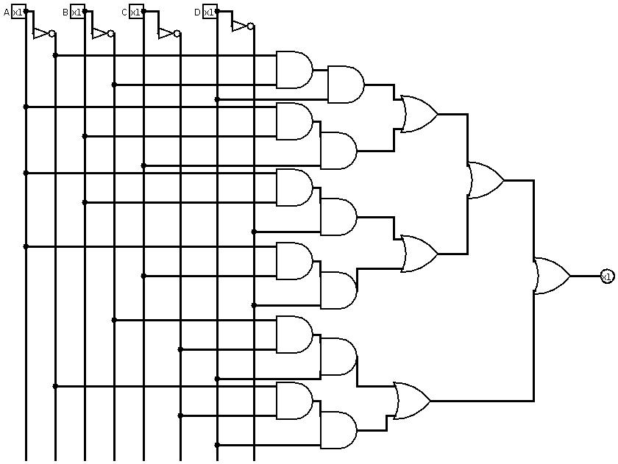
This is the circuit for A’B’D+ABC+ABD’+ACD’+B’C’D+A’C’D with using AND,OR and NOT gates. I will convert all of the AND,OR and NOT to NAND gate.
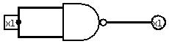
------------→ this is equivalent of NOT gate

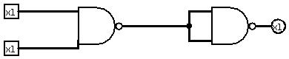

this one is equivalent of AND gate

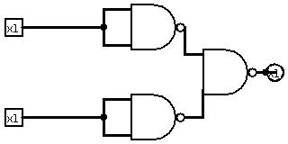

this one is equivalent of OR gate

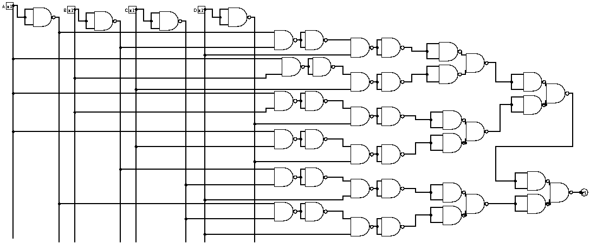

I deleted two not gates which are come after each other, because (A’)’=A

