**BLG 231E - Digital Circuits**

**Assignment 4**

**Name Surname: Seyfülmülük Kutluk**

**Student ID: 150180073**

**CRN: 11623**

**1.** The combinational circuit ARITHMETIC/LOGIC (A/L) performs the following operations depending on the value of the control inputs X, Y, and Z.

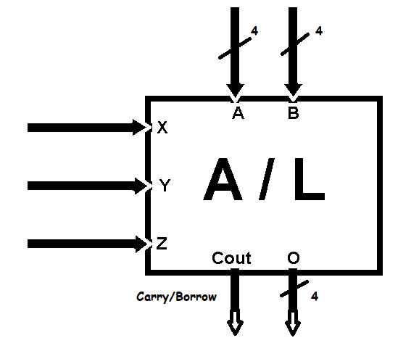

**X**

**Y**

**Z**

**Result (O)**

**Cout**

0

0

0

B – A

Borrow

0

0

1

A + B

Carry

0

1

0

A – 5

Borrow

0

1

1

Φ

Φ

1

0

0

A ⋅ B

Φ

1

0

1

Φ

Φ

1

1

0

A ⊕ B

Φ

1

1

1

Φ

Φ

Design and draw this circuit using

ONLY

the standard components and logic gates given below

1) B-A and B+A; I shoved both of them in the circuit below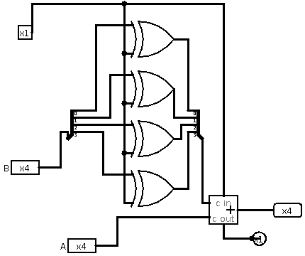.

If x1 is “0” it execute B+A.

If x1 is “1” it execute B-A.

2) This circuit Show (A-5) and x1 shows the Cout.

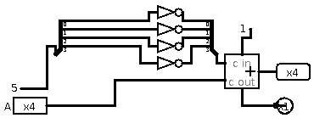

3)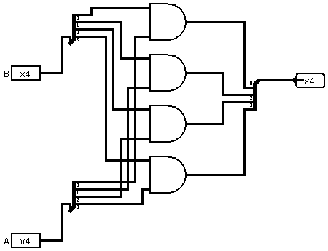 This circuit is for (A.B) : There is also with 2 input 4 bit and gate in the last image

4)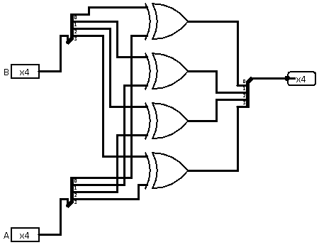 This circuit is for (A xor B) : There is also with 2 input 4 bit xor gate in the last image

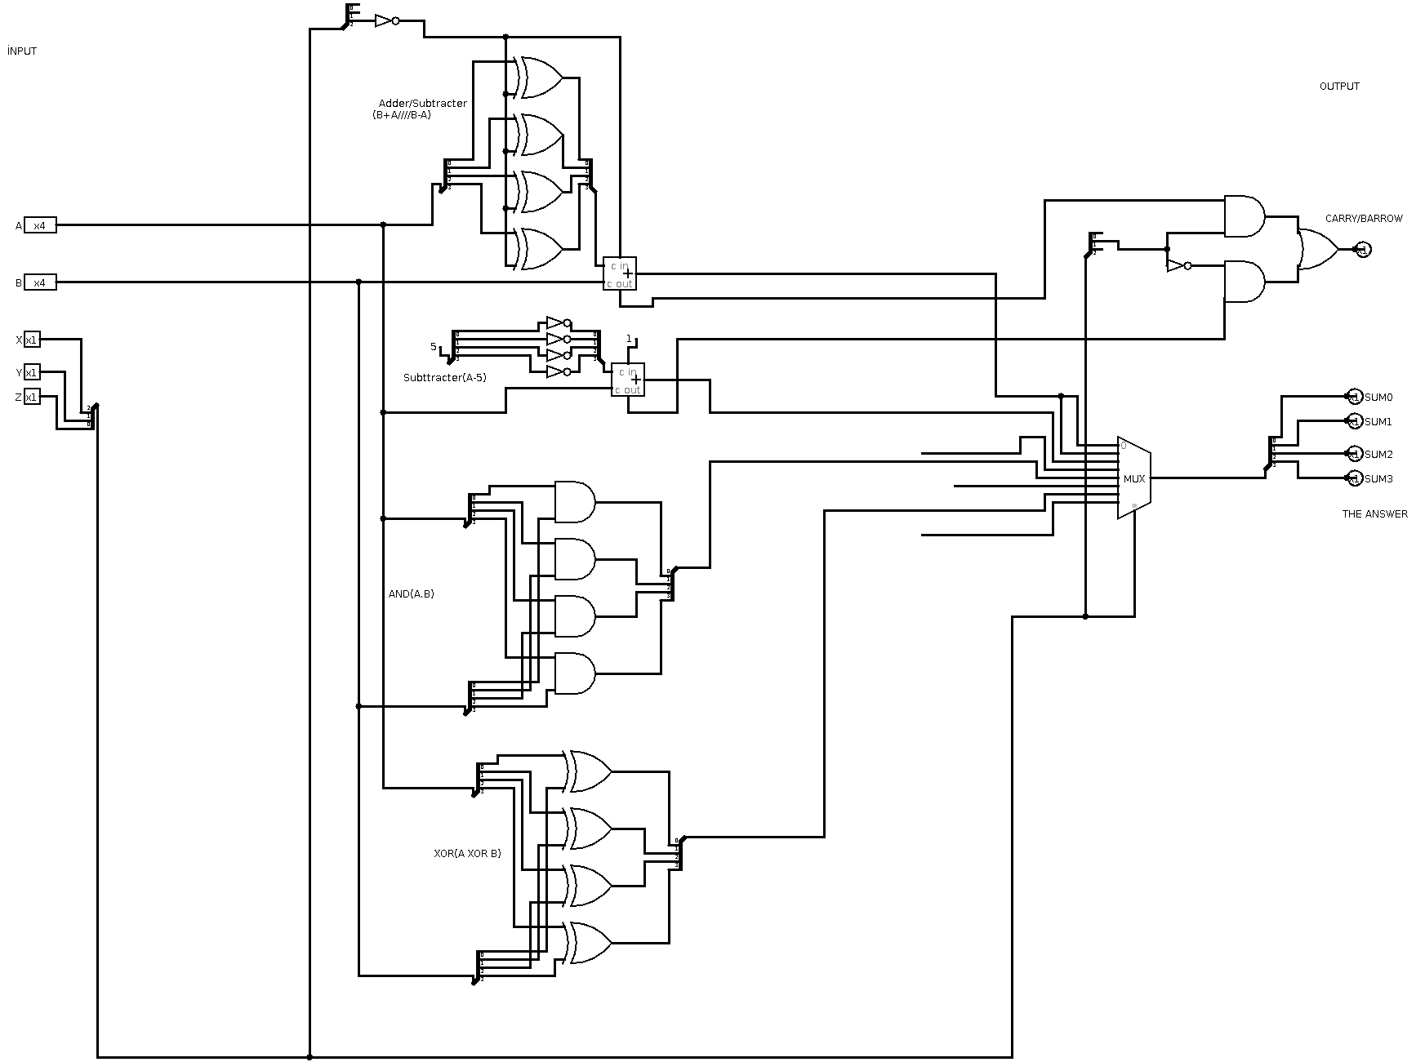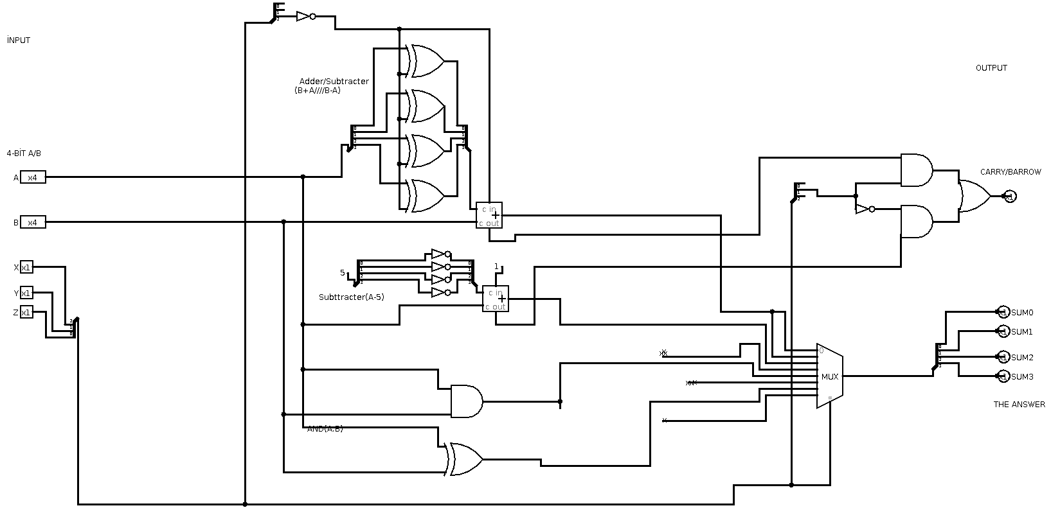5) Lastly ı combined all of the circuit in MUX. According to the truth table.

With 2 input AND and XOR gates.