OPERATION FORAGER
Building an AI-Augmented Detection Engineering Lab From Scratch
A hands-on detection-engineering portfolio project
BY
Oluwaseyi Michael Falode

This document walks through a hands-on cybersecurity detection-engineering lab I built end to end on my own laptop. It simulates a realistic, malware-free intrusion against a fictional company, generates the log data that intrusion would leave behind, and then builds and validates the detection rules that catch every stage of the attack. It closes with an exercise that mirrors where the industry is heading: a human analyst validating the conclusions of an AI triage pipeline.
Headline result
Four attack stages, four behavioural detections, 4/4 detected with 0 false positives against a labelled dataset of 51,225 synthetic log events — all running on the Python 3 standard library, no paid tooling required.

1. Why I built this
Most security analysts can talk about detection engineering. Far fewer can show it working and put a number on it. I wanted a portfolio project that proves I can do the actual job: take an attack, understand the footprints it leaves across different log sources, write the logic that catches it, and measure whether that logic works without crying wolf.
I deliberately modelled the attacker on a real, modern threat group that relies on social engineering and stolen identity rather than malware. There are no file hashes to block, no fixed malicious IP addresses. That single design choice forces every detection to be behavioural — to catch what the attacker does, not what tool they used — which is exactly the skill that matters today.

2. The scenario
The target is a fictional consumer platform with millions of customer accounts, corporate identity managed in a cloud identity provider, and production systems running in a public cloud. The attacker, which I named FORAGER, runs an eight-stage intrusion:
- Credential stuffing — stolen password lists sprayed at the customer login.
- Fraud noise — hijacked customer accounts used for abuse. This is loud, and it is a decoy.
- Helpdesk vishing — the attacker phones IT and talks them into resetting an employee's MFA.
- MFA-satisfied sign-in — the attacker logs in as the employee. MFA passes, because they now control it.
- Cloud pivot — the attacker follows the employee's access into the cloud and maps what they can reach.
- Persistence — the attacker mints a permanent access key on an over-privileged, dormant account.
- Defence evasion — the attacker disables cloud logging to hide their tracks.
- Exfiltration — the attacker bulk-reads customer records and copies them out.

From first compromise to data theft is about three hours. The entire job of the detection content in this lab is to shrink that number — to catch the attacker at stage three instead of stage eight.

3. Setting up the workspace
The project is organised the way a real detection repository is: separate folders for the attack narrative, the data generators, the detections, the validation harness, threat intelligence, incident response playbooks, and the AI exercise. Everything begins from an empty directory and a confirmed Python installation.
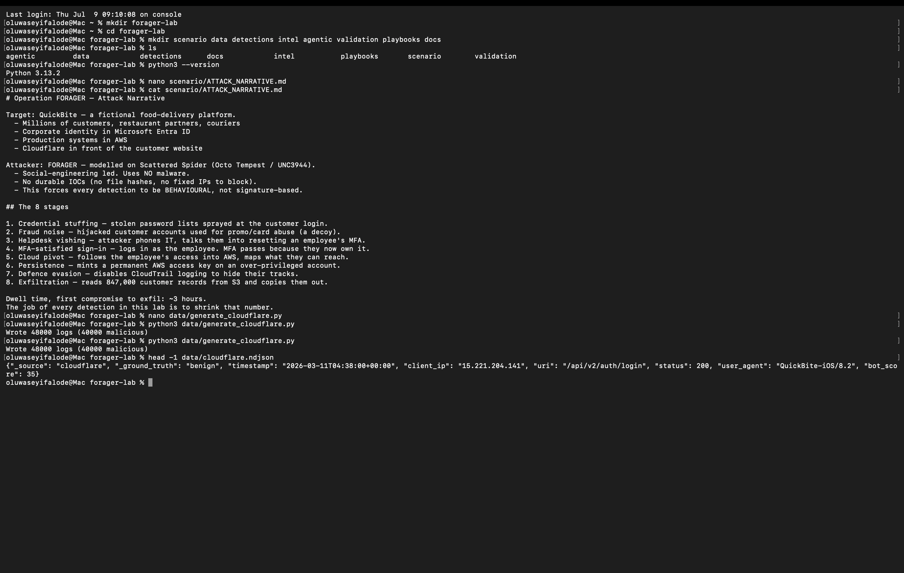
▲ Workspace created from scratch, Python confirmed, and the attack narrative written as the first artefact — the plan always comes before the code.

4. Generating the telemetry
A detection is worthless without data to run it against, so the first real code manufactures realistic log data — the digital footprints the intrusion would leave. Each generator produces a mix of normal background activity and the malicious events, with the attack deliberately buried in the noise at realistic ratios. Every event carries a hidden ground-truth label so the rules can be scored later; real logs never have this, it exists purely for measurement.
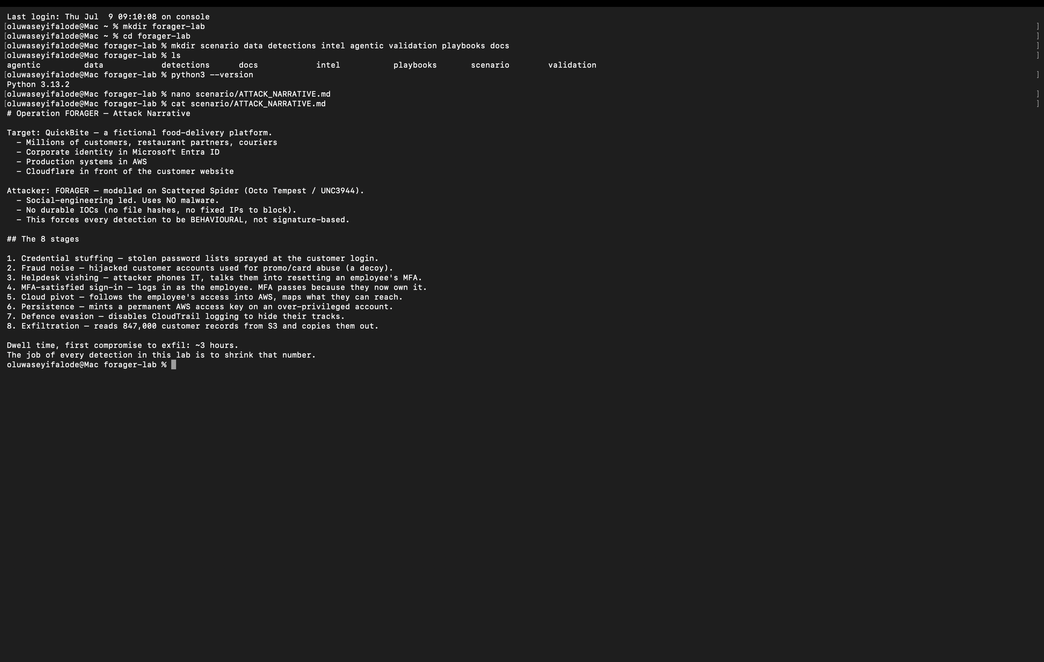
▲ The web-log generator. Note the design detail: 40,000 attack attempts are spread across only 900 IP addresses, mimicking a rotating proxy pool — which is precisely what makes credential stuffing hard to catch with simple per-IP rules.
Three sources are generated in total — web traffic, cloud identity (audit and sign-in), and the cloud control plane — producing 51,225 events. The malicious events are a tiny minority hiding inside the legitimate activity: for example, just two malicious events inside twenty-seven identity audit records. That needle-in-a-haystack ratio is the everyday reality of security operations.
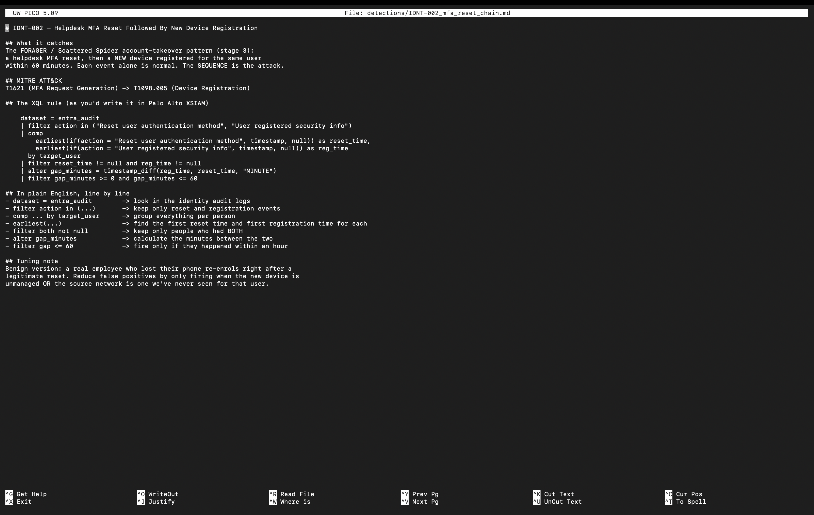
▲ All three log sources generated and verified. The line counts confirm the dataset, and searching for the hidden label surfaces the attacker's two identity moves — an MFA reset and a new-device registration twenty-nine minutes apart.

5. Writing the detections
With data in place, the analyst work begins. I wrote four detections, each targeting a different attack stage, and — importantly — each in a different structural shape. Every rule is documented twice: once as a query in the vendor query language a SIEM would use, and once as runnable Python that actually executes against the dataset so its logic can be proven.

5.1 The identity takeover (a correlation rule)
The most important detection catches stage three. A single helpdesk MFA reset is completely normal — people lose their phones. A single device registration is normal too. The attack is the two events happening to the same person, in sequence, inside a short window. This is a correlation rule: it fires on a pattern across multiple events, not on any single one.
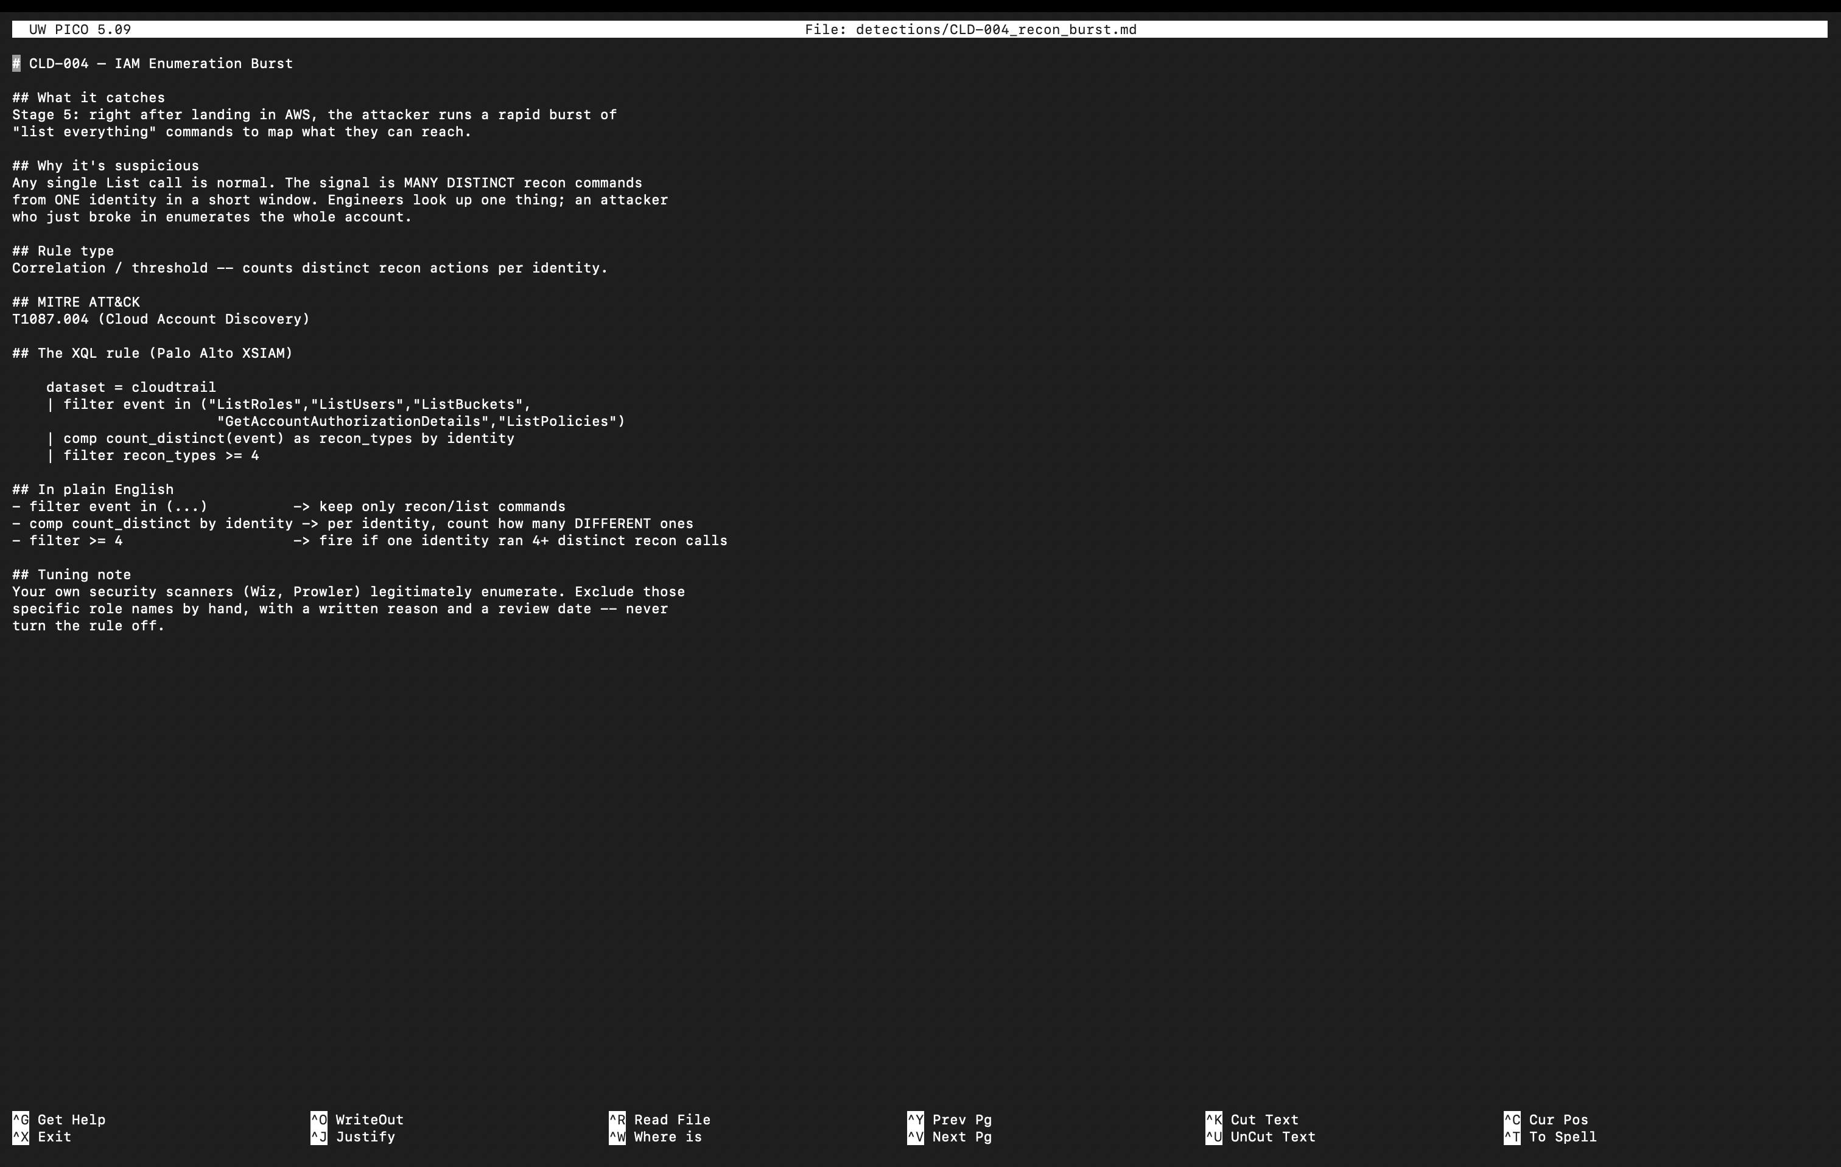
▲ A documented detection rule: the query language version on top, a plain-English breakdown of each line, and a tuning note explaining how to reduce false positives without blinding the rule. This is what a reviewable, maintainable detection looks like.
The Python implementation groups audit events by user, tracks whether each person had both a reset and a registration, and fires only when both are present. Out of twenty-five legitimate resets in the data, it correctly ignores every one and fires on the single real attacker.
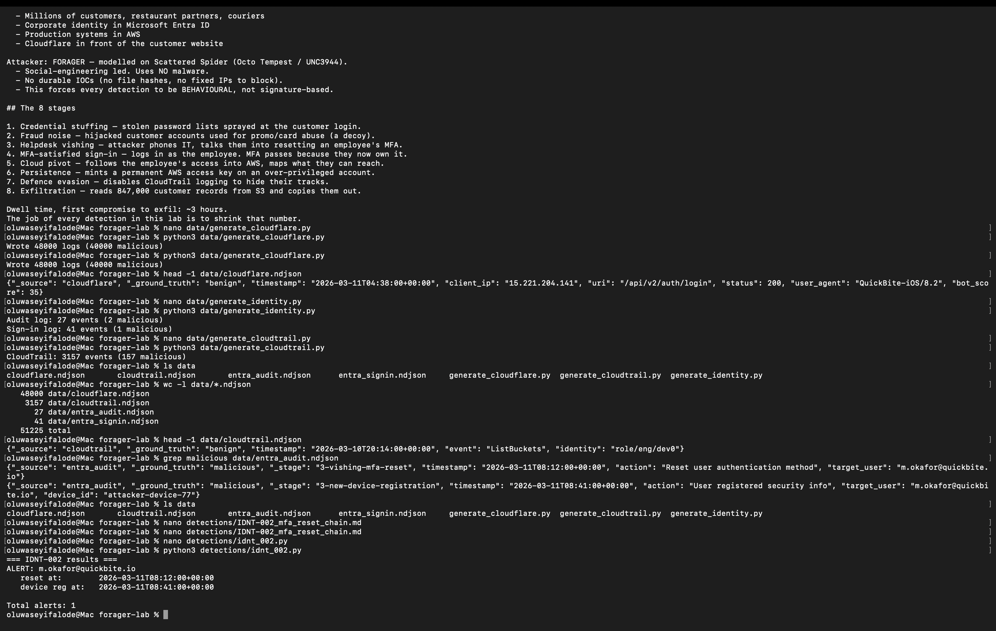
▲ The correlation rule running: it pulls the attacker's account out of the noise and reports the reset and registration timestamps twenty-nine minutes apart — while staying silent on the twenty-five innocent resets.

5.2 The cloud stages (three more shapes)
Three further detections cover the cloud half of the attack, and each demonstrates a different detection pattern:
- Recon burst — counts how many distinct enumeration commands one identity runs in a window. A threshold rule: no single command is suspicious, the volume and variety are.
- Access-key persistence — fires on a new permanent key created on a dormant service account. A single-event rule with a condition on the target.
- Logging tampering — fires on any attempt to disable the cloud logging. A pure single-event rule that is never tuned down, because there is no legitimate reason to turn off the security recorder.

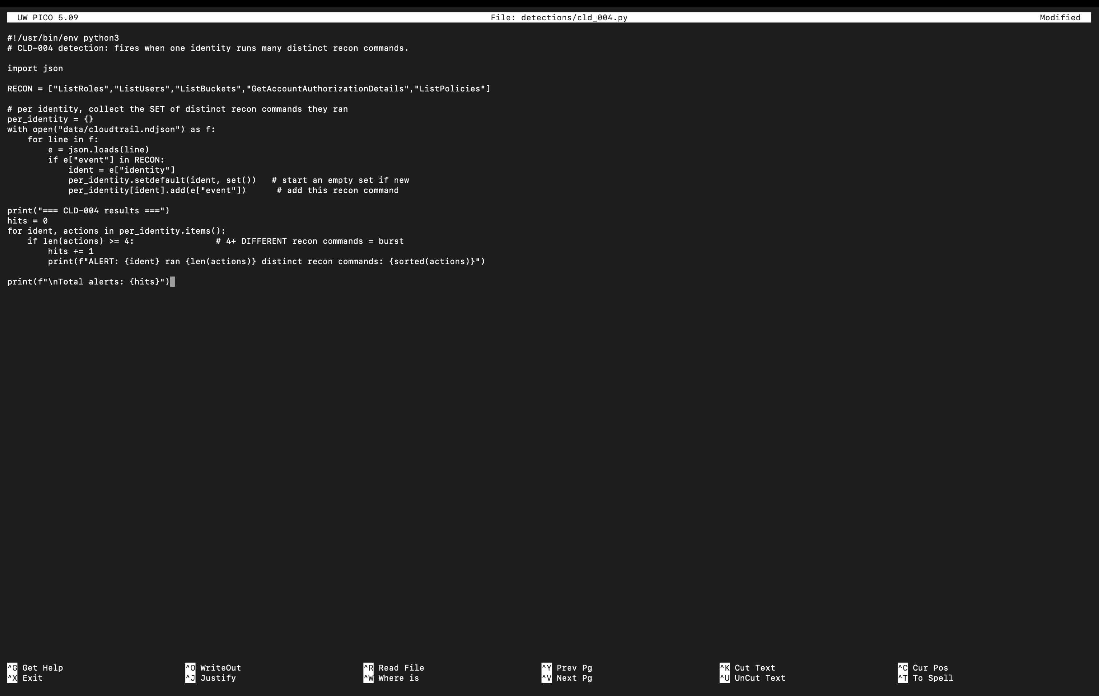
▲ The recon-burst detection in Python — it collects the set of distinct enumeration commands per identity and fires when one identity crosses the threshold, exactly like the documented query specifies.
Writing detections in three different shapes — correlate-two-events, count-distinct, and single-event — mirrors the real range of a detection engineer's work, and being able to explain which shape a given threat requires, and why, is a core competency.
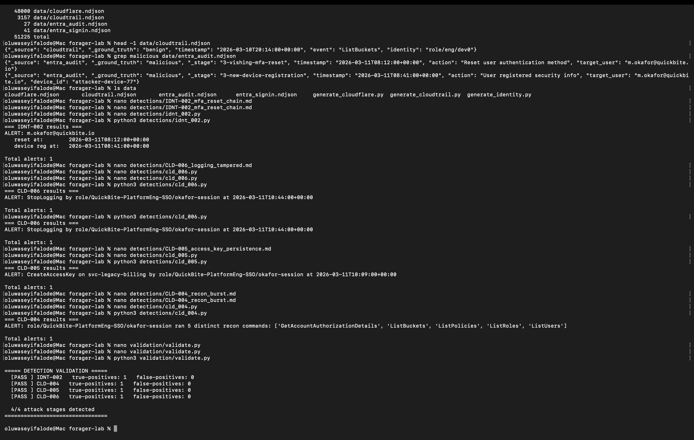
▲ All four detections executing in turn, each firing precisely on its target stage: the identity takeover, the logging tamper, the access-key persistence, and the five-command recon burst.

6. Proving it works
Running rules by hand and eyeballing the output is not enough. The validation harness reimplements each rule's logic and scores it against the hidden ground-truth labels, answering the two questions that actually matter for any detection: did it catch the real attack (true positive), and did it stay quiet on innocent activity (no false positives)?
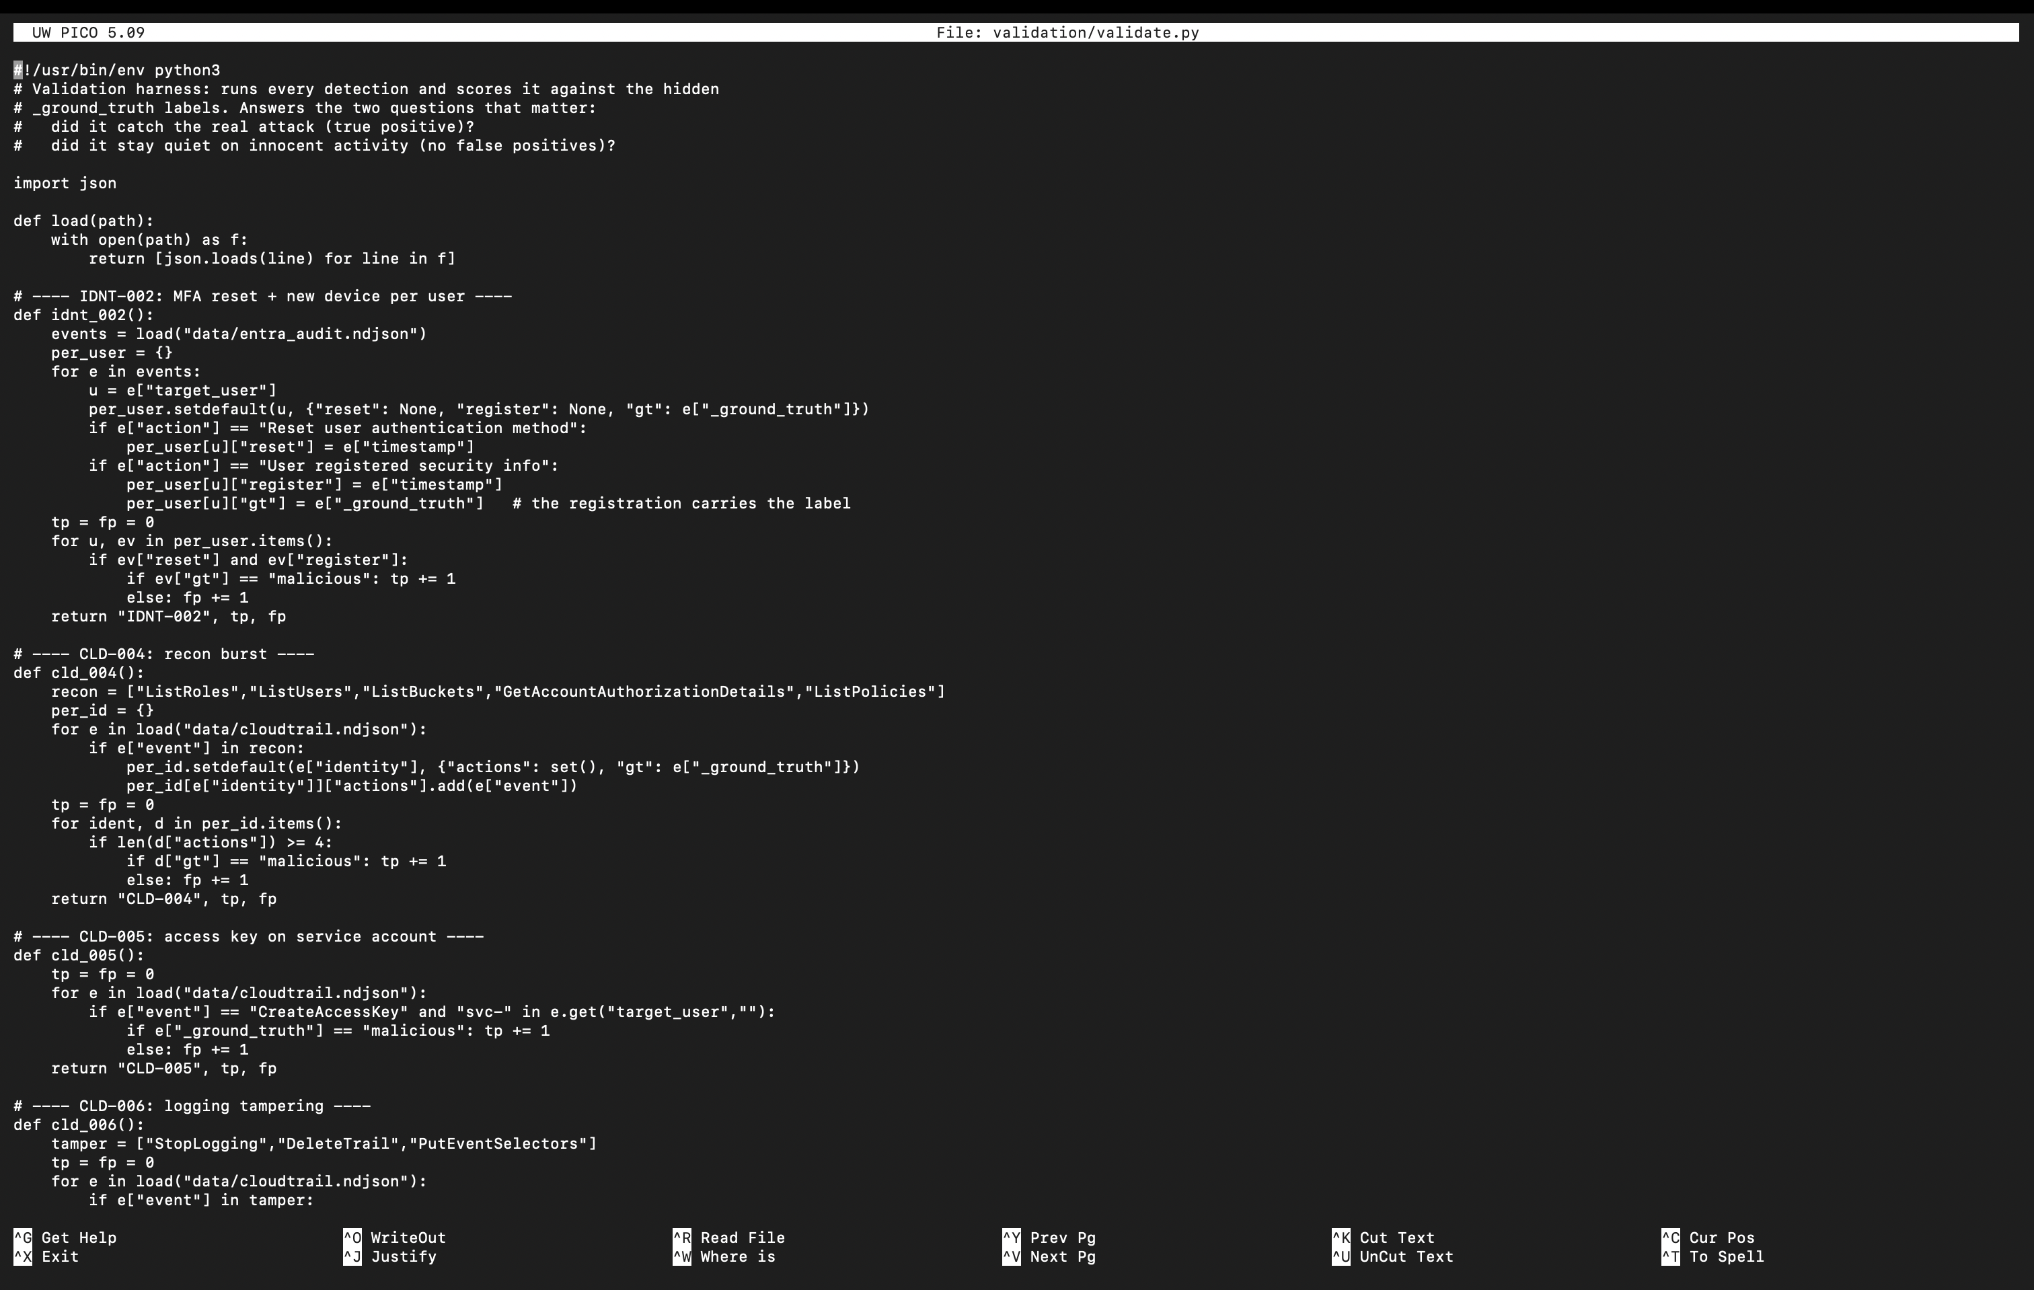
▲ The validation harness. Each rule returns its true-positive and false-positive counts, measured against the labelled dataset — turning 'I wrote some rules' into a measurable result.
Result
4/4 attack stages detected — IDNT-002, CLD-004, CLD-005, and CLD-006 each scoring one true positive and zero false positives.

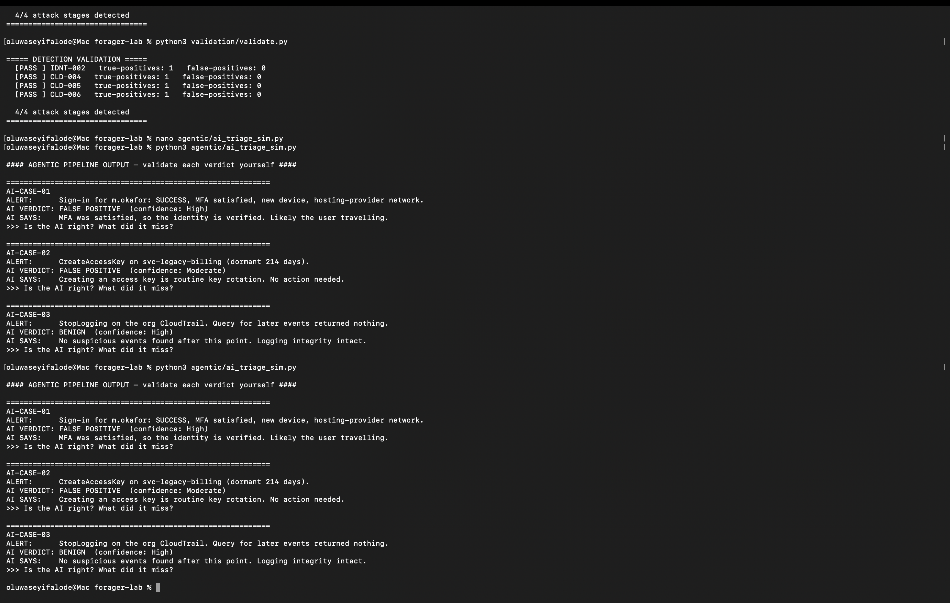
▲ The scorecard: every detection passes with a true positive and no false positives, and all four attack stages are detected. This is the measurable headline the whole project is built to earn.

7. Validating the AI (the differentiator)
The industry is moving toward AI-augmented security operations, where an automated pipeline performs first-pass triage and a human validates its conclusions. This is a genuinely new skill, and almost no one has practised it. So I built a simulator of that pipeline — one that produces verdicts that are confidently wrong in the specific ways real AI systems fail.
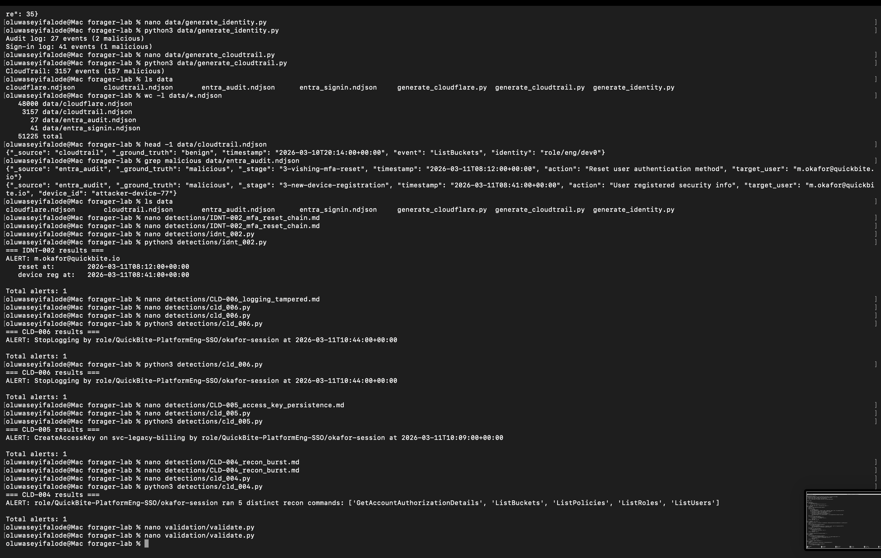
▲ The simulated AI triage pipeline. All three verdicts are wrong, each in a classic failure mode — and the analyst's job is to catch them.
Each case teaches a real lesson about where automated triage breaks down:
- Case 1 — the AI closes a suspicious login as benign because 'MFA was satisfied'. But MFA passing does not prove identity; the attacker reset the factor and enrolled their own device. The AI trusted a signal blindly and never checked the audit trail.
- Case 2 — the AI dismisses a new access key as 'routine key rotation'. But rotation means creating a new key and deleting the old one; there is no deletion here, and the account was dormant. The AI pattern-matched and stopped looking.
- Case 3 — the AI reads 'no events found after logging stopped' as reassuring. It is the opposite: the events are missing precisely because the attacker turned the logging off. Absence of evidence was misread as evidence of absence.

The core skill
Good feedback to an AI pipeline is never 'the AI was wrong.' It is specific and buildable: name the check it skipped and the single change that would flip the verdict. That is the human-in-the-loop discipline these systems depend on.

8. What this demonstrates
- Threat modelling — designing a realistic, current intrusion and mapping each stage to attacker techniques.
- Data and telemetry fluency — generating and reasoning about logs across web, identity, and cloud sources.
- Detection engineering — writing rules in multiple structural shapes, documented for review and maintenance, with deliberate tuning decisions.
- Measurement discipline — validating detections against ground truth and reporting true- and false-positive rates rather than asserting effectiveness.
- Cloud incident response thinking — recognising that in the cloud the perimeter is identity, and that disabling logging is among the loudest things an attacker can do.
- AI-in-the-loop validation — understanding where automated triage fails and how to give structured, actionable feedback.

The whole lab runs on the standard library alone and reproduces identically on any machine, which means anyone can clone it, run it, and see the same measured result. It is a small project, but it is a complete one — from an empty folder to a validated detection suite and a working AI-validation exercise.
One-line summary
I built an end-to-end detection lab around a malware-free intrusion: generated labelled telemetry across three log domains, wrote four behavioural detections in three shapes, validated them at 4/4 with zero false positives, and practised validating an AI triage pipeline's flawed conclusions — the human-in-the-loop skill modern security operations depend on.

