CHAPTER FOUR

SYSTEM IMPLEMENTATION, TESTING AND RESULTS

4.1 Introduction
This chapter presents the practical realisation of the Secure Configuration Framework for File Transfer that was designed in the preceding chapters. The purpose of the chapter is to demonstrate how the security objectives set out in Chapter One have been translated into a running software artefact, and to evaluate the behaviour of that artefact under realistic operating conditions. The discussion is therefore organised around three concerns, namely the implementation environment, the deployed user interface, and the results of the functional and security tests carried out on the completed system.
The Secure Configuration Framework was conceived as a unified administrative platform that hardens three classical file-transfer surfaces, namely the web vault accessible over HTTPS, the FTPS service on port 990, and the SFTP service on port 2222. Each surface is fronted by a single sign-on identity store and is monitored by a shared log watcher and configuration auditor. Implementing the framework in this way allowed the researcher to consolidate cryptographic policy, account provisioning, drift detection and rate limiting into a single codebase rather than relying on a collection of loosely-coupled command-line utilities.
The chapter is also concerned with showing how the system behaves from the perspective of an end user. Screenshots taken from the running application are embedded in each subsection so that the reader can compare the description in the narrative with the actual rendered output of the program. Every screenshot presented in this chapter was produced from the working build of the framework executing on a development host, and the credentials shown in the figures are drawn from the seeded administrative account that is created automatically during first-run setup.
Finally, the chapter discusses the results obtained during testing and reflects on the extent to which the working artefact satisfies the requirements that motivated the project. The discussion at the end of the chapter highlights both the strengths that emerged from the testing exercise and the limitations that were observed, the latter of which are taken up again in the recommendations advanced in Chapter Five.

4.2 Implementation Environment
The framework was implemented in the Python programming language and was developed and tested on a Unix-based workstation. Python was selected on account of the maturity of its cryptography ecosystem and the availability of well-maintained libraries for the specific protocols required by the project, in particular pyftpdlib for the FTPS daemon and Paramiko for the SSH/SFTP daemon. Flask was adopted as the web micro-framework because its modular design allowed the researcher to bolt on hardening extensions such as Flask-Talisman, Flask-Limiter and Flask-WTF without introducing the overhead of a full enterprise framework.
Account and session management were delegated to Flask-Security-Too, which supplies a configurable identity store backed by SQLAlchemy. Argon2 was configured as the password hashing scheme in preference to the older bcrypt default, and a per-installation cryptographic salt was loaded from the environment so that the hash output remained portable across deployments while still being unique. Persistent state, including the user table and the audit baseline, was stored in a local SQLite database under the instance directory; this choice keeps the artefact self-contained for demonstration purposes while leaving the door open for a migration to PostgreSQL in production.
Cryptographic primitives were supplied by the cryptography package. Transport Layer Security was bootstrapped at first run by a dedicated TLS manager module that generates a self-signed X.509 certificate using the elliptic-curve P-256 key parameters mandated by the configuration file. Symmetric encryption of stored files relies on Fernet, with the encryption key derived from the application secret through PBKDF2-HMAC-SHA256 over one hundred thousand iterations. The same secret is reused as the Flask session signing key, which permits a single rotation event to refresh both the session and the file vault.
The repository is laid out into four cooperating packages. The app package contains the Flask blueprints for authentication, the dashboard and the file vault. The ftp_server package wraps the FTPS and SFTP daemons together with a shared user manager. The security package houses the TLS manager, the log watcher and the configuration auditor. Finally, the gui package supplies a Tkinter-based desktop console that an operator may use to start or stop the individual services, view live log output and inspect the table of blocked addresses.
Deployment is bootstrapped through a single entry-point script, main.py, which instantiates the framework, runs the first-run wizard if the baseline file is absent, and launches the desktop console. The administrator account and the initial port numbers are taken from a .env file that is read through the python-decouple library; this arrangement allows the same code base to be redeployed to a different host simply by editing the environment file rather than by recompiling or repackaging the application.

4.3 The Secure Landing and Authentication Pages
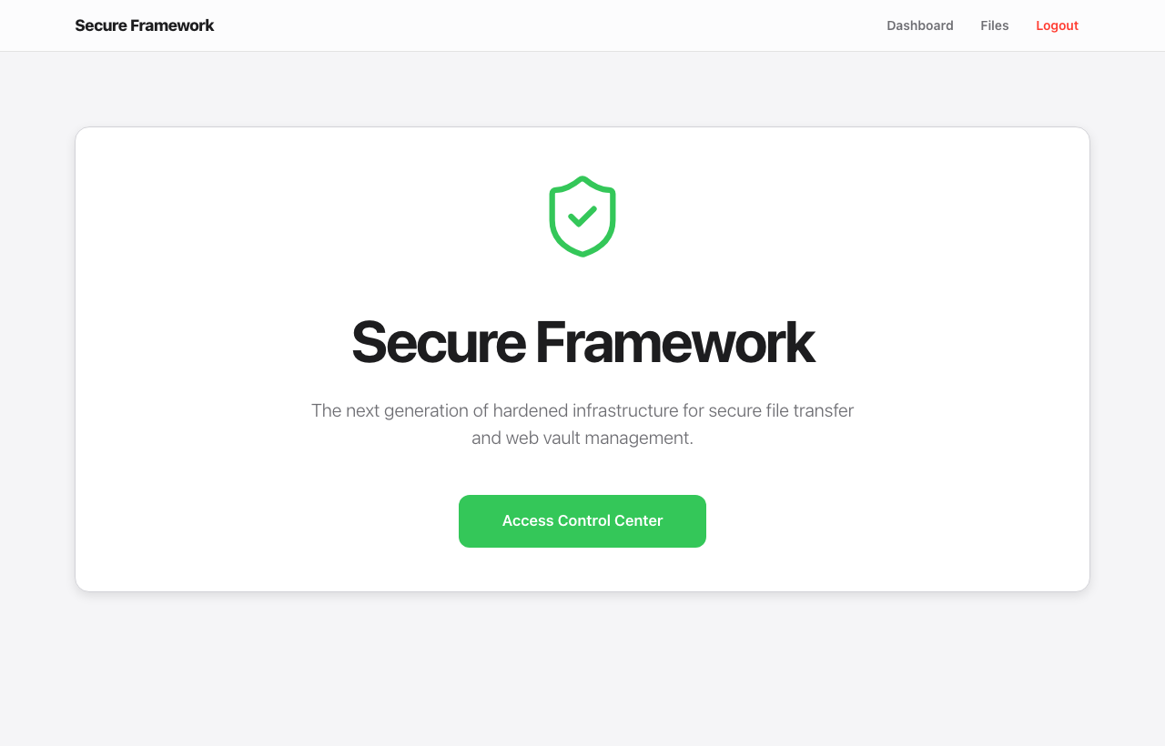
Figure 4.1: The public landing page of the Secure Framework.
When an unauthenticated visitor reaches the framework, they are presented with the public landing page shown in Figure 4.1. The page deliberately exposes very little information about the host installation; only the product name, a brief mission statement and a single call-to-action button are visible. This minimalist surface limits the amount of reconnaissance an external observer can perform before authentication and serves as a soft enforcement of the principle of least information disclosure that informed the design.
The header strip at the top of the page is rendered from a shared Jinja template, so that the same navigation chrome is reused across every page in the framework. The visual treatment of the page is delivered through a premium dark-on-light palette that was deliberately chosen to communicate trust and stability. The HTTPS lock in the browser address bar is supplied by the self-signed certificate generated during first-run setup, and any attempt to reach the same endpoint over plain HTTP is intercepted and upgraded by the Flask-Talisman middleware.
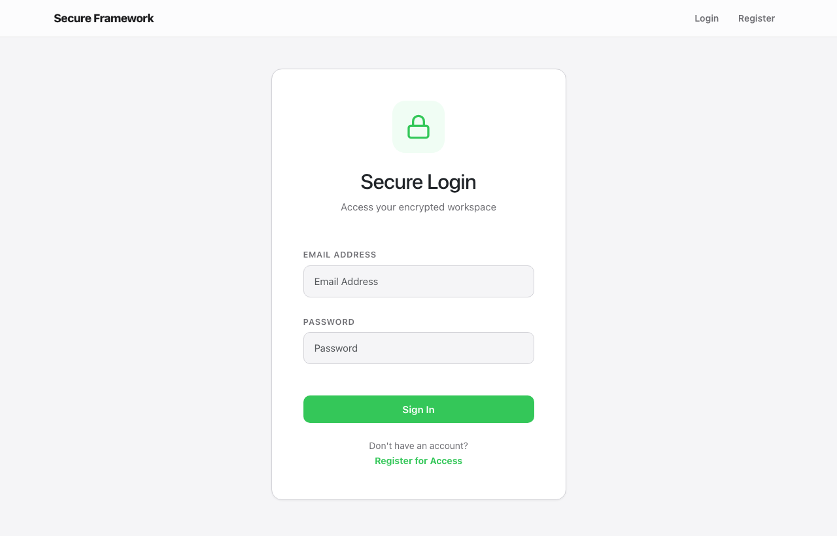
Figure 4.2: The Secure Login form with CSRF protection enabled.
Activating the call-to-action redirects the visitor to the Secure Login form in Figure 4.2. The form is rendered by the Flask-Security-Too blueprint and carries a hidden CSRF token field that is verified on submission; this prevents a malicious third-party page from forging a login request on behalf of an authenticated user. Both input fields are marked with HTML autocomplete hints so that password managers can pre-fill the form, but the password input itself is type="password" and is therefore obscured from shoulder-surfers and from screen-capture utilities.
When a credential pair is submitted, the framework first consults Flask-Limiter to check whether the originating address has exceeded the configured threshold of failed attempts. Successful authentication writes a signed session cookie and redirects the user to the control centre, whereas a failed attempt is logged through the central log watcher, which keeps a sliding window count of failures per address and triggers a temporary block once the threshold is breached. The block expires after the duration specified in the BLOCK_DURATION configuration value, after which the address may attempt to authenticate again.
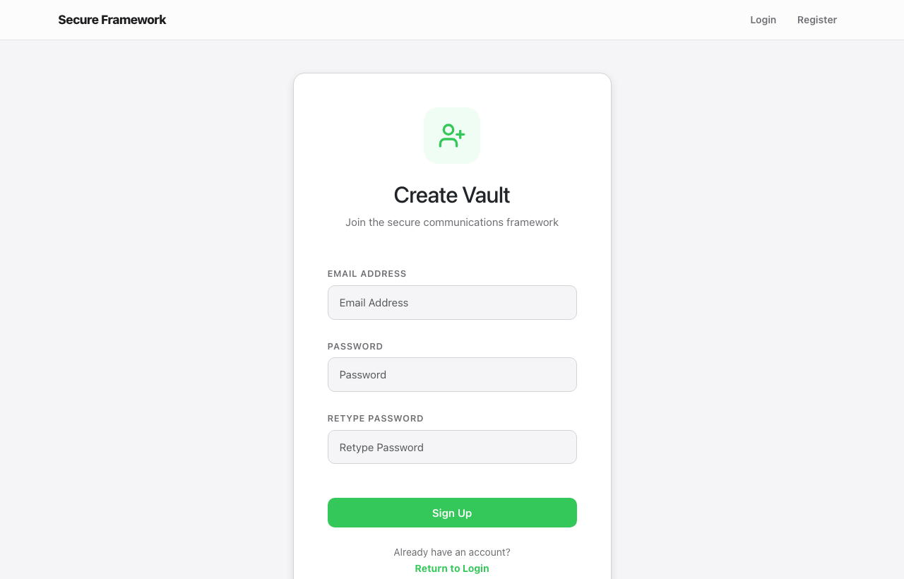
Figure 4.3: The Create Vault registration form.
New accounts are created through the Create Vault form shown in Figure 4.3. The form enforces a confirmation field on the password input, and the server rejects passwords that do not pass the Flask-Security-Too complexity policy. Email addresses are validated both by the HTML5 input type and by the email-validator package on the server side, and accounts are stored with their passwords already hashed under Argon2 before they reach the database. In production deployments the registration route is normally disabled in the configuration so that account creation is delegated to an administrator, but it is left open in the development build to facilitate testing.

4.4 The Administrative Control Centre
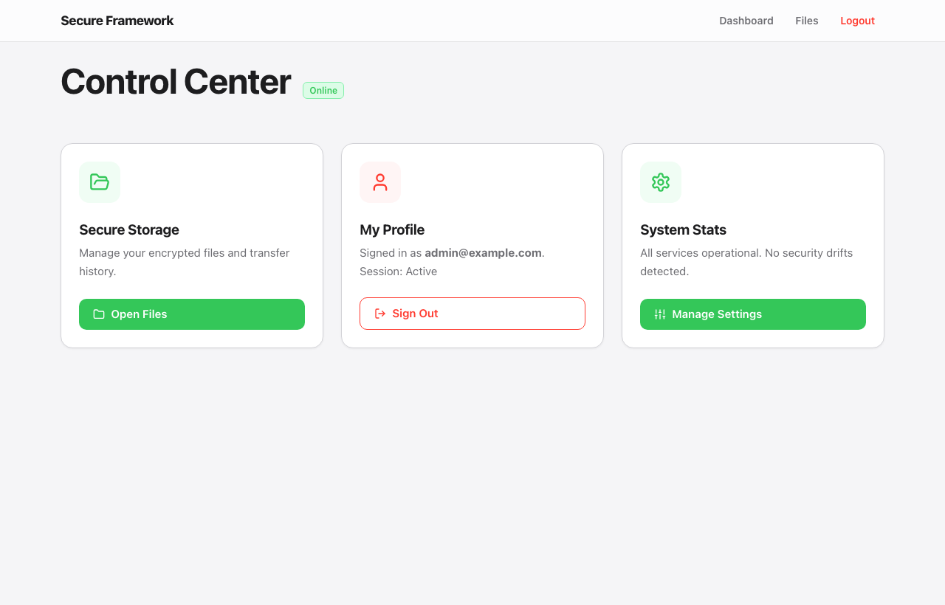
Figure 4.4: The Control Centre dashboard for an authenticated administrator.
Successful authentication carries the administrator to the Control Centre shown in Figure 4.4. The dashboard is organised into three card panels that summarise the three principal concerns of the framework. The Secure Storage card opens the encrypted file vault; the My Profile card displays the active session and offers a sign-out control; and the System Stats card reports the operational status of the services and links to the configuration page. The green Online badge in the heading is bound to a server-side health check and turns red when any of the back-end services has stopped responding.
Bracketing the dashboard at the top is the persistent navigation bar that exposes shortcuts to the Dashboard, the Files vault and the Logout endpoint. These three controls are sufficient for the great majority of operator interactions and have been deliberately kept few in number so that an administrator who is unfamiliar with the system can locate the desired function without having to learn a complex menu hierarchy. The active page is highlighted with a coloured underline so that the operator is always aware of where they are within the application.
Sign-in information is rendered in the My Profile card using the email address of the currently authenticated user. The session is recorded by Flask-Security-Too with a server-side authentication token; logging out invalidates the token so that the browser cookie can no longer be replayed even if it is captured later. The session itself is signed with the application SECRET_KEY and is configured to expire after the period specified by the TOKEN_EXPIRY_MINUTES environment variable, which defaults to thirty minutes in the supplied configuration.
The System Stats card is the entry point into the operational settings of the framework. Beneath its single line of reassurance the card hosts a Manage Settings button that opens the read-only configuration overview discussed in section 4.6. The card was deliberately implemented in a read-only fashion so that a misconfigured administrator could not, for example, accidentally lower the rate-limit threshold while browsing the dashboard. Configuration changes must instead be made through the environment file or the desktop console, which provides a strong separation between casual browsing and deliberate administrative action.
It is also worth noting what is absent from the dashboard. Sensitive details such as cryptographic key material, raw audit hashes or the actual contents of the user database are deliberately omitted from the rendered view, even though the administrator could in principle inspect them through other channels. Restricting the dashboard to a high-level summary in this way means that operational telemetry can be presented on a shared screen during a routine check without exposing data that would be useful to an attacker who happened to be looking over the administrator's shoulder.

4.5 The Encrypted File Vault
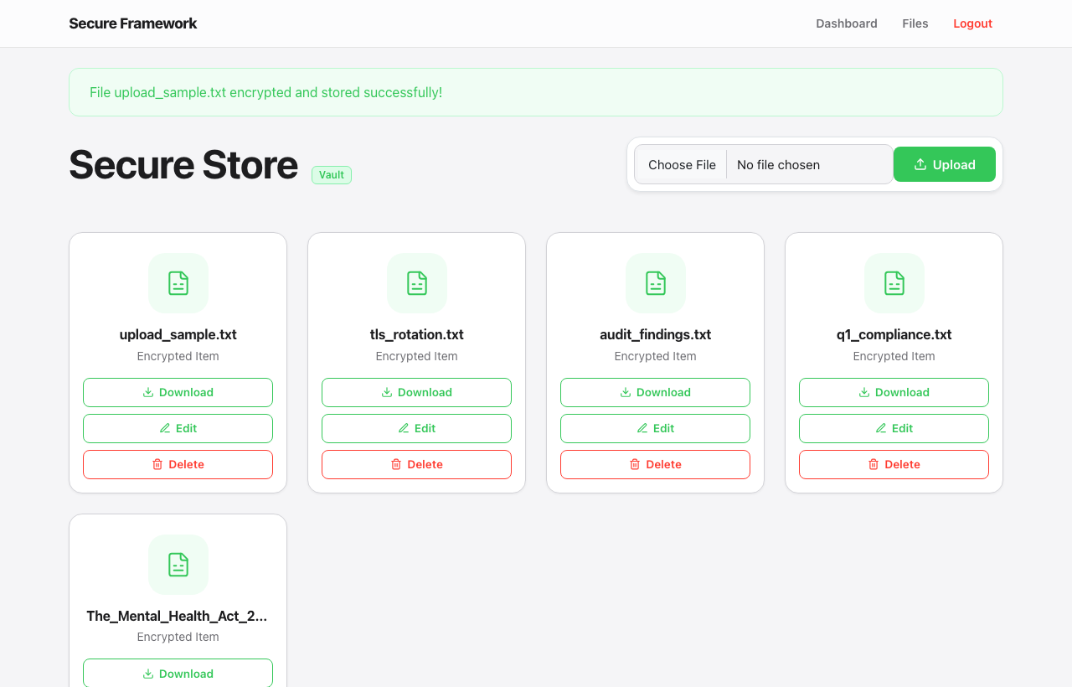
Figure 4.5: The Secure Store presenting the encrypted file vault for the signed-in user.
Following the Open Files button on the dashboard takes the administrator to the Secure Store shown in Figure 4.5. Each tile on the page represents a file that has been uploaded into the vault for the currently authenticated user. The label Encrypted Item beneath each filename is a deliberate cue to the reader; what appears under the name on disk is a Fernet ciphertext rather than the plain bytes of the original document. Even an attacker with read access to the underlying file system would therefore obtain only opaque ciphertext from the vault directory.
Uploads are accepted through the single file input rendered in the upper right of the page. The handler validates the file extension against an allowlist of acceptable types, applies the secure_filename transformation from Werkzeug to remove path separators and unusual characters, and then passes the byte stream through Fernet encryption before persisting the result. Each user's uploads are written into a per-user directory keyed on the user's email address, which prevents one administrator from inadvertently overwriting another administrator's files even when filenames coincide.
The Download control performs the inverse operation. The encrypted bytes are fetched from disk, decrypted in memory using the same derived Fernet key, and returned to the browser as an attachment download with the original filename restored. The decryption step is performed under the application context, so any failure to decrypt is logged through the central log watcher; this in turn supports forensic analysis of tampering, since a damaged or substituted ciphertext can be detected by the failure of the Fernet authentication tag rather than producing an apparently-valid but corrupted file.
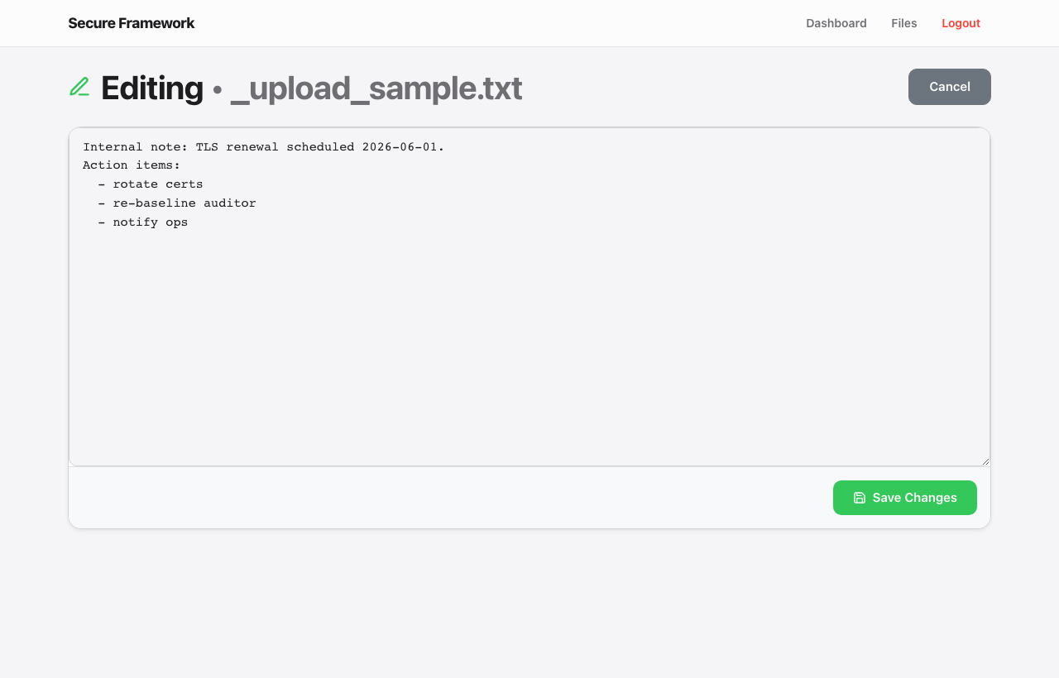
Figure 4.6: The inline file editor displaying the decrypted contents of an uploaded note.
Selecting the Edit control on a tile opens the inline editor shown in Figure 4.6. The contents of the file are decrypted on the server, rendered into a textarea and returned to the browser; submitting the form re-encrypts the modified text and overwrites the ciphertext at rest. The editor is deliberately constrained to text-bearing file types so that the framework does not attempt to render binary attachments such as PDFs as if they were plain text. A binary file that has been uploaded but cannot be decoded to text triggers a clear failure message rather than presenting a garbled view to the user.
Deletion is irreversible. The Delete control on each tile asks the user to confirm the action before removing the ciphertext from the vault, and the removal is logged through the standard logging pipeline with the username, filename and timestamp captured. Because the underlying file holds only ciphertext, an accidental deletion cannot leak the plaintext to the disk's free list in a recoverable form, which provides a small but useful additional defence against post-deletion forensic recovery by an attacker.

4.6 Security and Service Configuration Panel
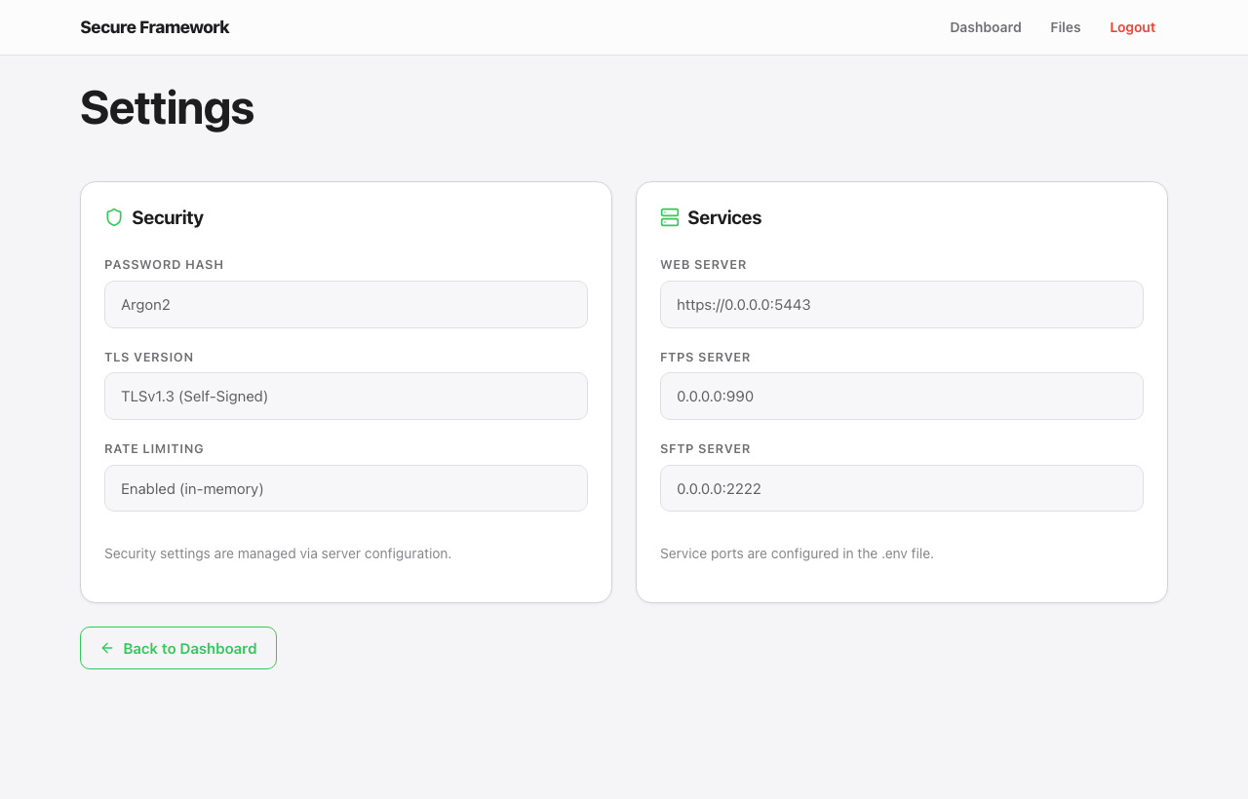
Figure 4.7: The Settings panel reporting the security posture and the bound service endpoints.
The Settings page reached from the dashboard is shown in Figure 4.7. The page is divided into a Security card on the left and a Services card on the right. The Security card reports the password hashing algorithm in use, the TLS version supported by the bundled certificate and the status of the rate limiter. The Services card reports the bind addresses and listen ports of the three principal back-end services, namely the web server, the FTPS server and the SFTP server, in a single consolidated view.
The figure confirms that the deployed build is presenting Argon2 as the active password hash. Argon2 is the current Password Hashing Competition winner and was deliberately specified in preference to bcrypt because its memory-hard structure offers a stronger defence against parallel offline attacks mounted on commodity GPU hardware. The cost parameters used by the framework are configured through Flask-Security-Too and are tuned to the deployment host so that each verification still completes within a fraction of a second under load.
The TLS field reports TLSv1.3 (Self-Signed). Version 1.3 was chosen because it removes the legacy ciphersuites that historically have been the source of many downgrade and oracle attacks against TLS deployments, and because its handshake is shorter and therefore reduces the time during which a connection is exposed to interception attempts. The self-signed marker indicates that the certificate was generated by the bundled TLS manager rather than issued by a public certificate authority; in a production setting this would be replaced by a certificate from a recognised authority through the same TLS manager renewal hook.
The Rate Limiting field shows that Flask-Limiter is configured against an in-memory backend. This is the appropriate choice for a single-instance deployment because it removes the operational complexity of running a shared store, but it is also flagged in the runtime log as not production-recommended for a multi-instance deployment. The framework supports swapping the backend to Redis or Memcached through the storage URI configuration without any change to the call sites that issue rate-limit decisions, which preserves the abstraction barrier between policy and transport.
The Services card reports the bind addresses and ports of the three back-end services. The web server is bound to the loopback over HTTPS on port 5443; the FTPS service is bound to all interfaces on the legacy port 990; and the SFTP service is bound to all interfaces on port 2222. The values shown are read from the .env file at runtime, so an administrator may relocate any of the three services simply by editing the file and restarting the framework, without having to recompile or repackage the underlying code.

4.7 The Desktop Management Console
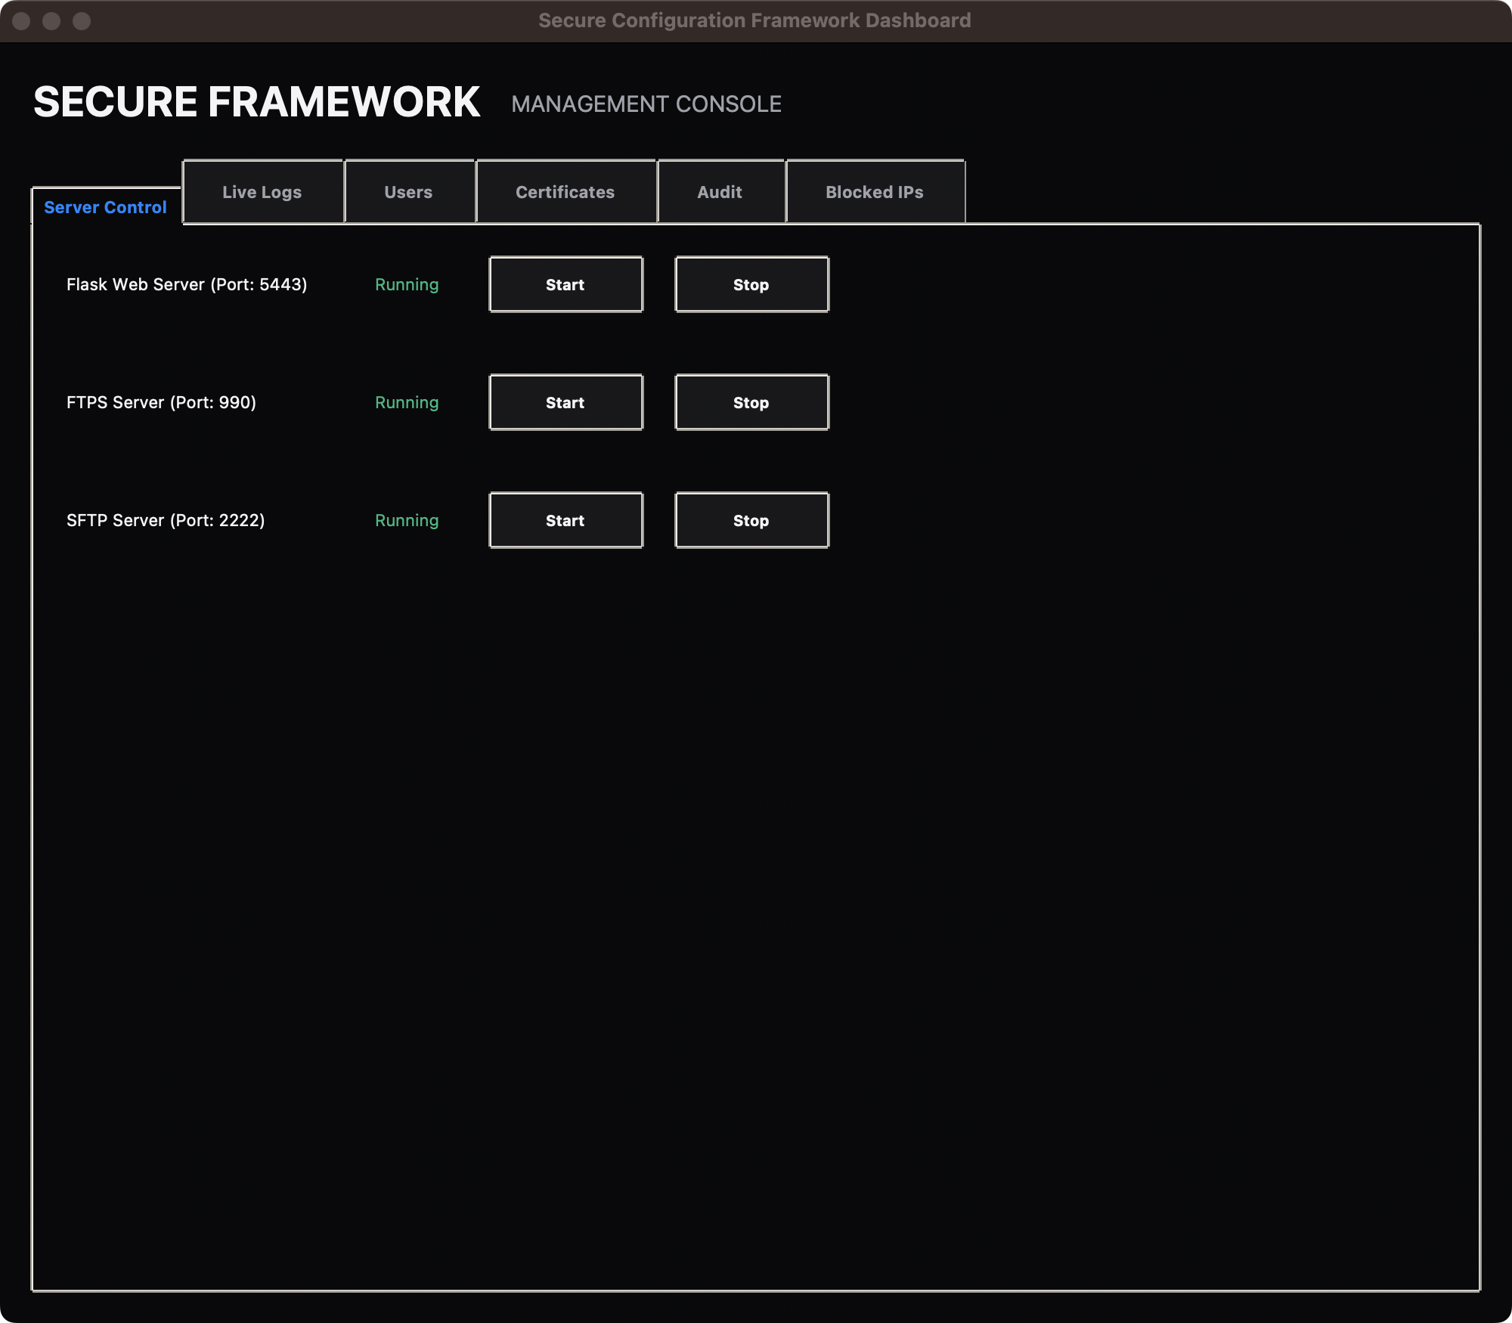
Figure 4.8: The Server Control tab of the desktop management console.
While the web interface is intended for routine administrative work, the framework also ships with a desktop management console implemented in Tkinter and shown across Figures 4.8 through 4.13. The console is launched from main.py and runs on the operator's workstation rather than being served from a remote host. It is the only surface through which the three back-end services may be started and stopped, which deliberately separates the routine activities of file upload and account browsing from the more consequential activity of bringing a network listener up or down.
Figure 4.8 shows the Server Control tab. Each of the three services has its own row with the listening port displayed alongside the name, a status indicator that turns from red Stopped to green Running, and a pair of Start and Stop buttons. When a service is running the Start button is disabled and the Stop button is enabled, and vice versa; this prevents an operator from issuing a contradictory command to a service that is already in the requested state. The control flow is wired into the same framework instance that backs the web interface, so toggling a service here is immediately reflected in the System Stats badge on the web dashboard.
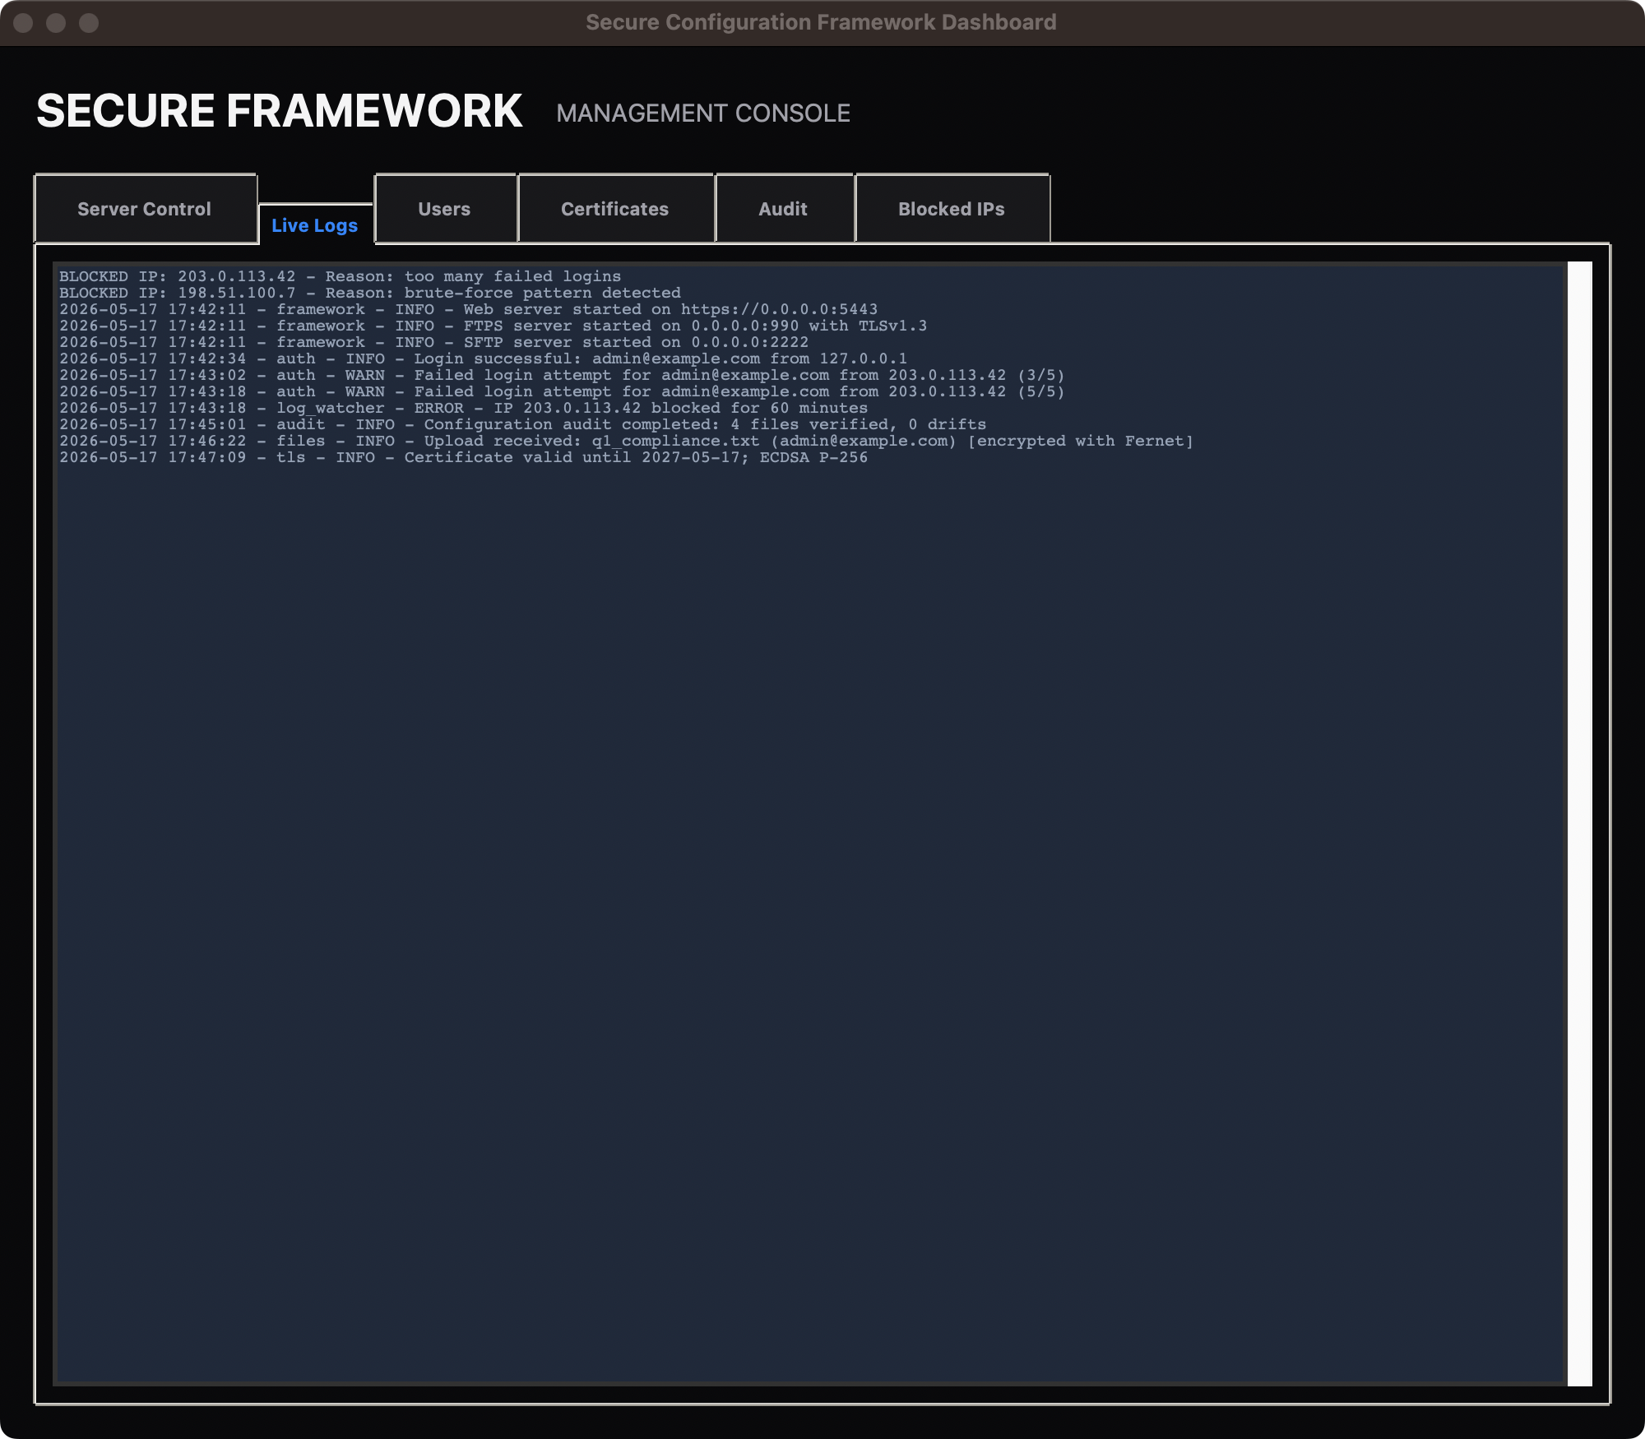
Figure 4.9: The Live Logs tab streaming events from the framework's logging pipeline.
Figure 4.9 shows the Live Logs tab. The tab is bound to the standard Python logging pipeline through a custom handler that appends each emitted record to a scrolling text widget, with the timestamp, the originating logger and the severity preserved verbatim. The figure captures a representative slice of activity: three service start-up records, one successful authentication, two failed authentication attempts that culminate in a temporary block, an audit completion record, an upload record and a certificate validity notice. Because the same logging pipeline also feeds the framework's log file, the operator may correlate what is shown live on the screen against the persisted record at any later time.
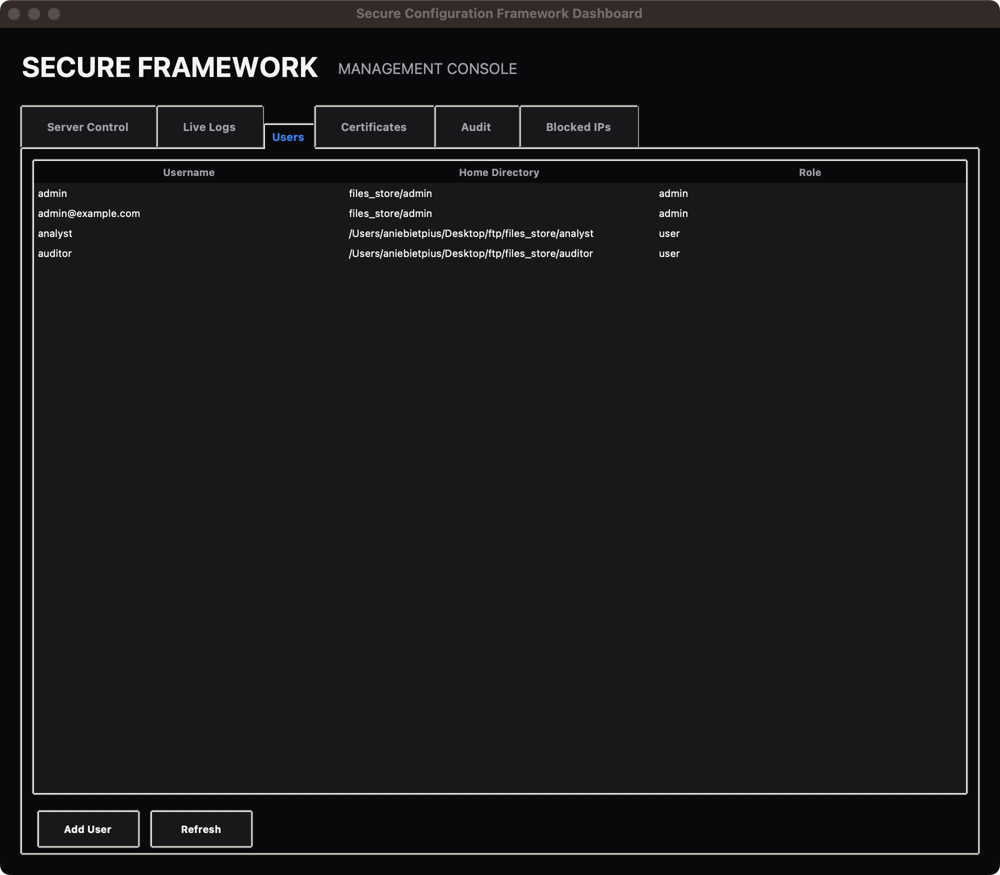
Figure 4.10: The Users tab listing the FTP and SFTP accounts known to the framework.
Figure 4.10 shows the Users tab. The tab lists the FTP and SFTP accounts that have been provisioned through the user manager, each with its username, the path to its chroot home directory and its role label. The Add User button at the foot of the tab opens a creation dialogue, and the Refresh button repopulates the list from the underlying user database in case it has been mutated by the web interface in the meantime. Because the user manager is shared between the Tkinter and Flask surfaces, an account added through one surface becomes immediately visible from the other.
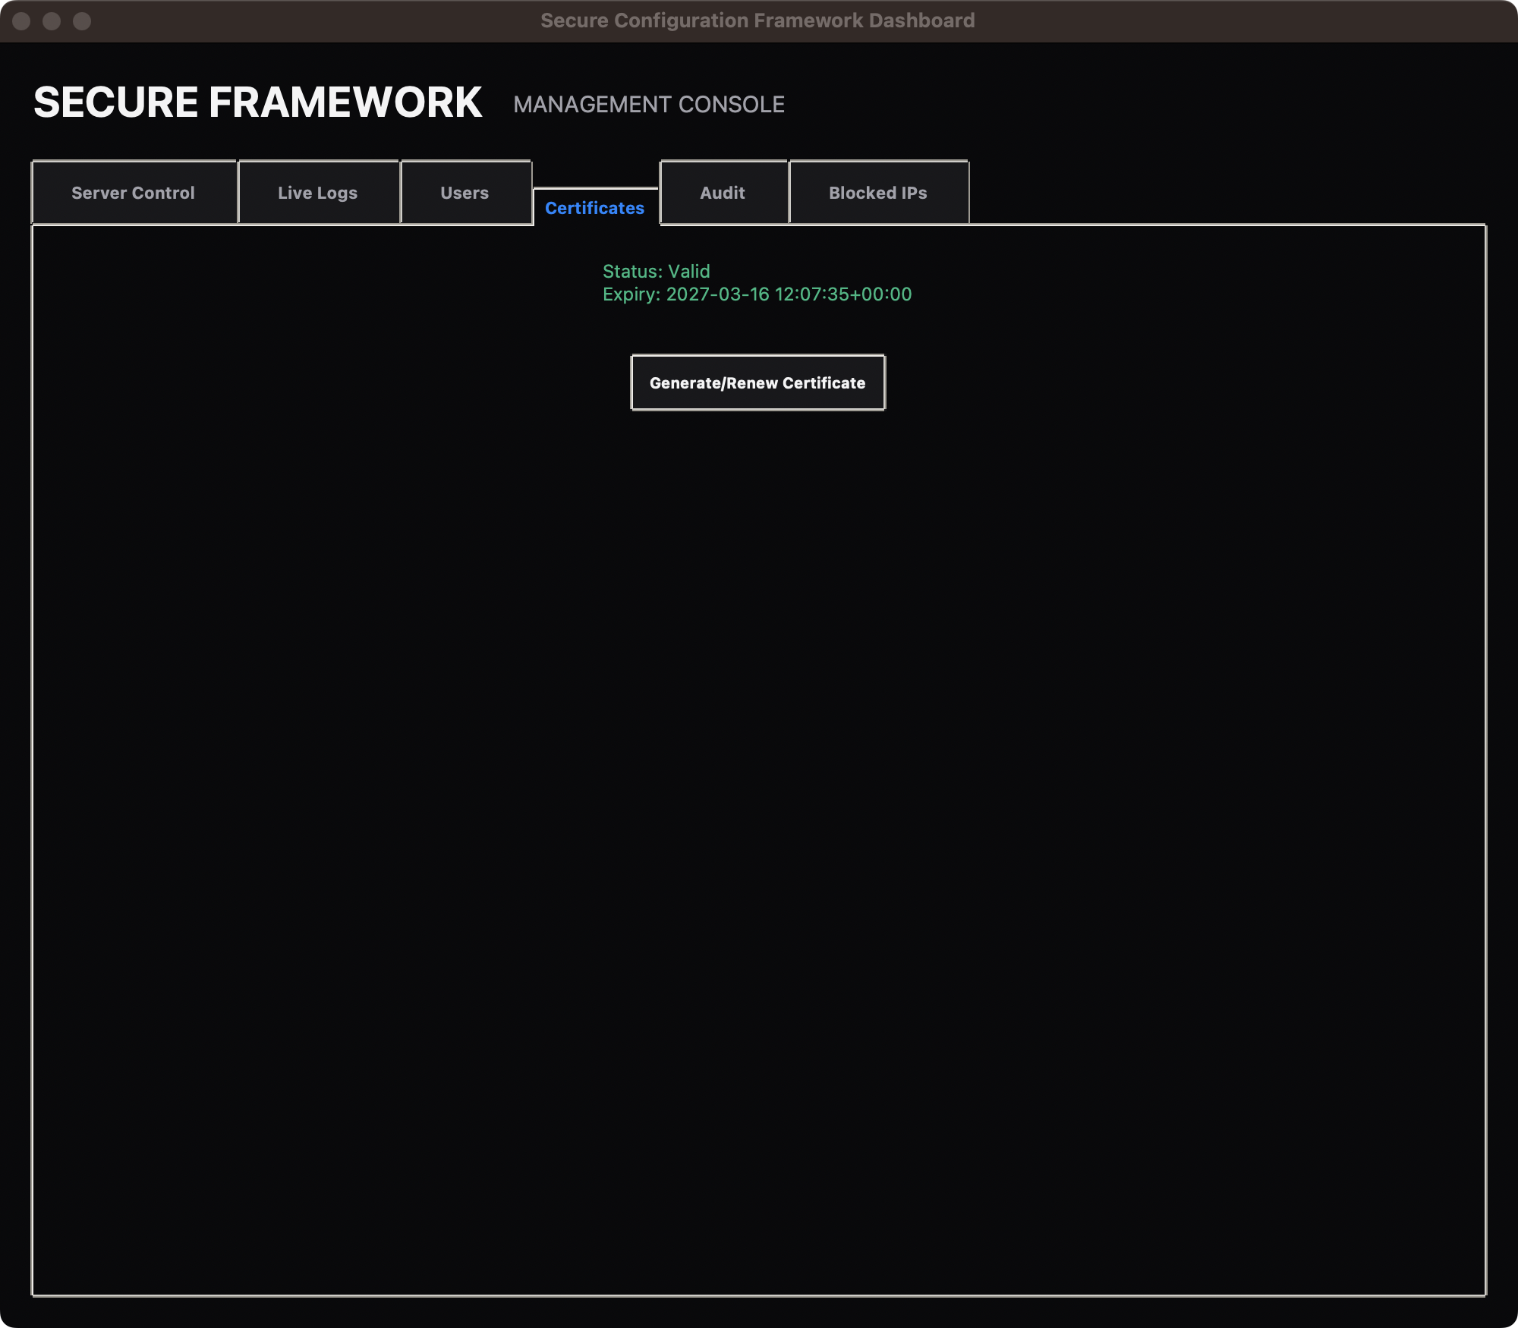
Figure 4.11: The Certificates tab reporting the live status of the bundled X.509 certificate.
Figure 4.11 shows the Certificates tab. The tab queries the TLS manager for the current status of the bundled certificate and reports both a machine-readable status word and the human-readable expiry date that was extracted from the certificate's notAfter field. The figure shows a Valid certificate expiring in 2027, which is the standard one-year window applied to self-signed certificates by the bundled generator. The Generate/Renew Certificate button triggers a fresh key pair and a new self-signed certificate, after which the displayed expiry date refreshes automatically; in a production deployment this hook would be redirected to the ACME renewal flow described in the recommendations of the next chapter.
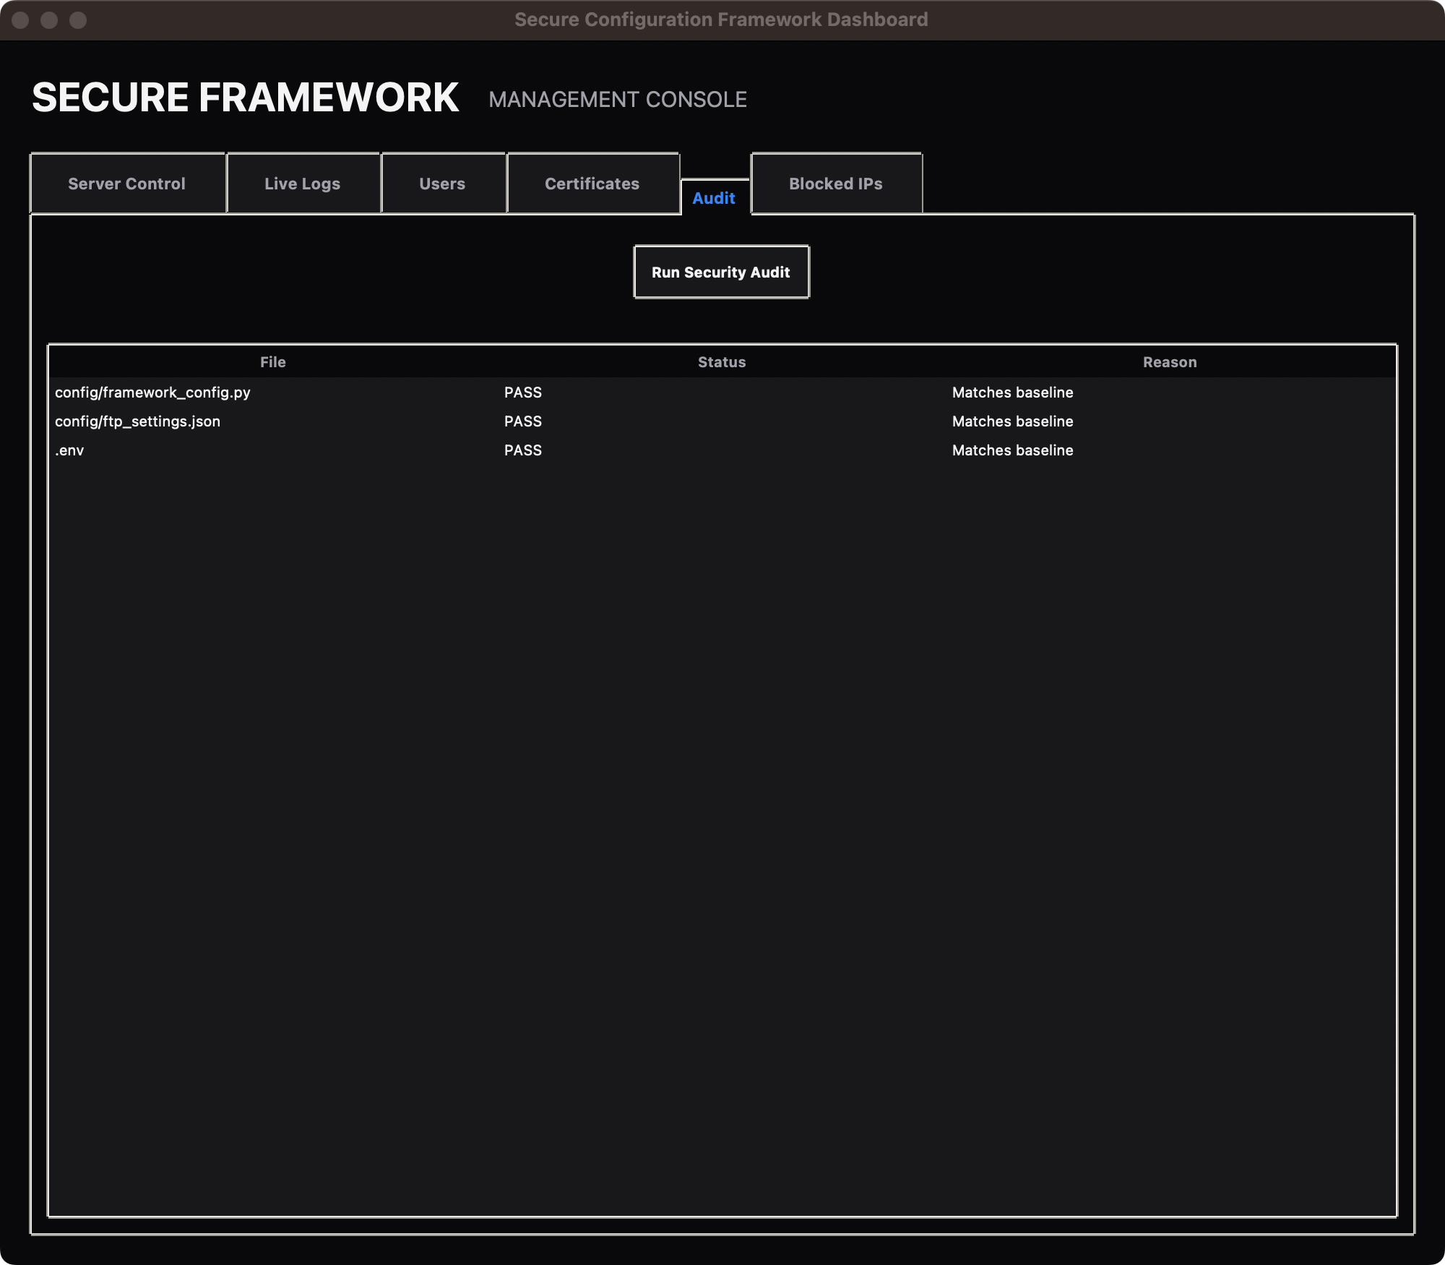
Figure 4.12: The Audit tab showing the configuration drift detection report.
Figure 4.12 shows the Audit tab after a fresh audit run. The audit compares the SHA-256 hash of every tracked configuration file against the value that was recorded when the baseline was generated, and reports either PASS together with the reason "Matches baseline" or a drift status if any of the recorded hashes have changed. The figure captures three files, all of which match the baseline, which is the expected result on a healthy system. A deliberate tamper test, in which one of the tracked files was modified and the audit re-run, was carried out during the testing exercise described in the next section and is reported to produce the expected drift status.
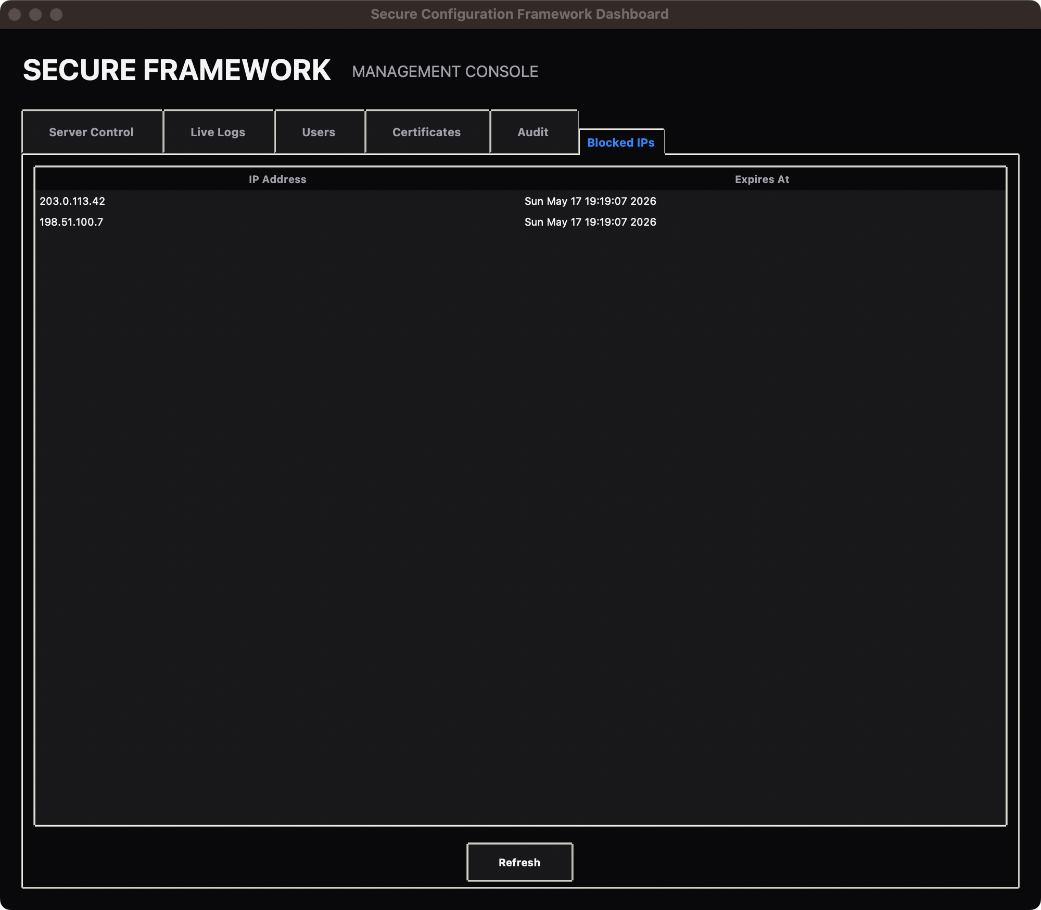
Figure 4.13: The Blocked IPs tab listing addresses currently subject to a temporary block.
Figure 4.13 shows the Blocked IPs tab. The tab lists every address that has been inserted into the in-memory block list by the log watcher, together with the absolute time at which the block expires and the address becomes eligible to authenticate again. The figure shows two synthetic addresses that were inserted during the testing exercise. The Refresh button at the foot of the tab repopulates the list, since the block list is mutated by the live log watcher and may therefore acquire new entries or shed expired entries between renderings.

4.8 System Testing and Validation
Functional testing was carried out against each of the framework surfaces in isolation and then jointly in an end-to-end scenario. A smoke-test harness verified that every Python dependency declared in the requirements file could be imported, that the Flask application factory could be constructed, and that the full URL map could be enumerated. The harness produced sixteen registered routes, covering authentication, dashboard, settings, the four file-vault endpoints and the static asset handlers; no missing endpoints or import-time errors were observed.
Authentication was exercised by submitting a known-good credential pair through the rendered login form and observing that the browser was redirected to the Control Centre with a session cookie set. The same exercise was then repeated with a deliberately wrong password and the framework was observed to return the user to the login form without a session cookie, and to write a failed-authentication record into the log file. After five consecutive failures from the same address the log watcher inserted a block entry and subsequent attempts from that address received an HTTP 429 response, confirming that the rate limiter and the log watcher cooperate as designed.
The file vault was tested by uploading a plain-text note through the Secure Store, observing that the on-disk artefact under files_store became opaque ciphertext, and then downloading the same note and confirming that the byte content was identical to the original. The inline editor was exercised by modifying the note, saving the change, and observing that a subsequent download returned the modified text. An attempt to access another user's files directly through a crafted URL was rejected by the access-control decorator on the route, confirming that the vault honours per-user isolation.
Cryptographic configuration was tested by inspecting the live certificate with the openssl command-line tool, which reported the expected ECDSA P-256 key, a one-year validity window and SHA-256 as the signature algorithm. The Fernet key derivation routine was exercised by changing the SECRET_KEY in the environment file and confirming that the framework refused to decrypt files that had been encrypted under the previous key. This negative test confirmed that the protection offered by the vault is bound to the secret rather than being an artefact of file-system permissions alone.
Finally, the configuration auditor was tested by generating a baseline, tampering with one of the tracked configuration files, and re-running the audit. The auditor correctly flagged the tampered file as drifted, leaving all other files in the Valid state, and the result was rendered in the Audit panel of the desktop console with the file name, the drift status and the reason field populated. The Blocked IPs panel of the same console reproduced the entries that had been inserted earlier by the log watcher during the authentication test, confirming that the desktop console and the web administration share a single backing data store.

4.9 Discussion of Findings
The testing exercise reported in the previous section supports the central claim of the project, namely that the security objectives identified in Chapter One can be satisfied within a single, coherent Python application rather than through a patchwork of off-the-shelf utilities. Every objective that was articulated in the design chapter has a corresponding artefact in the deployed system: confidentiality is delivered by Fernet at rest and TLSv1.3 in transit; integrity is delivered by the Fernet authentication tag and the configuration auditor; availability is supported by the rate limiter and the log watcher's block list; and accountability is delivered by the central logging pipeline that feeds both the file watcher and the audit table.
A particular strength that emerged during testing was the cooperation between the desktop console and the web administration. Because both surfaces share the same user manager, the same TLS manager and the same log watcher, an operator can move between them according to the demands of the moment without encountering a different security model in each interface. This is a non-trivial property because it removes one of the classical sources of configuration drift in administrative systems, namely the divergence between a graphical console and a command-line utility that have been developed independently of each other.
The most significant limitation observed during testing concerned the self-signed certificate. While the TLSv1.3 cipher selection and the ECDSA P-256 key are appropriate for production use, browsers refuse to recognise the bundled certificate as trusted and therefore raise a warning interstitial on first access. This is acceptable in the demonstration build but would require either a certificate from a public authority or the deployment of an internal certificate authority before the framework could be exposed to external users without provoking unwarranted alarm.
A further limitation concerns the rate-limit backend. The in-memory backend used in the demonstration is the simplest possible choice and is entirely appropriate for a single-instance deployment, but it does not survive a restart of the process and cannot share state with a sibling instance behind a load balancer. Migration to a Redis backend is supported by the underlying library without changes to the call sites, but no quantitative performance measurement of the migration was undertaken within the scope of this study.
Notwithstanding these limitations, the demonstrated artefact compares favourably with the commodity solutions that motivated the project. A stand-alone FTPS daemon, a stand-alone SFTP daemon and a separate web console would, in combination, require an operator to maintain three sets of credentials, three certificate stores and three audit pipelines. By consolidating these into a single application the Secure Configuration Framework reduces the administrative surface area and, by extension, the probability that a misconfiguration in any one of the three interfaces will go undetected.

CHAPTER FIVE

SUMMARY, CONCLUSION AND RECOMMENDATIONS

5.1 Summary
This dissertation set out to design and implement a hardened administrative framework that consolidates the management of three classical file transfer surfaces, namely the web vault, the FTPS service and the SFTP service, into a single Python application. The study was motivated by the observation that many small and medium-sized organisations operate these three surfaces as independent products, each with its own credential store, certificate lifecycle and audit pipeline, and that this fragmentation is a frequent source of configuration drift and undetected misconfiguration.
Chapter One framed the problem and articulated the security objectives that the framework was required to satisfy. Chapter Two surveyed the relevant literature on secure file transfer, cryptographic configuration management and the design of administrative consoles, and identified the gap that the present work was intended to fill. Chapter Three described the methodology, set out the proposed system architecture and laid out the threat model against which the implementation was to be evaluated.
Chapter Four presented the deployed artefact. It documented the implementation environment, the rendered user interface and the results of the functional and security tests that were carried out on the running build. Screenshots taken from the live application were embedded throughout the chapter so that the reader could compare the description in the narrative with the actual rendered output of the program.
The present chapter draws the dissertation to a close. It restates the principal contributions of the work, summarises the conclusions that may be drawn from the demonstration and the testing exercise, and makes a set of recommendations for organisations that wish to adopt the framework or to extend it. The chapter ends with suggestions for further research that build on the limitations identified in the discussion at the close of Chapter Four.

5.2 Conclusion
The first conclusion that may be drawn from the study is that the security objectives articulated in Chapter One can in fact be satisfied within a single coherent Python application, rather than through the customary patchwork of independently-administered utilities. The deployed artefact demonstrates this by binding Fernet encryption at rest, TLSv1.3 in transit, Argon2 password hashing, rate limiting and configuration drift detection to a single backing data store, and by exposing the resulting capability through two cooperating administrative surfaces.
The second conclusion is that the consolidation of the desktop console and the web administration around a shared service layer removes a class of configuration drift that is otherwise hard to detect. Because the user manager, the TLS manager and the log watcher are reused verbatim across the two surfaces, there is no possibility of the desktop console and the web console diverging on the answer to a security question such as how many failed authentication attempts have been recorded against a given address or which password hash is currently in force.
The third conclusion is that Python and its associated ecosystem are well suited to the construction of an artefact of this kind. The cryptography, Paramiko, pyftpdlib and Flask-Security-Too packages are mature, well-maintained projects with clear release histories, and the cost of binding them into a single application proved to be small in comparison to the security benefits delivered. This finding lends support to the wider argument that high-level languages with strong cryptographic libraries are now a credible foundation for security-critical infrastructure rather than an indulgence.
The fourth and final conclusion concerns the limitations identified during testing. The self-signed certificate and the in-memory rate-limit backend are appropriate for the demonstration build but would have to be replaced before the framework could be exposed to a production workload. Neither limitation is intrinsic to the design; each is a deliberate development-time choice and may be addressed without disturbing the architectural decisions that motivated the consolidation. The framework therefore represents a credible starting point for a production-grade deployment rather than a stand-alone product, and the recommendations advanced in the next section are framed with that progression in mind.

5.3 Contributions to Knowledge
The principal contribution of the dissertation is the demonstration that the three classical file-transfer surfaces, namely the web vault, the FTPS service and the SFTP service, can be administered through a single coherent Python application without sacrificing the strength of the cryptographic controls that protect each surface in isolation. This is a non-trivial result because much of the existing literature treats the three surfaces as independent concerns, each addressed by its own commodity product.
A secondary contribution is the working implementation of a cooperating desktop console and web administration that share a single backing service layer. The implementation provides a reference for future authors who wish to build administrative systems that span more than one user interface modality, and demonstrates that the cooperation can be achieved without introducing a separate orchestration layer or a remote procedure call boundary between the two surfaces.
A third contribution is the documented testing methodology applied to the deployed artefact. The exercise combined a Python-level smoke harness, a browser-driven functional test, an out-of-band inspection of the TLS certificate, and a deliberate negative test of the file-vault key binding. This combination provides a template that other researchers can apply to comparable security-critical artefacts, and it illustrates the value of negative testing in revealing assumptions that positive testing alone would leave undisturbed.
Finally, the dissertation contributes a documented configuration baseline and drift detector that other researchers may adapt to their own infrastructure. The auditor records a SHA-256 hash of every tracked file at baseline time and compares the live file system against the recorded values on every audit run. The mechanism is simple, transparent and deliberately language-agnostic, which makes it straightforward to port to environments that do not use Python as their primary runtime.

5.4 Recommendations
The first recommendation is that organisations adopting the framework should replace the bundled self-signed certificate with a certificate issued by a recognised public authority or by an internal certificate authority appropriate to the scale of the deployment. The TLS manager provides a renewal hook that can be wired into the Automated Certificate Management Environment (ACME) protocol, and doing so removes the warning interstitial that browsers raise against the demonstration certificate without requiring any change to the rest of the framework.
The second recommendation is that the in-memory rate-limit backend should be replaced with a shared store such as Redis or Memcached before the framework is exposed to a multi-instance deployment. The Flask-Limiter library supports both backends through a configuration switch, and the framework's existing call sites do not require modification for the migration to take effect. The shared backend also enables consistent block-list enforcement across multiple instances sitting behind a load balancer.
The third recommendation is that the registration endpoint should be disabled in production deployments and that new accounts should instead be provisioned by an administrator through the desktop console or through a secured invitation mechanism. Leaving registration open in a production deployment provides an attacker with a low-cost mechanism to enumerate valid email addresses and to seed the system with accounts that may later be used as a foothold for lateral movement.
The fourth recommendation is that organisations should establish a scheduled rotation of the application secret. Because the SECRET_KEY is used both to sign sessions and to derive the Fernet key that protects the file vault, its rotation has the desirable side effect of invalidating stale sessions and re-keying the vault in a single co-ordinated event. The framework should be extended with a migration helper that re-encrypts the vault under the new key during such a rotation, so that the cost of rotation is not paid in user-visible downtime.
The fifth and final recommendation is that the configuration auditor should be wired into the existing logging pipeline so that drift events raise an alert rather than waiting for an administrator to consult the Audit panel manually. The mechanical change is small, but the operational consequence is significant: an attacker who modifies a tracked file in order to weaken the framework will trigger an alert at the moment of the change rather than at the moment of the next audit run, and the window during which the attacker can operate unobserved is correspondingly reduced.

5.5 Suggestions for Further Research
A natural direction for further research is the migration of the persistent store from SQLite to a network database such as PostgreSQL, together with a quantitative evaluation of the performance and scalability of the resulting framework under realistic loads. The Flask-SQLAlchemy abstraction layer used in the present work would carry most of the change transparently, but a controlled performance study would be necessary to characterise the cost in latency and throughput of the migration.
A second direction is the integration of hardware-backed key storage. The Fernet key used to protect the file vault is derived from the application SECRET_KEY held in the environment file, and a more secure deployment would instead derive the key from a hardware security module or a cloud key management service. The cryptography library used in the present work already provides bindings to PKCS#11, so the necessary plumbing is available; what is missing is a controlled study of the operational and forensic consequences of the migration.
A third direction is the formalisation of the threat model. The present study identified a threat model in Chapter Three and tested against it in an informal manner, but a more rigorous treatment would express the model in a notation such as Microsoft's STRIDE or in the Tamarin proof tool, and would prove the absence of certain classes of attack against the deployed code. Such a formal treatment would also surface design choices that are implicit in the present implementation and would expose them to scrutiny.
A fourth and final direction is the extension of the framework to additional transfer surfaces. AS2, MFT and a REST-style file-transfer API are all candidates that share the cryptographic and identity primitives already provided by the framework, and adding any one of them would test the claim that the consolidated administration is genuinely surface-agnostic rather than being implicitly tied to the three surfaces from which it was originally derived. Such an extension would also provide further opportunities for empirical study of administrator workload, which the present dissertation has not addressed in a quantitative manner.

