Multimodal Data Analysis and Relational Database Integration Using Large Language Models and Low-Code Tools
1st Şeyma Okçu
Department of Computer Engineering
Kastamonu University
Kastamonu, Turkey
okcuseyma2@gmail.com

Abstract— This study developed an end-to-end data processing pipeline that automatically analyzes and makes sense of unstructured multimodal data, such as text and images, and periodically records the results in a relational database. n8n was used to manage the flow; multimodal AI analysis was done with Google Gemini 2.5 Flash; the data was stored in the cloud environment on Supabase (PostgreSQL). Thanks to the resulting architecture, it is now possible to successfully analyze and transfer complex and heterogeneous data structures, such as customer feedback, in terms of sentiment and category, to the database without the human touch.
Keywords— multimodal analysis, artificial intelligence, relational database, data processing pipeline, PostgreSQL.

I. Introduction
Most of the data produced by information systems these days comes in unstructured form, such as text, audio, or images. Classical relational database management systems effectively manage with structured data, but when it comes to getting unstructured data directly into the database and making it queryable, we face a serious engineering problem.
At this point, integrating large language models (LLMs) into data processing processes, which combine natural language processing and computer vision, emerges as a next-generation solution [2]. The goal of this project is to work on the n8n automation platform; to create an intelligent system architecture that can simultaneously process and save visual and text data from external sources (webhooks) to the database [1].

II. System Architecture and Methodology
The system consists of four main components and these parts work integrated with each other. Modularity and data integrity were prioritized during the design.

- Data Collection and Webhook Integration
The system receives data from the outside world through a Webhook node set up on the n8n platform [1]. A client that wants to trigger the system (for example, via Postman) wants to trigger the system; sends an HTTP POST request for this. The body of the request includes a "text" in JSON format and a "image_url" (image link). The webhook meets this asynchronous data and thus the data flow begins.

Multimodal AI Analysis
We send the collected data to the Google Gemini 2.5 Flash model via API [2]. The model examines both the image and the text at the same time with a special guidance we provide. As a result, it tells which main category the data belongs to and its mood (such as positive, negative, neutral).

Data Parsing
Artificial intelligence models usually present the outputs in Markdown format in a way that is easily read by a human (for example, "json"). We have added a JavaScript node to the system for the database to function properly. In this step, we convert the data to a tight JSON object, remove unnecessary characters [1]. In short, the systematic processing and storage of raw data is optimized.

D. Database Management (Supabase/PostgreSQL)
We transfer the extracted and cleaned data to the Supabase node, which is the last step of the process [3]. Here, the data is inserted directly into the PostgreSQL-based relational table.

III. Database Design
There is a table called "multimodal_analysis" in the permanent storage layer of the system [3]. This table securely stores both the AI-generated structured data and the original data from the client. Since it also ensures type security, data integrity and consistency are fully guaranteed regarding the consistency of the data.

Column Name | Data Type | Constraints
id | int8 | Primary Key, Auto-increment
original_text | text | Not Null
image_url | text | Not Null
category | text | Not Null
sentiment | text | Not Null
created_at | timestamp | Default: now()
Table I. Database Schema

IV. Testing and Findings
To test the developed architecture, we simulated customer feedback through Postman. For example, we found that for feedback that included both text and a photo of the damaged product, such as "My shipment arrived in shatters," the AI correctly identified the sentiment as "Negative" and the category as "Cargo Damage."
In the positive feedback, it became clear that the system was working smoothly. The system returned the HTTP code 200 OK and saved the incoming data completely in the Supabase PostgreSQL database, along with the id and created_at timestamp.
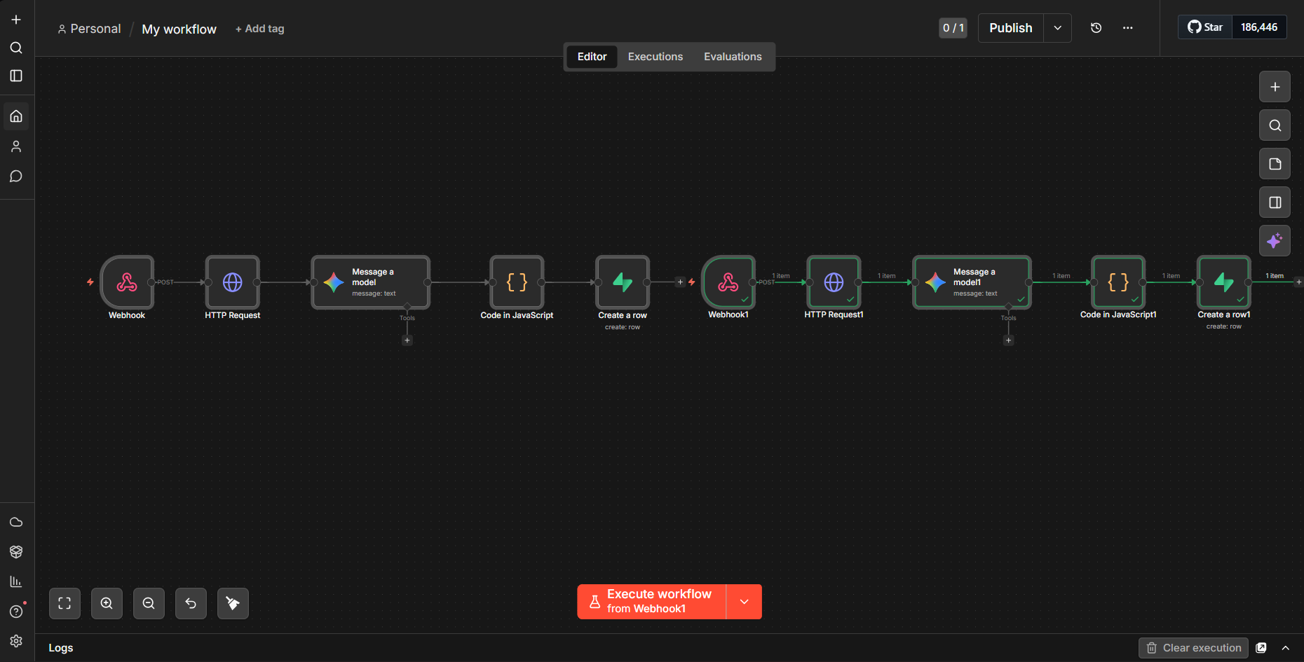
Figure 1. End-to-end multimodal data processing pipeline architecture on n8n.

V. Conclusion
In this project, we developed an end-to-end system that automates data entry and supports database management with artificial intelligence. By combining the flexibility of n8n with the reliability of Supabase, we overcame the challenges faced when handling unstructured data. In the next step, it is possible to set up a more independent structure that adds a notification to the system and sends automatic alerts to the authorities in times of crisis.

Resources
[1] n8n Documentation, "Webhook Node & Data Parsing," 2026. [Online]. Access: https://docs.n8n.io/
[2] Google for Developers, "Gemini API Documentation," 2026. [Online]. Access: https://ai.google.dev/
[3] Supabase, "PostgreSQL Database Architecture," 2026. [Online]. Access: https://supabase.com/docs

