Software Requirements Specification

Project: Hospital Management Automation

May 15, 2019

Hatice Seyma YIGIT

Refika ERSOY

Merve BALIK

Merve BAYRAKTAR

Oguzhan BAS

CENG 306 Software Engineering

1.0 INTRODUCTION |  |  |  |  |  | 1
1.1. PURPOSE |  |  |  |  |  | 1
1.2. SCOPE OF PROJECT |  |  |  |  |  | 1
1.3. GLOSSARY |  |  |  |  |  | 1
1.4 OVERVIEW OF DOCUMENT |  |  |  |  |  | 2
2.0 REQUIREMENTS |  |  |  |  |  | 3
2.1. FUNCTIONAL REQUIREMENTS |  |  |  |  |  | 3
2.2 NON- FUNCTIONAL REQUIREMENTS |  |  |  |  |  | 5
2.2.1 PERFORMANCE |  |  |  |  |  | 5
2.2.2 SECURITY |  |  |  |  |  | 5
2.2.3 AVAILABILITY |  |  |  |  |  | 5
2.2.4 FRONT DESK STAFF RIGHTS |  |  |  |  |  | 5
2.2.5 PROPERTIES |  |  |  |  |  | 5
3.0 USE CASE |  | AND SEQUENCE DIAGRAM |  |  |  | 6
USE-CASE MODEL |  |  |  |  |  | 6
3.1 ACTOR DESCRIPTIONS |  |  |  |  |  | 6
3.1.1 THE HOSPITAL MANAGER |  |  |  |  |  | 6
3.1.2 THE RECEPTIONIST |  |  |  |  |  | 6
3.1.3 THE DOCTOR |  |  |  |  |  | 6
3.1.4 THE NURSE |  |  |  |  |  | 6
3.2 USE CASE DIAGRAM |  |  |  |  |  | 7
3.3 USE CASE – FULLY DRESSED |  |  |  |  |  | 8
3.3.1 PATIENT REGISTRATION |  |  |  |  |  | 8
3.3.2 RECEIVING EMPLOYEES IN HOSPITAL |  |  |  |  |  | 10
3.3.3 ADD A PATIENT TO THE ROOM |  |  |  |  |  | 11
3.3.4 DOCTOR’S WEEKLY SCHEDULE |  |  |  |  |  | 13
3.3.5 DOCTOR EXAMINES AND THEN WRITES E-PRESCRIPTION |  |  |  |  |  | 14
3.4 BRIEF USE CASES |  |  |  |  |  | 16
3.4.1 THE HOSPITAL MANAGER |  |  |  |  |  | 16
3.4.2 | THE RECEPTIONIST |  |  |  |  | 16
3.4.3 | THE DOCTOR |  |  |  |  | 17
3.5 | SEQUENCE DIAGRAM |  |  |  |  | 18

1.0 INTRODUCTION

1.1. PURPOSE

The purpose of this document is to present a detailed description of the Hospital Automation Management system. It will explain the purpose and features of the system, the interfaces of the system, what the system will do, who will use it and who will influences. This document is intended for the lecturer of the course.

1.2. SCOPE OF PROJECT

This software system will be an automation for a local hospital with blocks in different regions. The main scope of the system is to provide a health service system where hospital staff can make the best use of it. Together with it, to create a platform that will facilitate the work for the hospital staff.

We will refer to the details of our project, firstly location and block information will be clearly defined since hospital departments are in different regions. But each block and these block employees will be managed by a single manager. Every employee on the system will write down specific record information. The same is true for patients. There will also be information for patients with bed or no bed, so room and bed number can be adjusted accordingly. As well as permission, seizure dates and operative information will be set by an administrator. Requirements statements in this document are both functional and non-functional.

1.3. GLOSSARY

Term | Definition
HPIMS | Hospital Patient Info Management System
SSN | Social Security Number for the patient.
Logon ID | A user identification number to enter the system
Password | A word that enables one to gain admission into the
 | system
Front-desk staff | Receptionist - administrative staff that work at
 | reception desk
Department | Information about the relevant departments of the
 | hospital.
Employee | General name of employees who are employed in
 | the hospital
Manager | The receptionist who manages the hospital and
 | hospital employees.
 | 1

Nurse |  | Health staff with specific tasks to help the doctor
Doctor |  | Health personnel who have the authority to examine
 |  | and write medication
Other employees |  | Employees outside the health staff in the hospital
Patient |  | People with health problems
Rooms |  | Hospital part for hospitalized patients
Medicine |  | Necessary for treatment
e-prescription |  | Medicine list given to the patient on via system
Software Requirements |  | A document that completely describes all of the
Specification |  | functions of a proposed system and the constraints
 |  | under which it must operate. For example, this
 |  | document.
1.4 OVERVIEW OF DOCUMENT

The next chapter, the Requirements section, of this document gives an overview of the functionality of the product. It describes the functional requirements and non-functional requirements in the next chapter.

The third chapter, Use Case section, of this document system of the users and the others that the system affects are discussed and detailed information about the tasks is given. We did five fully dressed notations and twenty-one brief notations in this section. We also provided information about the actors.

The fourth chapter, Data Information section, of this document is written primarily for the developers and describes in technical terms the details of the functionality of the product. There are logical data structure (diagram) and attributes information detailed.

All of the sections of the document describe the same software product in its entirety, but are intended for different audiences and thus use different language.

2
2.0 REQUIREMENTS

2.1. FUNCTIONAL REQUIREMENTS

Using.system

Check-in.patient

Check-out.patient

Appointments.lists

Add.patients

Assign.ID

Modify.patient

Rec.patient:

Rec.doctor:

Assign.Doctor

Each staff member (Receptionist, Manager, Doctor and Admin) using the system shall be uniquely identified by his or her 8-digit employee number.

The system shall allow receptionist to check-in patient and enters the required information. The system finds the patient.

The system shall allow receptionist to check-out patient and enters the required information to the system. The system displays the patient information

A receptionist shall be able to search the appointments lists for all clinics.

The system shall allow receptionist to add new patients to the system.

The system shall allow receptionist to give each patient ID and add it to the patient’s record. This ID shall be used by the patient throughout his/her stay in hospital.

The system shall allow receptionist to update patient information to the system

When the new patient arrives, he/she registers with the system and makes an appointment or controls the existing appointment.

Doctor can see newly patient added from receptionist.

The manager in the hospital shall use system to assign a doctor to a given patient.

3

Assign.Nurse

Assign.other.emp Inf.Doctors Generate.Report Record.procedure

seizures.permits

View.patient.schedule

Write.e-prescription

Select.medicine

Stay.in.hospital X-ray.MR

surgical.inf
The manager in the hospital shall use system to assign a nurse to a given patient.

The system shall allow manager to add new employee (except for the doctor and the nurse) to the system.

The system shall inform doctors of new patients.

The system shall generate the patient’s situation record

The whole treatment procedure for the patient should be recorded by the system.

The manager shall determine the dates of leave and seizure.

The system shall allow doctor to view the patient schedule.

The system shall allow doctor to write e-prescription for the patient.

The doctor shall prescribe medicine in the system when prescribing

The doctor shall decide to stay the patient in the hospital

The doctor shall send a request for the patient to go to MR or X-ray

The doctor shall enter patient information into the system after surgery.

4

2.2 NON- FUNCTIONAL REQUIREMENTS

2.2.1 PERFORMANCE

Response time

The system shall give responses in 1 second after checking the patient information. Capacity
-The system must support 100 people at a time.

  - The system shall have a maximum of 100 users.

- The system shall have 75 bed. Conformity
The system must conform to the Microsoft Accessibility.

2.2.2 SECURITY

Patient ID

The system requires to the patient ID.

Logon ID

Any user who uses the system shall have a logon ID and password.

2.2.3 AVAILABILITY

The system shall be available all the time.

2.2.4 FRONT DESK STAFF RIGHTS

Front Desk staff shall be able to view all information in HPIMS

2.2.5 PROPERTIES

The system shall display all options and messages in English language.

The size of letters displayed on the display console shall be 12.

5
3.0 USE CASE

USE-CASE MODEL

First we will give a description of the actors in the hospital domain that are going to use the system. Then we show our use case diagrams and then our use cases. The domain model is included in this chapter, and in the end of this chapter is our assumptions.

3.1 ACTOR DESCRIPTIONS

3.1.1 THE HOSPITAL MANAGER

The hospital administrator is a person who works in the hospital administration. The hospital administrator is a receptionist with access to most of the system. They have the sole responsibility of the administration of the employees. Example: A new nurse is employed, and the manager register she/he in the system.

3.1.2 THE RECEPTIONIST

The receptionist is a person who works in the hospital reception and are part of the hospital administrator team. They have restricted access to the system. Example: Check in/out patient.

3.1.3 THE DOCTOR

The doctor has responsibility for the treatment of the patients. The doctor can access most of the system. Example: Fetch patient information, do operation, view patient reports, suggest appropriate test, check-up etc.

3.1.4 THE NURSE

The nurse has responsibility for the daily care of patients and assisting the doctors, also during operations. Example: Fetch patient information, measure blood pressure etc.

3.1.5 THE OTHER EMPLOYEES

The other employees are cleaner, cook and technician. The other employees are responsible for their own duties. Example: Cleaner is cleaning, cook makes lunch, technician repairs the defective hospital devices etc.

3.1.6 ADMIN

The admin create accounts for high-level workers (manager etc.). The admin can any modification for the Database.

6
3.2 USE CASE DIAGRAM
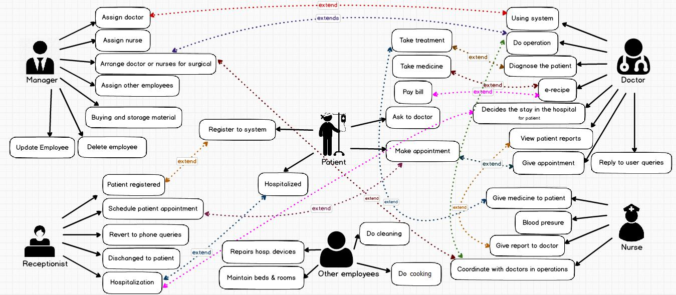

7
3.3 USE CASE – FULLY DRESSED

We have examined five use cases as fully dressed.

3.3.1 PATIENT REGISTRATION

Scope: | Hospital Management System
Level: | User goal
Primary Actor: | Receptionist
Stakeholder and Interests: | A patient needs to register in the system
Pre conditions: | Receptionist is logged into system
Post conditions: | Patient has been registered in the system
Main success scenario: | 1. Receptionist requests this function.
Main success scenario: | 2. System ask for name, email and contact no,
 | address, SSN, identification number, gender, age,
 | blood group and admit date.
 | 3. Receptionist enters name, email and contact no,
 | address, SSN, identification number, gender, age,
 | blood group and admit date.
 | 4. System validates name, email and contact no,
 | address, SSN, identification number, gender, age,
 | blood group and admit date.
 | 5. System output positive message and saves the
 | data.
Extensions/ Alternative | 1a The system has no answer.
flow: | 1. The system displays the appropriate error message
 | 2.Receptionist restarts the system and try again.
 | 1b The system has not connected with the database
 | 1. System gives an appropriate error message
 | 2. Receptionist has to synchronize the database first.

4a The system does not validate name, gender or age.

- The system displays the appropriate error message

- Receptionist re-enters correct information.

4b The system does not validate SSN or identification number.

8

- The system display error message “invalid SSN or identification number please enter a valid information”.

- Receptionist corrects the input.

4c The system does not validate email, contact no or address.

- The system gives a message about the invalid email, contact no or address.

- System prompts receptionist for re-entry

4d The system does not validate blood group or admit date.

- The system displays the appropriate error message
- Receptionist re-enters correct information.

Related non-functional -The system shall give responses in 1 second after requirement checking the patient information.

- The system requires to the patient ID.

Frequency of Occurrence HIGH

9
3.3.2 RECEIVING EMPLOYEES IN HOSPITAL

 | Scope: | Hospital Management System
 | Level: | User goal
 | Primary Actor: | Manager
 | Stakeholder and Interests: | Employee needs to work as doctor, receptionist, etc.
 |  | in the hospital.
 | Pre conditions: | Employee applies to work in the hospital.
 | Post conditions: | Manager accepts the person as employee.
 |  | Employee information added and saved.
 | Main success scenario: | 1. Manager requests this function.
 | Main success scenario: | 2. System ask for the person’s information as
 |  | employee. These important information are
 |  | identification number, name, email, phone number,
 |  | address, gender, age, and date of joining (for
 |  | employee).
 |  | 3. Employee provides all information to the system.
 |  | 4. Manager enters these information in the system.
 |  | 5. System checks identification number, name,
 |  | email, phone number, address, gender age, date
 |  | of joining fields. If these fields are empty, this is not
 |  | valid.
 |  | 6. System confirms and updates all information
 |  | then the person becomes employee in hospital.
 | Extensions/ Alternative | 1a The system has no answer.
 | flow: | 1.The system displays the appropriate error
 |  | message
 |  | 2. Manager restarts the system and try again.
 |  | 1b The system has not connected with the database
 |  | 1. System gives an appropriate error message
 |  | 2. Manager has to synchronize the database first.

10

5a The identification number does not valid.

- System gives an appropriate error message

- Manager corrects the input

5b Name, email, address, gender, age, date of joining or phone number is invalid.

- Information don’t suitable for system and system display error message

- Manager enters again the inputs.

5c If identification number is already exists in the system.

- Same value unapproved and error message

‘enter different value’

- Manager enters again the inputs.

Related non-functional Any user who uses the system shall have a logon ID requirement and password.

Frequency of Occurrence LOW

3.3.3 ADD A PATIENT TO THE ROOM

Scope: Hospital Management System

Level: User goal

Primary Actor: Receptionist

Stakeholder and Interests: A patient needs to register in the system

Pre conditions: Patient has been registered in the system

Post conditions: Patient has been added to the room and the system updated

11

Main success scenario: | 1. | Receptionist requests this function.
Main success scenario: | 2. | System ask for patient ID, doctor ID, room number,
 |  | date of hospitalization, duration of hospitalization.
 | 3. | Receptionist enters patient ID, doctor ID, room
 |  | number, date of hospitalization, duration of
 |  | hospitalization.
 | 4. | System validates patient ID, doctor ID, room
 |  | number, date of hospitalization, duration of
 |  | hospitalization.
 | 5. | System output positive message and saves the
 |  | data.
Extensions/ Alternative 1a |  | The | system | has | no | answer.
flow:1. The system displays the appropriate error message
 | 2.Receptionist restarts the system and try again.
 | 1b The system has not connected with the database
 | 1. | System | gives an | appropriate | error | message

- Receptionist has to synchronize the database first. 4a The patient ID does not exists

  - The system displays the appropriate error message
  - System prompts receptionist for re-entry

4b If room is full

- System signals error to the receptionist “chosen room is full”

- The system directs another suitable room.

4b The system does not validate patient ID, doctor ID, room number, date of hospitalization, duration of hospitalization.

- The system displays the appropriate error message
- Receptionist re-enters correct information.

Related non-functional - The system shall have 75 bed.

requirement

Frequency of Occurrence MEDIUM

12

3.3.4 DOCTOR’S VIEW PATIENT APPOITMENT DATE

Scope: Hospital Management Automation

Level: | User goal
Primary Actor: | Doctor
Stakeholder and Interests: | Doctor needs to view patient appointment date
Pre conditions: | Doctor is registered in the system
Post conditions: | Report is displayed. The system is left unchanged
Main success scenario: | 1. | Doctor requests to use this function
Main success scenario: | 2. | System asks for the doctor ID and patient id.
 | 3. | Doctor inputs the required information to the
 |  | system.
 | 4. | System checks if doctor ID is valid and if patient id
 |  | is within expected bounds.
 | 5. | System displays a report.
 | 6. | System is left unchanged.
Extensions/ Alternative | 1a The system has no answer.
flow: |  | 1. The system displays the appropriate error
 | message
 |  | 2. Doctor restarts the system and try again.
 | 1b The system has not connected with the database
 |  | 1. System gives an appropriate error message
 |  | 2. Doctor synchronizes the database first.

4a The Doctor ID does not exist

- The system gives a message about the invalid input.

- Doctor corrects the input

4b Date is invalid.

- The system gives a message about the invalid input.

- Doctor corrects the input

4c Date is not given.

- The system gives a message about the invalid input.

13
 |  | 2. System generates a report for current week.
 | Related non-functional | -The system shall be available all the time.
 | requirement
 | Frequency of Occurrence | HIGH

3.3.5 DOCTOR EXAMINES AND THEN WRITES E-PRESCRIPTION

Scope: Hospital Management Automation

Level: | User goal
Primary Actor: | Doctor
Stakeholder and Interests: | The doctor should write the necessary medicines after
 | you have examined the patient.
Pre conditions: | Doctor is entered in the system
Post conditions: | Prescription is displayed. Doctor approves.
Main success scenario: | 1. | Doctor requests to use this function
Main success scenario: | 2. | System asks for the doctor ID and password.
 | 3. | Doctor inputs the required information to the
 |  | system.
 | 4. | System checks if doctor ID is valid and if dates is
 |  | within expected bounds.
 | 5. | The doctor selects the prescription section.
 | 6. | System opens prescription section and ask for
 |  | patient ID.
 | 7. | The doctor enters the patient ID.
 | 8. | System checks if patient ID is valid then the
 |  | medicine section opens.
 | 9. | The doctor select the medicine name and dose.
 | 10. System saves the prescription and prescription is
 |  | displayed.
 | 11. Doctor approves.

14
 | Extensions/ Alternative | 1a The system has no answer.
 | flow: | 1. | The system displays the appropriate error message
 |  | 2. | Doctor restarts the system and try again.
 |  | 1b The system has not connected with the database
 |  | 1. | System gives an appropriate error message
 |  | 2. | Doctor synchronizes the database first.
 |  | 2a The system on.
 |  | 1. System does not ask for the doctor ID and
 |  |  | password.
 |  | 2. The doctor can go directly to the prescription
 |  |  | section.
 |  | 4a The Doctor ID is invalid
 |  | 1. | The system gives a message about the invalid
 |  | input.
 |  | 2. | Doctor corrects the input
 |  | 8a The patient ID does not exists
 |  | 1. The system gives a message about the invalid
 |  |  | input.
 |  | 2. Doctor checks and corrects the input
 |  | 9a The doctor does not select the medicine name
 |  | and dose.
 |  | 1. The patient does not need medication.
 |  | 2. The doctor does not make e-prescription.
 | Related non-functional | -The system shall be available all the time.
 | requirement | - The system requires to the patient ID.
 | Frequency of Occurrence | HIGH

15
3.4 BRIEF USE CASES

3.4.1 THE HOSPITAL MANAGER

Receiving employees in hospital

The manager wants to get employee for appropriate sections in hospital. Manager reviewer who applied and then accepts. The employee is successfully admitted to work.

Delete employees

The manager control to employees. If employees are not appropriate to hospital rules then manager can put out them from work.

Update employees

Has been updated employees information. If employee information changes, the manager updates them from the system.

Arrange all seizures and permits

Has been described in seizures and permits days in the hospital. These days are identified to prevent complexity and manager makes these.

Buying and storage material for hospital

Certain tools must be taken as tympanometry. Manager has lists of hospital tools and manager can organize these. At the same time, the manager is interested in storing the tools.

Security control

The manager follows the general security check points in the hospital.

Organize policlinic and laboratory

Has been organize policlinic and laboratory arrangements. Manager makes the edits and interference in lab or policlinic is prevented.

3.4.2 THE RECEPTIONIST

Generate patient list

Receptionist enters the required information to the system. The system displays a list of the patient in the whole patient register. The system is left unchanged.

Add room to system

16
The doctor examines the patient. The doctor considers the patient to be a resident and approves the system. The receptionist adds the appropriate one from the empty rooms to the system for the patient after receiving the approval.

Modify patient

Receptionist wants to modify a patient information and enters the required information. The system displays the patient information. Receptionist modifies the information and the system is updated.

View patient Schedule

Receptionist wants to view a patient’s schedule and enters the required information.

The system displays the patient`s appointments. The system is left unchanged.

View patient info

Receptionist wants to view patient info and enters the required information. The system displays the patient info. The system is left unchanged. For examples, reports, MR, graphical info etc.

Check-in patient

Receptionist wants to check-in a patient and enters the required information. The system finds the patient. If the patient doesn’t exist, it prompts Receptionist to add the patient. If the patient exists in the system, the system requests a patient ID. The system then assigns the patient to a room and a bed.

Check-out patient

Receptionist wants to check-out a patient and enters the required information. The system displays the patient info. The receptionist enters/updates the required information and the room is made available. The system calculates a total cost of the stay at the hospital.

3.4.3 THE DOCTOR

Reply to user queries.

The patient will make an appointment for the examination. Comes in time and talks to the doctor. He asks questions about his illness. The doctor will answer these questions.

Ask disease for medicines.

The doctor examines the patient and makes a diagnosis. Doctor want to write medicine for treatment. Doctor asks the patient whether he or she has any illnesses in order to avoid side effects.

17
To provide the feedback on user health after analyzing the data available for that patient in tabular and graphical form.

When the doctor receives the desired MR or X-ray results, doctor looks at the graphical forms and informs the patient.

Decides to stay for the patient in the hospital.

The doctor examines the patient and makes a diagnosis. Doctor decides to stay for the patient in the hospital. The doctor enters this information into the system. Gives the necessary approval.

Control and analyze daily situations of patients in boarding.

The doctor examines the patient and makes a diagnosis. Doctor decides to stay for the patient in the hospital. The doctor enters this information into the system. Gives the necessary approval. After the doctor makes daily checks of the patients who are hospitalized in the hospital and analyzes the reports.

Sends a request to the system for X-ray, MR with drawl.

The doctor examines the patient and makes a diagnosis. The doctor directs the patient to the MR or x-ray for further examination. The doctor sends a request for the relevant patient's MR or X-Ray via the system.

Do operation and adds surgical information to the system.

The doctor will do operation. The system enters the patient's condition after the operation is over.

18

3.5 SEQUENCE DIAGRAM

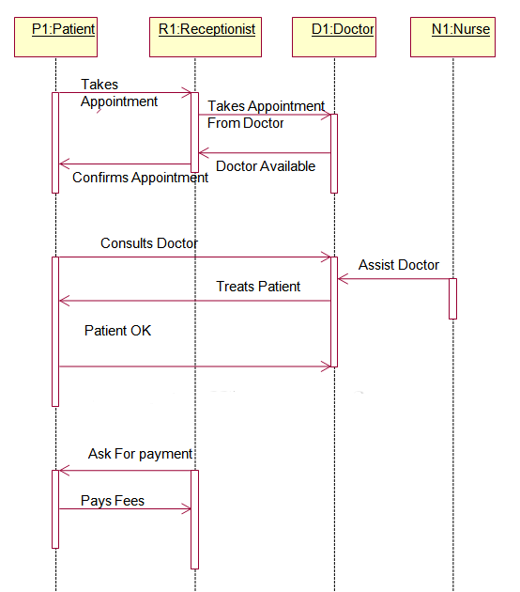

19

