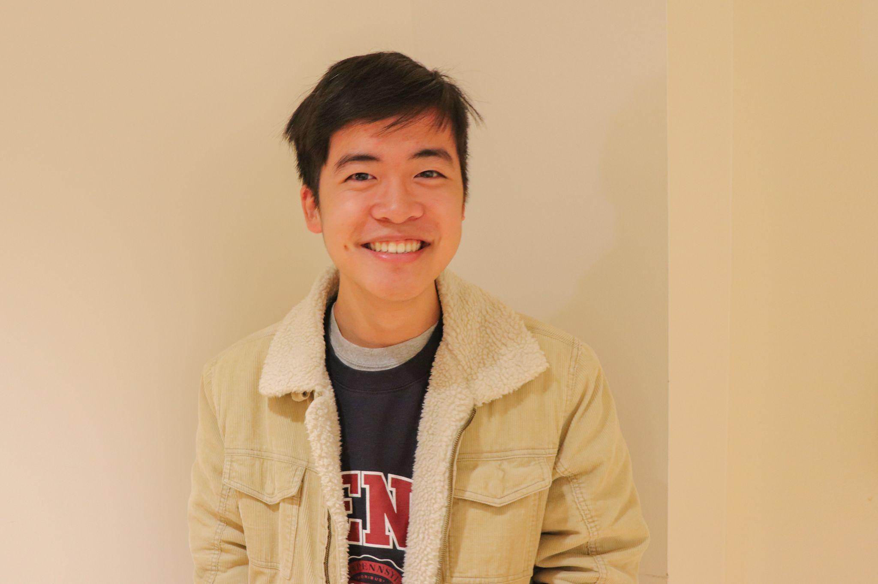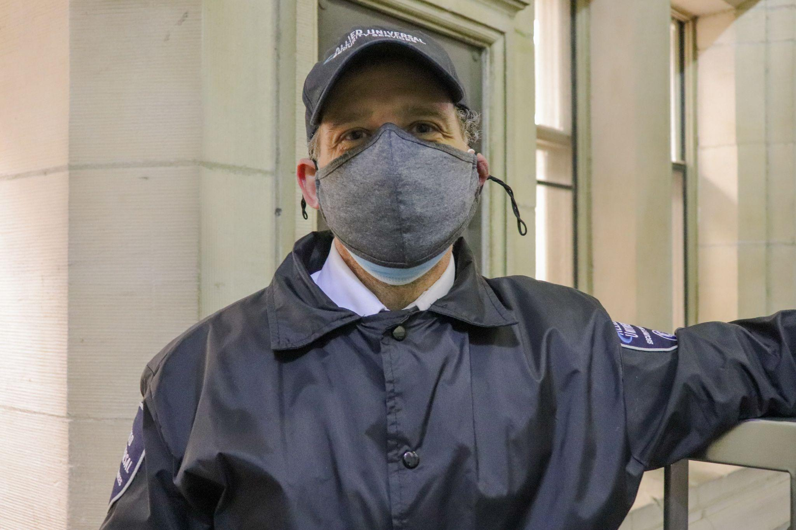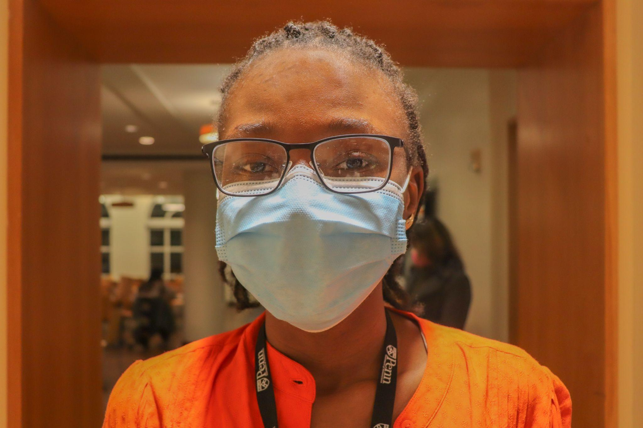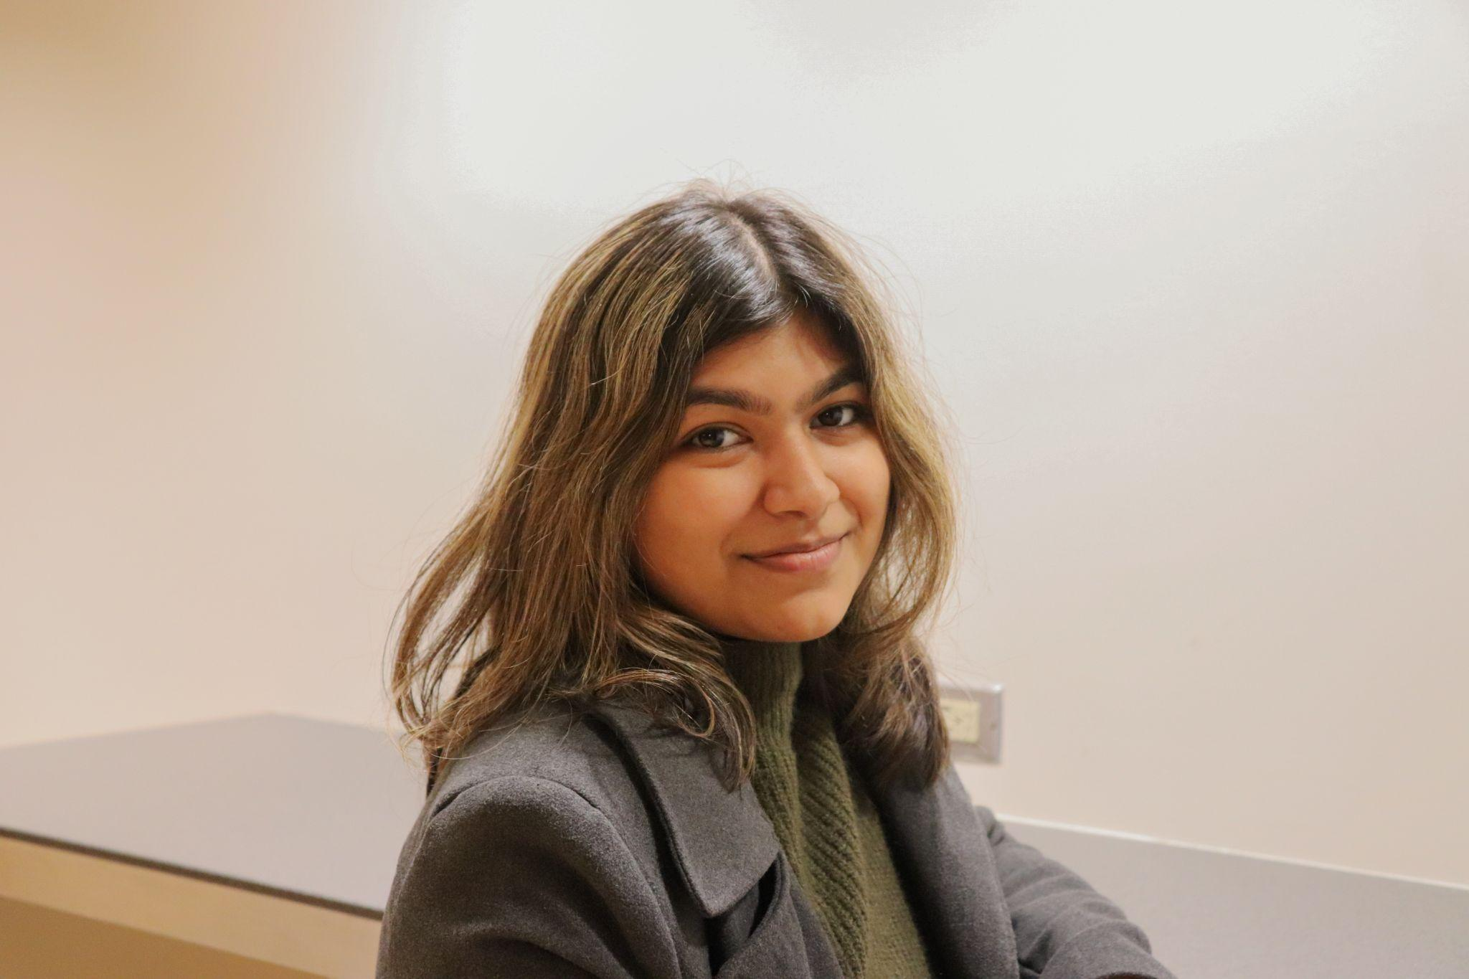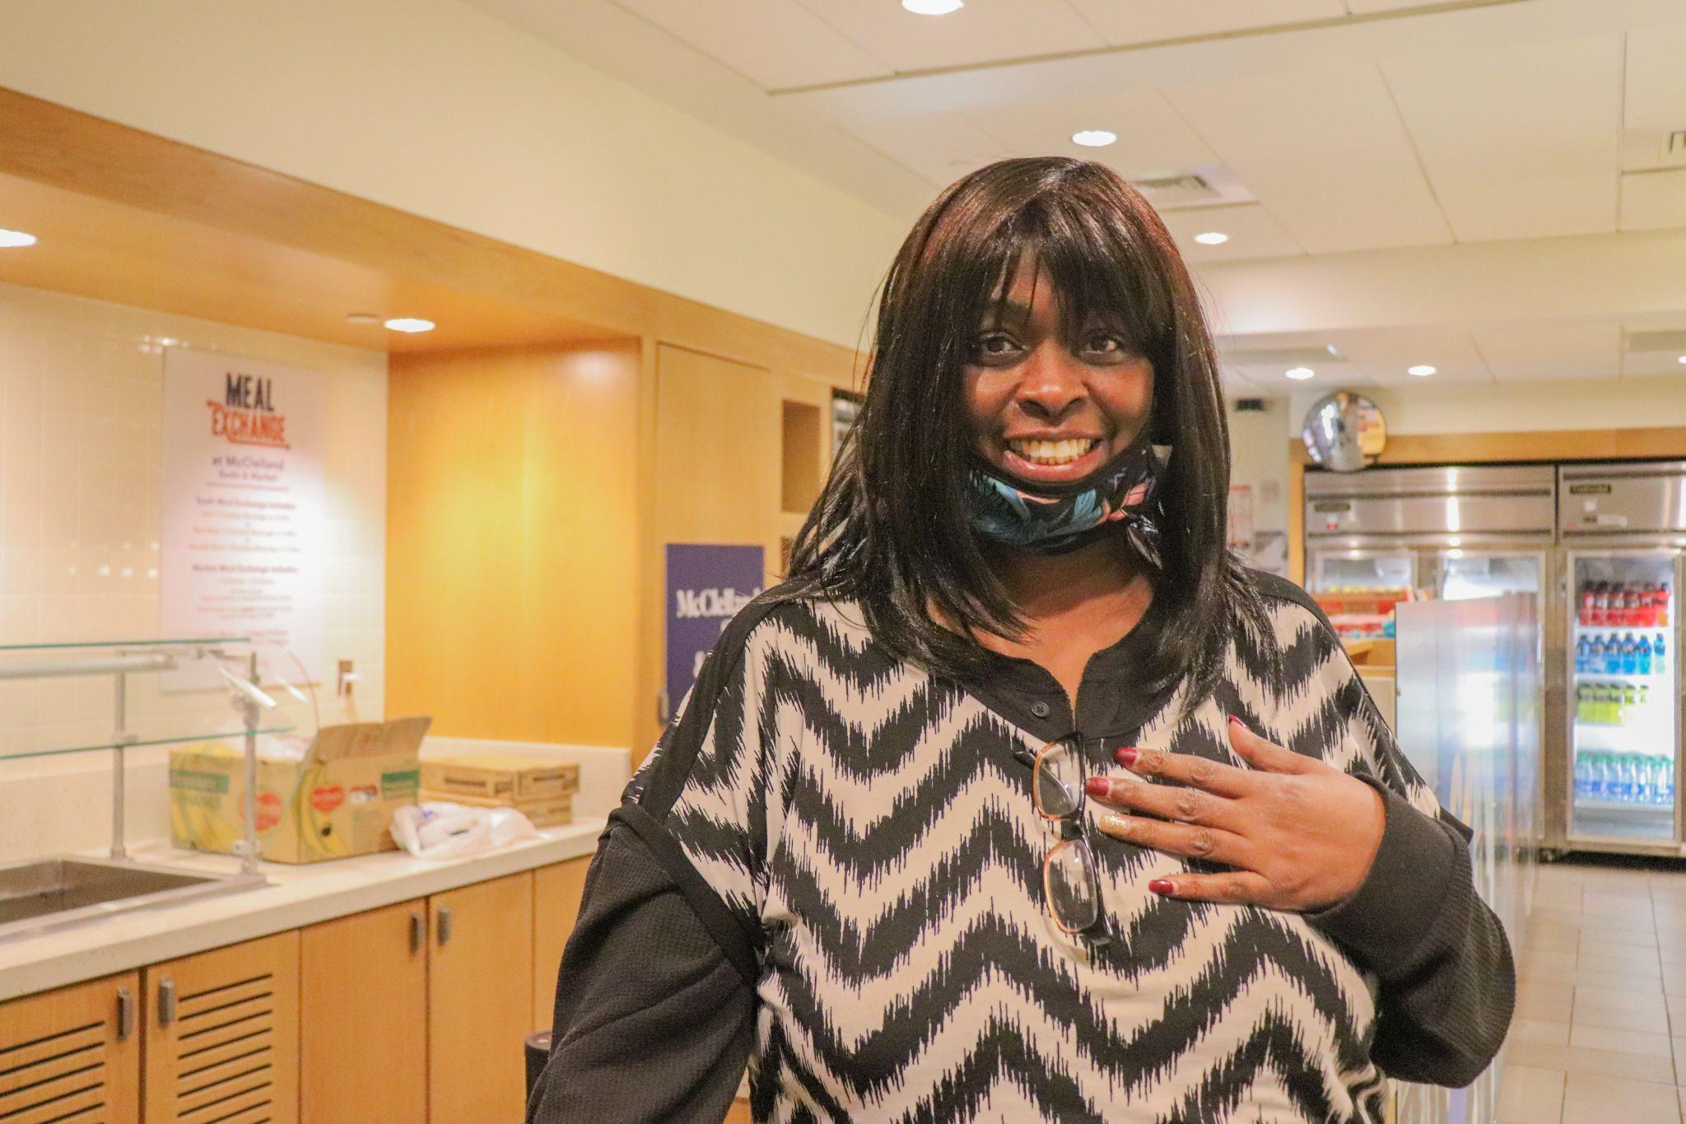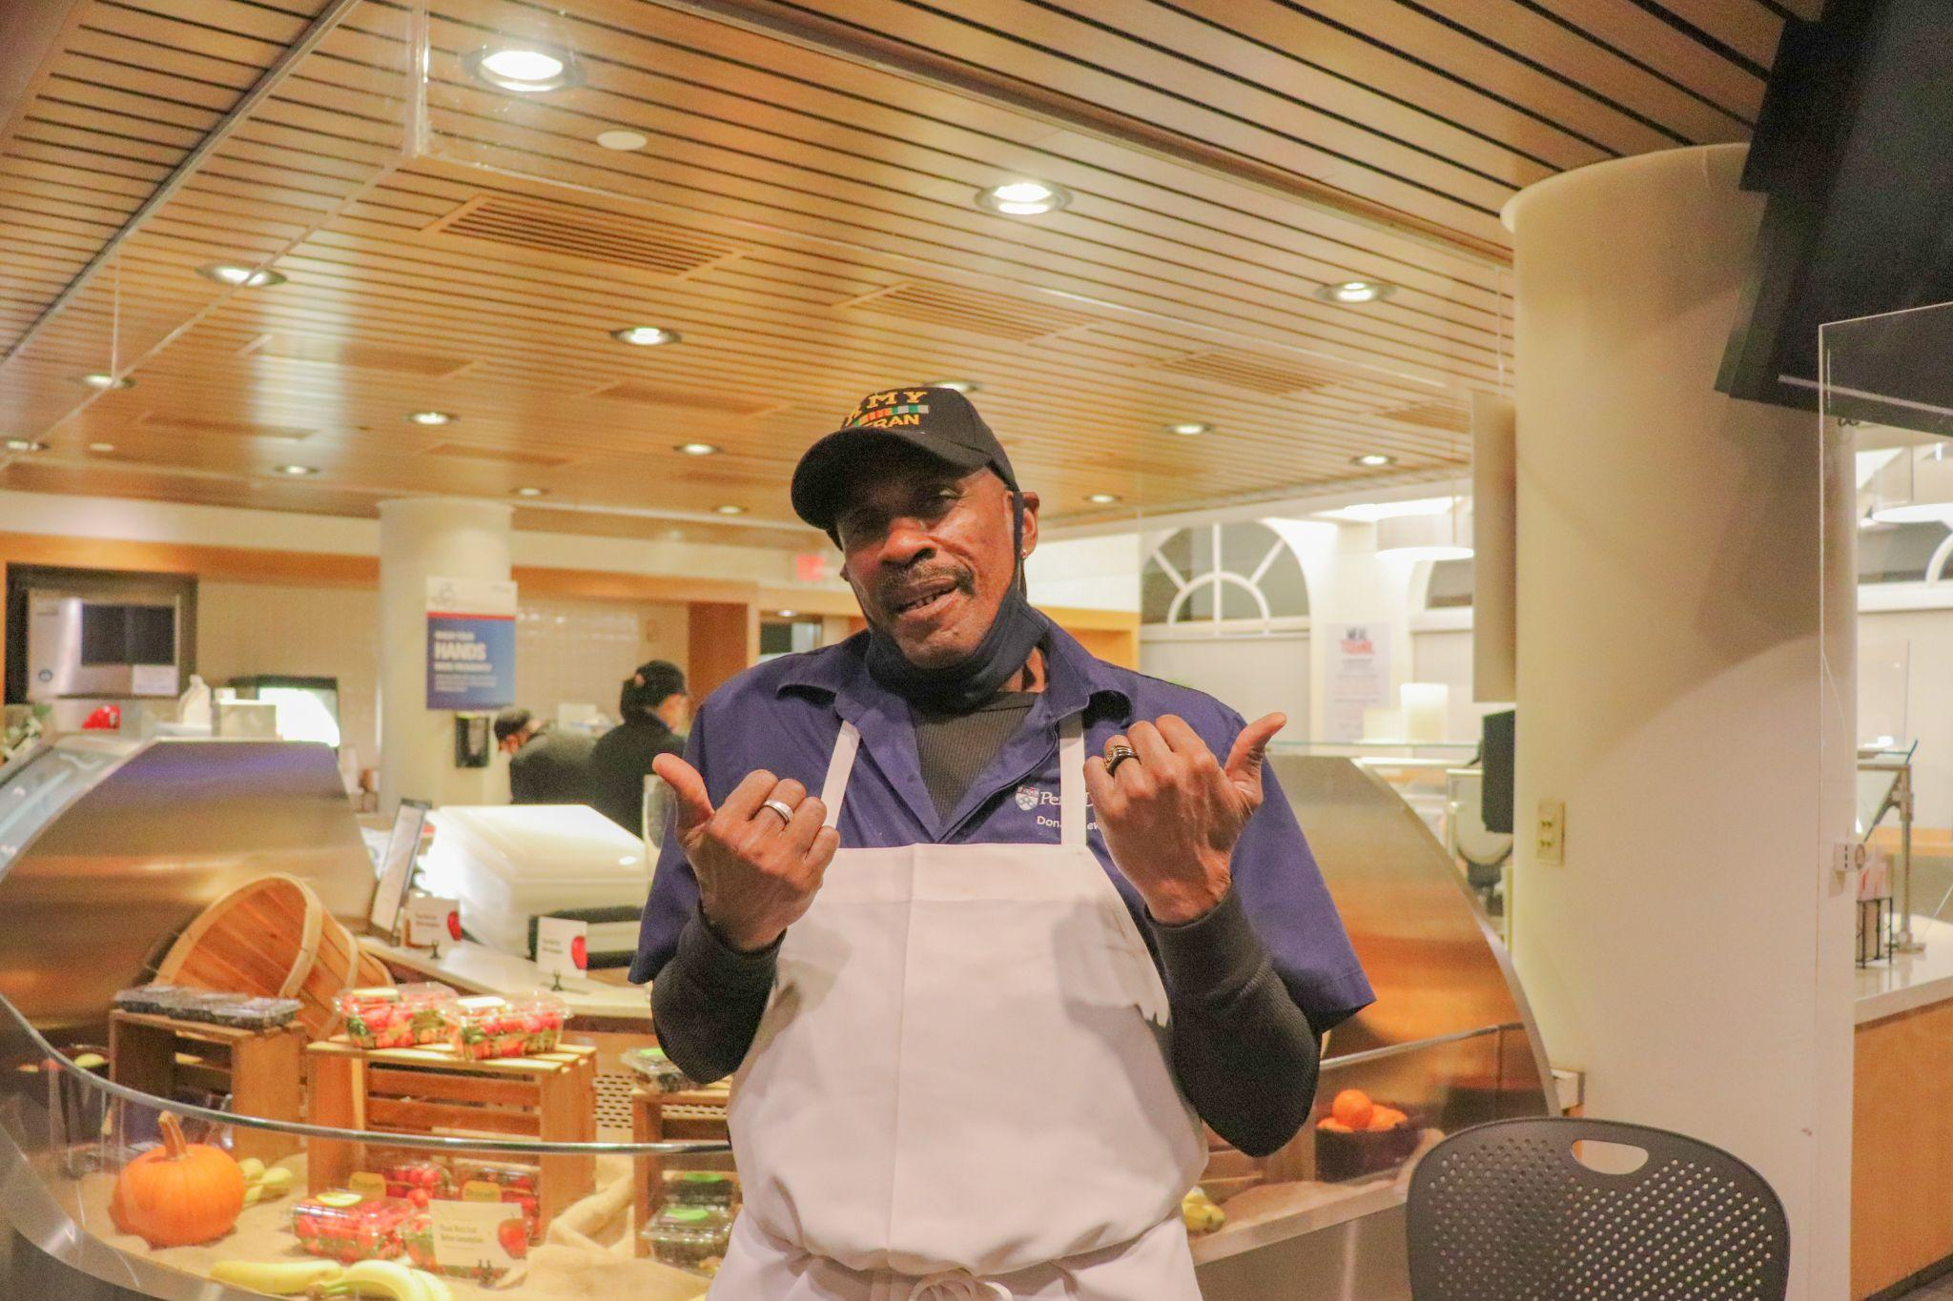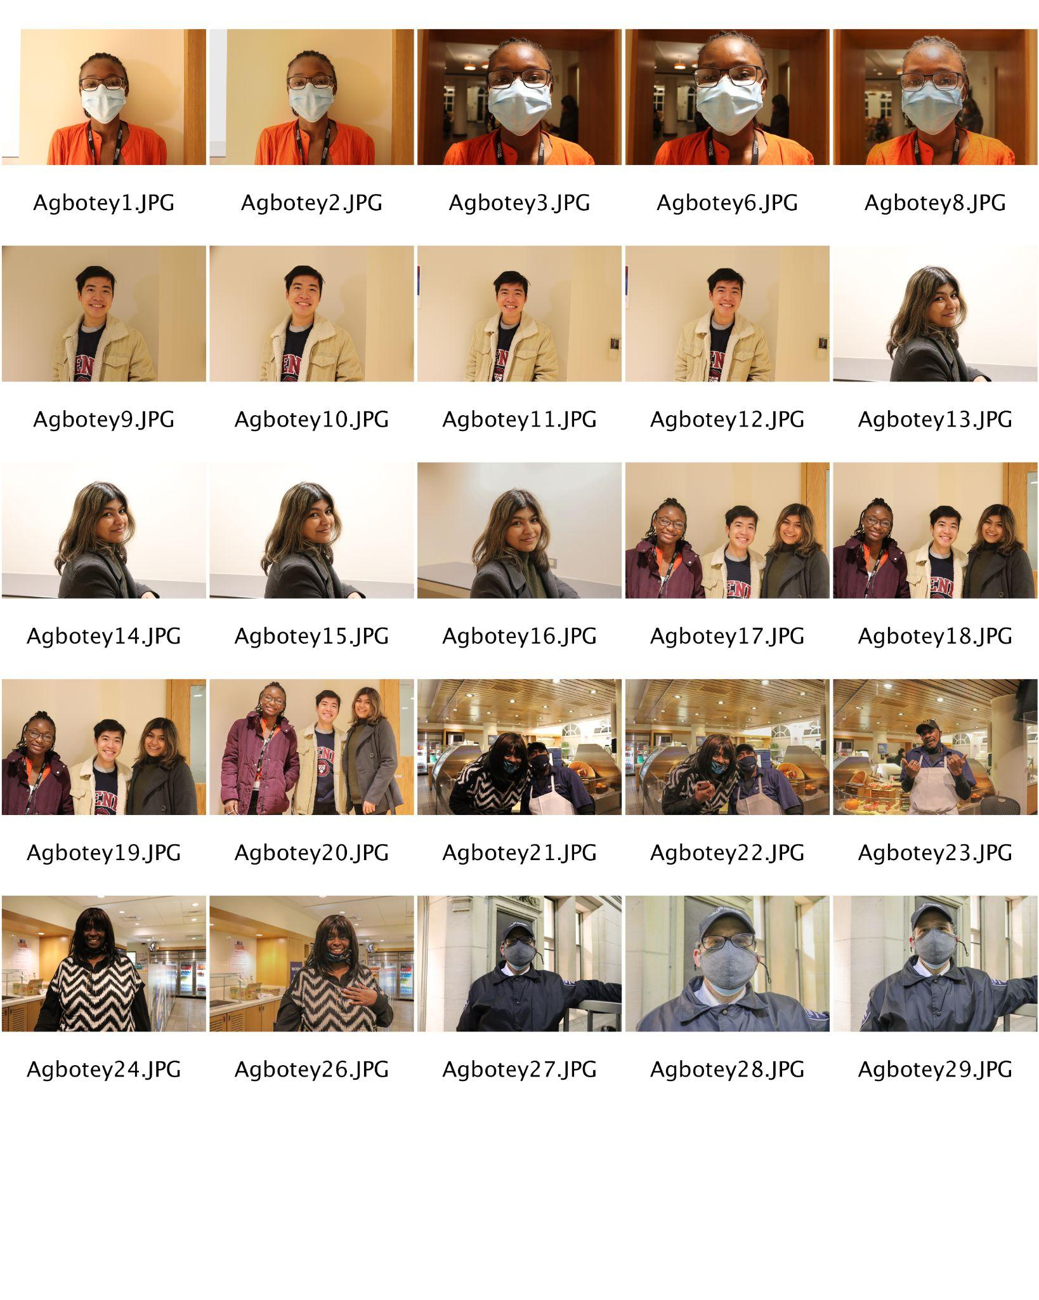

Artist Statement:

Within the past three months of my college experience in a very different environment, there have been people who have been able to cheer me on and contribute to my growth either on an intimate and personal level or in a general and casual manner. The images above are a reflection of these individuals and how valuable each of their personalities is. This is a representation of the warmth I’ve felt be it through a simple “good morning” or a collective mental breakdown at 4 am.