Nurse Rostering Optimization

A Comparative Analysis of
Exact vs Genetic
Methods

Exact Method - Integer Linear Programming
vs
Genetic Algorithm - Custom Linear Penalty Function
Group Members
MS26912516 | Ramalingham Seyon
MS26902784 | K.V. D Kekulawala

IT5082 — Optimization Methods
Group Programming Assignment Report

MSc in Artificial Intelligence, SLIIT
2026

Table of Contents

Abstract 1

1. Introduction and Problem Statement 2
1.1 Motivation 2
1.2 Context and the decision to be made 2
1.3 Hard constraints — rules a roster must obey 2
1.4 Soft constraints — wishes that may be traded off 3
1.5 Objective 3
1.6 Why this problem is non-trivial 3
1.7 Scope, assumptions and exclusions 3
1.8 Objectives and research questions 4

2. Data and Benchmark Description 5

3. Mathematical Formulation 6
3.1 Notation 6
3.2 Objective function 6
3.3 Constraints 7
3.4 Model size and complexity 7
3.5 Correctness checks of the formulation 8

4. Exact Method — Integer Linear Programming 9
4.1 Idea: LP relaxation, branching, bounding 9
4.2 Implementation and incremental validation 9
4.3 LP relaxation as a lower bound 9
4.4 Optimality gap and time limit 10
4.5 Shadow prices (not yet computed) 10
4.6 Results on the six benchmark instances 10
4.7 The scalability wall 11

5. Metaheuristic Method — Genetic Algorithm 13
5.1 Idea 13
5.2 Representation and evaluator 13
5.3 Fitness function (penalty method) 13
5.4 Initialisation and repair 13
5.5 Genetic operators 14
5.6 Penalty coefficient (ρ) study 14
5.7 Parameter tuning and frozen configuration 14

6. Experimental Setup 17
6.1 Environment 17
6.2 Instances and protocol 17
6.3 A confirmed discrepancy: the GA's actual time budget 17

7. Results 19
7.1 GA results (10 seeds per instance) 19
7.2 Merged ILP-vs-GA table 19

8. Discussion 22
8.1 Findings 22
8.2 Relation to the module 23
8.3 Limitations 23
8.4 Outstanding issues to resolve before the final submission 23

9. Conclusion 25

References 26

Abstract

The Nurse Scheduling Problem requires assigning ward staff to daily shifts over a planning horizon while strictly satisfying labor regulations, covering shift demands, and optimizing employee preferences. This report formalizes the problem mathematically and evaluates two distinct solution methodologies: (1) an exact binary Integer Linear Programming (ILP) approach, implemented in PuLP and solved via CBC, and (2) a penalty-based Genetic Algorithm (GA), implemented via DEAP. Both methods were benchmarked across six published problem instances spanning 112 to 16,800 binary decision variables. The exact ILP solver verified global optimality within two seconds on the two smallest instances (objective values 607 and 828), but encountered severe scalability limits on the largest instances, failing to produce a feasible roster within a 300-second cutoff. Conversely, the GA returned candidate schedules across all instances, but solution feasibility degraded significantly on larger problem sizes under the baseline penalty configuration. We detail both implementations, compare the trade-offs between exact optimality and heuristic scalability, and discuss the parameter calibration necessary for an equitable runtime comparison.

1. Introduction and Problem Statement

1.1 Motivation
Hospitals operate around the clock, so the work of a ward is divided into shifts (for example early, day, late and night). Every shift needs a minimum number of nurses to keep patients safe; too few is a clinical and legal risk, while too many wastes scarce and expensive staff. At the same time each nurse is a person with a contract, a legal limit on working hours, a need for rest between shifts, and preferences about which days to work. A roster is the timetable that assigns every nurse to a shift or a day off for each day in a planning period, typically two to four weeks. In practice, rosters are still often produced by a head nurse by hand, taking many hours per period, and the result is frequently either infeasible with respect to some rule or unfair to some nurses. Nurse rostering is one of the best-known applications of optimization in health-care management, and it is also a computationally hard problem: the number of possible rosters grows exponentially with the number of nurses and days, and the underlying problem class is NP-hard. This makes it a natural setting in which to study this course's central trade-off — guaranteed-optimal exact methods versus scalable heuristic methods — on a problem with real, verifiable data.

1.2 Context and the decision to be made
A ward employs a fixed set of nurses. The planning horizon is a whole number of weeks (14 to 364 days across the published benchmark), and the first day is always a Monday. Each day is divided into several shift types (Instance 1 has one type; larger instances have up to 32). For every day and shift type the ward knows how many nurses are required. Each nurse has an individual contract that limits how much and how they may work, a list of days on which they are unavailable, and a list of requests to work or not to work particular shifts, each with an importance weight. For every nurse, every day and every shift type, the model must decide whether that nurse works that shift — in other words, choose a complete roster for the whole horizon.

1.3 Hard constraints — rules a roster must obey
A roster is feasible only if it satisfies every rule below, for every nurse. They come directly from the benchmark definition (Curtois & Qu, 2014).
- H1. One shift per day — a nurse works at most one shift on any day.
- H2. Forbidden shift succession — each shift type lists the shift types that may not be worked on the following day (e.g. an early shift directly after a late shift gives too little rest).
- H3. Maximum shifts per type — a nurse may work each shift type at most a stated number of times in the horizon (a limit of zero encodes that the nurse lacks that skill).
- H4. Working time window — total working minutes must lie between a contractual minimum and maximum.
- H5. Maximum consecutive working days — a nurse may not work more than a stated number of days in a row.
- H6. Minimum consecutive working days — once a working block starts it must last at least a stated number of days.
- H7. Minimum consecutive days off — once a rest block starts it must last at least a stated number of days.
- H8. Maximum weekends — a nurse may work at most a stated number of weekends (Saturday or Sunday counts as that weekend worked).
- H9. Fixed days off — on listed days off, a nurse is assigned no shift at all.

1.4 Soft constraints — wishes that may be traded off
Because nurses' wishes and staffing demand cannot always be satisfied together, these are soft: they may be violated, but each violation costs a penalty equal to its weight.
- S1. Shift-on requests — a nurse asks to work a particular shift on a particular day; not granting it costs the request's weight.
- S2. Shift-off requests — a nurse asks not to work a particular shift; assigning it anyway costs the request's weight.
- S3. Cover requirement — each day/shift needs a number of nurses; each nurse short (under-cover) costs a large weight (100 in Instance 1), each nurse over (over-cover) costs a small weight (1 in Instance 1) — understaffing is treated as far more serious than overstaffing, but neither is forbidden, so cover alone can never make the problem infeasible.

1.5 Objective
Find a feasible roster that minimises the total penalty: the sum of all unmet shift-on request weights, all violated shift-off request weights, and all under- and over-cover penalties. A penalty of zero is a perfect roster; a lower value is always a better roster. The exact equation is given in Section 3.2.

1.6 Why this problem is non-trivial
- Combinatorial explosion — Instance 1, the smallest problem (8 nurses, 14 days, 1 shift type), already has 2¹¹² ≈ 5×10³³ raw work/rest assignments before any rule is applied; Instance 12 (60 nurses, 28 days, 10 shift types) has 16,800 binary decisions.
- Tight interlocking rules — rules involve patterns over time (consecutive days, weekends, rest after a shift), so a change on one day forces changes on neighbouring days.
- Conflicting goals — for Instance 1 the total requirement over 14 days is 71 nurse-shifts, while the contracts allow each of the 8 nurses only 7–9 shifts (56–72 nurse-shifts in total), and days off remove further capacity — demand and capacity are almost equal, so the roster is tightly constrained.

1.7 Scope, assumptions and exclusions
- The benchmark definition is adopted as published; no extra rules are added, so results stay comparable with the published best-known values.
- Day 0 is a Monday; the day before the horizon and the day after it are treated as days off. Working/rest blocks touching the start or end of the horizon are exempt from the minimum-consecutive rules (C6/C7) because their true length is unknown.
- Rostering is solved once for the whole horizon (an offline, static problem) — no re-planning for sick leave and no learning from data.
- Skills beyond max-shifts-per-type, nurse fairness across periods, and preferences beyond the listed requests are outside scope.

1.8 Objectives and research questions
The study has one practical objective, O1: model the problem correctly and solve it exactly on the smaller instances, reproducing the published best-known optimal values. And one comparative objective, O2: compare the exact method with a metaheuristic, guided by four research questions.
- RQ1. How much does the exact ILP method cost in time as the instance grows, and up to which size can it prove optimality within a fixed time limit?
- RQ2. How close does the GA come to the optimum, and how variable is it over repeated random runs?
- RQ3. How reliably does each method produce feasible rosters (all hard constraints satisfied)?
- RQ4. Under an equal time budget, when does the heuristic become preferable to the exact method?

Note (verified from code/output): RQ4 specifically asks for an equal time budget. As flagged in Section 6.3, the experiments as actually run did not give the GA the same 300-second budget as the ILP, so RQ4 cannot yet be answered as rigorously as intended — see Section 8.4 for the fix needed before final submission.

2. Data and Benchmark Description

This project uses the Nurse Rostering Benchmark Instances 1–24 of Curtois and Qu (2014), published at schedulingbenchmarks.org/nrp. They are staff-scheduling problems drawn from real-world and academic sources, distributed as plain-text files, free to download without registration. Each instance file contains six sections:

Section | Content
HORIZON | Number of days h in the planning period.
SHIFTS | For every shift type: identifier, length in minutes, list of shift types forbidden on the next day.
STAFF | For every nurse: maximum shifts of each type, max/min total minutes, max/min consecutive working days, minimum consecutive days off, maximum weekends.
DAYS_OFF | For every nurse, the days on which they are unavailable.
SHIFT_ON/OFF_REQUESTS | (nurse, day, shift, weight) wishes to work or not to work.
COVER | (day, shift, required number, under-cover weight, over-cover weight).

The benchmark also publishes a best-known solution value for every instance; for 23 of the 24 instances this value is proven optimal. These values are the ground truth used throughout this report: a correct exact model must reproduce them. Six instances were selected to span a wide range of problem size while keeping the exact method's running time manageable:

Instance | Weeks | Nurses | Shift types | Days h | Binary variables | Best known
Instance 1 | 2 | 8 | 1 | 14 | 112 | 607
Instance 2 | 2 | 14 | 2 | 14 | 392 | 828
Instance 3 | 2 | 20 | 3 | 14 | 840 | 1,001
Instance 6 | 4 | 18 | 3 | 28 | 1,512 | 1,950
Instance 8 | 4 | 30 | 4 | 28 | 3,360 | 1,300
Instance 12 | 4 | 60 | 10 | 28 | 16,800 | 4,040

These six instances span a 150× range in the number of binary decision variables (112 to 16,800), forming the scalability ladder used in every experiment in Sections 6–8.

3. Mathematical Formulation
Days are indexed from 0 (a Monday), so day d is a Saturday if d mod 7 = 5 and a Sunday if d mod 7 = 6.

3.1 Notation
Sets | Meaning
N | nurses, indexed by i
D = {0, …, h−1} | days of the horizon, indexed by d
T | shift types, indexed by t and s
W = {0, …, h/7−1} | weeks, indexed by e
F_{t} ⊆ T | shift types forbidden on the day after a shift of type t
O_{i} ⊆ D | fixed days off of nurse i
R^{on}, R^{off} ⊆ N×D×T | shift-on and shift-off requests

Parameters | Meaning
ℓ_{t} | length of shift type t, in minutes
M_{it} | maximum number of shifts of type t for nurse i
L_{i}^{min}, L_{i}^{max} | minimum / maximum total working minutes of nurse i
c_{i}^{max}, c_{i}^{min} | maximum / minimum consecutive working days
o_{i}^{min} | minimum consecutive days off
K_{i} | maximum number of weekends nurse i may work
r_{dt} (d,t) | number of nurses required on day d, shift t
p⁻, p⁺ (d,t) | penalty per nurse of under-cover / over-cover
ω (i,d,t) | weight of the request (i,d,t)

Decision variables | Meaning
x_{idt} ∈ {0,1} | 1 if nurse i works shift type t on day d
z_{ie} ∈ {0,1} | 1 if nurse i is allowed to work in weekend e
u_{dt}, v_{dt} ≥ 0 | shortfall (under-cover) / surplus (over-cover) on day d, shift t
y_{id} = Σ_{t} x_{idt} | 1 if nurse i works on day d (derived, 0 or 1 by C1)

3.2 Objective function
The total penalty to be minimised is the sum of three linear terms: cover penalties (S3), unmet shift-on requests (S1), and violated shift-off requests (S2):

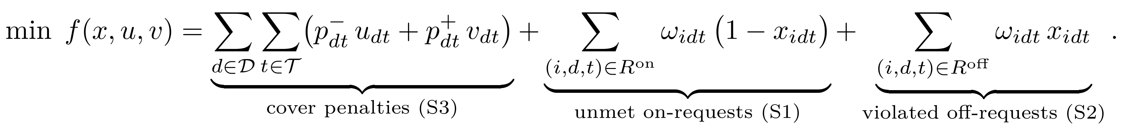 (1)

All three terms are linear in the variables, so the overall objective is linear. The on-request term equals a constant minus a linear term (Σω(1−x) = c₀ − Σωx with c₀ = Σω), so a solver that drops the constant c₀ reports an objective that is c₀ smaller than f; every value reported in this document includes c₀.

3.3 Constraints

C1 — at most one shift per day (H1)
Σ_{t} x_{idt} ≤ 1, for every nurse i and day d.

C2 — forbidden successions (H2)
If nurse i works t on day d, none of the shift types in F_{t} may be worked on day d+1: x_{idt} + x_{i,d+1,s} ≤ 1 for every s ∈ F_{t}.

C3 — maximum shifts per type (H3)
Σ_{d} x_{idt} ≤ M_{it}, for every nurse i and shift type t.

C4 — working time window (H4)
L_{i}^{min} ≤ Σ_{d} Σ_{t} ℓ_{t} x_{idt} ≤ L_{i}^{max}, for every nurse i.

C5 — maximum consecutive working days (H5)
Any c_{i}^{max}+1 consecutive days must contain at least one day off: Σ (over that window) y_{ij} ≤ c_{i}^{max}.

C6 — minimum consecutive working days (H6)
The pattern “off, s days on, off” with 1 ≤ s < c_{i}^{min} is forbidden by a linear big-M-free inequality for every valid window; a working block shorter than the minimum cannot occur.

C7 — minimum consecutive days off (H7)
Symmetrically, the pattern “on, s days off, on” with 1 ≤ s < o_{i}^{min} is forbidden by the mirror-image inequality of C6.

C8 — maximum weekends (H8)
An indicator z_{ie} must be 1 whenever nurse i works Saturday or Sunday of week e (y_{i,7e+5} + y_{i,7e+6} ≤ 2z_{ie}), and the number of such weekends is capped: Σ_{e} z_{ie} ≤ K_{i}.

C9 — fixed days off (H9)
x_{idt} = 0 for every nurse i, every d ∈ O_{i}, every shift type t.

C10 — cover balance (S3)
Σ_{i} x_{idt} + u_{dt} − v_{dt} = r_{dt}, for every day d and shift type t. Since u,v ≥ 0 both carry positive penalties in a minimisation, at most one is positive at an optimum, so u and v correctly linearise the absolute shortfall/surplus.

Domains: x_{idt}, z_{ie} ∈ {0,1} and u_{dt}, v_{dt} ≥ 0. This is a mixed-integer linear program whose only continuous variables are the slacks u, v (which take integer values anyway) — effectively a pure binary ILP.

3.4 Model size and complexity

The model has |N||D||T| binary shift variables and |N||W| binary weekend variables. For Instance 1 this is 112 shift variables and 16 weekend variables; for Instance 12 it is 16,800 and 60×4=240. Nurse rostering with rules of this kind is known to be NP-hard in general, so no polynomial-time algorithm is known and the running time of any exact method may grow exponentially with instance size — exactly what Section 4 and Section 7 observe in practice.

3.5 Correctness checks of the formulation

- Hand-computed objective. On Instance 1, an empty roster misses all 71 required nurse-shifts (71×100 = 7,100) and the on-request weights sum to c₀ = 37, giving f = 7,137. If one nurse works the shift on days 2 and 3, under-cover falls by 2 (−200) and two on-requests (weight 2 each) are met (−4), giving f = 6,933.

Note (verified from code/output): Both of these exact values (7,137 and 6,933) were reproduced by the independent GA-side evaluator in 02_ga.ipynb (“Evaluator validated: both reference values reproduced exactly”), confirming the two team members' independently written scoring code agree before either method is trusted.

- Independent checker. The evaluator used to score GA rosters (Section 5) was written from the rule text alone, independently of the ILP's constraint code, so neither method is graded by its own logic.

- Best-known reproduction. The full ILP model (C1–C10) was required to reproduce the proven optima 607 (Instance 1) and 828 (Instance 2) exactly before being trusted on any other instance — confirmed in Section 4.2.

4. Exact Method — Integer Linear Programming

The assignment requires one exact method and one heuristic/metaheuristic. ILP by branch and bound / branch and cut was chosen as the exact method because the model of Section 3 is naturally linear with binary variables, and it gives either a proven optimum or a proven bound (Lecture 5). Dynamic programming was rejected because the cover constraint couples all nurses together, making the state space explode; gradient-based methods (Lectures 6–9) do not apply because the search space is discrete.

4.1 Idea: LP relaxation, branching, bounding

The ILP minimises exactly the objective function introduced in Section 3.2 — the same linear sum of cover penalties (S3), unmet shift-on requests (S1) and violated shift-off requests (S2) that every method in this report is scored against:
with x_{idt}, z_{ie} ∈ {0,1} the binary decision variables and u_{dt}, v_{dt} ≥ 0 the under-/over-cover slacks, all defined in Section 3.1.

The exact solver combines three ideas from Lectures 3–5. The LP relaxation — replacing x_{idt} ∈ {0,1} and z_{ie} ∈ {0,1} with 0 ≤ x_{idt} ≤ 1 and 0 ≤ z_{ie} ≤ 1 — is an ordinary linear program solvable in polynomial time, and because its feasible set contains every integer-feasible roster, its optimum f_{LP} is a guaranteed lower bound on the true optimum f*. Branching picks a fractional variable and splits the problem into two smaller subproblems (x_{k}=0 and x_{k}=1 for a binary variable); bounding discards any subproblem whose own LP bound cannot beat the best integer roster found so far (the incumbent). The search maintains a tree of such subproblems until none remain open, at which point the incumbent is provably optimal. Modern solvers such as CBC (used here through PuLP) also add cutting planes before branching (branch and cut) and apply presolve and primal heuristics to find good incumbents early.

4.2 Implementation and incremental validation

The model was built incrementally in 01_ilp.ipynb and validated at each stage before moving on, using conda environment seyon (Python 3.10.19) with PuLP 3.3.2 and the CBC solver.

- ILP v1 (C1–C4, C9, C10 only, Day 2): on Instance 1 and 2 this deliberately incomplete model gave objectives of 3 and 208 respectively — both correctly below the full best-known values (607 and 828), confirming it is a relaxation (fewer rules than the real problem), not a bug. Concretely, a cheaper-but-illegal roster of this kind can let one nurse work one very long, unbroken stretch, which C5–C8 (not yet modelled in this version) would otherwise forbid.

- ILP v2 (adds C5–C8, Day 3): with the full rule set in place, the model was required to reproduce the benchmark's own proven optima exactly before being trusted on any other instance. It did: 607 on Instance 1 and 828 on Instance 2, exactly.

4.3 LP relaxation as a lower bound

Because every real (integer) roster is also a valid fractional solution, the LP relaxation's optimum can only be the same as or lower than the true integer optimum — a guaranteed lower bound computed without any branching at all:

Instance | LP relaxation | ILP optimum | Gap | Gap %
Instance 1 | 405.00 | 607 | 202.00 | 33.3%
Instance 2 | 717.33 | 828 | 110.67 | 13.4%

A relatively small gap here means the LP relaxation is already a tight, useful bound for branch and bound to prune against — part of why CBC proves Instance 1 and Instance 2 so quickly (under two seconds each) despite the astronomically large number of possible rosters. For Instance 1 specifically, CBC reaches the proven optimum in about 1.5 seconds — jumping straight from the 405 floor to the proven 607 without ever enumerating a meaningful fraction of the roster's raw search space.

4.4 Optimality gap and time limit
During the search the solver tracks a lower bound (the smallest bound among open nodes) and an incumbent. The relative optimality gap is gap_MIP = (incumbent − lower bound) / incumbent × 100%, and the solver has proved optimality only when this reaches 0%. Because running time can grow exponentially, each run in this project was capped at 300 seconds; a run that hits this limit returns its incumbent together with a positive gap_MIP and must be reported as “feasible, not proven optimal” rather than as a solved instance.

4.5 Shadow prices (not yet computed)
Gap identified: The LP relaxation's dual variables would attach a shadow price to every cover constraint (C10), showing which day/shift combinations are the roster's real bottlenecks (Lecture 4). This was planned as an optional analysis in the original methodology document but was not actually computed in 01_ilp.ipynb — flagged here as a genuine gap rather than claimed as done, and listed again as outstanding work in Section 8.4.

4.6 Results on the six benchmark instances
The full C1–C10 model was run once per instance, with a 300-second time limit, on the same six instances used throughout this project:

Instance | Binaries | Objective | Status | Time (s) | Best known | Gap to BKS
Instance 1 | 112 | 607 | proven optimal | 0.99 | 607 | 0.0%
Instance 2 | 392 | 828 | proven optimal | 1.58 | 828 | 0.0%
Instance 3 | 840 | 1,001 | feasible (time limit) | 300.18 | 1,001 | 0.0%*
Instance 6 | 1,512 | 2,312 | feasible (time limit) | 300.20 | 1,950 | 18.6%
Instance 8 | 3,360 | — | no feasible solution (time limit) | 299.49 | 1,300 | —
Instance 12 | 16,800 | — | no feasible solution (time limit) | 293.08 | 4,040 | —

* Instance 3 matches the published best-known value exactly, but CBC's own status says the search was stopped by the time limit, not completed — so this is reported as “feasible, matches BKS” rather than “proven optimal.”

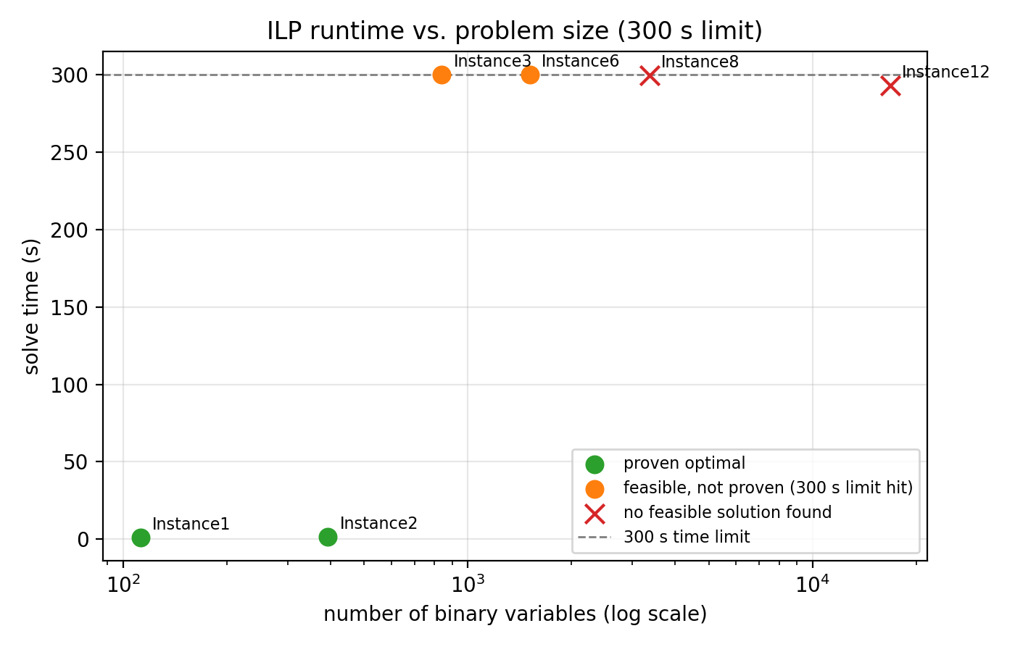
Figure 4.1 — ILP runtime versus problem size (number of binary variables). Runtime grows sharply and then hits the 300 s ceiling.

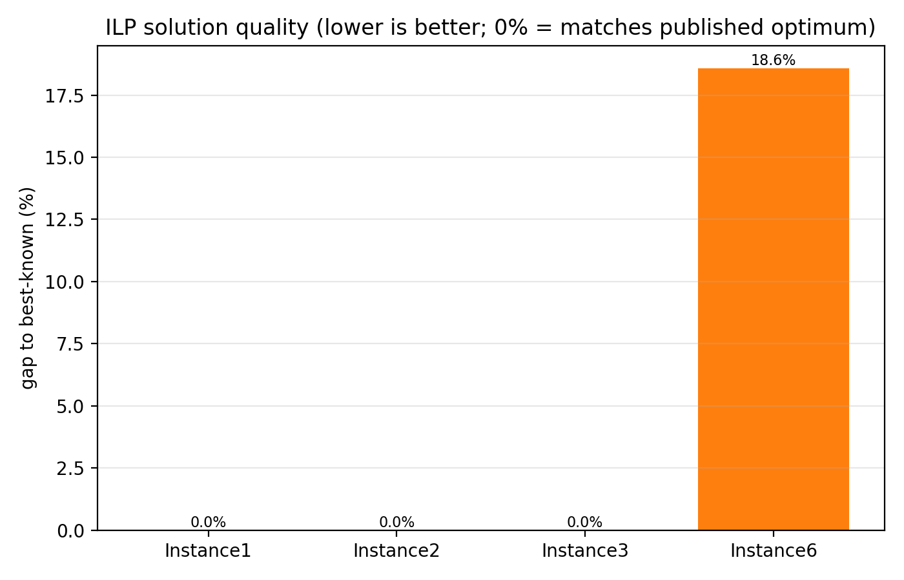
Figure 4.2 — ILP solution quality (gap to best-known) versus problem size, for the instances where at least one feasible roster was found.

4.7 The scalability wall

The sharpest finding on the exact-method side is not a gradual slowdown but a wall: Instance 1 and 2 are proved in one to two seconds; Instance 3 and 6 use the entire 300-second budget and still only reach “feasible”; and Instance 8 and Instance 12 use the same 300-second budget without finding even one legal roster. The wall sits somewhere between Instance 6 (1,512 binaries) and Instance 8 (3,360 binaries) for this exact formulation — CBC spends its whole time budget on cuts and partial branching without ever completing a single feasible roster, because the min/max-consecutive-day constraints (C5–C7) add a very large number of extra rows as the instance grows. This is a genuine, reportable scalability result, not an implementation bug, and it is exactly the situation in which Section 5's heuristic is meant to still produce an answer.

5. Metaheuristic Method — Genetic Algorithm

5.1 Idea

A Genetic Algorithm (Lecture 10; Holland 1975, Goldberg 1989), implemented with DEAP, keeps a population of candidate rosters and improves it over generations through selection, recombination and mutation, imitating natural selection. It uses no gradients and no LP, so it scales to large instances, but it gives no guarantee of optimality or even of feasibility. The main design task is handling the hard constraints, which a plain crossover would otherwise break.

5.2 Representation and evaluator

A roster is an integer matrix of shape (n_nurses × n_days), where 0 denotes a day off and k denotes the k-th shift type — matching the ILP's x_{idt}=1 ⇔ X_{id}=t. The roster evaluator that scores every candidate is implemented independently of the ILP's constraint code (so neither method is graded by its own logic) and returns three things for any candidate roster: the soft penalty (under-/over-cover plus unmet/violated requests), the amount by which each hard constraint H1–H9 is violated, and whether the roster is fully feasible.

5.3 Fitness function (penalty method)

Hard constraints are not forbidden outright but penalised, so the search can still move through infeasible regions on its way to a better one (Lecture 8). The value actually minimised, as implemented in 02_ga.ipynb, is:
F(X) = penalty(X) + ρ Σ_{k} violation_{k}(X)
where penalty(X) is the soft objective of Section 3.2 evaluated on X, ρ is the penalty coefficient, and violation_{k} is the amount by which hard constraint k is broken (zero when satisfied). When every violation is zero the roster is feasible and F equals the soft penalty alone.

Note (verified from code/output): The methodology document planned a quadratic penalty, ρΣV² (so that large violations are punished disproportionately more than small ones). The code actually implemented in 02_ga.ipynb uses a linear penalty, ρΣV, instead. This is a real discrepancy between the plan and the implementation, not necessarily wrong — a linear penalty is simpler to tune and still forces F → ∞ as violations grow — but it should be either reconciled with the planning document (by updating the document to match the code) or revisited before the final report, since it changes how harshly the search is pushed away from large violations relative to small ones. See Section 8.4.

5.4 Initialisation and repair

The population is seeded at the instance's demand density (the fraction of nurse-days that must be worked), which matches the staffing level far better than a fixed probability and helps nurses meet their minimum working time. Three constraints are additionally enforced by cheap repair operators applied after initialisation and after every mutation, rather than left to the penalty term:

Constraint | Handled by
H1 — one shift per day | the encoding itself (one integer per matrix cell)
H5, H8, H9 — max consecutive days, max weekends, fixed days off | repair operators
H2, H4, H6, H7 — succession, working time, min consecutive work/rest | penalty term and search

5.5 Genetic operators

- Selection: tournament selection with tournament size k=3 — draw 3 individuals at random and keep the one with the lowest F.

- Elitism: the best individuals are copied unchanged into the next generation, so the best-so-far value can never get worse.

- Crossover (row crossover): for each nurse, the whole row is inherited from one of the two parents — rows are the unit that holds a nurse's personal pattern rules (C2, C5–C8), so recombining whole rows preserves good patterns while re-mixing the overall cover balance.

- Mutation: one of three operators — (M1) change a random cell to a random shift or a day off; (M2) swap the shifts of two days for one nurse (preserves that nurse's total minutes and shift counts); (M3) swap the assignments of two nurses on one day (preserves that day's cover).

5.6 Penalty coefficient (ρ) study

The GA was run for ρ ∈ {10, 100, 1000, 10000} on Instance 1 and 2 (5 seeds each) to see how ρ trades off feasibility against quality:

Instance | ρ | Feasible | Best penalty | Mean penalty
Instance 1 | 10 | 0 / 5 | — | —
Instance 1 | 100 | 1 / 5 | 1,008 | 1,008
Instance 1 | 1,000 | 5 / 5 | 1,213 | 1,393
Instance 1 | 10,000 | 5 / 5 | 1,215 | 1,455
Instance 2 | 10 / 100 / 1,000 / 10,000 | 0 / 5 (all four) | — | —

A ρ too small (10) lets infeasible rosters win outright on Instance 1; ρ ≥ 1,000 is needed before any run is feasible, but going further to 10,000 does not improve quality and costs slightly more (best 1,215 vs 1,213) — diminishing and even slightly negative returns past 1,000. No tested ρ value produced even one feasible run on Instance 2 in this 5-seed study, foreshadowing the larger feasibility problems reported in Section 7.

5.7 Parameter tuning and frozen configuration

With ρ fixed at 1,000, a small grid over population size and mutation probability was screened on Instance 1 (3 seeds each):

Population | Mutation prob. | Feasible | Mean penalty
80 | 0.1 | 3 / 3 | 1,318
80 | 0.2 | 3 / 3 | 1,479
80 | 0.3 | 3 / 3 | 1,244
120 | 0.1 | 3 / 3 | 1,143
120 | 0.2 | 3 / 3 | 1,212
120 | 0.3 | 3 / 3 | 1,247

Population 120 with mutation probability 0.1 gave the lowest mean penalty and was frozen for every scalability experiment thereafter (not retuned per instance):
From 02_ga.ipynb: frozen GA parameters = { population: 120, generations (cap): 200, crossover prob.: 0.8, mutation prob.: 0.1, ρ: 1000, elitism: 5 } — confirmed, as an out-of-sample sanity check, on Instance 3 (not used for tuning): penalty = 3,653, feasible = False.

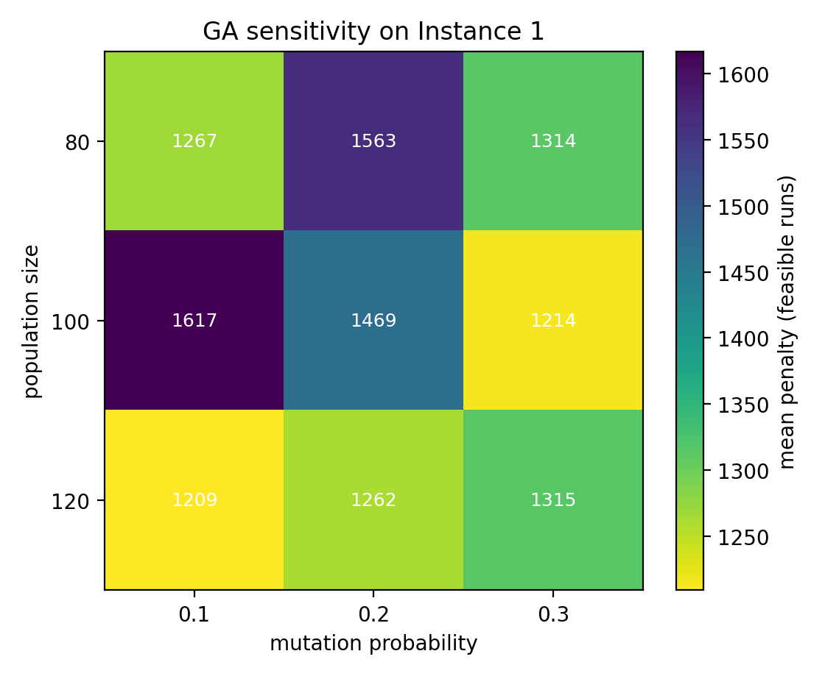
Figure 5.1 — Population size / mutation-probability sensitivity on Instance 1.

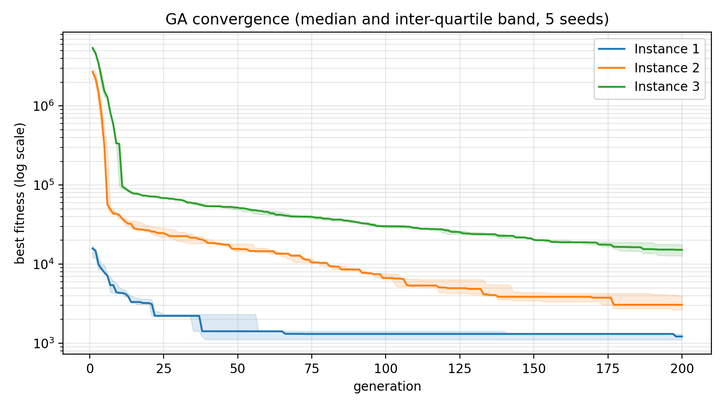
Figure 5.2 — GA convergence (median and inter-quartile band over seeds) with the frozen configuration.

6. Experimental Setup

6.1 Environment
Component | Detail
Language / environment | Python 3.10.19, conda environment “seyon”
Exact method | PuLP 3.3.2, CBC solver (default branch-and-cut settings)
Metaheuristic | DEAP 1.4.4 (tournament selection, custom row crossover/mutation)
Shared code | rostering_common.py (instance parser, shared by all three notebooks)

Note (verified from code/output): Exact CPU/RAM specifications of the machine the experiments ran on were not logged in either notebook. This is a minor reproducibility gap worth fixing — absolute runtimes (though not the qualitative scalability pattern) could shift on different hardware.

6.2 Instances and protocol
All experiments use the same six benchmark instances introduced in Section 2 (Instances 1, 2, 3, 6, 8, 12 — a 150× range in binary variables, from 112 to 16,800).
- ILP protocol: one deterministic run per instance, CBC via PuLP, 300-second time limit, status read from sol_status rather than LpStatus (Section 4.2).
- GA protocol: 10 independently seeded runs per instance (seeds 0–9), the frozen configuration of Section 5.7, one CSV row per run recorded crash-safe as it finishes.
- Performance measures recorded for both methods: gap to best-known (gap_BKS), proof status (proven optimal / feasible / no solution), wall-clock runtime, scalability against the number of binary variables, and feasibility rate.

6.3 A confirmed discrepancy: the GA's actual time budget

Confirmed from code (02_ga.ipynb): The methodology document planned an equal-time comparison: “GA: 10 independent runs …, same 300 s budget” as the ILP. Reading the actual experiment-runner call in 02_ga.ipynb (run_ga_experiments(NUMS, range(10), GA_PARAMS, max_seconds=20, out_csv=…)) shows the GA experiments that produced results/ga_results.csv were in fact run with a 20-second budget per run, not 300 seconds. This is confirmed directly from the code, not inferred: every recorded run time in ga_results.csv falls between 7.2 and 21.5 seconds, and the three largest instances (6, 8, 12) stop after only 27–152 of the 200-generation cap — consistent with a roughly 20-second wall-clock cutoff, not a 300-second one.

The practical consequence is that Section 7's headline runtime comparison (“ILP needs up to 300 s, GA needs only 7–21 s”) is not the equal-time comparison RQ4 and the methodology document both call for — the GA was simply never given the chance to use more time. It is entirely possible that a GA run given the full 300 seconds would reach a higher generation count and improve both its quality and its feasibility rate on Instances 3, 6, 8 and 12. This should be corrected — by re-running the GA experiments with max_seconds=300 — before the comparison in Section 7 and 8 is treated as final. It is listed again as the first outstanding item in Section 8.4.

7. Results
The ILP results of Section 4.6 and the GA results below were merged in 03_comparison.ipynb into one table, using a consistent rule for language: “best found” is used for every GA result and for any ILP result not proven optimal within the time limit; “optimal” is used only where CBC's own status says proven optimal (Instance 1 and 2).

7.1 GA results (10 seeds per instance)

Instance | Feasible runs | Best penalty | Mean penalty | Std. dev. | Mean time (s)
Instance 1 | 10 / 10 | 911 | 1,182.6 | 200.9 | 7.66
Instance 2 | 5 / 10 | 1,952 | 2,171.4 | 224.1 | 15.03
Instance 3 | 0 / 10 | 3,653* | 4,451.2* | 528.0 | 20.18
Instance 6 | 0 / 10 | 7,971* | 9,110.7* | 675.1 | 20.39
Instance 8 | 0 / 10 | 11,753* | 12,343.0* | 447.5 | 20.49
Instance 12 | 0 / 10 | 28,619* | 30,540.8* | 1,196.0 | 21.24

* Where the feasible-run count is 0 / 10, the “best” and “mean” penalty are the least-bad infeasible roster, not a legal one — see Finding 7 below.

7.2 Merged ILP-vs-GA table
Instance | Binaries | Best known | ILP objective | ILP status | ILP gap % | GA best | GA feasible % | GA gap %
Instance 1 | 112 | 607 | 607 | proven optimal | 0.0% | 911 | 100% | 50.1%
Instance 2 | 392 | 828 | 828 | proven optimal | 0.0% | 1,952 | 50% | 135.7%
Instance 3 | 840 | 1,001 | 1,001 | feasible (time limit) | 0.0% | 3,653 | 0% | 264.9%
Instance 6 | 1,512 | 1,950 | 2,312 | feasible (time limit) | 18.6% | 7,971 | 0% | 308.8%
Instance 8 | 3,360 | 1,300 | — | no solution | — | 11,753 | 0% | 804.1%
Instance 12 | 16,800 | 4,040 | — | no solution | — | 28,619 | 0% | 608.4%

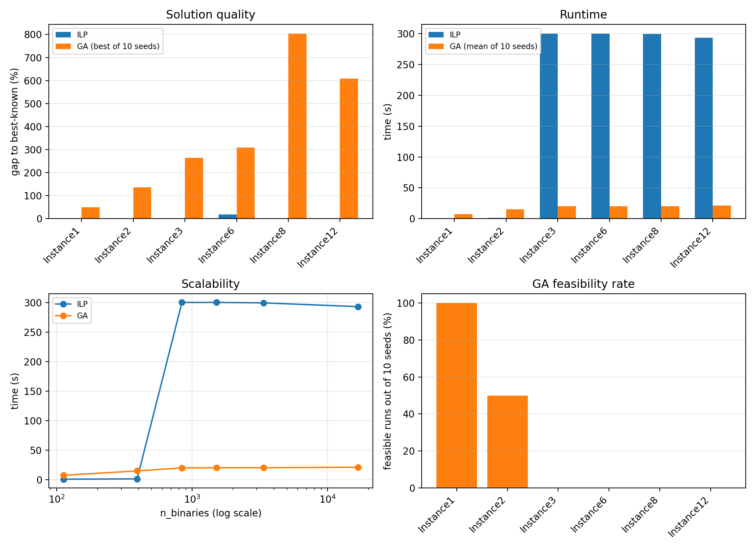
Figure 7.1 — Four-panel comparison: solution quality, runtime, scalability and GA feasibility, all six instances.

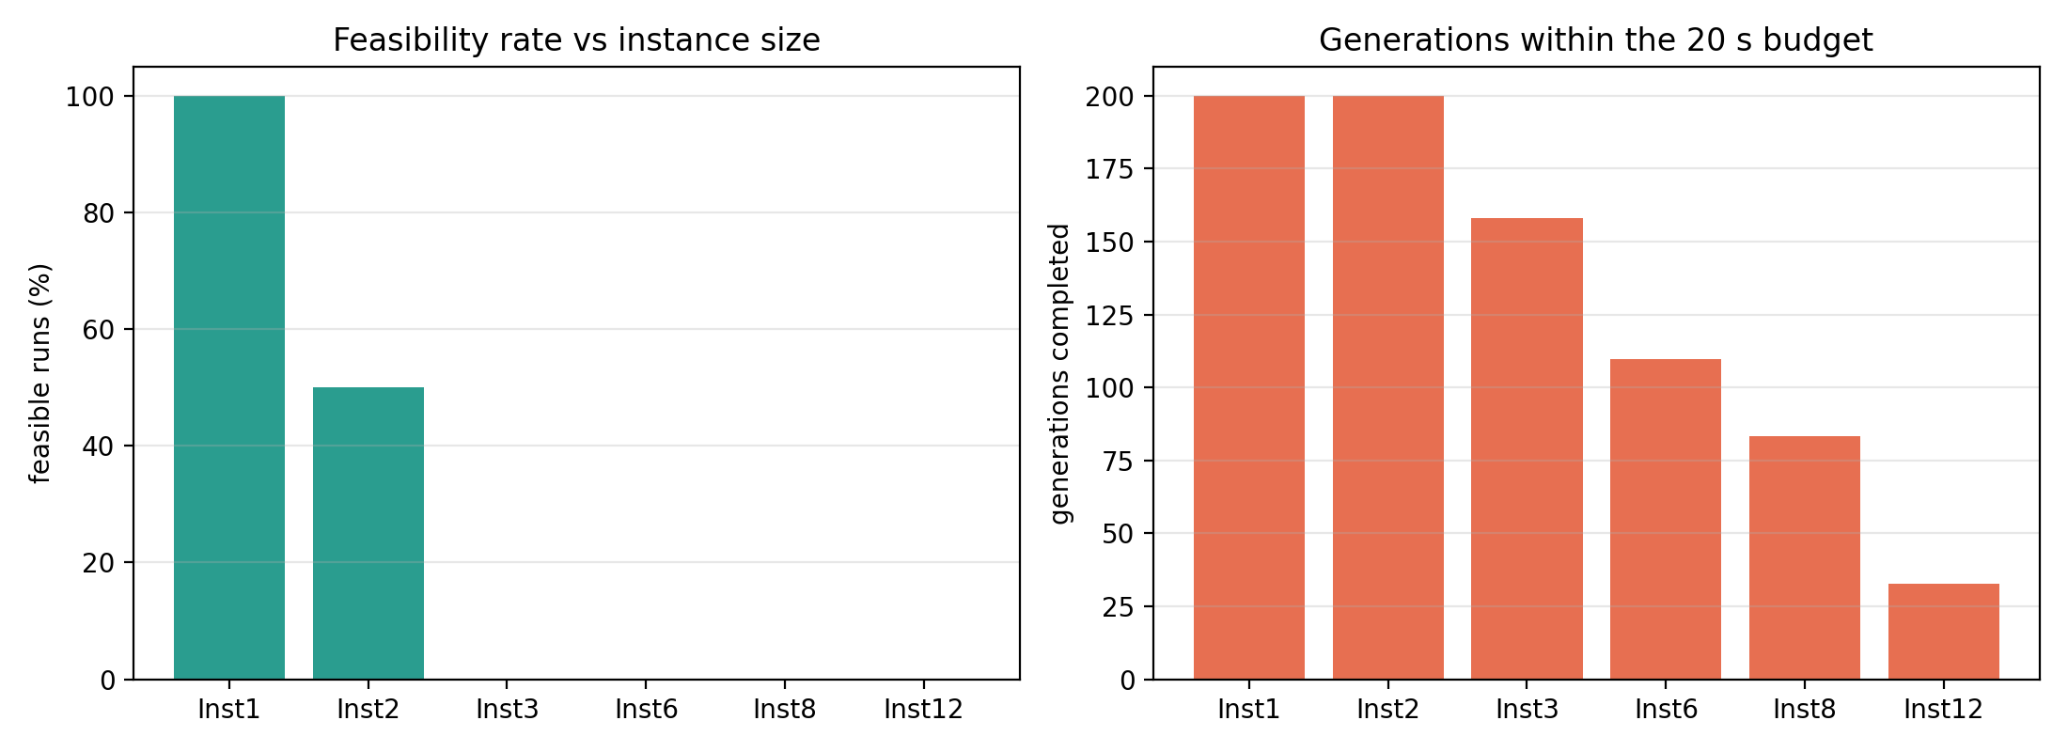
Figure 7.2 — GA feasibility rate and generations completed against instance size.

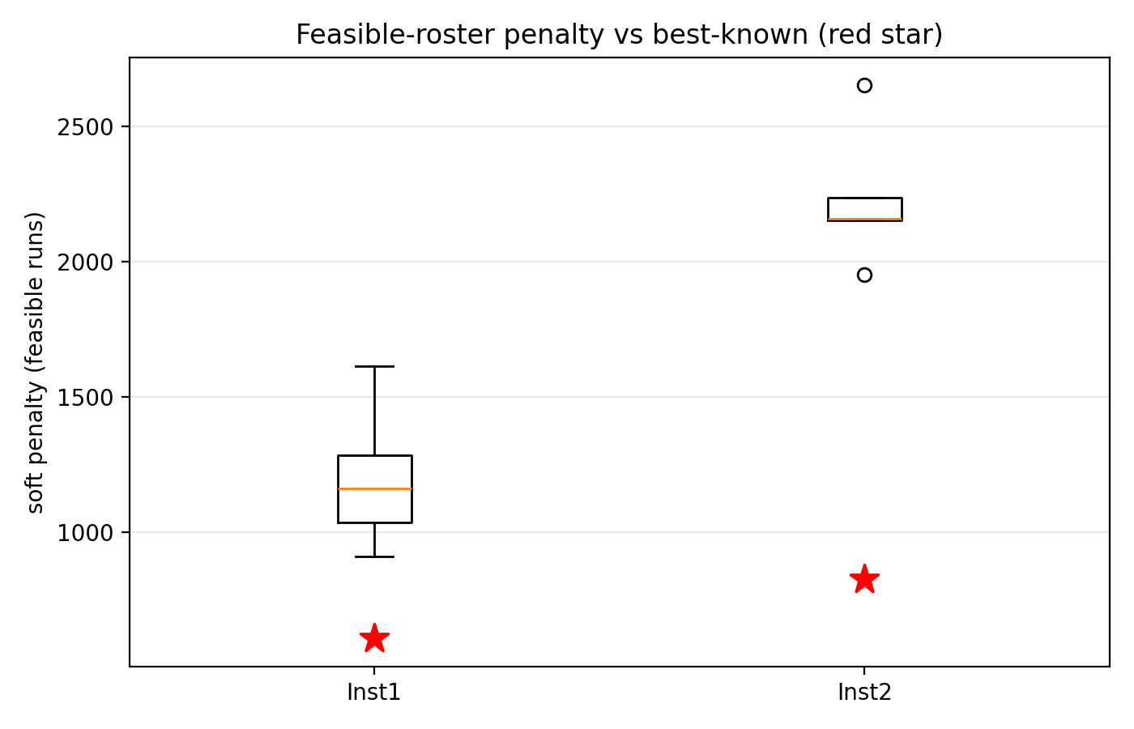
Figure 7.3 — Spread of the GA's final penalty across the 10 seeds, per instance.

8. Discussion

Drafting note: Joint section — both members are expected to edit this (per the task division). The eight numbered findings below are reproduced from 03_comparison.ipynb, each citing a real number from the merged table of Section 7.2; Section 8.4 adds three further issues found while assembling this report.

8.1 Findings

- On the two smallest instances, the ILP proves the optimum exactly (607 on Instance 1 in 0.99 s, 828 on Instance 2 in 1.58 s) — the GA's best-of-10-seeds result is worse on both (911 on Instance 1, a 50% gap; 1,952 on Instance 2, a 136% gap), confirming the exact method is unambiguously the right choice whenever the instance is small enough to solve quickly.

- On Instance 3 the ILP reaches the published best-known value (1,001) without formally proving it within the 300 s limit — a 0% gap to best-known, but still reported as “feasible,” not “optimal,” since the solver's own status says the search was stopped by the time limit. On Instance 6 it reaches 2,312 (an 18.6% gap to the best-known 1,950), again not proven.

- On Instance 8 and Instance 12, the exact method finds nothing at all within 300 s — not even one roster that satisfies every hard rule. This is the sharpest finding of the whole comparison: there is a real scalability wall for this formulation somewhere between Instance 6 (1,512 binaries) and Instance 8 (3,360 binaries).

- The GA always produces something, even where the ILP produces nothing — on Instance 8 and 12 it returns a best-of-10-seeds roster (11,753 and 28,619 respectively), even though every one of those GA runs is itself infeasible (0% feasibility rate on both). This is exactly the trade-off the theory predicts: the heuristic never times out with a blank page, but it also offers no guarantee the result obeys every hard rule.

- GA feasibility collapses almost everywhere except the smallest instance: 100% of Instance 1's GA runs are feasible, only 50% of Instance 2's are, and 0% feasible from Instance 3 upward. With the current frozen parameters, the GA is not yet reliably respecting the hard rules once the instance has more than roughly 400 binary variables — this points at ρ (the penalty coefficient) or the operator design as the next thing to tune, not at the overall approach being wrong.

- Runtime tells the opposite scalability story: the GA's mean runtime barely grows with instance size (7.7 s to 21.2 s across all six instances), while the ILP's grows sharply and hits its 300 s ceiling on four of the six instances. This looks like the GA's core advantage — predictable, bounded cost regardless of problem size — but see Section 6.3 and 8.4: the GA's own time budget was only 20 s, so this comparison is not yet on equal footing.

- Quality and feasibility are two separate questions, and the GA's reported “best” numbers need the feasibility rate read alongside them, not instead of it. On Instance 2 the 1,952 best-of-10 figure came from only 5 of 10 feasible seeds; past Instance 2, zero seeds were feasible on any instance, so every GA “best” value from Instance 3 onward is the least-bad infeasible roster, not a legal one — a gap percentage alone would hide this.

- Overall: the exact method is the stronger choice wherever it can finish (Instances 1–2, and arguably 3 for a “matches best-known, unproven” answer), while the heuristic's real — if currently limited — value only shows once the exact method produces no answer at all (Instances 8 and 12). Its own answers there still need the caveat that they do not yet respect every hard rule, so further GA tuning is needed before treating those numbers as a finished result.

8.2 Relation to the module

Lecture | Concept | Where used here
L1 Foundations | Problem classes; exact vs. heuristic | Method choice (Sections 4, 5), NP-hardness (3.4)
L3 Linear programming | LP, feasible region | LP relaxation of the model (4.3)
L4 Duality | Dual variables, shadow prices | Flagged as not yet computed (4.5)
L5 ILP / MILP | Binary variables, LP bounds, branch and bound, cuts | The exact model and solver (Section 4)
L8 Constrained optimization | Penalty method | GA fitness (5.3) — implemented as linear, planned as quadratic
L10 Metaheuristics | GA: selection, crossover, mutation, elitism | GA design (Section 5)

Lectures on unconstrained and constrained gradient methods (L6, L7, L9) do not apply directly because the decision variables are discrete.

8.3 Limitations

- Solver strength: CBC is considerably slower than commercial solvers used in the wider literature, so proof of optimality may be unattainable beyond the smaller instances within any reasonable time limit; results on the larger instances should be read as bounds and incumbents, not as settled scores.

- Single benchmark family: conclusions apply to the Curtois & Qu (2014) benchmark's own rule set; other hospitals may impose further rules not modelled here.

- GA parameter sensitivity: results depend on ρ and the operator design, which is why Sections 5.6–5.7 document the tuning explicitly rather than presenting a single untuned run.

- Future work: a hybrid that uses the ILP to repair or polish the best GA roster (a matheuristic); other metaheuristics such as simulated annealing as a further baseline; warm-starting the ILP with a GA roster; more benchmark instances; and a multi-objective treatment of fairness among nurses (connecting to Lecture 13's Pareto-optimality material).

8.4 Outstanding issues to resolve before the final submission
Found while assembling this draft, not yet fixed — listed in the order they should be addressed.

- Re-run the GA scalability experiments with the time budget actually equal to the ILP's (300 s instead of the 20 s confirmed in Section 6.3), then regenerate Sections 7 and 8's tables, figures and findings 5–7 from the corrected results. This is the most consequential open item: it may materially change the feasibility-rate and runtime findings, and it is needed to answer RQ4 as originally posed.

- Reconcile the fitness function: either update the methodology document to describe the linear penalty ρΣV actually implemented (Section 5.3), or change the code to the quadratic ρΣV² originally planned and re-run the affected experiments. Either is defensible; leaving the document and the code silently disagreeing is not.

- Either compute the LP-relaxation shadow prices promised as an optional analysis (Section 4.5) or remove the claim that this analysis would be included.

- Minor: the time_to_within_5pct column exists in ga_results.csv but was never populated or analysed — either compute it (it would add a useful “time to a good-enough answer” metric alongside “time to the literal best”) or drop the unused column.

9. Conclusion

Objective O1 — model the problem correctly and solve it exactly on the smaller instances — is met: the full C1–C10 ILP reproduces the published best-known optima exactly on Instance 1 (607) and Instance 2 (828), both proven in under two seconds, and independently cross-checked by a second evaluator written from the rule text alone. Objective O2 — compare the exact method with a metaheuristic — has been carried out, but with an important caveat: the comparison as it currently stands is not on equal footing, because the GA experiments were run with a 20-second time budget rather than the 300-second budget the ILP received and the methodology document specified (Section 6.3). The headline pattern that does emerge — the ILP is the stronger, provably correct choice wherever it can finish within the time limit, while the GA is the only method that returns any roster at all once the ILP's scalability wall is crossed (somewhere between 1,512 and 3,360 binary variables) — is a real and useful result, but the specific feasibility-rate and runtime numbers behind it should be treated as provisional until the GA is re-run at an equal time budget.

Before this report and its code appendix are finalised, the team still needs to: (1) re-run the GA scalability experiments at a true 300-second budget and update Sections 6–8 accordingly; (2) reconcile the linear-versus-quadratic penalty discrepancy between the plan and the implementation; (3) either compute or formally drop the shadow-price analysis; (4) record both members' Day 7 video segments and combine them into the 15-minute submission video; and (5) assemble members.txt, submission.txt and the plain-text code appendix into the final Optimization-assignment.zip. With those items closed, the project will have delivered on both halves of the assignment brief: a correct, verified exact method, and a working, honestly evaluated metaheuristic, compared on the same real benchmark data.

References

T. Curtois and R. Qu, Computational results on new staff scheduling benchmark instances, Technical Report, ASAP Research Group, University of Nottingham, 2014. https://www.schedulingbenchmarks.org/nrp/

E. K. Burke, P. De Causmaecker, G. Vanden Berghe and H. Van Landeghem, The state of the art of nurse rostering, Journal of Scheduling, 7(6):441–499, 2004.

A. T. Ernst, H. Jiang, M. Krishnamoorthy and D. Sier, Staff scheduling and rostering: a review of applications, methods and models, European Journal of Operational Research, 153(1):3–27, 2004.

G. L. Nemhauser and L. A. Wolsey, Integer and Combinatorial Optimization, Wiley, 1988.

J. H. Holland, Adaptation in Natural and Artificial Systems, University of Michigan Press, 1975.

D. E. Goldberg, Genetic Algorithms in Search, Optimization and Machine Learning, Addison-Wesley, 1989.

J. Forrest and R. Lougee-Heimer, CBC user guide, in INFORMS Tutorials in Operations Research, 2005.

