ECA – Linux SpaceWalk Server Setup & Maintenance

|  |
| --- |
|  |
| * Version: 0.1 (Draft) * INTERNAL |
|  |

|  |  |
| --- | --- |
| Document control | |
|  |  |
|  |  |
| |  |  | | --- | --- | | **Author** | Steven Eyre | | **Owner** | Andrew Raison | | **Approved by** | Paul Gabriel | | **Approval date** |  | | **Effective from** |  | | **Next review date** |  | | **Source location** | \\internal\london\IT\Documentation\Policies Standards and Procedures\Procedures\Access Management Procedures\Access provisioning | | **Audience** | IT department | | |

|  |  |
| --- | --- |
| Change history | |
|  |  |
|  |  |
| |  |  |  |  | | --- | --- | --- | --- | | Version | Date | Amended by | Details | | 0.1 | 25/11/2019 | Steven Eyre | First draft | |  |  |  |  | |  |  |  |  | |  |  |  |  | |  |  |  |  | | |

Contents

Introduction 3

Overview 3

Purpose/Scope 3

Procedure 4

Spacewalk Description 4

Assumptions 4

Spacewalk Pre-Requisites 5

Spacewalk Build 6

Create Updates Repository 17

Create Extra Repository 18

Related documents 27

|  |  |
| --- | --- |
| Introduction | |
|  |  |
|  |  |
| Overview ECA brought in-house the StarRate development environment. This necessitates several linux Servers (Both Desktop/Gnome and management servers be built. Previously builds were by hand/knowledge specific to Starrate.  This document covers the build/maintenance for the ForeMan server*.*  *Foreman is a complete lifecycle management tool for physical and virtual servers. It gives system administrators the power to easily automate repetitive tasks, quickly deply applications, and proactively manage servers, on-premise or in the cloud.* Purpose/Scope Build procedure for the ForeMan server  Configure Software channels (add online resources where patches are automatically downloaded from)  Define Software repositories (repos) Repos are point-in-time snapshots of Software channels  How to add new clients/subscribe clients to repos | |

|  |  |
| --- | --- |
| Procedure | |
|  |  |
|  |  |
| Spacewalk Description ***Spacewalk*** *is an open source Linux systems management solution. It is the upstream community project from which the* [*Red Hat Satellite 5*](https://www.redhat.com/products/enterprise-linux/satellite/) *and* [*SUSE Manager*](https://www.suse.com/products/suse-manager/) *products are derived.*  ForeMan's capabilities include:   * Inventory your systems (hardware and software information) * Install and update software on your systems * Collect and distribute your custom software packages into manageable groups * Provision (kickstart) your systems * Manage and deploy configuration files to your systems * Provision virtual guests * Start/stop/configure virtual guests * Distribute content across multiple geographical sites in an efficient man * Discover, provision and upgrade your entire bare-metal infrastructure * Create and manage instances in virtualization environment and across private and public clouds * Install operating systems via PXE, local media or from templates or images * Control and gather reports from your configuration management software * Group your hosts and manage them in bulk, regardless of location * Review historical changes for auditing or troubleshooting * Web user interface, JSON REST API and CLI for Linux * Extend as needed via a robust plugin architecture   **[URL]** [**https://theforeman.org/introduction.html**](https://theforeman.org/introduction.html) | |

## Assumptions

While this document covers the build/maintenance procedures – below assumptions are made:

1. A broad understanding of IT standards/methodologies.
2. Basic Linux administration skills.
3. Familiarity with ECA procedure and standards.

## Spacewalk Pre-Requisites

**[URL]** [**https://github.com/spacewalkproject/spacewalk/wiki/HowToInstall**](https://github.com/spacewalkproject/spacewalk/wiki/HowToInstall)

**SERVER SPECS**

* Hyper V VM
* 1-2CPU
* 4GB Minimum
* 16GB Disk for OS/Root
* 30GB Disk for Software Channels/Repos
  + Storage for packages (default /var/satellite): Depends on what you're storing; Red Hat recommend 6GB per channel for their channels
* Centos 7.7 DVD/ISO (*or later iteration if available*)
  + **[URL]** [**Centos Download**](https://www.centos.org/download/)
* Make sure your underlying OS is fully up-to-date (build from DVD should suffice)

**FIREWALL/PORTS**

* Outbound open ports 80, 443
* Inbound open ports 80, 443, 5222 (only if you want to push actions to client machines) and 5269 (only for push actions to a Spacewalk Proxy), 69 udp if you want to use tftp
* Storage for database: 250 KiB per client system + 500 KiB per channel + 230 KiB per package in channel (i.e. 1.1GiB for channel with 5000 packages)

Protect your Foreman environment by blocking all unnecessary and unused ports.

|  |  |  |
| --- | --- | --- |
| **Port** | **Protocol** | **Required For** |
| 53 | TCP & UDP | DNS Server |
| 67, 68 | UDP | DHCP Server |
| 69 | UDP | **\*** TFTP Server |
| 80, 443 | TCP | **\*** HTTP & HTTPS access to Foreman web UI / provisioning templates - using Apache + Passenger |
| 3000 | TCP | HTTP access to Foreman web UI / provisioning templates - using standalone WEBrick service |
| 3306 | TCP | Separate MySQL database |
| 5910 - 5930 | TCP | Server VNC Consoles |
| 5432 | TCP | Separate PostgreSQL database |
| 8140 | TCP | **\*** Puppet Master |
| 8443 | TCP | Smart Proxy, open only to Foreman |

**SOFTWARE REPOSITORIES**

|  |  |
| --- | --- |
| **repo id** | **Repo name** |
| epel/x86_64 | Extra Packages for Enterprise Linux 7 |
| group_spacewalkproject-java-packages | copr repo for java packages @spacewalkproject |
| spacewalk/x86_ | Spacewalk |

|  |  |
| --- | --- |
| Foreman Build | |
|  |  |
|  |  |

1 x Hyper-V (1-2 CPU/4GB Ram)

16GB

**SETUP REPOS**

**Install Puppet 6**

# yum -y install <https://yum.puppet.com/puppet6-release-el-7.noarch.rpm>

**Install Centos 7 EPEL (Extra Packages Enterprise Linux)**

# yum -y install <http://dl.fedoraproject.org/pub/epel/epel-release-latest-7.noarch.rpm>

**Install ForeMan Installer**

# sudo yum -y install <https://yum.foreman.org/releases/1.23/el7/x86_64/foreman-release.rpm>

**RUN ForeMan Installer**

The installation run is non-interactive, but the configuration can be customized by supplying any of the options listed in foreman-installer --help, or by running foreman-installer -i for interactive mode

By default it will configure:

* Apache HTTP with SSL (using a Puppet-signed certificate)
* Foreman running under mod_passenger
* Smart Proxy configured for Puppet, TFTP and SSL
* Puppet master running under mod_passenger
* Puppet agent configured
* TFTP server (under xinetd on Red Hat platforms)

**[CMD]**

# foreman-installer

After it completes, the installer will print some details about where to find Foreman and the Smart Proxy and Puppet master if they were installed along Foreman. Output should be similar to this:

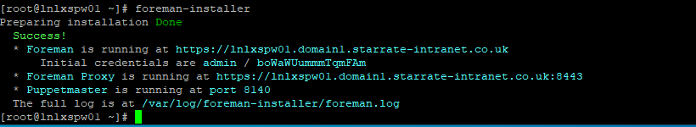

**Successful Install**

**FIREWALL – ADD PORTS**

Protect your Foreman environment by blocking all unnecessary and unused ports.

|  |  |  |
| --- | --- | --- |
| **Port** | **Protocol** | **Required For** |
| 53 | TCP & UDP | DNS Server |
| 67, 68 | UDP | DHCP Server |
| 69 | UDP | **\*** TFTP Server |
| 80, 443 | TCP | **\*** HTTP & HTTPS access to Foreman web UI / provisioning templates - using Apache + Passenger |
| 3000 | TCP | HTTP access to Foreman web UI / provisioning templates - using standalone WEBrick service |
| 3306 | TCP | Separate MySQL database |
| 5910 - 5930 | TCP | Server VNC Consoles |
| 5432 | TCP | Separate PostgreSQL database |
| 8140 | TCP | **\*** Puppet Master |
| 8443 | TCP | Smart Proxy, open only to Foreman |

Ports indicated with **\*** are running by default on a Foreman all-in-one installation and should be open.

**[CMD]**

# firewall-cmd –add-service=http

# firewall-cmd –add-service=https

# firewall-cmd –runtime-to-perm

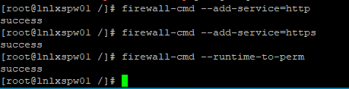

**HOSTNAME RESOLUTION**

Spacewalk needs to be able to resolve the FQDN. Ad interim (if we are not going to be using AD for DNS) add a local entry to the /etc/hosts file

**[CMD]**

# cp /etc/hosts /etc/hosts.BACKUP.YYYYMMDD # Where YYYYMMDD

# echo “192.168.130.76 lnlxspw01.domain1.starrate-intranet.co.uk lnlxspw01 spacewalk” >> /etc/hosts

**PUPPET – TEST AGENT ON MASTER**

Check Puppet agent is running on server

# puppet agent --test

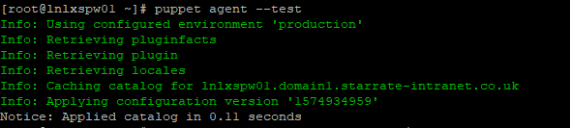

**PUPPET – Download Puppet module from Puppetlabs/Forge (online repo for Puppet)**

Install NTP puppet module from Puppetlabs

# puppet module install puppetlabs/ntp

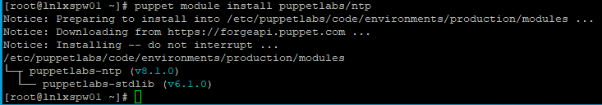

**REPOS**

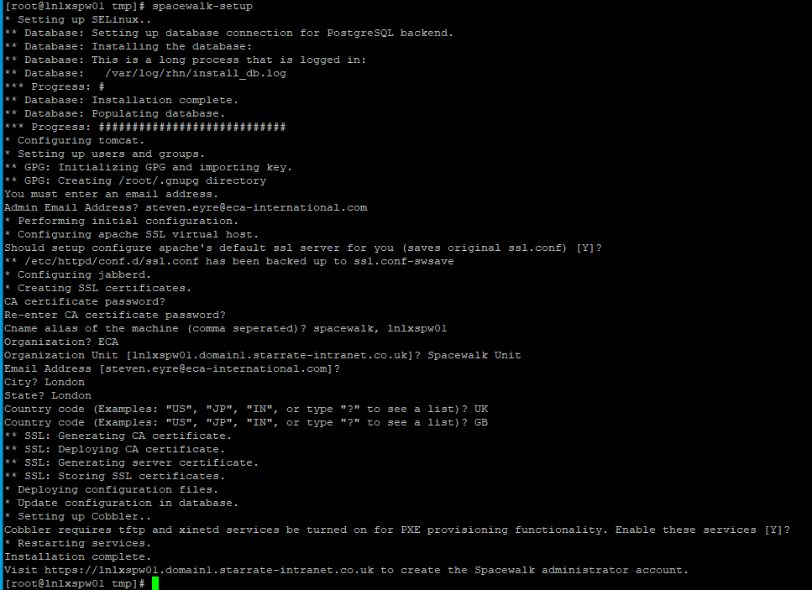

**SPACEWALK ADMIN SETUP**

[URL] <https://192.168.130.76>

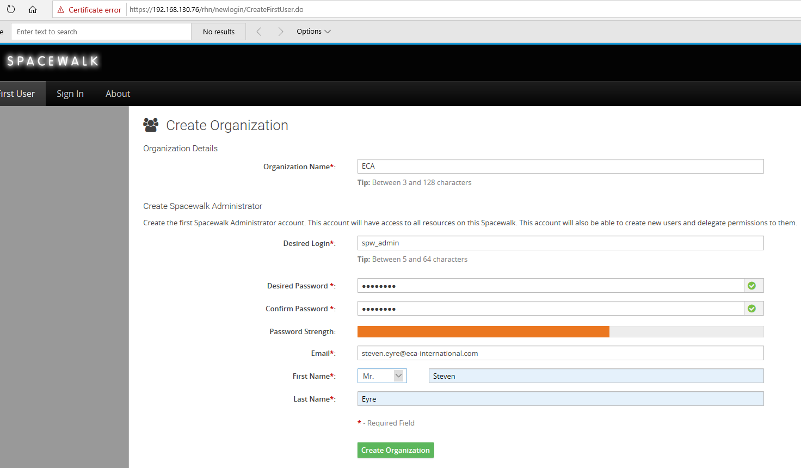

Username: spw_admin

Password: You know

##### **Step 1: Creating the Base Channel**

**CREATE CHANNEL**

[REMOVE] [URL] <https://www.linuxsysadmins.com/how-to-create-software-channels-repositories-activation-keys-and-sync-in-spacewalk-server-2-8/>

To create our first base channel navigate to the top menu by clicking on “**Channels**” by following in left side pane click “**Manage Software Channels**” at last in right side top corner locate for “**+ Create channel**” and click on it.

**Channels (top)–> Manage Software Channels(Left side pane) –> “+ Create Channel”(Right side top corner).**

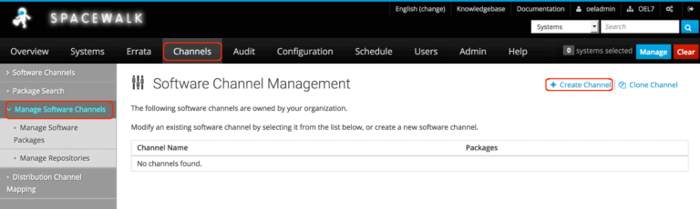Create base Channel

It will redirect to create a software channel page, Here we need to fill with our required Channel name, Channel Label, architecture, Yum repositories checksum type, Channel summary, description, information about the restrictions and GPG key information. Except for contact information all the fields are mandatory to fill out.  
  
  
  
First, we need have an extracted GPG key information, To get the key information download it in Spacewalk server under **/etc/pki/rpm-**gpg**/** from CentOS official website and extract it using **GPG** command. Hence we are running Spacewalk server in CentOS Linux 7 we don’t require to download, if we have installed in RHEL, Oracle or in Scientific Linux downloading CentOS key required for extracting **GPG ID** and Fingerprint information.

In our case navigate to **/etc/pki/rpm-**gpg**/** and extract GPG information.

# cd /etc/pki/rpm-gpg

# wget http://mirror.centos.org/centos/RPM-GPG-KEY-CentOS-7

# gpg --with-fingerprint RPM-GPG-KEY-CentOS-7

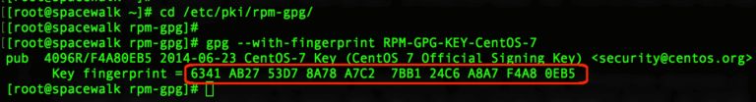Extracting GPG information

**From the extracted information last 8 digits in fingerprint will be “GPG Key ID”. We are using with below details.**

Channel Name: **Centos 7 Base x86_64**       # Channel name can any name, let us stick with the official name.  
Channel Label: **centos-7-base-x86_64**      # Label name should not contain any spaces.  
Parent Channel: **None**                                       # We are creating with our first channel, so not under any parent.  
Architecture: **x86_64**                                        # Our system repo architecture.  
Yum Repository Checksum Type:  **sha256**             # Use high security with **256 Checksum**.  
Channel Summary: **Centos 7 Base x86_64**             # Give a channel summary.  
Channel Description: **Centos 7 Base x86_64**         # Provide with a small description.  
Per-User Subscription Restrictions:              **All users** within your organization may subscribe to this channel.   
Organization Sharing:                                        This channel is private and cannot be accessed by any other org.  
GPG key URL:  **file:///etc/pki/rpm-gpg/RPM-GPG-KEY-CentOS-7**  
GPG key ID:  **F4A80EB5**  
GPG key Fingerprint:  **6341 AB27 53D7 8A78 A7C2 7BB1 24C6 A8A7 F4A8 0EB5**

Top half of the form

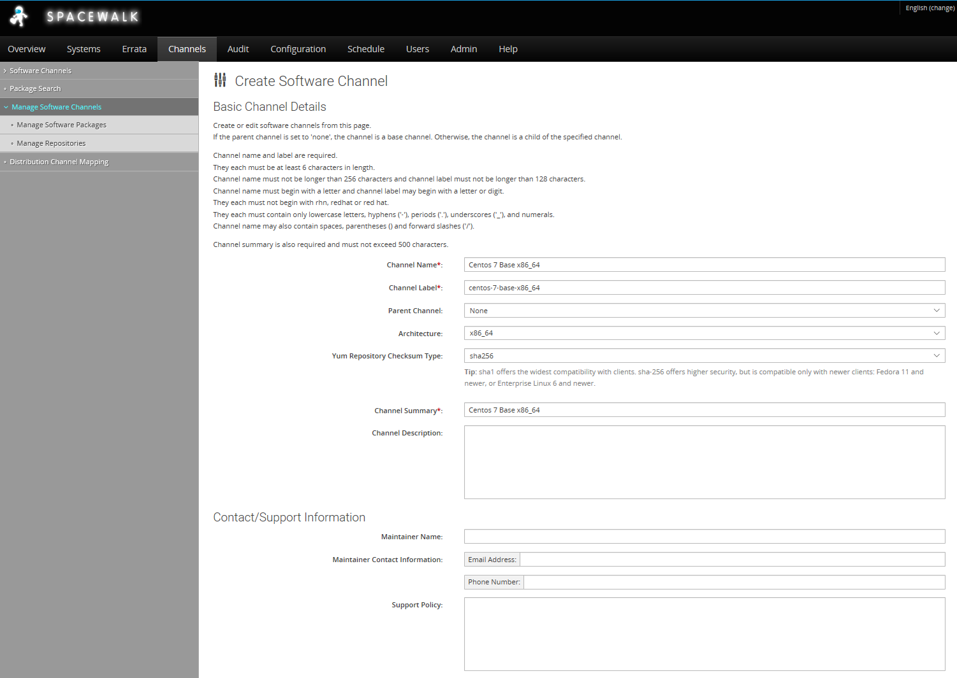

Bottom half of the form

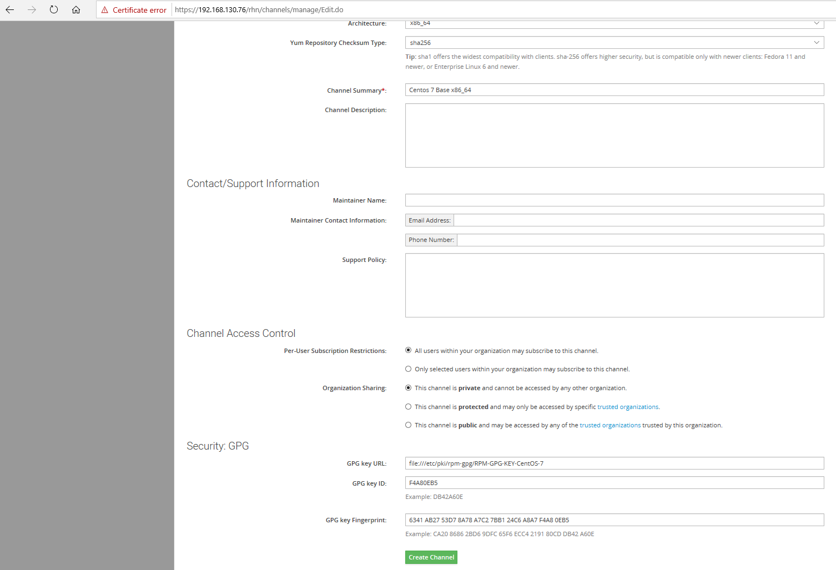

Click “**Create Channel**” to create our first “**Centos 7 Base x86_64**” channel,

**Channel Created**

Once created it will list under the “**Software Channel Management**“.

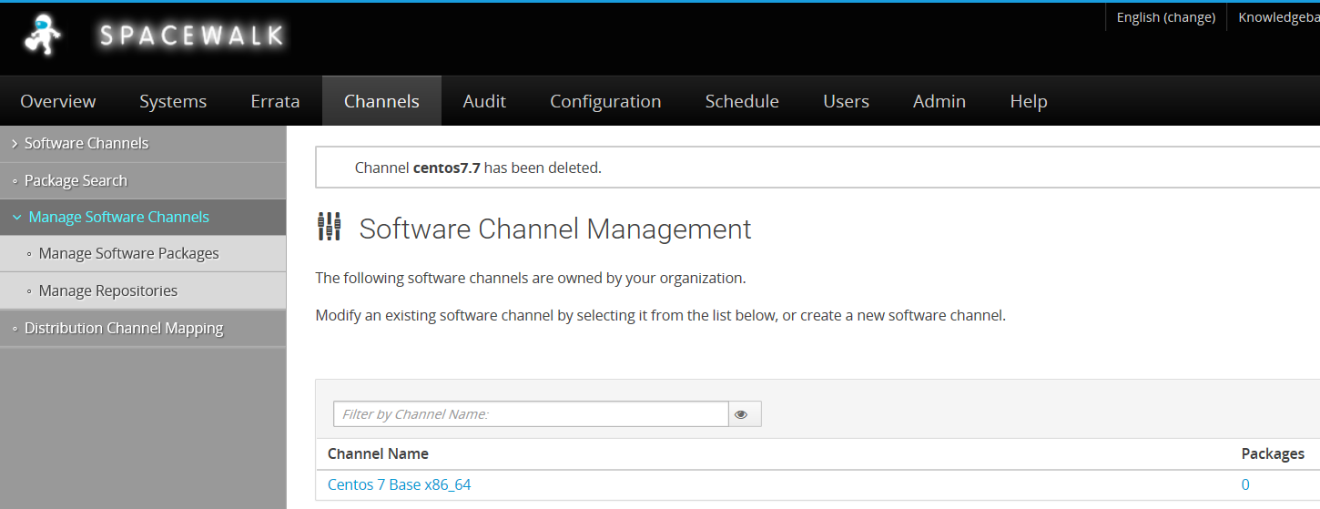

As you can see – at the moment it has no software packages –these are added/downloaded in the next steps (Create Repositories)

##### **Step 2: Creating repositories.**

To get all available repositories from CentOS 7 navigate to below URL.

http://mirror.centos.org/centos/7/

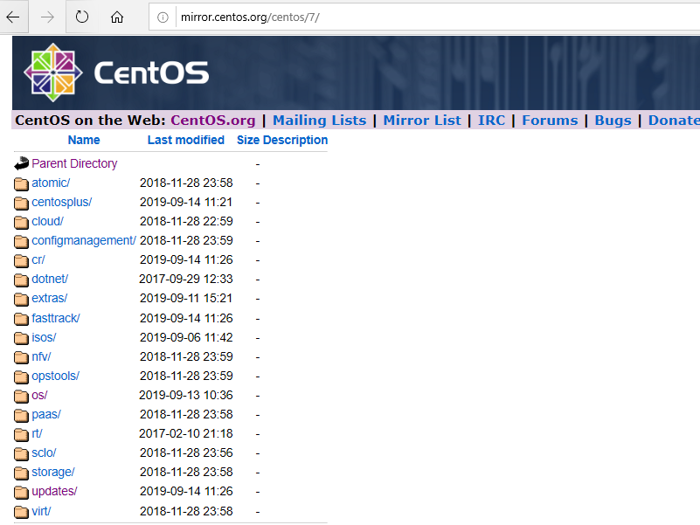

To create with repository click on “**Channels**” menu from the top, by following in left side pane click on “**Manage Software Channels**” under it click “**Manage Repositories**” we will get “**Create Repository**” in right side top corner click to create with it.

**Channels (Top)–> Manage Software Channels (Left side pane)–> Manage Repositories (Left side pane)–> Create Repository(Right side top corner).**

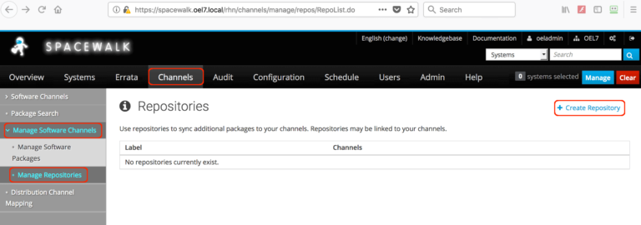Create Repositories

Repository Label :      centos7_base_x86_64_repo

Repository URL:         http://mirror.centos.org/centos/7/os/x86_64/

Repository Type:        yum

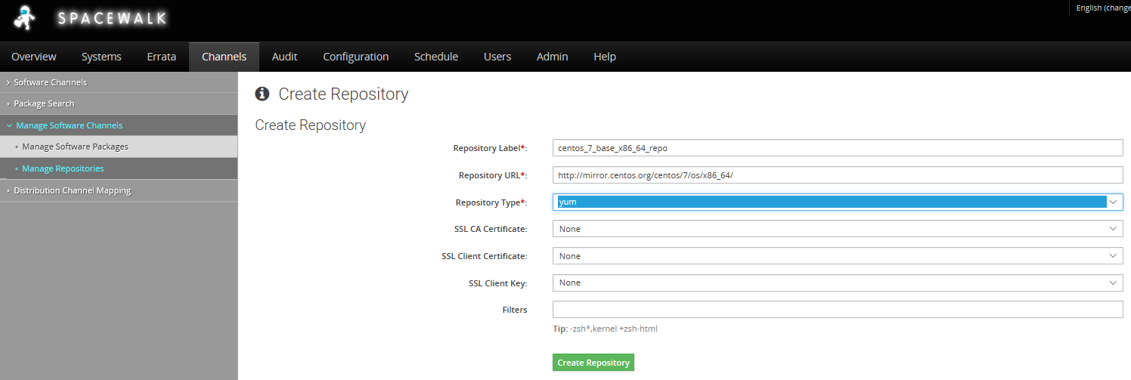

Click “**Create Repository**” to create with it.

### Create Updates Repository

We need to create the updates repository - Channels, Manage Software Channels,, Manage Repositories , Create Repository.

Repository Label : centos7_update_x86_64_repo

Repository URL: http://mirror.centos.org/centos/7/updates/x86_64/

Repository Type: yum

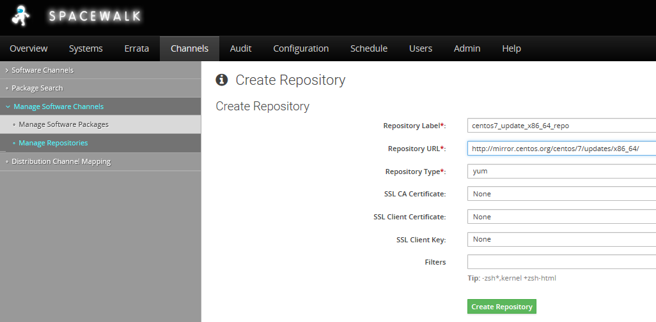

Click “**Create Repository**” to create with it.

### Create Extra Repository

We need to create the extras repository - Channels, Manage Software Channels,, Manage Repositories , Create Repository.

Click “**Create Repository**” to create with it.

Repository Label : centos7_extra_x86_64_repo

Repository URL: http://mirror.centos.org/centos/7/extras/x86_64/

Repository Type: yum

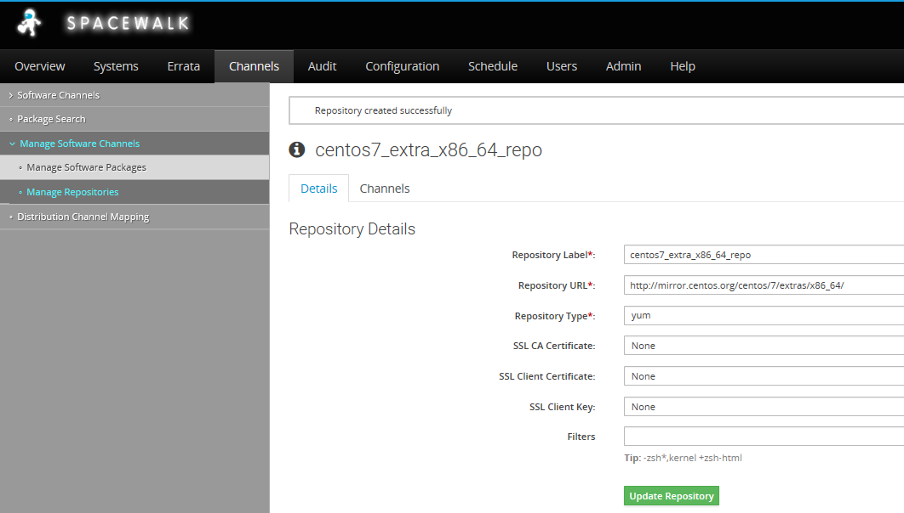

Click “**Create Repository**” to create with it.

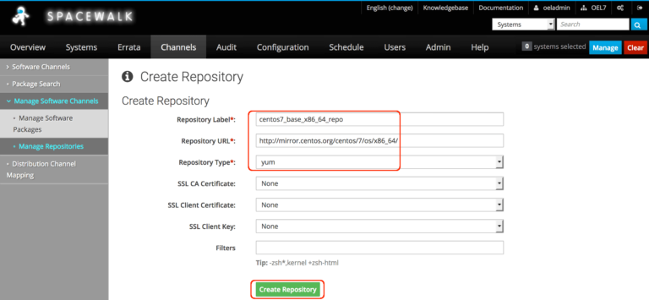Repositories Lable and URL

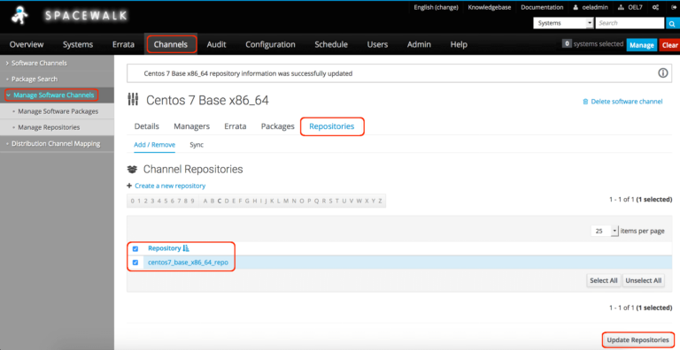Created Repository

##### **Step 3: Adding Repository to Channel.**

To add the repositories to channel navigate to “**Channels**” top menu click on ‘**Manage Software Channels**‘ our created channel “**Centos 7 Base x86_64**” will be listed here click on it and select “**Repositories**” TAB from it in the bottom of the page select the required repositories and click “**Update Repositories**“.

**Channels (Top)–> Manage Software Channels (Left side pane)–> Centos 7 Base x86_64 –> Repositories (Tab) –> centos7_base_x86_64_repo (Check box) –> Update Repositories (Bottom right corner).**

Add remaining “**centos7_update_x86_64_repo**”  and “**centos7_extra_x86_64_repo**” under base channel.



**Channels (Top)–> Manage Software Channels (Left side pane)–> Centos 7 Base x86_64 –> Repositories (Tab) –> centos7_base_x86_64_repo (Check box) –> Update Repositories (Bottom right corner).**

Adding the repository to Channel

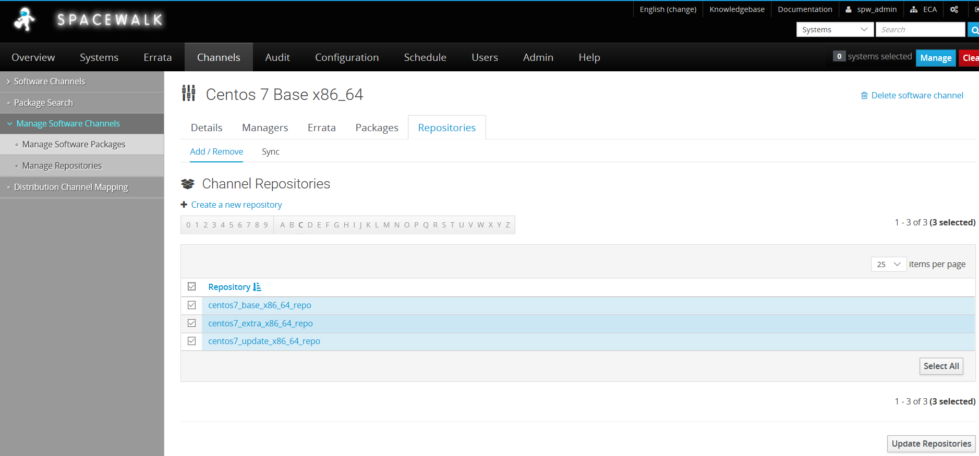

##### **Step 4: Creating activation Key.**

Once we done with all the above steps we required to have an activation key. Activation keys are used to automate the registration of client machines with the Spacewalk server without providing admin username/password.

**System –> ( Top menu) Activation Keys (Left Side pane) –> Create Key (Right side top corner)–> Fill description**

Description : CentOS Linux 7 x86_64

Key: centoslinux7-x86_64

Usage: Leave this blank for unlimited use

Base channels: Centos 7 Base x86_64 # Select the Base channel

Add-On Entitlements: Choose all available feature you about to use.

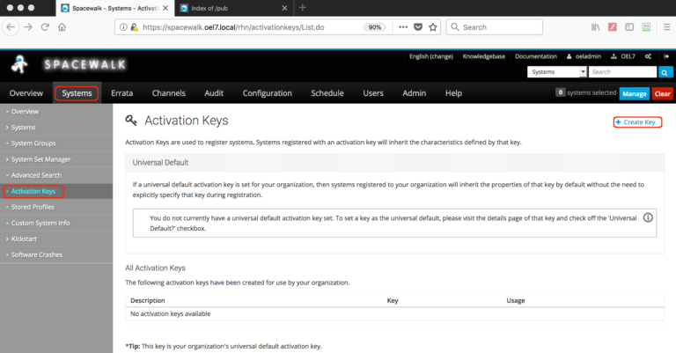Create Activation Key

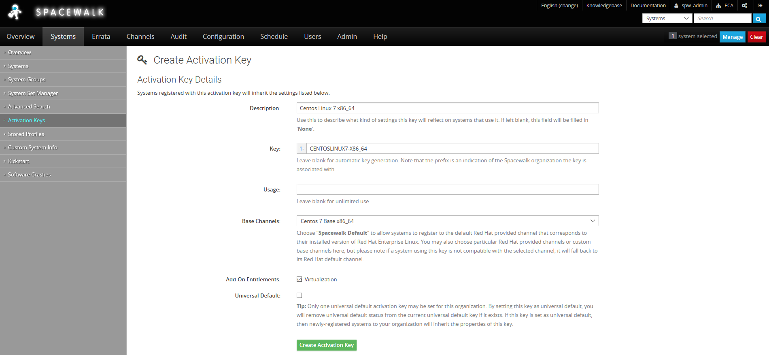key and channel selection

Click “**Create Activation Key**“.

To View Activation Key –

**Channel (Top)–> Activation keys (Left side pane)**

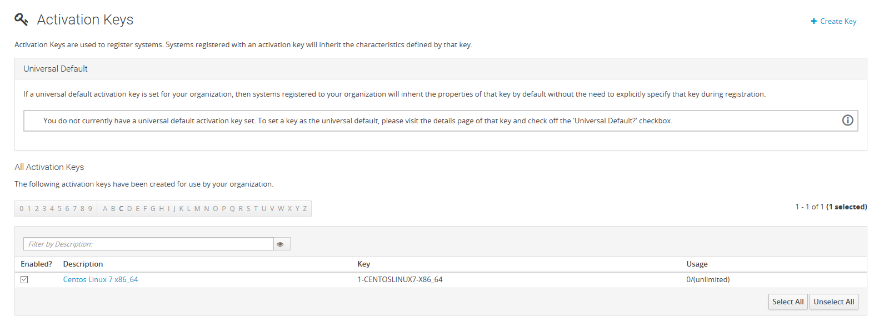Created Key

##### **Step 5: Start Syncing repositories.**

Once done with creating channels, repositories and activation Key our last task is to Sync all repositories to download the contents from CentOS official Repo to our spacewalk server. We can do with a immediate sync or schedule it for an off-peak hour from our production time.

**Channel (Top)–> Manage Software channels (Left side pane) –> Centos 7 Base x86_64 –> Repositories (Tab) –> Sync –> Click** “**Sync now” (Right side above scheduler)**or Schedule it for later.

If you wish to sync from the command line run with

# /usr/bin/spacewalk-repo-sync --channel centos-7-base-x86_64 --type yum

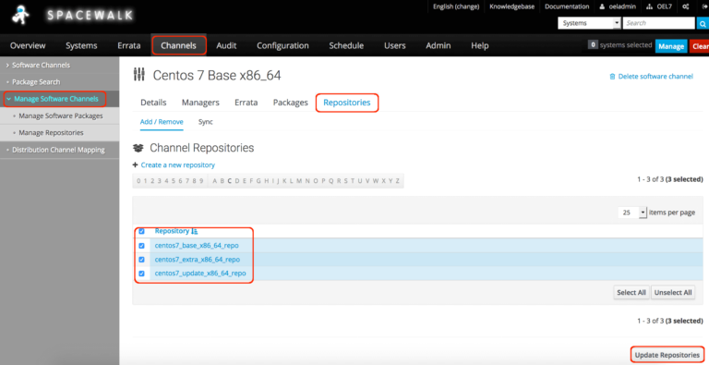Click Repositories tab

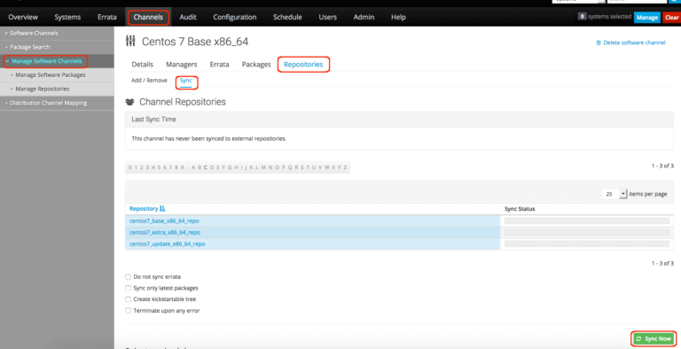Click Sync for immediate sync

**SCHEDULE OVENIGHT SYNC TO PULL DOWN UPDATES**

(I set 03:30 as the schedule time)

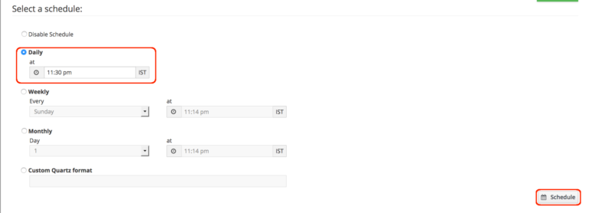Schedule a Sync

To monitor the Sync progress, tail the log of base channel.

# tail -f /var/log/rhn/reposync/centos-7-base-x86_64.log

The output of Sync progress logs

[root@spacewalk ~]# tail -f /var/log/rhn/reposync/centos-7-base-x86_64.log

2018/09/08 23:18:46 +05:30 364/9911 : atk-devel-2.22.0-3.el7.i686.rpm

2018/09/08 23:18:46 +05:30 365/9911 : atkmm-2.24.2-1.el7.i686.rpm

2018/09/09 02:01:23 +05:30 9910/9911 : xulrunner-31.6.0-2.el7.centos.x86_64.rpm

2018/09/09 02:01:48 +05:30 9911/9911 : xulrunner-31.6.0-2.el7.centos.i686.rpm

2018/09/09 02:01:48 +05:30 Importing packages started.

2018/09/09 02:01:48 +05:30

2018/09/09 02:01:48 +05:30 Importing packages to DB:

2018/09/09 02:46:54 +05:30 Importing packages finished.

2018/09/09 02:46:54 +05:30

2018/09/09 02:46:54 +05:30 Linking packages to the channel.

2018/09/09 02:47:24 +05:30

2018/09/09 02:47:24 +05:30 Errata in repo: 0.

2018/09/09 02:47:24 +05:30

Sync will take a long time to complete and it depends on our bandwidth we are using, Downloaded packages came around 14G which saved under /var/satellite.

[root@spacewalk ~]# df -hP /var/satellite

Filesystem Size Used Avail Use% Mounted on

/dev/mapper/spacewalk-var_satellite 50G 14G 37G 27% /var/satellite

[root@spacewalk ~]#

**That’s it, we have completed with our last step by syncing repositories contents.**

|  |  |  |
| --- | --- | --- |
| Related documents | | |
|  |  | |
|  |  | |
|  | |  |