ECA – StarRate Linux Development Server Build (Manual Steps)

|  |
| --- |
|  |
| * Version: 0.1 (Draft) * INTERNAL |
|  |

|  |  |
| --- | --- |
| Document control | |
|  |  |
|  |  |
| |  |  | | --- | --- | | **Author** | Steven Eyre | | **Owner** | Andrew | | **Approved by** | Paul Gabriel | | **Approval date** |  | | **Effective from** |  | | **Next review date** |  | | **Source location** | \\internal\london\IT\Documentation\Policies Standards and Procedures\Procedures\Access Management Procedures\Access provisioning | | **Audience** | IT department | | |

|  |  |
| --- | --- |
| Change history | |
|  |  |
|  |  |
| |  |  |  |  | | --- | --- | --- | --- | | Version | Date | Amended by | Details | | 0.1 | 25/11/2019 | Steven Eyre | First draft | |  |  |  |  | |  |  |  |  | |  |  |  |  | |  |  |  |  | | |

Contents

Introduction 3

Overview 3

Purpose/Scope 3

Procedure 3

Description 3

Assumptions 3

Centos Install Pre-Requisites 4

Server Build 5

Hyper-V – Create VM 5

Hyper-V – install Linux 13

Related documents 27

|  |  |
| --- | --- |
| Introduction | |
|  |  |
|  |  |
| Overview ECA brought in-house the StarRate development environment. This necessitates several linux Servers (Both Desktop/Gnome and management servers be built. Previously builds were by hand/knowledge specific to Starrate  This document covers a manual build to ECA/industry standards on ECA hardware. Purpose/Scope Step by Step manual build procedure for Linux Desktops | |

|  |  |
| --- | --- |
| Procedure | |
|  |  |
|  |  |
| Description ***Centos*** *is an open source Linux distribution* [*https://www.centos.org/*](https://www.centos.org/) *. It is derived from* [*Red Hat Enterprise Linyx (RHEL)*](https://www.centos.org/)  *sources.*  Since March 2004, CentOS Linux has been a community-supported distribution derived from sources freely provided to the public by Red Hat. As such, CentOS Linux aims to be functionally compatible with RHEL. We mainly change packages to remove upstream vendor branding and artwork. CentOS Linux is no-cost and [free to redistribute](https://www.centos.org/legal). Assumptions While this document covers the build/maintenance procedures – below assumptions are made:   1. A broad understanding of IT standards/methodologies. 2. Basic Linux administration skills. 3. Familiarity with ECA procedure and standards.  Centos Install Pre-Requisites **[URL]** [**https://github.com/spacewalkproject/spacewalk/wiki/HowToInstall**](https://github.com/spacewalkproject/spacewalk/wiki/HowToInstall)  **SERVER SPECS**   * Hyper V VM * 1-2CPU * 2GB RAM minimum, 6GB recommended * 16GB Disk for OS/Root * Centos 7.7 DVD/ISO (*or later iteration if available*)   + **[URL]** [**Centos Download**](https://www.centos.org/download/) * Make sure your underlying OS is fully up-to-date (build from DVD should suffice)   **FIREWALL/PORTS**   * Outbound open ports 80, 443   **SOFTWARE REPOSITORIES**  Check re DVD and OS   |  |  | | --- | --- | | **repo id** | **Repo name** | | epel/x86_64 | Extra Packages for Enterprise Linux 7 | | group_spacewalkproject-java-packages | copr repo for java packages @spacewalkproject | | spacewalk/x86_ | Spacewalk |  |  |  | | --- | --- | | Server Build | | |  |  | |  |  |  Hyper-V – Create VM Each server requires a new VM creating on the HyperV platform (lnvh7.eca-international.local)  **Remote Desktop to the server:**    **Server Manager**  **Windows Start (Bottom Left)–> Server Manager**    **Server Manager, Tools, Hyper-V Manager**    **Hyper-V Manager**  1st Check that enough CPU/RAM/Storage are available on the lnvh7.eca-international.local host. (recommend check with management if this is the target Hyper-V host)    **Hyper-V Manager, New, Virtual Machine(Top Right Panel Actions)**    **New, Virtual Machine Wizard, VM Name and Location of VM Store**    Specify Name of Machine  Change Virtual Machine Store/Location to be **D:\** (a folder with VM name is created where data files are stored)  **New, Virtual Machine Wizard, Specify Generation 2**    **New, Virtual Machine Wizard, Specify Generation**  6Gb Ram = 6144MB    **New, Virtual Machine Wizard, Configure Networking**  Virtual Guests    **New, Virtual Machine Wizard, Connect Virtual Hard Disk**  Disk = 16GB    **New, Virtual Machine Wizard, Installation Options**  Install Source/DVD/ISO (Downloaded from Centos Mirrors)    **New, Virtual Machine Wizard, Summary**    **Hyper-V – VM, Settings, Security (updates before booting !!!)**  Select VM you just created) Right Click, Settings, Security Tab  Update to be **Microsoft UEFI Certificate Authority, click apply.**    **Hyper-V – VM, Settings, Connect**   Hyper-V – install Linux **Hyper-V – VM, Settings, Connect (cont’d)**    **Click on Start**  **Linux Install**  Click in window, and user Arrow keys to move/highlight **Install Centos**    **Linux Install, Lang & Keyboard**  Select **English (United Kingdom)** from Right hand Panel, **Select Continue**.    **Note Timezone/Keyboard are now updated to be GB**    **Linux Install, Software Selection, Software Selection, Gnome Desktop**    **Linux Install, System, Installation Destination sda / 16GB**  Select 16GB/SDA device (should only be 1 x disk)  **Select Other Storage Options, Automatically configure partitioning**    **Linux Install, Exclamation Marks cleared from sections as you populate them**    **Linux Install, Network and Hostname**  Update Host Name (bottom Left, Apply)    **Configure (bottom Right)**    **Select IPv4 Settings (on row where Ethernet is underlined in blue text)**    **Change:**  **Method: Manual**  **DNS Servers: 192.168.130.2** (Check with network admin for the IP/Subnet you have been provided)  **Search Domains: domain01-starrate.intranet.co.uk**  **Addresses**  **Get IP/Netmask/Subnet (N.B)**    **Save, Enable Ethernet**    **IP 192.168.130.67/24**  **GW 192.168.130.1**  **Linux Install, begin Installation (Root Password, Add “admin” user)**  Select Begin Installation (Bottom Right)    **Linux Install, root Password, User Creation (“admin” user)**    **Select Root Password**    **Enter desired root passwd, Select Done Top Left**  **Select User Creation**    Select Make this user administrator  Current admin password is weak – so you will have to **Click Done twice**  **Reboot** | |
|  | |

**REGISTER WITH SPACEWALK SERVER**

Bit of chicken and Egg here ….. To register the server with Spacewalk – you have to have the software installed (and it doesn’t come on the DVD …..)

For ease – I’ve added all the software into a single place

**On Server you wish to register with Spacewalk**

**# mkdir /var/tmp/rhn**

**# scp admin@192.168.130.76: /var/satellite/RHN-Register/* .**

**# cd /var/tmp/rhn**

**# yum -y install python-gudev-147.2-7.el7.x86_64.rpm python-hwdata-1.7.3-4.el7.noarch.rpm rhn-check-2.0.2-24.el7.x86_64.rpm rhn-client-tools-2.0.2-24.el7.x86_64.rpm rhnlib-2.5.65-8.el7.noarch.rpm rhnsd-5.0.13-10.el7.x86_64.rpm rhn-setup-2.0.2-24.el7.x86_64.rpm yum-rhn-plugin-2.0.1-10.el7.noarch.rpm pyOpenSSL-0.13.1-4.el7.x86_64.rpm python-ethtool-0.8-8.el7.x86_64.rpm libnl-1.1.4-3.el7.x86_64.rpm python-dmidecode-3.12.2-3.el7.x86_64.rpm**

[CMD]

**# rhnreg_ks --activationkey 1-21ad0fddf8f510baf82b58788f384190 --serverUrl** [**http://192.168.130.76/XMLRPC**](http://192.168.130.76/XMLRPC)



**Check Server listed on Spacewalk Server**

**Systems (Top)–> Overview (Left side pane) –> Systems Overview.**

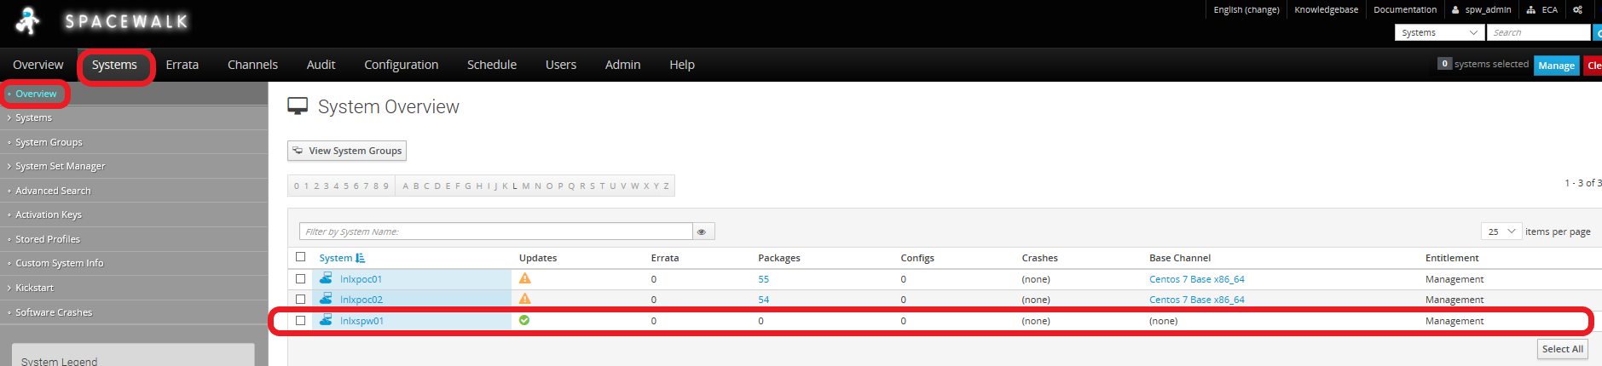

Add Server to Software Channel

**Systems (Top)–> Overview (Left side pane) –> Select Hostname -> Software (Main panel) -> Software Channels (Main panel)**

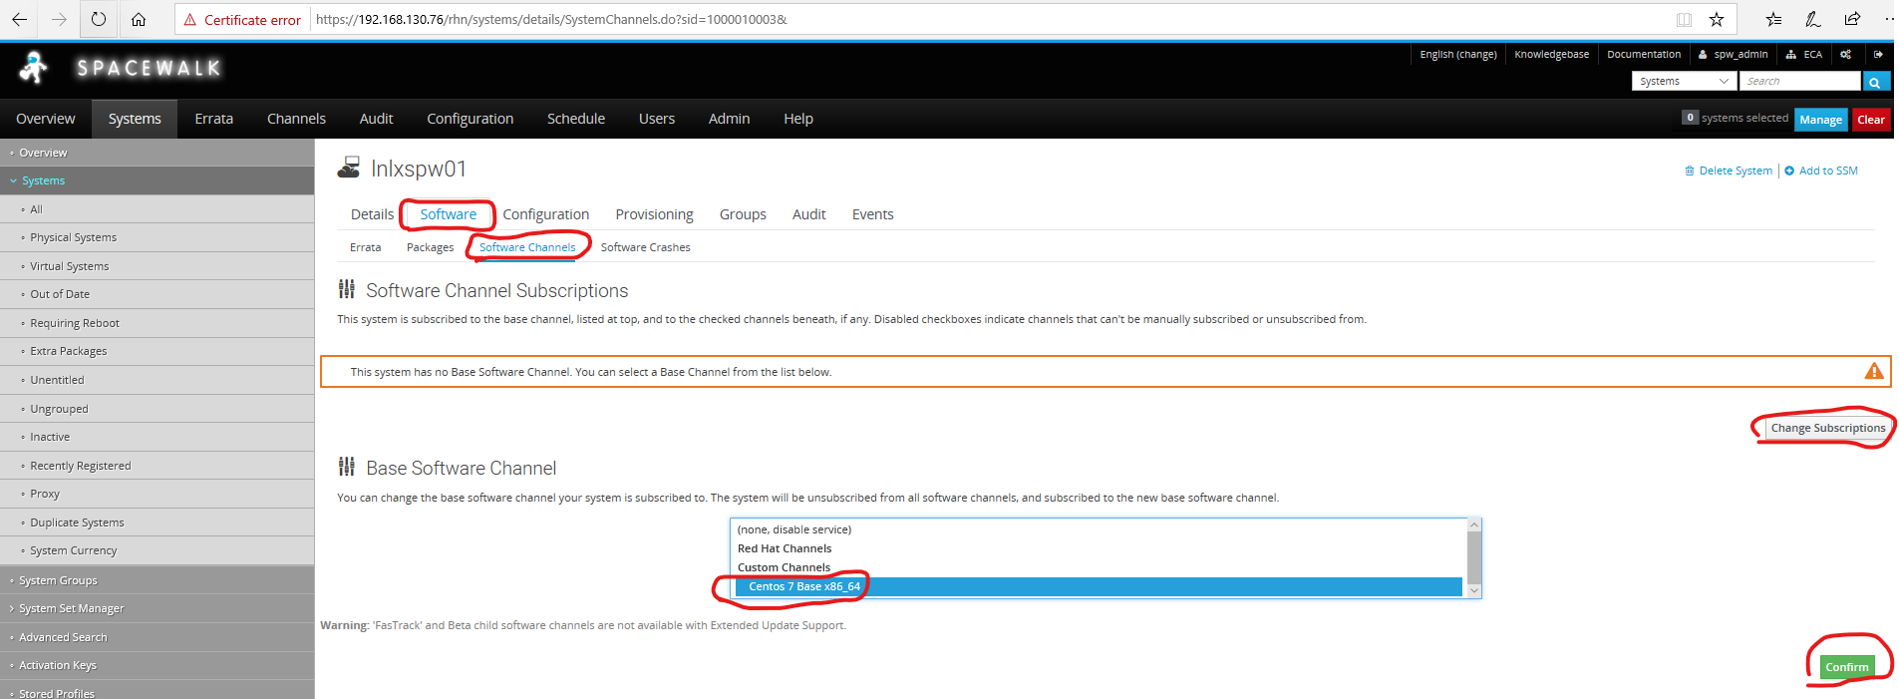

* Select Base Software CHANNEL (Centos 7 Base x86_64)
* Select Confirm

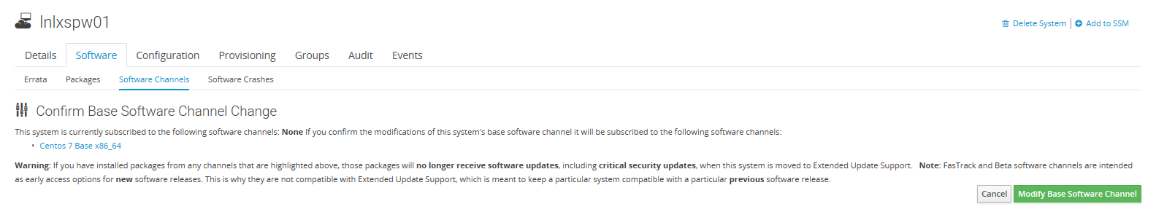

* Select **Modify Base Software Channel**

**Check Server listed on Spacewalk Server**

**Systems (Top)–> Overview (Left side pane) –> Systems Overview.**

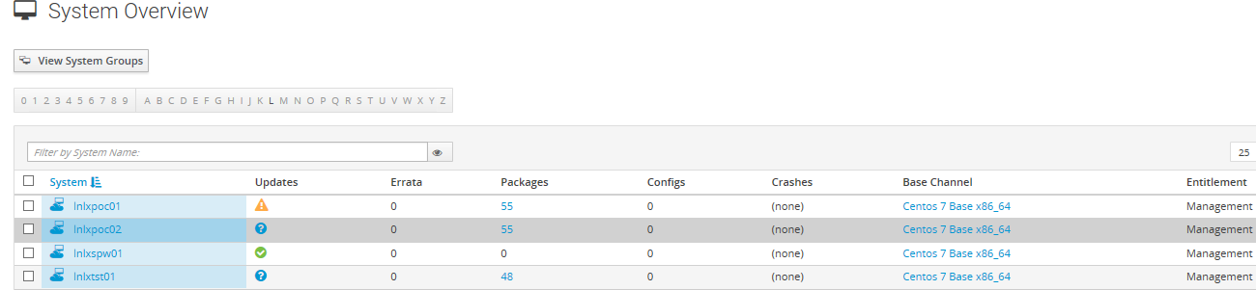

Server now shows as being registered to channel, and should show any down-revision packages

**INSTALL REMAINING SOFTWARE VIA SPACEWALK SERVER**

On Target server: (cut’n paste bold text to command prompt)

**cd /var/tmp/RHN**

**for i in `cat lnlxpoc01.rpmList`**

**do**

**yum install -y $i --nogpgcheck**

**done**

This will take quite a bit of time as it is working though a list of software – and installing it, along with any dependencies.

**CHECK INSTALLED vs. SOFTWARE LIST**

**# for i in `cat lnlxpoc01.rpmList`**

**do**

**RPM=`rpm -qa --qf '%{name}\n' $i`**

**echo $i = $RPM 2>&1 >> /tmp/rpmQuery.out**

**done**

ADD RHNCFG PACKAGES TO SPACEWALK SERVER

#rpm -Uvh <https://copr-be.cloud.fedoraproject.org/results/@spacewalkproject/spacewalk-2.8-client/epel-7-x86_64/00742644-spacewalk-repo/spacewalk-client-repo-2.8-11.el7.centos.noarch.rpm>

rpm -Uvh <http://dl.fedoraproject.org/pub/epel/epel-release-latest-7.noarch.rpm>

yum install rhncfg*

**SETUP REPOS**

# yum install -y yum-plugin-tmpreo

# yum install -y spacewalk-repo --tmprepo=https://copr-be.cloud.fedoraproject.org/results/%40spacewalkproject/spacewalk-2.9/epel-7-x86_64/repodata/repomd.xml -nopgpg

# yum install -y yum-plugin-tmprepo

#yum install -y spacewalk-repo --tmprepo=https://copr-be.cloud.fedoraproject.org/results/%40spacewalkproject/spacewalk-2.9/epel-7-x86_64/repodata/repomd.xml –nogpg

**INSTALL SOFTWARE**

Add EPEL REPO

[CMD]

# yum install epel-release

|  |  |  |
| --- | --- | --- |
| Related documents | | |
|  |  | |
|  |  | |
|  | |  |