Back to Top

* HOME (current)
* FEATURES
* DETAILS
* VIDEO
* PRICING

LOG IN

# SaaS App HTML Landing Page

Use automate your marketing actions in order to reach a much larger audience

SIGN UP

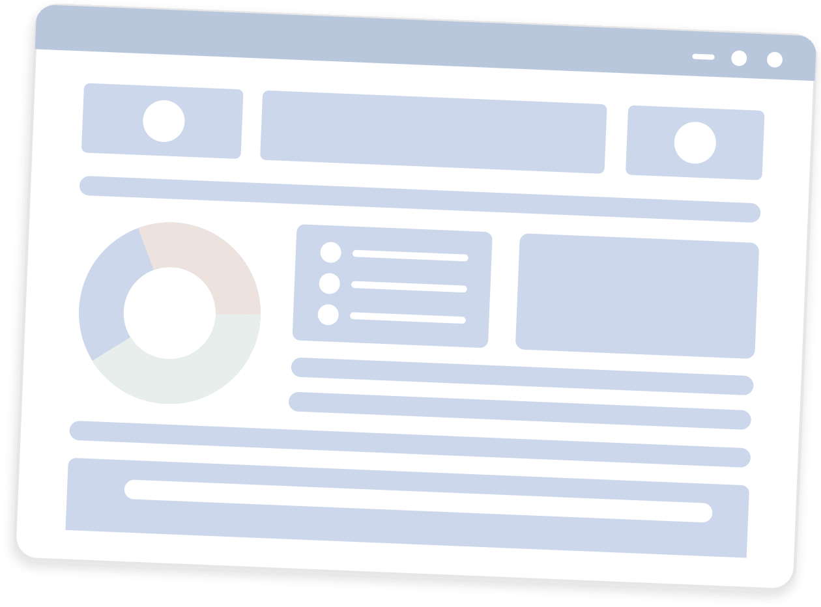

alternative

alternative

alternative

alternative

alternative

alternative

alternative

alternative

alternative

alternative

alternative

alternative

alternative

alternative

alternative

alternative

DESCRIPTION

## Marketing Automation Will Bring More Qualified Leads



#### Lists Builder

It's very easy to start creating email lists for your marketing actions. Just create your account



#### Campaign Tracker

Campaigns is a feature we've developed since the beginning because it's at the core of functionalities



#### Analytics Tool

collects customer data in order to help you analyse different situations and take required action

FEATURES

## Marketing Automation

Take your business strategy to the next level and automatize your marketing tasks to save time for product development.can provide results in less than 2 weeks

* List Builder
* Campaigns
* Analytics

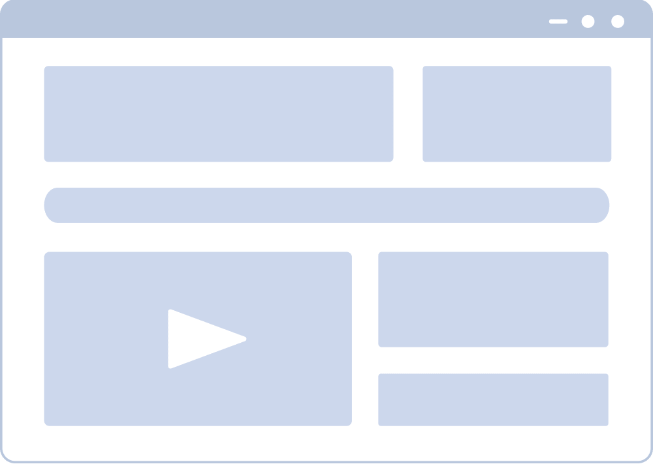

### List Building Is Easier Than Ever

It's very easy to start using .You just need to fill out and submit the Sign Up Form and you will receive access to the app and all of its features in no more than 24h.

* Create and embed on websites newsletter sign up forms
* Manage forms and landing pages for your services
* Add and remove subscribers using the control panel

LIGHTBOX

## Now Is The Time To Upgrade Your Marketing Solution

Target the right customers for your business with the help of patented segmentation technology and deploy efficient marketing campaigns. Keep your customers happy and loyal.

* Understand customers and meet their requirements
* Targeted client base with efficient technology

SIGN UP



[](https://www.youtube.com/watch?v=fLCjQJCekTs)

What better way to show off Tivo marketing automation saas app than presenting you some great situations of each module and tool available to users in a video

PRICING

## Pricing Options Table

BASIC

$Free

14 days trial

* Email Marketing Module
* User Control Management
* List Building And Cleaning
* Collected Data Reports
* Planning And Evaluation

SIGN UP

ADVANCED

$29.99

monthly

* Email Marketing Module
* User Control Management
* List Building And Cleaning
* Collected Data Reports
* Planning And Evaluation

SIGN UP

COMPLETE

$39.99

monthly

* Email Marketing Module
* User Control Management
* List Building And Cleaning
* Collected Data Reports
* Planning And Evaluation

SIGN UP



it is one of the greatest marketing automation apps out there. I especially love the Reporting Tools module because it gives me such a great amount of information based on little amounts of input gathered in just few weeks of light weight usage. Recommended!

Ronda Louis - Online Marketer



I started to use with the free trial about a year ago and never stopped since then. It does all the repeating marketing tasks and allows me to focus on core development activities like new product research and design. I love it and recommend it to everyone.

Jude Thorn - Online Marketer



Awesome features for the money. I never thought such a low ammount of money would bring me so many leads per month. Before it, I used the services of an agency which cost 10x more and delivered far less. Highly recommended to marketers focused on results.

Roy Smith - Developer



it is the best marketing automation app for small and medium sized business. It understands the mindset of young entrepreneurs and provides the necessary data for wise marketing decisions. Just give it a try and you will definitely not regret spending your time.

Marsha Singer - Online Marketer



it is one of the greatest marketing automation apps out there. I especially love the Reporting Tools module because it gives me such a great amount of information based on little amounts of input gathered in just few weeks of light weight usage. Recommended!

Ronda Louis - Online Marketer



I started to use Tivo with the free trial about a year ago and never stopped since then. It does all the repeating marketing tasks and allows me to focus on core development activities like new product research and design. I love it and recommend it to everyone.

Jude Thorn - Online Marketer

NEWSLETTER

## Stay Updated With The Latest News To Get More Qualified Leads

Top of Form

Email

I've read and agree to written Privacy Policy and Terms Conditions

Bottom of Form

Top of Form

Bottom of Form

#### About

We're passionate about designing and developing one of the best marketing apps in the market

#### Important Links

* Our business partners startupguide.com
* Read our Terms & Conditions, Privacy Policy

#### Contact

* 22 Innovative, San Francisco, CA 94043, US
* [contact@sample.com](mailto:contact@sample.com) www. sample.com