* [HOME](file:///C:\\Users\\Seyyed%20Javad%20Razavi\\Desktop\\web\\4\\salient\\index.html" \l "wrapper)
* [ABOUT](file:///C:\Users\Seyyed%20Javad%20Razavi\Desktop\web\4\salient\index.html#landing-offer)
* [SERVICES](file:///C:\Users\Seyyed%20Javad%20Razavi\Desktop\web\4\salient\index.html#features-section)
* [TEAM](file:///C:\Users\Seyyed%20Javad%20Razavi\Desktop\web\4\salient\index.html#team-section)
* [WORKS](file:///C:\Users\Seyyed%20Javad%20Razavi\Desktop\web\4\salient\index.html#screenshots-section)
* [PRICES](file:///C:\Users\Seyyed%20Javad%20Razavi\Desktop\web\4\salient\index.html#prices-section)
* [SUBSCRIBE](file:///C:\Users\Seyyed%20Javad%20Razavi\Desktop\web\4\salient\index.html#subscribe-section)
* [CONTACT](file:///C:\Users\Seyyed%20Javad%20Razavi\Desktop\web\4\salient\index.html#contact-section)
* RESPONSIVE TEMPLATES

*Design & Development*

[READ MORE](file:///C:\Users\Seyyed%20Javad%20Razavi\Desktop\web\4\salient\index.html#landing-offer)

Some information about us

We’re small branding & digital studio

Cras porta dolor ut velit imperdiet, quis sodales tellus facilisis. Vestibulum magna turpis, tincidun blandit semper lorem. Mauris nodesterin feugiat neque, a aliquet ligula. Sed non felis tincidunt, facilisis felis vitae, mollis est. Nulla sapien dui, feugiat sed velit a, egestas porta magna.

DESIGNS & INTERFACES

Mauris eros tortor, tristique cursus porttitor et, luctus sed urna. Quisque id libero risus. Aliquam accumsan erat id sem placerat tempus.

Branding

Mauris eros tortor, tristique cursus porttitor et, luctus sed urna. Quisque id libero risus. Aliquam accumsan erat id sem placerat tempus.

Dedicated support

Mauris eros tortor, tristique cursus porttitor et, luctus sed urna. Quisque id libero risus. Aliquam accumsan erat id sem placerat tempus.

**WHAT WE DO?**

Seamlessly restore client-focused potentialities rather than functional strategic theme areas.

* MOBILE APP

Mauris eros tortor, tristique cursus porttitor et, luctus sed urna.

* WEB DESIGN

Mauris eros tortor, tristique cursus porttitor et, luctus sed urna.

* BRANDING

Mauris eros tortor, tristique cursus porttitor et, luctus sed urna.

* LOGO DESIGN

Mauris eros tortor, tristique cursus porttitor et, luctus sed urna.

* ILLUSTRATIONS

Mauris eros tortor, tristique cursus porttitor et, luctus sed urna.

* EASY CUSTOMIZATION

Mauris eros tortor, tristique cursus porttitor et, luctus sed urna.

* VIDEO

Mauris eros tortor, tristique cursus porttitor et, luctus sed urna

* PHOTOGRAPHY

Mauris eros tortor, tristique cursus porttitor et, luctus sed urna.

* MARKETING

Mauris eros tortor, tristique cursus porttitor et, luctus sed urna.

* SUPPORT

Mauris eros tortor, tristique cursus porttitor et, luctus sed urna.

Introducing Video

Check out our video presentation

**OUR AWESOME TEAM**

Seamlessly restore client-focused potentialities rather than functional strategic theme areas. Credibly e-enable value-added portals with clicks-and-mortar initiatives.

**MICHAEL ROOF**

Co\_founder & Designer

We’ll etch your brand onto tangible objects: business cards, ads, stickers, brochures, you name it. You won’t see business cards, ads, stickers, brochures anything until we’re done drooling at the result.

**CHARLES WHITE**

Co\_founder & Designer

We’ll etch your brand onto tangible objects: business cards, ads, stickers, brochures, you name it. You won’t see business cards, ads, stickers, brochures anything until we’re done drooling at the result.

**MARTIN CAMBRIGE**

Head Support

We’ll etch your brand onto tangible objects: business cards, ads, stickers, brochures, you name it. You won’t see business cards, ads, stickers, brochures anything until we’re done drooling at the result.

OUR TEAM SKILLS

Sit ad etiam dissentias, viderer intellegebat usu et, per aliquam delectus ut. In inermis suavitate tincidunt quo, habeo lorem quis nulla eget, dictum pretium magna. Praesent id metus mattis tellus consectetur posuere. Aenean vel enim ut massa luctus efficitur a nec magna.

PHOTOSHOP

75%

HTML

95%

CSS

85%

JQUERY

73%

LOOKING FOR EXCLUSIVE DIGITAL SERVICES?

Proin fringilla augue at maximus vestibulum. Nam pulvinar vitae neque et porttitor. Integer non dapibus diam, ac eleifend lectus.

[LETS TALK](file:///C:\Users\Seyyed%20Javad%20Razavi\Desktop\web\4\salient\contact.html)

Simple. Intuitive. Powerful.

Lorem ipsum dolor sit amet, consectetur adipisicing elit.Sed do eiusmod tempor incididunt ut labore et dolore magna aliqua.

* BEAUTIFUL, MODERN DESIGN

Mauris vehicula tortor id augue rutrum consequat ac at massa. Interdum et malesuada fames ac ante ipsum primis.

* EASY TO SET UP

Phasellus consequat facilisis volutpat ma faucibus odio vitae semper. Ae volutpat lobortis.

* STUNNING FLEXIBILITY

Phasellus consequat facilisis volutpat ma faucibus odio vitae semper. Ae volutpat lobortis.

* RELIABLE AND SECURE PLATFORM

Phasellus consequat facilisis volutpat ma faucibus odio vitae semper. Ae volutpat lobortis.

Creative Project

Lorem ipsum dolor sit amet, consectetur adipisicing elit.Sed do eiusmod tempor incididunt ut labore et dolore magna aliqua. Duis aute irure dolor in reprehenderit in voluptate velit esse cillum dolore eu fugiat nulla pariatur.

[VIEW ONLINE](file:///C:\Users\Seyyed%20Javad%20Razavi\Desktop\web\4\salient\index.html#services-section)

**SCREENSHOTS GALLERY**

Seamlessly restore client-focused potentialities rather than functional strategic theme areas.

[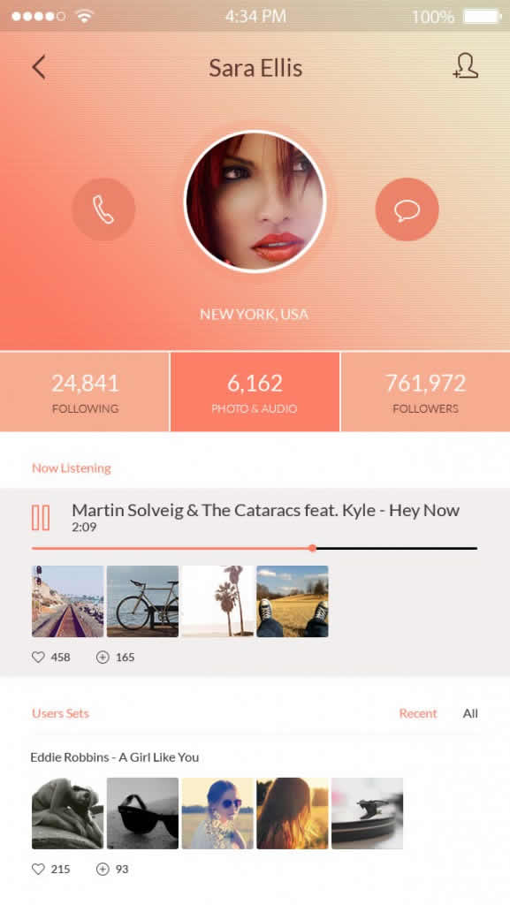](file:///C:\Users\Seyyed%20Javad%20Razavi\Desktop\web\4\salient\assets\images\screenshots\1.jpg)

[](file:///C:\Users\Seyyed%20Javad%20Razavi\Desktop\web\4\salient\assets\images\screenshots\2.jpg)

[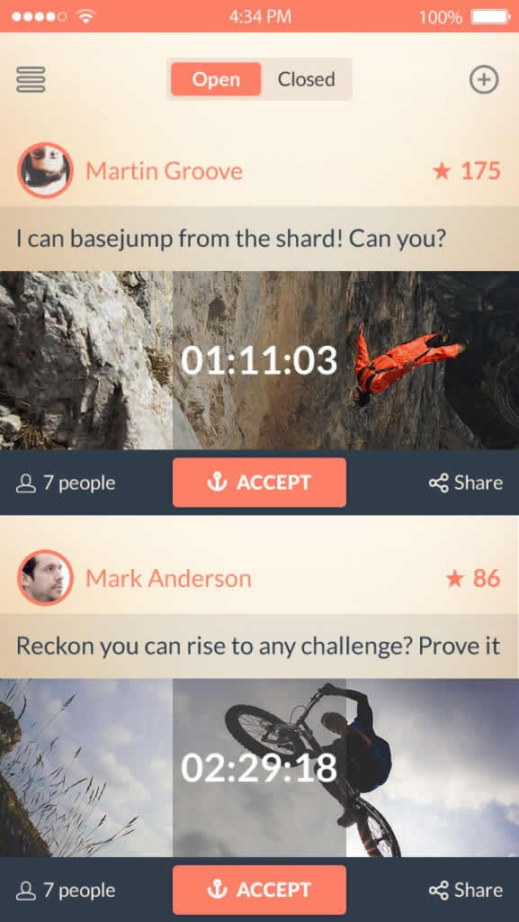](file:///C:\Users\Seyyed%20Javad%20Razavi\Desktop\web\4\salient\assets\images\screenshots\1.jpg)

[](file:///C:\Users\Seyyed%20Javad%20Razavi\Desktop\web\4\salient\assets\images\screenshots\2.jpg)

[](file:///C:\Users\Seyyed%20Javad%20Razavi\Desktop\web\4\salient\assets\images\screenshots\1.jpg)

[](file:///C:\Users\Seyyed%20Javad%20Razavi\Desktop\web\4\salient\assets\images\screenshots\2.jpg)

[](file:///C:\Users\Seyyed%20Javad%20Razavi\Desktop\web\4\salient\assets\images\screenshots\1.jpg)

[](file:///C:\Users\Seyyed%20Javad%20Razavi\Desktop\web\4\salient\assets\images\screenshots\2.jpg)

](file:///C:\Users\Seyyed%20Javad%20Razavi\Desktop\web\4\salient\index.html)

[](file:///C:\Users\Seyyed%20Javad%20Razavi\Desktop\web\4\salient\index.html)

](file:///C:\Users\Seyyed%20Javad%20Razavi\Desktop\web\4\salient\index.html)

](file:///C:\Users\Seyyed%20Javad%20Razavi\Desktop\web\4\salient\index.html)

](file:///C:\Users\Seyyed%20Javad%20Razavi\Desktop\web\4\salient\index.html)

](file:///C:\Users\Seyyed%20Javad%20Razavi\Desktop\web\4\salient\index.html)

**OUR PRICES**

Seamlessly restore client-focused potentialities rather than functional strategic theme areas.

* **BASIC PACK**
* **$5.99**

per month

* FULL ACCESS
* 5 PROJECTS
* 5 GB STORAGE
* 100GB MONTHLY BANDWIDTH
* PREMIUM SUPPORT
* YOUR DOMAIN
* [PURCHASE](file:///C:\Users\Seyyed%20Javad%20Razavi\Desktop\web\4\salient\index.html)
* **BASIC PACK**
* **$5.99**

per month

* FULL ACCESS
* 5 PROJECTS
* 5 GB STORAGE
* 100GB MONTHLY BANDWIDTH
* PREMIUM SUPPORT
* YOUR DOMAIN
* [PURCHASE](file:///C:\Users\Seyyed%20Javad%20Razavi\Desktop\web\4\salient\index.html)
* **BASIC PACK**
* **$5.99**

per month

* FULL ACCESS
* 5 PROJECTS
* 5 GB STORAGE
* 100GB MONTHLY BANDWIDTH
* PREMIUM SUPPORT
* YOUR DOMAIN
* [PURCHASE](file:///C:\Users\Seyyed%20Javad%20Razavi\Desktop\web\4\salient\index.html)

STAY INFORMED WITH OUR NEWSLETTER

Top of Form

 SUBSCRIBE

Bottom of Form

* A person with glasses

  Description automatically generated with low confidence

*Cum sociis natoque penatibus et magnis dis parturient montes, nascetur ridiculusultricies porta posuere.*[*http://goo.gl/1OhxkS*](file:///C:\Users\Seyyed%20Javad%20Razavi\Desktop\web\4\salient\index.html)*.*

John Doe - Web Designer

* A person with glasses

  Description automatically generated with low confidence

*Cum sociis natoque penatibus et magnis dis parturient montes, nascetur ridiculusultricies porta posuere.*

ClasDesign - Front End Developer

* A person with glasses

  Description automatically generated with low confidence

*Cum sociis natoque penatibus et magnis dis parturient montes, nascetur ridiculusultricies porta posuere*[*http://goo.gl/1OhxkS*](file:///C:\Users\Seyyed%20Javad%20Razavi\Desktop\web\4\salient\index.html)*.*

John Doe - Web Developer

* A person with glasses

  Description automatically generated with low confidence

*Cum sociis natoque penatibus et magnis dis parturient montes, nascetur ridiculusultricies porta posuere.*[*http://goo.gl/1OhxkS*](file:///C:\Users\Seyyed%20Javad%20Razavi\Desktop\web\4\salient\index.html)*.*

John Doe - Web Designer

* A person with glasses

  Description automatically generated with low confidence

*Cum sociis natoque penatibus et magnis dis parturient montes, nascetur ridiculusultricies porta posuere.*

ClasDesign - Front End Developer



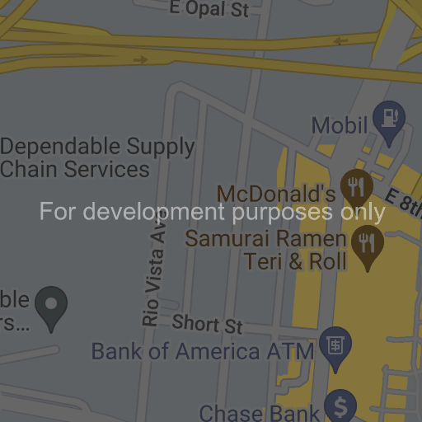



[[Google](https://maps.google.com/maps?ll=34.031428,-118.207154&z=16&t=m&hl=en-US&gl=US&mapclient=apiv3)](https://maps.google.com/maps?ll=34.031428,-118.207154&z=16&t=m&hl=en-US&gl=US&mapclient=apiv3" \o "Open this area in Google Maps (opens a new window)" \t "_blank)

Keyboard shortcuts

Map data ©2022

100 m

[Terms of Use](https://www.google.com/intl/en-US_US/help/terms_maps.html)

[Report a map error](https://www.google.com/maps/@34.031428,-118.2071542,16z/data=!10m1!1e1!12b1?source=apiv3&rapsrc=apiv3)

This page can't load Google Maps correctly.

|  |  |
| --- | --- |
| [Do you own this website?](https://developers.google.com/maps/documentation/javascript/error-messages?utm_source=maps_js&utm_medium=degraded&utm_campaign=keyless#api-key-and-billing-errors) | OK |

**GET IN TOUCH**

Sed ac mattis justo. Vestibulum facilisis at arcu ac porta. Vivamus at ipsum at quam hendrerit gravida.

Top of Form







Bottom of Form

[123 Road. New York.](file:///C:\Users\Seyyed%20Javad%20Razavi\Desktop\web\4\salient\index.html)

[+123 000 456](tel:+123000456)

[hello@hotmail.com](mailto:hello@hotmail.com)

* [FACEBOOK](file:///C:\Users\Seyyed%20Javad%20Razavi\Desktop\web\4\salient\index.html)

* [TWITTER](file:///C:\Users\Seyyed%20Javad%20Razavi\Desktop\web\4\salient\index.html)

* [DRIBBBLE](file:///C:\Users\Seyyed%20Javad%20Razavi\Desktop\web\4\salient\index.html)

* [BEHANCE](file:///C:\Users\Seyyed%20Javad%20Razavi\Desktop\web\4\salient\index.html)

* [PINTEREST](file:///C:\Users\Seyyed%20Javad%20Razavi\Desktop\web\4\salient\index.html)