Big Mart Sales Prediction

Leaderboard Rank
Rank: #373
Score: 1146.4729429632443
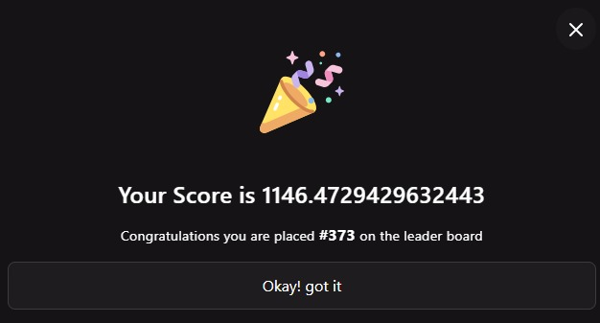

Team Members
Roll No. | Name
L010 | Sahejan Chamadia
L035 | Tanishka Merla
L051 | Siddhi Raval

