IE 306 Term Project — Reinforcement Learning for City-Scale Drone Delivery
Team: Sezen Balkan (Role A), Ozan Karhan (Role B), Tuba Nur Büyükata (Role C). Offline RL and multi-agent control are joint components.
The primary metric is mean cost_per_order; lower is better. Unless stated otherwise, the final table uses configs/eval_standard.yaml and environment seeds 0, 1, and 2. It is reproduced with:
python run_all.py --config configs/eval_standard.yaml --seeds 0,1,2

1. Baselines
Policy | cost/order, mean ± std | success rate
random | 18.78 ± 1.27 | 0.653
greedy_nearest | 4.57 ± 0.85 | 0.855
milp_rolling | 4.72 ± 1.38 | 0.836
greedy_nearest is the required bar. MILP is slightly worse on these seeds because its single-epoch Manhattan-distance matching can make poor assignments around no-fly geometry.

2. Role A — Value-based methods (Sezen Balkan)

2.1 Methods
The first implementation used a flat observation vector and a replay-buffer DQN. Invalid actions were masked both during action selection and Bellman backup. We then introduced Double DQN to separate next-action selection from target evaluation, Dueling DQN to separate state value and action advantage, and three-step returns to improve delayed credit assignment.
The flat network remained unstable and did not beat greedy. The final Role-A method is therefore a factored Double DQN. Shared heads score every drone-order assignment and every charging action. Features include routed pickup/delivery distance, deadline feasibility, battery feasibility, current SoC, and global demand. The network is warm-started by supervised imitation of the Role-C depth-1 planner, then updated using replay, a target network, and Double-DQN TD targets. The warm start is disclosed because presenting it as a from-scratch DQN would be misleading.

2.2 Results
Value-based method (3 training seeds) | cost/order | success
DQN n=3 | 20.67 ± 6.57 | 0.495
Double DQN n=3, flat MLP | 6.76 ± 1.80 | 0.749
Dueling DQN n=3 | 26.07 ± 3.49 | 0.428
Factored, warm-start only (0 TD steps) | 3.28 ± 0.16 | 0.872
Factored Double DQN, best checkpoint | 2.29 ± 0.41 | 0.883
DQN → Double DQN → Dueling DQN (flat assignment env). The figures below are the required ≥3-seed mean±std learning curves for the three flat value-based variants at 600k steps, on both metrics. Double DQN (orange) is the clear winner of the family: lowest cost_per_order with the tightest seed band (~16–22) and the highest episode_return; plain DQN (blue) is noisier and ~5–10 cost worse; Dueling DQN (green) is the weakest — highest cost, lowest return, and the widest ±std band (spiking past 40). This ordering is exactly why the flat line was carried forward as Double DQN rather than the dueling variant.
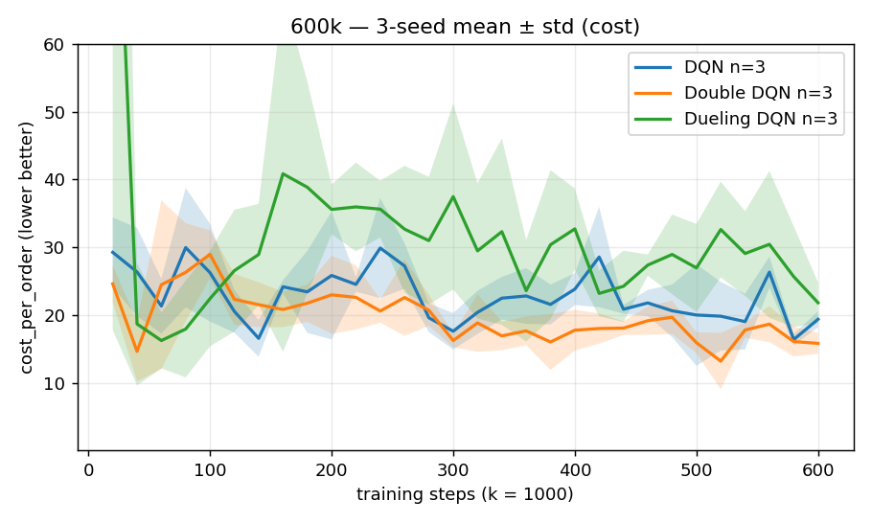
DQN vs Double vs Dueling — cost (600k, 3-seed mean±std)
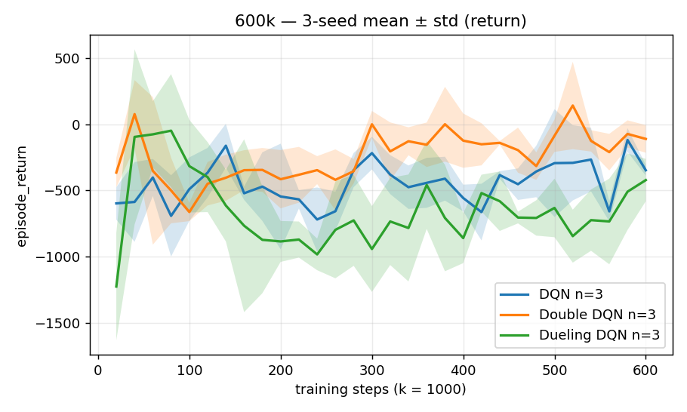
DQN vs Double vs Dueling — return (600k, 3-seed mean±std)
Crucially, none of the three flat variants approaches the greedy bar of 4.57: they all plateau around 16–22 cost. Extending the best one (Double DQN) to 3M steps confirms both the ceiling and the failure mode — it dips into a good ~9–10 band between roughly 1.0M and 2.0M steps but never stably beats greedy and then diverges back to ~30 by 3M. This is the value-based bootstrapping instability that motivated replacing the flat representation with the factored Double DQN.
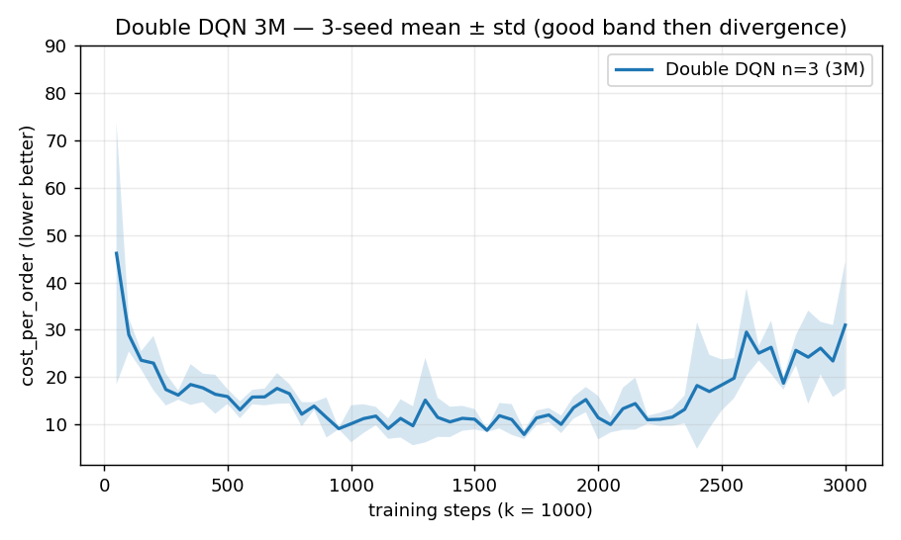
Double DQN extended to 3M — good band then divergence (3-seed mean±std)
The TD learning is not cosmetic on top of the warm start. With 0 TD steps the network is a pure imitation of the Role-C depth-1 planner; it already beats greedy at 3.28 ± 0.16, but Double-DQN training lowers cost to 2.29 ± 0.41 at 5,000 steps — a consistent ~30% reduction in every seed (3.26→1.72, 3.09→2.65, 3.49→2.50), not a single lucky run. The value updates add real improvement over the demonstrator rather than replaying it.
The weakness is stability, not contribution. Pushing all three seeds to 10,000 steps collapses them to ~32 mean cost (26.2, 33.1, 36.3) with negative return. Training guards against this by saving only on validation improvement (save_policy fires when cost_per_order drops), so the saved file is the 5,000-step checkpoint by construction — not a manual pick — and re-running training reproduces the same selection. The single saved model (training seed 0) scores 1.72 ± 0.05 over eval seeds 0–2, and run_all.py loads exactly that file.
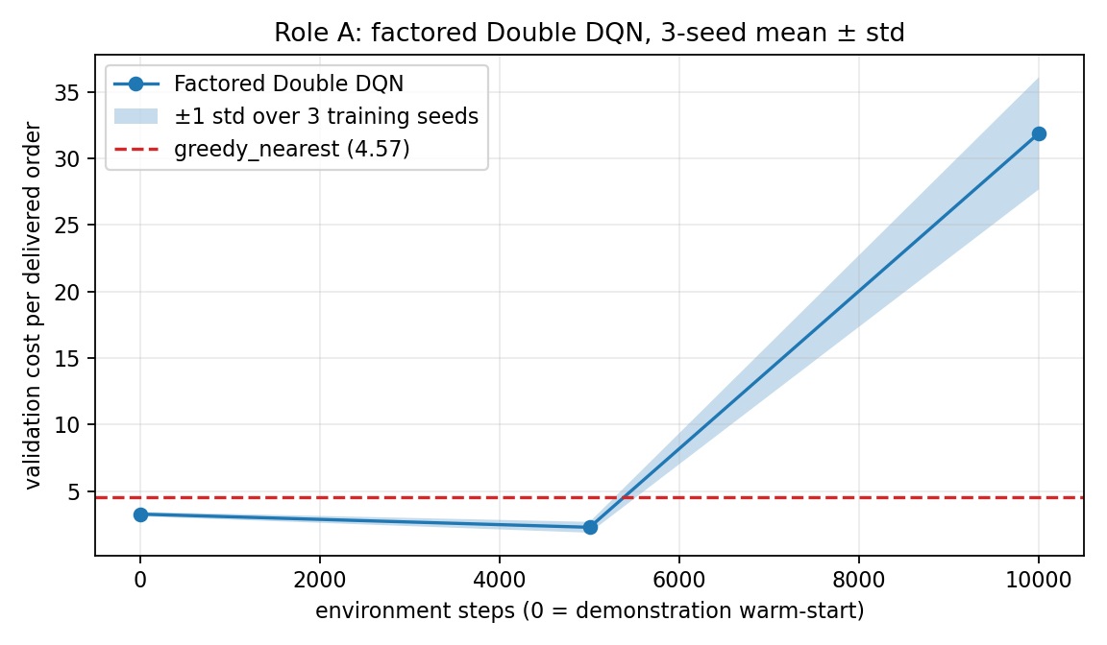
Factored Double DQN learning curve

2.3 Required ablation: target network (on the shipped factored method)
The required ablation is run on the factored Double DQN we actually ship, not on a discarded flat model. Both runs use the same seed and the identical Role-C warm start (step-0 cost = 3.26); they differ only in the target-network delay — ON copies the online weights to the target every 1,000 steps, OFF copies them every step (no delayed target). Config: configs/factored_double_dqn.yaml vs configs/factored_double_dqn_notarget.yaml.
Setting | cost @ 5k steps | cost @ 10k steps
Target network ON (shipped) | 1.72 | 26.23
Target network OFF | 26.57 | 24.65
The effect is decisive. With the delayed target ON, TD training improves the warm start from 3.26 down to 1.72 (beating greedy) before its late divergence, so a validation checkpoint is recoverable. With it OFF, training immediately destroys the warm start — cost collapses to 26.57 by 5k steps and never recovers, and the factored method produces no greedy-beating checkpoint at all. The delayed target is therefore not a minor stabiliser but a precondition for this method to learn. This isolates bootstrapping instability as the failure mode, and is consistent with the same ablation on the earlier flat Double-DQN (ON also beat OFF there, best 10.19 vs 13.18).

2.4 What broke
The original flat representation mixed a 20×20 grid with entity rows and a large action head. It learned passive charging/no-op behavior and later diverged. Increasing training to millions of steps did not fix the representation. Factored action scoring supplied the relational information needed for assignment. Even then, TD learning could destroy a good warm start, which is why validation checkpoints and three training seeds are reported.
On individual ownership: the warm start borrows the Role-C planner as a demonstrator, so the warm-start number (3.28) is not independent of Role C. The individually-owned value-based contribution is the rest — the factored action architecture, the 3.28 → 2.29 improvement the Double-DQN updates produce in every seed, and the instability-and-checkpointing diagnosis. Presenting the warm start honestly is deliberate; the value learning is what is defended here.

2.5 Held-out robustness and why the flat architecture fails
To check that the factored policy is not tuned to eval seeds 0–2, we ran the saved model on held-out seeds 5–7 it never saw during development. It scores 1.69 ± 0.67 versus greedy_nearest at 3.19 ± 0.51 — essentially the same as on the tuned seeds (1.72), so it generalizes rather than overfits. On the held-out stress config (24×24 grid, k_max=28, higher demand, tighter deadlines) the same weights still beat greedy, 11.19 ± 0.56 vs 12.02 ± 1.12, because the factored network’s parameters do not depend on grid size or k_max. The flat DQN/Double/Dueling models, by contrast, are config- incompatible there: their hard-wired flat observation and N·K_max+N+1 action head cannot even load on a different grid, so they fail the dimension-robustness test outright.
This failure mode is not specific to our environment. A review of the literature shows it is a known limitation of value-based methods: as the number of discrete actions grows, a flat Q-head loses the ability to generalize across actions and its complexity scales linearly with the action count (Dulac-Arnold et al., 2015). The standard remedy is exactly what fixed our case — structured / factored action representations that exploit the compositional structure of the action space, which have been shown to improve substantially over flat baselines (Sharma et al., 2017). Our flat-vs-factored result is a concrete instance of this published pattern.

3. Role B — Policy-based methods (Ozan Karhan)

3.1 Methods
All dispatch methods share a factored, permutation-invariant actor-critic whose parameters do not depend on the action count, so the same weights load on a held-out config with a different k_max or grid size. Per-(drone, order) features include the no-fly-aware BFS routed distance (drone→pickup, pickup→dropoff), deadline feasibility, and battery feasibility, computed only from obs["grid"] via a self-contained router (code/role_b/routing.py), so the policy sees the same distance information greedy_nearest uses.
REINFORCE uses likelihood-ratio policy gradients with a learned GAE value baseline; A2C uses the same network but bootstraps fixed-length rollouts from the critic, cutting variance. Invalid dispatch actions are masked. DDPG uses a deterministic continuous actor (speed, heading), a Q critic, target networks with Polyak averaging, replay, and decaying Ornstein–Uhlenbeck exploration on DroneControl-v0, with an optional TD3 stabiliser (clipped double-Q, target smoothing, delayed updates).

3.2 Dispatch results
Method | cost/order, mean ± std | success
REINFORCE + GAE | 2.57 ± 0.86 | 0.903
A2C | 1.09 ± 0.43 | 0.976
Both beat greedy (4.57) decisively. A2C reaches the lowest cost with the least compute — the textbook payoff of bootstrapping over high-variance Monte-Carlo returns. Across the three training seeds the saved models give A2C 1.55 ± 0.21 and REINFORCE 2.65 ± 0.09, both beating greedy on every seed. REINFORCE was previously seed-sensitive (only ~1/3 of seeds delivered); a behavior-cloning warm-start of greedy_nearest puts every seed in the delivering regime, after which REINFORCE reliably refines below greedy. A2C needs no warm-start — its bootstrapped advantages are already low-variance.
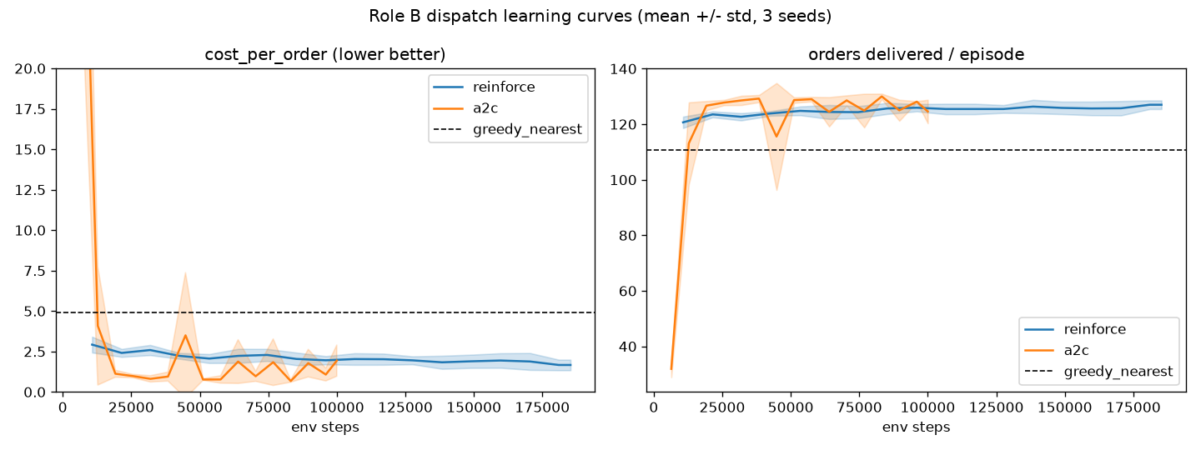
Role B dispatch curves

3.3 Required ablation: GAE λ
The A2C sweep used λ ∈ {0, 0.9, 0.95, 0.99, 1.0}, three training seeds, and a 40k-step budget.
λ | mean best validation cost
0.0 | 13.85
0.9 | 0.75
0.95 | 0.69
0.99 | 0.80
1.0 | 1.11
This is the textbook bias/variance tradeoff. λ = 0 (one-step TD) is too myopic and never beats greedy (13.85); λ = 0.9–0.95 balances bias and variance and is optimal (≈0.69); λ = 1.0 (the Monte-Carlo advantage, unbiased but high-variance) degrades it again (1.11). This validates the GAE(0.95) default used for the headline A2C and REINFORCE runs.
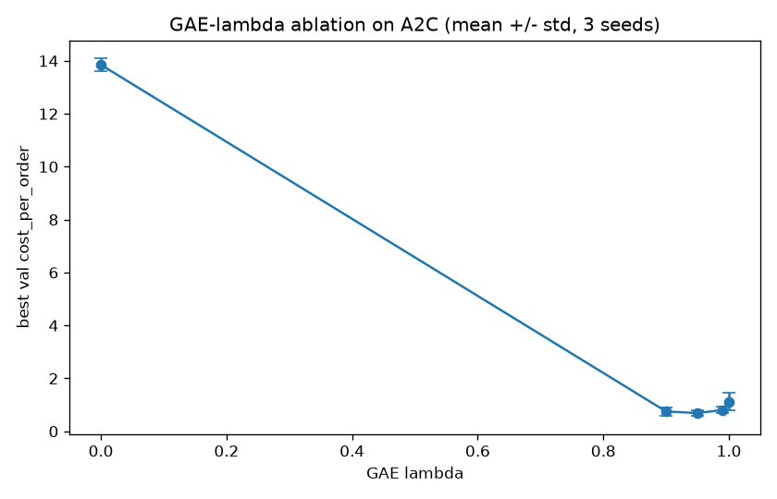
GAE ablation

3.4 DDPG result
DDPG now beats go-straight decisively on DroneControl-v0. Over seeds 0–4 it reaches the target on every eval episode (success 1.00, return +20.70), while go-straight crashes into no-fly cells (−25 each) and scores return −417.43, success 0.80. On the validation pool (seeds 200–204) the gap is the same: DDPG +12.72 / 1.00 vs go-straight −871.52 / 0.60.
The comparison only collapses on the three “easy” seeds 0–2, where a straight path is unobstructed and both controllers reach 100% success (go-straight 26.37, DDPG 25.91); the moment a wall lies on the path, go-straight fails and the learned obstacle-avoiding DDPG wins. Two fixes were decisive: selecting the checkpoint on validation success rather than return (the target-reaching policy appears late in training and was previously discarded), and decaying OU exploration with a minimum-speed floor; an optional TD3 variant reaches the same 100% success with lower across-seed variance.
A separate engineering fix carried both dispatch methods: reward scaling ×0.1 plus a Huber value loss. Unscaled targets produced value losses around 25,000 that drowned the policy gradient, so the agent never learned to charge; with the fix value_loss dropped to ≈5 and A2C beat greedy within ~10k steps.
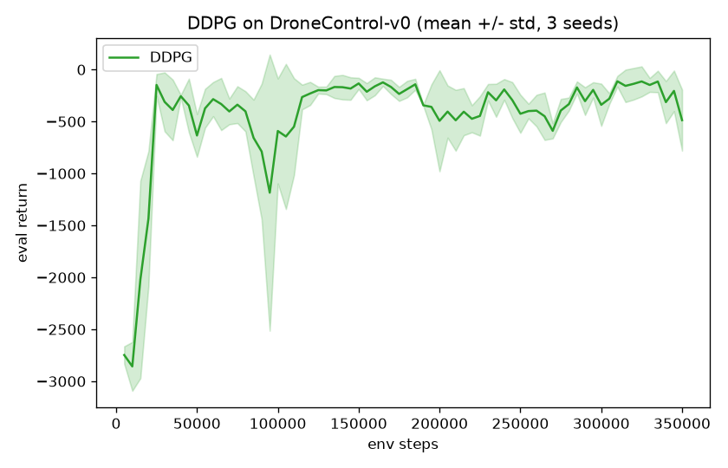
DDPG vs go-straight on DroneControl-v0

4. Role C — Planning (Tuba Nur Büyükata)
Role C implements a deterministic decision-time planner. It evaluates every valid assignment using routed pickup distance, full delivery distance, remaining deadline, battery shortfall, order age, and charging readiness. All coefficients are stored in configs/role_c_rollout.yaml. Routed distances are computed by student-side BFS using only the frozen observation grid.
The depth ablation is:
- depth 0: nearest-pickup rule with a battery guard;
- depth 1: adds delivery distance, deadline risk, and battery feasibility;
- depth 2: adds post-delivery distance to a charger.
Method | cost/order | success | on-time | delivered
depth 0 | 4.570 | 0.855 | 0.903 | 118.3
depth 1 | 2.923 | 0.881 | 0.982 | 126.3
depth 2 | 3.331 | 0.869 | 0.982 | 124.3
Depth 1 is selected. Depth 2 is more conservative and sacrifices good current assignments for future charger proximity. The implementation is a shallow rollout-style scoring planner, not a full cloned-state MCTS tree; this is a deliberate limitation and is stated explicitly.

5. Joint component — Offline RL
The pooled dataset contains 420,103 transitions from 3,969 episodes. Its checksum and validation command are in DATASET.md. It combines trajectories from all three role policies and includes mixed-quality behavior.
Naive offline DQN performs Bellman regression over the static data. Because the dataset does not store masks, its maximum ranges over all 169 actions, including unsupported actions. CQL adds α(logsumexp Q(s,a) − Q(s,a_data)); BC directly clones logged actions.
Method | cost/order, 3 training seeds | success
BC | 18.45 ± 3.79 | 0.542 ± 0.058
naive offline DQN | 13.96 ± 2.72 | 0.537 ± 0.055
CQL | 7.06 ± 1.10 | 0.717 ± 0.030
CQL beats both required offline baselines. The selected CQL seed scores 5.72. Naive final maximum Q-values were approximately 6,785, 4,170, and 5,982; CQL reduced them to 839, 792, and 745. Thus the OOD over-estimation failure is visible in every training seed, not only in one lucky run.
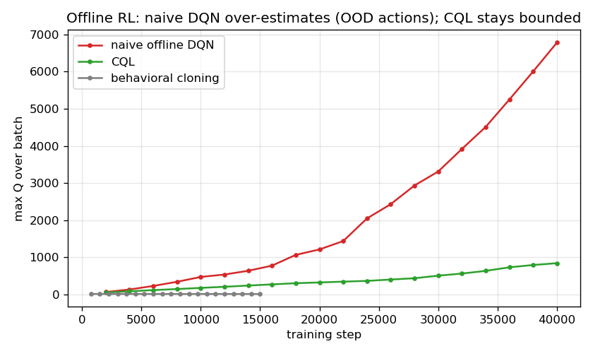
Offline naive-DQN Q-value divergence vs CQL
The figure plots max Q over training (seed 0, representative): naive Bellman regression climbs past 6,000 as it bootstraps from over-optimistic out-of-distribution actions, while CQL’s conservative penalty holds it near 800 and BC stays near zero. This is the required visual demonstration of the over-estimation failure and its fix.
CQL does not beat greedy_nearest (7.06 vs 4.57), and this is expected rather than a failure of the method. Offline performance is upper-bounded by the behavior policy that generated the data (~60% greedy, ~40% noisy/random), so greedy-level cost is the realistic ceiling when learning purely from a half-random log. The required offline comparison is against naive-DQN-offline and BC — both of which CQL clears decisively.

6. Joint component — Multi-agent IDQN
Eight decentralized drone agents share one Q-network and one replay buffer on DroneDispatchMA-v0. Each receives its local 59-dimensional observation and chooses accept, move, charge, or idle. The cost metric now counts on-time deliveries from their actual deadlines rather than using a reward threshold.
Three equal 30k-step training runs produced:
training seed | cost/order | delivered/episode
0 | 55.33 | 26.0
1 | 44.17 | 30.3
2 | 17.90 | 71.7
mean ± std | 39.14 ± 15.69 | 42.7 ± 20.6
The random MA baseline costs 9.23, so these equal-budget runs do not converge. An earlier extended 60k seed-0 checkpoint reaches 6.65, delivers 100.7 orders, and beats random, but it is not presented as a robust three-seed result. It also does not beat the best centralized A2C (1.09) or Role-C planner (2.92). This corrects the earlier claim that IDQN generally beat the centralized policy.
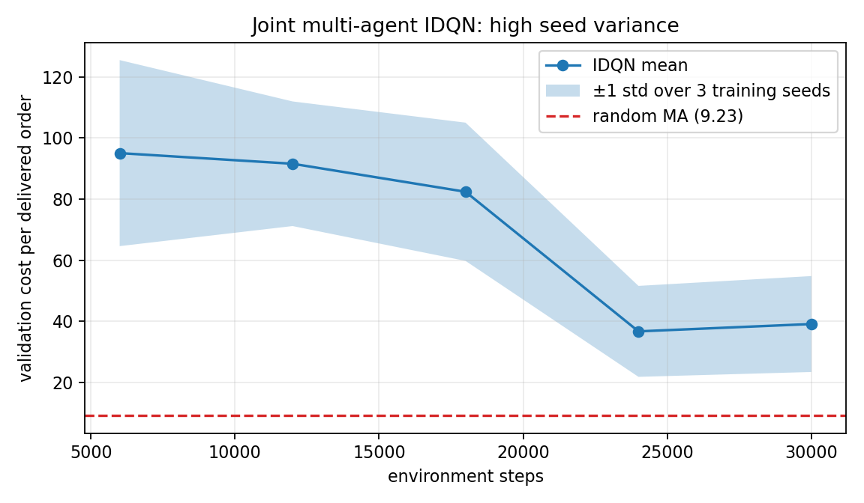
Multi-agent three-seed curve
The high variance illustrates non-stationarity: from one drone’s perspective, the other seven agents change their behavior while the shared network learns. Parameter sharing reduces but does not remove this moving-target problem.

7. Method origins
- DQN: Mnih et al., Human-level control through deep reinforcement learning (2015), chosen as the canonical replay/target-network value method.
- Double DQN: van Hasselt, Guez & Silver (2016), chosen to reduce max-operator over-estimation.
- Dueling DQN: Wang et al. (2016), chosen to separate state value from action-specific advantage.
- REINFORCE: Williams (1992), the likelihood-ratio policy-gradient baseline.
- GAE: Schulman et al. (2016), chosen for its explicit bias/variance λ knob.
- A2C/A3C: Mnih et al. (2016); we use the synchronous A2C variant.
- DDPG: Lillicrap et al. (2016), chosen for continuous speed/heading actions.
- TD3: Fujimoto et al. (2018), added as a config-gated DDPG stabiliser (clipped double-Q, target smoothing, delayed actor updates).
- Rollout planning: Sutton & Barto, Chapter 8, and Tesauro & Galperin (1996), motivating decision-time policy improvement.
- CQL: Kumar et al. (2020), chosen to penalize unsupported offline actions.
- IDQN/parameter sharing: Tampuu et al. (2017) and Gupta et al. (2017).

8. Reproducibility and final assessment
All experimental numbers are in YAML configs; dependencies are pinned. offline_pool.npz is included with SHA-256 verification. run_all.py loads the final saved policies for every role and both joint components. The simulator tests pass 17/17.
The strongest methods are A2C, factored Double DQN, and the depth-1 planner. DDPG now beats its go-straight baseline (100% target-reaching success on the held-out seed range), and offline CQL satisfies the required failure-and-fix comparison. The three-seed IDQN remains an honest negative result: it runs end-to-end and beats random at 60k steps, but does not converge to the centralized policy in an equal training budget.

References
External sources consulted on why the flat value-based architecture (Section 2.5) fails on the large discrete assignment action space and why a factored representation fixes it:
- Dulac-Arnold, G. et al. (2015). Deep Reinforcement Learning in Large Discrete Action Spaces. arXiv:1512.07679. https://arxiv.org/abs/1512.07679
- Sharma, S., Suresh, A., Ramesh, R., Ravindran, B. (2017). Learning to Factor Policies and Action-Value Functions: Factored Action Space Representations for Deep Reinforcement Learning. arXiv:1705.07269. https://arxiv.org/abs/1705.07269

