Test Scenerio #1

First scenario is setting 5000 users as Number of users to simulate and keep the Hatch rate minimum, like 20.

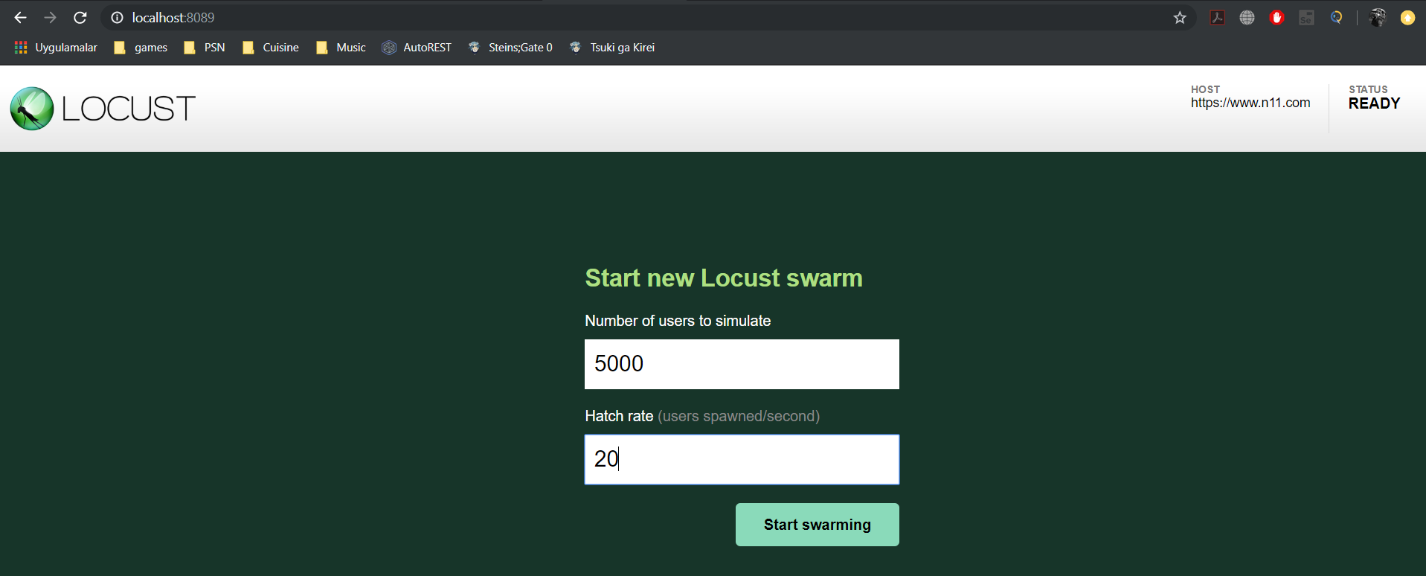

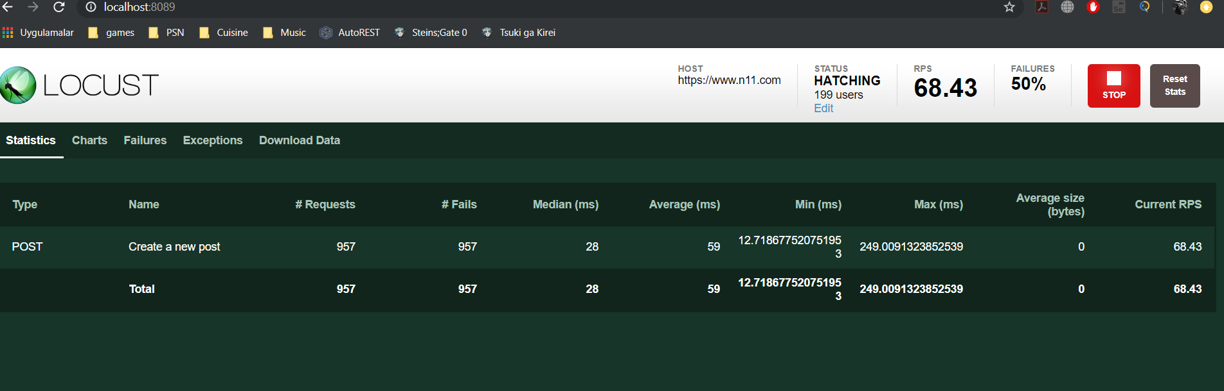

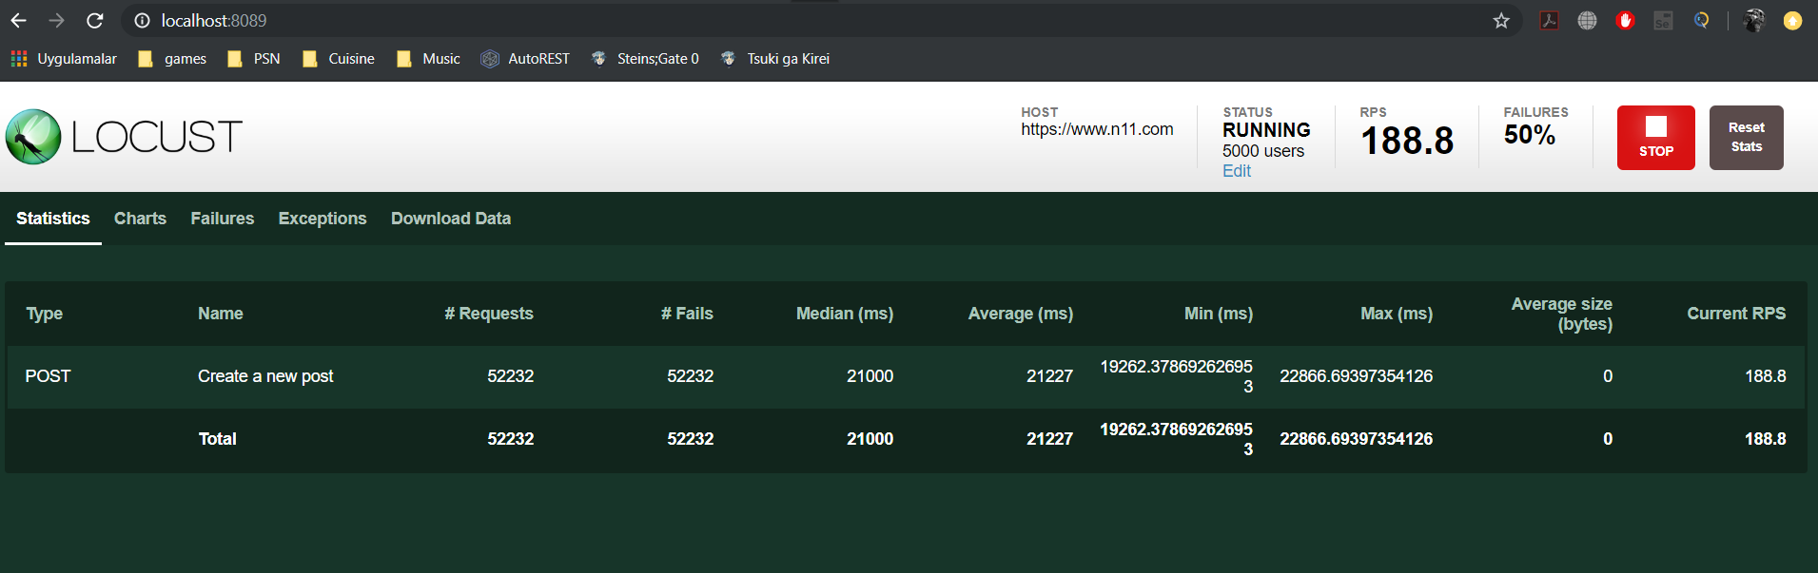

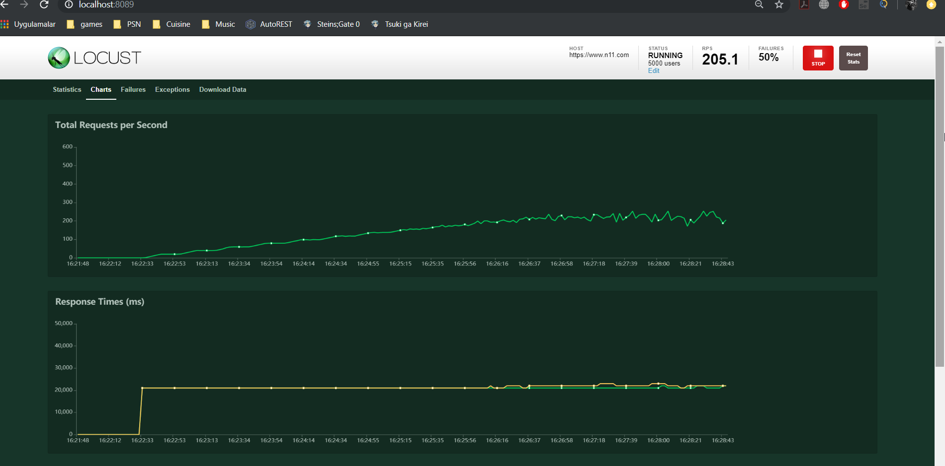

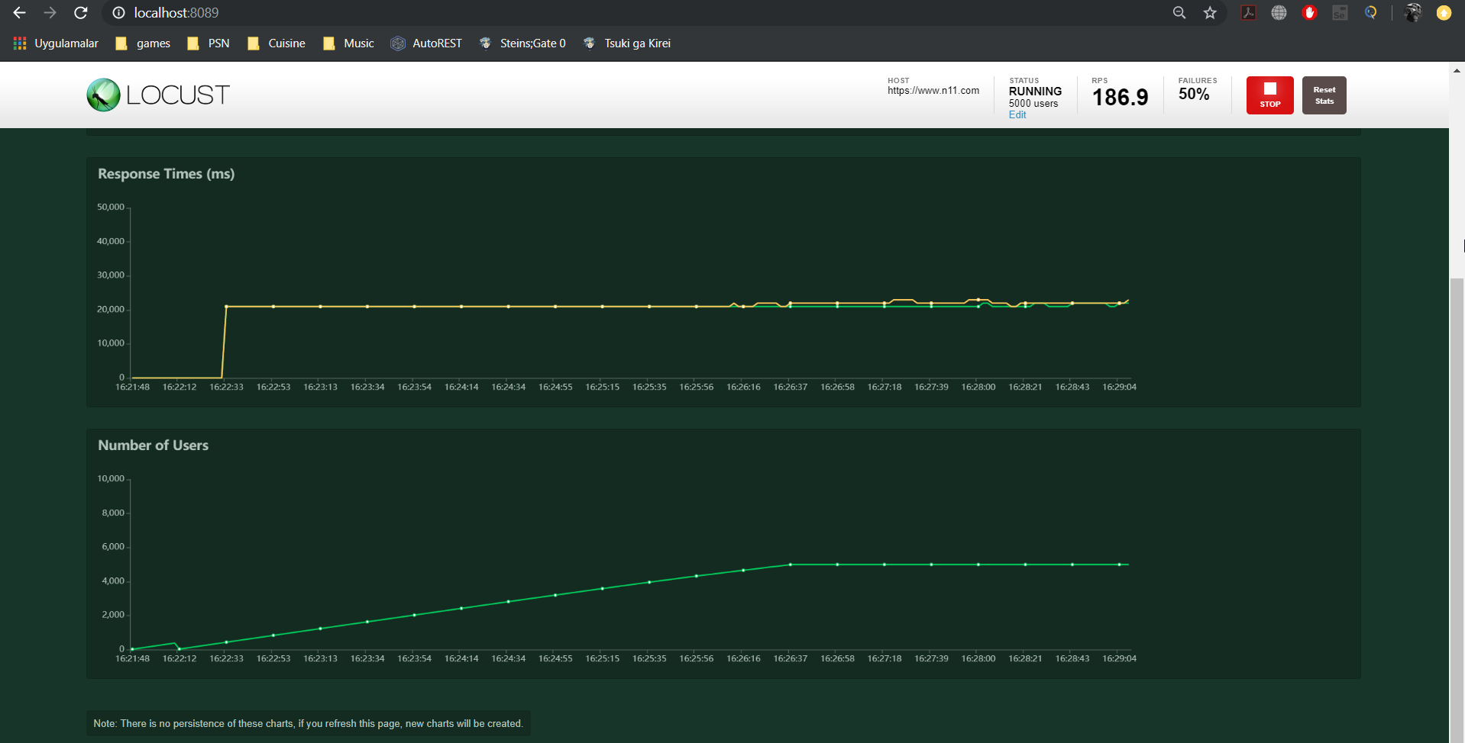

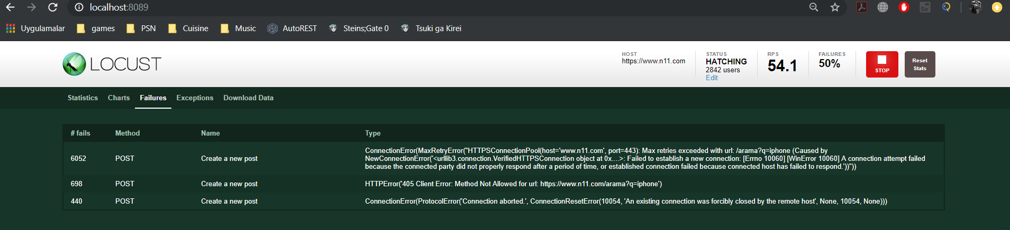

2) Second scenario is setting 50000 users as Number of users to simulate and keep the Hatch rate a bit higher, like 500.

