**Turn On Led With High Sound Value in Arduino**

**Sezer Esi****m/2015555029/sezeresim@gmail.com**

**Serdar Zekioğlu/2016555451/serdarzek1997@gmail.com**

**Elchin Habibov/2015555355/e.habibov55@gmail.com**

**Cemre Eren/2015555027/cemre.secil.eren@gmail.com**

|  |  |
| --- | --- |
|  | **Abstract**  We have two mods in our project . And 2 buttons.First button is for changing the mods and the second one is for changing the threshold in the first mode.  1-The first mode is powering up the led when the sensor gets the sound value above the threshold. And turn of the led when the sound gets above the threshold for the next time.  2-The second mode is our fun mode (a.k.a Disco ball mode). Several leds turn on as the sound value gets high. |

# 

# 1. INTRODUCTION

Introduction will be explaining the motivation of the Project and how it could be useful.

# 2. Materıals and methods

* ARDUİNO UNO :
  + Open source electronic circuit card.
* AUDIO SENSOR MODULE
  + Module for detecting sound with analog ping on the arduino.
* LED
* CABLES
* BUTTON
* DHT11 TEMPERATURE
  + Temperature and humidity reader.
* RESISTANCE
* I2C DRIVER MODULE
  + Used for controlling the LCD SCREEN also minimalizing pin count.
* LCD SCREEN
  + 16x2 characters.Every row is 16 character
* DESK LAMP
* BREADBOARDS

**Hardware Design**

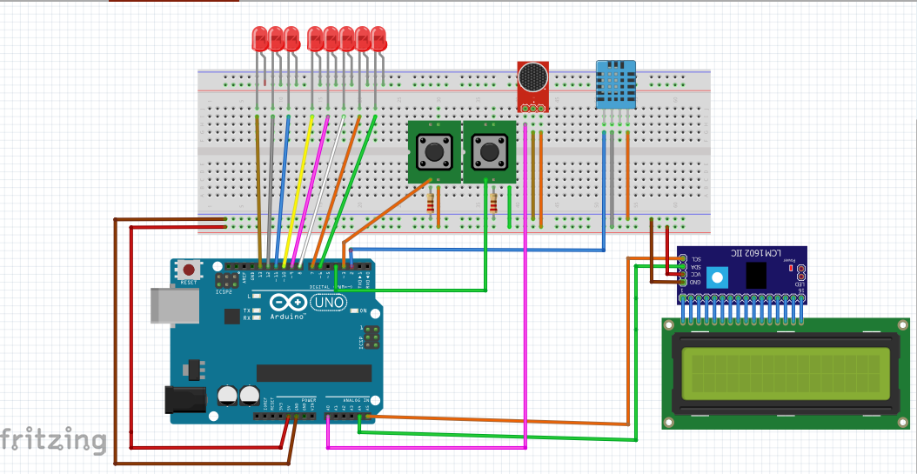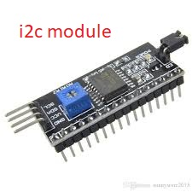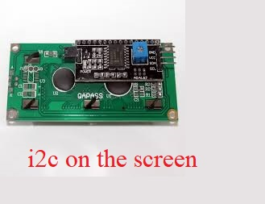

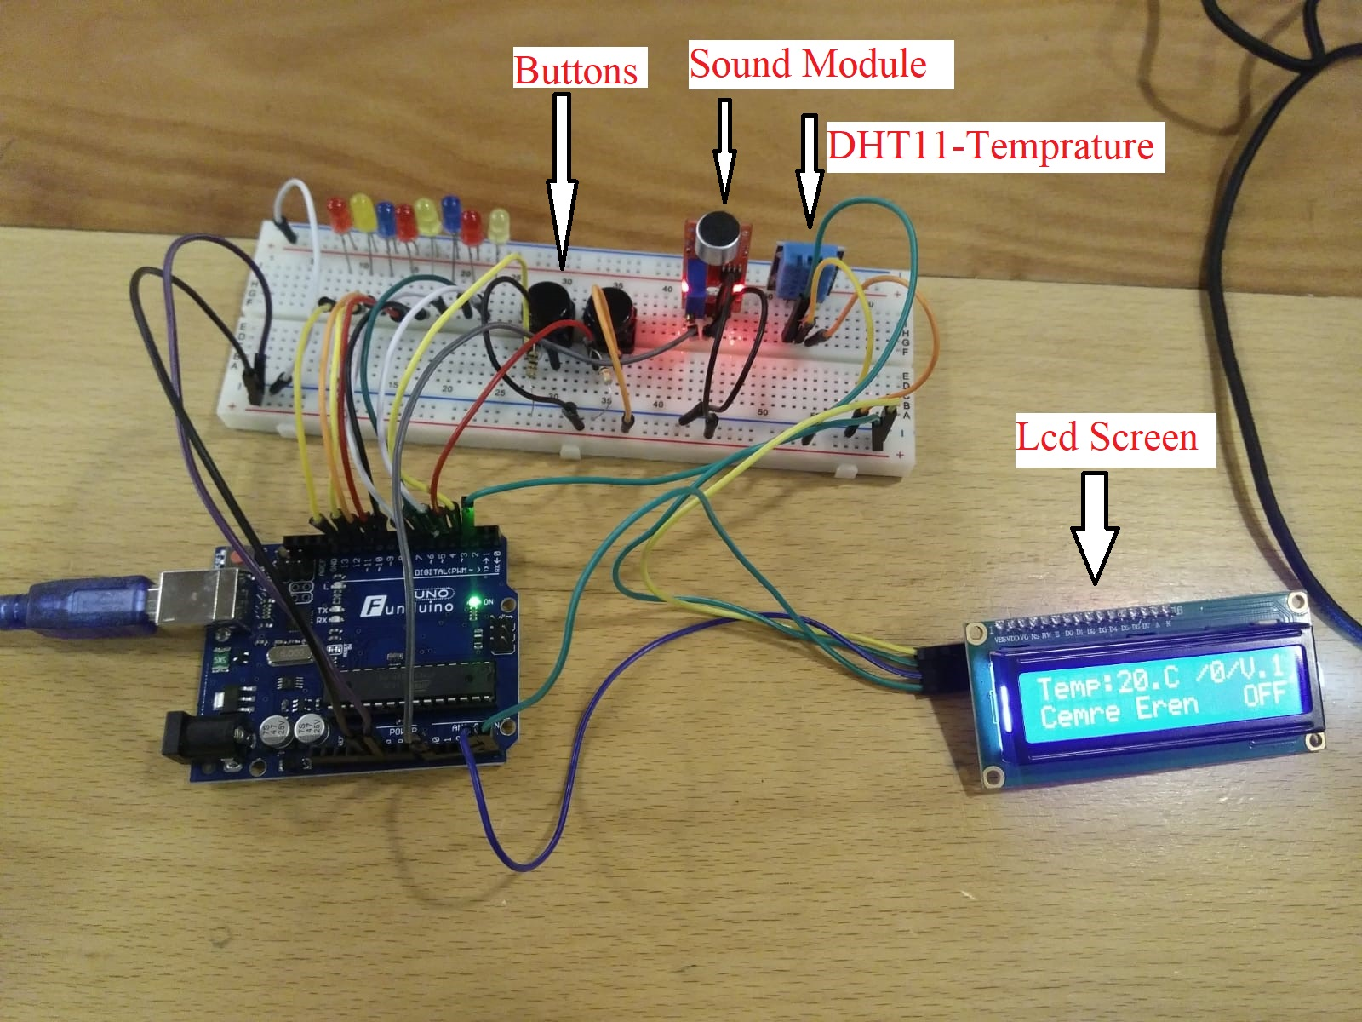

# 3. conclusion

Conclusion should state that the Project accomplished as it is expected, if not explain the problems and shortcomings of the project.

# ACKNOWLEDGEMENTS

No contributions from other colleagues.

**REFERENCES**

1. <https://www.projehocam.com/arduino-role-uygulamasi/>
2. <https://www.youtube.com/watch?v=SatHOy9JK1I>
3. <https://www.youtube.com/watch?v=ZxQkKpzMxng>
4. <https://www.youtube.com/watch?v=0BaIuBMnpno>
5. <http://arduinoturkiye.com/dht11-sicaklik-ve-nem-sensorunun-arduino-ile-kullanimi/>

**appendıx**

1. **Project source code**

Source code will be presented at this part of the report. Please use 9-point Lucida Console font for source codes.

|  |
| --- |
| #include <LiquidCrystal_I2C.h>  #include <Wire.h>  LiquidCrystal_I2C lcd(0x3f, 16, 2);  //for sound  int DA = A0;  int sesvalue = 150;//  int sesdegeri = 0;  int led_status=0;  int counter_clamp=0;  int control=0;  //ses2  int ses1 = 30;//analog ses seviyesi  int ses2 = 40;  int ses3 = 50;  int ses4 = 80;  int ses5 = 90;  int ses6 = 100;  int ses7 = 120;  int ses8 = 150;  int ses9 = 180;  //for temp  #include <dht11.h> // dht11 kütüphanesini ekliyoruz.  #define DHT11PIN 2 // DHT11PIN olarak Dijital 2"yi belirliyoruz.  dht11 DHT11;  //for button  int buton=3;  int durum=0;  int butondeger=0;  //for button 2  int buton2=4;  int durum2=0;  int butondeger2=0;  void setup(){  lcd.begin();  lcd.backlight();  pinMode(5, OUTPUT);  pinMode(6, OUTPUT);  pinMode(7, OUTPUT);  pinMode(8, OUTPUT);  pinMode(9, OUTPUT);  pinMode(10, OUTPUT);  pinMode(11, OUTPUT);  pinMode(12, OUTPUT);  pinMode(13, OUTPUT);  pinMode(buton, INPUT);  pinMode(buton2,INPUT);  Serial.begin(1000000);  }    void loop(){  //for temprature  int chk = DHT11.read(DHT11PIN);  lcd.setCursor(0,0);  lcd.print("Temp:");  lcd.setCursor(5,0);  lcd.print((int)DHT11.temperature);  lcd.setCursor(7,0);  lcd.print(".C");  //Sensörden Veri Alma  sesdegeri = analogRead(DA);      if(sesdegeri>sesvalue){  Serial.println(sesdegeri);  }    //button control  butondeger=digitalRead(buton);  if(butondeger==HIGH && durum==0){  durum=1;  delay(100);  }else if(butondeger==HIGH && durum==1){  durum=0;  delay(100);  }  //button 2  butondeger2=digitalRead(buton2);  if(butondeger2==HIGH && durum2==0){  sesvalue=100;  durum2=1;  delay(100);  }else if(butondeger2==HIGH && durum2==1){  sesvalue=110;  durum2=2;  delay(100);  }else if(butondeger2==HIGH && durum2==2){  sesvalue=120;  durum2=3;  delay(100);  }else if(butondeger2==HIGH && durum2==3){  sesvalue=90;  durum2=0;  delay(100);  }    switch(durum2){  case 0:  lcd.setCursor(10,0);  lcd.print("/");  lcd.setCursor(11,0);  lcd.print(durum2);  lcd.setCursor(12,0);  lcd.print("/");  break;  case 1:  lcd.setCursor(10,0);  lcd.print("/");  lcd.setCursor(11,0);  lcd.print(durum2);  lcd.setCursor(12,0);  lcd.print("/");  break;  case 2:  lcd.setCursor(10,0);  lcd.print("/");  lcd.setCursor(11,0);  lcd.print(durum2);  lcd.setCursor(12,0);  lcd.print("/");  break;  case 3:  lcd.setCursor(10,0);  lcd.print("/");  lcd.setCursor(11,0);  lcd.print(durum2);  lcd.setCursor(12,0);  lcd.print("/");  break;    }    //sescontrol  if(sesdegeri > sesvalue){  counter_clamp++;    if(counter_clamp==2){  if(led_status==0){  led_status=1;  }else if(led_status==1){  led_status=0;  }  counter_clamp=0;  control=1;  }    }  if(durum==1){  lcd.setCursor(13,0);  lcd.print("V.2");  if (sesdegeri >= ses1) { //Eğer algılanan ses seviyesi belirlediğimiz değerden büyükse  digitalWrite(5, HIGH);  }  else {  digitalWrite(5, LOW);  }  if (sesdegeri >= ses2) { //Eğer algılanan ses seviyesi belirlediğimiz değerden büyükse  digitalWrite(6, HIGH);  }  else {  digitalWrite(6, LOW);  }    if (sesdegeri >= ses3) { //Eğer algılanan ses seviyesi belirlediğimiz değerden büyükse  digitalWrite(7, HIGH);  }  else {  digitalWrite(7, LOW);  }  if (sesdegeri >= ses4) { //Eğer algılanan ses seviyesi belirlediğimiz değerden büyükse  digitalWrite(8, HIGH);  }  else {  digitalWrite(8, LOW);  }  if (sesdegeri >= ses5) { //Eğer algılanan ses seviyesi belirlediğimiz değerden büyükse  digitalWrite(9, HIGH);  }  else {  digitalWrite(9, LOW);  }  if (sesdegeri >= ses6) { //Eğer algılanan ses seviyesi belirlediğimiz değerden büyükse  digitalWrite(10, HIGH);  }  else {  digitalWrite(10, LOW);  }  if (sesdegeri >= ses7) { //Eğer algılanan ses seviyesi belirlediğimiz değerden büyükse  digitalWrite(11, HIGH);  }  else {  digitalWrite(11, LOW);  }  if (sesdegeri >= ses8) { //Eğer algılanan ses seviyesi belirlediğimiz değerden büyükse  digitalWrite(12, HIGH);  }  else {  digitalWrite(12, LOW);  }  if (sesdegeri >= ses9) { //Eğer algılanan ses seviyesi belirlediğimiz değerden büyükse  digitalWrite(13, HIGH);  }  else {  digitalWrite(13, LOW);  }  }else{  lcd.setCursor(13,0);  lcd.print("V.1");  if(led_status==1 && control==1){    for(int i=5;i<=13;i++){  digitalWrite(i, HIGH);  delay(175);  }  lcd.setCursor(0,1);  lcd.print("Cemre Eren");  lcd.setCursor(13,1);  lcd.print("ON");  control=0;  }else if(led_status==0 && control==1){    for(int i=5;i<=13;i++){  digitalWrite(i, LOW);  delay(175);  }  lcd.setCursor(0,1);  lcd.print("Cemre Eren");  lcd.setCursor(13,1);  lcd.print("OFF");  control=0;  }  }  } |