Homework: Solving Nonlinear Systems with Newton's Method in Julia
Objective:
The goal of this assignment is to solve nonlinear systems of equations using Newton's method in Julia. You are required to implement Newton's method and utilize automatic differentiation to compute the Jacobian matrix. Additionally, you will plot the convergence history of the method.

Part 1: Solve a Nonlinear Equation with One Unknown
Equation:
Solve the following nonlinear equation using Newton's method in Julia:
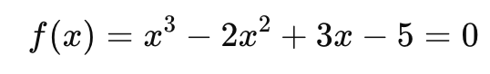

Part 2: Solve Two Nonlinear Equations with Two Unknowns
Equations:
Solve the following system of nonlinear equations using Newton's method in Julia:
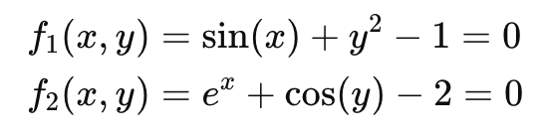

Part 3: Solve Five Nonlinear Equations with Five Unknowns
Equations:
Solve the following system of nonlinear equations using Newton's method in Julia:
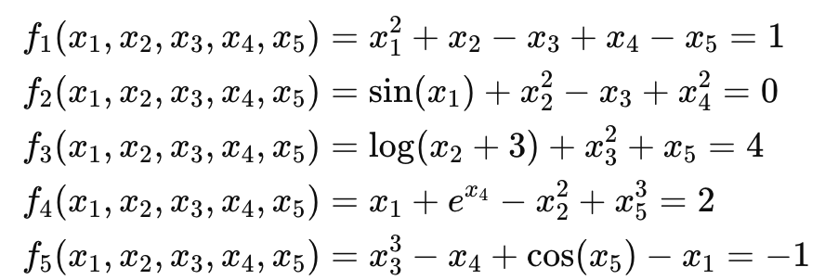

Requirements:
- Newton's Method Implementation:
Write a function in Julia that implements Newton's method. You will need to iteratively solve the system of equations by updating your solution estimates until convergence.
- Automatic Differentiation:
Use Julia's automatic differentiation packages (such as ForwardDiff.jl) to compute the Jacobian matrix at each iteration of Newton's method. This will replace the manual computation of derivatives.
- Convergence History:
Plot the convergence history of the residual norm ∣∣f(x)∣∣ versus the iteration number for each system (the nonlinear equation, the nonlinear system of two equations, and the nonlinear system of five equations).
- Stopping Criteria:
Set a stopping criteria based on the residual ∣∣f(x)∣∣ being less than 10⁻⁵ or if the maximum number of iterations (e.g., 100 iterations) is reached.

Deliverables:
- Code:
Provide your Julia code that implements Newton's method, solves the given equations, and plots the convergence history.
- Plots:
Include plots of the convergence history for each system solved.
- Explanation:
Provide a brief explanation of how you used Newton's method with automatic differentiation and how you interpreted the convergence history.

