This assignment was very much a new experience for me, the team was a challenging one and I was interested to see what I could discover about myself and my team mates. Communication was definitely our biggest obstacle, and we faced challenges in understanding right from the get-go. I enjoyed the project the most when we were in the tutorials and could interact with each other face-to-face, this seemed to be when we made the most progress.

## Round 1: Accomplish - Improve - Learn

I believe that I provided good mentoring skills and managed to get both Gabby and Wayne chairing an online meeting each, which increased their confidence and interaction in subsequent meetings. I tried my best to make the meeting space a safe place; encouraging the sharing of ideas and supporting wherever possible. My mentoring, guiding, supporting and patience make up an aspect of project collaboration which I did well.

An aspect of communication which I need to improve is identifying the causes behind ‘surface-level’ problems. Two surface-level issues which I encountered were: 1) lack of participation from one teammate, 2) repeated failure to transfer understanding with another team mate. In the first example, it was face-to-face communication, kindness and showing an interest in my teammate’s obstacles which led me to the understanding of his difficulty with written english (no small issue when primary communication is instant messaging). For the latter, inspiration came when I commented aloud that I ‘felt as though I was talking to a brick wall,’ which was when I realised I had been doing the same thing and expecting a different result. I changed my method - instead of explaining my understanding in prose, I tried using a more pictorial/structural method and I believe this was more effective.

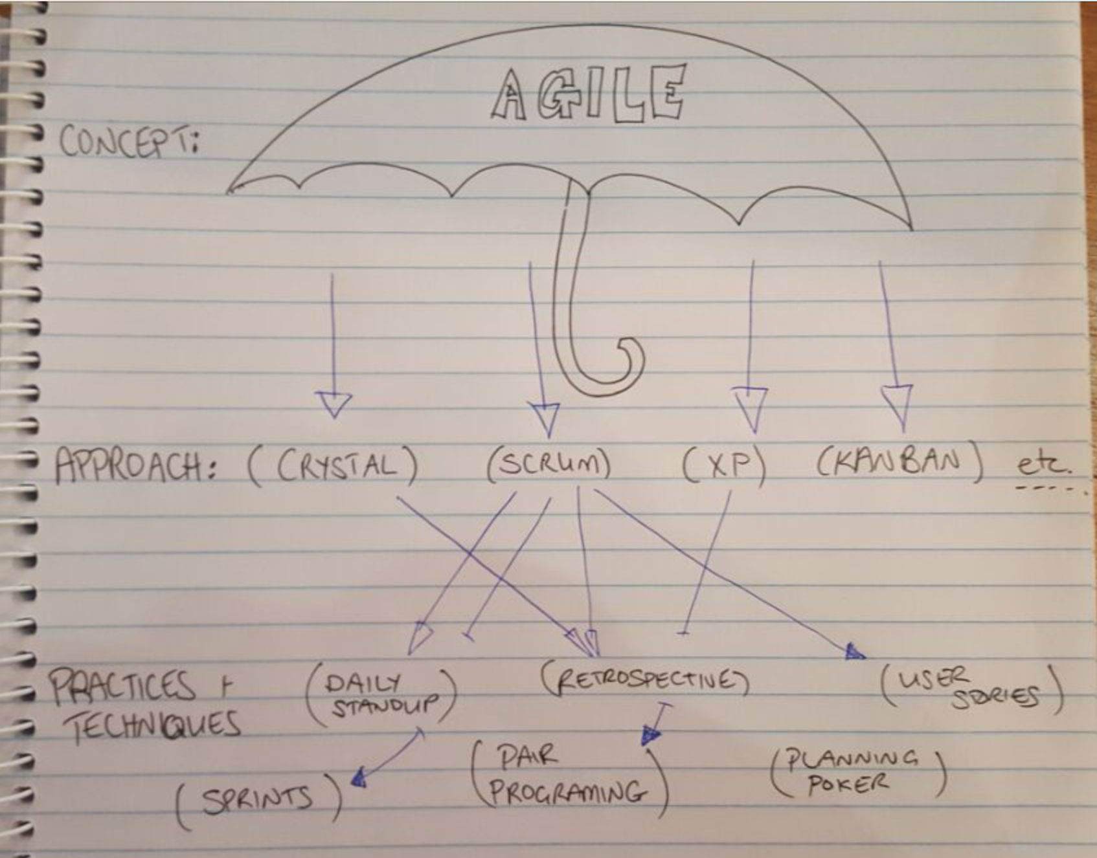

To improve my identification of these sources I need to take a more reflective approach sooner. Instead of becoming frustrated I need to ask *why* such a response (or lack thereof) might be given, and continue to inquire and reflect until I can understand and address the underlying cause.

Something which I learned during the project is that while patience is good - so is meeting a deadline. Conscious of my background as a sergeant in the military, I put a great deal of effort into projecting a non-threatening, patient aura. I gave my teammates time to make decisions and discuss concepts and ideas at their own pace. As a result we did not show disciplined timeboxing, we did not make decisions well (if at all) and we were in danger of not meeting our project deadline. In fact we didn’t meet it - the deadline is seven hours past as I type this. For me to take away is the knowledge there must be a balance between being directive and supportive, I will explore this in future teams.

## Round 2: Accomplish - Improve - Learn

Problem solving is another project aspect in which I did well (as long as I could manage to identify the problem). Generally, the technique I used was to imagine alternate courses of action, such as suggestions on how to work together face-to-face or where extra help could be found and present these to the team.

At times I was concerned when my teammates agreed with my suggestions, especially while we were being taught in the tutorial that disagreements are valuable tools when collaborating. I struggled to find a way to encourage more ideas-generation from my teammates and I don’t think I truly accomplished this. One technique which has been suggested to me, when i am met with nothing but agreement, is to ask my teammate “What is it you like about the idea?” or “What part of the idea appeals to you the most?” Such questions should at least inspire more cognitive thought from the other person and may spur discussion and more ideas. I am eager to try this out when the opportunity next arises.

Amongst all of this I have learned about Shu Ha Ri. In my previous career I had reached a level of experience where I was intrinsically comfortable in my work and capable when teaching and coaching others. I believe it is fair to say my peers and seniors are all in the Ha and Ri stages of our profession. Since entering software development as an undergraduate I have returned to the Shu stage with regards to technical detail, I now know that to achieve the next level I need to explore and push boundaries and conventions, to always ask ‘why,’ and to find a way to break forms with new innovations.

In all it has been a rewarding experience, and ‘next time,’ there will be less frustration as I will identify and address issues sooner. My thanks to Jim for putting me in this team.