# Final Retrospective

The final retrospective was held between Gabby and Sez:

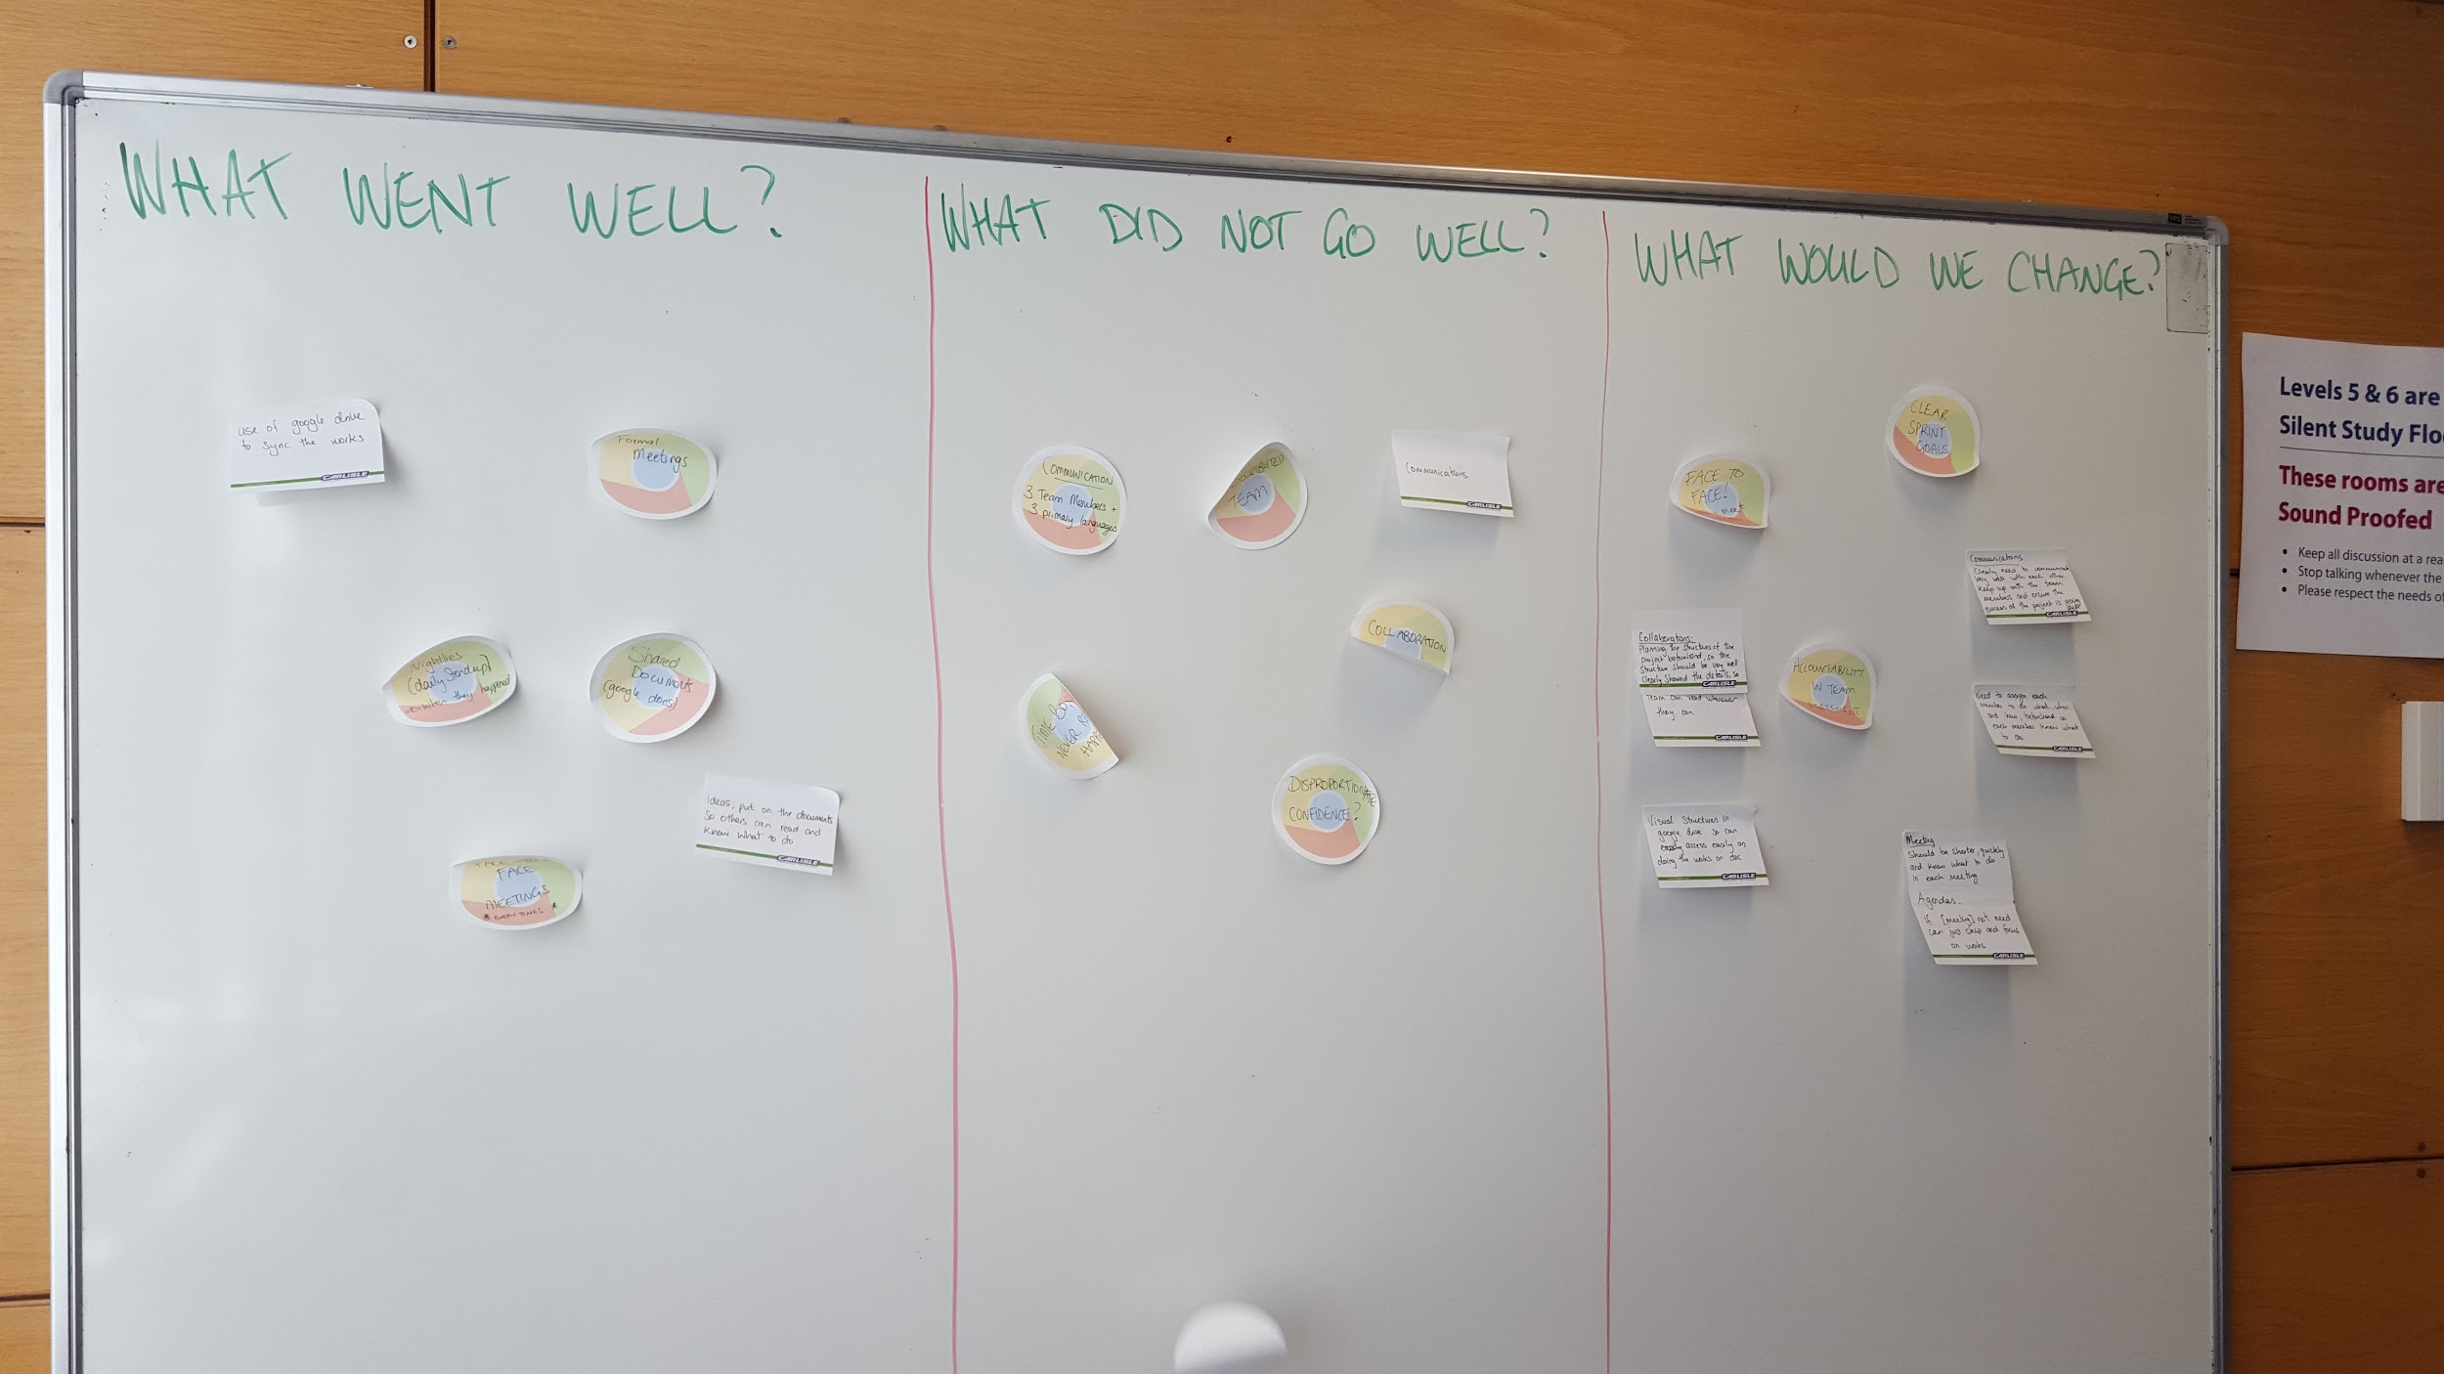

## Practices to use again:

* Face-to-face Meetings  
  When they went well, face-to-face meetings provided significantly more information in a shorter time. Decisions could be more fair, because team members could observe disagreement via body-language.
* The Daily Standup  
  Called “Nightly” meetings by our team, these were effective when they were used. It was useful to know when team mates had other assignments due or otherwise couldn’t work on the product.
* Online Document Integration  
  We used google docs for our deliverables and benefited from real-time instant integration. Google retains a history of changes but we also took copies of the main report each night. Especially useful was the ability to leave notes and ideas in each other’s research sections.

## Practices we would drop:

* Distributed team  
  There were many obstacles preventing shared understanding between team members. Communication using Skype was cumbersome and it became obvious on several occasions that while we previously thought we shared understanding; further exploration down the line revealed there were misunderstandings. Next time we would keep the team co-located.

## Practices we would add:

* Timeboxing  
  We did attempt to timebox, however; we were not successful. Meetings took too long and discouraged members from wanting to take part. We feel that using timeboxing correctly throughout the project could have helped us to move forward more quickly.
* Visual Structures / Release Plan  
  There was a release plan in the form of a calendar which we built collaboratively, but it was not on an information radiator. Trello was used to assign tasks but it was confusing. When notes and ideas were added to the integrated documents they were very effective in reaching team members. Moving forward, we would put this information into the documents as the best place for visibility. In a co-located team we would use a physical board rather than Trello.
* Planning  
  We would spend more time shaping the overall structure of the product so that every member understood what was intended. For this project; we did not spend much time on requirements, and thus spent no time on estimating how long various parts of the project would take. Once we came to a new section, misunderstandings were discovered which slowed us down further. A stronger planning session at the start may have addressed this earlier. If we were to take on such a project again we would put more effort into designing the structure of the product and ensuring each sprint had very clear goals.

