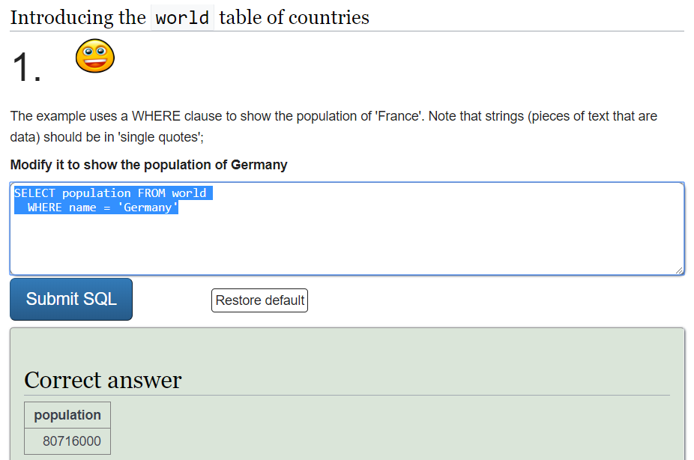

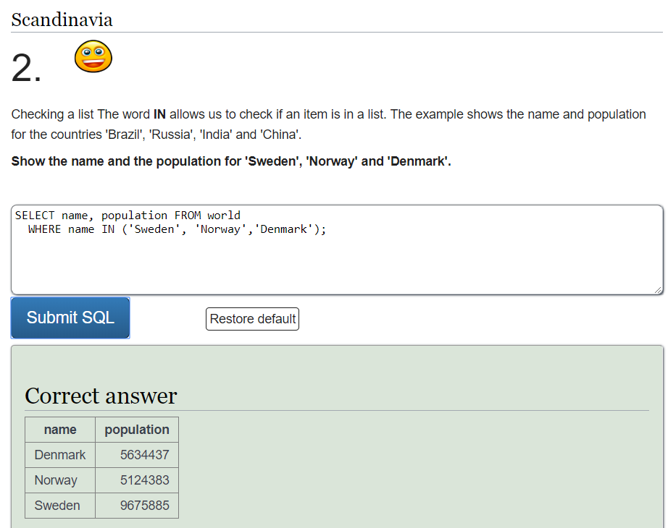

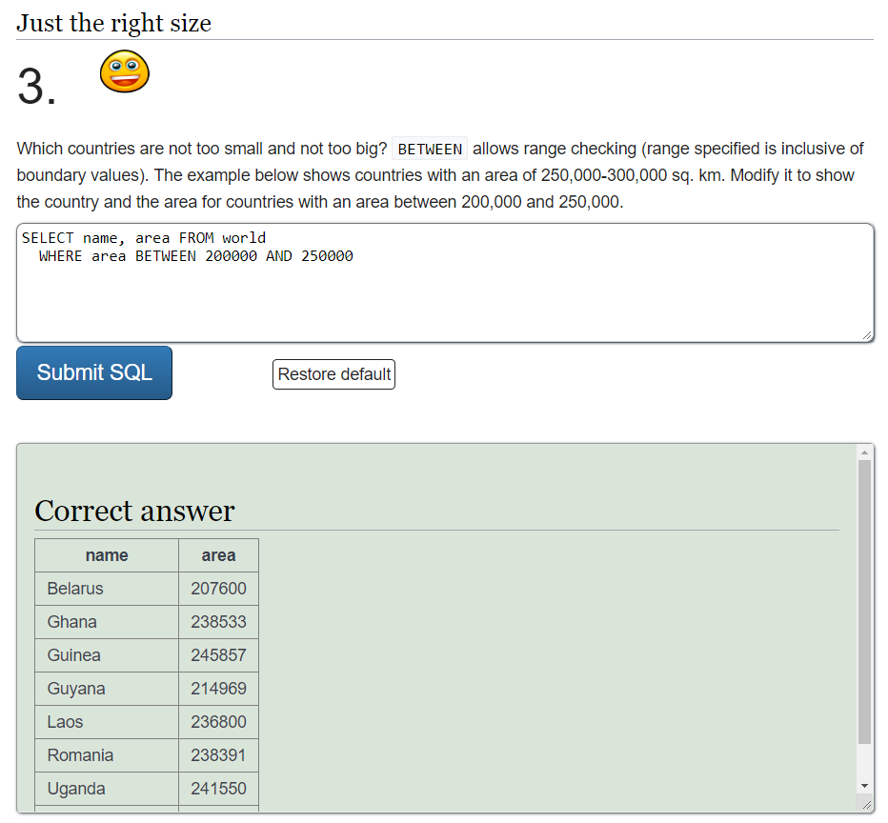

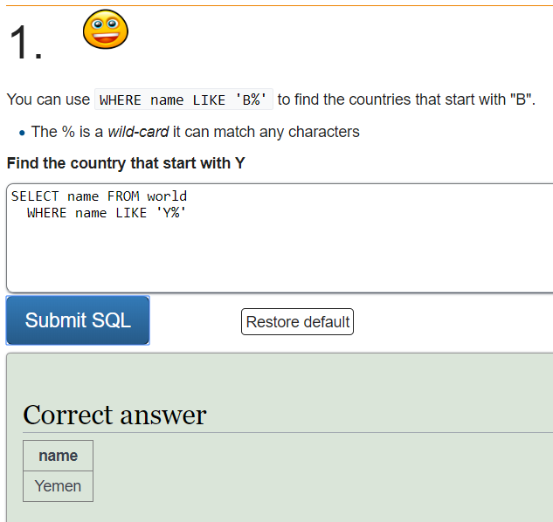

SELECT name FROM world

WHERE name LIKE 'Y%'

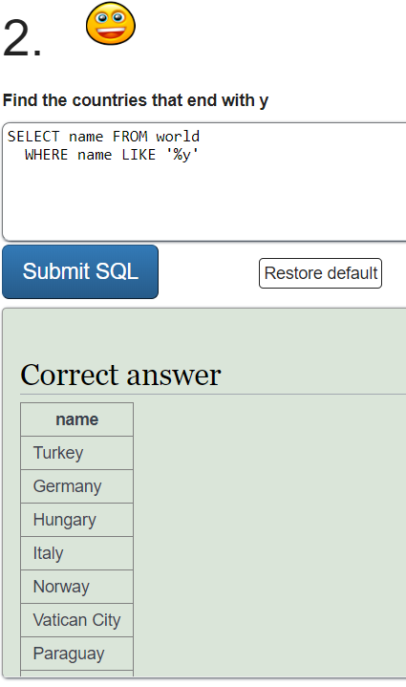

SELECT name FROM world

WHERE name LIKE '%y'

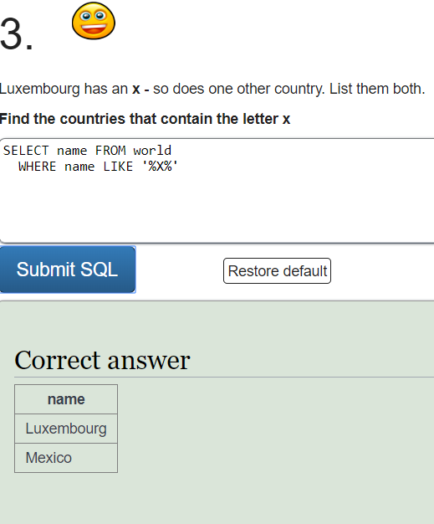

SELECT name FROM world

WHERE name LIKE '%X%'

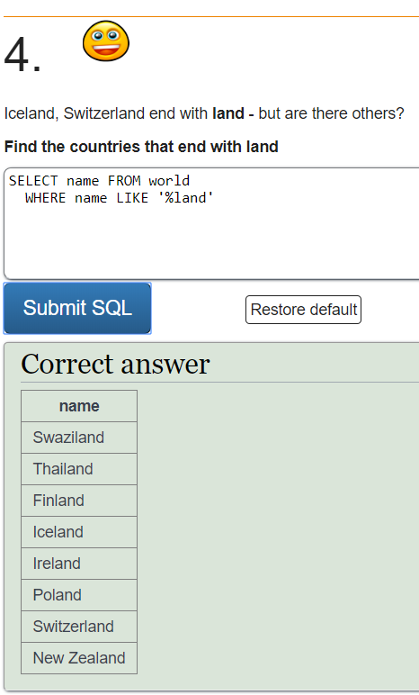

SELECT name FROM world

WHERE name LIKE '%land'

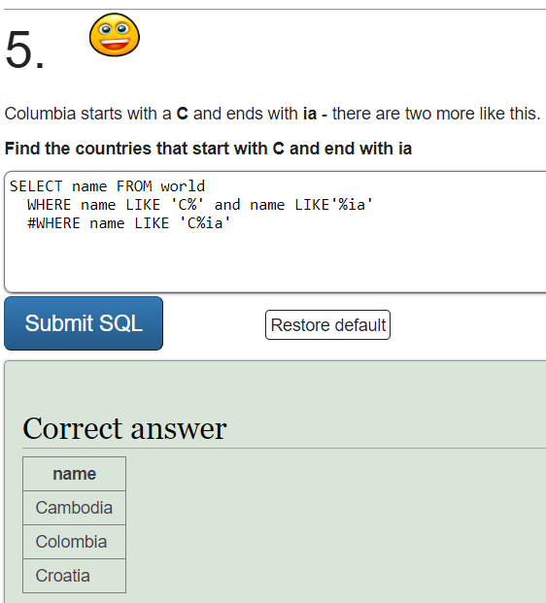

SELECT name FROM world

WHERE name LIKE 'C%' and name LIKE'%ia'

#WHERE name LIKE 'C%ia'

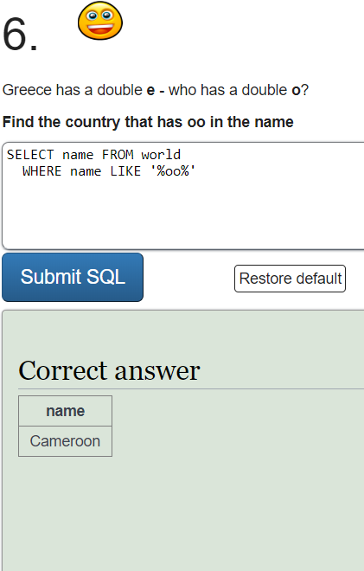

SELECT name FROM world

WHERE name LIKE '%oo%'

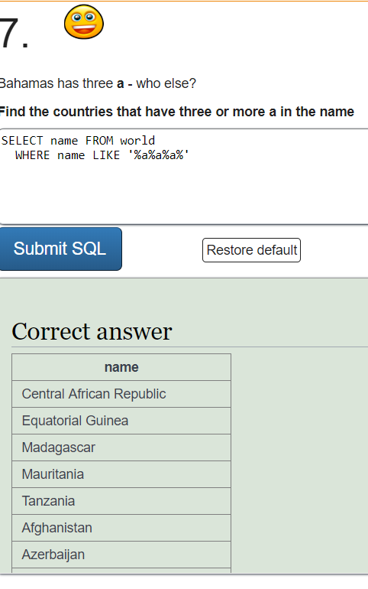

SELECT name FROM world

WHERE name LIKE '%a%a%a%'

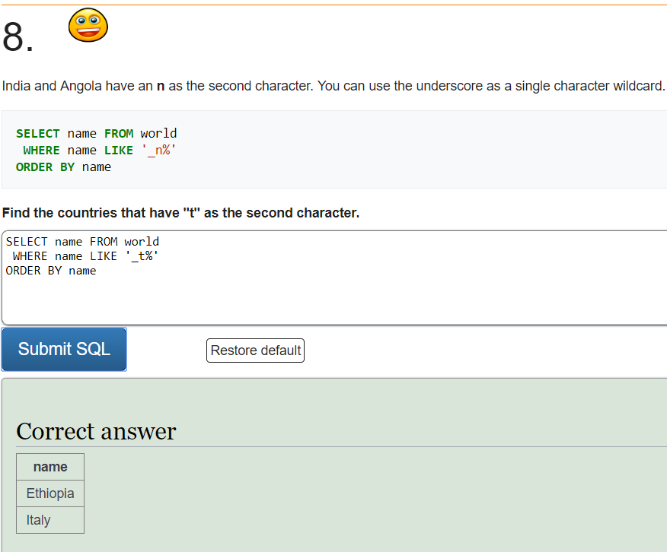

SELECT name FROM world

WHERE name LIKE '_t%'

ORDER BY name

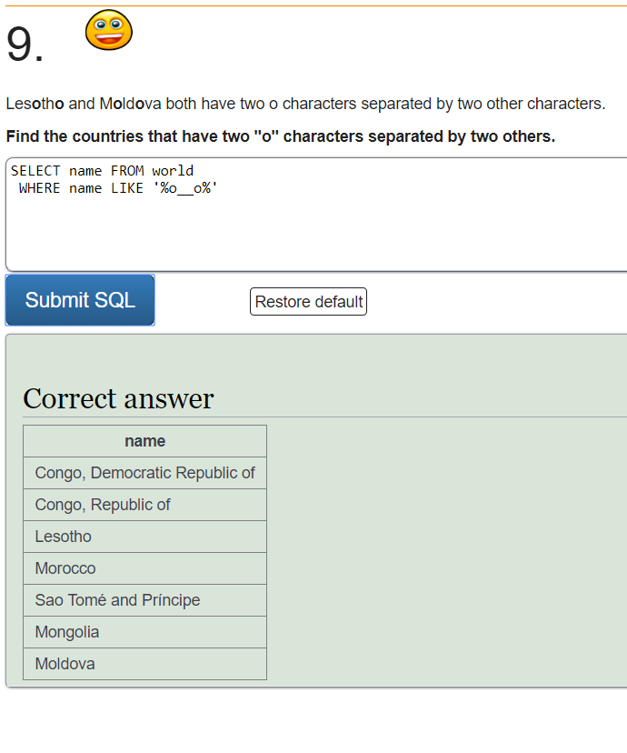

SELECT name FROM world

WHERE name LIKE '%o__o%'

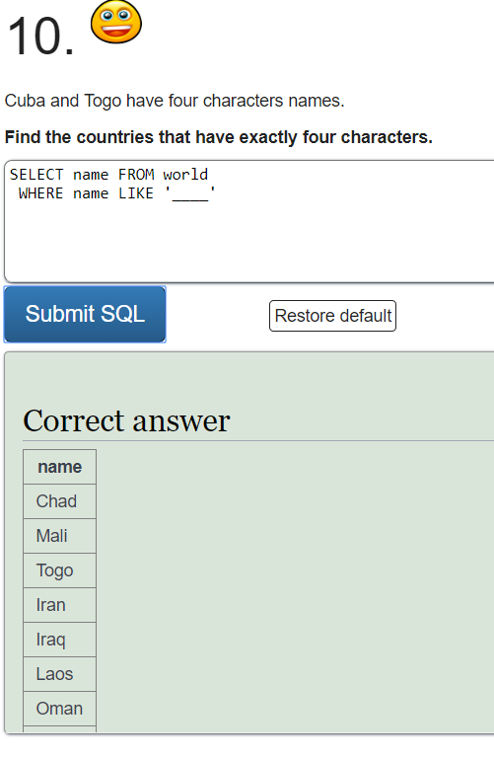

SELECT name FROM world

WHERE name LIKE '____'

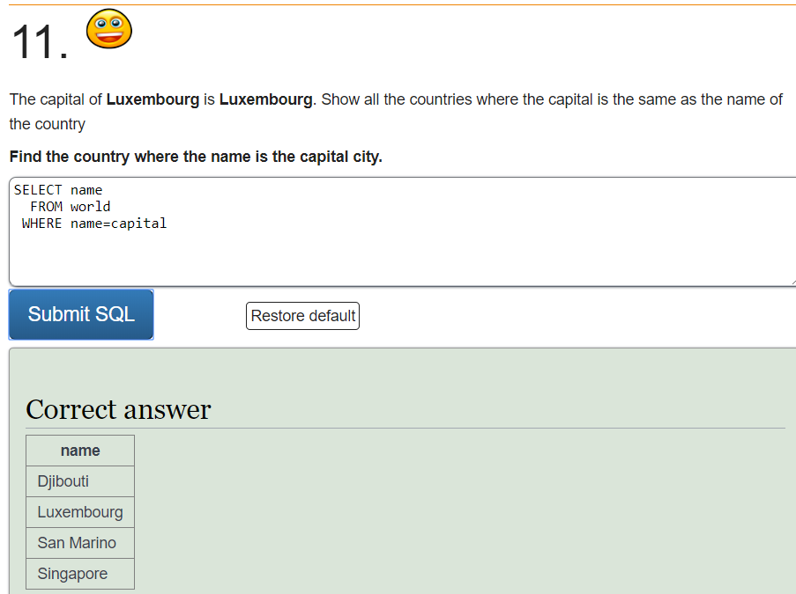

SELECT name

FROM world

WHERE name=capital

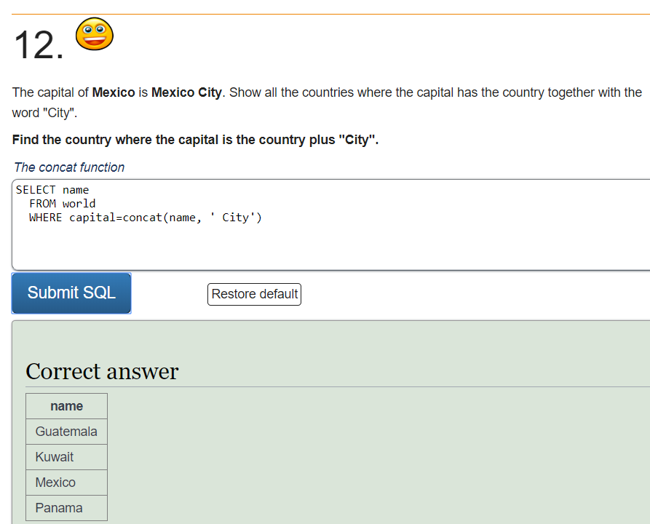

SELECT name

FROM world

WHERE capital=concat(name, ' City')

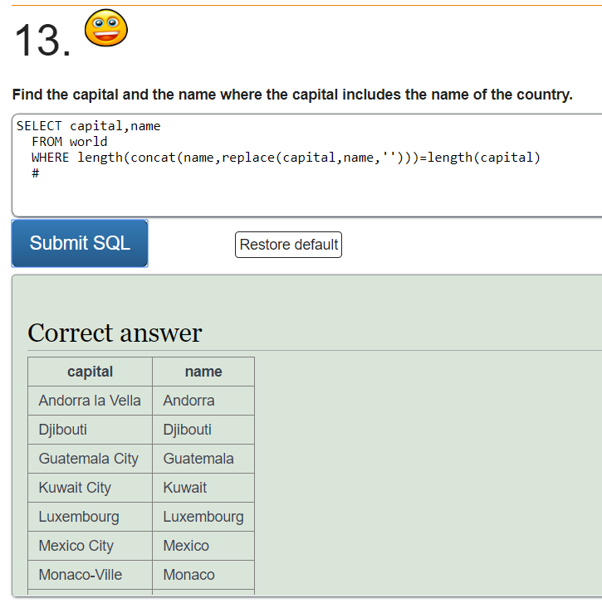

SELECT capital,name

FROM world

WHERE length(concat(name,replace(capital,name,'')))=length(capital)

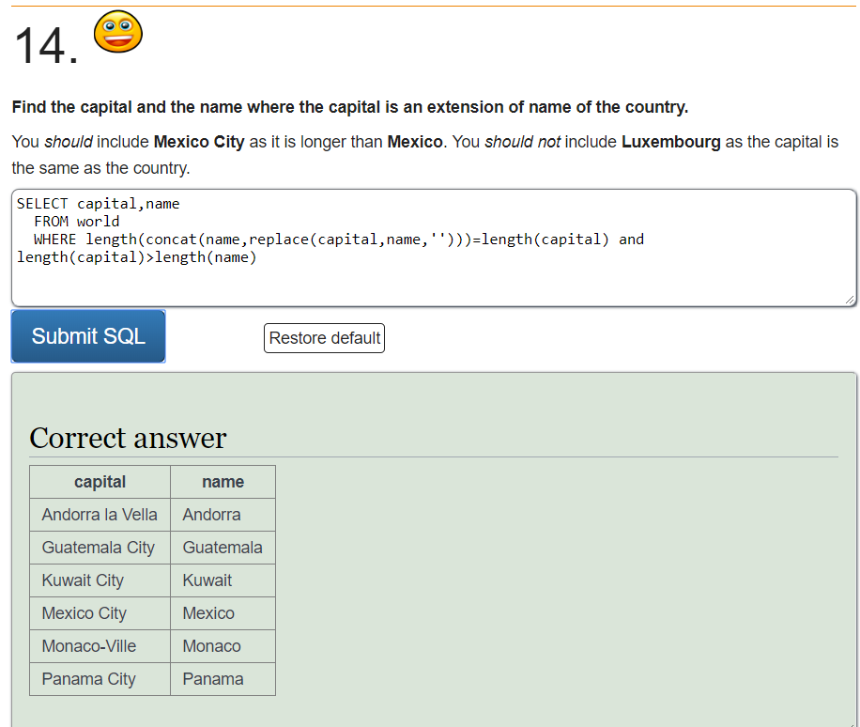

SELECT capital,name

FROM world

WHERE length(concat(name,replace(capital,name,'')))=length(capital) and length(capital)>length(name)

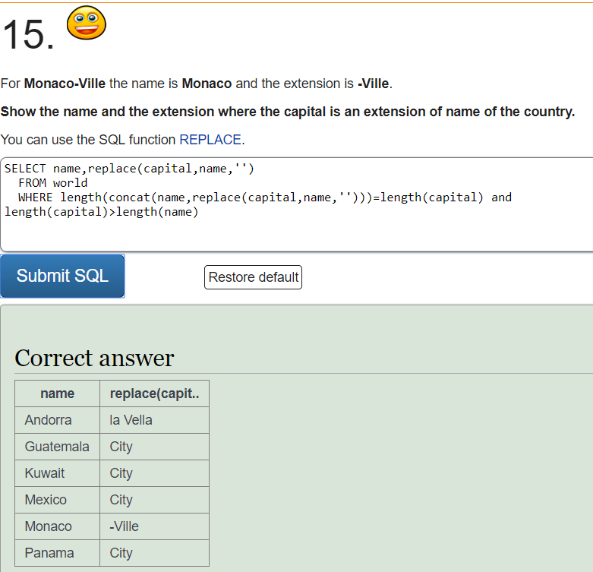

SELECT name,replace(capital,name,'')

FROM world

WHERE length(concat(name,replace(capital,name,'')))=length(capital) and length(capital)>length(name)

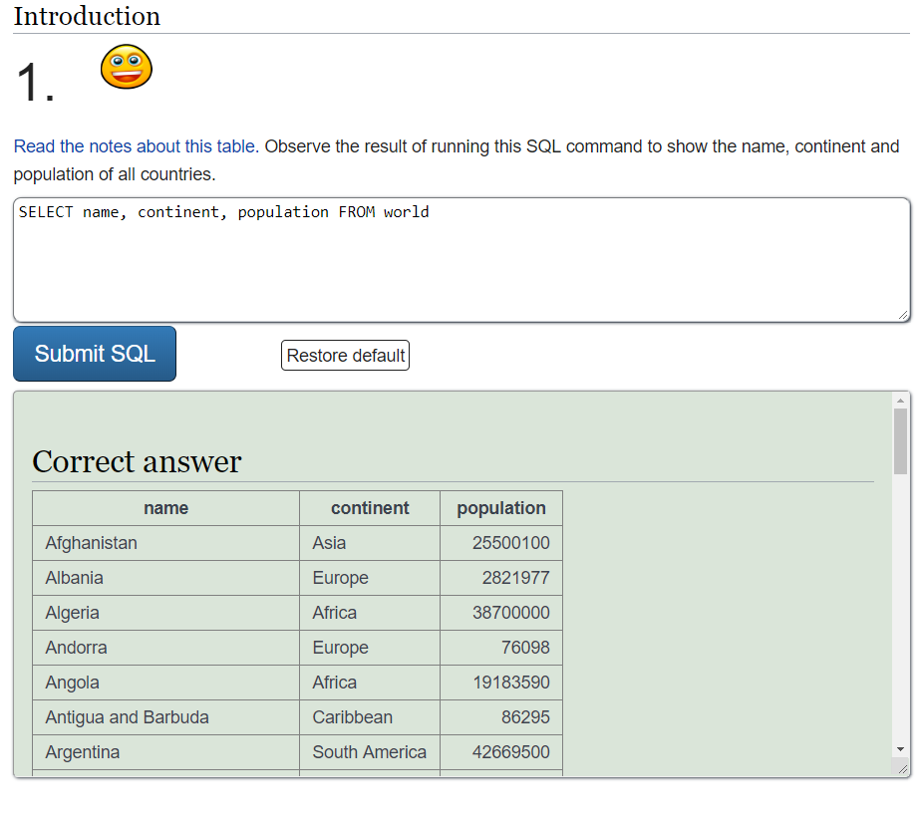SELECT name, continent, population FROM world

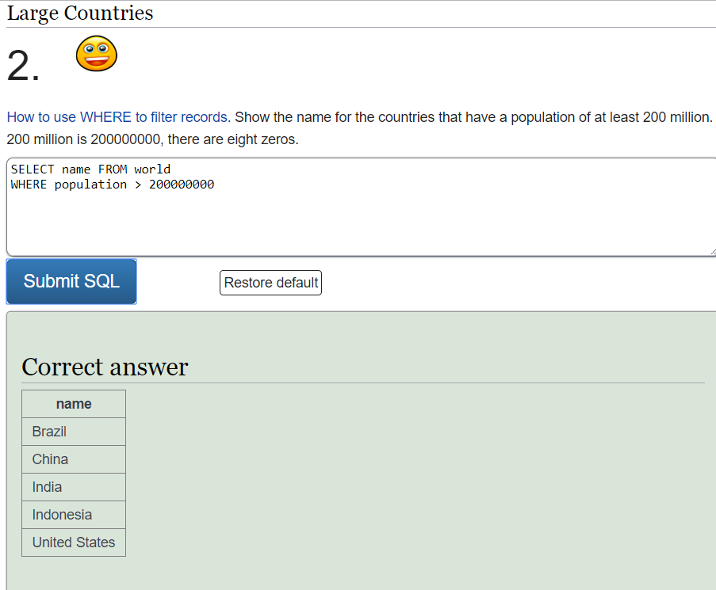

SELECT name FROM world

WHERE population > 200000000

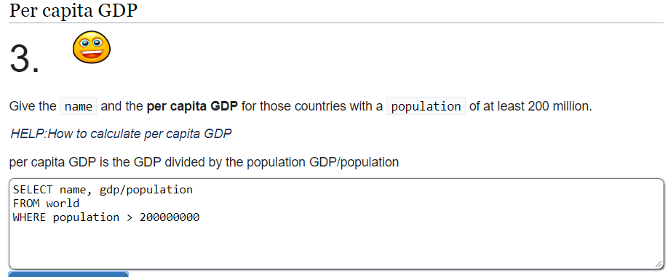

SELECT name, gdp/population

FROM world

WHERE population > 200000000

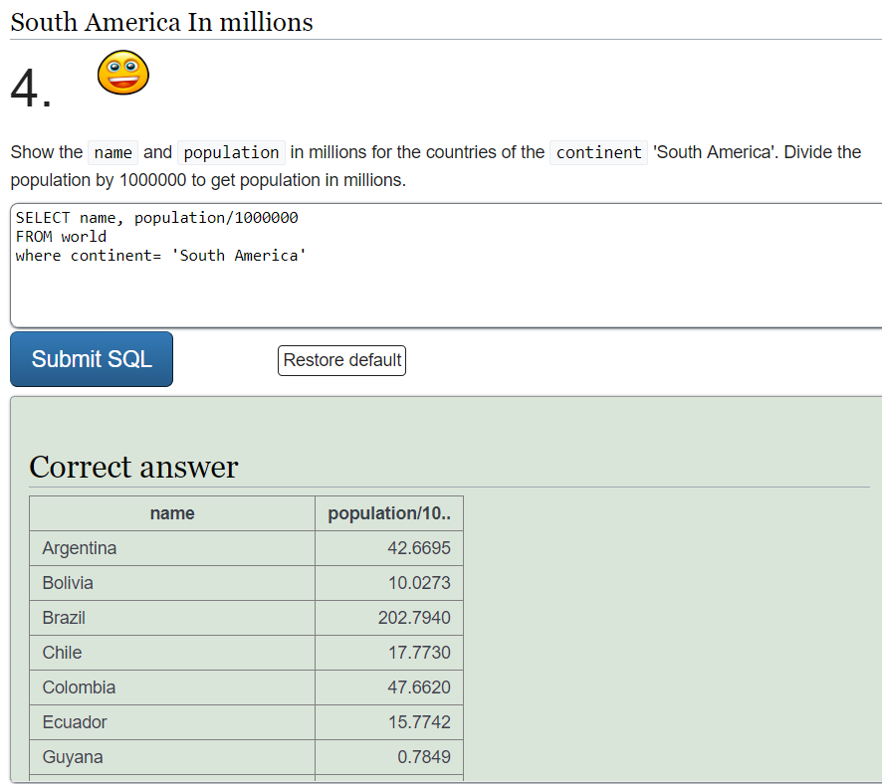

SELECT name, population/1000000

FROM world

where continent= 'South America'

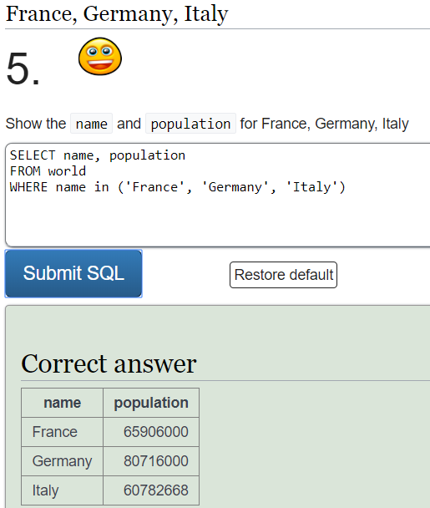

SELECT name, population

FROM world

WHERE name in ('France', 'Germany', 'Italy')

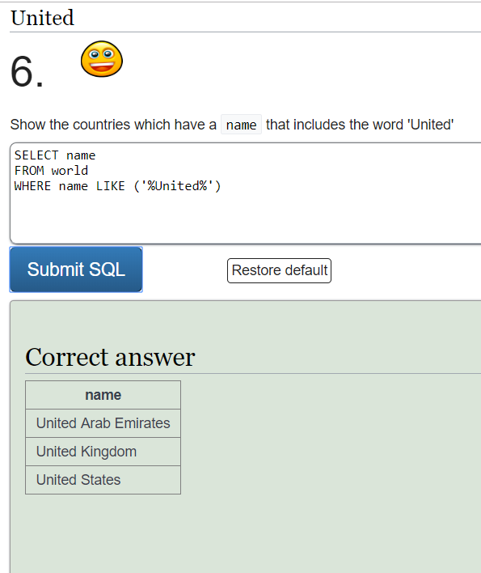

SELECT name

FROM world

WHERE name LIKE ('%United%')

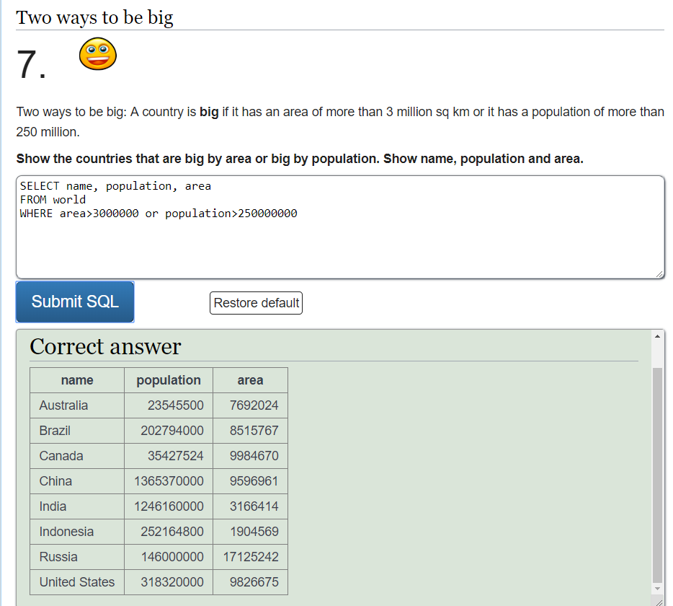

SELECT name, population, area

FROM world

WHERE area>3000000 or population>250000000

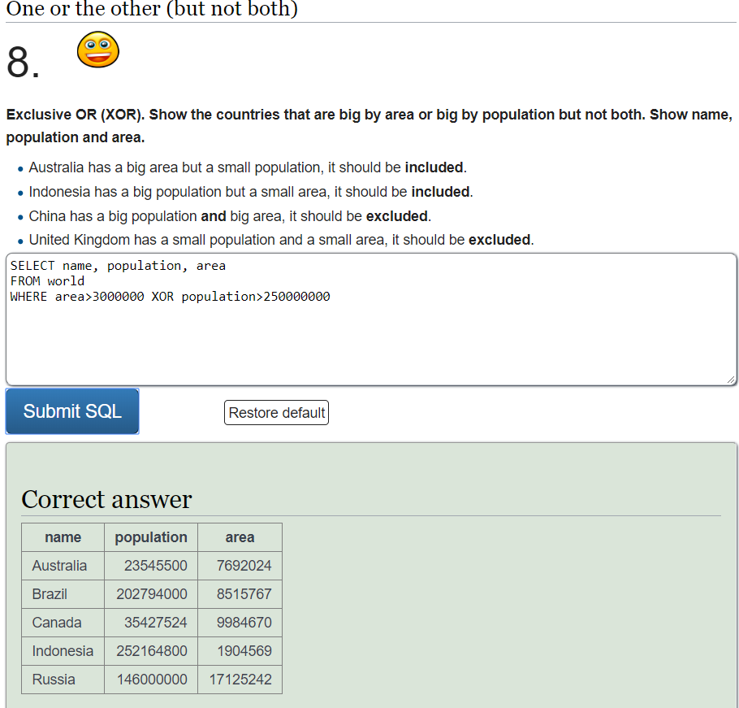

SELECT name, population, area

FROM world

WHERE area>3000000 XOR population>250000000

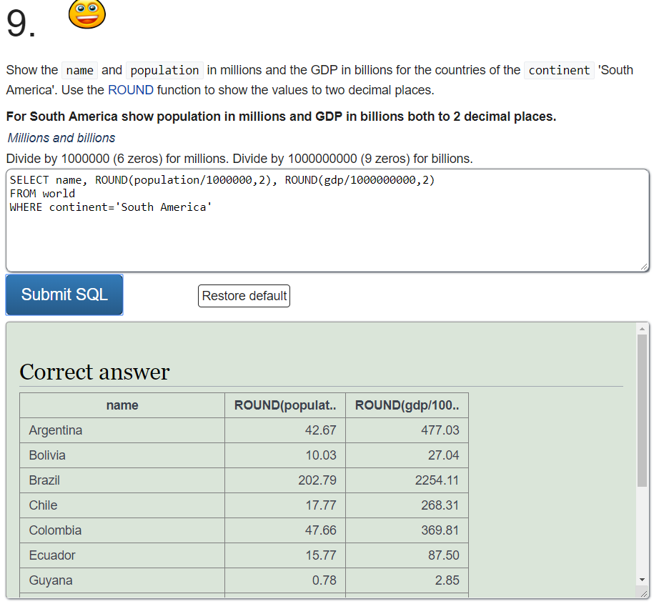

SELECT name, ROUND(population/1000000,2), ROUND(gdp/1000000000,2)

FROM world

WHERE continent='South America'

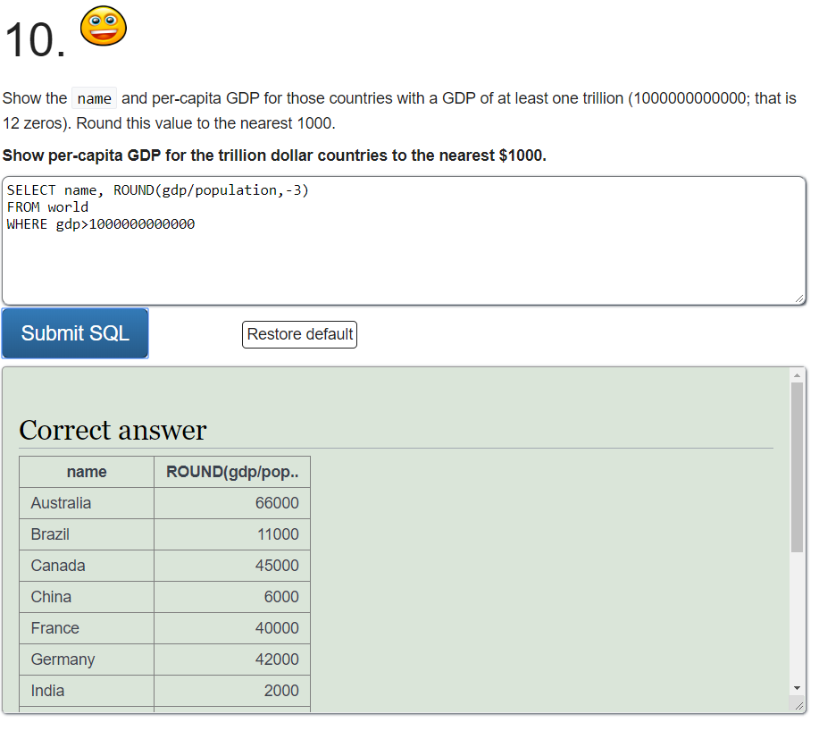SELECT name, ROUND(gdp/population,-3)

FROM world

WHERE gdp>1000000000000

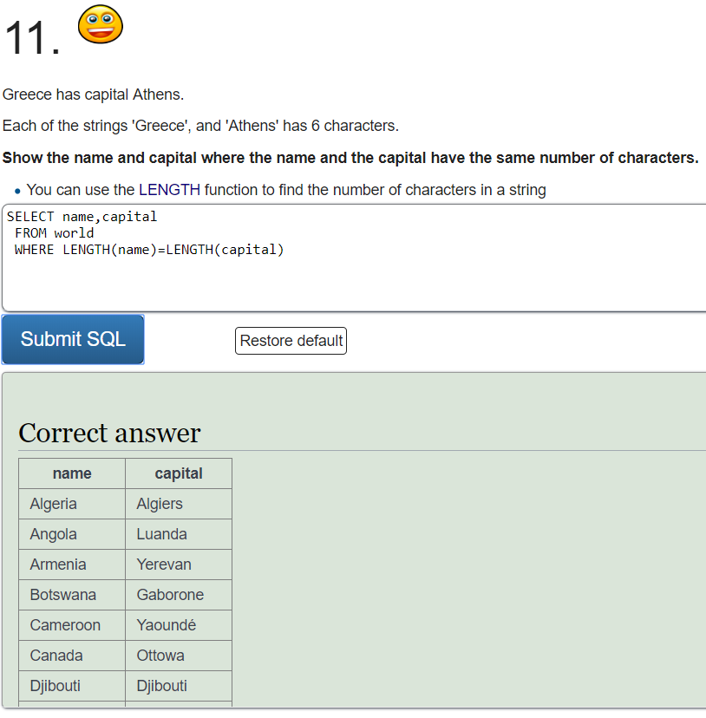

SELECT name,capital

FROM world

WHERE LENGTH(name)=LENGTH(capital)

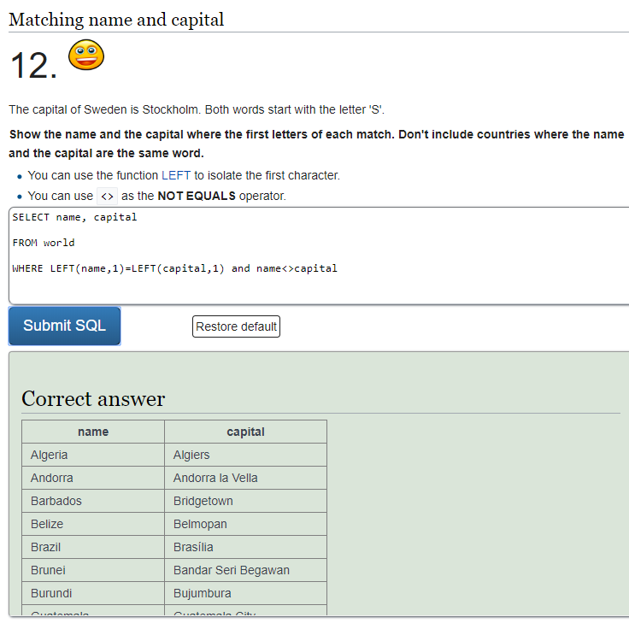

SELECT name, capital

FROM world

WHERE LEFT(name,1)=LEFT(capital,1) and name<>capital

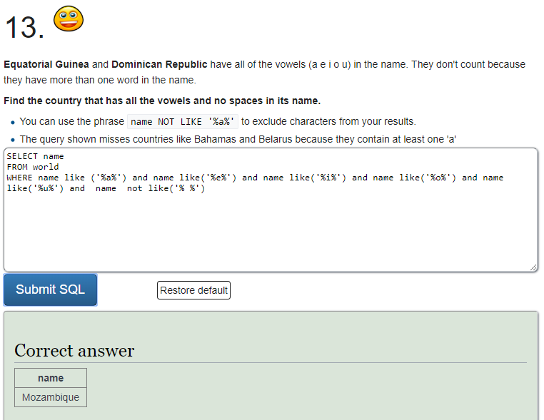

SELECT name

FROM world

WHERE name like ('%a%') and name like('%e%') and name like('%i%') and name like('%o%') and name like('%u%') and name not like('% %')

SELECT from Nobel Tutorial

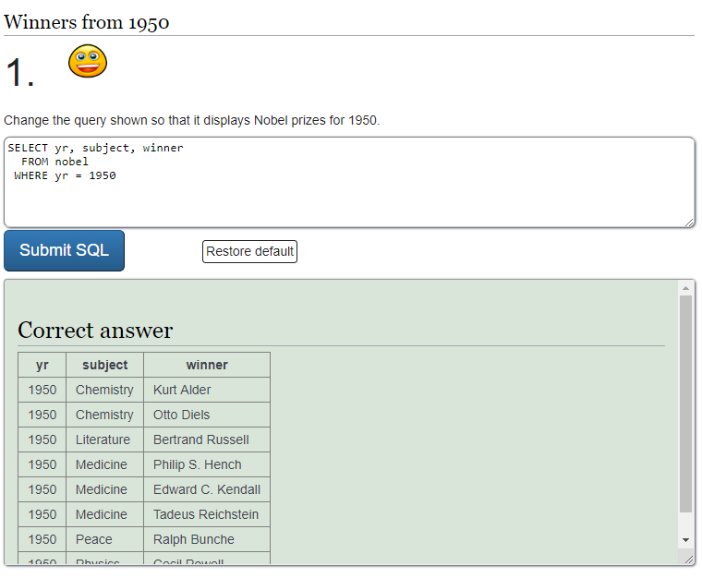

SELECT yr, subject, winner

FROM nobel

WHERE yr = 1950

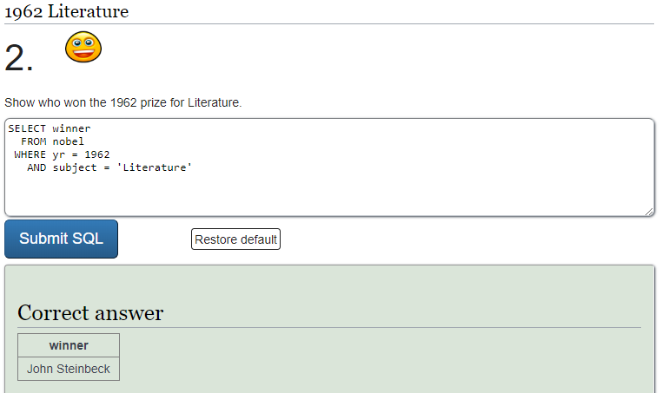

SELECT winner

FROM nobel

WHERE yr = 1962

AND subject = 'Literature'

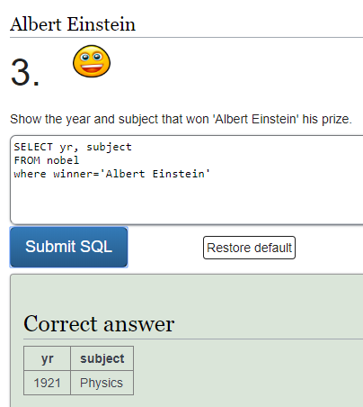

SELECT yr, subject

FROM nobel

where winner='Albert Einstein'

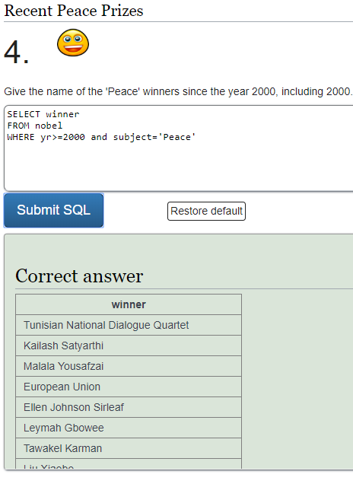

SELECT winner

FROM nobel

WHERE yr>=2000 and subject='Peace'

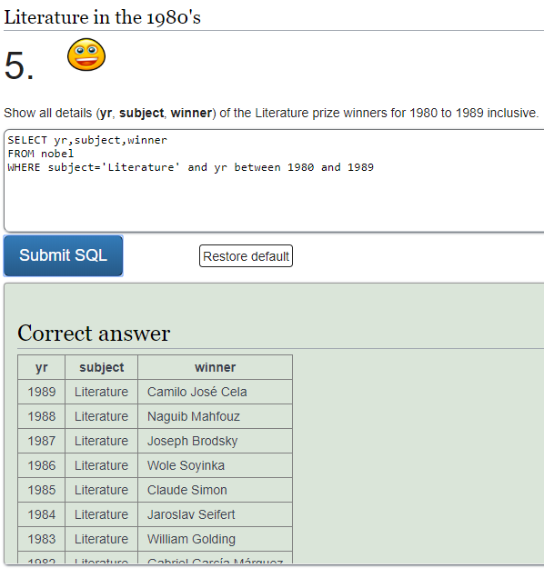

SELECT yr,subject,winner

FROM nobel

WHERE subject='Literature' and yr between 1980 and 1989

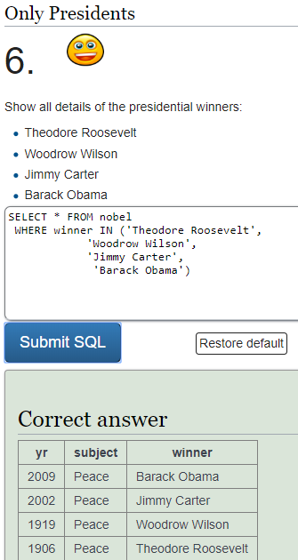

SELECT *

FROM nobel

WHERE winner IN ('Theodore Roosevelt',

'Woodrow Wilson',

'Jimmy Carter',

'Barack Obama')

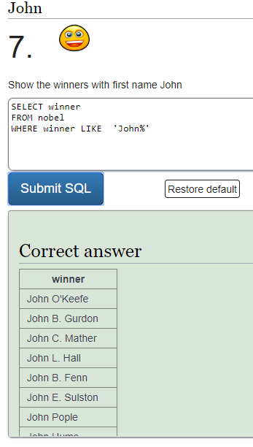

SELECT winner

FROM nobel

WHERE winner LIKE 'John%'

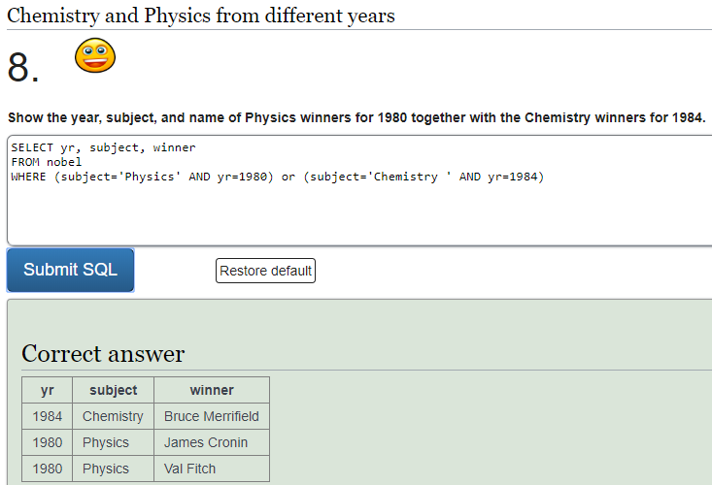

SELECT yr, subject, winner

FROM nobel

WHERE (subject='Physics' AND yr=1980) or (subject='Chemistry ' AND yr=1984)

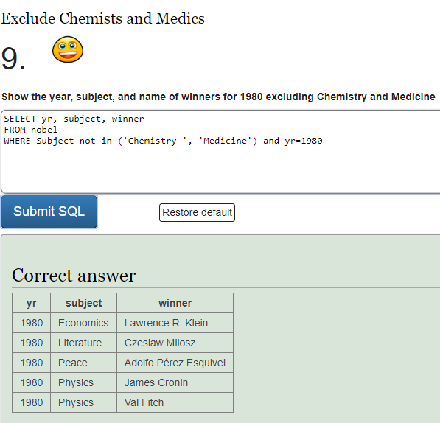

SELECT yr, subject, winner

FROM nobel

WHERE Subject not in ('Chemistry ', 'Medicine') and yr=1980

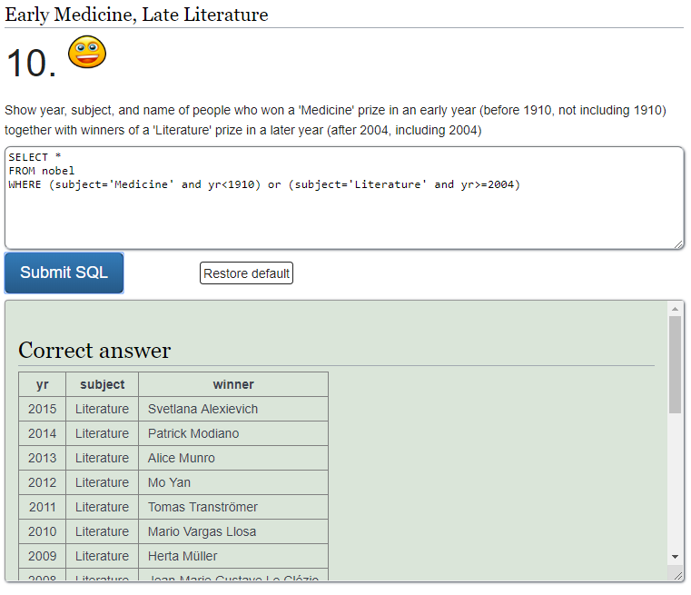

SELECT *

FROM nobel

WHERE (subject='Medicine' and yr<1910) or (subject='Literature' and yr>=2004)

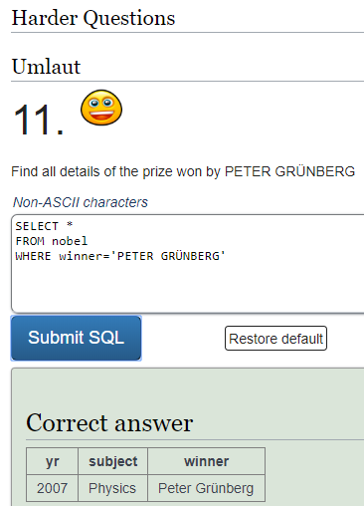

SELECT *

FROM nobel

WHERE winner='PETER GRÜNBERG'

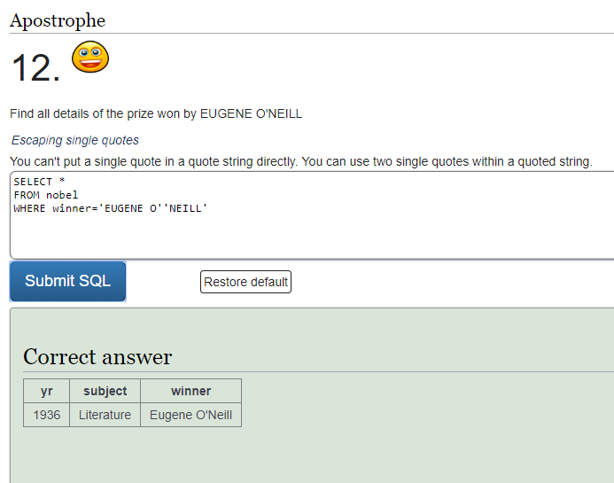

SELECT *

FROM nobel

WHERE winner='EUGENE O''NEILL'

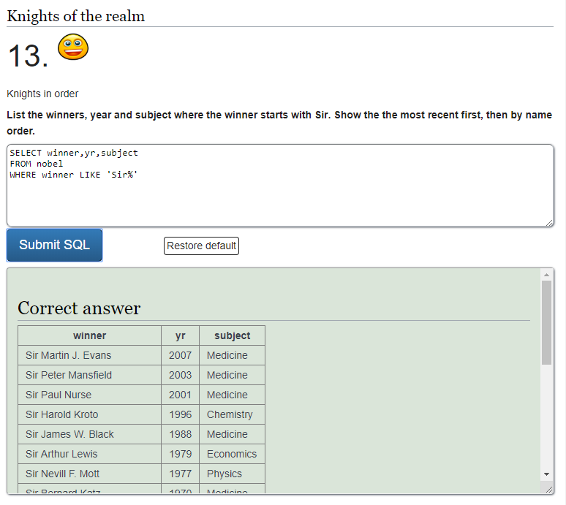

SELECT winner,yr,subject

FROM nobel

WHERE winner LIKE 'Sir%'

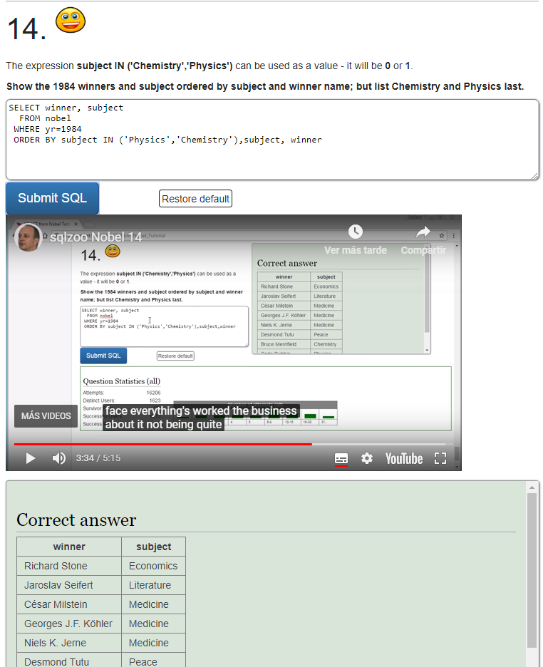

SELECT winner, subject

FROM nobel

WHERE yr=1984

ORDER BY subject IN ('Physics','Chemistry'),subject, winner

# SELECT within SELECT

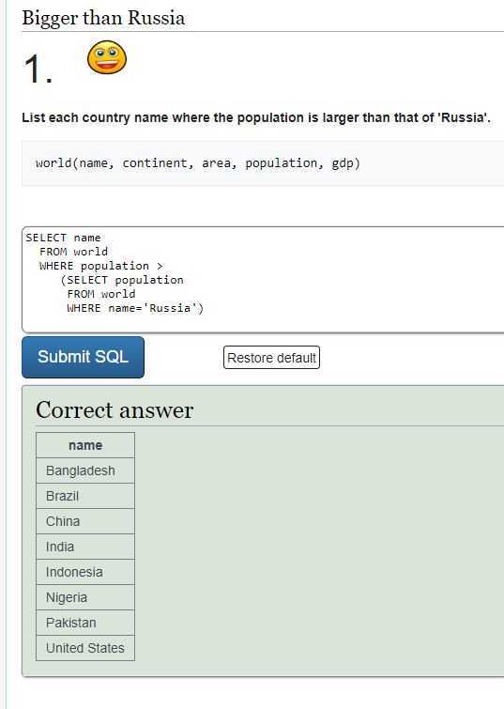

SELECT name

FROM world

WHERE population >

(SELECT population

FROM world

WHERE name='Russia')

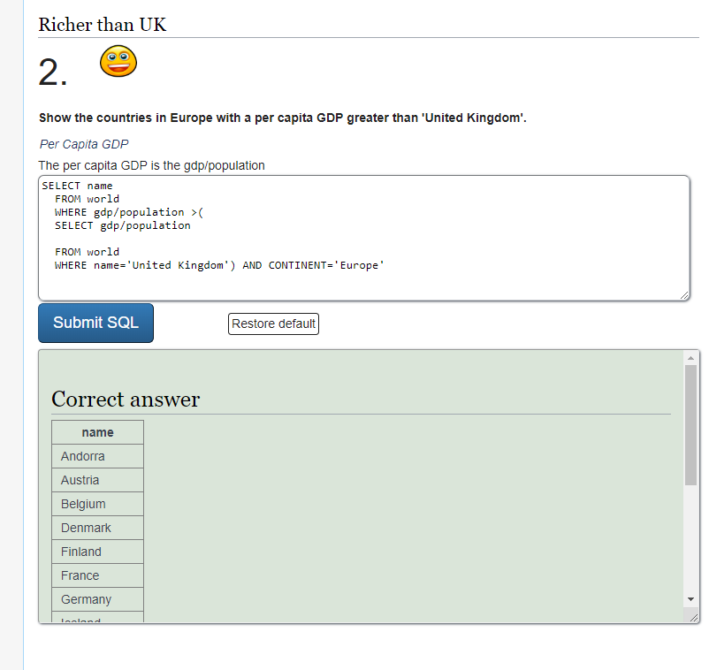

SELECT name

FROM world

WHERE gdp/population >(

SELECT gdp/population

FROM world

WHERE name='United Kingdom') AND CONTINENT='Europe'

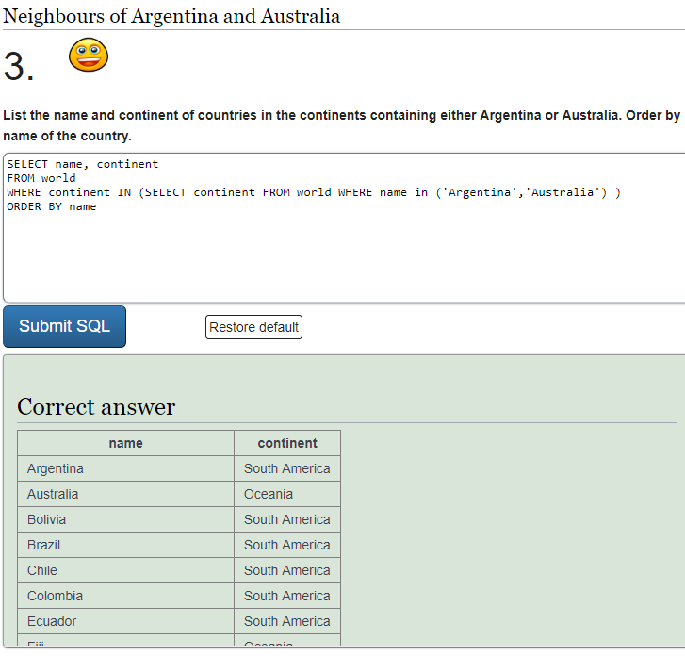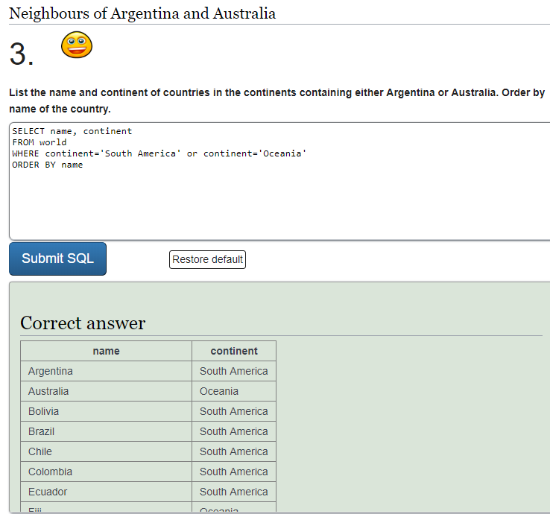

SELECT name, continent

FROM world

WHERE continent IN (SELECT continent FROM world WHERE name in ('Argentina','Australia') )

ORDER BY name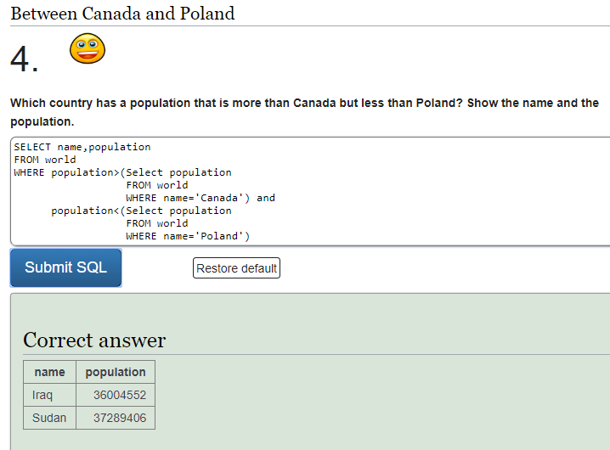

SELECT name, population

FROM world

WHERE population>(Select population

FROM world

WHERE name='Canada') and

population<(Select population

FROM world

WHERE name='Poland')

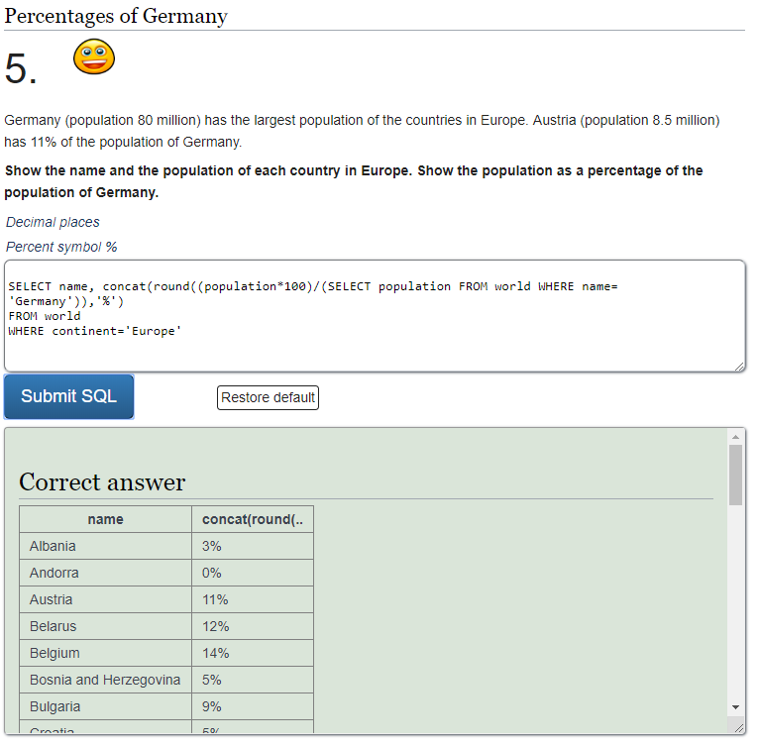

SELECT name, concat(round((population*100)/(SELECT population FROM world WHERE name= 'Germany')),'%')

FROM world

WHERE continent='Europe'

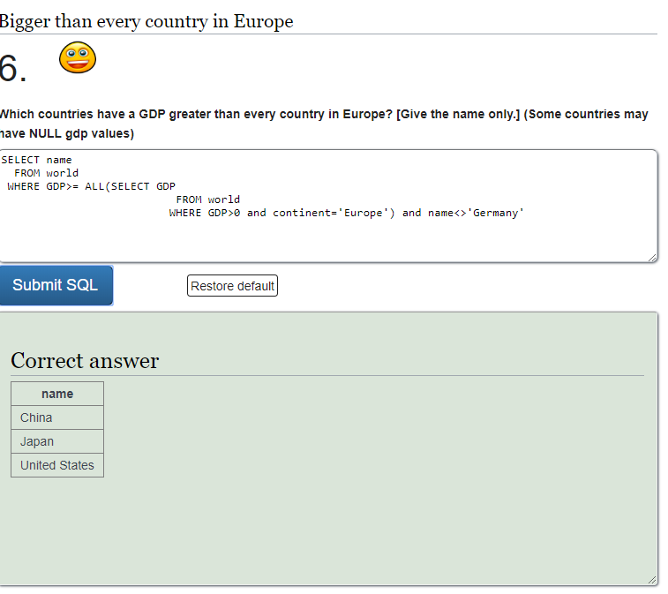

SELECT name

FROM world

WHERE GDP>= ALL(SELECT GDP

FROM world

WHERE GDP>0 and continent='Europe') and name<>'Germany'

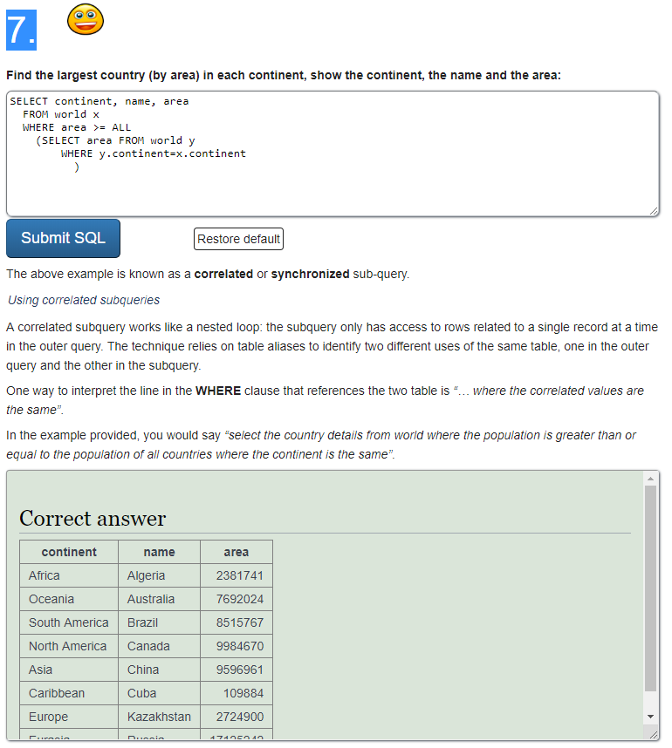

SELECT continent, name, area

FROM world x

WHERE area >= ALL

(SELECT area FROM world y

WHERE y.continent=x.continent)

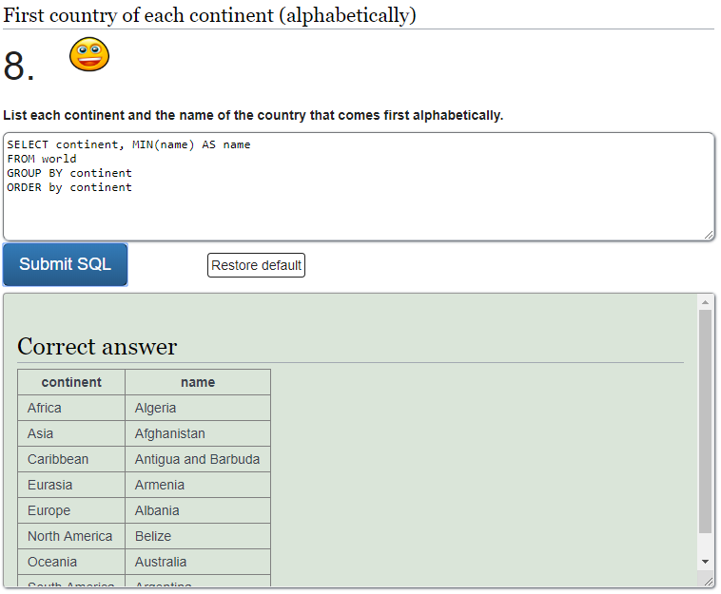

SELECT continent, MIN(name) AS name

FROM world

GROUP BY continent

ORDER by continent

2

SELECT continent, name

FROM world x

WHERE name<= ALL(SELECT name FROM world y WHERE y.continent=x.continent)

ORDER by continent

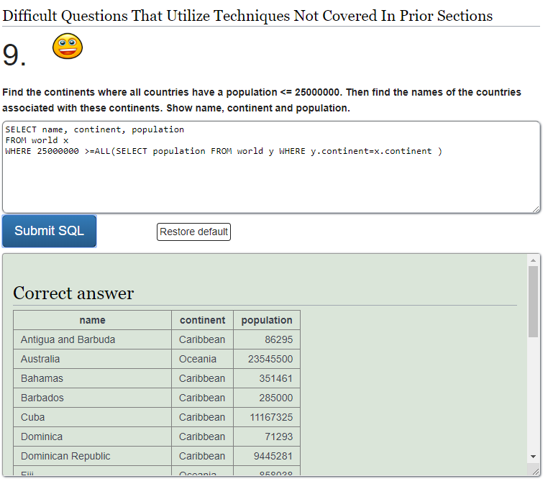

SELECT name, continent, population

FROM world x

WHERE 25000000 >=ALL(SELECT population FROM world y WHERE y.continent=x.continent )

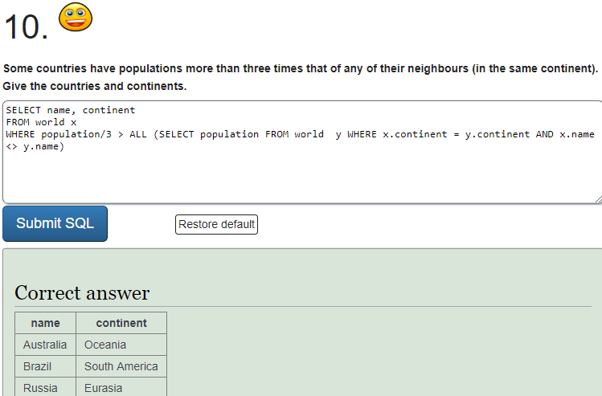

SELECT name, continent

FROM world x

WHERE population/3 > ALL (SELECT population FROM world y WHERE x.continent = y.continent AND x.name <> y.name)

# SUM and COUNT

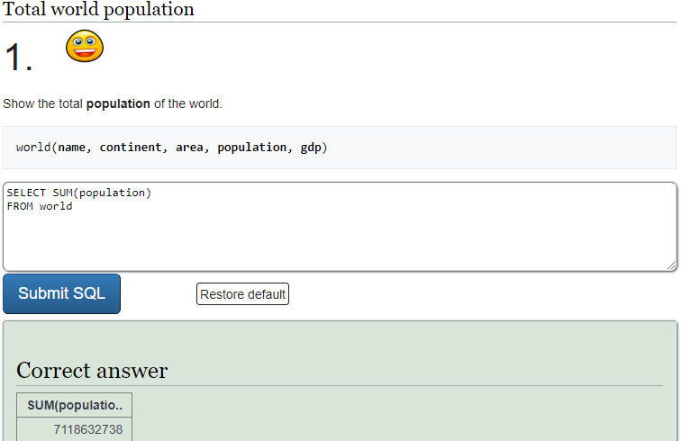

SELECT SUM(population)

FROM world

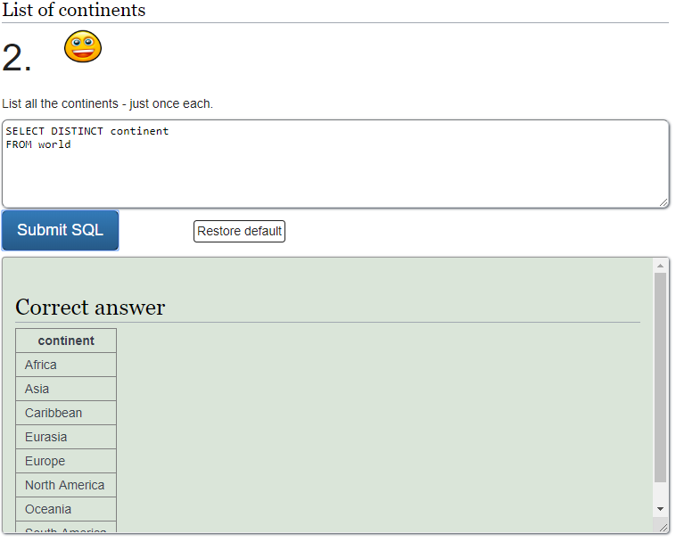

SELECT DISTINCT continent

FROM world

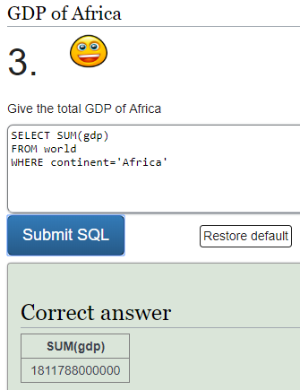

SELECT SUM (gdp)

FROM world

WHERE continent='Africa'

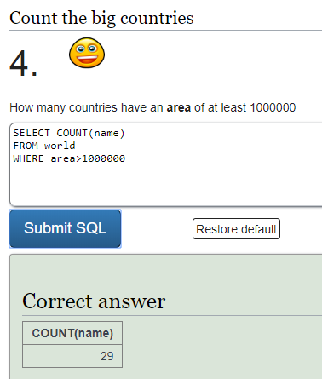

SELECT COUNT(name)

FROM world

WHERE area>1000000

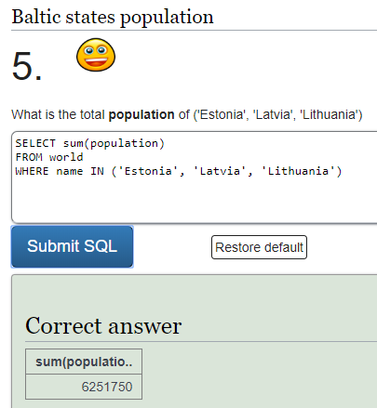

SELECT sum(population)

FROM world

WHERE name IN ('Estonia', 'Latvia', 'Lithuania')

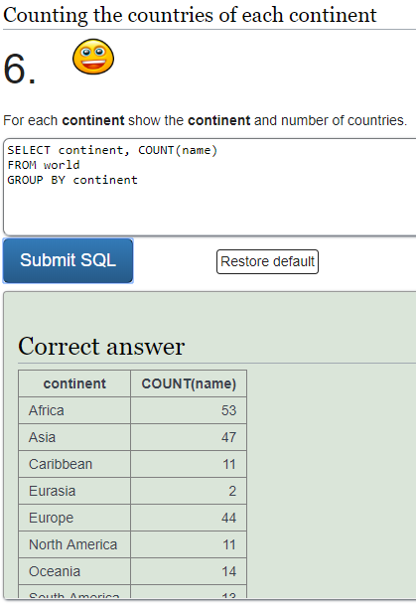

SELECT continent, COUNT(name)

FROM world

GROUP BY continent

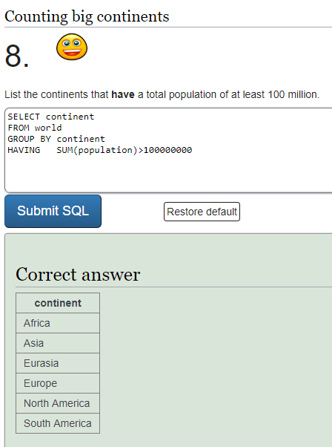

SELECT continent

FROM world

GROUP BY continent

HAVING SUM(population)>100000000