Software Requirements Specification

for

Sense2Aim
Version 0.9 (draft)
Prepared by Maira Penayo Nunez, Noah Maniace, Sofia Filgueira Fernandez, Mallie Lawson, and Kobe Thurmond
West Virginia University Institute of Technology
September 27, 2026
Table of Contents
Revision History ii
1. Introduction 1
1.1 Purpose 1
1.2 Document Conventions 1
1.3 Intended Audience and Reading Suggestions 1
1.4 Product Scope 1
1.5 References 2
2. Overall Description 3
2.1 Product Perspective 3
2.2 Product Functions 3
2.3 User Classes and Characteristics 4
2.4 Operating Environment 5
2.5 Design and Implementation Constraints 5
2.6 User Documentation 5
2.7 Assumptions and Dependencies 5
3. External Interface Requirements 6
3.1 User Interfaces 6
3.2 Hardware Interfaces 7
3.3 Software Interfaces 7
3.4 Communications Interfaces 7
4. System Features 7
4.1 Session Management 8
4.2 Controller and Gameplay Capture 8
4.3 Hand-Motion Sensing (Webcam and Radar) 10
4.4 Synchronization and Storage 10
4.5 Feature Extraction and Performance Scoring 11
4.6 Model Training and Evaluation 12
4.7 Recommendation and Validation 12
4.8 Cloud Pipeline and LLM Explanation 13
5. Other Nonfunctional Requirements 14
5.1 Performance Requirements 14
5.2 Safety Requirements 14
5.3 Security Requirements 14
5.4 Software Quality Attributes 15
5.5 Business Rules 15
6. Other Requirements 16
6.1 Data Requirements 16
6.2 Legal and Ethical Requirements 16
Appendix A: Glossary 17
Appendix B: Analysis Models 17
Appendix C: To Be Determined List 18

Revision History
Name | Date | Reason For Changes | Version
Sense2Aim team | 9/27/26 | First draft for team review | 0.9

Introduction

Purpose
This Software Requirements Specification (SRS) describes the requirements for Sense2Aim, version 1.0, our senior design project at WVU Tech. Sense2Aim records how a player uses a PlayStation DualSense controller while playing Call of Duty on a PC, together with their in-game results and their hand movements, which we capture with a webcam and an mmWave radar. We then use machine learning to recommend game settings that fit that specific player.
This SRS covers the whole system: the software we are writing and the hardware and services it connects to. The hardware is the same as in our proposal [1]. This document also responds to the feedback on our proposal [2]; Appendix B shows where each comment is addressed.

Document Conventions
- "Shall" means mandatory, "should" means desired, and "may" means optional [4].
- Each requirement has a unique ID made of a feature prefix and a number (for example, CAP-02). Deleted IDs are not reused.
- Each requirement ends with its own priority and verification method in parentheses, for example (High; Test). High means the project cannot meet its goal without it, Medium means planned but not critical, and Low means stretch goal. Following IEEE Std 730 [5], each requirement is verified by Test (measured with data), Demonstration (shown working), Inspection (reviewing code, files, or documents), or Analysis (calculations or statistics).
- Values not decided yet are marked TBD-n and listed in Appendix C, with our current planning value.

Intended Audience and Reading Suggestions
This document is for our faculty advisors and evaluators, who should read Sections 1 and 2 first and then Sections 4 and 5; our team members, who will mostly use Sections 3, 4, and 6 while building the system; and esports participants and coaches, who can read Sections 1.4, 2.3, and 5.3 to see how their data is used. Section 2 describes the system, Section 3 for the external interfaces, Section 4 for the functional requirements, Section 5 for the nonfunctional requirements, and Section 6 for the data and legal requirements.

Product Scope
First person shooter (FPS) games have many settings that change how aiming feels, such as sensitivity, dead zones, response curves, aim assist, field of view (FOV), aim-down-sights (ADS) sensitivity, and button layout. Most players choose them by trial and error or by copying professionals. Instead of looking for one "best" setup, Sense2Aim learns how an individual player uses the controller and how well they perform and recommends settings for that person.
The project also answers a research question: does hand and controller motion measured by a camera and mmWave radar add useful information beyond controller and gameplay data? Both "yes" and "no" are valid results, so we designed the system to measure the answer. Our goals for version 1.0, working by May 2027, are to record synchronized data with WVU Tech Esports players, compare a controller-only model with models that add camera and radar data, recommend personalized settings after a 30-to-60-minute session and check if they help, and train models in AWS with an optional LLM explanation. Table 1 shows how we will judge success.
Table 1. Project success criteria
ID | Success criterion | How it is judged
SC-1 | Any trained model predicts a player's Aim Performance Score (APS) better than a naive "average" predictor. | Lower mean absolute error (MAE) in leave-one-participant-out testing (MDL-03, MDL-04).
SC-2 | The contribution of each sensing modality (camera, radar) is measured and reported, whether positive, zero, or negative. | Improvement is "meaningful" if MAE drops by at least 10% versus the controller-only model and a Wilcoxon signed-rank test gives p < 0.05 (TBD-5).
SC-3 | Recommended settings improve performance for real players. | Primary: in-game accuracy rises by at least 2 percentage points from calibration (Phase B) to validation (Phase C) for at least 60% of validation participants. Secondary: mean APS rises (TBD-5).
SC-4 | The full pipeline runs end to end for a new player. | Demonstration: register, record, process, and show a recommendation within the limits of Section 5.1.

References
[1] Sense2Aim Team, "Senior Design Proposal: Neural Network-Based Personalized FPS Setting Optimization Using Controller Telemetry and Hand-Motion Tracking," WVU Tech, 2026.
[2] "Senior Design Proposal – Computer Science and Information Evaluation: Sense2Aim," WVU Tech, 2026 (final grade 92/100).
[3] IEEE Std 830-1998, IEEE Recommended Practice for Software Requirements Specifications, IEEE, 1998.
[4] ISO/IEC/IEEE 29148:2018, Systems and Software Engineering – Life Cycle Processes – Requirements Engineering, 2018.
[5] IEEE Std 730-2026, IEEE Standard for Software Quality Assurance Processes (Revision of IEEE Std 730-2014), IEEE, 2026.
[6] K. E. Wiegers, "Software Requirements Specification Template," 1999.
[7] F. Zhang et al., "MediaPipe Hands: On-device Real-time Hand Tracking," arXiv:2006.10214, 2020.
[8] F. Pedregosa et al., "Scikit-learn: Machine Learning in Python," Journal of Machine Learning Research, vol. 12, pp. 2825–2830, 2011.
[9] A. Paszke et al., "PyTorch: An Imperative Style, High-Performance Deep Learning Library," Advances in Neural Information Processing Systems 32, 2019.
[10] USB Implementers Forum, "Device Class Definition for Human Interface Devices (HID)," Version 1.11, 2001.
[11] Texas Instruments, mmWave sensor and mmWave SDK documentation for the selected 60 GHz evaluation module (model TBD-1).
[12] Amazon Web Services, "Security best practices for Amazon S3," AWS documentation (accessed 2026).
[13] Activision, Call of Duty Terms of Use and Security Enforcement Policy (accessed 2026).
[14] G. van Rossum, B. Warsaw, and N. Coghlan, "PEP 8 – Style Guide for Python Code," Python Software Foundation.
[15] Sense2Aim GitHub repository (URL TBD-14).

Overall Description

Product Perspective
Sense2Aim is a new, self-contained system; it does not replace an existing product. Our software runs next to an unmodified copy of Call of Duty on the PC and only reads data from the controller and sensors. Figure 1 shows the system context: the users, the devices the system reads from, and the outside services it uses. Dashed parts are optional or stretch components.
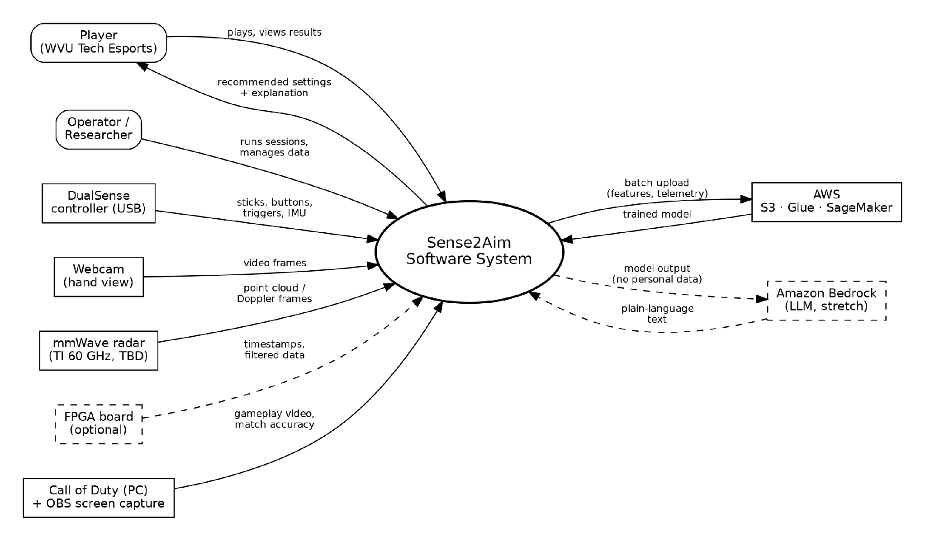
Figure 1. System context diagram
Existing tools, such as in-game menus, aim-trainer "sensitivity finders," and controller calibration, let players change settings, but none of them combine controller data with hand-motion sensing or learn from a player's measured performance. That combination is what our project tests.

Product Functions
The system manages sessions, records controller, gameplay, webcam, and radar data, puts all data on one timeline and stores it, extracts features and an Aim Performance Score, trains and compares models, recommends settings and validates them, and uploads data to AWS for training. Figure 2 shows the software architecture and how the main components of the system interact.
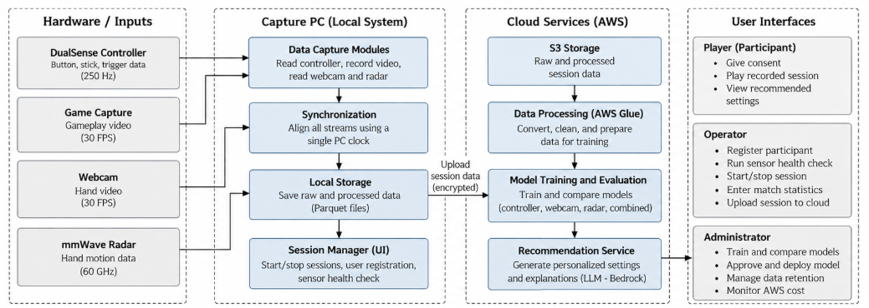
Figure 2. Software architecture diagram
A model cannot learn the effect of a setting from a player who has only used one setting, so the study has three phases. In Phase A, each participant plays several predefined configurations so the model can see how settings change performance. In Phase B, a player plays 30 to 60 minutes with their default settings, and the model uses what it learned from similar players to recommend new settings. In Phase C, the player uses the recommended settings, and we check whether they actually improved.

User Classes and Characteristics
Table 2. User classes
User class | Description | Functions used
Participant (player) | WVU Tech Esports members, 18 or older. Skilled players, no technical knowledge of the system, always supervised. | Consent, gameplay, results screen
Operator | Trained Sense2Aim team members. | Registration, health check, sessions, match entry, uploads
Administrator | Team members responsible for data and models. | Training and approving models, deleting data, AWS costs
Advisor / evaluator | Dr. Zahmeeth Sakkaff and Dr. Mingyu Lu. | Reads reports and results only

Because our participants are skilled players, results may not apply to casual players. This is a known limitation.

Operating Environment
- Capture PC: Windows 11 gaming PC that runs Call of Duty at 1920×1080 and at least 60 fps while our software records, with 16 GB RAM or more and a separate SSD for data (TBD-4).
- Game and controller: Call of Duty for PC with the DualSense plugged into the same PC by USB.
- Software: Python 3.11 or later, OBS Studio 30 or later, and the libraries in Section 3.3.
- Training: a team laptop for local work and AWS (S3, Glue, SageMaker) for cloud training.

Design and Implementation Constraints
- No game API: Call of Duty gives no live data, so performance comes from post-match stats, screen recordings, and controller data.
- Anti-cheat: the software shall only read the controller and shall never read game memory, change game files, or send inputs (CAP-02, BR-05) [13].
- Small dataset: with 10 to 20 participants, simple baseline models are required, and a neural network is only used if it beats them (MDL-06).
- Hardware limits: a standard Full-HD webcam records at about 30 fps (one frame every 33 ms), which is too slow for the fastest flicks. Fast movements are therefore measured from controller data, and the camera is used for slower thumb movements. Radar resolution is tested before use (HMS-06).
- Tools, budget, and schedule: Python, scikit-learn [8], PyTorch [9], and GitHub; hardware within the proposal budget; AWS under a monthly limit (TBD-7); High-priority requirements done by May 2027.

User Documentation
We will deliver an operator manual with a setup checklist and troubleshooting table, a participant information sheet and consent form, a README for each code module with instructions to reproduce our results, and a one-page guide to the player results screen.

Assumptions and Dependencies
Table 3. Assumptions
ID | Assumption | If it is false
AS-1 | Python can read the DualSense while Call of Duty also uses it (TBD-2). | Switch Phase A to a PC aim trainer and keep the same pipeline.
AS-2 | Our read-only software does not trigger the anti-cheat system. | Test on a team account first; use an aim trainer if flagged.
AS-3 | Call of Duty shows match accuracy, and private matches against bots can be repeated the same way (TBD-3). | Estimate hits from video (CAP-08) or use an aim trainer.
AS-4 | At least 10 esports members can attend all three phases (TBD-12). | Use fewer configurations per player and report lower confidence.
AS-5 | The radar can detect thumb-sized movements while a controller is held. | Radar becomes exploratory after HMS-06.
AS-6 | AWS credits or funds are available. | Train everything locally (CLD-05).

Table 4. Proposed milestones
Period | Milestone
Oct–Dec 2026 | SRS and design documents; hardware setup; controller capture prototype; anti-cheat and controller test (AS-1, AS-2)
Jan–Feb 2027 | Webcam and radar integration; session manager; synchronization test; radar test; pilot sessions
Mar 2027 | Phase A data collection; cloud upload pipeline
Apr 2027 | Model training and comparison; Phase B sessions
May 2027 | Phase C validation; final analysis, demonstration, and report

External Interface Requirements

User Interfaces
Both interfaces run as a local web dashboard on the capture PC (TBD-13, planned Streamlit). The operator console has pages for participants, sessions, health check, match entry, data, and results. The results screen shows one participant's results only.
UI-01: Every operator page shall show the state of each data stream, the session timer, and the current phase and configuration. Status shall never be shown by color alone. (High; Demonstration)
UI-02: Error messages shall explain the problem and how to fix it in plain language (for example, "Controller disconnected – check the USB cable"). (High; Inspection)
UI-03: Deleting participant data shall require typing the participant ID to confirm. (High; Test)
UI-04: The results screen shall show current and recommended settings, the predicted change in APS, a chart of APS per block, and the explanation when available. (High; Demonstration)
UI-05: The operator console shall show a live webcam preview with a guide for placing the hands and controller. (Medium; Demonstration)

Hardware Interfaces
The hardware is the same as listed in our proposal [1]. Table 5 shows how the software connects to each device.
Table 5. Hardware interfaces
Device | Connection | Data | Rate
Sony DualSense controller | USB, HID [10], read-only | Sticks, L2/R2, buttons, gyroscope, accelerometer | ≥ 250 Hz (TBD-2)
TI 60 GHz mmWave radar board | USB (virtual UART for configuration and data) | Configuration in; point cloud and Doppler data out | ≥ 10 frames/s (TBD-1)
DCA1000EVM (backup) | Ethernet | Raw radar samples | Only if HMS-07 is used
Full-HD USB webcam | USB (UVC) | Video of hands and controller | 1920×1080, ≥ 30 fps
Capture PC and SSD | Internal | Game, capture software, storage | SSD size TBD-4
Mounts and powered USB hub | Physical / USB | Keep sensors in fixed positions; power devices | —

Software Interfaces
The software runs on Windows 11 with Python 3.11 or later. It uses hidapi/pydualsense to read the controller, OpenCV and MediaPipe Hands [7] for the webcam, pyserial with the TI mmWave firmware [11] for the radar, the OBS WebSocket to control gameplay recording, pandas and pyarrow to save Parquet files, scikit-learn [8], PyTorch [9], and SHAP for the models, boto3 for AWS, and GitHub Actions for automated tests.

Communications Interfaces
OBS is controlled through its password-protected WebSocket on localhost, and the dashboard only listens on localhost, so the system accepts no incoming connections. All AWS communication uses HTTPS (TLS 1.2 or later) through boto3 with a limited IAM user (SEC-05). Data is uploaded in batches after each session, never streamed during gameplay, and each file is checked with a checksum (CLD-02).

System Features
Figure 3 shows which user uses each function. Table 6 lists the proposed lead for each feature, which the team still needs to confirm (TBD-11).
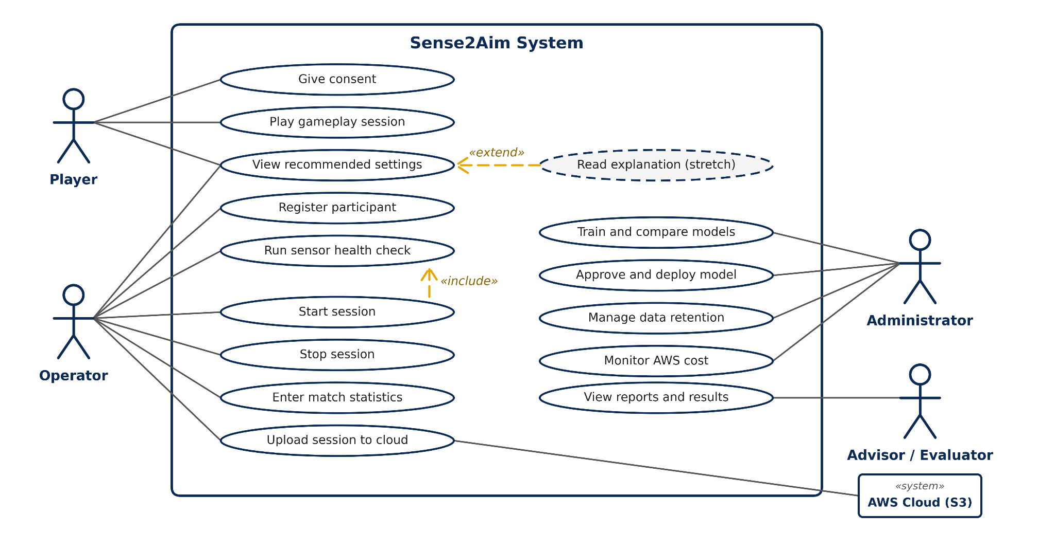
Figure 3. Use case diagram
Table 6. Proposed feature leads
Team member | Lead for
Noah Maniace (ECE) | 4.2 Controller and Gameplay Capture
Maira Penayo Nunez (ECE) | 4.3 Hand-Motion Sensing (radar); 4.4 Synchronization and Storage
Mallie Lawson (CS) | 4.3 Hand-Motion Sensing (webcam); 4.5 Feature Extraction
Sofia Filgueira Fernandez (CS & Math) | 4.6 Model Training; 4.7 Recommendation; 4.8 Cloud Pipeline and LLM
Kobe Thurmond (CS) | 4.1 Session Management; testing and validation

Session Management
4.1.1 Description and Priority
Lets the operator register participants, confirm consent, check the sensors, and control recordings. Priority: High.
4.1.2 Stimulus/Response Sequences
- Operator registers a participant → system checks the ID and asks for consent confirmation.
- Operator runs the health check → each stream is tested for 10 seconds; Start and Stop control all streams together.
4.1.3 Functional Requirements
SES-01: The system shall register each participant under a unique anonymous ID (P01, P02, …) and reject duplicate IDs. (High; Test)
SES-02: The system shall not start recording until the operator confirms the participant signed the consent form. (High; Test)
SES-03: Before recording, the operator shall select the study phase (A, B, or C) and the settings configuration from a predefined list. (High; Demonstration)
SES-04: The health check shall confirm that each enabled stream delivers at least 90% of its target rate for 10 seconds, and shall block recording if the controller or gameplay stream fails. (High; Test)
SES-05: One action shall start or stop all streams, and the operator shall be able to pause, resume, and add timestamped markers. (High; Demonstration)
SES-06: If a participant withdraws, the system shall stop recording immediately and mark the session as withdrawn. (High; Demonstration)
SES-07: When a session stops, the system shall save a metadata file with the participant ID, phase, configuration, times, streams, software version, and notes. (High; Inspection)

Controller and Gameplay Capture
4.2.1 Description and Priority
Records every controller input with a timestamp, the gameplay screen, and the match statistics. The controller is our main data source, so it must work even if every other sensor fails. Priority: High.
4.2.2 Stimulus/Response Sequences
- Session starts → the controller is opened read-only and OBS starts recording.
- Match ends → operator enters the match statistics and saves a scoreboard screenshot.
4.2.3 Functional Requirements
CAP-01: The system shall record both sticks, L2/R2, all buttons, and the gyroscope and accelerometer at no less than 250 Hz (TBD-2), timestamping each sample on arrival. (High; Test)
CAP-02: The system shall only read the controller and shall never remap, block, delay, or send inputs. (High; Inspection)
CAP-03: The system shall alert the operator within 1 second if the controller disconnects, and stop the session after 5 seconds without it, keeping the data already recorded. (High; Test)
CAP-04: The system shall record gameplay at 1920×1080 and 60 fps through OBS, controlled by the session manager. (High; Test)
CAP-05: For each match the operator shall enter map, mode, accuracy, kills, deaths, and length; the system shall reject impossible values and save a scoreboard screenshot. (High; Test)
CAP-06: The in-game settings used in each block (sensitivity, dead zones, response curve, aim assist, FOV, ADS, button layout) shall be saved with the session. (High; Inspection)
CAP-07: Study matches shall be private matches against bots with the same map, mode, and bot difficulty within a phase (TBD-3). (High; Inspection)
CAP-08: The system may detect hitmarkers in gameplay video to estimate hits over time. (Low; Test)

Hand-Motion Sensing (Webcam and Radar)
4.3.1 Description and Priority
Measures how the player physically makes each input, using the Full-HD webcam and the TI 60 GHz radar. The radar is not blocked when the hands cover each other, but its resolution is uncertain, so it must pass a test first. Priority: Medium.
4.3.2 Stimulus/Response Sequences
- Session starts → the radar is configured and both sensors start recording; landmarks are extracted after the session.
4.3.3 Functional Requirements
HMS-01: The system shall record the hands and controller with the webcam at 1920×1080 and at least 30 fps, timestamping each frame. (Medium; Test)
HMS-02: After the session, the system shall extract 21 landmarks per hand per frame with MediaPipe Hands [7] and mark frames with confidence below 0.5 as missing. (Medium; Test)
HMS-03: The system shall compute right-thumb speed and the time and distance between the right stick and the face buttons. (Medium; Test)
HMS-04: The system shall configure the radar from a saved configuration file and record its point cloud and Doppler output with a timestamp per frame. (Medium; Test)
HMS-05: The system shall compute radar motion features, such as Doppler energy and point count near the controller, for each time window. (Medium; Test)
HMS-06: Before Phase A, a bench test shall check whether radar features tell a thumb flick apart from a still hand with at least 80% accuracy; if not, radar is not used for recommendations. (Medium; Test)
HMS-07: If the processed radar output is too coarse, the system may record raw data through the DCA1000EVM. (Low; Demonstration)

Synchronization and Storage
4.4.1 Description and Priority
Puts every stream on one timeline so that a controller movement, a video frame, and a radar frame from the same moment can be compared, and stores the data safely. Priority: High.
4.4.2 Stimulus/Response Sequences
- Stop pressed → files are closed, checksums calculated, and metadata written.
4.4.3 Functional Requirements
SYN-01: Every sample and frame shall have a timestamp from the PC's monotonic clock with at least microsecond resolution. (High; Inspection)
SYN-02: Before Phase A, a synchronization test shall measure the delay and jitter of each stream (median and 95th percentile). (High; Test)
SYN-03: The system shall align all streams on a common timeline using the measured delays. (High; Test)
SYN-04: Each session shall be saved in the folder layout of Section 6.1 with a SHA-256 checksum per file and the missing samples per stream in the metadata. (High; Inspection)
SYN-05: Each session shall be copied to a backup drive within 24 hours. (Medium; Inspection)
SYN-06: If the FPGA is used (TBD-15), its timestamps shall be recorded as an extra stream; all High-priority functions shall work without it. (Low; Test)

Feature Extraction and Performance Scoring
4.5.1 Description and Priority
Turns raw data into features and one score so that speed and accuracy can be compared. The Aim Performance Score (APS) of a block is 0.4·z(accuracy) + 0.2·z(kills per minute) − 0.2·z(corrective movements per minute) − 0.2·z(overshoot rate), where z() standardizes each value against the Phase A data. The weights are starting values (TBD-9) stored in a configuration file. Priority: High.
4.5.2 Stimulus/Response Sequences
- Session saved → processing runs and the feature table is written.
4.5.3 Functional Requirements
FEA-01: For every 5-second window and block, the system shall compute controller features, including stick speed, direction changes, time at rest, trigger timing, and time between buttons. (High; Test)
FEA-02: The system shall count corrective movements (a right-stick reversal over 15% within 300 ms after a movement over 50%; TBD-6) and compute the overshoot rate. (High; Test)
FEA-03: The system shall compute the APS of each block with the configured weights. (High; Test)
FEA-04: Running the pipeline twice on the same session shall give identical results. (High; Test)
FEA-05: Before Phase A, the corrective-movement definition shall agree with at least 80% of 100 hand-labeled aiming movements from gameplay video. (High; Analysis)

Model Training and Evaluation
4.6.1 Description and Priority
Trains models that predict a player's APS and compare the sensing methods fairly. Because our dataset is small, simple models come first. Priority: High.
4.6.2 Stimulus/Response Sequences
- Administrator chooses a dataset version and model, the system trains, evaluates, and saves a report and model.
4.6.3 Functional Requirements
MDL-01: The system shall train a mean predictor, ridge regression, and gradient-boosted trees, and may train a small neural network such as a 1D CNN or GRU. (High; Test)
MDL-02: Each model shall be trained on four feature sets: controller and game only (baseline), plus webcam, plus radar, and plus both. (High; Test)
MDL-03: Models shall be evaluated with leave-one-participant-out cross-validation, so no player is in both training and test data. (High; Inspection)
MDL-04: The system shall report MAE, RMSE, and R² per model and feature set, and a Wilcoxon signed-rank test against the baseline. (High; Analysis)
MDL-05: Each run shall log its seed, dataset version, settings, and Git commit, and export a versioned model that runs offline on the capture PC. (High; Inspection)
MDL-06: A neural network shall only be used for recommendations if its MAE is lower than that of gradient-boosted trees. (High; Analysis)

Recommendation and Validation
4.7.1 Description and Priority
After a Phase B session, predicts how the player would score with other configurations and recommends the best one. Phase C then checks if the recommendation helps (SC-3). Recommendations are advice; the player changes settings in the game menu. Priority: High.
4.7.2 Stimulus/Response Sequences
- Phase B session processed, recommended settings, predicted change, confidence, and top reasons are shown.
- Phase C session processed, Phase B and C results are compared.
4.7.3 Functional Requirements
REC-01: After a Phase B session of at least 30 minutes, the system shall rank the Phase A configurations by predicted APS and recommend the best one. (High; Test)
REC-02: The system may also search values between tested configurations, labeled "interpolated". (Medium; Test)
REC-03: Recommended values shall always be values the game allows. (High; Test)
REC-04: Each recommendation shall show the predicted APS change, a confidence level, and the three most important features; if the gain is below the threshold (TBD-5), the system shall recommend keeping the current setting. (High; Test)
REC-05: Phase C shall use the same map, mode, and bot difficulty as Phase B, after at least 10 minutes of practice with the new settings. (High; Inspection)
REC-06: The system shall compare accuracy and APS between Phase B and Phase C for each player and report whether SC-3 was met. (High; Analysis)
REC-07: When time allows, Phase C should end with a short block using the original settings to separate the effect of the settings from practice. (Medium; Inspection)

Cloud Pipeline and LLM Explanation
4.8.1 Description and Priority
Stores processed data in S3 and trains models in HPC; models run locally. Our data is small, so AWS is used for shared access, and model versions, and the system must also work offline. As a stretch goal, Amazon Bedrock explains each recommendation in plain language. Priority: Medium.
4.8.2 Stimulus/Response Sequences
- Session complete → files are uploaded and checked.
- Recommendation generated → an explanation is requested, checked, and shown.
4.8.3 Functional Requirements
CLD-01: After each session, the system shall upload telemetry, radar, landmark, feature, and metadata files, but never raw video, to s3://<bucket>/sessions/<phase>/<participant>/<session>/. (Medium; Test)
CLD-02: Interrupted uploads shall resume, and each uploaded file shall be checked against its checksum. (Medium; Test)
CLD-03: A Glue job shall build the training table, and HPC training shall match the local MDL-04 results within ±2% MAE. (Medium; Test)
CLD-04: Models shall be stored in the HPC, and only a model approved by an administrator shall be deployed. (Medium; Demonstration)
CLD-05: All training and recommendation functions shall also work locally without AWS. (High; Test)
CLD-06: The system shall generate a 3–5 sentence explanation through Bedrock using only settings and numbers, never names, IDs, or video. (Low; Inspection)
CLD-07: If the explanation contains a setting or number not in the recommendation, or Bedrock does not answer within 10 seconds, a template explanation shall be shown. (Low; Test)

Other Nonfunctional Requirements

Performance Requirements
PER-01: Controller data shall be recorded at 250 Hz or more with less than 1% missing samples per session. (High; Test)
PER-02: The webcam shall record at 30 fps or more with less than 2% dropped frames, and the radar at 10 frames per second or more (TBD-1). (Medium; Test)
PER-03: After delay correction, the median mismatch between a controller event and the matching webcam frame shall be 20 ms or less, and never more than one frame of the slower stream in 95% of test events. (High; Test)
PER-04: Running all capture software shall lower the game's average frame rate by no more than 10%, measured over 5-minute runs. (High; Test)
PER-05: Features for a 60-minute session shall be ready within 15 minutes (45 minutes with hand landmarks), and the recommendation within 60 seconds after that. (Medium; Test)
PER-06: The health check shall take 30 seconds or less, and one session's non-video files shall upload within 10 minutes on the campus network. (Medium; Test)

Safety Requirements
SAF-01: Players shall take a break of at least 5 minutes every 30 minutes, and no session shall exceed 90 minutes; the console shall remind the operator. (High; Demonstration)
SAF-02: The operator shall stop the session immediately if the participant reports pain, discomfort, dizziness, or eye strain. (High; Inspection)
SAF-03: The radar shall only be used with manufacturer firmware and settings within its rated limits; cables and mounts shall be secured and no sensor shall touch the participant. (High; Inspection)
SAF-04: No data shall be deleted from the capture PC until its backup copy is verified by checksum. (High; Test)

Security Requirements
Formal IRB approval is not required for this learning project [2], but will be obtained. However, the project’s participant permission and consent process must be reviewed and approved by the faculty advisors before any participant data is collected. The project will also follow appropriate privacy and data-protection practices, including collecting only necessary data, using anonymous participant IDs, restricting access, and limiting data retention.
SEC-01: Participants shall be identified only by anonymous IDs; the list linking names to IDs shall be stored offline in an encrypted file only administrators can open. (High; Inspection)
SEC-02: The webcam shall show only the hands and controller, and any frame with a detected face shall be blurred before it is stored or shared. (High; Test)
SEC-03: Raw video shall stay on the encrypted local drive and never be uploaded to the cloud or GitHub; gamertags shall not appear in datasets, figures, or reports. (High; Inspection)
SEC-04: S3 buckets shall block public access, use server-side encryption, and accept only TLS connections. (High; Inspection)
SEC-05: The capture PC shall use an IAM user that can only write to its own S3 folder; team AWS accounts shall use MFA, and root keys shall not be used. (High; Inspection)
SEC-06: No passwords, keys, or participant data shall be committed to GitHub; .gitignore rules and secret scanning shall be on. (High; Inspection)
SEC-07: If a participant withdraws, all their data, local and in S3, shall be deleted within 7 days; raw video shall be deleted at the end of the project (TBD-8). (High; Demonstration)
SEC-08: AWS budget alerts shall be sent at 50% and 80% of the monthly limit (TBD-7). (Medium; Demonstration)

Software Quality Attributes
QUA-01: Code shall follow PEP 8 [14], checked by a linter in GitHub Actions, and every merge to the main branch shall be a pull request approved by another member. (High; Inspection)
QUA-02: The synchronization, feature, and scoring modules shall have pytest unit tests with at least 70% line coverage. (High; Test)
QUA-03: Every reported result shall be reproducible from a Git commit and a dataset version. (High; Demonstration)
QUA-04: Capture shall run 60 minutes without crashing in three pilot sessions in a row. (High; Test)
QUA-05: Each sensor stream shall be a separate module that can be turned off in the configuration file without breaking the others. (High; Test)
QUA-06: A trained operator shall go from powered-off hardware to recording in 10 minutes or less using the operator manual. (Medium; Test)

Business Rules
- BR-01: Only trained operators run sessions; only administrators delete data or approve models.
- BR-02: No data is recorded before consent is confirmed (SES-02).
- BR-03: Participation is voluntary and does not affect a player's place on the esports team; individual results are not shared with coaches without permission.
- BR-04: Participants must be 18 or older.
- BR-05: Recommendations are advice only; the system never changes game settings, reads game memory, sends inputs, or automates gameplay [13].

Other Requirements

Data Requirements
Each session is saved in its own folder, sessions/<phase>/<participant>/<session_id>/, with the files in Table 7. One hour of recording is about 9–10 GB, almost all of it video, so 20 participants with about 2.5 hours each need about 0.5 TB. This is why we plan an SSD of at least 1 TB (TBD-4).
Table 7. Session files
File | Contents | Stored
metadata.json | IDs, phase, settings, times, streams, gaps, software version, notes | Local + S3
controller.parquet | Timestamp, sticks, triggers, buttons, gyroscope, accelerometer | Local + S3
radar.parquet | Timestamp, frame, point positions, Doppler, signal strength | Local + S3
hand_landmarks.parquet | Timestamp, frame, hand, landmark ID, position, confidence | Local + S3
matches.json + screenshots | Map, mode, accuracy, kills, deaths, length; scoreboard images | Local + S3
features.parquet | Participant, phase, configuration, block, window features, APS | Local + S3
gameplay.mp4, hand_video.mp4 | Gameplay and webcam video (about 9 GB per hour together) | Local only

Legal and Ethical Requirements
The system follows the Call of Duty terms of use [13]. Participants receive an information sheet and consent form explaining what we record, why, where it is stored, for how long, and how to withdraw. All libraries must have licenses that allow academic use, such as MIT, BSD, or Apache 2.0. The capture, synchronization, and feature modules do not depend on one game, so they can be reused with an aim trainer (our backup in AS-1 to AS-3) or by future teams.
Appendix A: Glossary
Table 8. Glossary
Term | Meaning
ADS / FOV | Aim down sights / field of view (how wide the game view is).
APS | Aim Performance Score, the combined score defined in Section 4.5.
Corrective movement | A quick reversal of the right stick right after a large aiming movement (FEA-02).
Deadzone | The area around the stick center that the game ignores.
DualSense | The PlayStation 5 controller.
HID | Human Interface Device, the USB standard used by controllers [10].
LOPO | Leave-one-participant-out: testing a model on a player it never saw in training, repeated for every player.
MAE / RMSE / R² | Standard measures of prediction error and fit.
mmWave radar | Radar using very short radio waves that can sense small motions.
Overshoot rate | Share of large aiming movements that go past the target and need correction.
Parquet | An efficient file format for data tables.
S3, Glue, SageMaker, Bedrock | AWS services for storage, data processing, model training, and LLMs.

Appendix B: Analysis Models
Our analysis models are the system context diagram (Figure 1), the data-flow diagram (Figure 2), and the use case diagram (Figure 3). Table 9 shows where this SRS addresses each comment from our proposal evaluation [2].
Table 9. Traceability to proposal feedback
Evaluation feedback | Addressed in
No software architecture, data format, or storage design | Figures 1–2; Sections 3, 4.4, 6.1
AWS and LLM only in the slides | Section 4.8 (CLD-01 to CLD-07)
No measurable success criteria; speed vs. accuracy undefined | Table 1; APS in Section 4.5
Recommendations only among tested settings; no plan for new players | REC-01, REC-02; Phase B in Section 2.2; MDL-03
Neural network needs simpler baselines | MDL-01, MDL-06
"High-speed" camera vs. standard webcam; radar frame rate | Section 2.5; HMS-01, HMS-06; PER-02, PER-03
Human subjects and data management | Sections 5.2, 5.3, 6.1; BR-02 to BR-04
Budget/SSD size; team roles; Spring 2027 schedule | Section 6.1; Table 6; Table 4

Appendix C: To Be Determined List
Table 10. Open items
ID | Open item | Planning value
TBD-1 | Radar frame rate the TI board delivers reliably | ≥ 10 frames/s
TBD-2 | Controller sample rate while the game runs | ≥ 250 Hz; test by Dec 2026
TBD-3 | Call of Duty title, map, mode, bot difficulty | Private match vs. bots
TBD-4 | SSD size | 1 TB minimum
TBD-5 | Success thresholds; minimum gain to recommend a change | Table 1; 0.1 APS units
TBD-6 | Corrective-movement thresholds | 50% / 15% / 300 ms
TBD-7 | AWS monthly limit | $50, credits first
TBD-8 | Data kept after May 2027 | Delete video; keep anonymous features
TBD-9 | APS weights | 0.4 / 0.2 / 0.2 / 0.2
TBD-10 | Phase A configurations and block length | 5 configurations × 2 blocks × 8 min
TBD-11 | Final feature leads, including Kobe's role | Table 6
TBD-12 | Number of participants | 10–20
TBD-13 | Dashboard framework | Streamlit
TBD-14 | GitHub repository link | To be added
TBD-15 | Whether the FPGA is used, and its role | Optional timestamps only

