Santiago Fleiderman

Programming Challenge 8

**PART I**

#include <stdio.h>

#include <stdlib.h>

int main()

{

char word[40];

char check[40];

int m=0;

int i=0; // count

int total;

int bit;

int length;

bit=0;

printf("Enter a Message: ");

gets(word);

//printf("word is %s \n",word);

total = strlen(word);

// Removes the spaces and commas to get just the chars.

for(m=0;m<total;m++) {

char ch = word[m];

if((ch >= 65 && ch <= 90 )||(ch >= 97 && ch <= 122)){

check[i] = ch;

i++;

printf("%c \n ",ch);

}

}

length = strlen(check);

printf("length is %d \n",length);

printf("string is %s \n",check);

m=0;

//length = length/2;

//while(m<length){

//printf("m=%d \n",m);

while (m<length/2){

printf("char by char %c %c \n",check[m],check[length-1-m]);

printf("%d ",m);

char checkAll;

checkAll = check[m]-check[length-m-1];

if ((checkAll!=32)&&(checkAll!=-32)&&(checkAll!=0)){

bit = 1;

break;

}

m++;

}

if (!bit){

printf("Yes palindrome");

}

else if (bit){

printf("not palindrome");

}

getchar();

return 1;

}

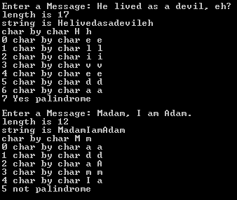

**PART II**

#include <stdio.h>

#include <stdlib.h>

#include <string.h>

int main()

{

char word[40];

char check[40];

int m;

char *wordpointer = word;

char *checkpointer = check;

int i=0; // count

int total;

int bit;

int length;

bit=0;

printf("Enter a Message: ");

gets(word);

//printf("word is %s \n",word);

total = strlen(word);

// Removes the spaces and commas to get just the chars.

for(m=0;m<total;m++) {

char ch = *(wordpointer+m);

if((ch>='a' && ch <='z')||(ch>='A' && ch <='Z')){

check[i] = ch;

//printf("Prints the letters %c \n",check[i]);

//check[i] = ch;

i++;

}

}

length = strlen(check);

printf("length is %d \n",length);

printf("string is %s \n",check);

m=0;

//length = length/2;

//while(m<length){

//printf("m=%d \n",m);

while (m<length/2){

printf("char by char %c %c \n",check[m],check[length-1-m]);

char checkAll;

checkAll = check[m]-check[length-m-1];

if ((checkAll!=32)&&(checkAll!=-32)&&(checkAll!=0)){

bit = 1;

break;

}

m++;

}

if (!bit){

printf("Yes palindrome");

}

else if (bit){

printf("not palindrome");

}

getchar();

return 1;

}

