**–––** SIARD Suite – Getting Started

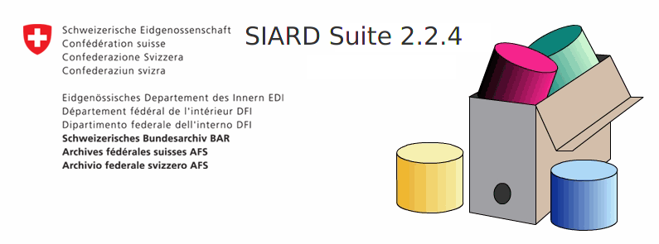

Date: 07.09.2022

Version: 1.3

# Prerequisites and Software Download

A Java Runtime Environment 1.8 (JRE) is needed in order to run SIARD Suite on your system. You can either install a JRE on your system or download a release package that includes the JRE for your operating system.

SIARD Suite with pre-packeged JREs are available for the following systems:

* Windows 32 and 64 Bit
* Linux 32 and 64 Bit

In order to run SIARD Suite on other operating systems or with an installed JRE on an operating system you can download the distribution that has no bundled JRE.

All releases are available on the GitHub Release Page: <https://github.com/sfa-siard/SiardGui/releases>

Note: Versions prior to 2.2.x are available only without a bundled JRE. We recommend to use the latest version.

# Installation

Unzip the downloaded ZIP at any location and follow the instructions for your operating system below.

## Windows

Depending on your setup, there are different options to install SIARD Suite:

* Double click siardgui.cmd or run siardgui.ps1 from the unpacked folder.
* Manually execute lib/siardgui.jar from the command line.

### Option 1: No security barriers

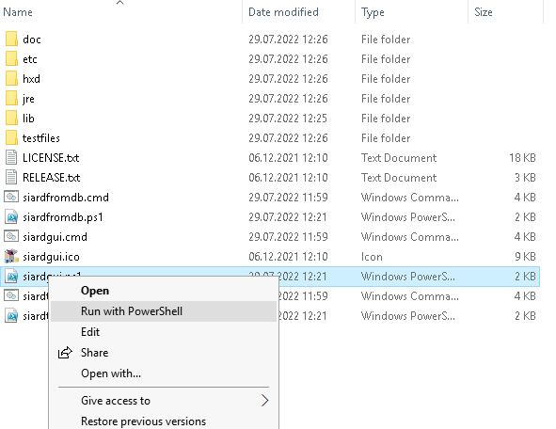Navigate to the folder where you’ve just unzipped the application and double click siardgui.cmd or right-click siardgui.ps1 and select Run with PowersShell.

### Option 2: Run from the command line

Open a command window (Windows + R, then type “cmd”) and navigate to the application folder. Start the application with the bundled JRE:

**jre\bin\javaw.exe –jar lib\siardgui.jar**

If you are not allowed to run exe files on your machine, you need to have a preinstalled JRE 1.8. Download the distribution without a bundled JRE, then run:

**javaw.exe –jar lib\siardgui.jar**

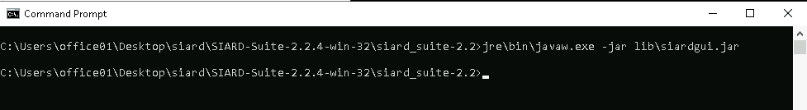

After running either option 1 or option 2, the following window will open automatically:

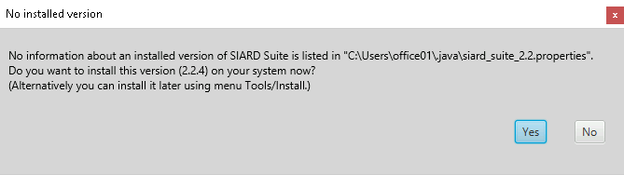

If you choose “Yes”, you will be prompted to enter the name of a new or empty folder where a copy of the SIARD distribution will be installed. Actually “Installation” means that

* the application binaries and dependencies are copied to the specified folder,
* a shortcut to run the application is created on your desktop (if possible),
* the application settings are stored in the user's home directory.

## Linux

* Download SIARD Suite distribution for Linux (32 or 64 bit or without JRE) and unzip the archive.
* Open a terminal and navigate to the folder where you’ve unzipped the archive.
* Run ./siardgui.sh and follow the installation instructions.

# First steps

The installation created a desktop shortcut (on windows) that you can use to start the application. Alternatively, you can follow of the steps above to run the application from the installation folder that you’ve chosen.

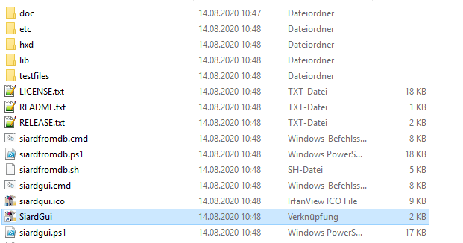

The main window will open, which first always appears empty. It consists of a menu, navigation tree, content and a status line.

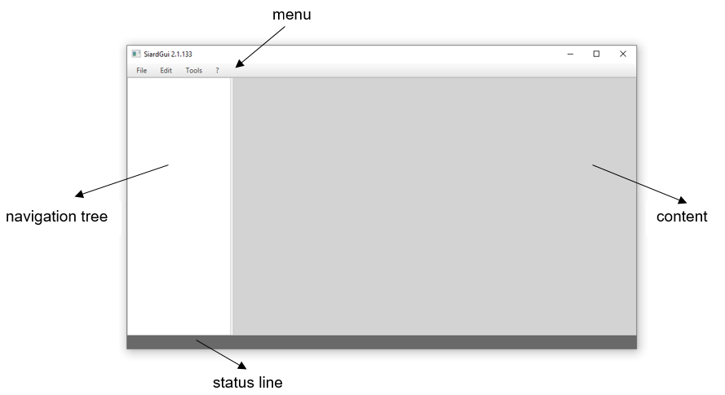

Note that the menu items are disabled if they are not applicable to the current situation.

* Open a file at *File > Open*

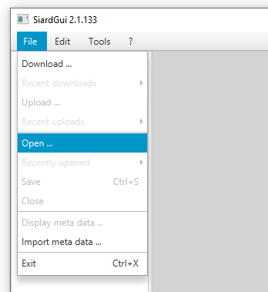

* You can browse the archive using the navigation tree and see the data in the content area.

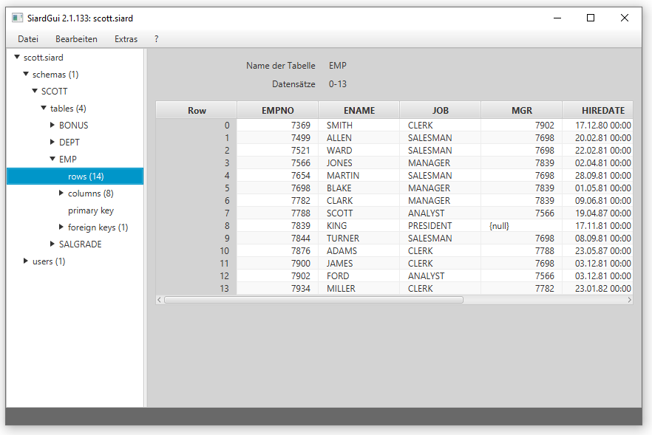

* The user manual is available at *? > Help.*

