**–––** SIARD Suite for Windows – Getting Started

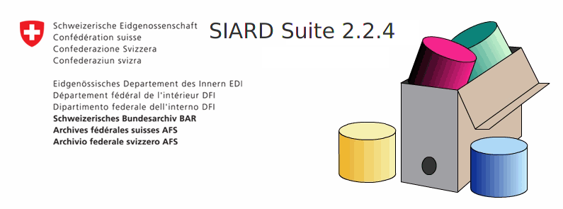

Date: 29.07.2022

Version: 1.1

# Installation

* Download the latest release of “SIARD-Suite-2.2.xxx.zip” for your operating system from the GitHub release page: https://github.com/sfa-siard/SiardGui/releases
  + Note: Versions prior to 2.2.x did not include a Java Runtime Environmet. That is why there are no OS specific downloads for these versions. Refer to the corresponding manuals on how to get started with these versions of SIARD Suite
* Unzip the downloaded release at any location.
* Depending on how the computer is set up, there are different options to install SIARD Suite (for Windows):
  + Double click siardgui.cmd or run siardgui.ps1 from the unpacked folder
  + Manually execute the jar file from the command line

# Windows

## Option 1: No security barriers

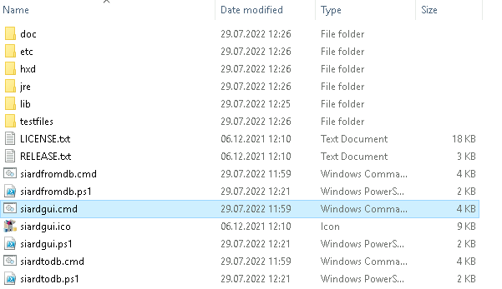

Navigate to the unzipped folder siard_suite-2.x and double click on the file siardgui.cmd or right-click siardgui.ps1 and select Run with PowersShell.

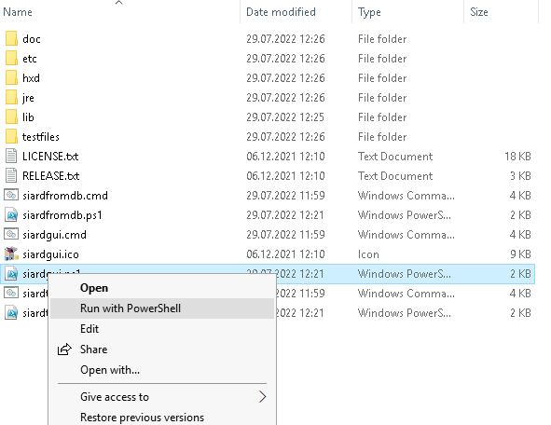

## Option 2: Run from the command line

Open a command window (Windows + R, then type “cmd”) and navigate to the path of the file siardgui.cmd described above. Start the application with the bundled JRE:

**jre\bin\javaw –jar lib\siardgui.jar**

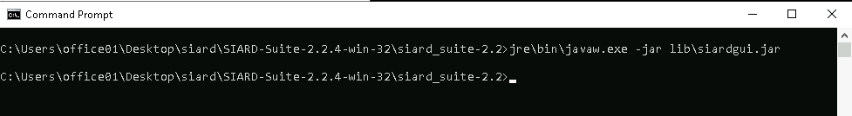

→ Whichever option you choose, the following window will open automatically:

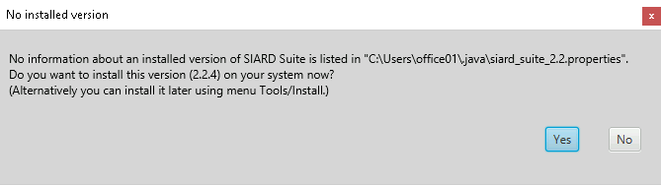

If you choose “Yes”, you will be prompted to enter the name of a new or empty folder where a copy of the SIARD distribution will be installed.

# Linux

* Download SIARD Suite distribution for Linux (32 or 64 bit) and unzip the archive.
* Open a terminal and navigate to the folder where you’ve unzipped the archive
* run ./siardgui.sh and follow the installation instructions

# First steps

The installation created a desktop shortcut (windows= that you can use to start the application or run use one of the steps above to run the application from the installation folder that you’ve chosen.

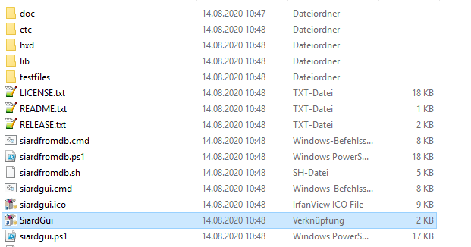

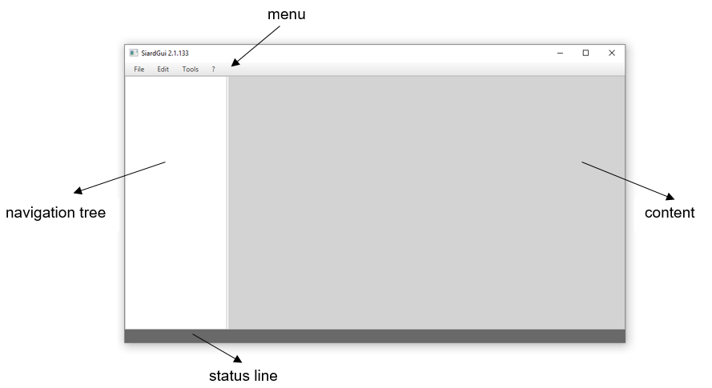The main window will open, which first always appears empty. It consists of a menu, navigation tree, content and a status line.

Note that the menu items are disabled when they are not applicable to the current situation.

* Open a file under *Menu > File > Open*

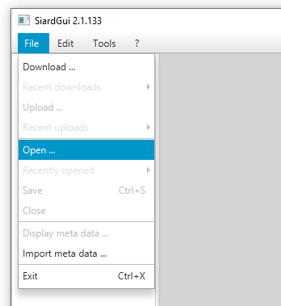

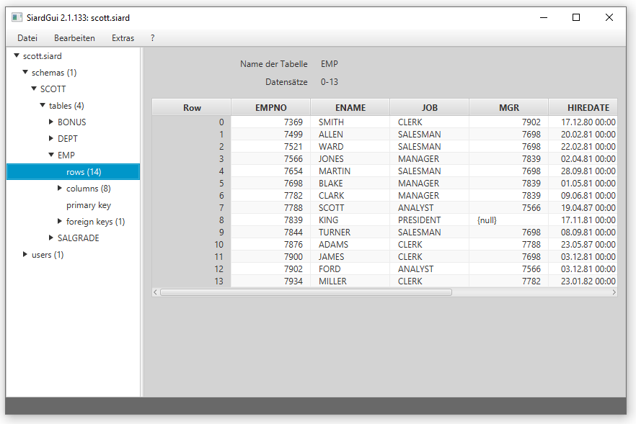

* Select your preferred language under *Menu > Tools > Language*

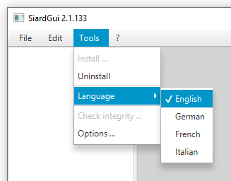

* You can find the extensive user manual under *Menu > ? > Help.* This will help you with all further steps while using SIARD Suite

