CSEC 730 - Advanced Computer Forensics
Unix Forensics Lab
Sumayyah Fahad

Due Date: Please submit your answers to the Linux Lab dropbox by midnight of 10/7/2018.

Objective
This lab will use Autopsy (GUI) and Sleuthkit to analyze a Linux image. You will practice the Sleuthkit tools at data layer, meta data layer, file system layer and file name layer in Part 1. In part 2, you will learn Autopsy, a GUI-based front-end for Sleuthkit, basic features for forensic analysis. Finally, you will provide a short conclusion for your analysis of a given image. The steps provided below are only the guidelines. Please feel free to try a variety of Sleuthkit tools with different options to fully understand this powerful tool.

Case Scenario
Mark Watson works as a Director of Finance at an advertising firm. He suspects that a contractor, Frank Lewis, has read the confidential annual financial report (Earnings.xls) to influence his next contract with the firm. The IT administrator informed you that there is a Linux-based file server in the office where all employees save the official documents. Mark and Frank each have their own folders on this server.
You have been given the image of the hard drive, Linux_Financial_Case.001, to find any evidence that suggests Frank may have read Earnings.xls.

Evidence File
The acquired image “Linux_Financial_Case.001.zip” is posted on myCourses > Content > Hands-on Labs.

After you download and extract the image .zip file, validate both its md5 and sha1 hash values:
- MD5 (Linux Financial Case.001) = 7b39de0ca146c89ad73d1d421c8f7a05
- SHA1 (Linux Financial Case.001) = c7b06f006ff79711e692bd2620aba4cc2a4426d2
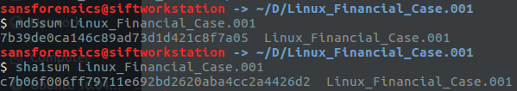

Deliverable
Answer all the exercise questions and include screenshots as supporting data if required.

******************************************************

PART 1. Practice the sleuthkit commandline tools to analyze the image “Linux_Financial_Case.001”

Instructions
- Launch the SIFT Workstation 3. The default login username is sansforensics, and the default password is forensics.
- The image “Linux_Financial_Case.001” contains one partition. In able to analyze this image, you have to first find the offset of the starting sector for the partition.
Question 1. What is the command along with appropriate options you used?
mmls Linux_Financial_case.001
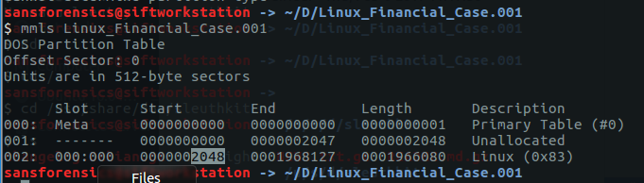

- Find the image’s file system information. You have to provide the offset you got from step 2.
Question 2. What is the command along with appropriate options you used?
fsstat -o 2048 Liunux_Financial_Case.001
Question 3. What type of file system is the image used?
Ext2
Question 4. In which scenarios, you do not have to use the offset option –o for a sleuthkit command?
So basically -o used to specify the sector offset of the image file where the file system start. If the file sector starting from zero, in this case we don’t have to use -o to specify the offset start. Sometime without this value we will be having “invalid magic value” error. So I am assuming in specific file system such as EXTxFS we don’t have to use -o.

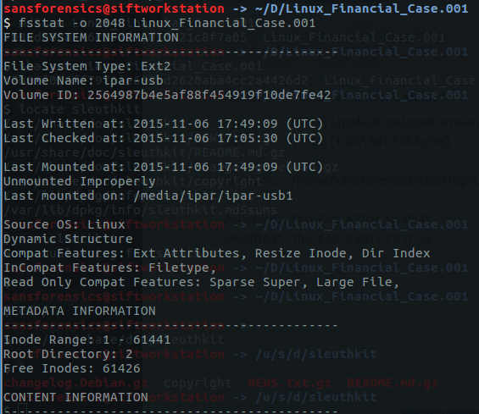

- Use fls to list the deleted files and directories, as a mactime body (-m), and save the file as flsBody.
Question 5. What is the command along with appropriate options you used?
fls -f ext2 -o 2048 -d -m / Linux_Financial_Case.001 >flsBody
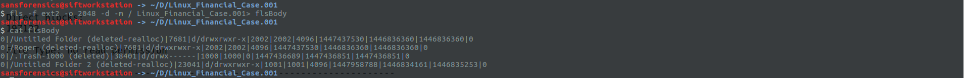

- Use Sleuthkit’s mactime to create a timeline of flsBody. Save the timeline in a file called flsMactime and examine the timeline.
Question 6. What is the command along with appropriate options you used?
mactime -b flsBody > flsMactime
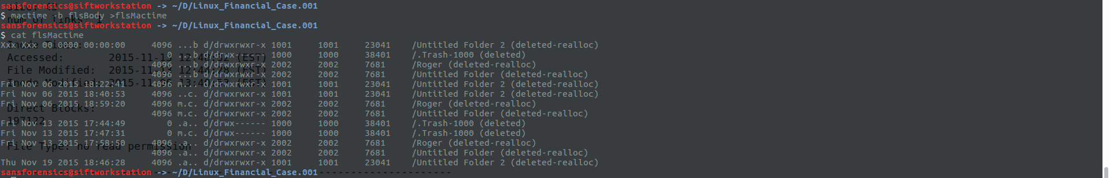

- Use ils to list the inode information for all deleted files, as a mactime body (-m), and save the file as ilsBody.
Question 7. What is the command along with appropriate options you used?
ils -f ext2 -o 2048 -aL -m Linux_Financial_Case.001 >ilsBody

- Use Sleuthkit’s mactime to create a timeline of ilsBody. Save the timeline in a file called ilsMactime and examine the timeline.
Question 8. What is the command along with appropriate options you used?
mactime -b ilsBody > ilsMactime
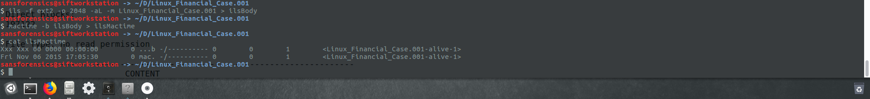

- Compare the number of entries from ilsMactime and from flsMactime.
Question 9. Do ilsMactime and flsMactme have the same number of entries? Explain your findings.
No. they have different number of entries. Because not all listed deleted file still have its inode information.
- use istat to view the details of the inode 46082.
Question 10. What is the command along with appropriate options you used? Include a screenshot.
istat -f ext2 -o 2048 Linux_Financial_case.001 46082
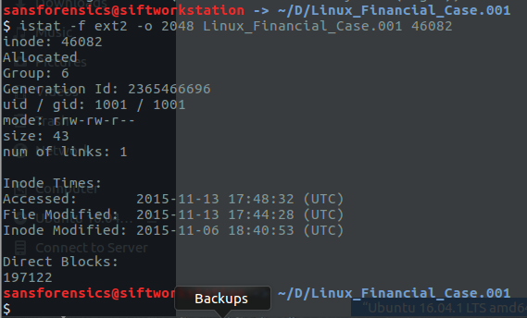
- use icat to dump out data from the inode 46082.
Question 11. What is the command along with appropriate options you used?
icat -f ext2 -o 2048 Linux_Financial_case.001 46082
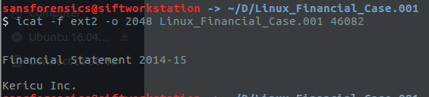
- Use ffind to find the file’s filename that has the inode 46082.
Question 12. What is the command along with appropriate options you used? Include a screenshot.
ffind -f ext2 -o 2048 Linux_Financial_case.001 46082
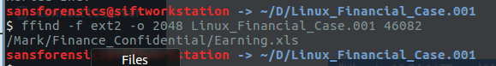

- Use blkcat to dump out the data content of the datablock 197122
Question 13. What is the command along with appropriate options you used?
blkcat -f ext2 -o 2048 Linux_Financial_case.001 197122
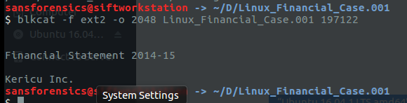
Question 14. If a file with the inode 100 uses two block addresses, block 1000 and block 1001, will “icat -f ext2 image 100” dump out the same content as the command “blkcat –f ext2 image 1000”? Explain your answer.
Yes because icat will present the content of a specific file by its given inode while blkcat present the content of a file given its block number. So both will dump out same content but icat may show more information, since blkcat will show only 1 portion of that file.

- Use ifind to find the inode number that one of its correspondent data blocks is 197122.
Question 15. What is the command along with appropriate options you used? Also provide a case scenario that shows the usefulness of ifind.
ifind -f ext2 -o 2048 Linux_Financial_case.001 -d 197122
In a scenario where we have to find the inode number given only the name file and the corresponding block, Ifind tool would be useful to map the block to its inode number so the investigator can find its meta data.
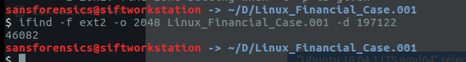

PART 2. Use Autopsy to analyze “Linux_Financial_Case.001” case

Instructions

To Start autopsy:
Start a terminal (go to applications -> Accessories->Terminal) and type in
$ sudo autopsy
While this process is running, open a web browser point it to the URL indicated – http://localhost:9999/autopsy

Click on “New Case”.

Enter “linux_financial_case” as the case name, you may fill in other optional information, then click “New Case”. Confirm the information and click “OK”. (Names with spaces will not work.)

Click “Add Host”.
Enter “Host1” under “Host Name” and “EST” under “Timezone” and click “Add Host”.

Confirm the information and click “ADD HOST”.
Click “Add Image”.
Click “ADD IMAGE FILE”.

Select “Disk” since this image contains a disk image (vs a partition).

In “Location” type the path to the image file “Linux_Financial_Case.001”.

Explore the various “Import Methods”.

Review the options for checking / creating md5’s and select the appropriate entry based on the information you currently have.

Question 1: Which option did you choose and why?
I chose add and verify the following md5 hash because we have the hash in advanced. After verifying the hash is the same.
Autopsy identifies the partition and the file system type of this partition.

Question 2: Which Sleuthkit tool does Autopsy use to identify the partition?
Mmls

Question 3: Which Sleuthkit tool does Autopsy use to determine the file system type of this partition?
Fsstat

Click “Add” to add the image to host 1.
Confirm the information and click “OK”.

Now Autopsy should have mounted the partition.
Select the partition, click “Analysis” and choose “FILE ANALYSIS” tab.

In this mode, you can view file and directory metadata and file content.
Click the inode of directory Mark, 23041, to see the detail information about Mark’s directory.

Go to Mark/Finance_Confidential directory, and click on Earning.xls file. In the information window at the bottom, explore the “display”, “report”, “export” links.

Question 4 What information do you get from “display” and “report”? What does “export” do?

Display: show Earning.xls file’s path location.
Report: general information like hashes and offset. Also meta data information like inode, group and generation id.
Export: it will export the xls file by download/ save it

From here you can recover any of the files shown, including deleted ones if the content has not been overwritten.

Question 5: How can you determine that a file has been deleted?
We can press the “deleted file” button to show us all the deleted file or when browsing the directories, a deleted file will have a check mark to show it’s deleted.

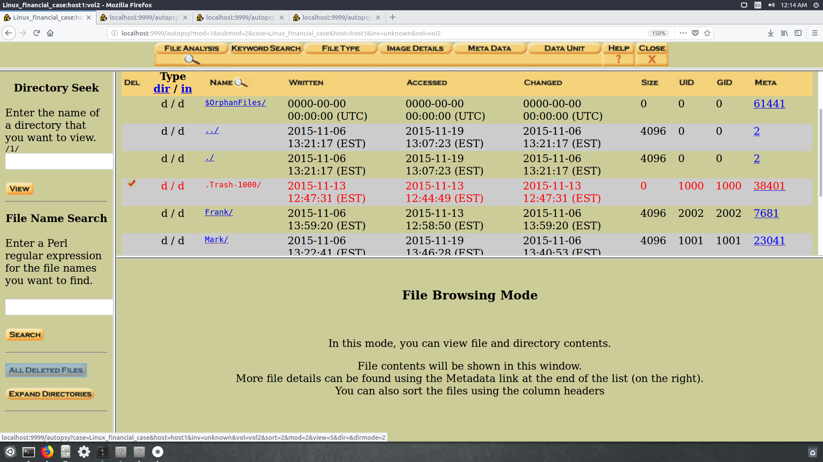

Click “File Type”. Then click “Sort Files by Type”. Then click “OK”.

Question 6: How is “Sort Files by Type” formation useful in an investigation?

This feature, sorting file by type, is quite important for the investigator in order to explore more information about the image. It present the file, file skipped and detailed category. The classification and the total number of files on the image will help the investigator have a better understanding of the image structure.
To view sorted file, click on “View Sorted Files” and copy/paste the URL into a browser.

Click on “Meta Data” and provide a valid inode number.

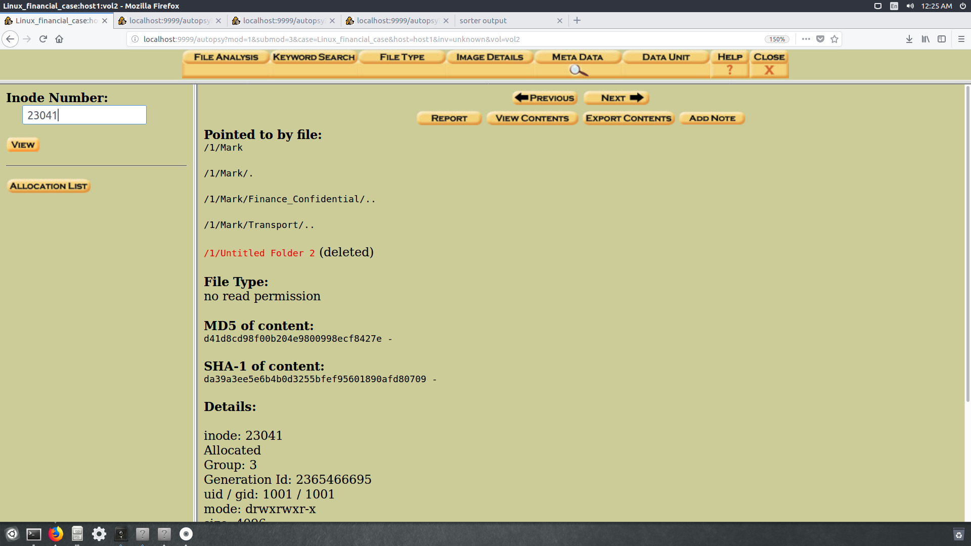

Question 7: Knowing an inode number, which Sleuthkit tool does Autopsy use to determine the data blocks referenced by the inode?
Istat
Click on the “Image Details” tab and read the information given.
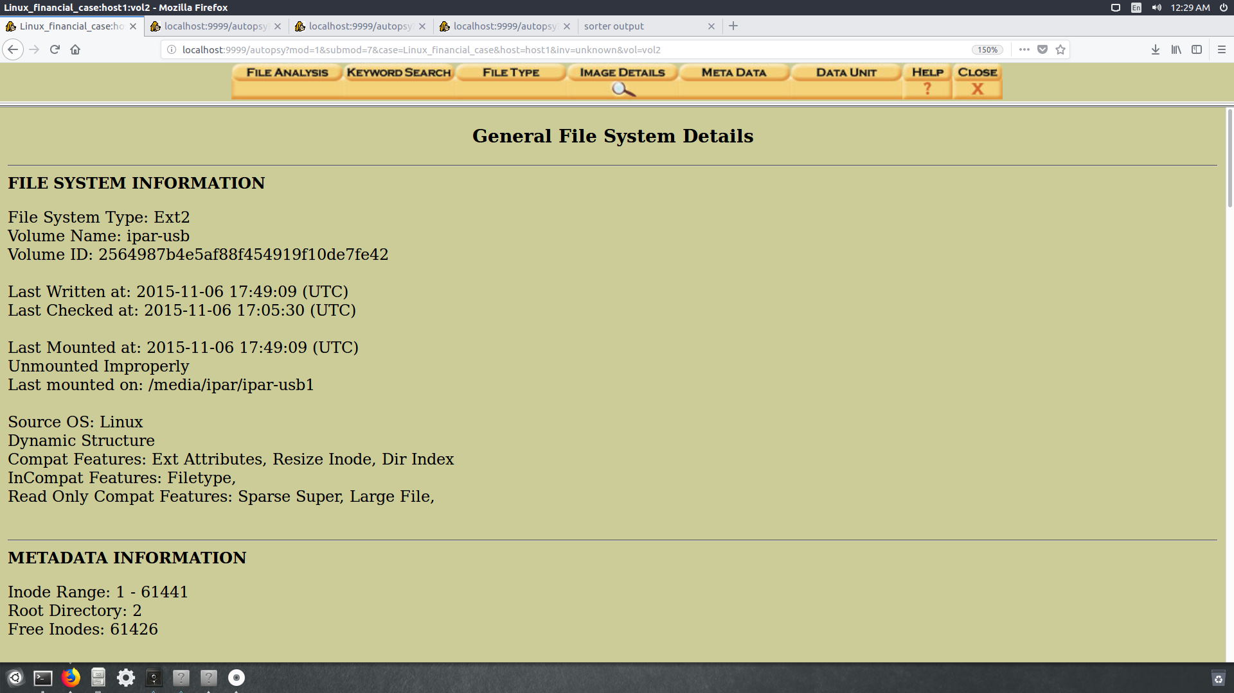
Question 8: What information can you get from this window? Where does Autopsy get this information from?
From fsstat, you can get many important information about the image file system such as the type of the file system the volume id and volume name. Also, meta data information such as inode range, root directory and number of free inode.

Click the “Close” tab to close the “Analyze”, and you will be back to the “Host Manager”.
select the partition and click “File Activity Timelines”
Click “Create Data File”.
Select the disk partition and click “OK”, and confirm the information.
Question 9: What Sleuthkit command line tool(s) was/were used to generate the body file?
Fls with -o -f -m
Click “OK”.Now we have the body file, we can sort the body file to generate a timeline.
Autopsy this version has a bug for creating a timeline.
To fix it, you will run “sudo cp /usr/bin/mactime /usr/bin/mactime-sleuthkit”.
In the “Create Timeline” window, you can select the starting and ending dates of file activity that you want to see, for example, from Jan. 2015 to Jan. 2016.

Note the sorted information. Click the links at the top to look at other dates.
Question 10: How might this timeline information be useful for forensic investigations?
In case there are some malicious activity that happen in a specific time, the investigator can go back to the period of time ane retrieve the data. So the investigator doesn’t have to search byond the period of time that he is interested in. and that information include access, modification and changing time.

Click “Close”.Back to “Host Manager” Explore any other features of Autopsy & Sleuthkit you would like to.After you are done, close the case by clicking “Close Host” then “Close Case”. You can reopen the case to work on it later if you choose to.

Part 3. Report
Now you are familiar with Autopsy/Sleuthkit features. Read the case scenario again,
provide your statement and evidence that indicates Frank may have read Earnings.xls.
Why is Frank able to read a confidential document?
and how to change permissions, so that “Earning.xls” file will not be accessible by others?

Yes frank may have read the earning file because the couple entries in the timeline below shows that in Nov 13 a link has been created to the earning file by frank.
Frank was able to read the earnings file because the file permission allowed him to as it shown below the permission for the the group and all users allow anyone to read the file.
We have to change the permission so that unauthorized users are not able to read or write the confidential file. chmod 700 /Mark/Financial_Confidential/Earning.xls

