Open Shortest Path First (OSPF)

Sumayyah Alahmadi [sfa8135@rit.edu](mailto:sfa8135@rit.edu)

CSEC.744.01

Professor Jonathan Weissman

**Table of contents**

1. OSPF theory ...……..……………………………………………………………….. 3
2. OSPF implementation ..…………………………………………………………….. 4
3. Conclusion……………………………………………………………………………. 16
4. References ……………………………………………………………………………. 17

OSPF Theory:

OSPF is a dynamic routing protocol and it stands for open shortest path first and it is referring to the shortest path in term of cost or metric. OSPF is an interior gateway protocol. It contains multiple area and each area has multiple router range from 50 to 70 routers. All area must be attached physically or virtually to the backbone are which is area zero. In each area there is one router that is responsible for updating other OSPF router, and it has the highest priority; this router called the Designated Router (DR). In case if the designated router failed or shut down there are is a backup designated router. There are two types of network point to point and broadcast segment. In point to point no DR or BDR election is needed. There are many types for the ospf packet which are: Hello, DBD, LSR, LSU and LSACK. All these types are based on LSA link state advertisement which is the router way to communicate information within OSPF and it reboots every 30 minutes. We need to identify uniquely the router ID which is 32-bit identifier that should not be confused with the IP address. It’s responsible for sourcing and receiving LSA. Process ID: locate to the router, and it keeps track of the maintain local database for OSPF. ARP is an area border router that has one interface in the backbone area and the other interface is not in the area 0. We can choose null or set a password to authenticate OSPF routers whether by a plain text type 1 or md5 encryption type 2 which is more secure than plaintext and harder to sniff. The hello LSA contain the router ID, the priority, subnet mask, network ID and the router ID for the designated router and for the backup designated router. We can elect the designated router based on the following criteria: first router that comes up within 40 second. If all router comes up with the same time, then we elect by the router with highest priority which is usually range from 0 to 255. Lastly, if both previous criteria didn’t work, we choose the router with the highest router ID.

OSPF implementation:

Topology:

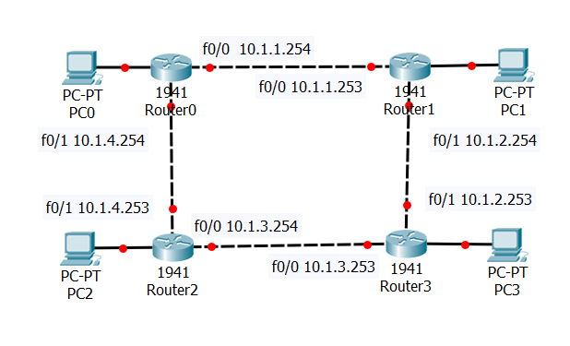

we will have 4 routers with 4 different subnets and 4 hosts as a console for each router. First we have to assign IP for each 8 interfaces for 4 routers then we make sure that every interface has the right IP address and the status is up by using the command: show ip interface brief. Here are 4 screenshots for each routers.

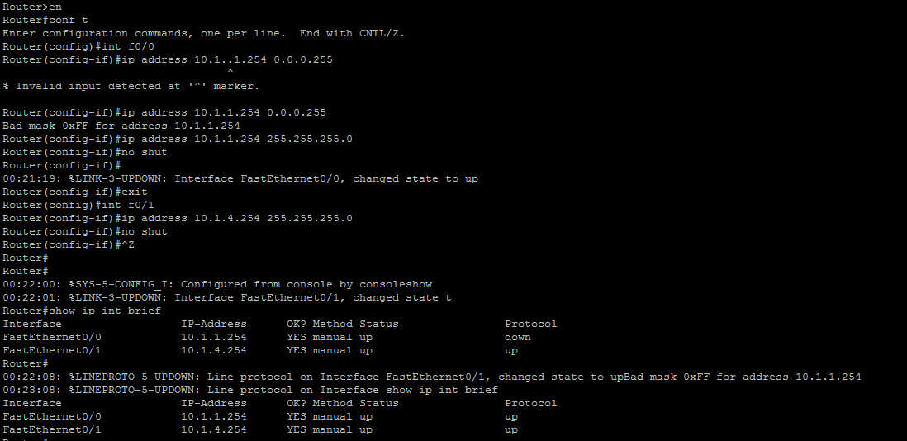

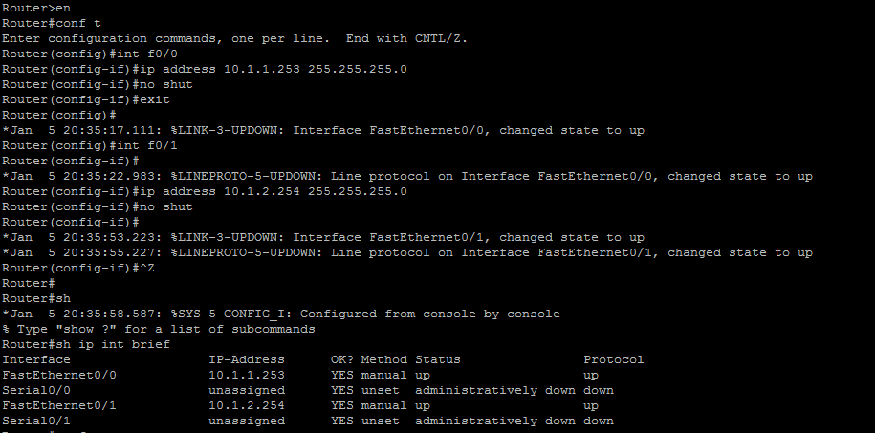

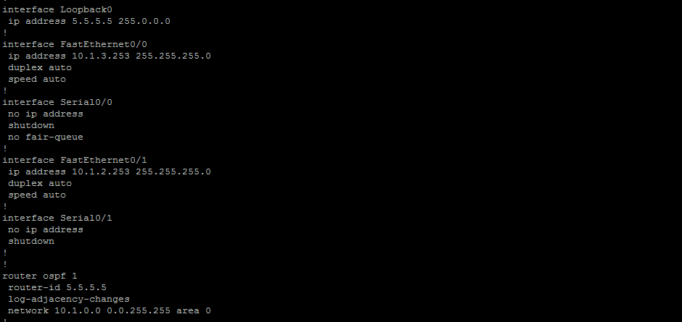

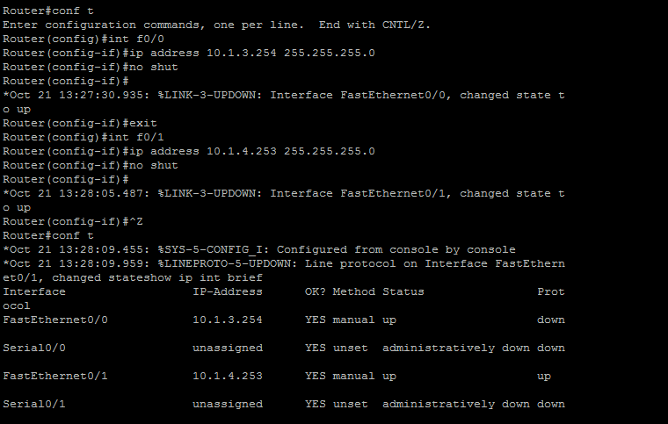

Then we setup OSPF by using the following command : router ospf #. Where the number is a for the process ID. We determine the network IP and the area number by the following command: network (network ip) (wild cart) area (area number). Where the wild cart is the opposite of the subnet mask. We have to sustutute every 0 with one and every one with 0, then calculate the decimal form. Here are four screenshots for seeting up ospf for the 4 routers and determine the area number.

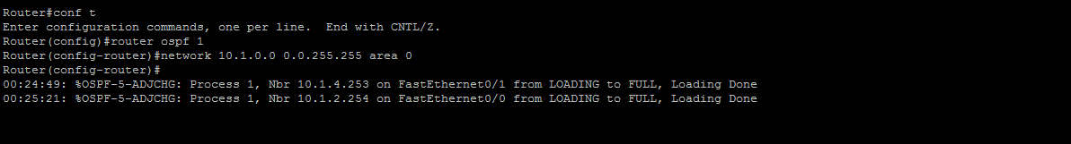

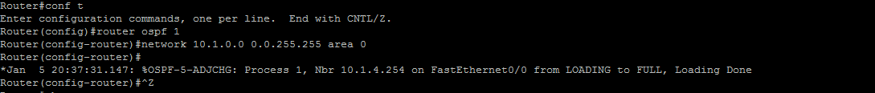



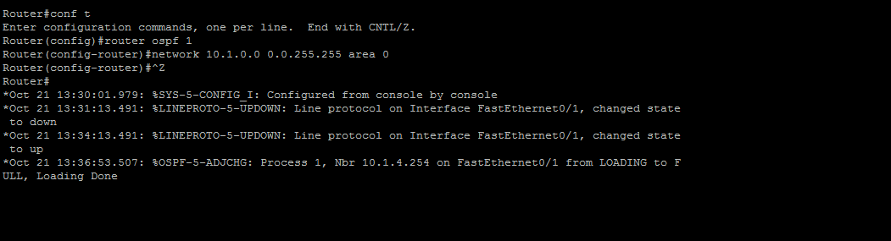

Then to show the convergence phase where we can see the full path and the complete map which subnet connect to which interface. We use the command: show ip route.

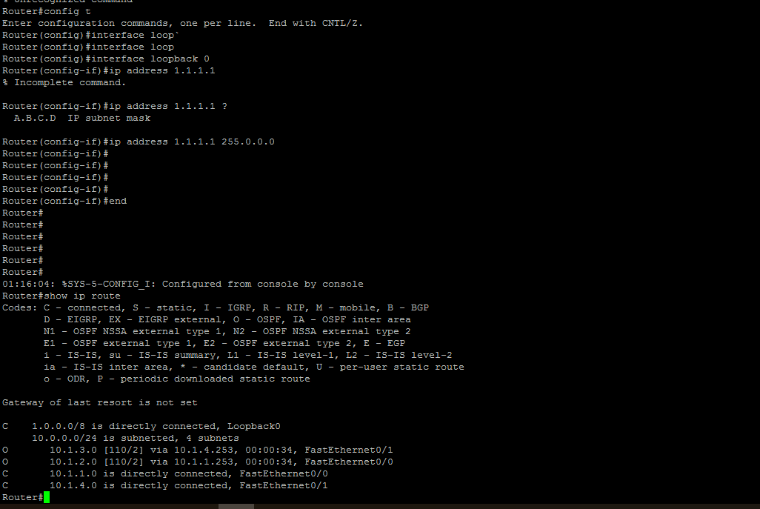

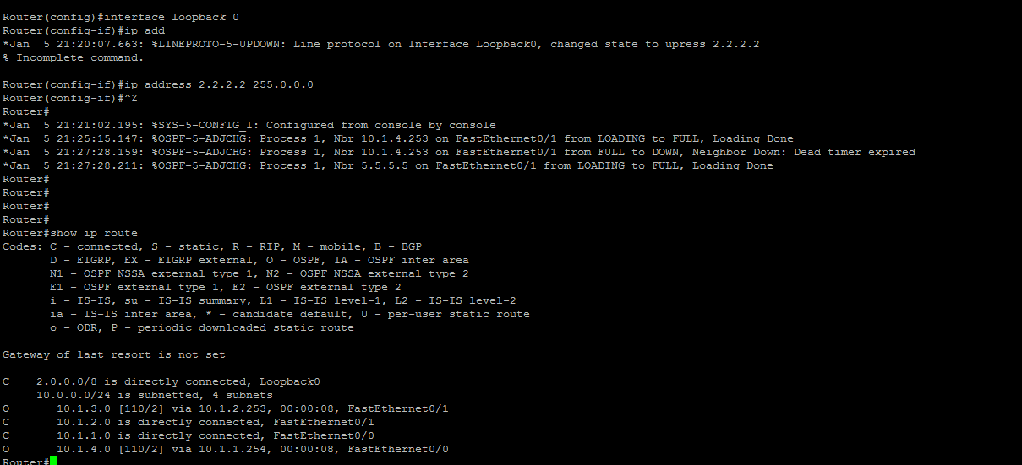

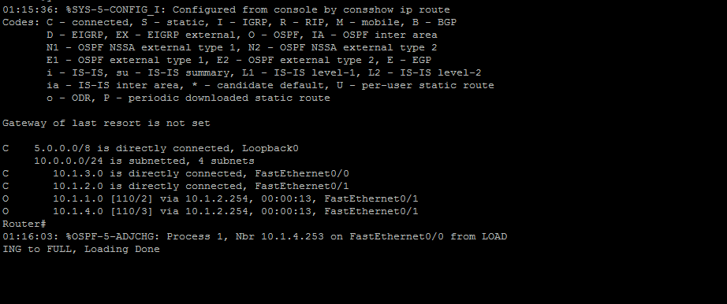

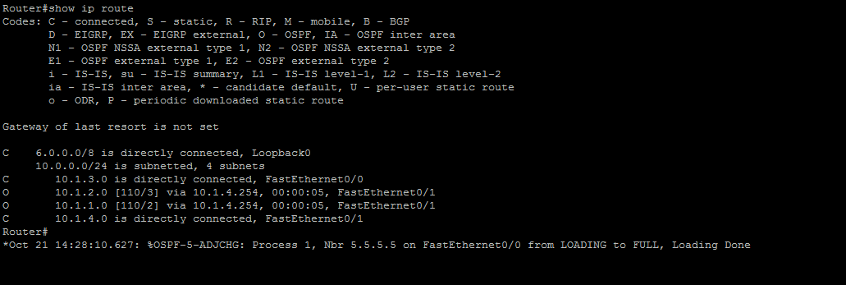

There is another useful command to show is which router connected to which in other word the direct neighbors for each router: show ip ospf neighbor. This command show is the ip neighbor, the priority for that neighbor, their status, dead time and the interface.

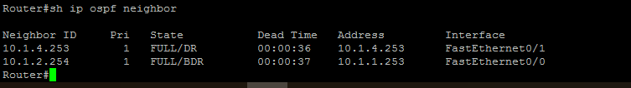

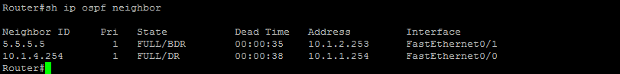

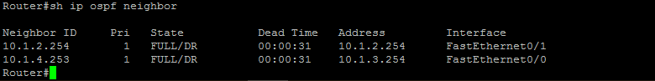

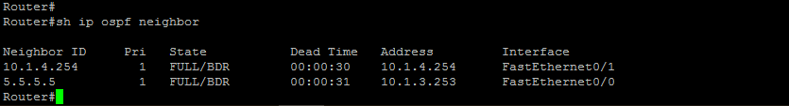

Moreover, we can see the database for the router with the link ID: show ip ospf database. Here are 4 screenshots for each router link database

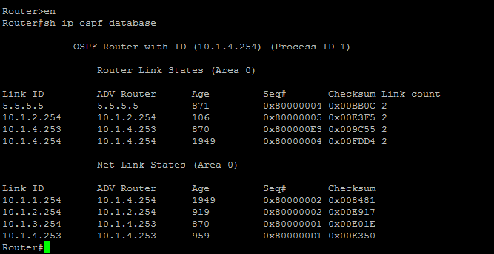

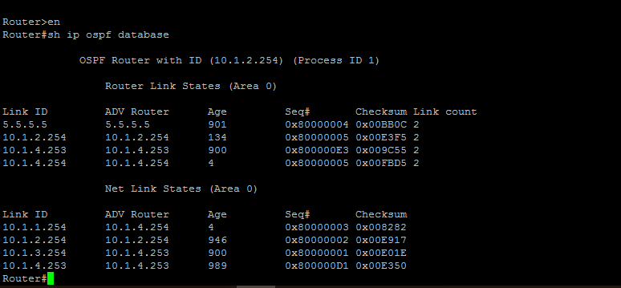

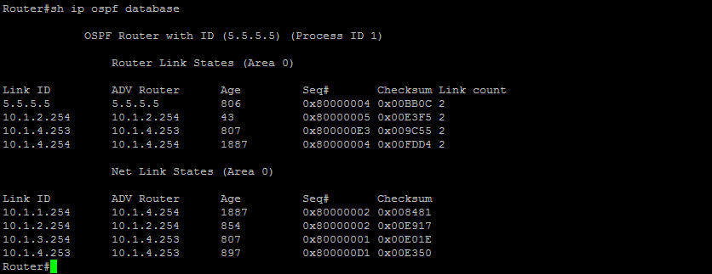

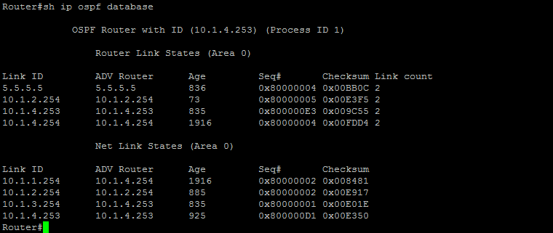

Then we can authenticate the SDBF router by plaintext using the key: 111. By enabling authentication, it allows flexibility and secure exchanges LSU between the routers. Using the command: ip ospf authentication-key 111. Here are screenshots showing enabling the commands and displaying the running configuration

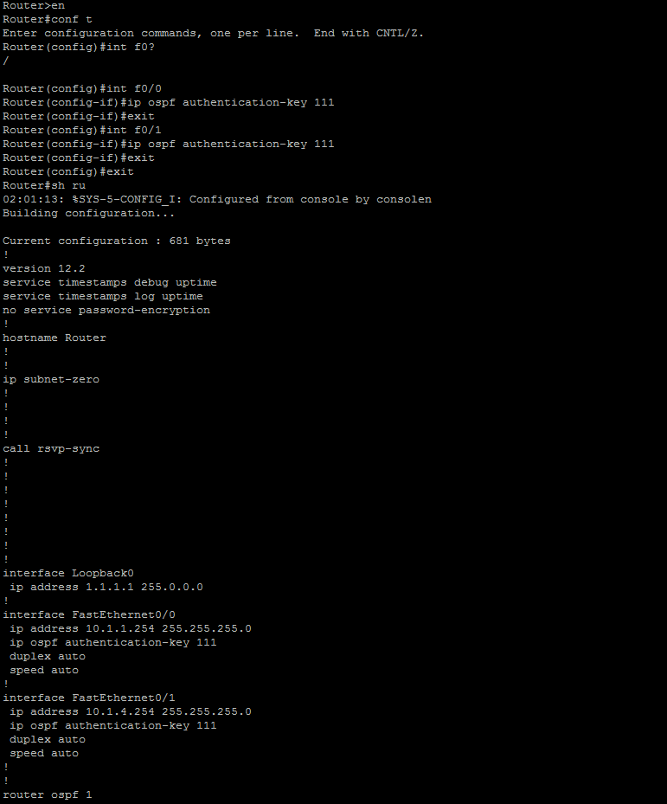

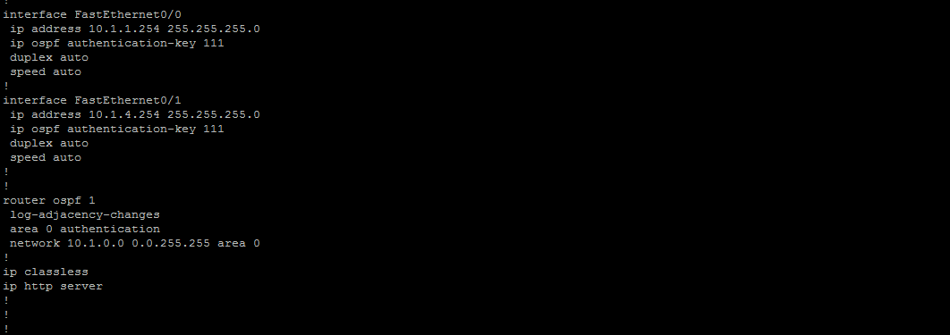

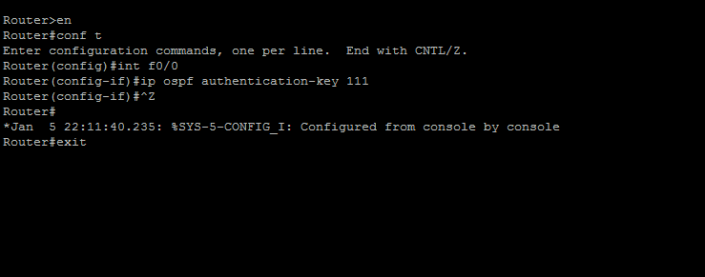

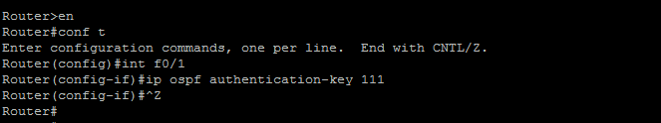

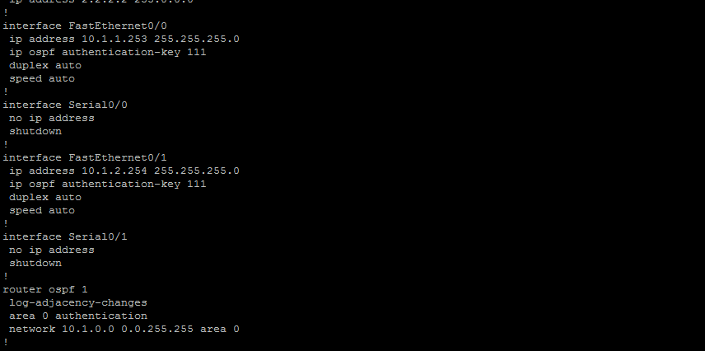

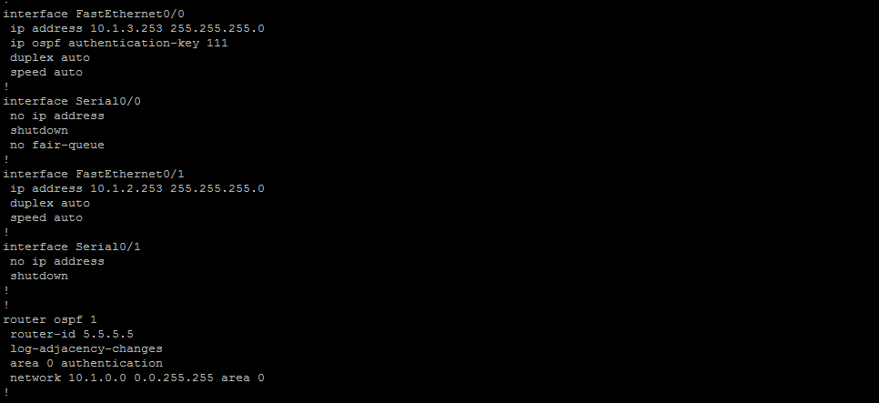

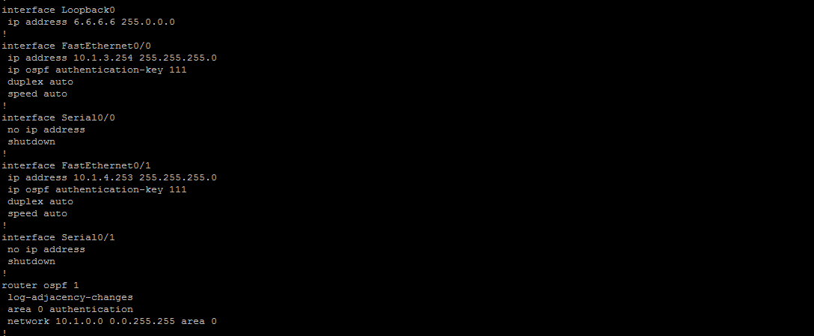

Lastly, we enable an authentication using MD5 encryption using the key: abcd123 for the four routers. Here is the screen shots showing the running configuration and the key

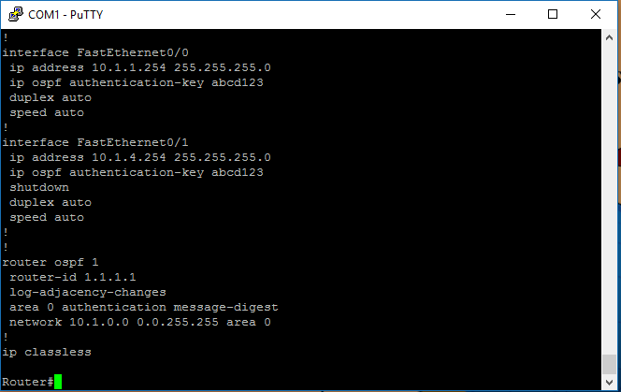

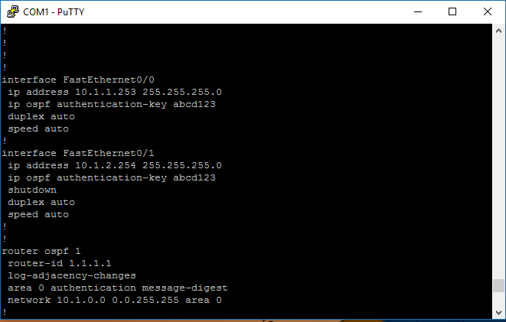

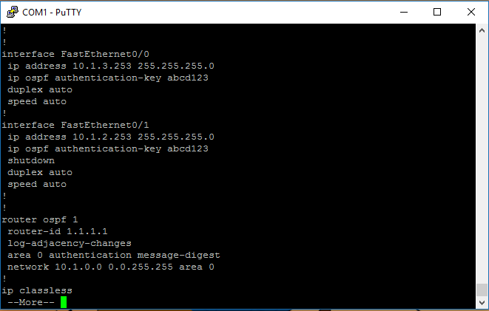

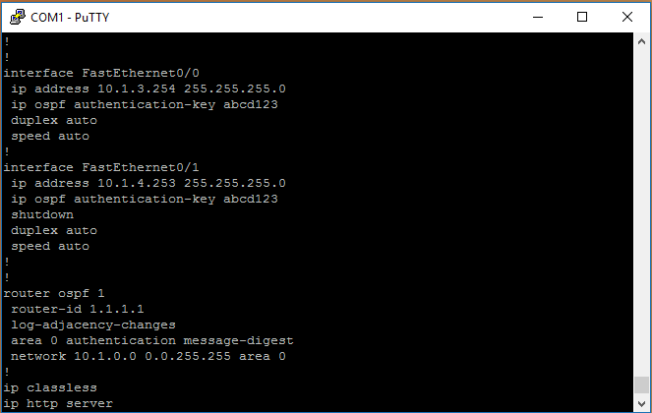

Conclusion:

In summary, OSPF is a link state routing protocol that we configure go through three phases. First, we have to start up by discover neighbor routers, exchange database, draw a tree for each network using Dijkstra SPF algorithm and build the routing table using the low cost. Then at convergence phase we care about stability where the router will send LSA refresh each 30 minutes and hello to keep the connection alive. Third, change phase when the router sends partial trigged update to the network to inform them of that changes.

Reference:

[1] Cisco ASA 5500 Series Configuration Guide using the CLI, 8.2 - Configuring OSPF [Cisco ASA 5500-X Series Firewalls]. (2013, November 01). Retrieved April 16, 2018, from <https://www.cisco.com/c/en/us/td/docs/security/asa/asa82/configuration/guide/config/route_ospf.html>

[2] ComputerNetworkingNotes. (2018, February 05). OSPF Configuration Step by Step Guide. Retrieved April 16, 2018, from <https://www.computernetworkingnotes.com/ccna-study-guide/ospf-configuration-step-by-step-guide.html>

[3] Pearson IT Certification. (n.d.). Retrieved April 16, 2018, from <http://www.pearsonitcertification.com/articles/article.aspx?p=1868078>