**Overview**

Characterizing clouds and their larger-scale influence is central to accurately modeling many physical processes spanning ranges from localized precipitation to global albedo affects. A more thorough understanding is required despite many years of focused work and rapid advances in computing and in-situ probe capacities. Continued improvement of cloud, weather, and climate models requires a detailed understanding of how processes influence deviations from adiabatically-predicted values (Boucher 1995). Investigations are complicated by fine temporal and spacial scales, complex feedbacks, and incomplete instrument limitation characterization.

The use of cloud droplet size distributions (DSDs) are nearly ubiquitous in microphysical studies because they provide insight into formation, precipitation, and dynamical processes (Lamb and Verlinde 2011). Characteristic distributions are related to specific cloud traits and processes. DSDs under 100 um diameter are especially useful for droplet activation and primary precipitation formation studies. Vapor diffusion growth rate is inversely proportional to droplet diameter therefore, clouds composed of newly-activated droplets rapidly progress to a near-monodisperse small diameter distribution. Growth to precipitation-sized droplets by vapor diffusion alone would require timescales far longer than are observed, implying the importance of primary precipitation processes. One such process, droplet collection and coalescence, alters narrow newly-activated droplet distributions to a more disperse bi-modal shape (Lamb and Verlinde 2011). Distribution widening can create positive coalescence feedbacks (fall speed is proportionally related to droplet size) which accelerate droplet growth. Extra-tropical clouds are rarely composed solely of liquid water therefore another vapor diffusion effect, the Bergeron process, further complicates precipitation formation theory. Vapor diffusion is driven by the fact that saturation vapor pressure over ice is less than saturation pressure over supercooled liquid water. Water vapor is preferentially deposited onto ice particles at the expense of liquid droplet mass. The Bergeron process can quickly (with regards to cloud lifetime) progress and acts to narrow and shift DSDs to a greater mean diameter. Entrainment and mixing processes further complicate DSD evolutions. Several factors, most importantly mixing/evaporation timescale relationships, substantially alter the nature of drop spectra evolution (Tolle, 2014).

**Significance**

The Droplet Measurement Technologies Cloud Droplet Probe (CDP) is a forward scattering spectrometer commonly flown during cloud microphysical studies. The probe retrieves sub-precipitation sized cloud droplets (up to 50 um diameter) size distributions and derived LWC (Droplet Measurement Tech. 2014). Manufacturer specifications state the CDP is capable of retrieving concentrations up to 2,000 particles cm-3 but studies have shown sample area size uncertainty, inhomogeneous instrument response, and coincidence error (error caused by simultaneous detection of multiple droplets) significantly impacts retrieval capabilities. CDP sample volumes are often found to be many times more extensive than theorized, suggesting that coincidence events are quite likely, even at concentrations as low as 200 particles cm-3 (Lance 2012). The afore-mentioned error sources contribute to deviations from truthful DSDs and can significantly reduce effective CDP operational ranges. Coincidence events’ respective contributions to droplet sizing and counting error are difficult to determine because coincidence can lead to several different outcomes; droplets can be undercounted, undercounted and oversized, or rejected altogether (Reference here).

CDP calibration traditionally uses precision glass beads or polystyrene spheres; both of which introduce complexities due to differential refractive index differences (with respect to water), inability to precisely place particles, and volume control difficulty. A handful of institutions and instrument manufactures have developed water droplet calibration devices (or droplet generators) to mitigate calibration challenges. Droplet generators are capable of creating pure liquid water particles of repeatable size, velocity, concentration, and placement; attributes which allow for calibration and uncertainty investigations less effected by refractive index problems and spacial uncertainty. Generally, designs are based on previous work by Lance et. al. (2010) in which a piezoelectric print head (typically used for circuit printing or biomedical applications) dispenses pure water droplets into a sheath airflow. Droplets are accelerated by the flow, focused through a tapered exit region, and passed through an instrument sample volume. High speed cameras and imaging software independently verify droplet size, velocity, and trajectory while precision microstages alter sample area injection location. Generator setups can produce a range of droplet sizes, velocities, and concentrations through altering the droplet sheath flow introduction point, interchanging print head size, and modifying print head jetting parameters. Droplet generating calibration devices are especially adept at investigating an instrument’s spatially-dependent sizing precision and measuring extended sample volume dimensions (areas where particles can potentially trigger counting events beyond idealized sample volumes).

The Nevzorov hotwire probe retrieves bulk liquid and total water content by monitoring the power consumption of a constant-temperature element. Water content values are calculable using sensor power consumption due to hydrometeor evaporation and basic thermodynamic principles. The Nevzorov has several advantages over similar hotwire designs including phase discrimination capability, a freely rotating vein to decrease bias caused by aircraft orientation, and paired collector/reference coil architecture. The latter simplifies water content calculations, significantly reduces baseline noise, and increases retrieval confidence in low water content environments (Korolev 1997). A few well-characterized bias sources including LWC underestimation (or roll off) in high water content situations (due to sensor saturation), non-unity particle collection efficiency, and power consumption due to sources other than particle evaporation (dry air heat losses) can compromise Nevzorov measurements. Fortunately, many of these major error sources have been characterized and can be compensated for using straight-forward methods.

In-situ analysis by Sulskis (2016) has demonstrated typical CDP and Nevzorov LWC values to be in good agreement. The two instrument’s LWC similarity and retrieval of separate droplet distribution moments (the CDP senses the first moment whereas the Nevzorov senses the third) provides opportunity for probe uncertainty assessment and performance constraint. Of particular interest is the relative impact of CDP LWC error contributed by droplet mis-sizing and mis-counting. More recent work by Lance et. al. (2012) demonstrated the pinhole mask modification significantly reduces droplet sizing and counting uncertainty but further investigation is pertinent for more completely defining CDP limitations. Furthermore, it is expected mis-sizing and mis-counting uncertainty is, to a certain extent, probe specific. UWKA CDP uncertainty investigation will provide tailored knowledge for in-situ studies and future UWKA missions.

**Background**

Lance et. al. (2012) have shown the CDP is subject to sizing response inhomogeneity and coincidence effects contributing to as great as 27% undercounting and 30% oversizing bias at concentrations as few as 500 droplets cm-3. A simple pinhole mask modification substantially reduced coincidence error but the effect remains significant especially for more numerous concentrations or populations composed of small diameter droplet (~ 20 μm or less) (Lance 2012).

In-situ CDP, Nevzorov, LWC-100, and PVM-100A cross-analysis preformed by Sulskis (2016) investigated inter-probe LWC agreement. The Nevzorov was found to be in the best agreement with CDP/Nevzorov LWC percent differences often an order of magnitude less than found in the other CDP/hotwire device comparisons. Furthermore, CDP and Nevzorov LWC were the most similar across all concentration and droplet diameter ranges. Many Nevzorov uncertainty sources have been previously characterized including baseline drift caused by airspeed and altitude deviations which can skew LWC measurements as much as 2.0*10-3 g m-3 / 10 m s-1 and 5.0*10-3 g m-3 / km respectively (Korolev 1997). Collection efficiency effects introduce significant bias for particle volume weighted mean diameters (VMD) less than 5 μm (due to aerodynamic effects) or greater than 25 μm (incomplete particle evaporation) (Korolev 1997, Schwarzenboeck 2009). Sensor saturation roll off is apparent for particle median volume diameter (MVD) greater than 50 μm (Strapp 2003) or LWC equal to or greater than 1.3 g m-3 (Sulskis 2016).

**Nevzorov Data Processing**

Nevzorov data processing routines have been developed and tested against well-established COPE-MED 2013 calculations provided by Alexi Korolev, an expert directly involved in Nevzorov development. Calculated and independent LWC provided by Korolev have been shown to be in good agreement despite unique calculation methods. Algorithms include corrections for error sources including baseline drift due to airspeed and pressure deviations. Derived Nevzorov values are calculated using the following formulae as defined in the Nevzorov operating manual (SkyPhysTech).

Nevzorov liquid water content is defined as

$LWC= \frac{V_{col}*I_{col} - k*V_{ref}*I_{ref}}{e*U*S*L^{*}}$

where Vcol and Vref are collector and reference sensor voltage, sensor current is denoted as Icol and Iref, k is the convective heat loss coefficient, e is particle collection efficiency, U represents true airspeed, S is collector sensor surface area, and L* is the expended heat for liquid water.

Heat expended due to hydrometeor evaporation is calculated as

$$L^{*}=\left(T_{sensor}-T_{ambient}\right)*C_{liq}+ L_{V liq}*T_{sensor}$$

where Tambient is the environmental temperature measured by the reverse flow temperature sensor, Cliq is the liquid water specific heat capacity, and Lv liq is the latent heat of vaporization at Tsensor.

Neglecting convective heat loss airspeed and pressure dependence introduces mean uncertainty on the order of 180.0% (assuming Korolev’s COPEMED calculations as truth). The convective heat loss coefficient (valid only for clear air points) is defined as the ratio of collector/reference sensor power consumption

$k= \frac{V_{col}*I_{col} }{V_{ref}*I_{ref}}$

March 2016 test flights provided data for k airspeed and pressure calibrations. Four flight legs flown at 700, 600, 500, and 400 mb levels each contained multiple one minute sections of incrementally varying true airspeeds ranging from 80 to 115 m s-1. A power law function fitted to each calibration leg’s indicated airspeed/k relationship provided dry air heat loss estimates across the King Air’s operational airspeed range. k values were fitted against indicated, instead of true, airspeed because indicated airspeed minimizes k uncertainty due to pressure drift. The effectiveness of each flight level specific k parameterization was examined using clear air points collected at flight levels spanning 400 – 700 mb and true airspeeds covering 80 – 125 m s-1. The four k parameterizations performed quite similarly but the 700 mb k calibration showed the least median absolute uncertainty (where uncertainty is equal to LWC for clear air data) regardless of the flight level at which data were collected. Therefore, calculations only use the 700 mb k parameterization.

k calibration and correction for pressure fluctuation-related error requires identification of clear air (out of cloud) points. In order to isolate clear air points, the collector sensor voltage baseline is normalized in 30 second increments and a clear air voltage threshold is then set as the 75th percentile of normalized voltages. A point is considered clear air if it and the following 5 points’ voltages are less than the threshold value. Requiring the threshold criteria be met by consecutive points ensures isolated signal events are not erroneously flagged as clear air.

**Fig 1a. Fig 1b.**

---Add figures related to Nevzorov calculations---

Post airspeed-corrected LWC is still subject to uncertainty on the order of 0.03 g m-3 due to flight level pressure fluctuations despite k/indicated airspeed parameterizations including an intrinsic pressure compensation. Correction for pressure related LWC drift is performed by linearly-fitting flight level pressure vs. Pliq values for clear air data (where clear air points are filtered as outlined in the previous paragraph) and then forcing the linear clear air regression to zero. The aforementioned process reduces LWC drift due to pressure fluxuations by at least an order of magnitude.

LWC error is also introduced by non-unity particle collection efficiencies due to small droplet (VMD less than 6 um) aerodynamic effects or splattering and incomplete evaporative complications for VMD greater than 35 um. Fig 2a shows a typical relative droplet mass distribution with Nevzorov LWC collection efficiency estimates as modeled by Korolev et. al. (1998) and later elaborated on by Schwarzenboeck et. al. (2009). It should be noted very little water mass is contributed by droplets in the range biased by aerodynamic effects but a significant mass portion lies in the region where splattering and saturation effects are non-trivial.

**Fig 2a.**

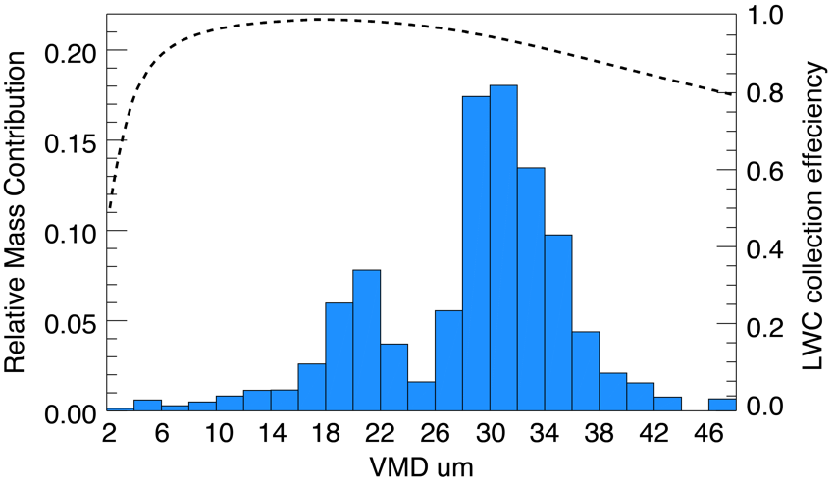

*Fig 2a. Shows the relative mass contributions of droplets binned by VMD for CDP droplet distributions collected during COPEMED 13 where Mass Contribution ≣ Frequency * Bin Geographic Mean3.*

Several other potential LWC error sources including aircraft angle of attack, yaw, sideslip, roll, presence of turbulence and differing sources of airspeed, pressure, and temperature measurements have been found to be negligible.

**Water Droplet Generating Calibration System for Cloud Particle Probes**

Development of an optical cloud probe calibration system which uses pure water droplets as calibration media is currently underway with a majority of components having already been implemented. Fig 2a. shows a schematic of the major system components. The droplet generator assembly (in grey) houses a glass flow tube and print head device (available in diameters of 5 um increments spanning 20 – 80 um) which produces droplets inside the flow tube’s sheath flow. Droplets are focused and accelerated in the flow tube’s tapered exit region and passed through a probe’s sample volume. The print head device is fixed to the end of a re-positional rod. Raising or lowering the rod alters droplet in-flow residence time providing adjustment of droplet velocity and diameter (through evaporation).

Separate compressed air sources provide reservoir water level regulation and sheath flow to the droplet generator assembly. A microfluidic pressure regulator placed between the first air source and reservoir provides both the precise adjustments required during print head operation and pass through of higher pressures used to purge water lines of air bubbles and contaminants. Control of sheath flow rate and minimization of flow tube/ambient pressure differential is accomplished using a critical orifice and choked flow principles.

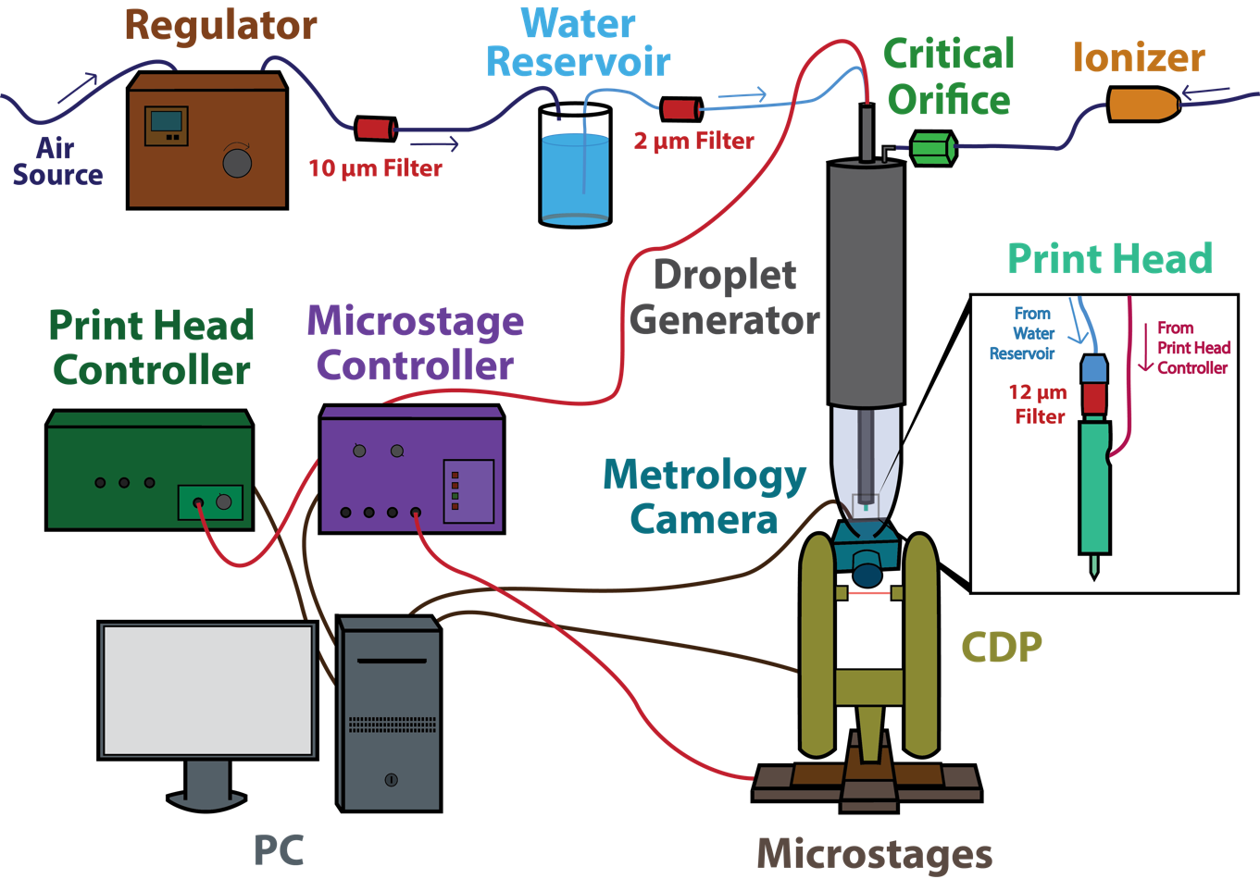

***Fig 2.*** *Schematic of the droplet generator system layout.*

The print head device includes a fluid cavity surrounded with a piezoelectric membrane, and capped by a precision glass nozzle. The piezoelectric element is driven by a programmable controller which supplies pulses of positive voltage for water intake and a following negative pulse in order to force droplet creation at the nozzle’s exit.

Independent droplet diameter and velocity estimates are calculated using the glare technique, as initially described by Korolev et al. (1991). A high speed metrology camera images droplet glares (bright regions located at a droplet’s left and right sides) as they are illuminated in the CDP’s sample volume. Droplet diameters are estimated using glare longitudinal pixel separation, pixel/distance relationships determined using glass microbeads, and camera geometry. Droplet velocity can be approximated by further considering the pixel counts of glare “streaks” in the latitudinal dimension and camera exposure times. Fig 4b. shows an image of glares cast by a 40 um droplet.

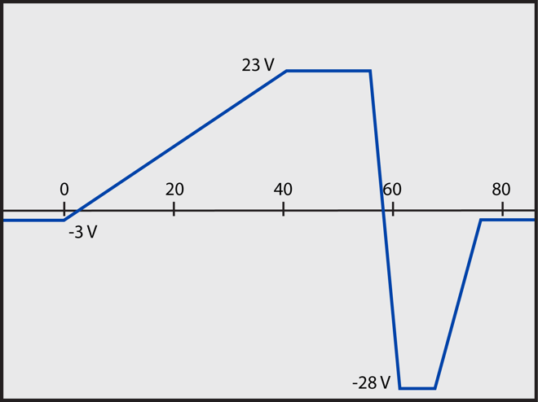

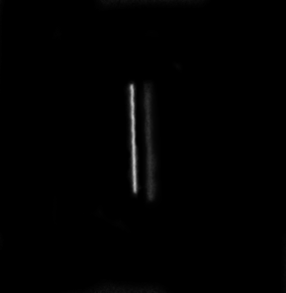

***Fig 4.*** *(a) Print head ejection waveform for 40 um droplets (x-axis in us). Water is pulled into the main cavity during the positive pulse spanning 0 to 60 us and subsequently ejected during the rapid negative pulse. This example waveform is programmed to create stable drops at 250 hz. (b) 40 um droplet glares captured with 250 um exposure.*

---Add brief section about obstacles/solutions---

**Objectives**

The proposed work will improve King Air in-situ droplet distribution and LWC retrieval capabilities through algorithm development, laboratory equipment setup and testing, and UWKA data analysis. A two-tiered methodology, including both laboratory-based experiments and in-situ analysis, will enhance departmental observational study abilities through improved calibration capabilities for optical cloud particle probes and detailed error characterization for the CDP and Nevzorov devices (through the two instruments’ mutual retrieval of LWC). CDP specific investigation will probe sizing error due to non-ideal detector response and LWC error caused by coincidence events. Efforts focused on Nevzorov error sources will characterize LWC uncertainty introduced by sensor saturation (insufficient electronic response time) effects.

A droplet generating calibration device will expand departmental optical probe calibration and characterization capabilities. Efforts are to be focused on preliminary system development, operating procedure development, documentation of procedures, and algorithm coding. The system will initially be compatible with the CDP but future work will expand compatibility to include the FSSP and SPEC inc. 2D-S.

Once operational, the calibration system will allow detailed measurements of CDP sample volume characteristics including position-dependent sizing accuracy and sample volume dimensions.

--Add outline of methods for CDP/Nevzorov characterization--

**--Timeline--**

**--References--**