Nevzorov LWC Calculation Overview

Spencer Faber

**Remaining Issues**

* My out of cloud LWC values are consistently greater than Alexei’s
* My values at higher LWC are consistently less than Alexei’s
* There seems to be a pressure dependence in the dry air coefficient (k) but I’m having trouble with it for a couple reasons
  + I had a hard time finding points at different pressure levels with similar airspeeds
  + I currently have K pressure dependence crudely implemented

**LWC Calculation**

I used the equations from the beginning of section 8 in the Nevzorov manual.

LWC =

P = Heat loss

P = Vcol*Icol – k*Vref*Iref

Vcol = collector voltage [V]

Icol =collector current [A]

Vref = reference voltage [V]

Iref = reference current [A]

k = dry air coefficient (discussed more a little later)

e = Collection Efficiency - assumed to = 1

U = airspeed [m/s]

S = Collector coil surface area - 3.28*10-5 m3

L* = Expaned heat for water

L* = (Te – Ta)Cw + Lw

Te = Temperature of Evaporation (Sensor temperature) – 110 C

Ta = Air Temperature – Reverse Flow Temp [C] (var = trf)

Cw = Specific Heat capacity of liquid water at 110 C – 4.223 J/g C

LW = Latent heat of vaporization at 100 C – 2260 J/g

**K airspeed dependence**

I found linear regression values for true airspeed K dependence from the 070913 cope flight. K regression values were calculated by selecting k values for 3 airspeeds (~80, 85, 90 m/s) at two pressure levels (~900, 620 mb). The regression values were then averaged over the two flight levels. The whole process was then repeated for the same data using indicated airspeed values.

I calculated LWC values for the COPE 081413 flight and created a scatterplot of my LWC values vs Alexei’s to test the effectiveness of the two K values based on airspeed types (true, indicated). 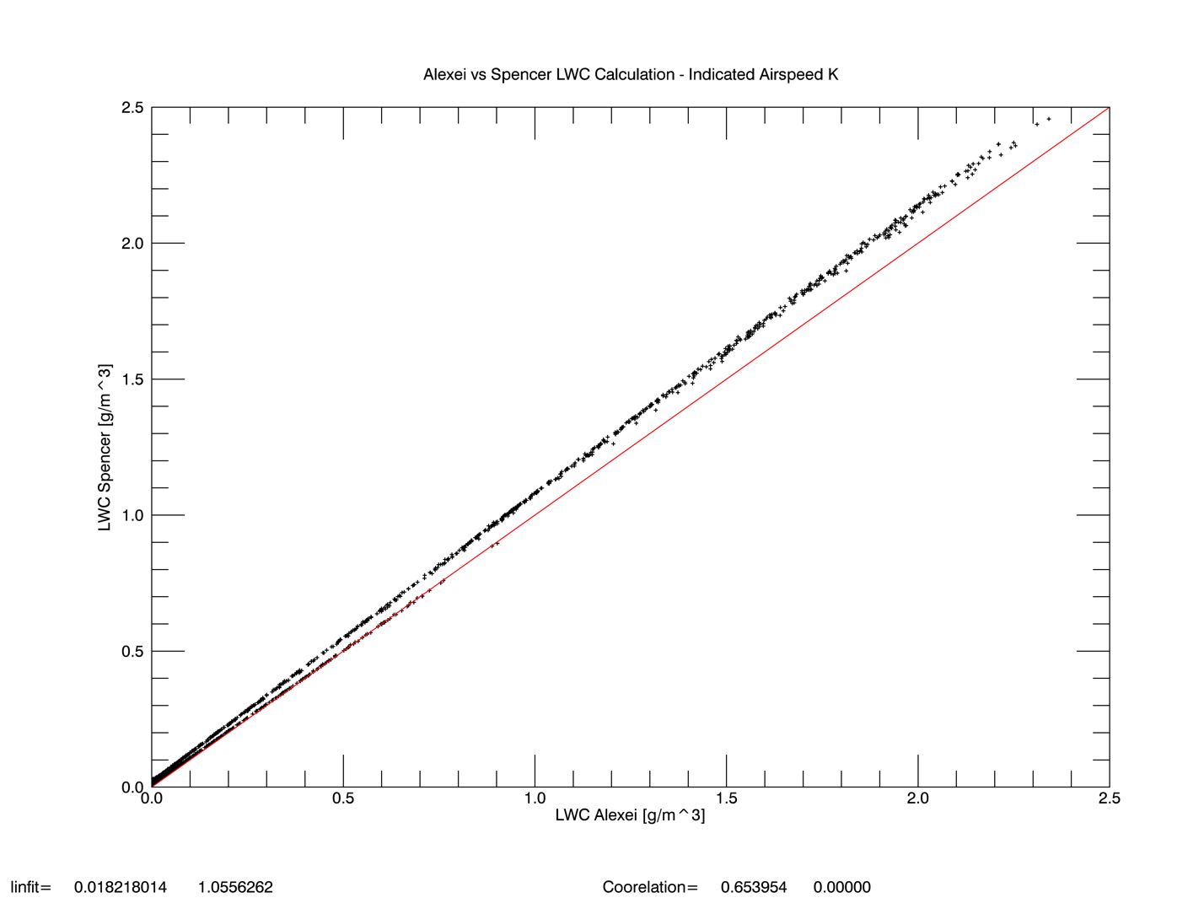

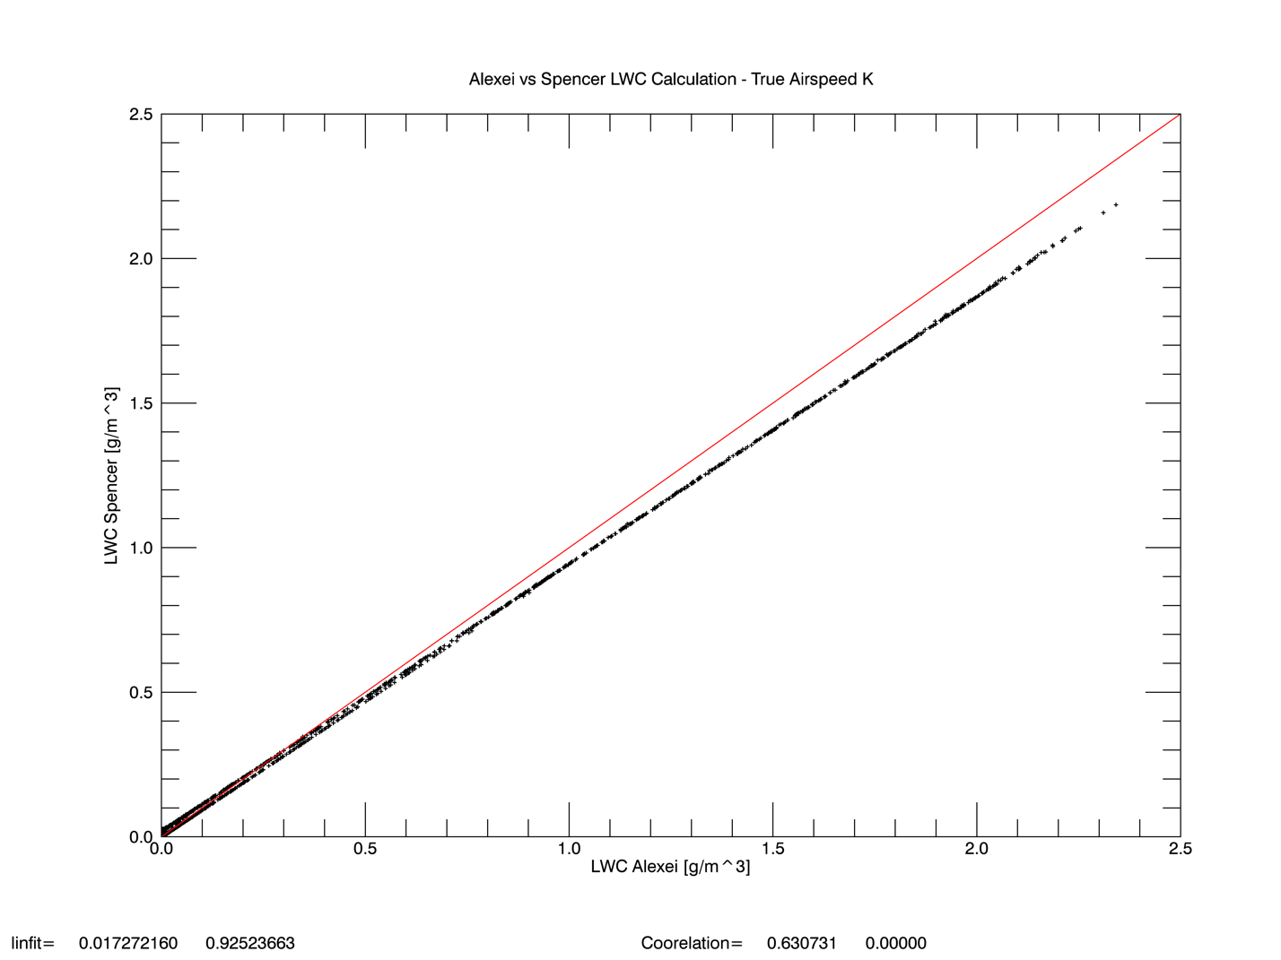

The K airspeed dependence calculated based on indicated airspeed seems to perform better so I’ll continue on with those values.

K values were found using the following two sets of points from the 070913 flight.

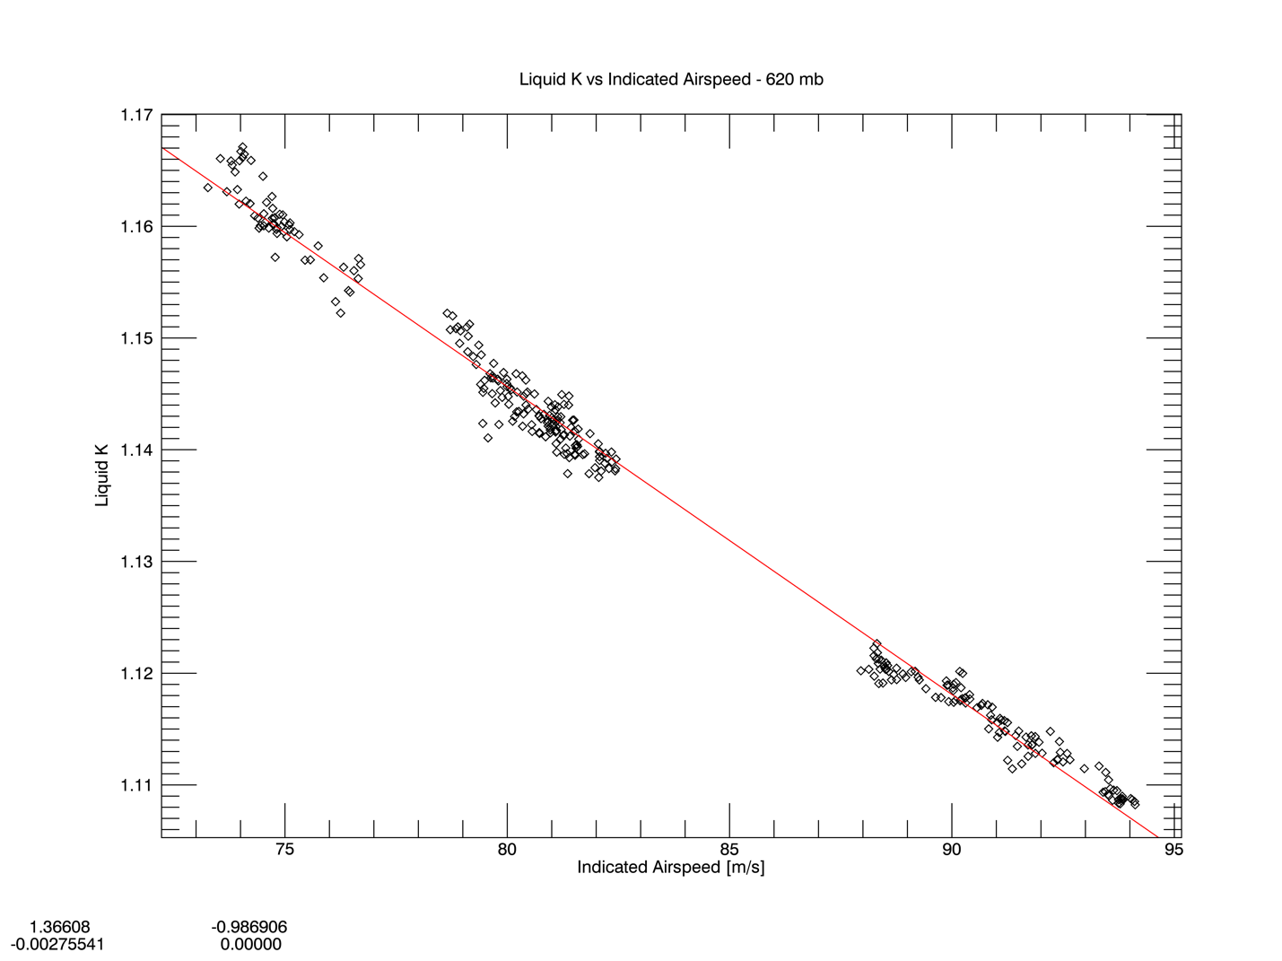

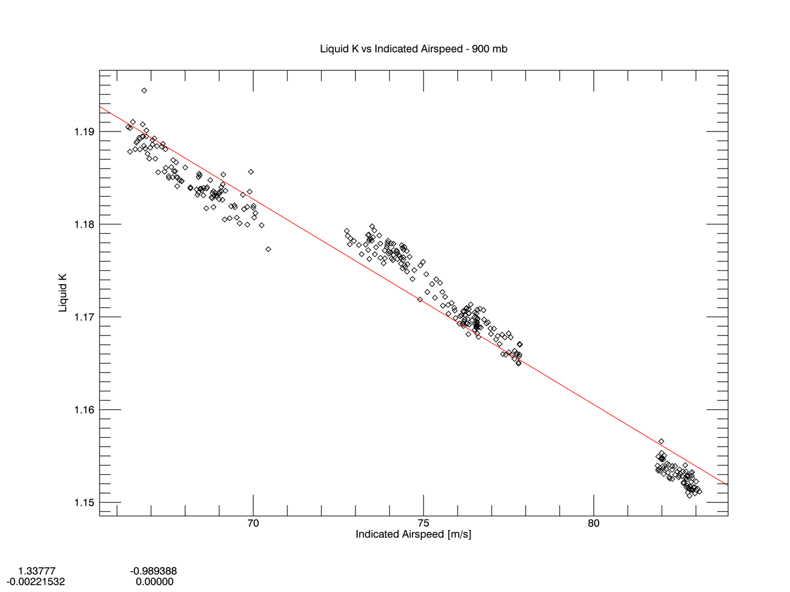

**k pressure dependence**

I then calculated LWC values for the 081413 flight, took the difference from Alexei’s values and noted a pressure dependence.

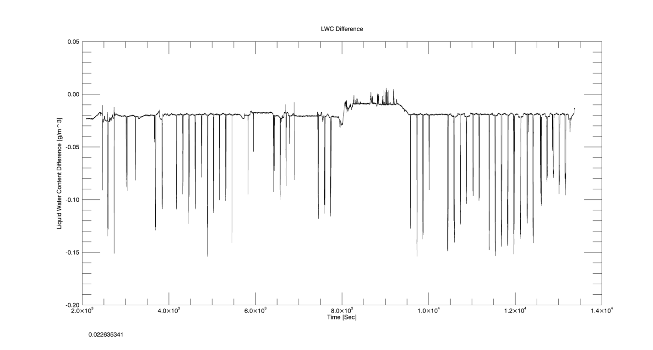

Here’s another plot showing the area of increased LWC difference that occurs about halfway through the flight.

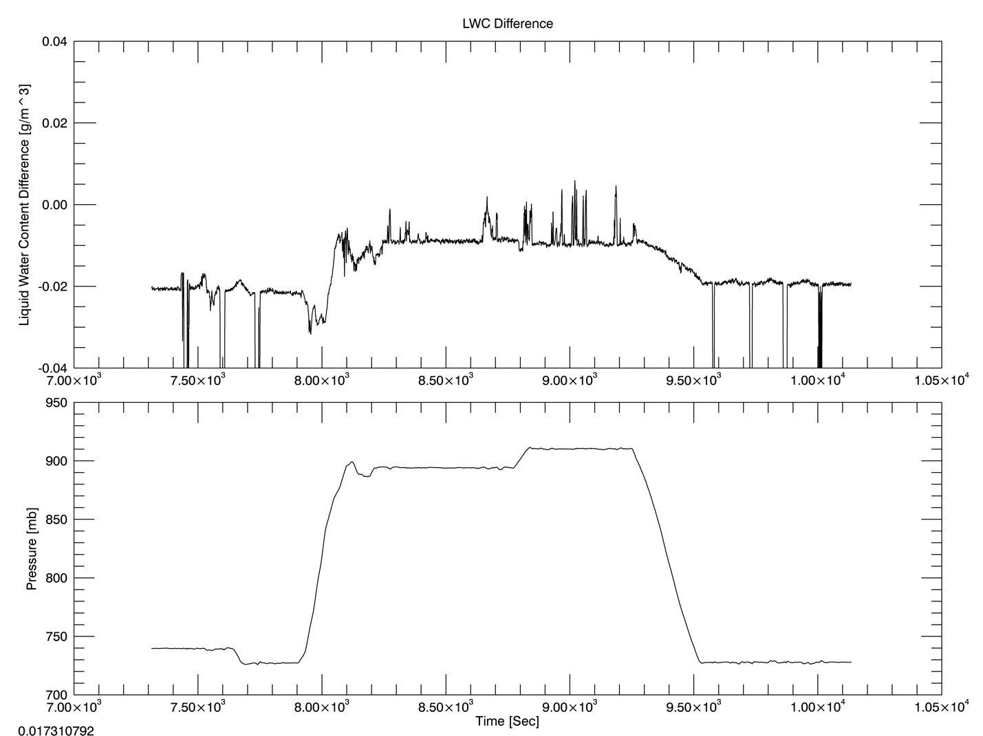

And a scatterplot of Pressure vs LWC difference.

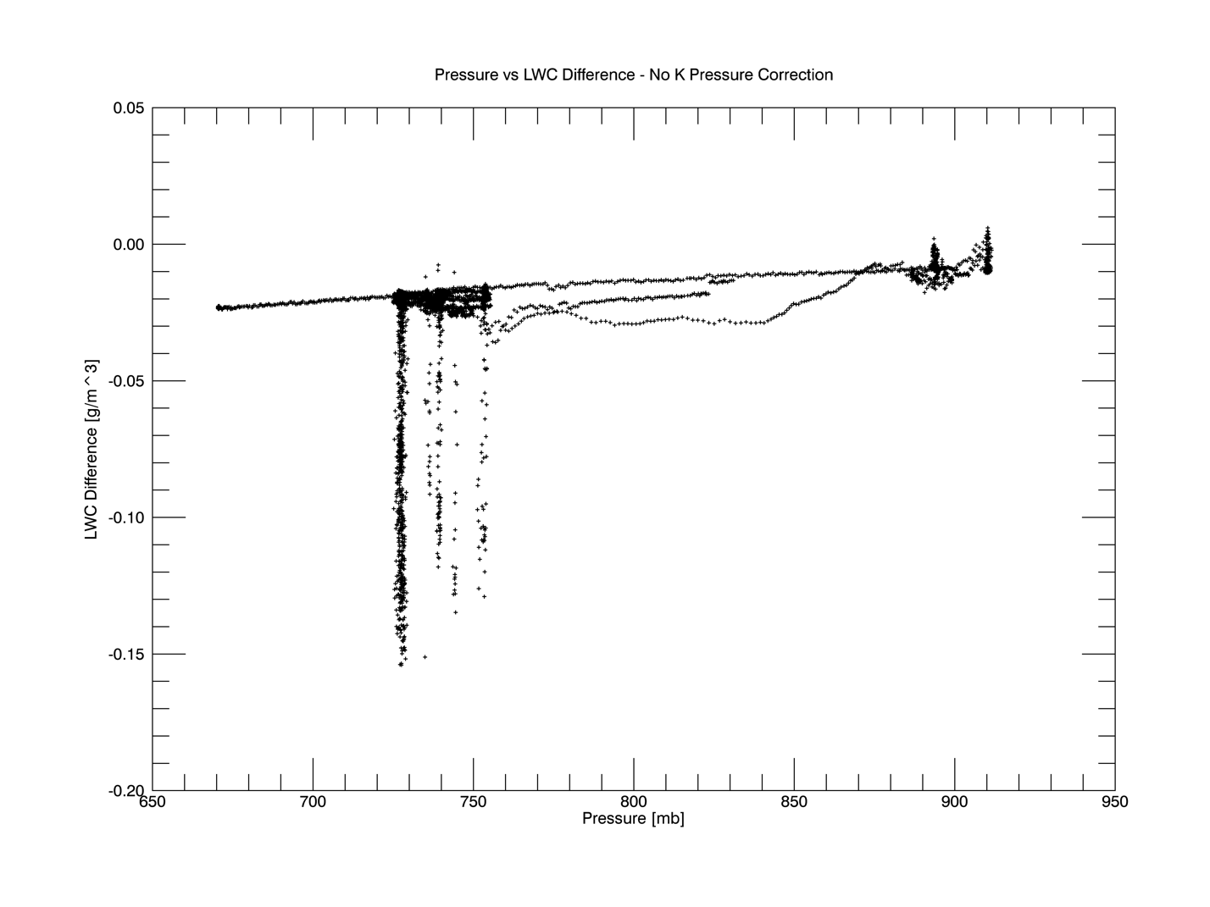

Next, I sampled Liquid K points at two pressure levels with similar airspeeds to find a pressure correction for the liquid K coefficient. I had a difficult time finding groups of suitable points so the regression values I found are fairly crude (probably something I’ll have to revisit).

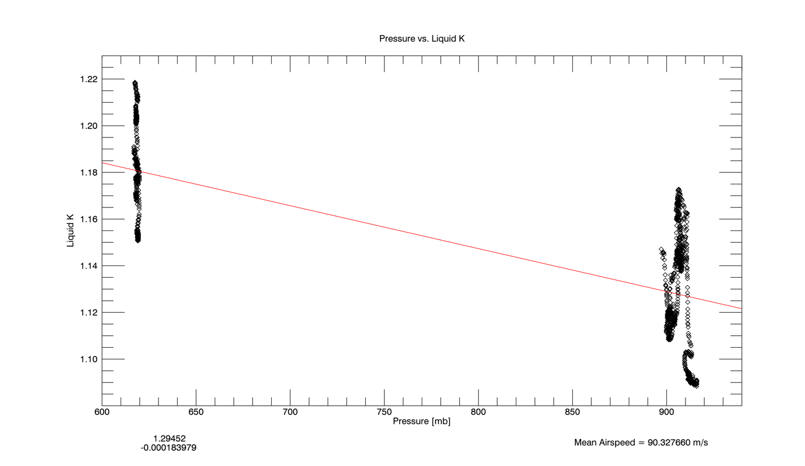

I’m not 100% sure how to calculate K values when I have two linear regression values (airspeed, pressure) so I just did a simple mean of K values as follows

kAirspeed=(-.002485365)*indicatedAirspeed+1.351925

kPressure=(-.000183979)*pressure+1.29452

kTotal=(kAirspeed+kPressure)/2

I encountered another problem while trying to calculate K pressure dependence – The mean airspeeds of the two pressure levels were 90.32 m/s and 88.64 m/s which certainly affects the regression values for pressure dependence.

There seems to be a decrease in the pressure dependence of LWC values. The following figure shows the same time period as the figure on page 7 but has K pressure dependence factored in.

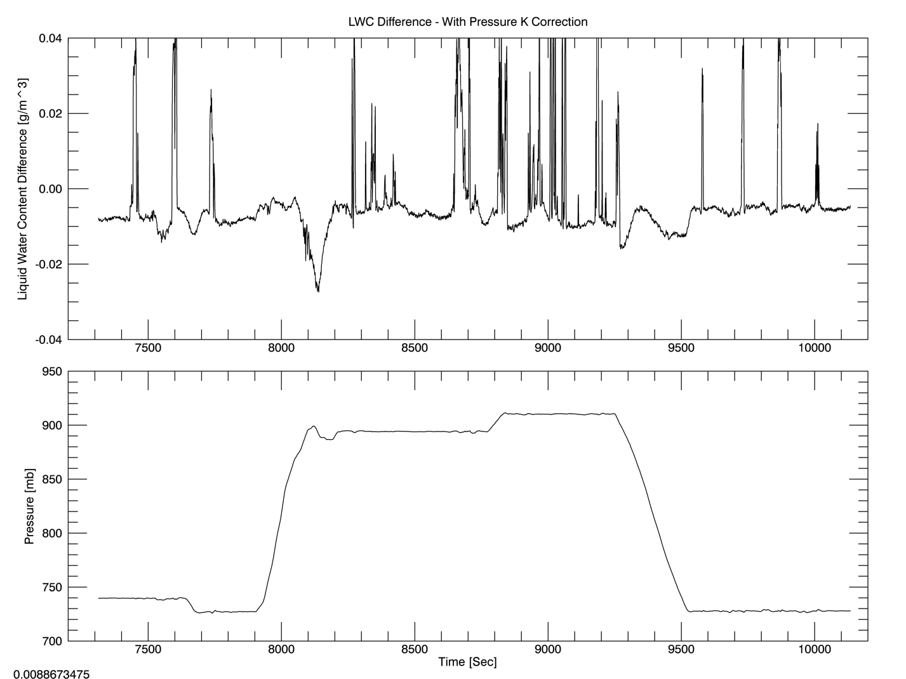

My baseline values are more similar and most pressure dependence has been removed. But, high LWC values are less accurate.