Nevzorov Log

2/25/16

* Investigating if it’s worth defining clear air points based on linfit instead of 0.5 lwc.
* Improved baseline point selection in nevbase.pro
  + Airspeed correction lwc are filtered by lwc < .05 g/m^3
  + Linfit applied to <.05 g/m^3 filtered points, (as,lwc)
  + Points abs < .02 from linfit are “Clearair”
* Working on new nevstats.pro for correction eval

Turns out… 400 mb k may not be the best performer. 900 mb k is doing best **after** applying baseline correction. Look at new pro for more…

2/26/16

* Validating performance of airspeed dependent K correnction on **clear air points**
  + Baseline LWC drift, mean all flights, k=1.1189852 == 0.02674 g/m^3 / 10m/s ias
  + Baseline LWC drift, mean all flights, k=400 mb K ais == 0.00554 g/m^3 / 10m/s ias
* Validating performance of pressure baseline correction on **clear air points**.
  + Baseline LWC drift, mean all flights, k=1.1189852 == 0.00933 g/m^3 / 100 mb, mean= 0.043707181, stddev = 0.017174830
  + Baseline LWC drift, mean all flights, k=400 mb K ais == 0.00504 g/m^3 / 100 mb, mean= 0.0088031524, stddev= 0.0073048132
  + Baseline LWC drift, mean all flights, k=400 mb K ais, baseline correct == 0.000564 g/m^3 / 100 mb, mean= 0.0046354026, stddev= 0.0053911177

2/27/16

* **Working on draft 2 of write-up**
* Outline
  + Liquid Water Content
    - Short theory of operation?
    - Variables and calculations
  + Total Water Content
    - Short theory of operation?
    - Variables and calculations
  + Error Sources
    - K airspeed dependence
      * Short intro (magnitude of error, etc.)
      * Methods
        + Including baseline selection process
      * Examples of expected results
    - K airspeed dependence
      * Short intro (magnitude of error, etc.)
      * Methods
      * Examples of expected results
  + Insignificant factors
    - Temperature Dependence
    - Aircraft heading?
    - Aias vs Bias?
    - Collection efficiency?

2/27/16

* **Working on draft 2 of write-up**
* Fixed kliqpresimprove.pro, now Calcs/plots all flights mean clearair lwc error/stddev for each kLiq regression value

3/06/16

* **Working on draft 2 of write-up and implementing a clear air selection process based upon sensor current or power consumption instead of actual LWC values.**
* Added clearairselecttest.pro for investigation of improved clear air selection process.
* Old clearair point detection = 90132 points for all flights, mean(lwcnev1[clearair]) = 0.0017262927 g m3, stddev(lwcnev1[clearair]) = 0.0047626519
* New clearair point detection = 77244 points for all flights, mean(lwcnev1[clearair]) = 0.00065176800 g m3, stddev(lwcnev1[clearair]) = 0.0018929613
* 400 indicated k = -0.0055691628 g/m3 10 m s-1 ind airspeed
* 600 indicated k = 0.0059646266 g/m3 10 m s-1 ind airspeed

**03/11/16**

* Wondering why march calibration flight showed stacked/linear k curves
  + I think There’s still some non-linearity at lower p
  + Groups are stacked because legs were flow at constant Indicated AS vs. constant True AS.
  + ----------------------------------------
  + larcal900
  + TRUE AS- 95.2357
  + IND AS- 82.5023
  + ----------------------------------------
  + larcal600
  + TRUE AS- 109.355
  + IND AS- 83.7625
  + ----------------------------------------
  + larcal400
  + TRUE AS- 116.600
  + IND AS- 82.7093
  + –
  + –
  + ----------------------------------------
  + copecal900
  + TRUE AS- 86.1850
  + IND AS- 81.7976
  + ----------------------------------------
  + copecal600
  + TRUE AS- 96.4629
  + IND AS- 78.1973
  + ----------------------------------------
  + copecal400
  + TRUE AS- 105.858
  + IND AS- 73.2528
  + ----------------------------------------
* Both were flow against indicated airspeed but March 2016 calibration flight has less as drift
* Investigating if miscellaneous factors (such as temperature, orientation, pitot tube location) introduce error.
  + Yaw - 0.0095644081 g/m3 error across -.1 to .1 degree yaw
  + Pitch - 0.0017985996 g/m3 error across -5 to 13 degree pitch
  + Vertical speed - 0.016571695 error across -10 to 10 m/s
  + Sideslide angle - 0.0029563298 error across -.08 to degree .05
    - Accelerate *may* have an impact. Look at that more using kliqpresimporve.

**3/13/16**

* + Typical pressure related error 0.0021108027 g m-3/20 mb
  + Typical pressure related error after correction 9.4153143e-05 g m-3/20 mb

**3/16/16**

* + Left off on histogram2.pro. Use that to make a histogram of baseline bins.

**3/19/16**

* + For COPE
  + Baseline selection
  + Used Alexei’s values to confirm accuracy
    - Can now use my LWC clear air values for Airspeed/pressure corrections
  + Tested Different K regessions using baseline values
    - Showed that 400 mb k works best for baseline points
      * Whisker plot
      * Also show that indicated performs best for all pressure levels
  + Normalized Error per Pressure Level Histogram for 400 mb ind, 600 mb true
* Pressure Level Drift Correction
  + Histogram Clear Air LWC before/after baseline correction
* All point LWC accuracy
  + Calculated All point LWC
  + Demonstrate that LWC is accurate
* Use “meeting” scatter to show match with Korolev’s
  + Mention that Korolev’s manually forced baseline values in places
* Validation with CDP
* ???
* Quickly mention non-factors
* Directional effects

December test flight

* K Calibration/Pressure Correction
  + Show which k performed best
    - Mention that these k regressions work about the same cause airspeed were more similar than COPE runs
  + Mention pressure correct but don’t spend too much time on it
* Confirm accuracy with CDP data
  + Show that CDP agreement is within COPE tolerance

**3/21/16**

* Working TWC code

**3/23/16**

* Still working on TWC code
  + Korolev’s signal points are ~.1 g/m3 greater
  + My baseline is consistently .2 g/m3 too large
    - Pretty sure it’s collection efficiency
    - Black= TWC COLEFF=1
    - Green= TWC COLEFF=.5
    - 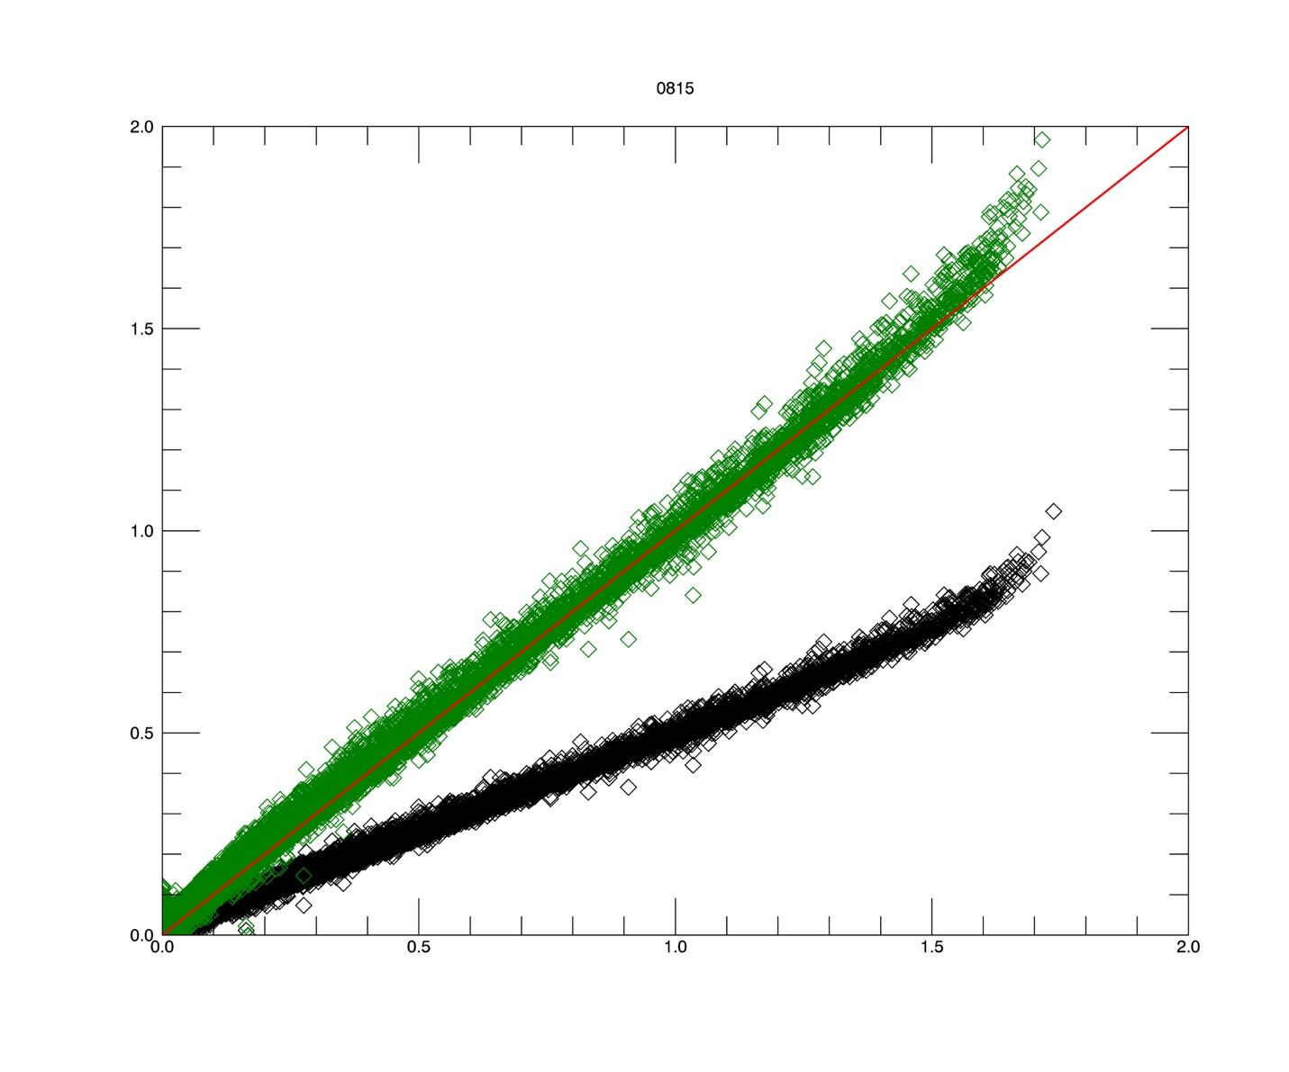
* Tried to fix coleff problem by…
  + Selecting points where twcnev – lwcnev < .02 and lwc gt .1
  + Solving for colETot that would make lwc=twc at those points
  + Finding trend to trf
  + After that this is twcnev, twcnev - twc

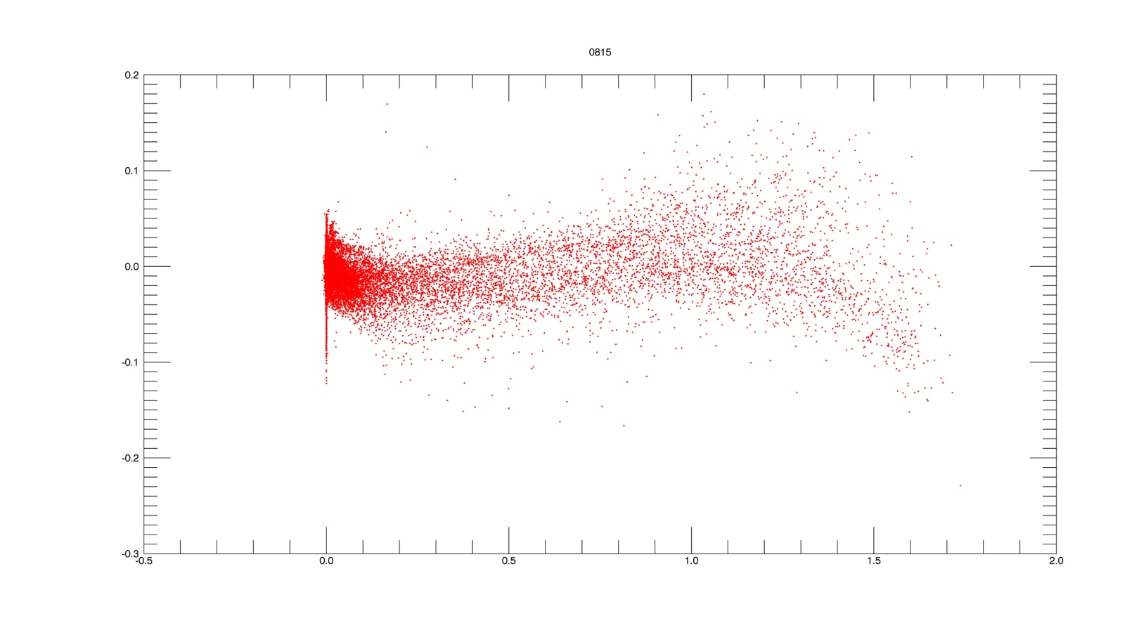

03/25/16

* For TWC, 600 ind k works best (by baseline standards)

03/31/16

* Exploring effect of total collection efficiency
  + Isolated clear air penetrations
    - Solved for total collection efficieny that makes twc, lwc equal
    - There’s a cdpdbar v. “corrected total collection efficiency” very similar to the curve noted in Korolev 1998
      * Having a hard time getting a good fit
      * Going to try forcing to .2 at 3 um, 1. At 40 um
      * Parameterization for tot e col based on cdpdbar reduced liq only error (lwc v twc) from -16% to -.1%
        + Basic.pro, testVarColETot = 1:1 scatter comparing param performance
        + Basic.pro, liqonlypoints,liqonlypoints2 = curvefit

04/01/16

* Looking at error introduced by total col e =1
  + Filtered liquid only points with…
    - Trf gt -3
    - Lwc gt .02
    - Cdpconc gt 10
  + Using colETot.pro
  + Error w/ colETot=1 is -13.66