**Nevzorov Methods Overview 2/27/2016**

The Nevzorov is an airborne hotwire probe designed to measure liquid and total cloud water content. The instrument consists of two sets of paired heated elements where each set has a leading edge “collection” sensor and a trailing edge “reference” sensor. The liquid water content element is rod-shaped in order to shed ice crystals with minimal sensor contact while the total water content sensor is in the shape of a convex cone so that it captures solid and liquid hydrometeors alike. At a basic level, water content is calculated using heat losses caused by hydrometeor evaporation. The paired sensor design of the Nevzorov somewhat simplifies calculations and minimizes the need for inter-probe calibrations. Each of the two leading-edge sensors are fully exposed to airflow and hydrometeor impact (collector sensors) while the second (reference sensors) are shielded from hydrometeor interaction while still being ventilated by similar airflows. Collector and reference temperatures are maintained at an equivalent value and sensor current and voltage values are continuously collected. Evaporative cooling caused by collector sensor hydrometeor impact causes an increase in comparative power consumption (with regards to reference sensor power). The reference sensor doesn’t experience hydrometeor evaporative heat loss, therefore collector and reference sensor differential power consumption can be used to calculate water content values.

Nevzorov data processing methods were developed and tested using UW King Air flight data sourced from the COPEMED13 field campaign. Ten COPEMED flight data files were utilized – a calibration flight occurring on 07/09/2013 and nine research flights occurring on 07/10/2013, 07/25/2013, 07/27/2013, 07/28/2013, 07/29/2013, 08/03/2013, 08/07/2013, 08/14/2013, and 08/15/2013. Research flight files include Nevzorov liquid water content and total water content calculations provided by Alexei Korolev. More COPEMED13 information (including flight notes) is available at <http://flights.uwyo.edu/projects/copemed13/> .

**Basic Liquid Water Content Calculations**

LWC values are calculated using the following formulas available in the Nevzorov hot wire LWC/TWC Probe Operating Manual (Sky PhysTech).

Tables 1 through 4 outline the various King Air flight file variables and constants used in liquid water content value calculations.

**Table 1. Flight file variables required for LWC calculation**

|  |  |  |
| --- | --- | --- |
| Variable Name | Description | Units |
| vlwcref | Liquid reference sensor voltage | Volt |
| vlwccol | Liquid collector sensor voltage | Volt |
| ilwcref | Liquid reference sensor current | Amp |
| ilwccol | Liquid collector sensor current | Amp |
| trf | Reverse flow static temperature | Celsius |
| aias | Indicated boom airspeed | Knot |
| pmb | Rosemount pressure | Millibar |
| timeForm | Flight time formatted as HHMMSS UTC |  |
|  |  |  |
|  |  |  |
|  |  |  |

*LWC calculation-required variables obtained from 1 hz King Air flight file.*

**Table 2. Flight file header variables required for LWC calculation**

|  |  |  |
| --- | --- | --- |
| Header Variable Name | Description | Units |
| ilwccol:SampleArea | Liquid sensor sample area | meter2 |
| ILWCCOL_RAW:temperature | Liquid sensor temperature | Celsius |
|  |  |  |
|  |  |  |

*LWC calculation-required variables obtained from 1 hz King Air flight file header entries.*

**Table 3. Additional constants required for LWC calculation**

|  |  |  |  |
| --- | --- | --- | --- |
| Constant Name | Description | Value | Units |
| eliq | Liquid water collection efficiency | 1.0 |  |
| L* | Expended energy due to heating & evaporation | 2589.0 | Joule gram-1 |
|  |  |  |  |
|  |  |  |  |

**Table 4. Additional flight file variables used for error investigation**

|  |  |  |
| --- | --- | --- |
| Variable Name | Description | Units |
| avpitch | Pitch | Degree |
| avroll | Roll | Degree |
| hivs | Vertical speed | Meter Sec-1 |
| betaB | Sideslip angle | Degree |
| avyawr | Yaw | Degree |
| bias | Indicated starboard nose pitot airspeed | Knot |
| tas | True airspeed | Meter Sec-1 |
| nevlwc1 | Nevzorov LWC provided by Korelev | Meter Sec-1 |

*Additional King Air flight file variables used in LWC error investigations.*

The following equations for collector sensor heat loss (P) and liquid water content (LWC) rely on fundamental heat transfer principles. Formulas (written in terms of flight file variable names) are referenced in the Nevzorov hot wire LWC/TWC Probe Operating Manual (Sky PhysTech).

The liquid water collector sensor heat loss (*P*) due to hydrometer impact is

*vlwccol – Liquid water collector sensor voltage [Volt]*

*ilwccol – Liquid water collector sensor current [Amp]*

*vlwcref – Total water reference sensor voltage [Volt]*

*ilwcref – Total water reference sensor current [Amp]*

*kliq – Dry air heat loss coefficient†*

*†*LWC calculation accuracy is affected by collector sensor heat losses due to factors other than hydrometeor heat losses, hereafter called dry air heat loss. Korelev et. al. have shown water content values are most affected by airspeed deviations which can cause LWC baseline drift of 2*10-3 g m-3 / 10 m s-1, and changes in environmental pressure which can attribute LWC baseline drift ~5*10-3 g m-3 / km. Correcting for dry air heat loss airspeed/altitude dependence is required to minimize LWC error. (see ‘Dry Air Heat Loss Airspeed Dependence Correction’ and ‘Dry Air Heat Loss Airspeed Dependence Correction’ sections for more detail).

LWC [g m-3] is calculated based on

*Pliq – Liquid sensor evaporative heat loss [Watt]*

*eliq - Collection Efficiency = 1.0†*

*tas - True airspeed [m s-1]*

*Sliq – Liquid collector sensor surface area [m3]*

*L* - Expended energy due to heating & evaporation = 2589.0*Ψ *[J g-1]*

*† - TWC Collection efficiency is assumed to be 1.0 for drops larger than ~ 10 μm with minimal error therefore collection efficiency variations are not considered (Korolev 1998).*

Ψ - L* is actually a function of ambient temperaturebut using a fixed value of 2589.0 *J g-1 only introduces error on the order of ±5% (Sky PhysTech).*

**Clear Air Point Filtering**

The determination of out-of-cloud or “clear air” points is necessary for airspeed/pressure-dependent drift corrections and method validation. Data were filtered on a per-flight basis to isolate clear air points using the following method.

Liquid voltage ratio is calculated with liquid collector sensor and liquid reference sensor voltage and current

provided a relatively well-behaved signal with discrete sections of low amplitude baseline oscillations and abrupt spikes indicative of signal events. Voltage ratio baseline drift is reduced by forcing the lowest voltage ratio value within each 230 second interval to zero. Baseline-corrected noise is reduced with an IDL curve smoothing function (essentially a 3 second rolling mean). Figure 2 shows an example of a typical liquid voltage ratio before processing (figure 2a) and after baseline correction/smoothing (figure 2b).

**Figure 2 – Typical Liquid Voltage Ratio Profile**

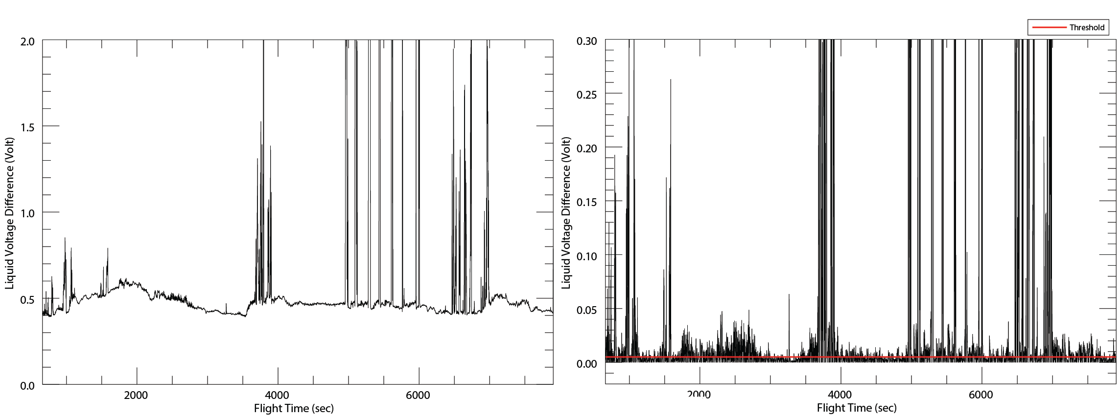

*Raw (figure 2a) and baseline corrected (figure 2b) liquid voltage ratio for 07/27/13 COPEMED flight clearly showing contrast between periods of clear air flight and signal (signal starting around 3500 seconds). Pressure deviation related baseline drift (from ~ 0 to 3000 seconds) is greatly reduced after processing.*

Finally, clear air points are filtered by a threshold set to .45% of maximum baseline corrected voltage difference (profile in figure 2b).

Clear air filtering was applied to nine COPEMED13 flights (listed in the introduction section) flagging 62,147 of 97,077 total points as clear air. The clear air point filter effectiveness was examined with Nevzorov LWC values provided by Korolev (flight file variable = nevlwc1). Clear air points from all nine flights had a mean absolute LWC (based on Korolev’s calculations) of 0.00120 g m-3 and standard deviation 0.00224 g m-3. Clear air detection performed adequately considering Nevzorov baseline noise is estimated to be ±0.002 g m-3 (Korolev 1998). Figure XXX shows Korolev’s LWC value distribution for all 62,147 clear air points.

**Figure** XXX **– Korolev’s LWC For All Clear Air Points**

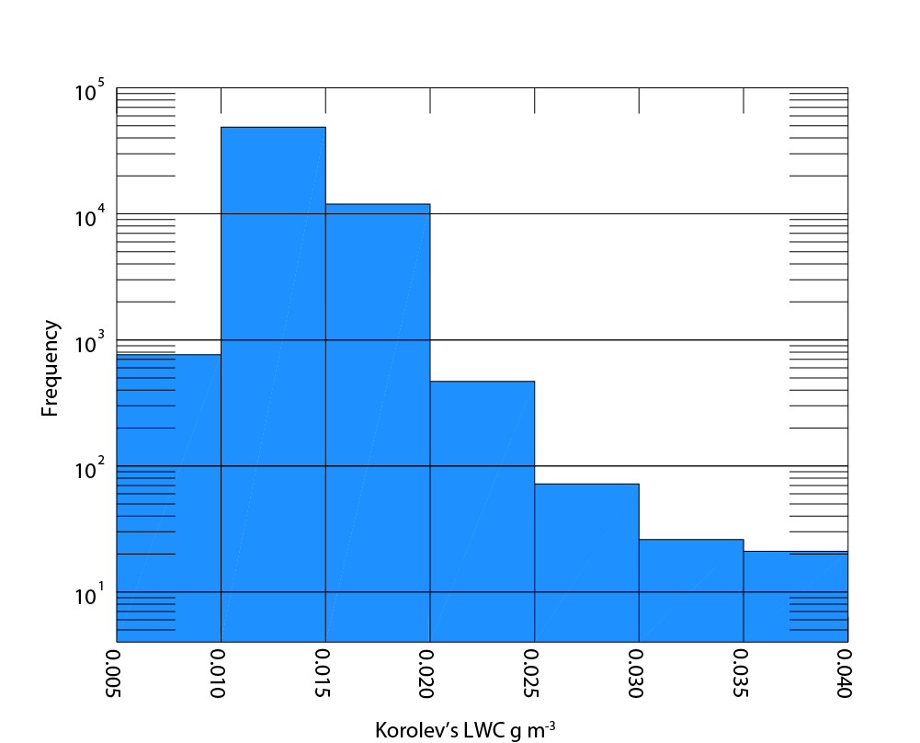

*Korolev’s LWC values for all clear air points, binned by liquid water content. Only 9 values were greater than 0.040 g m-3.*

**Clear Air Liquid Power Coefficient (k) Airspeed Dependence**

Clear air power coefficient (k) airspeed dependence was examined by calculating the ratio between power consumed by the liquid collector sensor and liquid reference sensor during a July 9, 2013 clear air calibration flight.

Three k value groups were selected from calibration legs flown at distinct flight levels (approximately 900 mb, 600 mb, and 400 mb) where each flight level contained five unique airspeed legs (ranging from approximately 60 to 100 m s-1 indicated airspeed). Care was taken to manually select calibration sample points with minimal roll, yaw, pitch, and linear acceleration. Three flight level sample groups, each group containing five airspeed legs, were selected. Next, a geometric fit

was applied to each flight level group with respect to *both* true and indicated airspeed (totaling to six regression values). Figure 1 shows the three regression curves calculated with respect to indicated airspeed.

**Figure 1 – Dry air heat loss regressions with respect to indicated airspeed.**

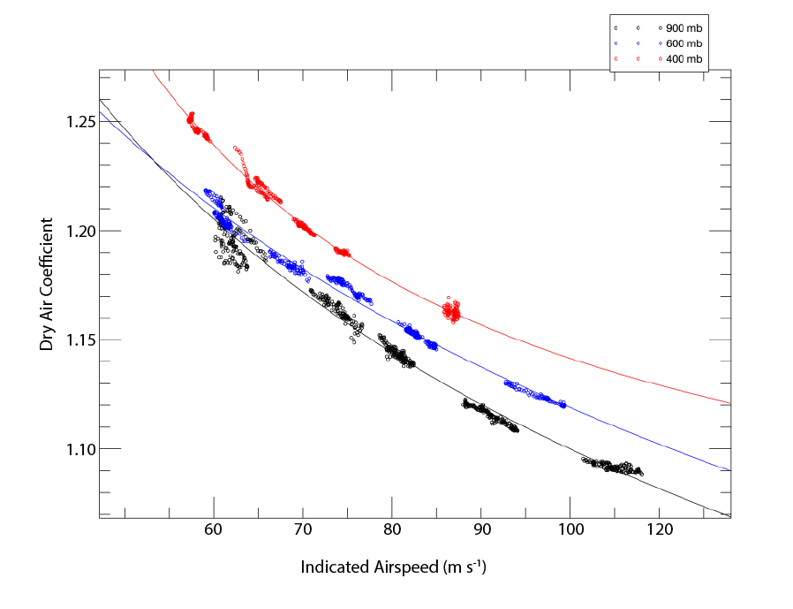

*Dry air heat loss coefficient regressions from 07/09/2013 COPEMED calibration flight. Each group of points/regression curve corresponds to calibration legs flown at distinct flight levels (900 mb in black, 600 mb in blue, and 400 mb in red).*

LWC calculations were performed for clear air points from all COPEMED flights using each of the six k regressions. k regression performance was judged based upon LWC mean absolute error (where error for clear air points is considered to be equal to LWC value), and LWC error standard deviation. Figure XXX illustrates each regression’s mean absolute LWC error and standard deviation.

**Figure XXX – All Flights k Airspeed Regression Performance**

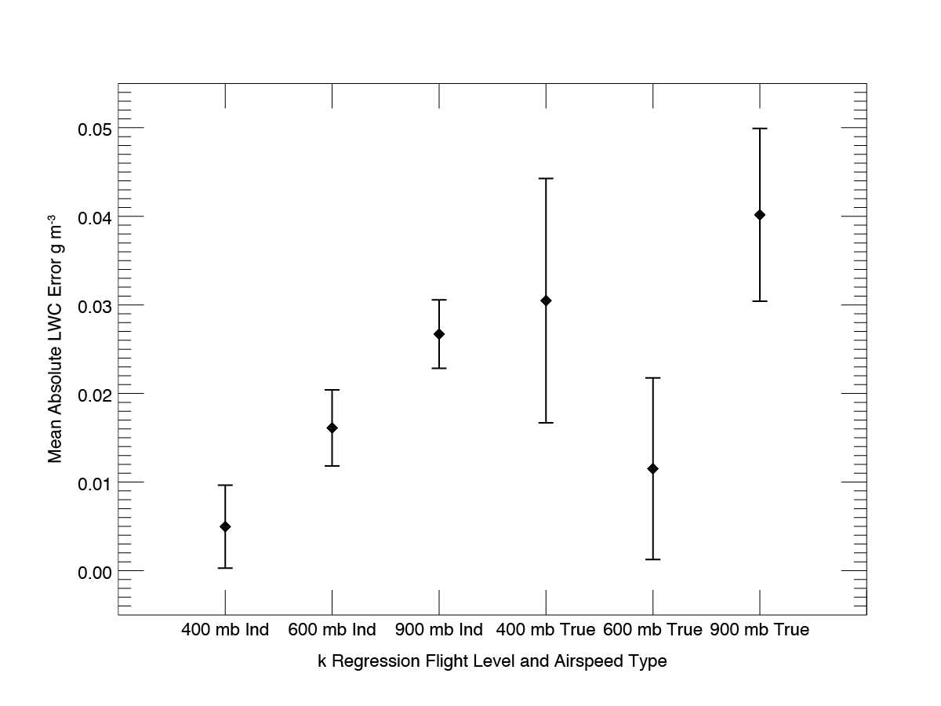

*Dry air heat loss coefficient regression performance based upon clear air mean LWC absolute error calculated for* 07/10/13, 07/25/13, 07/27/13, 07/28/13, 07/29/13, 08/03/13, 08/07/13, 08/14/13, and 08/15/13 COPEMED flights. Note – “Ind” in x-axis labels signifies k regressions calculated with respect to indicated airspeed and “True” signifies regression calculated with respect to true airspeeds.

In general, k regressions calculated against indicated airspeed resulted in less clear air LWC error absolute mean value and standard deviation. Furthermore, indicated airspeed k regressions resulted in corrected clear air LWC values that were much less correlated with the pressure level the k regression was calculated from (indicated airspeeds have an intrinsic pressure compensation, true airspeeds do not).

**Figure XXX – Pressure-Related Absolute Mean Clear Air LWC Error for all COPEMED flights**

400 mb Indicated Airspeed Regression 400 mb True Airspeed Regression

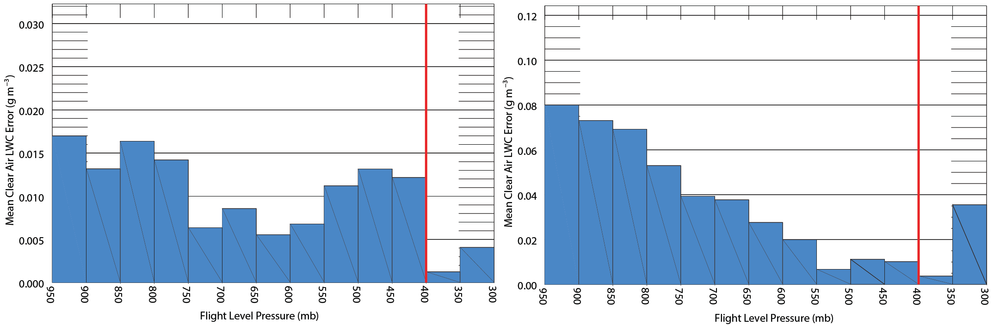

*Figure XXX illustrates how indicated airspeed calculated k regression performance is much less dependent upon the similarity of the pressure level the regression was calculated and actual flight level pressure. The red vertical line denotes pressure level at which the k regression was calculated.*

The 400 mb indicated airspeed k regression (mean absolute error = 0.00496 g m-3, standard deviation = 0.00468 g m-3) showed the best performance by a significant margin. LWC calculation will be performed using only this k regression throughout the remainder of this document.

**LWC Error Due to Dry Air Coefficient Flight Level Pressure Fluctuation**

Nevzorov dry air coefficient values (and ultimately LWC values) are also affected by flight level environmental pressure fluctuations. Fortunately, pressure-related baseline drift was minimal after correcting for k airspeed dependence (1.983*10-6 g m-3 / 20 mb). A baseline correction was applied to post airspeed-corrected clear air kliq values on a per-flight basis for all ten afore-mentioned flight days. Baseline correction amount was calculated with a linear regression fit to kliq values deemed to be clear air points. Figures XXXa and XXXb show clear air LWC error values from all flights both before (XXXa) and after (XXXb) pressure-dependent baseline correction.

**Figure 3 – Pressure-Related Clear Air LWC Error for all COPEMED flights, Before (XXXa) and After (XXXb) Baseline Correction**

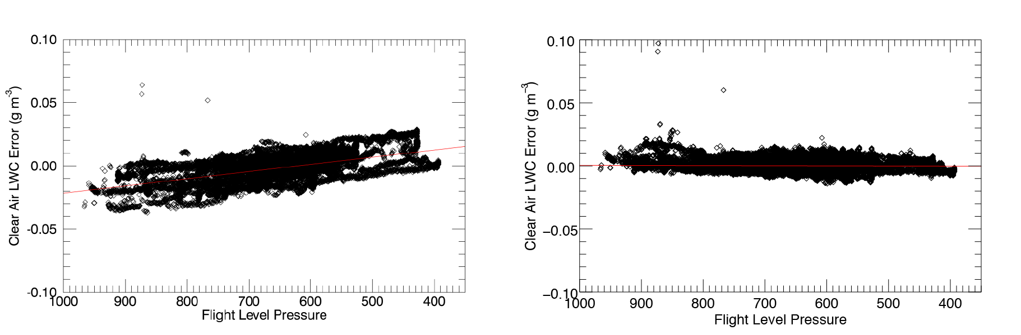

*Clear air pressure dependent LWC error before (figure 3a) and after (figure 3b) baseline correction. LWC error is considered equal to LWC value for clear air points.*

The baseline *kliq* correction procedure performed well for all nine COPEMED13 flights. Clear air LWC error means and standard deviations were reduced from pre-correction values of 0.00790 g m-3 absolute mean error, 0.0118 g m-3 standard deviation topost-correction values of 0.00372 g m-3 absolute mean error, 0.00807 g m-3 standard deviation.

**LWC Value Verification For All Points**

A handful of probes recorded redundant LWC measurements during COPEMED research flights (DMT LWC-100, Gerber PVM-100, DMT CDP, PMS FSSP-100), but recent work by Jason Sulskis indicates.

**Figure XXX – Comparison of Korolev’s LWC and Calculated LWC For All COPEMED Flights**

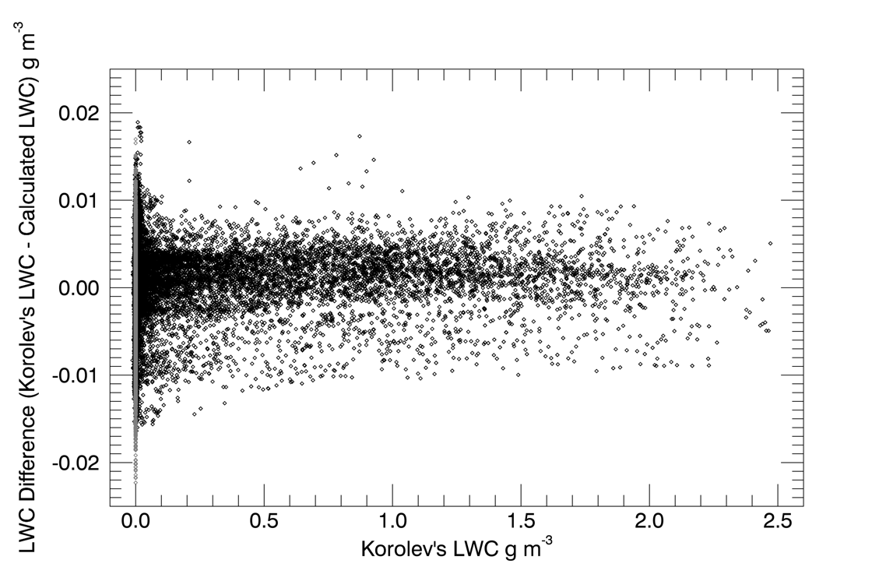

*Direct comparison of Korolev’s LWC and calculated LWC values for all COPEMED flights. Grey points indicate values that Korolev manually forced to zero.*