The Nevzorov is an airborne hotwire probe designed to measure liquid and total cloud water content. The instrument consists of two sets of paired heated elements where each set has a leading edge “collection” sensor and a trailing edge “reference” sensor. The liquid water content element is rod-shaped in order to shed ice crystals with minimal sensor contact while the total water content sensor is in the shape of a convex cone so that it captures solid and liquid hydrometeors alike. At a basic level, water content is calculated using heat losses caused by hydrometeor evaporation. The paired sensor design of the Nevzorov somewhat simplifies calculations and minimizes the need for inter-probe calibrations. Each of the two leading-edge sensors are fully exposed to airflow and hydrometeor impact (collector sensors) while the second (reference sensors) are shielded from hydrometeor interaction while still being ventilated by similar airflows. Collector and reference temperatures are maintained at an equivalent value and sensor current and voltage values are continuously collected. Evaporative cooling caused by collector sensor hydrometeor impact causes an increase in comparative power consumption (with regards to reference sensor power). The reference sensor doesn’t experience hydrometeor evaporative heat loss, therefore collector and reference sensor differential power consumption can be used to calculate water content values.

Nevzorov data processing methods were developed and tested using UW King Air flight data sourced from the COPE-MED field campaign. Ten COPE-MED flight data files were utilized – a calibration flight occurring on 07/09/2013 and nine research flights occurring on 07/10/2013, 07/25/2013, 07/27/2013, 07/28/2013, 07/29/2013, 08/03/2013, 08/07/2013, 08/14/2013, and 08/15/2013. Research flight files include Nevzorov liquid water content and total water content calculations provided by Alexei Korolev. More COPE-MED information (including flight notes) is available at <http://flights.uwyo.edu/projects/copemed13/> .

**Liquid Water Content Calculations**

LWC values are calculated using the following formulas available in the Nevzorov hot wire LWC/TWC Probe Operating Manual (Sky PhysTech).

Tables 1 through 4 outline the various King Air flight file variables and constants used in liquid water content value calculations.

**Table 1. Flight file variables required for LWC calculation**

|  |  |  |
| --- | --- | --- |
| Variable Name | Description | Units |
| vlwcref | Liquid reference sensor voltage | Volt |
| vlwccol | Liquid collector sensor voltage | Volt |
| ilwcref | Liquid reference sensor current | Amp |
| ilwccol | Liquid collector sensor current | Amp |
| trf | Reverse flow static temperature | Celsius |
| aias | Indicated boom airspeed | Knot |
| pmb | Rosemount pressure | Millibar |
| timeForm | Flight time formatted as HHMMSS UTC |  |

**Table 2. Flight file header variables required for LWC calculation**

|  |  |  |
| --- | --- | --- |
| Header Variable Name | Description | Units |
| ilwccol:SampleArea | Liquid sensor sample area | meter2 |
| ILWCCOL_RAW:temperature | Liquid sensor temperature | Celsius |
|  |  |  |
|  |  |  |

**Table 3. Additional constants required for LWC calculation**

|  |  |  |  |
| --- | --- | --- | --- |
| Constant Name | Description | Value | Units |
| eliq | Liquid water collection efficiency | 1.0 |  |
| L* | Expended energy due to heating & evaporation | 2589.0 | Joule gram-1 |

**Table 4. Additional flight file variables used for error investigation**

|  |  |  |
| --- | --- | --- |
| Variable Name | Description | Units |
| avpitch | Pitch | Degree |
| avroll | Roll | Degree |
| hivs | Vertical speed | Meter Sec-1 |
| betaB | Sideslip angle | Degree |
| avyawr | Yaw | Degree |
| bias | Indicated starboard nose pitot airspeed | Knot |
| tas | True airspeed | Meter Sec-1 |
| nevlwc1 | Nevzorov LWC provided by Korelev | Meter Sec-1 |

The following equations for collector sensor heat loss (P) and liquid water content (LWC) rely on fundamental heat transfer principles. Formulas (written in terms of flight file variable names) are referenced in the Nevzorov hot wire LWC/TWC Probe Operating Manual (Sky PhysTech).

The liquid water collector sensor heat loss (*P*) due to hydrometer impact is

$$P_{liq}= vlwccol*ilwccol-k_{liq}*vlwcref*ilwcref$$

*vlwccol – Liquid water collector sensor voltage [Volt]*

*ilwccol – Liquid water collector sensor current [Amp]*

*vlwcref – Total water reference sensor voltage [Volt]*

*ilwcref – Total water reference sensor current [Amp]*

*kliq – Dry air heat loss coefficient†*

*†*LWC calculation accuracy is affected by collector sensor heat losses due to factors other than hydrometeor heat losses, hereafter called dry air heat loss. Korelev et. al. have shown water content values are most affected by airspeed deviations which can cause LWC baseline drift of 2*10-3 g m-3 / 10 m s-1, and changes in environmental pressure which can attribute LWC baseline drift ~5*10-3 g m-3 / km. Correcting for dry air heat loss airspeed/altitude dependence is required to minimize LWC error. (see ‘Dry Air Heat Loss Airspeed Dependence Correction’ and ‘Dry Air Heat Loss Airspeed Dependence Correction’ sections for more detail).

LWC [g m-3] is calculated based on

$$lwc= \frac{P_{liq}}{e_{liq}*tas*S_{liq}*L^{*}}$$

*Pliq – Liquid sensor evaporative heat loss [Watt]*

*eliq - Collection Efficiency = 1.0†*

*tas - True airspeed [m s-1]*

*Sliq – Liquid collector sensor surface area [m3]*

*L* - Expended energy due to heating & evaporation = 2589.0*Ψ *[J g-1]*

*† - TWC Collection efficiency is assumed to be 1.0 for drops larger than ~ 10 μm with minimal error therefore collection efficiency variations are not considered (Korolev 1998).*

Ψ - L* is actually a function of ambient temperaturebut using a fixed value of 2589.0 *J g-1 only introduces error on the order of ±5% (Sky PhysTech).*

**Clear Air Point Filtering**

The determination of out-of-cloud or “clear air” points is necessary for airspeed/pressure-dependent drift corrections and calculation validation. Data were filtered on a per-flight basis to isolate clear air points using the difference of liquid collector and reference sensor voltages

$${voltage difference}_{liq}= vlwccol-vlwcref$$

which provided a relatively well-behaved signal with discrete sections of low amplitude baseline oscillations and abrupt spikes indicative of signal events. Voltage difference baseline drift is reduced by forcing the lowest value within each 10 second interval to zero. Figure 2 shows an example of a typical liquid voltage difference profile before processing (figure 2a) and after baseline correction (figure 2b).

**Figure 1 – Typical Liquid Voltage Ratio Profile**

1a) Raw Liquid Voltage Diff. 1b) Baseline corrected Liquid Voltage Diff.

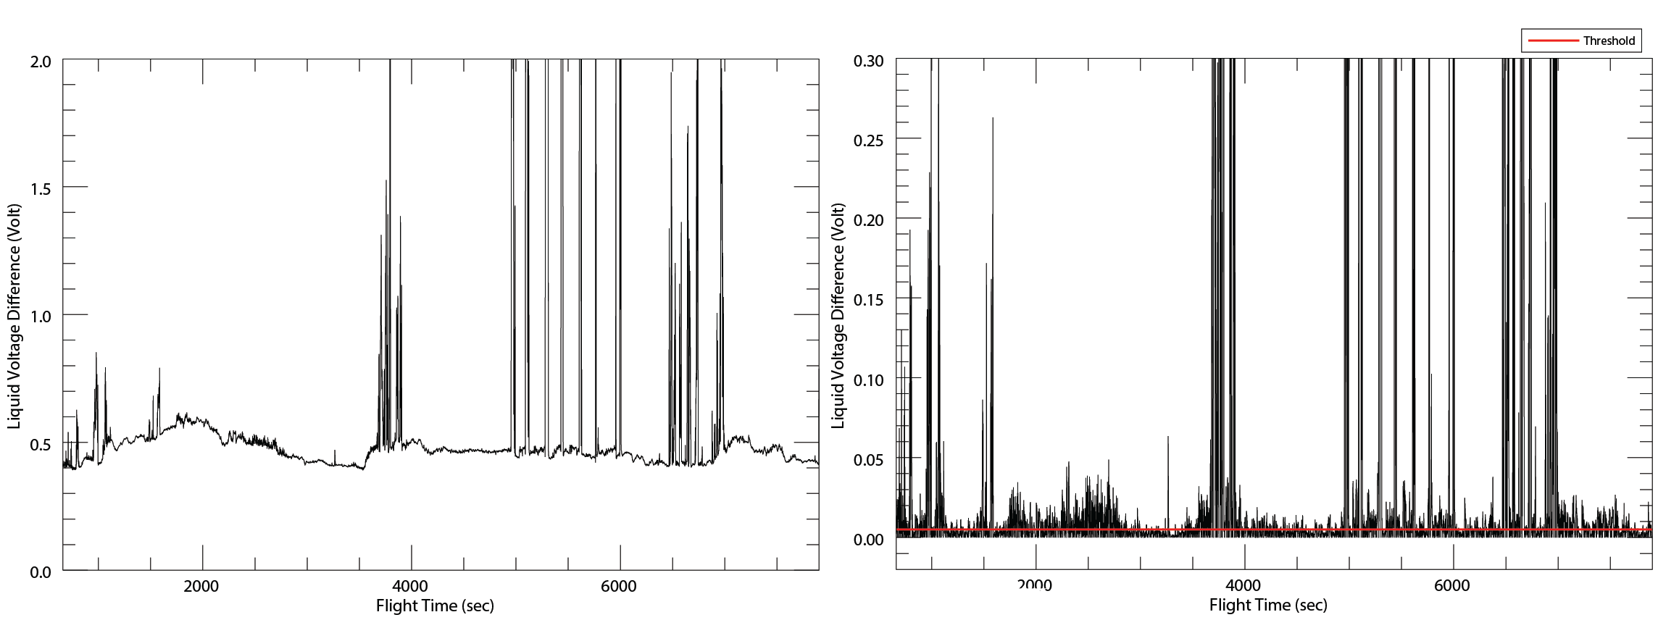

*Raw (figure 1a) and baseline corrected (figure 1b) liquid voltage ratio for 07/27/13 COPE-MED flight clearly showing contrast between periods of clear air flight and signal (signal starting around 3500 seconds). Pressure deviation related baseline drift (from ~ 0 to 3000 seconds) is greatly reduced after processing.*

Clear air points are selected by a threshold set to .45% of maximum baseline corrected voltage difference (red line in figure 1b).

Clear air filtering was applied to nine COPE-MED flights (listed in the introduction section) flagging 62,147 of 97,077 total points as clear air. The clear air point filter effectiveness was examined with Nevzorov LWC values provided by Korolev (flight file variable = nevlwc1). Clear air points from all nine flights had a mean absolute LWC (based on Korolev’s calculations) of 0.00120 g m-3 and standard deviation 0.00224 g m-3. Clear air detection performed adequately considering Nevzorov baseline noise is estimated to be ±0.002 g m-3 (Korolev 1998). Figure 2 shows Korolev’s LWC value distribution for all 62,147 clear air points.

**Figure 2 – Korolev’s LWC For All Clear Air Points**

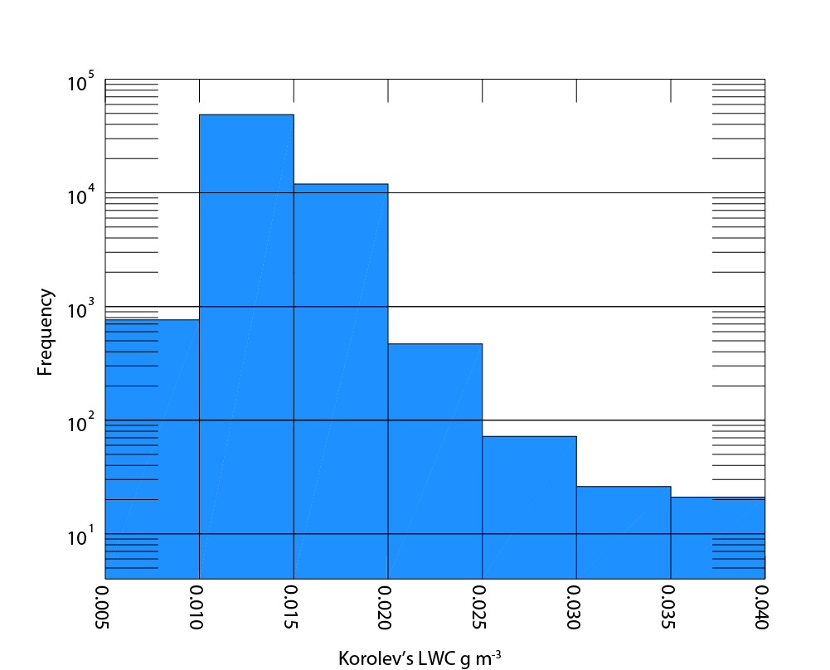

*Korolev’s LWC values for all clear air points, binned by liquid water content. Only 9 clear air values were greater than 0.040 g m-3. Note: the 0 – 0.005 g m-3 bin is not displayed because ~ 6,000 clear air points were manually forced to 0 g m-3 during Korolev’s calculations.*

**Dry Air Heat Loss Coefficient (k) Airspeed Dependence**

Dry air heat loss coefficient (k) airspeed dependence was examined by calculating the ratio between power consumed by the liquid collector sensor and liquid reference sensor during a July 9, 2013 clear air calibration flight.

$$k_{liq}= \frac{vlwccol*ilwccol}{vlwcref*ilwcref}$$

Three k value groups were selected from calibration legs flown at distinct flight levels (approximately 900 mb, 600 mb, and 400 mb) where each flight level contained five unique airspeed legs (ranging from approximately 60 to 100 m s-1 indicated airspeed). Care was taken to manually select calibration sample points with minimal roll, yaw, pitch, and airspeed deviation. Three flight level sample groups, each group containing five airspeed legs, were selected. Next, a geometric fit

$$y= a_{0}x^{a_{1}}+ a_{2}$$

was applied to each flight level group with respect to *both* true and indicated airspeed (totaling to six regression values). Figure 3 shows the three regression curves calculated with respect to indicated airspeed.

**Figure 3 – Dry air heat loss regressions with respect to indicated airspeed.**

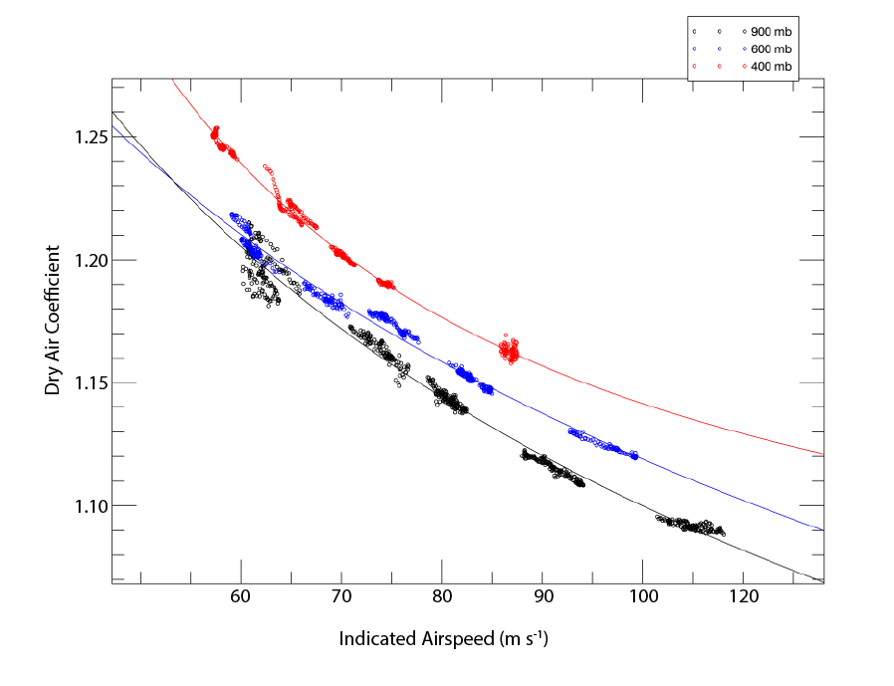

*Dry air heat loss coefficient regressions from 07/09/2013 COPE-MED calibration flight. Each group of points/regression curve corresponds to calibration legs flown at distinct flight levels (900 mb in black, 600 mb in blue, and 400 mb in red).*

LWC calculations were performed for clear air points from all COPE-MED flights using each of the six k regressions. k regression performance was judged based upon clear air LWC mean absolute error (where error for clear air points is considered to be equal to LWC value), and LWC error standard deviation. Figure 3 illustrates each regression’s mean absolute clear air LWC error and standard deviation.

**Figure** 3 **– All Flights k Airspeed Regression Performance**

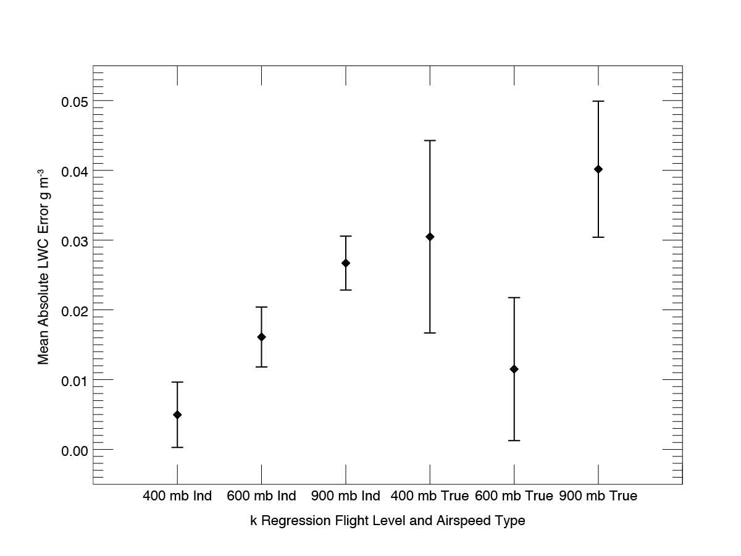

*Dry air heat loss coefficient regression performance based upon clear air mean LWC absolute error calculated for* 07/10/13, 07/25/13, 07/27/13, 07/28/13, 07/29/13, 08/03/13, 08/07/13, 08/14/13, and 08/15/13 COPE-MED flights. Note – “Ind” in x-axis labels signifies k regressions calculated with respect to indicated airspeed and “True” signifies regression calculated with respect to true airspeeds.

In general, k regressions calculated against indicated airspeed resulted in less clear air LWC error and standard deviation. Furthermore, indicated airspeed k regressions resulted in clear air LWC error values that were much less correlated with the similarity of pressure level from which the k regression was calculated and pressure level of individual values (indicated airspeeds have an intrinsic pressure compensation, true airspeeds do not). Figure 4 illustrates this relationship.

**Figure 4 – Pressure-Related Absolute Mean Clear Air LWC Error for all COPE-MED flights**

400 mb Indicated Airspeed Regression 400 mb True Airspeed Regression

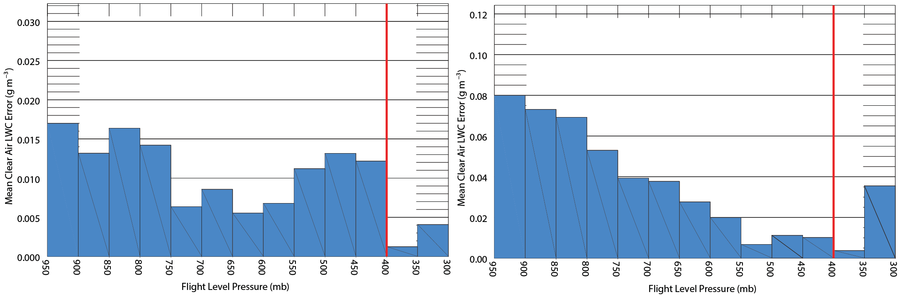

*Figure 4 illustrates how indicated airspeed calculated k regression performance is much less dependent upon the similarity of the pressure level the regression was calculated and actual flight level pressure. The red vertical line denotes pressure level at which the k regression was calculated.*

The 400 mb indicated airspeed k regression (mean absolute error = 0.00496 g m-3, standard deviation = 0.00468 g m-3) showed the best performance of all six k regression values. LWC calculation will be performed using only this k regression throughout the remainder of this document.

**LWC Error Due to Dry Air Coefficient Flight Level Pressure Fluctuation**

Nevzorov dry air coefficient values (and ultimately LWC values) are also affected by flight level environmental pressure fluctuations. Fortunately, pressure-related LWC baseline drift was minimal after correcting for k airspeed dependence (1.983*10-6 g m-3 / 20 mb). A baseline correction was applied to post airspeed-corrected clear air kliq values on a per-flight basis for all ten COPE-MED flight days. Baseline correction amount was calculated with a linear regression fit to kliq values deemed to be clear air points. Figures 5a and 5b show clear air LWC error values from all flights both before and after pressure-dependent baseline correction.

**Figure 5 – Pressure-Related Clear Air LWC Error for all COPE-MED flights, Before (5a) and After (5b) kliq Baseline Correction**

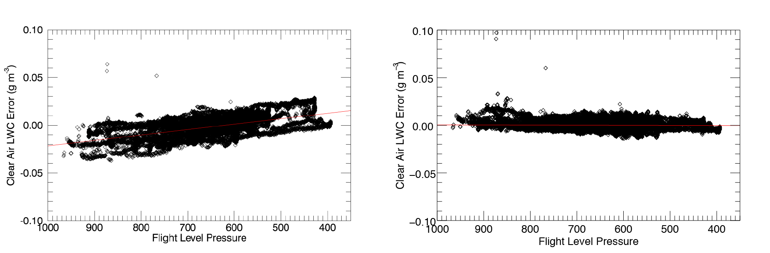

*Clear air pressure dependent LWC error before (figure 5a) and after (figure 5b) kliq baseline correction. LWC error is considered equal to LWC value for clear air points.*

The baseline *kliq* correction procedure performed well for all nine COPE-MED flights. Clear air LWC error means and standard deviations were reduced from pre-correction values of 0.00790 g m-3 absolute mean error, 0.0118 g m-3 standard deviation topost-correction values of 0.00372 g m-3 absolute mean error, 0.00807 g m-3 standard deviation.

**LWC Verification For All Points**

Post airspeed and pressure-dependence corrected LWC value truthfulness for all points (clear air and in-cloud) was examined by comparisons of calculated Nezorov LWC, Korolev’s Nevorov LWC, and Cloud Droplet Probe (CDP) measured LWC. Comparisons against Korolev’s values serve as calculation method verification while comparison against CDP LWC will provide a useful LWC truthfulness metric for future King Air missions (which won’t include Korolev’s LWC calculations). Comparison of Korolev’s LWC and calculated LWC values show good agreement. A direct comparison (figure 6a) indicates all points lie very near a 1:1 slope line. A per-flight breakdown (figure 6b) reveals absolute mean differences for all flights were less than 0.006 g m-3 with standard deviation on the order of 0.010 g m-3.

**Figure 6a, 6b – Comparison of Korolev’s LWC and Calculated LWC For All Points**

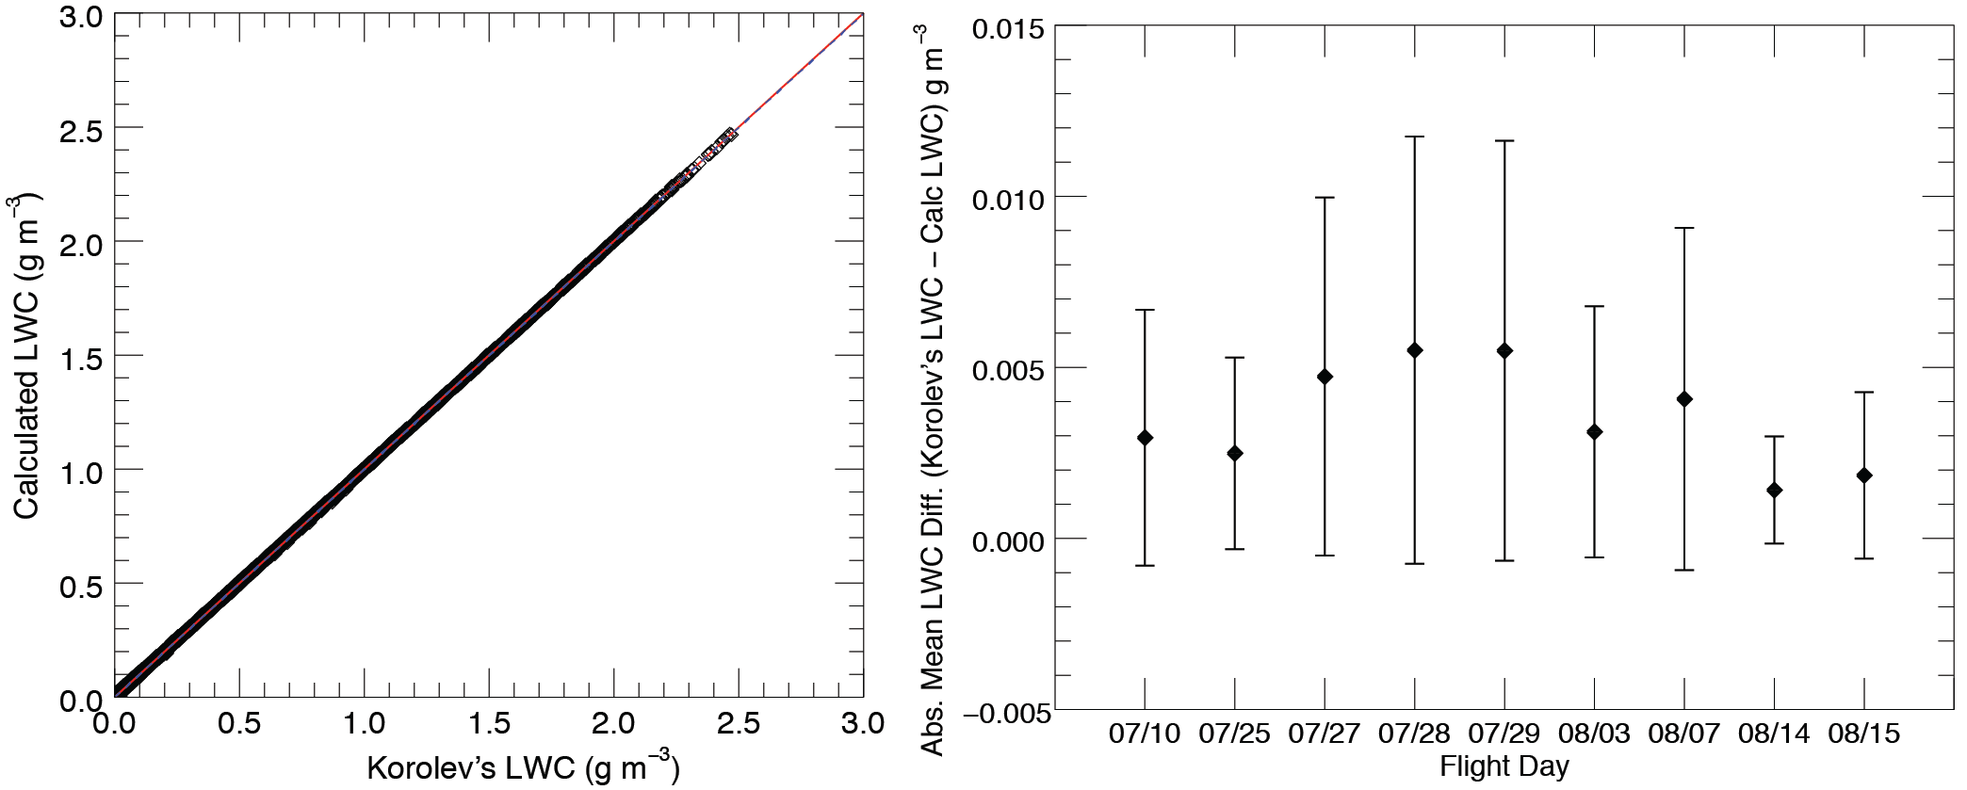

*Figure 6a shows a direct comparison of Korolev’s LWC and calculated LWC values for all COPE-MED points (1:1 line (red) and linear fit (blue) are nearly indistinguishable). Figure 6b displays mean absolute difference between Korolev’s LWC and calculated LWC per flight.*

Calculated LWC and CDP LWC values were also found to be in good agreement. Figure 7a reveals CDP values tend to run higher for data points with high liquid water content (a tendency noted in an independent airborne probe meta-analysis. Sulskis, 2016). Per-flight LWC mean absolute difference was less then 0.02 g m-3 with typical standard deviation around ±0.03 g m-3.

**Figure 7a, 7b – Comparison of CDP LWC and Calculated LWC For All Points**

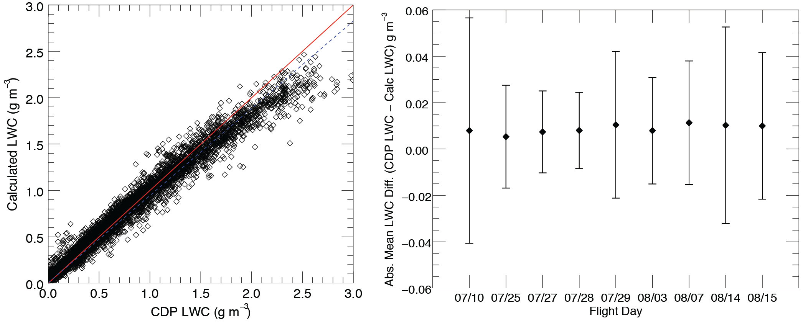

*Figure XXXa shows a direct comparison of CDP LWC and calculated LWC values for all COPE-MED points (with 1:1 line in red and linear regression line in blue). Figure XXXb displays mean absolute difference between CDP LWC and calculated LWC on a per-flight.*