CHAPTER 1

Calibri with Constantia
Firstly, I will provide an overview of the intended research design. This is a necessary backdrop for the discussion of paradigmatic issues relating to ontology, epistemology and methodology that will follow. Then I will consider …

Overview of research design
To address the research issues described in Chapter 2, an explanatory study employing a qualitative interpretive case study methodology was undertaken …

Research paradigms and their importance
Broadly speaking, there are four major research paradigms: positivism, postpositivism, critical theory and constructivism.
Figure 1: This is a linked .emf image imported via the field function IncludePicture. Press Alt+F9 to show the underlying field code. EMF files will produce the best resolution here as well as in a PDF export because they are vector images. Unfortunately, such files cannot be rendered in the Github Desktop diff view.
Figure 2: This is a linked .emf image imported via the “Insert > Image > Options - Link Image” menu. It does not have a field code, but it will also not increase file size. However, its file path is absolute and not relative (check “File > Information” to see the full path).
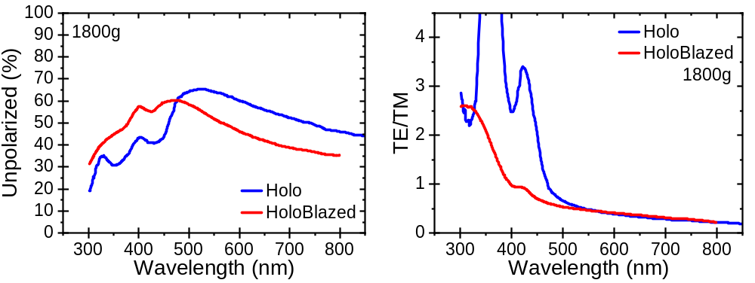
Figure 3: This is an embedded .emf image imported via the “Insert > Image” menu. It will not automatically be updated in the .docx file size increases according to the image file size.
Figure 4: This is a linked .png image. PNG files are limited by the original file resolution, but they can nicely be diffed in Github Desktop. Check out the tools section to find a Python script that recursively replaces embedded PNG graphics with PDF vector grafics if provided.

