|  |  |
| --- | --- |
| Active Directory Usage for DM  CUSTDM10 (iLab), DM10, and USMLVV1D0A Domains | Abstract  DM controls a portion of the USMLVV1D0A Active Directory Domain and has access to portions of the iLab’s CUSTDM10 domain as well as portions of the DevCloud DM10 domain.  Fairbrother,Stephen  Author |

Table of Contents

**1** **CUSTDM10 – QA** 2

**1.1** **Overview** 2

**1.2** **Accessing the CUSTDM10 Active Directory** 4

**1.3** **Adding New Users** 5

**1.4** **Adding Users to Groups** 6

**1.5** **Secure the Group or User in DM** 7

**1.5.1** **To give the Group or User access to all of the tokens:** 7

**1.5.2** **To give the Group or User access to selected tokens:** 7

**2** **DM50/DM10 – DevCloud** 8

**2.1** **Overview** 8

**2.2** **Getting Access to the DM10 Taskpad** 8

**2.3** **Accessing the DM10 Taskpad** 8

**2.4** **Accessing the DM10 Domain** 8

**2.5** **Adding New Users** 9

**2.6** **Adding a User to a Group** 10

**2.7** **Secure the Group or User in DM** 10

**3** **CUSTDM10 – iLab** 10

**3.1** **Overview** 10

# **CUSTDM10 – QA**

## **Overview**

DM controls the MIS2000 container in the USMLVV1D0A.shshsc.net Active Directory (USMLVV1D0A.smshsc.net/US/I03/I03 - MIS2000). For access to the MIS2000 container, contact Stephen Rathgeber.

Previously groups were created that were specific to the environment. With a few exceptions we have not created new groups post-F250. Instead we have been using the F250 groups to secure the 25.0 and higher instances of the application.

In addition we typically created 7 service accounts for each environment. This was an artifact of the time when different accounts were used to run services. Since all services are now run using the hhrr_stm_server account, you can use the F250_STM_Server account for all net new installs.

If you are cloning from one environment to another, you need to check to be sure what groups are being used to secure things. If you are doing a net new install in USMLVV1D0A, you will just use the F250 groups during the install, when prompted.

The F250 groups of interest are:

|  |  |  |
| --- | --- | --- |
| Group Name | Purpose | Contents of F250 Groups |
| USI03G-EDM-F250Administrators | Users with Admin role |  |
| USI03G-EDM-F250Analysts | Users with Analyst role | And all users whose ID’s start with ana_ |
| USI03G-EDM-F250DIAdmins | Group secured during application installs with access to all tokens, unless the install is RHO |  |
| USI03G-EDM-F250DIServices | Group that contains account used to run services and pools; Group is secured during the installation of the application | F250_STM_Server is used to run the application pools and services |
| USI03G-EDM-F250DIUsers | Group that contains all users associated with an instance of DM. Group is secured during the installation of the application | Contains all of the other groups and a few user ID’s |
| USI03G-EDM-F250Physicians | Users with Physician role | Contains all of the logons that start with either doc_ or phy_. Also contains a few other individual users: EDMHIM, EDMHIM2, and testmu |
| USI03G-EDM-F250RegularUsers | Users with minimal access to DM |  |
| USI03G-EDM-F250SCSAdmins | Secure Messaging Admins | Empty |
| USI03G-EDM-F250SCSUsers | Secure Messaging Admins | Empty |
| USI03G-EDM-F250STMAdmins | Used in RHO installs only. Group members get access to the STM maintenance tokens. |  |
| USI03G-EDM-F250Supervisors | Users with Supervisors role |  |

## **Accessing the CUSTDM10 Active Directory**

1. Log onto a USMLVV1D0A server using your USMLVV1D0A logon ID and password.
2. Click **Start**.
3. In the **Search Programs and Files** field, type **Active**.
4. From the list above, click on **Active Directory Users and Computers**.
5. Click on **View** from the top menu.
6. Select **Advanced Features**.
7. Navigate to USMLVV1D0A.smshsc.net/US/I03/**I03 - MIS2000.**
8. Click on the **I03 - MIS2000** Organizational Unit (OU).
9. In the right panel you will see the following:

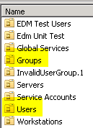

Of interest are the **Groups** and **Users** OU’s.

You can define new Groups or Users in the relevant OU.

## **Adding New Users**

1. Double-click on the **Users** OU.
2. Scroll to the bottom of the list of names and groups on the right and right-click in the white space at the bottom:

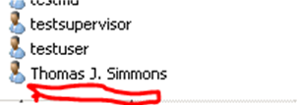

1. Click on **New**.
2. Click on **User**.
3. Define your user. You can just enter the name in the Full Name and User Logon Name fields:

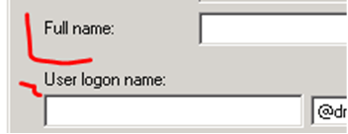

1. Press **Next**.
2. Enter the **password** (2 times).
3. Uncheck **User must change password at next logon**.
4. Check **User cannot change password**.
5. Check **Password never expires**.

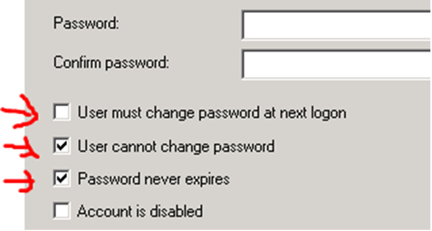

1. Click **Next**.
2. Click **Finish**.

## **Adding Users to Groups**

1. Double-click on the user you want to add to a group.
2. Click on the **Member Of** tab. 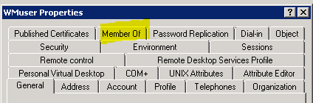
3. Click on the Add button. 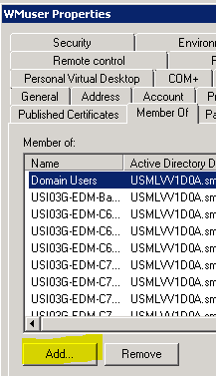
4. If you did not log onto the server with your USMLVV1D0A ID, you will get the following prompt for your USMLVV1D0A domain credentials:

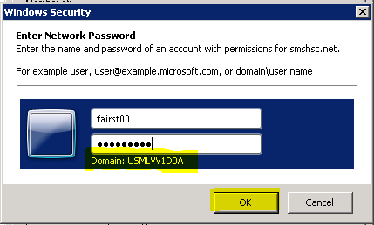

1. Enter your ID and password.
2. Click **OK**.
3. In the **Enter the object names to select** field, enter the name of the group to which you want to add the user.

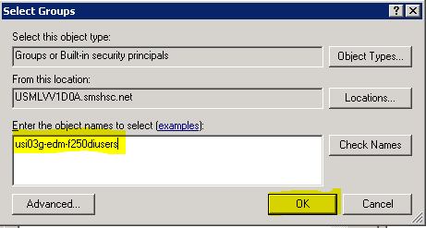

1. Click **OK**.
2. Click **OK** on the next screen.

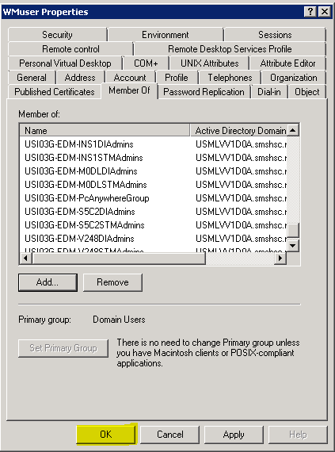

The user has now been added to the selected group.

## **Secure the Group or User in DM**

NOTE: Changes to the Active Directory may take a little time to become available as changes replicate across the domain controllers.

If you added a user to a group already secured in your instance of DM, your work is done once the changes replicate. If not, read on.

1. Log onto DM as adminuser / Phillies05.
2. Click on **Security** on the main menu.
3. Click on **Security** on the submenu.
4. Click on the radio button to select **Group** or **User**, depending on what you want to secure.
5. Enter the name of the Group or User in the field next to the **Find** button.
6. Click on the **Find** button.
7. Click on the **Revise** button in the lower left.

### **To give the Group or User access to all of the tokens:**

1. Click on the name of the first token.
2. Scroll to the bottom.
3. Hold the Shift key.
4. Highlight the last token name on the list.
5. In somewhere between 10 and 30 seconds, all of the token names will be highlighted.
6. Scroll back to the top of the token display.
7. Click on each of the column names, starting with **Create**. You will see each column fill with a green check mark.
8. Once you have clicked on all of the column names, click on the **Save** button in the lower right.
9. Recycle the pool associated with the application and then try logging on with the user.

### **To give the Group or User access to selected tokens:**

1. Click on a token.
2. Click on the boxes to the right of the token name to give the specific access you want the group or user to have to the specific token.
3. Repeat this process for all target tokens.
4. Once finished granting access to all of the target tokens, click on the **Save** button in the lower right.
5. Recycle the pool associated with the application and then try logging on with the user.

# **DM50/DM10 – DevCloud**

## **Overview**

In the DevCloud servers are in the DM50 domain and DM groups and users are in the DM10 domain. You cannot access the Active Directory by the usual means. Instead, a Taskpad has been created to which you will need access. See below for the process to get the access.

DM uses ONC1 groups and users to secure some of the DM applications in the DevCloud.

SFET groups and users are used to secure Soarian Financials instances of DM.

KCFG and PRD1 groups and users were used formerly.

## **Getting Access to the DM10 Taskpad**

1. You must have a DM10 ID. If you do not, your manager has to make that request.
2. Once you have a DM10 ID, a second ticket has to be opened for you to get access. You can tell them to model you after Shefali Ameser, DM10\SA036200.

## **Accessing the DM10 Taskpad**

1. Log onto a server in the DevCloud.
2. Click on the **Start** button.
3. Right-click on the **command window icon**.
4. Select **Run as administrator**.
5. In the command window, type the following command: runas /user:DM10\userid "mmc %windir%\system32\dsa.msc"

(replace userid with your DM 10 ID).

1. Hit **Enter**.
2. When prompted, enter your DM10 password.
3. Hit **Enter**.

## **Accessing the DM10 Domain**

1. When the Active Directory appears, right-click on the dm50.dev.smed.net entry on the right: 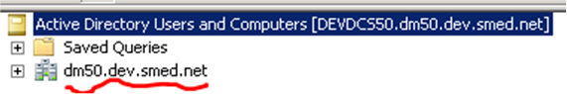
2. Select **Change Domain…**
3. Change the number **5** to the number **1**:
4. Before: 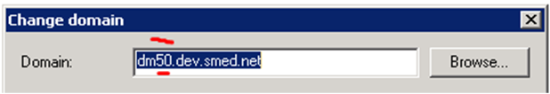
5. After: 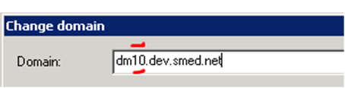
6. Click **OK**.

## **Adding New Users**

1. In the righthand pane, click on the plus (**+**) sign next to the DM10 domain name:

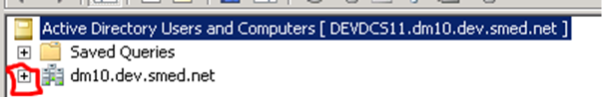

1. Click on the plus (**+**) sign next to Customers:

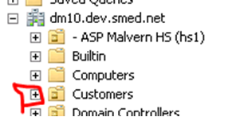

1. Scroll down to the ONC1 Golden System container and click on the plus(**+**) sign:



1. Click on the plus (**+**) sign next to ONC1 Users:



1. Scroll to the bottom of the list of names and groups on the right and right-click in the white space at the bottom:



1. Click on **New**.
2. Click on **User**.
3. Define your user. You can just enter the name in the Full Name and User Logon Name fields:



1. Press **Next**.
2. Enter the **password** (2 times).
3. Uncheck **User must change password at next logon**.
4. Check **User cannot change password**.
5. Check **Password never expires**.



1. Click **Next**.
2. Click **Finish**.

## **Adding a User to a Group**

You will be adding a user to an ONC1 group. The operation is the same as described above for USMLVV1D0A, except all groups adhere to this naming pattern: ONC1 DI Admins (where the DI Admins portion is variable and there are spaces between the names.

Click on this heading to see the instructions: **Adding Users to Groups**

## **Secure the Group or User in DM**

Click on this heading to see the instructions: **Secure the Group or User in DM**

# **CUSTDM10 – iLab**

## **Overview**

Usage of the iLab has diminished and will no longer require DM attention.