|  |  |
| --- | --- |
| **Testing Net New Installs and Creating Permanent Test Environments** | Abstract  Oh no. Somebody has told you to use this document because you either have to create a net new environment for testing or you have to do net new installation testing. Poor you.  Fairbrother,Stephen  Author |

**Testing Net New Installs and Creating Permanent Test Environments**

Table of Contents

**1** **Net New Installs** 2

**1.1** **Overview** 2

**1.2** **Getting the files from Artifactory by way of Jenkins** 2

**2** **Installing the Databases** 2

**2.1** **Overview** 2

**2.2** **Steps to Creating the Databases** 2

**2.3** **Opening a Command Prompt and Running as Administator** 5

**2.4** **Running the Data Base Installation** 5

**2.5** **Run the Shrink IDB Log SQL** 5

**3** **Installing the Application** 6

**3.1** **Background on the backgroundroot Share** 6

3.2 **Create the backgroundroot Share** 6

**3.3** **Background on Directory Structures used by DM in QA Environments** 7

**3.3.1** **Local Environment: Application Location on Web\App Servers** 7

**3.3.2** **Shared Configuration: Configuration Share Located on Database Server** 7

**3.4** **Running the Install** 8

**4** **Review the Settings before turning the Environment over for Use** 10

**5** **Additional Steps for Permanent Environments** 10

**5.1** **Create the Organization** 10

5.2 **Install the Services** 11

**6** **Smoke Test** 13

**7** **Final Steps for Permanent Environment** 15

# **Net New Installs**

## **Overview**

To do a net new install you will obtain the DMInstallDb.zip and DmSetup.exe files needed to install the databases and application, respectively. The DmInstallDb.zip file will be used on the SQL server where the databases will be installed. The DmSetup.exe file will be used on the server(s) where the application is installed.

## **Getting the files from Artifactory by way of Jenkins**

1. Go to Jenkins: <https://usmlvv1cto2874.usmlvv1d0a.smshsc.net/jenkins/>
2. To select the build you want:
3. Click on **DM-25.2** or **DM-25.3**.
4. Click on **IMS**.
5. Click on the **branch** you want. Usually you will apply the production build so the branch value will be either **25.2** or **25.3**.
6. Click on the build number you want.
7. Click on the **Artifactory Build Info** link. This will take you to Artifactory.
8. Under the **Published Models** tab, click on the link displayed.
9. Hover over the .zip file name and select the **Show in Tree** option.
10. Click on the icon next to the .zip file to show the files in the .zip file.
11. Right-click on the DMInstallDb.zip file and select **Download**.
12. When prompted, click the **Save** button.
13. When the file has downloaded, click on the **Open folder** button.
14. Obtain the DMInstallDb.zip file from the directory.
15. Copy the DMInstallDb.zip file to the SQL server where you will be installing the databases.
16. Returning to Artifactory, download the DmSetup.exe file (installation kit) and copy it to the server(s) where you will be running the install.
17. Make a note of the location(s) of the kit.
18. You can close Arifactory and Jenkins now.

# **Installing the Databases**

## **Overview**

You must choose a name for the new environment, something like TST2 will serve. You will be unzipping the DMInstallDb.zip file in a directory that you create on the SQL server. You will then run the ImsScriptGenerator.exe program to launch the UI used to create the files that will allow you to install the databases and associated object shares. For this example, we will be using the USMLVV1EDM067.USMLVV1D0A.smshsc.net SQL server in QA. The same process applies for installation in the Dev Cloud.

## **Steps to Creating the Databases**

1. Create a directory on the C:\ drive of the server, using a name that is meaningful to you.
2. Place the DMInstallDb.zip file in the new directory.
3. Right-click on the DMInstallDb.zip file, hover over the 7-zip option and click on Extract Here. The files will be extracted into a subdirectory named DMInstallDb.
4. Open the DMInstallDb directory.
5. Right-click on the DMInstallDb file and select the **Run as administrator** option.
6. You will now see the Script Generation Tool UI.

In this example, the name of the environment is 1234 (where 12 = the Hospital Code and 34 = the Region Code).

1. Below is a screen shot of how this would normally be completed with all of the necessary fields valued (see notes below for more information):

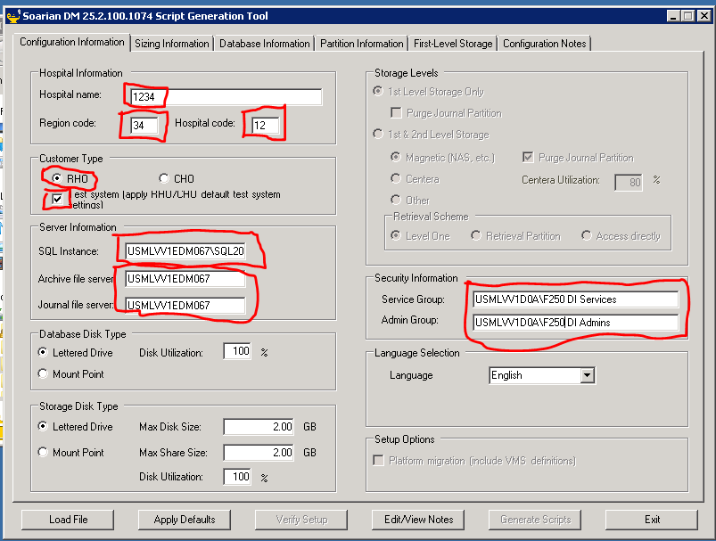

1. Hospital Name is the name of the environment.
2. The RR and HH are the reverse of the environment name.
3. The SQL instance in this case is USMLVV1EDM067\SQL2014.
4. The Archive and Journal file server is just the name of the server.
5. Always use the USMLVV1D0A\F250 DI Services and USMLVV1D0A\F250 DI Admins groups to secure the application.
6. Areas not circled in red are defaults. Just use them.
7. Click on the **Apply Defaults** button.
8. Click on the **Database Information** tab.

For installs on USMLVV1EDM067, you can accept the defaults to the E:\ drive. Change this if you are on a server where the Data_Dev and Log_Dev directories are on a different drive.

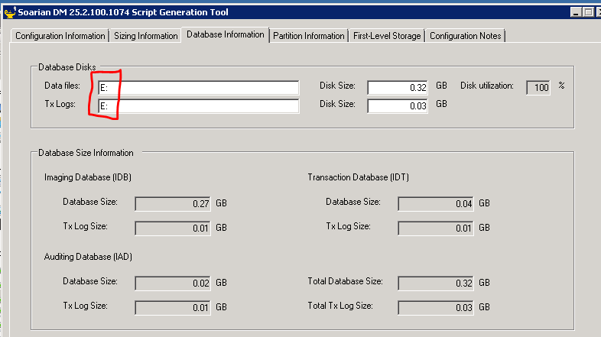

1. Click on the **First-Level Storage** tab.
2. Change the Disk value to E: for both the Archive and Journal Storage shares (no slash “\” after the drive name.
3. Accept the defaults for the Share Names.

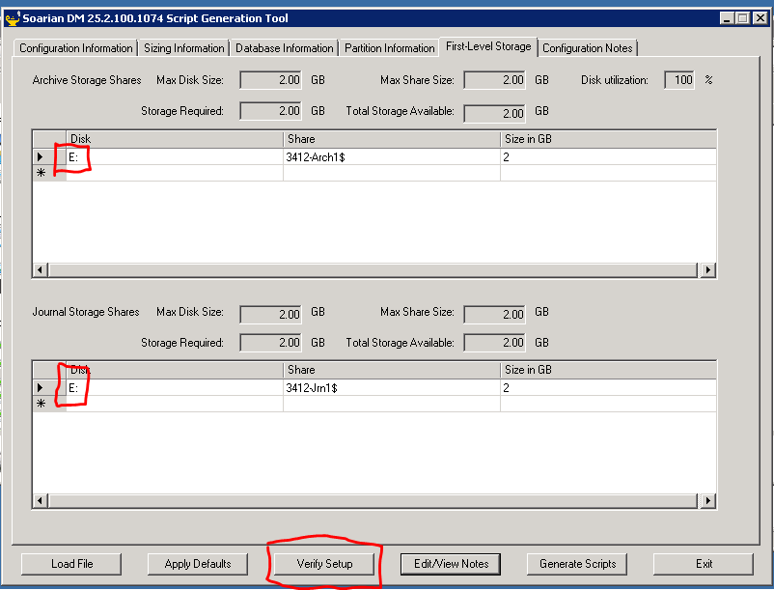

1. Click the **Verify Setup** button.
2. Review the **First-Level Storage** screen to make sure there is no indication of a problem.
3. Click on the **Database Information** tab and review the screen to make sure there is no indication of a problem.
4. Click on the **Configuration Information** tab and review the screen to make sure there is no indication of a problem.

In each case, if there is a problem a small red icon with appear. Examine the screen to determine the issue, change the problematic field. Click Verify Setup again, review the screens, and if there is no red icon, you are ready for the next step.

1. Click on the **Generate Scripts** button in the lower right.
2. You will receive the following informational messages. Click **OK** on each:

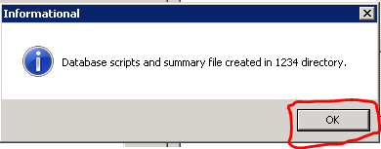

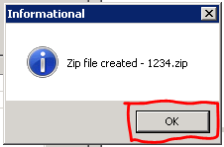

1. There will now be a subdirectory named HHRR (in this case 1234) in the directory that contains the ImsScriptGenerator.exe program that you just ran.

## **Opening a Command Prompt and Running as Administator**

1. Click on the Start button in the lower left of the server screen.
2. Enter **cmd** in the lower left field that says “Search programs and files”
3. Cmd.exe will be displayed above.
4. Right-click on the cmd.exe entry and select **Run as administrator**.

## **Running the Data Base Installation**

1. At the command prompt, type the following: cd C:\name\DMInstallDb\1234 (where name = the name of the directory you created and put the DMInstallDb.zip file in).
2. Click on the **Enter** key.
3. At the prompt, type: **BuildAndLoadDatabases.cmd**.
4. Click on the **Enter** key.

The scripts will run and the databases will be created.

1. Once the command has finished, type the following at the prompt:
2. **CreateStmArchShares.cmd**
3. Click on the **Enter** key.

The scripts will run and the archive shares will be created.

1. Once the command has finished, type the following at the prompt: **CreateStmJrnShares.cmd**
2. Click on the **Enter** key.

The scripts will run and the journal shares will be created.

## **Run the Shrink IDB Log SQL**

This SQL is applied after creating a new IDB data base and keeps the log from getting too large.

1. Open the model file: 
2. Replace the IDB database name in the model SQL with the name of your database.
3. Copy the edited SQL.
4. Open the SQL Server Management Studio that houses your IDB database.
5. NOTE: You must be an administrator on the server and should use Windows Authentication when logging onto the Studio.
6. Click on New Query in the second level of the toolbar at the top of the Studio.
7. Paste the edited SQL into the query window on the right.
8. Highlight the SQL.
9. Click on the **Execute** button. 

You may exit the SQL Server Management Studio.

You are now finished installing the databases and ready to install the application.

# **Installing the Application**

## **Background on the backgroundroot Share**

1. Log onto the server from which you will be performing the backups.

You must be an administrator on the server. When you log onto the server, include the /admin command in the RDP **Computer:** field.

**Example**: usmlvv1edm603.usmlvv1d0a.smshsc.net /admin

* For net new installations that will be used for testing, you will do this process on both USMLVV1EDM226 and USMLVV1EDM603
* For net new install tests and verifications, I recommend that you use the usmlvv1edm603.usmlvv1d0a.smshsc.net server.

You will now install the application to verify that the install kit is working properly. You first create a backgroundroot_hhrr directory on the drive where the other backgroundroot directories already exist, and then run the installation kit.

* For net new installations that will be used for testing, create the backgroundroot_hhrr share on USMLVV1EDM226.
* For net new install tests and verifications, create the backgroundroot_hhrr share on USMLVV1EDM603.

These instructions use USMLVV1EDM603 as the destination.

## **Create the backgroundroot Share**

1. On the usmlvv1edm603 D:\ drive, create a new backgroundroot directory. In this example, we will create backgroundroot_1234.
2. Right-click on the directory, and select **Properties**.
3. Click on the **Sharing** tab.
4. Click on the **Share…** button.
5. In the field to the left of the Add button, enter the following:

usi03g-edm-f250diservices

1. Click on the **Add** button.
2. On the line with the new group, click on the dropdown and change **Read** to **Read/Write**.
3. In the field to the left of the Add button, enter the following:

usi03g-edm-f250diusers

1. Click on the **Add** button.
2. On the line with the new group, click on the dropdown and change **Read** to **Read/Write**.
3. Click on the **Share** button.
4. Click on the **Done** button.

## **Background on Directory Structures used by DM in QA Environments**

### **Local Environment: Application Location on Web\App Servers**

The first value for which you are prompted when installing DM is the physical location of the application [drive]:\ Program Files\Cerner\DM\HHRR (where HHRR = the name of the DM environment). You can use the kit to create that directory or create it yourself in advance of the install and select it during the install.

The installation kit will extrapolate from the value and actually value the first field in the install kit with a value like this: [drive]:\Program Files\Cerner\DM\ENVIRONMENT\HHRR. That is okay. The kit will create the new ENVIRONMENT\HHRR subdirectory automatically for you.

### **Shared Configuration: Configuration Share Located on Database Server**

The second value for which you are prompted when installing DM, is the configuration share location for the instance of DM you are installing. The configuration share is typically on the database server. The name of the share will follow this convention: \\servername\CernerApps

Once you have identified the correct share name for your install, you can put it in the second field of the installation screen and use the browse button to navigate through the structure:

\\servername\CernerApps \Program Files\Cerner\DM\ENVIRONMENT\HHRR\DATA

(where HHRR = the name of the DM environment; DATA is a commonly used subdirectory for the configuration but is not mandatory)

Before continuing with the installation, your screen will look like this:

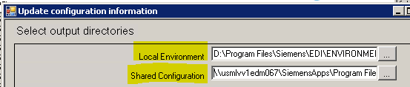

## **Running the Install**

1. Go to the folder on the server where you placed the DmSetup.exe file.
2. Double-click on the DmSetup.exe file.
3. Select the **Browse** button. You are now looking for the location of other instances of the application on the web\app server.
4. When you locate other instances of the application (click here for more information), create a directory named 1234 (or whatever yours will be named).
5. Click **OK**.
6. Click Yes on INSTALL NEW environment message: 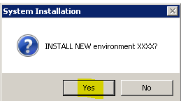
7. Select the **Configure** button.
8. Click on the **Shared Configuration** field.
9. Enter the name of the appropriate CernerApps share (in this case \\USMLVV1EDM067\CernerApps).
10. Select the three dots (…) next to the share name field and navigate down to the ENVIRONMENT level directory (click here for more information).
11. While focused on the ENVIRONMENT directory, select the **Make New Folder** button.
12. Enter the name of the new folder (in this case 1234).
13. Focused on the 1234 directory, select the **Make New Folder** button.
14. Enter the name DATA for the second folder. (This step is optional and does not affect functionality).
15. Focused on the DATA directory (of 1234 directory, if you are not creating the DATA directory), click the OK button.
16. Review the entries in the Local Environment and Shared Configuration fields to be sure they are the way that you want them.
17. Select the **Data Center (RHO) install** checkbox twice to value it.
18. Click **OK**.
19. Answer **Yes** to the create folder message.
20. Click **OK**.
21. Click the checkboxes for the **Application Server** and **Web Server**.
22. Click **Next**.
23. Click **Next** to accept the **Default Web Site**.
24. Enter the name in the **Background root folder** field on the installation kit, in this case \\USMLVV1EDM603\backgroundroot_1234
25. Click **Next**.
26. On the next screen, change the **Default logon domain** to **USMLVV1D0A**.
27. Check the **Use Netscaler** checkbox.
28. Click **Next**.
29. On the **Netscaler settings** UI, value as follows:

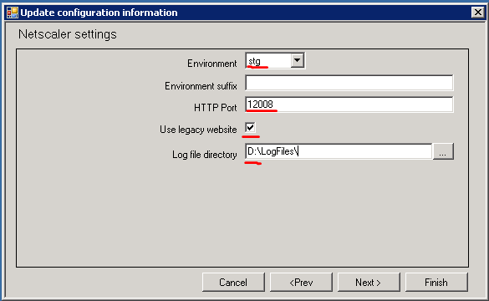

1. Select stg in the **Environment** dropdown.
2. Leave the **Environment suffix** blank.
3. Enter a value for the **HTTP Port** (look in IIS to see what the highest number in use is and increment by 1).
4. Check the **Use legacy website** checkbox.
5. Change the drive value to D:\LogFiles\ in the **Log file directory** field.
6. Click **Next**.
7. Enter the **Serve**r name (in this case USMLVV1EDM067\SQL2014).
8. Enter the Database name (in this case SMSPHidb3412).
9. Click **Next**.
10. Click **Next**.
11. Click **Next**.
12. Select the EDM Base and Completion checkboxes.
13. Click **Next**.
14. Value everything as shown below on the **Configure user identities** UI:

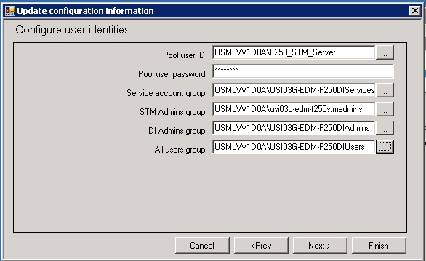

1. The password for F250_stm_server is Passw0rd.
2. Click **Next**.
3. Click **Finish**.
4. Eventually you should get a message that the installation has completed. Close the popup message.
5. Look at the display on the screen and check near the bottom for a success message.

The application is now installed.

# **Review the Settings before turning the Environment over for Use**

1. Log onto the application (in IE, enter usmlvv1edm603/1234, in this case), using the adminuser / Phillies05 account.
2. Click on Help in the upper right and click **Help**, then click **About**.
3. Review the contents of the screen to be sure the correct version of the software has been installed (value at top center).
4. Review the **Server Process Information** to see if all of the values are expected:

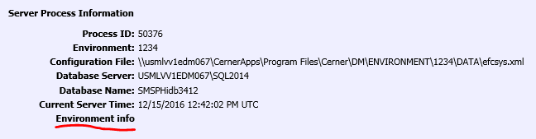

1. Click on the **Environment info** link for further details. A separate screen will appear.
2. Review the entries on the **Environment Information** screen to be sure all values are as expected.
3. Once satisfied, close the **Environment Information** screen.

Click here to skip to Smoke Test if this is just an installation test.

# **Additional Steps for Permanent Environments**

## **Create the Organization**

You will create the main organization, since it will be needed to install an instance of the poller.

1. While still on the application, click on the **Administrator** option on the main menu.
2. Once the menu expands, under **Other**, click on **Organizations**.
3. Click **Create**.
4. Enter the values as shown below:

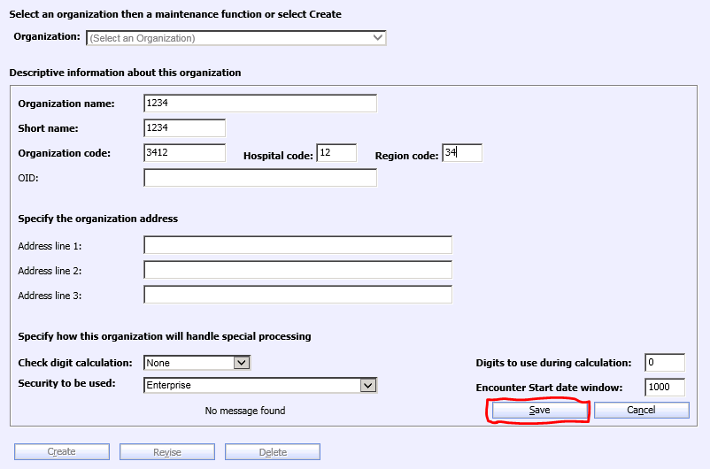

1. Click **Save**.
2. You can close the Organizations access by clicking on the red X on the tab:



## **Install the Services**

The services you install may vary, depending on need. In addition to those delivered automatically by the install, a new environment typically needs a poller and a receiver. Directions for creating those follow.

1. Run the command prompt as an administrator. (Directions for this are above where you installed the databases).
2. Change to the bin directory for the application (in this case cd "E:\Program Files\Cerner\DM\1234\WWWROOT\BIN").
3. At the prompt type: cd "D:\Program Files\Cerner\DM\1234\WWWROOT\BIN"
4. Hit **Enter**.
5. Type ikmser and hit the tab key. This should find the IkmServiceController.exe file.
6. Hit **Enter**.
7. The **Interactive Service Controller** UI will display.
8. Click on the **Configure Group** button.
9. Click the **Create** button.
10. Value the fields as follows (password is Passw0rd):

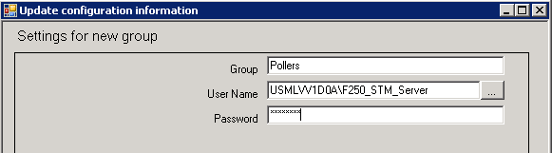

1. Click **OK**.
2. Click the **Create** button again.
3. Value the fields as follows:

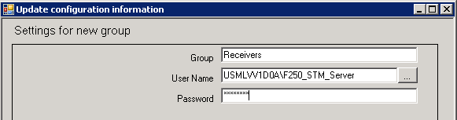

1. Click **OK**.
2. Click **Cancel**.
3. Click **Create New Service**.
4. In the dropdown select **OlcPoller**.
5. Click **OK**.
6. Click on the dropdown in the **Choose Organization** field and select the organization that is specific to the install:

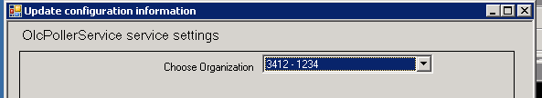

1. Click **OK**.
2. Change the **Group** value to Poller.
3. Enter F250_stm_server as the **User Name**.
4. Click on the **Create** button.
5. In the Source Folder field, enter the \\servername\backgroundroot_sfethhrr\upload location (in this case \\usmlvv1edm603\backgroundroot_1234\upload
6. Click **OK**.
7. Click **Cancel**.
8. Click **Create New Service**.
9. In the dropdown select **IsdReceiver**.
10. Click **OK**.
11. For the **Port number of service** value, do the following:
12. Go to the CernerApps share. Locate the previously created environment (next lowest number or whatever was created last) and open the associated eycsys.xml file (in this case D:\CernerApps\Program Files\Cerner\DM\ENVIRONMENT\SFET1786\efcsys.xml). Search for “receiver$” and you will find the previously installed receiver and its associated port number. Increment that number by one and you now have your new port number.
13. Enter the new port number in the **Port number of service** field.
14. Click **OK**.
15. On the next UI, select **Receiver** from the **Group** dropdown.
16. Enter sfet_stm_server in the **User Name** field.
17. Scroll to the bottom of the UI and locate the **Parser template file name and location** field.
18. The value for an installation depends on the purpose of the receiver and the type of data being processed. Check with the requestor to see what they want.
19. An example value is shown below:

\\USMLVV1EDM067\CernerApps\Program Files\Cerner\DM\ENVIRONMENT\1234\DATA\SHARED\INTERFACE\IsdIsHl7Generic.xml.model

1. Click **OK**.
2. Click on the **Install Service** button.
3. In the **Group** dropdown window, select **Pollers**.
4. Click **OK**.
5. Click on the **Install Service** button.
6. In the **Group** dropdown window, select **Receivers**.
7. Click **OK**.
8. Log back onto the application (in IE, enter usmlvv1edm603/1234, in this case), using the adminuser / Phillies05 account.
9. Click on the **Operations** option on the main menu.
10. Click on the **Service Control Manager** option.
11. Verify whether or not all of the services are running.
12. To start any that are not running, click on the **Application Servers** tab.
13. Click on the **circle with the square red box** next to the server name.
14. Click on the **Start** icon.
15. Click on the **Services** tab.
16. Click on the **Refresh** sub-tab periodically to see if the services are coming up.
17. If a service will not start, seek help for diagnosing the issue.
18. If this is a permanent test environment, log onto the other server (usmlvv1edm226).
19. Run the installation kit for the new environment.
20. Install the poller and receiver on the server.

You will do the smoke test on both servers.

# **Smoke Test**

This section details how to import and display documents after a system refresh or upgrade has been done. This process exercises a significant portion of the application’s overall functionality and serves as a good initial test to establish that base functionality has not been disrupted by the refresh or upgrade.

To check out the application install or refresh:

1. Launch the application from Internet Explorer.
2. Enter a logon ID and password for an account that has administrative access to the application.
3. On the **Help** menu, click **About**.
4. Verify that the Version number at the top center of the screen matches the build level of the software that you have just applied.
5. On the top menu of the application, click **Acquire**.
6. Select **Assisted Filing**.
7. Select a **Worklist** folder type.
8. Enter a **Worklist Name and Worklist title**.
9. Click **Find**. If the name does not exist, answer **Yes** to the create folder question.
10. Select the STM **Document type**.
11. Make sure the **Source** value is set to **Import**.
12. Select the TXT Text Files **File type**.
13. Click the **Browse** button and select a file with the *.TXT* extension.
14. Click the **Add to list** button. (If you get a new screen, you may have to resize it to see this question at the bottom: “This file is smaller than the blank page threshold. Do you wish to import it?” Click the **Yes** button.)
15. Click the **Import** button.  
    The document should appear on the **Folder Display** window.
16. In the document display on the right, click on the **X Clear** button to remove the document from the display.
17. On the left, click on the Folder **Retrieve** button. 
18. Select the Worklist folder type and enter the name of your worklist.
19. Click the **Find** button.
20. Under **Select folders** **to display**, double-click the name of your worklist.  
    The **Folder Display** window should appear.
21. Click the plus (+) sign next to the name of your worklist and verify that there is a document in the folder with today’s date on it.
22. Double-click that document and verify that the document successfully displays in the **Document Display** window on the right side of the screen.
23. Click on the icon next to the folder name and document name and make sure information is displayed.
24. On the left, click on the Document **Retrieve** button.



1. Scroll down and highlight the STM document type by clicking it.
2. Specify today’s date in the **Document Date To** and **From** fields.
3. Click the **Find** button.
4. Double-click the document in the **Select documents to display** window.  
   The **Split Folder/Document Display** window should appear.
5. Double-click the document in the Folder Display window on the left of the display and verify that the document successfully displays in the **Document Display** portion of the screen on the right.
6. You may now use the **Maintain** documents and **Maintain** folders functions to remove the document and worklist.



If this is an installation test, you may log off of the application and report your test findings in the JIRA that was created to record your test.

# **Final Steps for Permanent Environment**

1. Close the application.
2. Log off of the server.
3. Notify the requesting parties that the application is available for use.