|  |  |
| --- | --- |
| Provisioning vRealize Servers for Components and Platforms  Better than Sliced Bread | Abstract  Welcome to the exciting world of virtual servers. With a few clicks you can now please your colleagues with their very own server. Need to add a drive? No problem. Need to increase the size of a drive? No problem. Need to figure out what VLAN to use? No problem. Need to know the status of available resources? Talk to Roy Lampe (CAP) about the vrops report, or ask Jim Schofield.  Stephen Fairbrother  Author |

Table of Contents

1 vRealize Requests 2

2 Notes on vRealize values: 2

2.1 Available Operating Systems (as of December 16, 2016) 2

2.2 Memory 2

2.3 Special Field Values 2

2.4 Obtaining Resources Status 3

3 Accessing vRealize 3

4 Provisioning a Server 3

5 Adding a Drive to a Server 4

5.1 To get to the existing server: 4

5.2 Adding a Drive 4

6 Adding Space to an Existing Drive 6

# vRealize Requests

The requestor should provide the following information:

* **Domain** (USMLVV1D0A or DM50 in the DevCloud)
* **Operating System**: various flavors of Windows Server and Linux available
* **Number of Machines needed**
* **Lease duration**
* **Number of CPUs**: 1-8
* **Memory**: 4096-32768 MB
* **Description:** Purpose of Machine and Owner
* **Reason for Request**
* **Number of Drives and Size of Each**

# Notes on vRealize values:

## Available Operating Systems (as of December 16, 2016)

|  |  |
| --- | --- |
| Name | Domain |
| Windows Server 2008 R2 SP1 Enterprise | USMLVV1D0A |
| Windows Server 2008 R2 SP1 Standard | USMLVV1D0A |
| Windows Server 2012 R2 Standard | USMLVV1D0A |
| Red Hat Enterprise Linux 6.6 | USMLVV1D0A |
| Red Hat Enterprise Linux 6.6 IBus (Intelligent Input Bus – default input framework for Asian Languages) | USMLVV1D0A |
| Windows Server 2008 R2 SP1 Enterprise | DM50 |
| Windows Server 2008 R2 SP1 Standard | DM50 |
| Windows Server 2012 R2 Standard | DM50 |
| Red Hat Enterprise Linux 6.5 | DM50 |
| Red Hat Enterprise Linux 6.6 | DM50 |

## Memory

vRealize requires that memory is expressed in MB. Often the request you get will be expressed in GB. Here is a tool to do the conversion to MB:

<http://www.convertunits.com/from/MB/to/GB>

## Special Field Values

**Enable Machine Prefix**: always set to **true**

**Machine Prefix:**

* Set to **CTODEV** if domain is **DM50**
* Set to **USMLVV2CTO** if domain is **USMLVV1D0A**

**VLAN: Obtaining VLAN Availability Information**

* **USMLVV1D0A:** <http://usmlvv1sc731.usmlvv1d0a.smshsc.net/dhcpresults.htm>
* **DM50:** You can use VLAN 1114 or VLAN 1137 ONLY.

**Storage Reservation Policy**: Always use **ActiveTier Storage Policy**.

(unless you get training in cloning)

## Obtaining Resources Status

**Note from vRealize manager Stanford White**

As far as memory, cpu, disk etc, they can check the vrops report that is distributed to each business group weekly… Jim Schofield also gets this report, which will tell you how you sit with resources for your business group and which resource pool has what.

# Accessing vRealize

1. Log onto ASP: <https://ssa.asp.cernerworks.com/Citrix/XenApp/auth/preLoginMessage.aspx>
2. Click on the **Virtualization** folder.
3. Click on the **vRealize** folder.
4. Click on **vRealize Automation Chrome**.
5. Click **OK** on the message displayed.
6. On the **VMware vRealize Automation** screen, enter your RESDM50 ID, prefixed with RESDM50\.
7. Enter your password.
8. Click the **Logon** button.

# Provisioning a Server

1. Click on the **Catalog** tab.
2. Click on the template that corresponds with the requested operating system and domain.
3. Value the following fields on the **Request Information** tab:

* **Machines**: Number of machines you are provisioning (usually 1)
* **Lease duration**: 90 day minimum
* **CPUs**: Number of CPUs needed
* **Memory (MB)**: Memory expressed in MB (click [here](http://www.convertunits.com/from/MB/to/GB) to convert from GB).
* **Description:** Purpose of Machine and Owner
* **Enable Machine Prefix**: Set to true
* **Machine Prefix**: **CTODEV** for **DM50** domain**; USMLVV2CTO** for **USMLVV1D0A** domain
* **VLAN**: Click here for VLAN value information.
* **Reason for request**

# Adding a Drive to a Server

You can add a drive during the initial creation of the server or add one at a later point.

## To get to the existing server:

1. Click on the **Items** tab.
2. Change the **Owned by:** dropdown to **All Groups | Manage.**
3. Enter the server name in the find field and click on the magnifying glass icon.
4. Click on the server name displayed below.
5. On the right, click on the **Reconfigure** link.

## Adding a Drive

**(From this point the instructions are the same for an existing or net-new server):**

1. Click on the **Storage** tab.
2. In the upper right, click on **New Volume**: 
3. Enter the capacity of the drive in the **Capacity (GB)** field.
4. Select the ActiveTier Storage Policy from the dropdown in the **Storage Reservation Policy** field.
5. Click on the **green check icon** on the left: 
6. Click the **Submit** button.
7. Click **OK** on the screen that says “The request has been submitted successfully.”
8. Click **OK** on the screen that says “The request has been submitted successfully.”
9. On the Machines UI, you can monitor the progress of the request (visible in the **Status** field).
10. Click on the refresh icon at the bottom of the screen to update the display. 
11. (It may not change to On (Reconfiguring) right away. Click the refresh button a few times and the status should contain the (Reconfiguring) value.)
12. Once the **Status** changes to **On**, double-click on the server name.
13. On the **Item Details** screen for the server, click on the **Connect to Remote Computer** link on the right.
14. Click on the Send Crtl+Alt+Del button at the top right.
15. Log onto the server with your credentials from the appropriate domain.
16. Under Administrative Tools, select Computer Management.
17. Double-click on **Disk Management**.
18. The display for the disk you added space to should look like this:

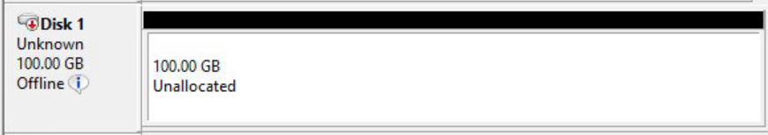

1. If the disk you added doesn’t appear on the display, under **Actions\Disk Management\More Actions**, in the upper right, click on the **Rescan Disks** option. This should refresh the display of the drive so you can see the newly added disk.
2. On the left side of the new disk, right-click on the **Offline** indicator and select **Online**. 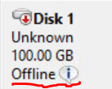
3. The value changes from Offline to Not Initialized.

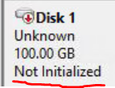

1. Right-click on **Not Initialized** and select **Initialize Disk**.
2. Click **OK**.
3. The display will now show as follows:

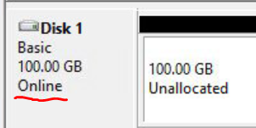

1. Right-click on the Unallocated area, and select **New Simple Volume…**
2. The **New Simple Volume Wizard** will launch.
3. Click **Next**.
4. Click **Next** to accept the entire amount of the disk.
5. Select the dropdown in the field associated with the **Assign the following drive letter** radio button and select the drive letter you wish to use.
6. Change the **Volume label** to the value you want and check **Enable file and folder compression**. Accept the other defaults.

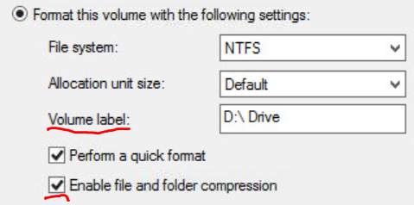

1. Click **Next**.
2. Click **Finish**.
3. The display should now look like this for your new drive.

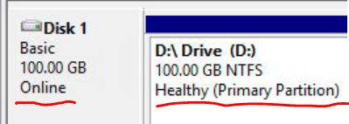

1. Your work is done. Log off of the server and vRealize.
2. Notify the requestor that their new drive is ready.

# Adding Space to an Existing Drive

1. Click on the **Items** tab.
2. Change the **Owned by:** dropdown to **All Groups | Manage.**
3. Enter the server name in the find field and click on the magnifying glass icon.
4. Click on the server name displayed below.
5. On the right, click on the **Reconfigure** link.
6. Click on the **Storage** tab.
7. Click on the **Pencil icon** next to the targeted drive.
8. In the **Capacity (GB)** field, enter the new storage size.
9. Click on the **green check icon** on the left: 
10. Click the **Submit** button.
11. Click **OK** on the screen that says “The request has been submitted successfully.”
12. On the Machines UI, you can monitor the progress of the request (visible in the **Status** field).
13. Click on the refresh icon at the bottom of the screen to update the display. 
14. (It may not change to On (Reconfiguring) right away. Click the refresh button a few times and the status should contain the (Reconfiguring) value.)
15. Once the **Status** changes to **On**, double-click on the server name.
16. On the **Item Details** screen for the server, click on the **Connect to Remote Computer** link on the right.
17. Click on the Send Crtl+Alt+Del button at the top right.
18. Log onto the server with your credentials from the appropriate domain.
19. Under Administrative Tools, select Computer Management.
20. Double-click on **Disk Management**.
21. The display for the disk you added space to should look like this:

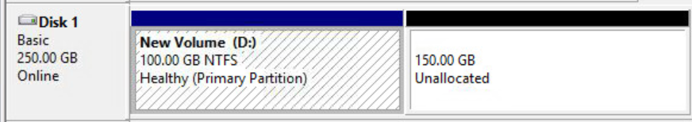

1. If the disk you added space to doesn’t show **Unallocated** space, under **Actions\Disk Management\More Actions**, in the upper right, click on the **Rescan Disks** option. This should refresh the display of the drive so you can see the newly added space.
2. Right-click on the **existing volume** to which you wish to add thespace. (In the example above, the New Volume (D:) portion of the display.)
3. Click on the **Extend Volume …** option and the **Extend Volume Wizard** will launch.
4. Click **Next**.
5. Make sure the **Selected:** column contains the disk you want to expand and click **Next**.
6. Click **Finish**.
7. The image of the drive in the Disk Manager should change and look like this:

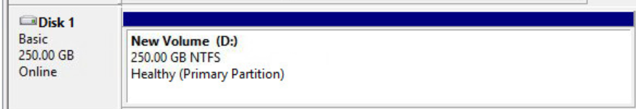

1. You can now log off of the server and let the requestor know the drive now contains the requested additional space.
2. Click the Send Crtl+Alt+Del button.
3. Click Sign out.
4. You can now click on the **X** on the tab that contains the server name.
5. Let the requestor know the drive has been expanded.