|  |  |
| --- | --- |
| **Running Ubmatic**  The Folder Addition and Population Tool | Abstract  The Ubmatic tool is used primarily to populate DM with Inpatient and Outpatient Folders, complete with model data. Frank Racis is the creator of the tool.  Fairbrother,Stephen  Author |

Table of Contents

**1** **Overview** 2

**1.1** **Location of Ubmatic Software** 2

**2** **Install the Application** 2

**3** **Add the Ubmatic-Specific Doc Types** 2

**3.1** **Check to see if the Necessary Doc Types are Present** 3

**3.2** **Run the SQL to Add Missing Doc Types** 3

**4** **Rerun the Application Install** 3

**5** **Give the Ubmatic Account access to the Application and All Security Tokens** 3

**6** **Create the Ubmatic Upload Subdirectory** 3

**7** **Configure the Config.xml File** 3

**8** **Add Organizations in DM and the Organizations.xml File** 3

**9** **Run Ubmatic Test** 3

**10** **Run Ubmatic to Populate the Application** 4

**10.1** **Inpatient Additions** 4

**10.2** **Outpatient Additions** 5

# **Overview**

In order to successfully run Ubmatic to populate a DM environment, you must follow the order below:

1. Install DM.
2. Add the doc types.
3. Rerun the application install to make sure the new doc types are available in the application.
4. Secure USMLVV1D0A\ubmatic (or account you will use to run Ubmatic) giving it access to all security tokens.
5. Create the ubmatic subdirectory under the application Upload directory (e.g., \\usmlvv1edm226\backgroundroot_hhrr\Upload\ubmatic).
6. Configure the [drive]:\[ubmatic software]\data\**config.xml** file to contain the values you are using.
7. Add the organizations that you will be using to the application and the [drive]:\[ubmatic software]\data\**organizations.xml** file.
8. Run the **ubmatic.exe** file to initiate the Ubmatic interface and test the configuration.
9. Run the ubmatic.exe to populate inpatient and outpatient folders for each organization.

## **Location of Ubmatic Software**

Located on the Master branch in GIT, in the Utilities directory.

Live location with compiled software: \\usmlvv1edm067\c$\ubmatic

Backup on: \\usmlvv1cto2874\ims-share\UTILITY\UBMATIC

# **Install the Application**

Install the application as you normally would.

# **Add the Ubmatic-Specific Doc Types**

The following DM Doc Types are needed to successfully run Ubmatic.

1500SHS

ACCTHSTY

DCINST

DISCHARG

DRORDER

EKG

FACE

HDX

HYSTO

INS-ID

LABRSLT

LEGAL

LIVEWILL

MAIL

MANAGE

PDF

PROGNOTE

PROMNOTE

PT-PAY

RACAID

RACARE

RADRPT

REFERRAL

SUMMARY

TELEMET  
TELMORD

UB92EDIT

## **Check to see if the Necessary Doc Types are Present**

Run this SQL on the DM IDB Database**: **

## **Run the SQL to Add Missing Doc Types**

If the check SQL reveals that doc types are missing, run this SQL to add the missing doc types:



# **Rerun the Application Install**

Rerun the application install to make sure the new doc types are available in the application.

# **Give the Ubmatic Account access to the Application and All Security Tokens**

Use the DM Security/Security UI, to secure the ubmatic user. Give the user access to all security tokens.

# **Create the Ubmatic Upload Subdirectory**

Create the ubmatic subdirectory under the application Upload directory (e.g., \\usmlvv1edm226\backgroundroot_hhrr\Upload\ubmatic).

# **Configure the Config.xml File**

The Config.xml file is used to log onto the DM application and identify the location of the upload share Ubmatic will be using. It is located in the data subdirectory of the Ubmatic software.

Sample file here: 

# **Add Organizations in DM and the Organizations.xml File**

Organizations need to be defined and match in both the instance of DM as well the Organizations.xml file, for folders and data to be created in DM by Ubmatic. The Organizations.xml file is located in the data subdirectory of the Ubmatic software.

Sample file here: 

# **Run Ubmatic Test**

1. Run Ubmatic.exe as an Administrator.

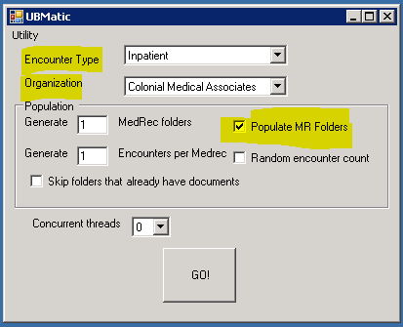

1. Pick your **Encounter Type**, **Organization**, and check the **Populate MR Folders** option.
2. Click the **GO!** button.

If successful, you are ready to load data. If unsuccessful, check your configuration.

# **Run Ubmatic to Populate the Application**

## **Inpatient Additions**

1. Run Ubmatic.exe as an Administrator.
2. Set the **Encounter Type** to **Inpatien**t.
3. Set **Organization** to the name associated with the DM HHRR.
4. Set **Population/Generate x MedRec folders** to 200.
5. Check **Populate MR Folders**.
6. Set **Generate x Encounters per Medrec** to 5.
7. Set **Concurrent threads** to 9.
8. Press the **GO!** button.
9. Repeat the above for each Organization.

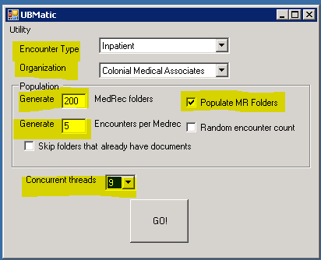

## **Outpatient Additions**

1. Run Ubmatic.exe as an Administrator.
2. Set the **Encounter Type** to **Outpatien**t.
3. Set **Organization** to the name associated with the DM HHRR.
4. Set **Population/Generate x MedRec folders** to 100.
5. Check **Populate MR Folders**.
6. Set **Generate x Encounters per Medrec** to 3.
7. Set **Concurrent threads** to 9.
8. Press the **GO!** button.
9. Repeat the above for each Organization.

