|  |  |
| --- | --- |
| **DM Installation Process for Soarian Financials**  Dealing with a Longer Environment Name | Abstract  The installation process of DM for Soarian Financials is a bit different since Soarian Financials names their DM environment in the following fashion: SFETHHRR. This document details the additional steps needed to handle their naming requirement for QA systems.  Fairbrother,Stephen  Author |

Table of Contents

**1** **Overview** 2

**2** **Database Installation** 2

**2.1** **Run the Shrink IDB Log SQL** 4

**3** **Installation and Services** 5

**3.1** **Create the Backgroundroot Share** 5

**3.2** **Running the Installation Kit** 5

**3.3** **Create the Organizations** 7

**3.4** **Install the services** 8

**4** **Review the Settings before turning the Environment over to Soarian Financials** 10

**5** **Smoke Test** 10

**6** **Final Steps** 11

# **Overview**

Soarian Financials (SF) likes to name their DM environments in the following fashion:

SFEThhrr (where hhrr usually equals a 4-digit number).

The DM install does not support the longer name out of the box, so there is some editing you will need to do. Below is a screen shot of the 3 Script Generation Tool screens as they are normally valued to generate the scripts needed to install the SF environment. In this example the DM environment will be named SFET1791.

# **Database Installation**

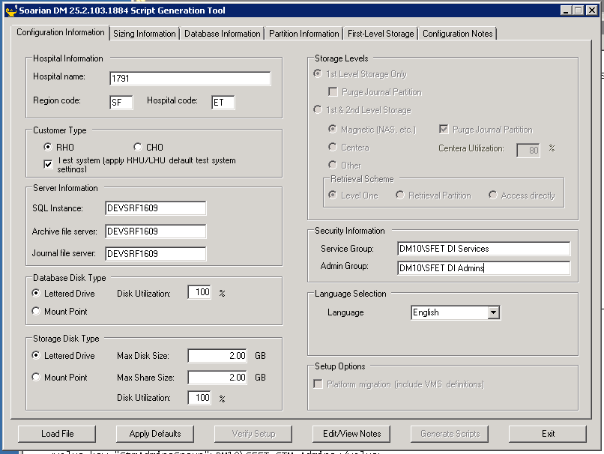

1. Click on the Apply Defaults button.
2. Click on the Database Information tab and change the drive letter (in this case to D:).

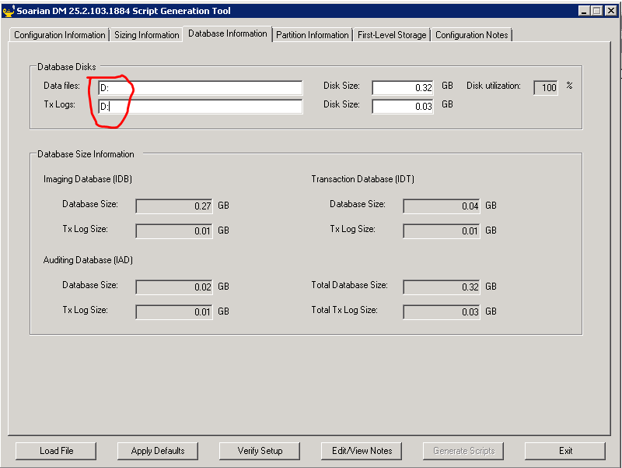

1. Click on the **First Level Storage** tab.
2. Change the **Disk** values to D:.
3. Revise the default **Share** names to include the number for the environment.

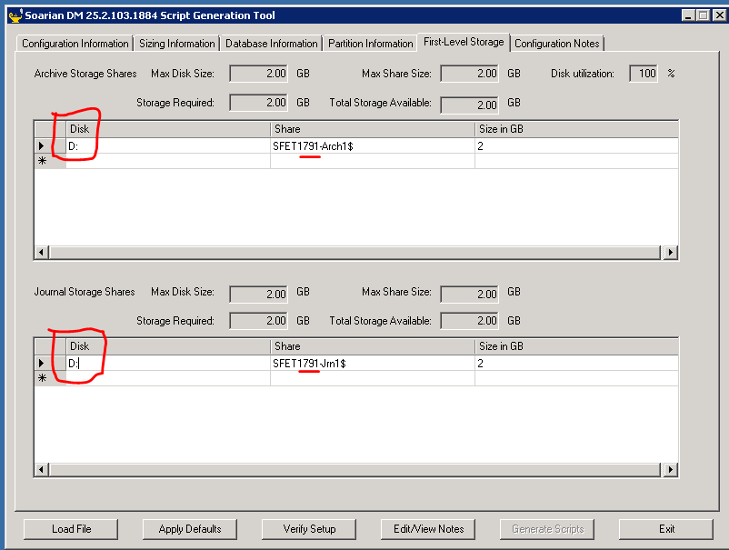

1. Select the **Verify Setup** button and review the screens to make sure no errors are detected.
2. Press the Generate Scripts button.
3. You will receive the following informational messages. Click **OK** on each:

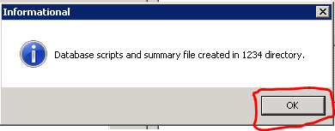

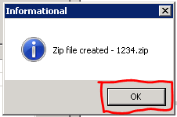

1. There will now be a subdirectory named HHRR (in this case 1791) in the directory that contains the ImsScriptGenerator.exe program that you just ran.
2. You can close the tool now.
3. Go to the 1791 subdirectory, where you will edit the following files.

* BuildAndLoadDatabases.cmd
* CreateDbDirs.cmd
* IasCreatePhysicalDb.sql
* IdtCreatePhysicalDb.sql
* IsdCreatePhysicalDb.sql
* StmCreatePhysicalDb.sql

1. In each file, do a replace all on the value SFET, changing it to SFET1791.
2. In the following files do the same replacement but do not change the SFET value associated with the Service and Admins groups.

* CreateStmArchShares.cmd
* CreateStmJrnShares.cmd

1. Once you have edited all of the files, open a command window using the **Run as administrator** option.
2. CD to the directory that contains the files you just edited.
3. Run the following files:

* BuildAndLoadDatabases.cmd
* CreateStmArchShares.cmd
* CreateStmJrnShares.cmd

## **Run the Shrink IDB Log SQL**

This SQL is applied after creating a new IDB data base and keeps the log from getting too large.

1. Open the model file: 
2. Replace the IDB database name in the model SQL with the name of your database.
3. Copy the edited SQL.
4. Open the SQL Server Management Studio that houses your IDB database.
5. NOTE: You must be an administrator on the server and should use Windows Authentication when logging onto the Studio.
6. Click on New Query in the second level of the toolbar at the top of the Studio.
7. Paste the edited SQL into the query window on the right.
8. Highlight the SQL.
9. Click on the **Execute** button. 

You may exit the SQL Server Management Studio.

You have now created the databases and shares and are ready to run the installation kit.

# **Installation and Services**

## **Create the Backgroundroot Share**

1. On the D:\ drive (or drive on the server where you find other backgroundroot_hhrr directories), create the following folder: Backgroundroot_SFET1791
2. Right-click on the Backgroundroot_SFET1791 folder, and select properties.
3. Click the **Sharing** tab.
4. Click the **Share** button.
5. In the **Add** entry field, type SFET DI Services and click the Add button.
6. In the list below, click on SFET DI Services, and change the rights to read/write.
7. In the **Add** entry field, type SFET DI Users and click the Add button.
8. In the list below, click on SFET DI Users, and change the rights to read/write.
9. Click on the **Share** button.
10. Click on the **Done** button.
11. Click on the **Close** button.

## **Running the Installation Kit**

You will run the installation as usual but there are some things you will need to do afterwards to get the longer names into the services.

1. Go to the folder on the server where you placed the DmSetup.exe file.
2. Double-click on the DmSetup.exe file.
3. Select the Browse button.
4. When you browse for the location of the application, create a directory named SFET1791 (or whatever yours will be named).
5. Select the Configure button.
6. Enter the name of the appropriate CernerApps share (in this case \\DEVSRF1609\CernerApps).
7. Select the three dots (…) next to the share name field and navigate down to the ENVIRONMENT level directory.
8. While focused on the ENVIRONMENT directory, select the **Make New Folder** button.
9. Enter the name of the new folder (in this case SFET1791).
10. Focused on the SFET1791 directory, select the **Make New Folder** button.
11. Enter the name DATA for the second folder. (This step is optional and does not affect functionality).
12. Focused on the DATA directory (of SFET1791 directory, if you are not creating the DATA directory), click the OK button.
13. Review the entries in the Local Environment and Shared Configuration fields to be sure they are the way that you want them.
14. Select the **Data Center (RHO) install** checkbox twice to value it.
15. Click **OK**.
16. Answer **Yes** to the create folder message.
17. Click **OK**.
18. Click the checkboxes for the **Application Server** and **Web Server**.
19. Click **Next**.
20. Click **Next** to accept the **Default Web Site**.
21. Now that you have created the share, enter the name in the **Background root folder** field on the installation kit, in this case \\DEVSRF1609\backgroundroot_SFET1791
22. Click **Next**.
23. On the next screen, change the **Default logon domain** to **DM10**.
24. Leave the **Use Netscaler** checkbox checked.
25. Click **Next**.
26. On the Netscaler settings, value as follows:

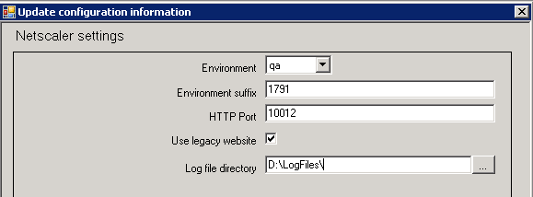

1. Select qa in the **Environment** dropdown.
2. Enter the **Environment suffix** (in this case 1791)
3. Enter a value for the **HTTP Port** (look in IIS to see what the highest number in use is and increment by 1).
4. Check the **Use legacy website** checkbox.
5. Change the drive value to D:\LogFiles\ in the **Log file directory** field.
6. Click **Next**.
7. Enter the Server name (in this case DEVSRF1609).
8. Enter the Database name (in this case SMSPHidbSFET1791).
9. Click **Next**.
10. Click **Next**.
11. Click **Next**.
12. Select the EDM Base and Completion checkboxes.
13. Click **Next**.
14. Value everything as shown below on the **Configure user identities** UI:

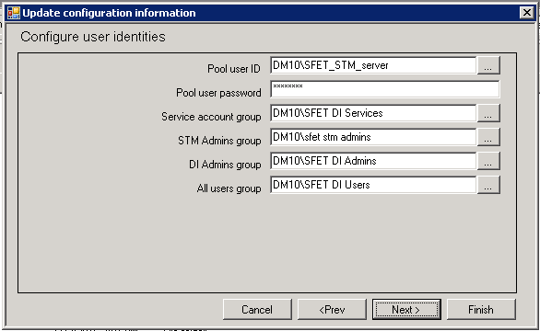

1. The password for SFET_stm_server is Passw0rd.
2. Click **Next**.
3. Click **Finish**.

## **Create the Organizations**

1. Launch the application by typing the following in IE: devsrf1609/SFET1791 (in this case)
2. Log on using the sfet_stm_server / Passw0rd account.
3. Click on the **Administrator** option on the main menu.
4. Once the menu expands, under **Other**, click on **Organizations**.
5. You will create the following organizations first clicking **Create** and then entering the displayed values in the Organization name, Short name, Organization code, Hospital code, ad Region code fields. The first three are generic. After valuing the fields, click the **Save** button.

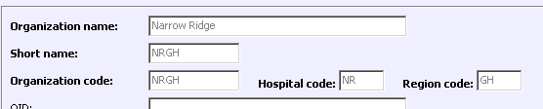

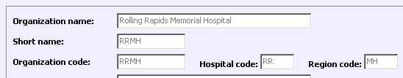

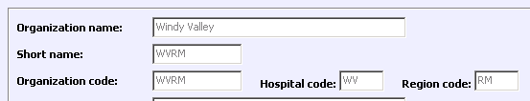

This one is specific to the environment you are creating.

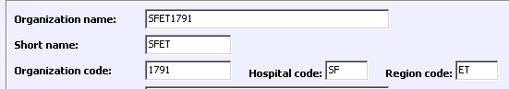

## **Install the services**

1. Run the command prompt as an administrator.
2. Change to the bin directory for the application (in this case cd "Program Files\Cerner\DM\SFET1791\WWWROOT\BIN").
3. Type ikmser and hit the tab key. This should find the IkmServiceController.exe file.
4. Hit **Enter**.
5. The **Interactive Service Controller** UI will display.
6. Click on the **Configure Group** button.
7. Click the **Create** button.
8. Value the fields as follows:

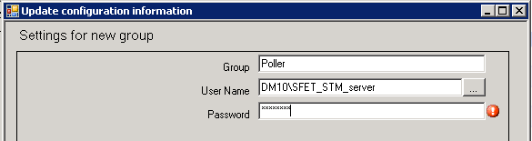

1. Click **OK**.
2. Click the **Create** button again.
3. Value the fields as follows:

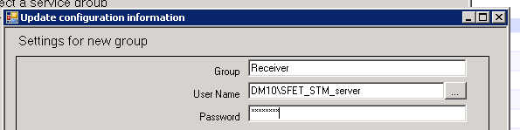

1. Click **OK**.
2. Click **Cancel**.
3. Click **Create New Service**.
4. In the dropdown select **OlcPoller**.
5. Click **OK**.
6. Click on the dropdown in the **Choose Organization** field and select the organization that is specific to the install:

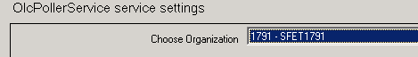

1. Click **OK**.
2. Change the **Group** value to Poller.
3. Enter sfet_stm_server as the **User Name**.
4. Click on the **Create** button.
5. In the Source Folder field, enter the \\servername\backgroundroot_sfethhrr\upload location (in this case \\devsrf1609\backgroundroot_SFET1791\upload
6. Click **OK**.
7. Click **Cancel**.
8. Click **Create New Service**.
9. In the dropdown select **IsdReceiver**.
10. Click **OK**.
11. For the **Port number of service** value, do the following:
12. Go to the CernerApps share. Locate the previously created environment (next lowest number) and open the associated eycsys.xml file (in this case D:\CernerApps\Program Files\Cerner\DM\ENVIRONMENT\SFET1786\efcsys.xml). Search for “receiver$” and you will find the previously installed receiver and its associated port number. Increment that number by one and you now have your new port number.
13. Enter the new port number in the **Port number of service** field.
14. Click **OK**.
15. On the next UI, select **Receiver** from the **Group** dropdown.
16. Enter sfet_stm_server in the **User Name** field.
17. Scroll to the bottom of the UI and locate the **Parser template file name and location** field.
18. The value for this installation is as follows:
19. \\DEVSRF1609\CernerApps\Program Files\Cerner\DM\ENVIRONMENT\**SFET1791**\SHARED\INTERFACE\IsdIsHl7SoarianFin_Enc_VN.xml.model
20. Your value will be the same with the exception of the SFET1791 value in the example. Yours will be specific to the environment that is being installed.

**NOTE:** There are other values used by Soarian Financials and if there are issues with the Receiver, it may be that they selected a value in their system that will necessitate using a different file (same location, different file name).

1. Click **OK**.
2. Click on the **Install Service** button.
3. In the **Group** dropdown window, select **Poller**.
4. Click **OK**.
5. Click on the **Install Service** button.
6. In the **Group** dropdown window, select **Receiver**.
7. Click **OK**.
8. Log back onto the application (in IE, enter devsrf1609/sfet1791, in this case), using the adminuser / Phillies05 account.
9. Click on the **Operations** option on the main menu.
10. Click on the **Service Control Manager** option.
11. Verify whether or not all of the services are running.
12. To start any that are not running, click on the **Application Servers** tab.
13. Click on the **circle with the square red box** next to the server name.
14. Click on the **Start** icon.
15. Click on the **Services** tab.
16. Click on the **Refresh** sub-tab periodically to see if the services are coming up.
17. If a service will not start, seek help for diagnosing the issue.

# **Review the Settings before turning the Environment over to Soarian Financials**

1. While still in the application, click on **Help** in the upper right, then click **About**.
2. Review the contents of the screen to be sure the correct version of the software has been installed (value at top center).
3. Review the **Server Process Information** to see if all of the values are expected:

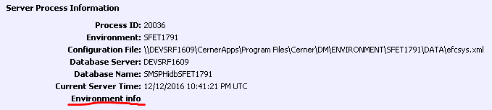

1. Click on the **Environment info** link for further details. A separate screen will appear.
2. Review the entries on the **Environment Information** screen to be sure all values are as expected.
3. Once satisfied, close the **Environment Information** screen.

# **Smoke Test**

This section details how to import and display documents after a system refresh or upgrade has been done. This process exercises a significant portion of the application’s overall functionality and serves as a good initial test to establish that base functionality has not been disrupted by the refresh or upgrade.

To check out the application install or refresh:

1. Launch the application from Internet Explorer.
2. Enter a logon ID and password for an account that has administrative access to the application.
3. On the top menu of the application, click **Acquire**.
4. Select **Assisted Filing**.
5. Select a **Worklist** folder type.
6. Enter a **Worklist Name and Worklist title**.
7. Click **Find**. If the name does not exist, answer **Yes** to the create folder question.
8. Select the STM **Document type**.
9. Make sure the **Source** value is set to **Import**.
10. Select the TXT Text Files **File type**.
11. Click the **Browse** button and select a file with the *.TXT* extension.
12. Click the **Add to list** button. (If you get a new screen, you may have to resize it to see this question at the bottom: “This file is smaller than the blank page threshold. Do you wish to import it?” Click the **Yes** button.)
13. Click the **Import** button.  
    The document should appear on the **Folder Display** window.
14. In the document display on the right, click on the **X Clear** button to remove the document from the display.
15. On the left, click on the Folder **Retrieve** button. 
16. Select the Worklist folder type and enter the name of your worklist.
17. Click the **Find** button.
18. Under **Select folders** **to display**, double-click the name of your worklist.  
    The **Folder Display** window should appear.
19. Click the plus (+) sign next to the name of your worklist and verify that there is a document in the folder with today’s date on it.
20. Double-click that document and verify that the document successfully displays in the **Document Display** window on the right side of the screen.
21. Click on the icon next to the folder name and document name and make sure information is displayed.
22. On the left, click on the Document **Retrieve** button. 
23. Scroll down and highlight the STM document type by clicking it.
24. Specify today’s date in the **Document Date To** and **From** fields.
25. Click the **Find** button.
26. Double-click the document in the **Select documents to display** window.  
    The **Split Folder/Document Display** window should appear.
27. Double-click the document in the Folder Display window on the left of the display and verify that the document successfully displays in the **Document Display** portion of the screen on the right.
28. You may now use the **Maintain** documents and **Maintain** folders functions to remove the document and worklist.



# **Final Steps**

1. Close the application.
2. Log off of the server.
3. Notify the requesting parties that the application is available for use.