|  |  |
| --- | --- |
| Changing SPU Values in AccuRev and AnthillPro  So Nice, We Do It Thrice | Abstract  As our use of AccuRev and AnthillPro approaches the last wheezing gasp (we hope), here’s a little ditty on changing the Service Pack Update values used to control the version number applied to executables.  Fairbrother,Stephen  Author |

Table of Contents

**Overview** 2

**Using AccuRev to Increment SPU Values** 2

**VersionStamp.targets Modification** 3

**PROJECT.BLD Modification** 3

**Promoting the Changes to DEV** 3

**Promoting the Changes to PROD – 25.0 SP1** 3

**Promoting the Changes to PROD – 25.1 SP1** 4

**Using AnthillPro to Increment SPU Values** 4

**Overview** 4

**Location of Values You Will Change** 5

**Changing the stamp-servicepack Property in AHP** 6

**Building the Software with the New SPU Value** 6

**Overview** 6

**Building Software with AHP** 7

**Troubleshooting – My Build isn’t Green** 7

**Red Builds** 7

**Yellow Builds** 8

# **Overview**

**AccuRev** is our Version Control tool for software prior to DM 25.2.

**AnthillPro** (AHP) is the way we control our software builds prior to DM 25.2.

**SPU** is the term we use for Service Pack Updates. (What’s SPU?)

**Word of Caution**: To execute both phases of this process you must be

* In the **CTO-admins** security group in AccuRev
* In the **Build Master Role** in AHP.

At this point, the chief versions of interest in both tools are 25.0 SP1 and 25.1 SP1.

Periodically we have to increment the SPU value that is included in the version information on our files. To do this, you have to make changes to specific files in AccuRev and variables in AHP that contain the version information used during software builds.

The SPU value is the third portion of the quartet that composes our version information. Examples below:

25.0.**108**.577

25.1.**103**.949

You will be changing (in all but one case) the VersionStamp.targets file. In one case (TFM_Imaging_Scan ) you will be changing the PROJECT.BLD file.

**Directories containing the VersionStamp.targets file**

|  |
| --- |
| IFF_Imaging_Formatting_Functions |
| IFL_Imaging_Freeware_Library |
| IFT_Imaging_Format_Translation |
| IIC_Imaging_Indirection_Components |
| IKM_Control_Downloader |
| IMS_Imaging |
| IMS_Imaging_Controls |
| IRI_Imaging_Recognition_Interfaces |
| IRT_Imaging_Routing |
| IVC_INSO_Viewer_Controls |

**Directories containing the PROJECT.BLD file**

|  |
| --- |
| TFM_Imaging_Scan |

# **Using AccuRev to Increment SPU Values**

Log onto AccuRev.

Locate your workspace attached to **CTO-EDM-25.0SP1-DEV** or **CTO-EDM-25.1-DEV**, depending on which level you are modifying.

## **VersionStamp.targets Modification**

1. In the VersionStamp.targets files, locate the following entry:

* <ServicePack>

1. Increment the associated value.
2. Save the file.

## **PROJECT.BLD Modification**

1. In the PROJECT.BLD file, locate the following variable:

* EDM_SPACK=

1. Increment the associated value.
2. Save the file.

## **Promoting the Changes to DEV**

Click on the highest level of the tree on the left in your workspace.

Click on the Outgoing button.

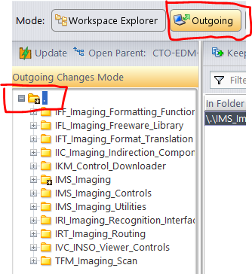

Highlight the files you changed in the well on the right.

Click the Promote button above the list. 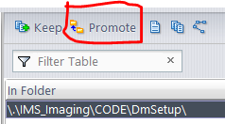

This will promote the changed files into the DEV stream.

## **Promoting the Changes to PROD – 25.0 SP1**

1. Click the container next to the 25.0 SP1 DEV stream.
2. Highlight the files you want to promote.
3. Click the Promote button.
4. Fill in the requested information (usually the JIRA issue number).
5. Click on the Promote button in the dialog box.

Your files will now be in 25.0 SP1 PROD. You may now exit AccuRev.

## **Promoting the Changes to PROD – 25.1 SP1**

Since we don’t use the QA stream in 25.1 SP1, the directions are a little different. You will promote directly from DEV to PROD.

1. Click the container next to the 25.1 SP1 DEV stream. 
2. **Highlight the files** you want to promote.
3. Click the green pallet button. 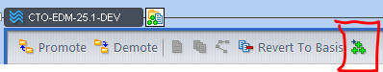
4. When the file list is displayed in the pallet, click on the Change Destination button. 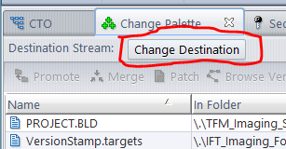
5. Enter CTO-EDM-25.1-PROD in the filter field of the dialog box.
6. Click OK.
7. The display will now look like this: 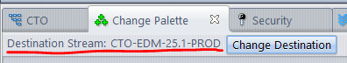
8. Make sure your files are still highlighted and click on the Promote button.
9. Fill in the requested information (usually the JIRA issue number).
10. Click on the Promote button in the dialog box.

Your files will now be in 25.1 SP1 PROD. You may now exit AccuRev.

# **Using AnthillPro to Increment SPU Values**

## **Overview**

From the Administration tab in AHP, there are 4 areas of interest:

* EDM_25.0_SP1
* EDM_25.0_SP1_PROD
* EDM_25.1
* EDM_25.1_PROD

You will be changing the stamp-servicepack property in each of the various builds supported in AHP (the ancillary builds, like IIF, IIC, IRT, etc.) and the big build: IMS. The changes will be made at both the DEV and PROD levels. When finished making the changes, you will start a build.

See image below for locations:

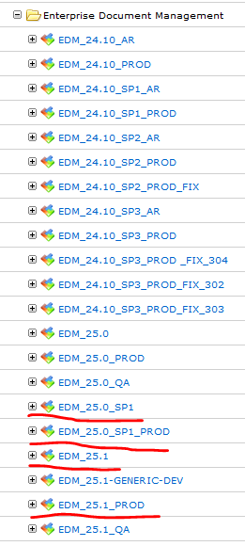

## **Location of Values You Will Change**

1. Logon: <https://us-anthillpro.usmlvv1d0a.smshsc.net/>
2. Click on the **Administration** tab.
3. Click on the plus (**+**) signs next to the following entries:
4. Shared Applications
5. Enterprise Document Management
6. Click on the plus (**+**) sign next to the stream level you are editing (one of the underlined names in the image above).

When you open your target stream level, you will see an image like this:

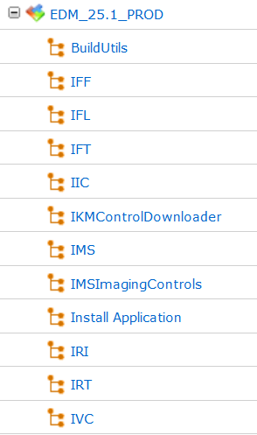

With the exception of the Install Application entry, you will be performing the same operation of each of the entries.

## **Changing the stamp-servicepack Property in AHP**

1. Click on the link to **Build Utils** workflow.
2. Click on the **Properties** tab.
3. Click on the **pencil icon** on the far right associated with the stamp-servicepack property. 
4. On the next screen, change the **Default Value** field to the number you will be using for the new service pack update.
5. Click the **Save** button in the lower left.
6. Click on the stream value link displayed toward the upper left of the screen.

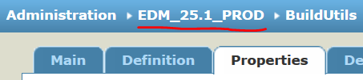

1. Scroll down and select the next workflow to edit.
2. Repeat the above process for each of the workflows (except Install Application) in the stream.
3. When finished, repeat it all over again in the associated PROD or DEV stream (whichever you haven’t done yet).

## **Building the Software with the New SPU Value**

### **Overview**

With the new SPU level in place, both in AccuRev and AHP, you can now build the software. If the changes for the new level are only in IMS_Imaging, that is the only level you will need to build. If changes are in any of the ancillary builds (like IIC), you will have to build that one first.

Your goal is to get a green IMS_Imaging Production build since then you will have software to deliver. Consult with the person who requested the build to determine whether both a DEV and PROD build are needed. In either case, you should change the stamp-servicepack property in both levels of the build.

If you have to start by doing one or more ancillary build, the IMS_Imaging build (or any of the builds in between) may not be green.

If the build is red, go back to bed.

If the build is yellow, try to stay mellow.

If the build is green, it’s all peachy keen.

See the Troubleshooting section below for help on what to do when the build is not green.

### **Building Software with AHP**

Build dependencies are chained in AHP. This means the build attempts to build all ancillary components in the correct dependency order. This rarely works properly, especially if IIC is involved in the chain. Some rebuild of one or more ancillary components will probably be necessary.

To build ancillary software or IMS_Imaging, do the following.

1. In AHP, click on the **Dashboard** tab.
2. Under **Shared Applications\Enterprise Document Management**, click on the stream level you want to build (e.g., EDM_25.0_PROD).
3. Click on the **Workflow** that you want to build (e.g., IIC, IMS, etc.).
4. Scroll down and click on the **Build** button.

You will eventually get an email/emails as each component builds. If a build “fails” because a kit didn’t get copied to a server, that is okay.

# **Troubleshooting – My Build isn’t Green**

## **Red Builds**

Kick off another build to see if it fails the same way. These builds can blow up for reasons related to the network so if you are lucky, it was a fluke. If it fails the same way a second time, look for the step on which the build failed and open the associated output.

To examine build output, do the following.

1. From the Dashboard, drill down to the link under Shared Applications/Enterprise Document Management and click on the link to the stream you are building.
2. Click on the link for the failed build (say the IMS_Imaging build failed, click on IMS).
3. The failed build will appear on the list and look like this:



1. The first thing to do is look at the build time – value on the far right.
2. Most successful builds take around 48 minutes (longer if in the afternoon and there is a lot of network traffic). In this case things are very suspicious due to the build length. Looks like something hung up.
3. Extra-long builds usually fail in a testing step. Click on the Build Life link (blue number on the far left in the example above). Build failures are reported on several levels: The top, the section of the build, and the specific sub-section of the build. You are generally interested in the sub-section information.
4. In such a case, there will be a document icon or image of a command window in the far right Actions column. (Document image for things like testing; Command window for compiles.)
5. Click on the image and examine the contents. The log can be cryptic. In this case, an extra-long build and a cryptic message = try building again. Sometimes there are indications of space on drive issues and then some cleaning of the build machine (MD17BYEC) will probably be necessary. That is one of the few conditions that will not allow successful rebuilding. So other than that, just build again and hope for better results.

Continued failures will probably necessitate a consult with Frank.

## **Yellow Builds**

Yellow builds of IMS_Imaging most frequently occur when preceded by an ancillary build and are almost always in the **Get Dependency Artifacts** step of the Build section.

1. Click on the document associated with that step and you will probably see a message like the following:

**2016-11-11 13:58:44,881 WARN - Conflicts of dependencies caused warning:**

**- conflict of 'EDM_25.0_SP1_PROD - IIC' between build life 1034937 and build life(s) 836455**

1. You can drill into this by clicking on the **Search** tab.
2. Click on the **Build Life** tab.
3. Put the first build life number (in this case **1034937**) into the **Build Life ID:** field.
4. Click the **Search** button.
5. You will see a display like this:



1. The blue numbers in the **Used In** field on the right are links to the dependent builds that used the new level of IIC.
2. Click on each link and note which ones are yellow. The IMS_Imaging build will be one of the yellow builds but you already knew that. At least one other build will be yellow. That is the one (or those are the ones) that you will want to build again. This happens most often when IIC is rebuilt because the build chains automatically and sometimes an ancillary build doesn’t pick up the newest version of IIC.