**Using Orchestration to do Application Refreshes**

**Make sure the kit you want to run is in the correct directory on the USMLVV1EDM603 D:\ drive. Below are the locations on the server for the 521 and 530 environments:**

**D:\CA_Orch_25_2_SP1\InstallKit**

**D:\CA_Orch_25_3\InstallKit**

Log onto Orchestration: <https://usmlvv1cto805.usmlvv1d0a.smshsc.net:8443/itpam/>

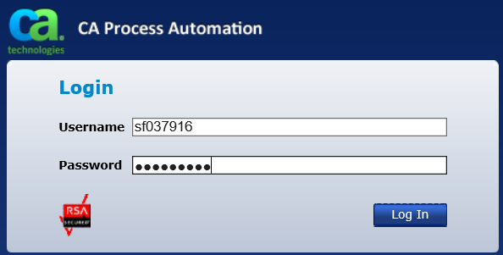

Click on the Operations tab along the top right:

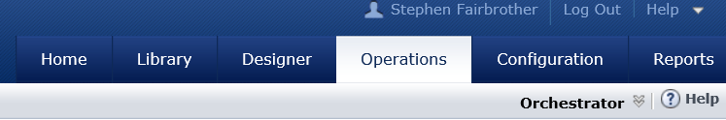

On the left side, click on the Start Requests menu item.

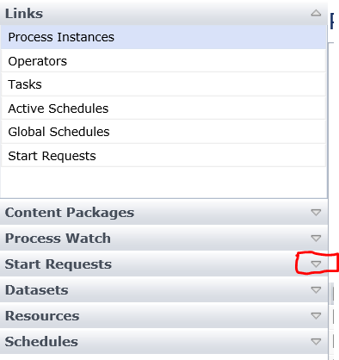

Click on DM after expanding Start Requests:

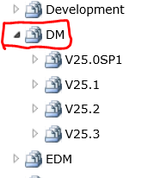

Drill to the bottom of the structure until you get to the StartEDMWorkflow option.

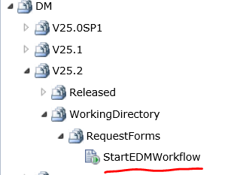

Right-click on StartEDMWorkflow and click on Start:

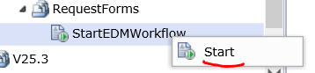

On the Start Request Form:

Enter your ID in this format: whq_nt_domain\XY000000

(Your ID must be prefixed with the whq_nt_domain\ value.)

Enter your password.

Change the Configuration Path value to reflect the directory where you put the installation kit.

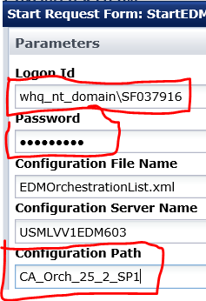

Click the **Finish** button.

Click OK on this message:

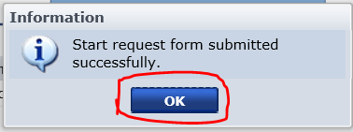

In the **Links** section on the upper left, click on **Tasks**.

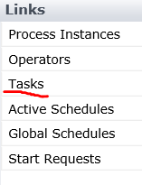

In the upper right, click on the dropdown that contains My Tasks and **select All Tasks**.

The task you just initiated will probably be at the very top of the list, with the **Title**, “Select Environment …” with no value in the **Description** field.



Right-click on the entry and chose Reply from the dropdown.

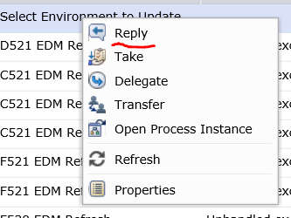

On the next screen, click on the dropdown on the right and highlight the environment name that you to which you want to apply the software.

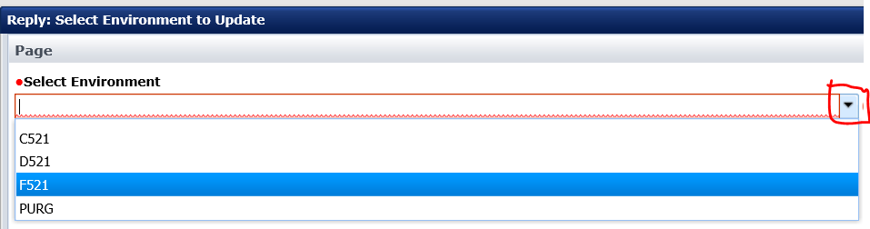

Click the Finish button at the bottom right of the Reply dialog:

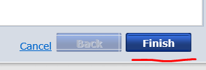

If you go back down to the StartEDMWorkflow option and click on it, you will now see the process is running:

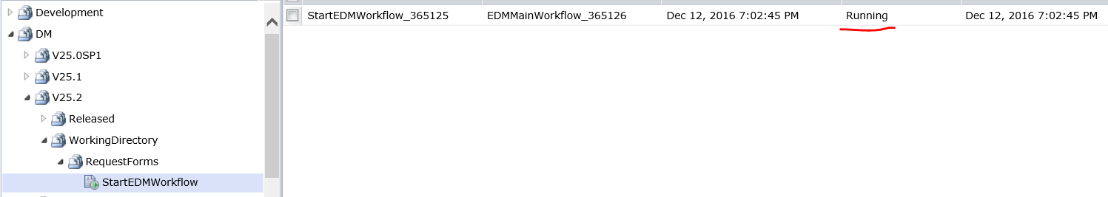

Eventually you will get an email with the one below. Another satisfying install completed!

