Victor Bui’s Activity 3 Methodology:
For this activity, I used the following Python libraries to handle and visualize the RHESSI solar flare data in VSCode:
Astropy: reading and loading .FITS scientific data files
NumPy: for transposing, averaging, and finding brightest intensity values
Matplotlib: for creating plots and visualizations
Pillow (PIL): to create frame sequences and convert it to animated GIFS

Preparation and Loading FITS files
Two FITS files were given for this activity: one representing a M-class solar flare and the other representing a non-flare event.
By following the screenshots given at the end of Task 3 document, I coded and used Astropy.fits.open() to read the 4D image cubes where each cube had the dimensions (x, y, energy bands, time).
When I printed the data shape using .shape(), it appeared reversed as (time, energy band, y, x). So, I fixed it by using NumPy’s transpose() function to switch the order back to (x, y, energy band, time). Afterward, I created an array list of the energy bands for both events: two bands (“6-12 keV”, “12-25 keV”) for M-class and three bands (“3-6 keV”, “6-12 keV”, “12-25 keV”) for non-flare.

Part (a): Visualize all energy bands for a single time frame
For this part, I used the first time frame (i = 0). I created a small loop with matplotlib to display each energy band side by side for both datasets. This allows me to compare how bright each band was in each dataset while seeing how intensity changes with higher energy levels.

Part (b): Visualize a selected energy band over time
Here I selected the 12-25 keV energy band since it shows the strongest activity. I looped through every time step and displayed each frame with a short pause using plt.pause(). By doing so, I can visualize how the flare ramps up and fades away over time in both dataset.

Part (c): Visualize all energy bands averaged over time
In order to see how all energy bands averaged over time for both dataset, I calculated the average intensity over all time frames using np.mean(). As a result, I created a 2D image showing the average brightness distribution across the sun surface for each energy range.

Part (d): Create an animation over time and save it as GIF
For the animation, I decided to use Pillow (PIL) as my method for creating GIFs for both M-class flare and non-flare. For each frame in time, I saved an image using Matplotlib’s savefig(). Then, I used the Pillow’s Image() to load the images and combined them into an animated GIF with Image.save().

Part (e): Pinpoint flare location over the Sun
Finally, I pinpointed the flare location over the Sun by averaging the data cube over both energy and time (axis=(2,3)). This gave me one overall intensity map. Then, I used np.argmax() to find the pixel with the highest brightness/intensity and marked that pointed with a cyan “x” using plt.scatter().

Results for each part

Part (a)
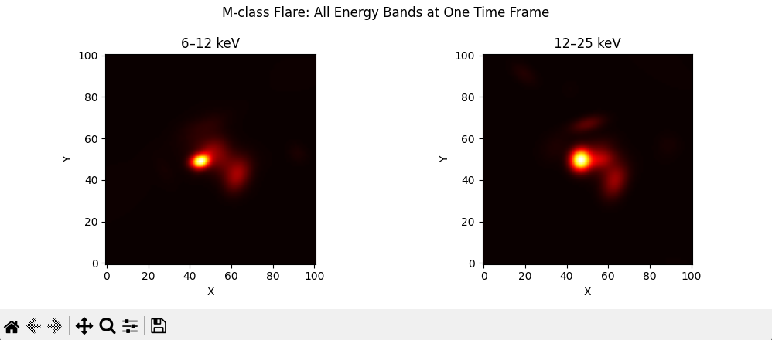
All energy bands display at one time frame (I =0) for M-class flare.

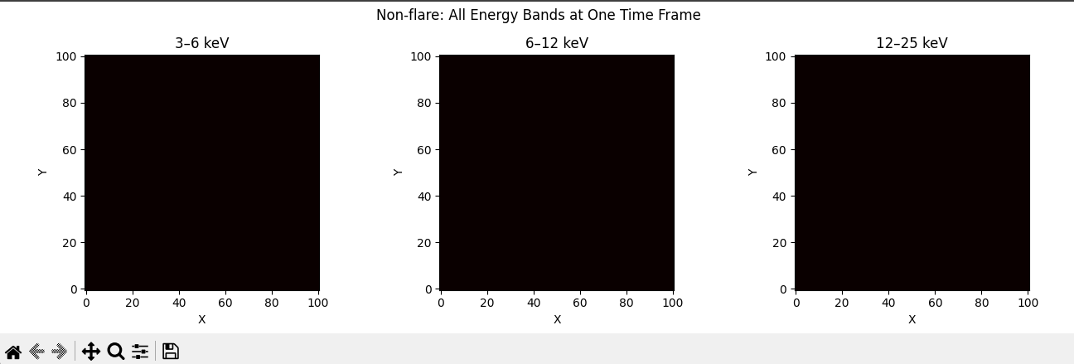
All energy bands display at one time frame (I =0) for non-flare.

Part (b)

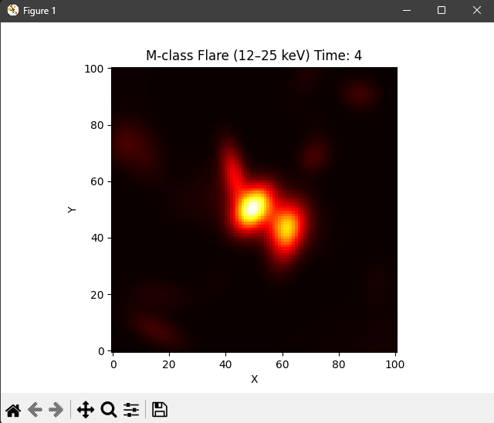
Selected energy bands (12-25 keV) displayed over time for M-class flare (this picture was taken at one of the time frames)

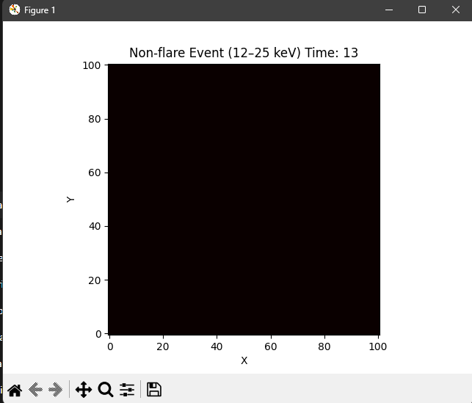
Selected energy bands (12-25 keV) displayed over time for non-flare (this picture was taken at one of the time frames).
Part (C)
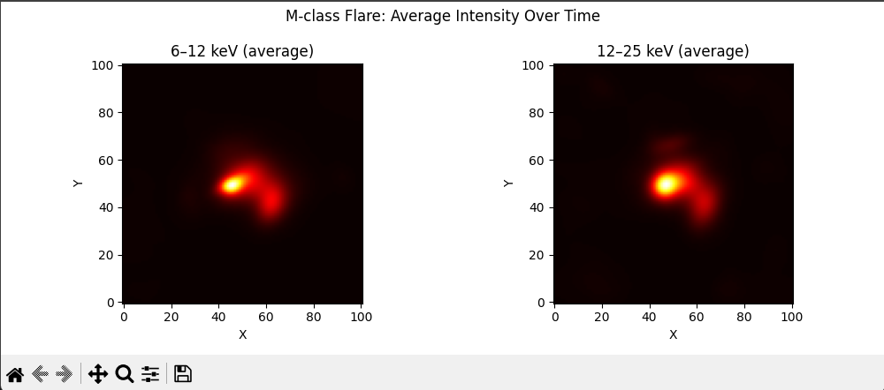
All energy bands averaged and displayed over time for M-class flare.

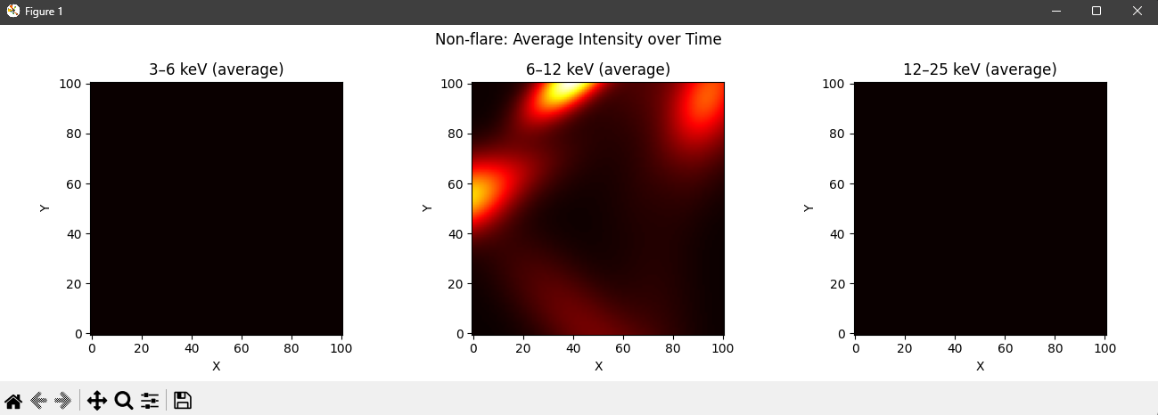
All energy bands averaged and displayed over time for non-flare.

Part (D)
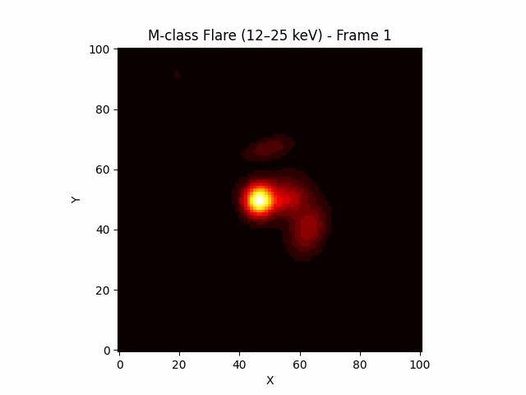
M-class GIF of part (b)

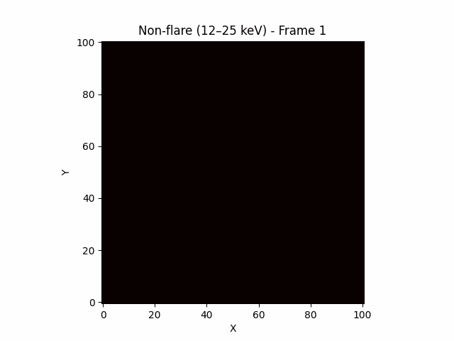
Non-flare GIF of part (b)
Part (E)
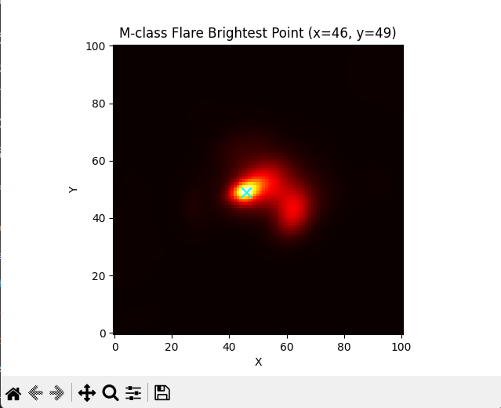
The M-class brightest point is marked by the cyan “x” at (x = 46, y =49). You can tell that it’s a flare by how concentrated the area is.

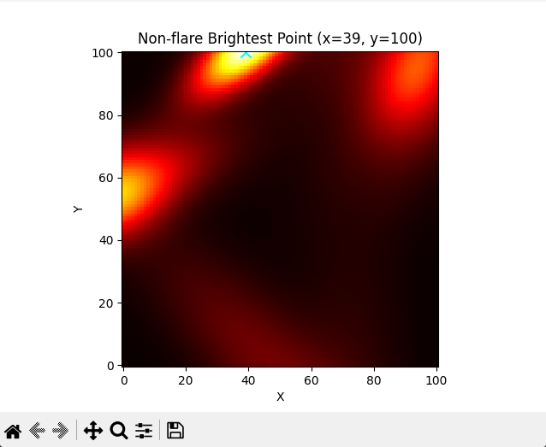
The non-flare brightest point is marked by the cyan “x” at (x = 39, y =100). While there are some bright area, it’s still considered a non-flare because it shows weak brightness and has no single, dominant hot region. In order words, you’re just seeing background solar activity, not a flare.

