

**MOBILE PHONE**

**DATA ANALYSIS**

Through MySQL



**ABOUT THE DATA**

The data provides detail of mobile phones types and models available. The data set provides detail of each and every model i.e. its brand, price, memory, operating system, battery range, 5G availability etc.

This report provides insights of the data basically the demographics and to answer questions related to it. The basic purpose is to categorize the mobile phones available as per brand, memory, price & other features.

**BASIC QUERRIES**

* Total Number of Mobile Phones

select count(Total_Mobile) as Total_Mobiles from mobile_analysis



* Total Number of Brands

select count(distinct(brands)) as Total_Brands from mobile_analysis

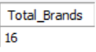

* Total Number of Mobile Phones against each brand

select brands, count(Total_Mobile) as Total_Mobiles from mobile_analysis

group by brands order by Total_Mobiles desc;

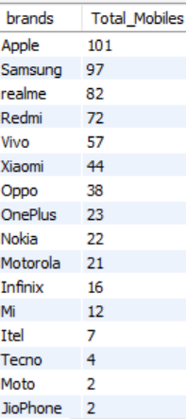

**RESEARCH QUESTIONS**

Question 1:

List of Mobile Phones available ordered as per Price List?

select phone_name, price from mobile_analysis order by price desc;

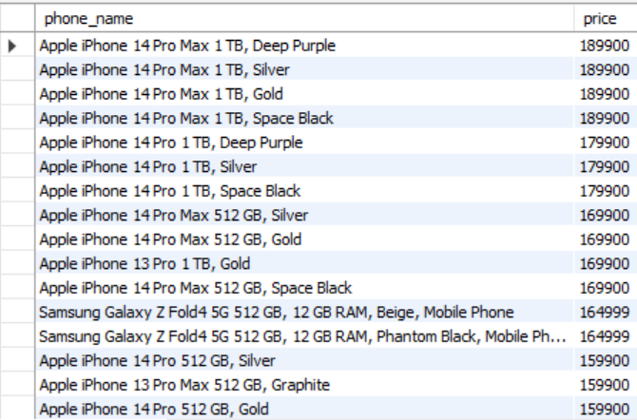

Question 2:

Which are the ten most expensive phones?

select * from mobile_analysis

order by price desc

limit 10;

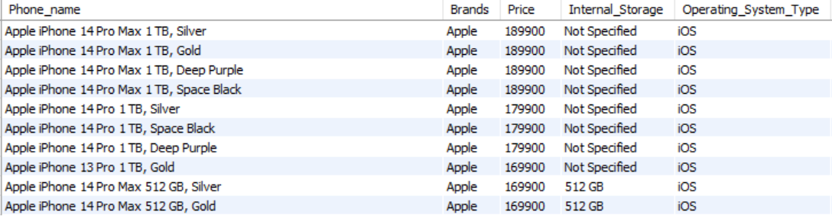

Question 3:

Which are the top ten cheapest phones?

select * from mobile_analysis

order by price

limit 10;

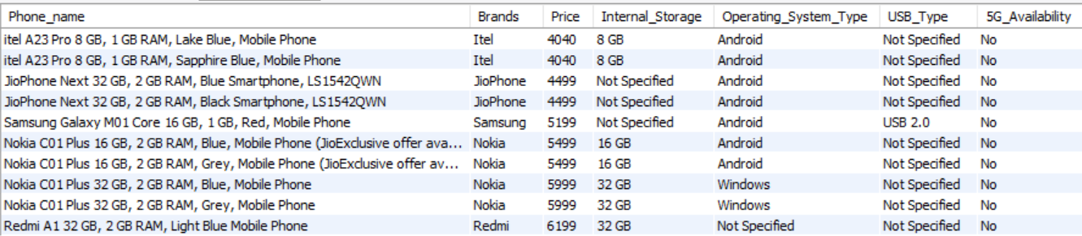

Question 4:

List of Top 10 Samsung phones as per price with all features?

select * from mobile_analysis

where brands = 'Samsung'

order by price desc

limit 10;

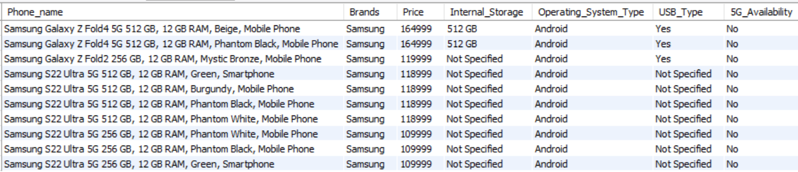

Question 5:

List of Top 10 mobile phones as per price with Android?

select * from mobile_analysis

where Operating_System_Type = 'Android'

order by price desc

limit 10;

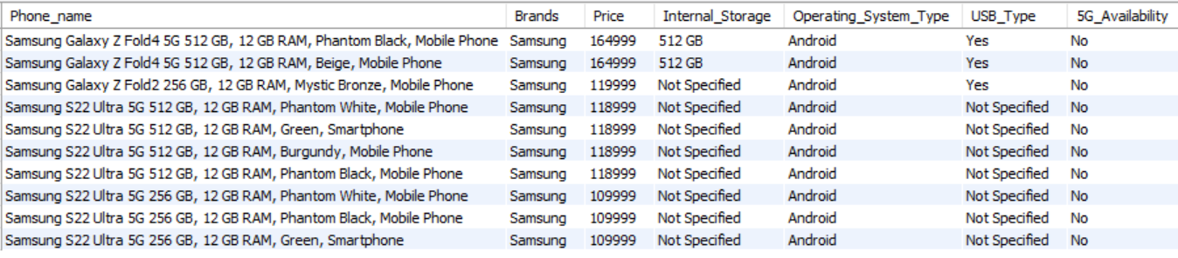

Question 6:

List of 10 cheapest mobile phones as per price with Android?

select * from mobile_analysis

where Operating_System_Type = 'Android'

order by price

limit 10;

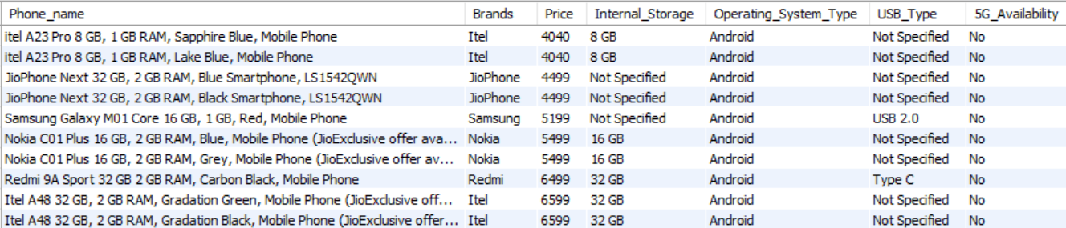

Question 7:

List of Top 10 mobile phones as per price with IOS?

select * from mobile_analysis

where Operating_System_Type = 'iOS'

order by price desc

limit 10;

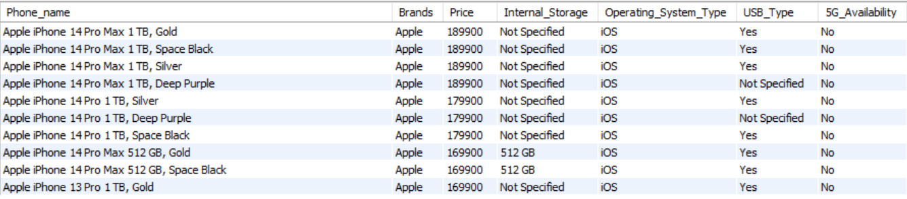

Question 8:

List of 10 cheapest mobile phones as per price with IOS?

select * from mobile_analysis

where Operating_System_Type = 'iOS'

order by price

limit 10;

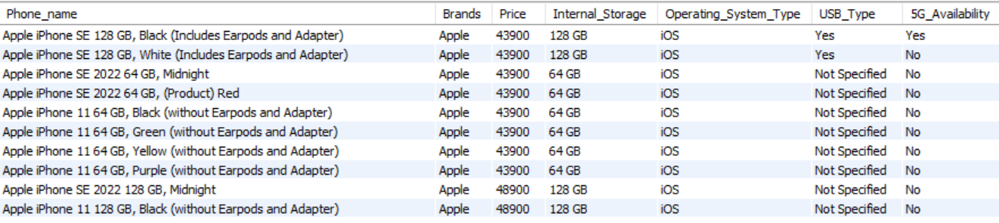

Question 9:

List of Top 10 mobile phones as per price with 5G?

select * from mobile_analysis

where 5G_Availability = "Yes"

order by price desc

limit 10;

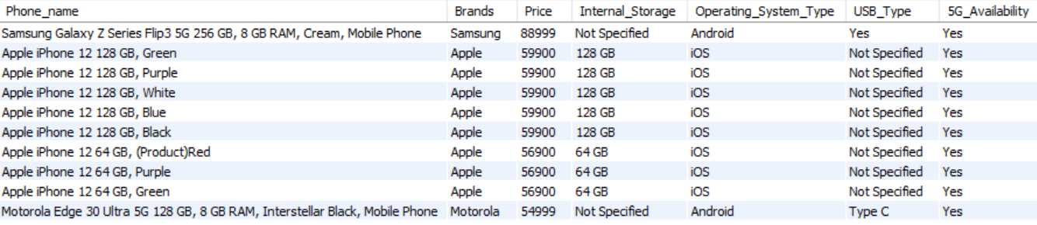

Question 10:

Total price of all mobiles of each brand?

select brands as Brand_Name,

sum(price) as Total_Price

from mobile_analysis

group by brands

order by Total_Price desc;

