MEDIA SECTION

**Understanding the code:**

**[evo:category id=1044 showCategoryTitle=none maxArticles=365 orderArticlesBy=dateavailable showSeparator=400 showArticleTitle=hyperlink descLength=0 descHyplerlink=false displayFormat=textonly /]**

**category id=1044**   
Refers to the parent ID of a category. Every time a new category is created it is given a parent ID. You can find this number by looking in the URL for a desired category.

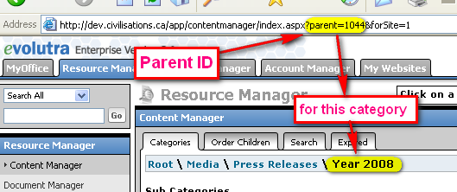

**showCategoryTitle=none**Not sure what this does, but since it is set to none, I found that removing it or leaving it does not make a difference.

**MaxArticles=365**   
This represents the number of Articles that will be displayed.

**orderArticlesBy=dateavailable**   
Every time a article is created it is given a date of creation. This date of creation will be set to the present date unless it is changed by the user. Since the articles are listed according to the date, one can manipulate the ordering of the articles by manipulating the date.

**showSeparator=400**   
This function basically displays a HR(horizontal line) in between the articles when displaying them.

The number represents how long the HR will be.   
In this case it is set to 400px.  
It can also be set as percentages, so for example it can be showSeparator=100% depending on the desired length, most common is 100%.

**showArticleTitle=hyperlink**   
This displays the title of the article as a hyperlink. If one clicks on it they will see the page related to the article. This can also be set to **showArticleTitle=none** ....the code will not display the title at all.

**descLength=0 descHyplerlink=false**

These two parameters work in conjunction with each other.

**descLength=0** displays the content of the article following the title. The desired characters that we want to display in this case happens to be zero since we don’t want nothing to show as a description (e.g. if set to 100 it will display the first 100 characters).

**descHyplerlink=false** displays the content (description) as an hyperlink to the article.

Note if  **descLength=0** it doesn’t make a difference if it is set to true or false.

**IMPORTANT:** If **descLength** is zero than please set **descHyplerlink**=false so as not to cause any errors.

**displayFormat=textonly**Specifies how it wants the title of the article to, I think it can also be set to HTML.

**FURTHERMORE (language):**

**If the code is in an English article than it will display all the corresponding English documents in that specific category.**

**If the code is in a French article than it will display all the corresponding French documents in that specific category.**

**CREATING MEDIA FOR YEAR 2010**

1. **Create new category under “press releases” (not hidden) and note the parent ID (category ID) in the URL so it can be used in the snippet of code. (New category=1192)**



**Please note that the title of the category is different from the URL. The reasoning for this is to avoid duplicate URL’s.**

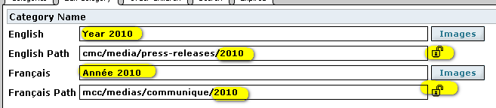

***Make sure not to lock before saving or else the url will revert back to the title and we don’t want that!!***

1. **Create default article for the above category to maqke the bread crumb functional.**

**Therefore when someone clicks on the bread crumb Year 2010 they will be taken to a page that will list all the articles for that year.**

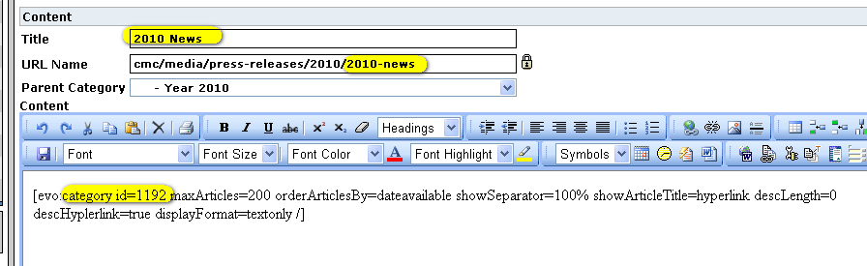

**The code used should refer to 2010 category = 1192 (basically it should refer to its own category so when someone clicks on the bread crumb all the articles in that category will be listed)**

*[evo:category id=1192 maxArticles=200 orderArticlesBy=dateavailable showSeparator=100% showArticleTitle=hyperlink descLength=0 descHyplerlink=true displayFormat=textonly /]*

1. **Create article under press release category called year 2010. Make sure it is HIDDEN as we don’t want it to show up in the side menu. This is created for the purposes of “NEWS ARCHIVES LISTING” at the bottom of this page:**

[**http://dev.civilization.ca/cmc/media/media2**](http://dev.civilization.ca/cmc/media/media2)

**The code used refers to the 2010 category, therefore listing all its articles**

[evo:category id=1192 showCategoryTitle=none maxArticles=365 orderArticlesBy=dateavailable showSeparator=400 showArticleTitle=hyperlink descLength=0 descHyplerlink=false displayFormat=textonly /]

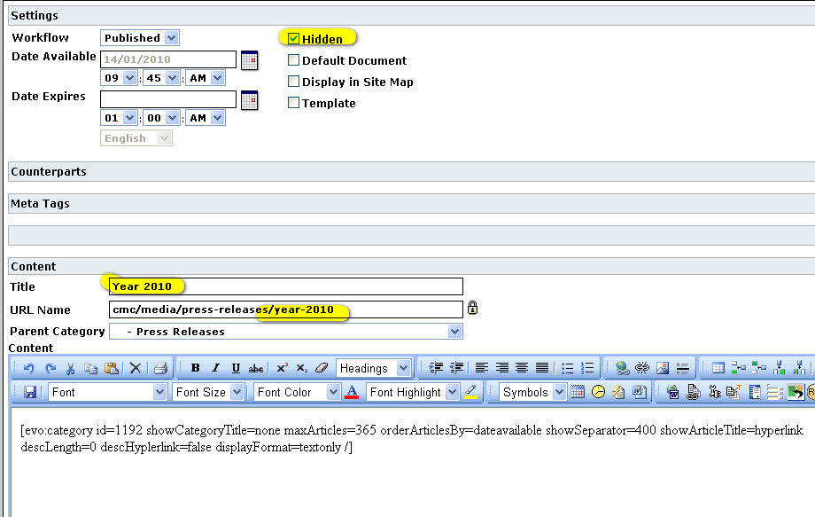

**The same was done for all the previous years.**

1. **Adjust the snippet of code on the main media pages which displays top 5 articles:**

[**http://dev.civilization.ca/cmc/media/media2**](http://dev.civilization.ca/cmc/media/media2) **So that they refer to the new category for year 2010 and display the latest articles for that year.**

**Note that when the year starts their may only be 1 or 2 articles in the 2010 category so a duplicate code can be used for 2009 right below it to be able to display the 5 articles for each museum by adjusting maxArticle**

**So if 2010 category only has 2 articles ( 3 minus the default article since we don’t want that to display) use:  
For 2010 - maxArticles=2**

**For 2009- maxArticles=3**

**Once 2010 has 3 than:  
For 2010 - maxArticles=3**

**For 2009- maxArticles=2**

**Once 2010 has 4 than:  
For 2010 - maxArticles=4**

**For 2009- maxArticles=1**

**Once 2010 has 5 than:  
For 2010 - maxArticles=5**

**REMOVE CODE FOR 2090**

1. **French articles would have the exact same coding as the English. Please refer to last years for the correct naming conventions.**

***\*\*\*\*\*\*\*\*\*\*\*\*\*\*\*\*\*\*\*\*\*\*\*\*\*\*\*\*\*\*\*\*\*\*\*\*\*\*\*\*\*\*\*\*\*\*\*\*\*\*\*\*\*\*\*\*\*\*\*\*\*\*\*\*\*\*\*\****

***Please use previous year coding as further reference if needed. One can simply follow and duplicate last years info as long the correct category ID is used and the user has a good understanding of the functioning of the “snippet of code” explained in this document.***