/*

*** FILE NAME : Cos.c

*** DESCRIPTION : This program draws a cosine wave for y=A+Bcos(x)

*** DATE : Jan. 2015

*** WRITTEN By : Farheen Sultana

*/

/*

The program draws a Cosine wave for the function y= A+Bcos(x) on a window of size 480*480.

The variables A and B are the scaling factors.

A is the center line for graph, it represents the horizontal stretch from center line.

B is the Maximum deviation of graph from center line on Y-Axis, i.e., it represents the vertical displacement of graph from center line.

As the center here is at 240,240:

The Maximum Vertical Displacement needed is 240 ==> B= 240

The Maximum Horizontal Stretch needed is 240 ==> A = 240

So, A= 240 and B = 240.

*/

#include <stdio.h> // standard C libraries

#include <stdlib.h>

#include <math.h>

#include <time.h>

#include <string.h>

#include <GL/glut.h> // GLUT library

#include "cs_graphics_setup.h" // Header for CS4250/5250/6250 courses

//@@***********************************************************************************@@

// Constants

#define WINDOW_XS 480 // Window size

#define WINDOW_YS 480

#define WINDOW_NAME "Cosine Wave" // Window name

//@@***********************************************************************************@@

// Structure

typedef struct pt2d

{

GLint x, y;

}My2DPoint;

//@@***********************************************************************************@@

// Function prototypes

void display_func(void);

void keyboard_func(unsigned char c, int x, int y);

void mouse_func(int button, int state, int x, int y);

//@@***********************************************************************************@@

// Global Variables

My2DPoint XAxis1, XAxis2; //Coordinates of X-axis

My2DPoint YAxis1, YAxis2; //Coordinates of Y-axis

float DegToRad = 3.141592 * 1.0 / 180.0; // Convert Degrees to Radian Degree = Radian * 3.14/180

float LineX1 = 0.0, LineY1 = 0.0; // Coordinates of Smaller Line Segments used to draw cosine curve

float LineX2 = 0.0, LineY2 = 0.0; // Coordinates of Smaller Line Segments used to draw cosine curve

float A1 = 240.0, B1 = 240.0; // A and B are Scaling Factors

float x; // X is the pixel X-Coordinate

int flag = 1; //flag variable used to change the curve from solid to dashed upon right mouse click

float set_angle = 0.0; // variable to adjust axis (480) to angle (360)

//@@***********************************************************************************@@

int main(int argc, char **argv)

{

glutInit(&argc, argv);

init_setup(WINDOW_XS, WINDOW_YS, WINDOW_NAME);

// initializing x-axis

XAxis1.x = 0;

XAxis1.y = 240;

XAxis2.x = 480;

XAxis2.y = 240;

// initializing y-axis

YAxis1.x = 240;

YAxis1.y = 0;

YAxis2.x = 240;

YAxis2.y = 480;

glutDisplayFunc(display_func); // call back for display event

glutKeyboardFunc(keyboard_func); // call back for keyboard event

glutMouseFunc(mouse_func); // call back for mouse event

glutMainLoop();

return 1;

} // end of main()

//@@***********************************************************************************@@

void display_func(void)

{

glClearColor(1.0, 1.0, 1.0, 1.0); // background color (white)

glClear(GL_COLOR_BUFFER_BIT); // clearing the buffer not to keep the color

//Draw X-axis

glColor3f(1,0,0);

glBegin(GL_LINES);

glVertex2i(XAxis1.x, XAxis1.y);

glVertex2i(XAxis2.x, XAxis2.y);

glEnd();

//Draw y-axis

glBegin(GL_LINES);

glVertex2i(YAxis1.x, YAxis1.y);

glVertex2i(YAxis2.x, YAxis2.y);

glEnd();

//DRAW SOLID CURVE

if (flag == 1)

{

glColor3f(0, 0, 1);

glBegin(GL_LINES);

set_angle = 0.0;

for (x = 0.0; x < 480.0; x += 1.3333)

{

set_angle = set_angle + 0.3333;

LineX1 = x;

LineY1 = A1 + B1* cos((x-set_angle)*DegToRad);

LineX2 = x + 1.3333;

LineY2 = A1 + B1* cos((x + 1.3333 - set_angle)*DegToRad);

glVertex2f(LineX1, WINDOW_YS - LineY1);

glVertex2f(LineX2, WINDOW_YS - LineY2);

}

glEnd();

}

//DRAW DASHED CURVE UPON RIGHT MOUSE CLICK

if ( flag == 2)

{

glColor3f(0, 1, 0);

glBegin(GL_LINES);

set_angle = 0.0;

for (x = 0.0; x < 480.0; x += 1.3333)

{

set_angle = set_angle + 0.9999;

LineX1 = x;

LineY1 = A1 + B1* cos((x - set_angle)*DegToRad);

LineX2 = x + 1.3333;

LineY2 = A1 + B1* cos((x + 1.3333 - set_angle)*DegToRad);

glVertex2f(LineX1, WINDOW_YS - LineY1);

glVertex2f(LineX2, WINDOW_YS - LineY2);

x = x + 2.6666;

}

glEnd();

}

glFlush();

} // end of display_func()

//@@***********************************************************************************@@

void keyboard_func(unsigned char c, int x, int y)

{

switch(c)

{

case 'q' :

case 'Q' :

exit(1);

break;

} // end of switch

} // end of keyboard_func()

//@@***********************************************************************************@@

void mouse_func(int button, int state, int x, int y)

{

if (button == GLUT_RIGHT_BUTTON && state == GLUT_DOWN)

{

if (flag == 1)

flag = 2;

else

flag = 1;

glutPostRedisplay();

}

} // end of mouse_func()

Output:

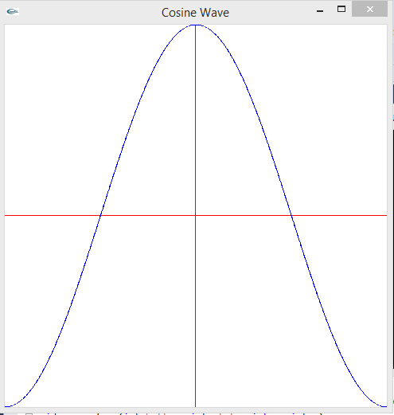

Right Mouse Click:

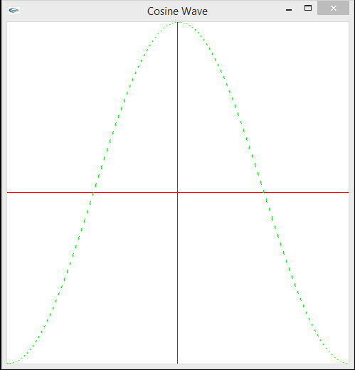

Right Click Again:

