--- Spring Core ----

- Technologies
- Why we need Framework (In-built code Common code over the Technology)
The major benefit of framework is RAD(Rapid Application Development)
BookMyShow
- What is API (Classes, Interfaces, Enums, Annotations)
- How the framework provides you the code.
- What is JAR, WAR (these jars are published on repository) I.e (Maven repository)
- What is spring Framework:- Spring framework has its’ own API and follows the container system.
- What is Spring Container. It takes care of object. (Object handling) and Inversion of Control is often achieved through techniques like dependency injection
- And what is its job..
* Scan Classes (Spring Bean which follows some rule) * Create the object
* Provide the data * Link the object * Destroy
- Dependency Injection is a concept/theory which is implemented by Spring IOC (Inversion of Control) also called as Spring container. For example

ORM | HIBERNATE, JPA
OOP | Core Java

-Types of Container
1. BeanFactory: (I) It supports only XML Configuration. It has one Impl classXmlBeanFactory(C).
2. ApplicationContext(I): It is new container. It supports XML, Java and AnnotationConfiguration.
It has multiple Impl class:
ClassPathXmlApplicationContext(C)
AnnotationConfigApplicationContext(C)
- Types of applications (WEB, Distributed, Micro-services)
Web Services: Integration of multiple (at least two) applications which runs on different servers and implemented using different languages (Java,. Net, PHP, Python..etc)
=> Here both applications are linked using IL (Integration Layer)
Using HTTP protocol and JSON/XML as Data Formats.
- What is Spring Container
- Old Container (Supports only XML Configuration)
- New Container (Supports All Configuration XML/JAVA/Annotation)

======== 02 Jan 2024 ==========
- Spring core gives the guidelines to work with the different modules. i.e (Web, Security, Rest...)
- The programmer needs to give the two inputs to the container
(i) Spring Bean (ii) Configuration file (Additional Information)
- The instance variables exists in class is called dependencies. * PTD * RTD * CTD
- Injection is the process of providing the data is called dependencies.
-Dependency Injection:
- Types of Dependency (4) * SI use default const. * CI Use parameterized cons. * LMI * II
- Look Up Method Injection (When parent bean is Singleton and child bean is Prototype)
- What are the Spring Bean Rules:
* Class must be public * Must follow common package * Fields must be private (Optional)
* If fields have then provide the default constructor or parameterized constructor.
* We can only inherit the spring core related interfaces and classes. (Inheritance rule)
* Only We can add Spring API Annotation and Integration API Annotations
Annotation ---> | Compile --> interface
Enum -------> | Compile ---> class
- What is P Schema? Vary short cut format to tell the container about the object details.
When a Programmer uses interface in coding, then Container chooses a default implementation for a collections. Given as,
List -> ArrayList - Set -> LinkedHashSet - Map -> LinkedHashMap, Properties --> --NA--
Q) Can we Inject null value to a collection object? in Spring Config?
A) Yes. Use <null></null> or <null/> (not for Properties)

====== 03 Jan 2024 ==========
- What is RTD?
Generally if a classes have instance of another class then its is RTD. Expect collections and String
- IS-A Relation (Extends) - HAS-A relation (Instance in class)
- What is the Constructor and Setter injection?
The constructor injection uses the parameterized constructor. And setter use the setter method.
- Spring Core Annotation. (Stereo-type & Data Annotation)
=> This is easy to configure.
=> Faster in execution (Compared to XML)
- Stereotype Annotations:- (All common duty is create the object)
These annotations informs Spring Container Hey! Spring container please create the Object.
(These annotations must be applied at class level).
=> They are 5 annotations given by Spring F/w.
=> These annotations are added in Spring version 2.5
@Component: Creates object inside container.
@Service: Creates object + Transaction/Logics/calculations..etc
@RestController: Creates object + HTTP Protocol (Webservices)
The @RestController annotation is a specialized version of @Controller. It is used to create RESTful web services. When a method in a class annotated with @RestController returns a value, that value is written directly to the HTTP response body, typically in JSON or XML format. The @RestController annotation is a combination of @Controller and @ResponseBody.
@Controller: Creates object + HTTP Protocol (Web Apps)
The @Controller annotation is used to define a traditional Spring MVC controller. This controller can handle web requests and return views (usually JSPs, Thymeleaf templates, etc.). When a method in a class annotated with @Controller returns a String, it typically refers to a view name that should be resolved by a ViewResolver.
@Repository: Creates object + Database Operations

***********************************************

Data Annotation: (There are total four data annotations)
@value i) Direct value ii) reading the data from properties file. iii) SPEL (Spring expression language)
@Autowired is the process of linking the objects i.e (Reference-Type dependency). Autowired can be write on top of the interface Reference then it will go and search for one of its implement class.
There are four

@Qulifier

@Primary
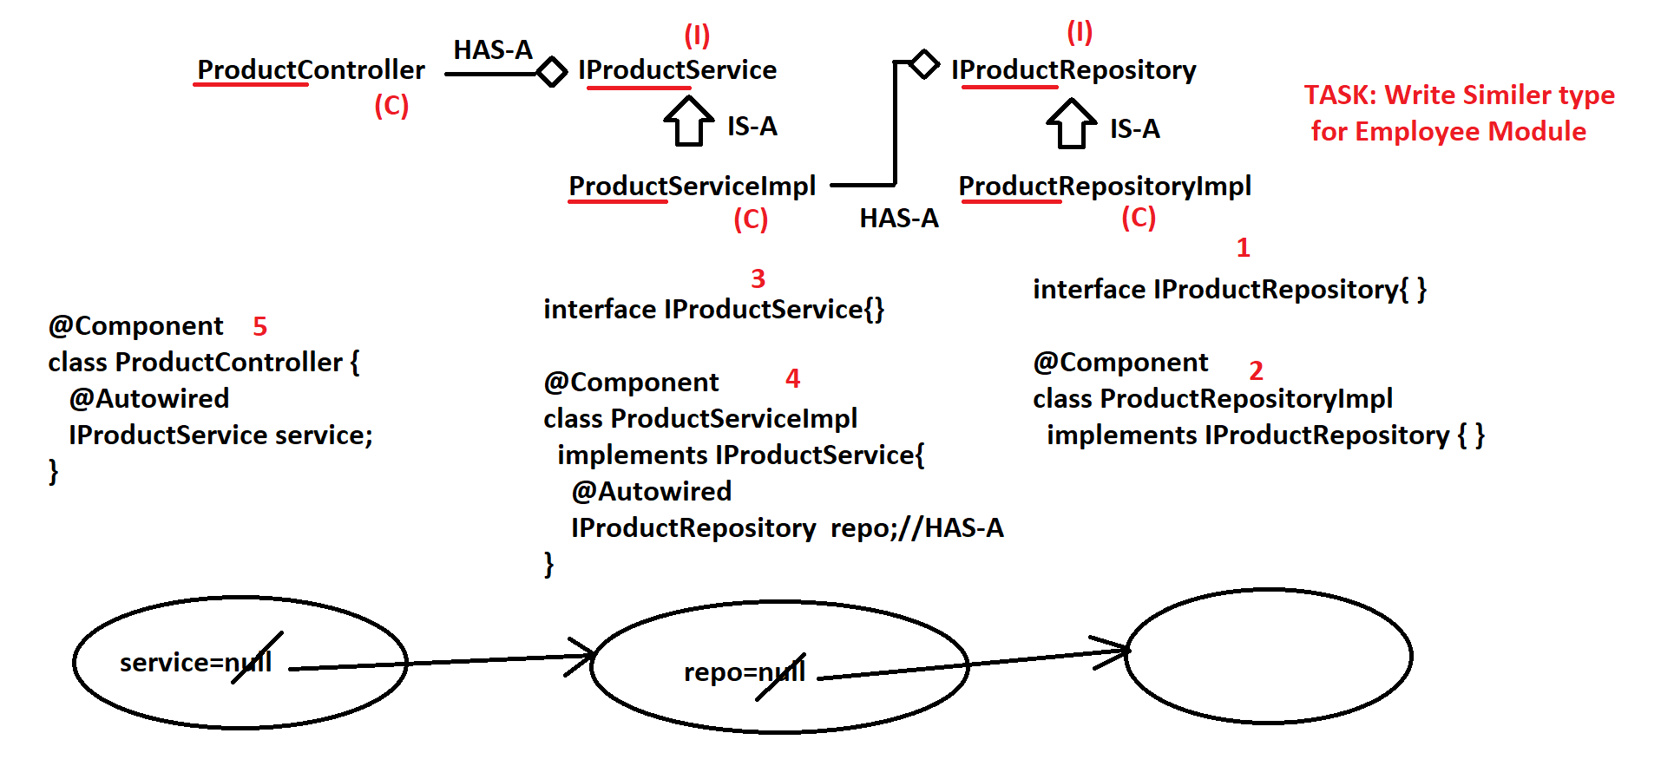

--- @value (field injection)
******************************
@Component
- For this is we have to tell the container please scan the package load them and refresh it.
ac.scan(“Base Package Rule”);
ac.refresh();
- What is BasePackage? It is a packageName. from this package name, Spring container will search for classes from current package and all its subpackages.
- @ComponentScan
Find for classes having stereotype annotation from given package or subpackage into Spring container. i) Define the public name ii) Apply the @Component Scan @ Give name to ACAC.
For Please refer the following questions.
Q) is BasePackage must be given as input to ApplicationContext?
A) In case of Annotation Config, it is must.
Q) Can we provide multiple basePackages to Spring container?
A) YES. use {} symbol. ex: @ComponentScan({"com.app","test.one","abc.xyz"})
Q) A class is found in basePackage but not having any Stereotype annotation. does Spring container create Object?
A) No. @Component or any equal type is required.
Q) If a class is not under basePackage but having @Component does Spring container create Object?
A) No. Class must present under given basePackage and must have @Component.
====== 04 Jan 2024 ==========
- why. properties & .yml file need? (Application Setup Data)
@value can inject the data directly & from .yml or .properties @value(“${key})file. # is used of //
- @PropertySource (this is used to load the data from .yml or .properties to Spring container)
- .properties file can be loaded using annotation @PropertySource
ex: @PropertySource("classpath: jdbc.properties") where classpath: = src/main/resources
Then Container stores all these details into Environment(I) memory.
Spring f/w has given impl class: StandardEnvironment(C).
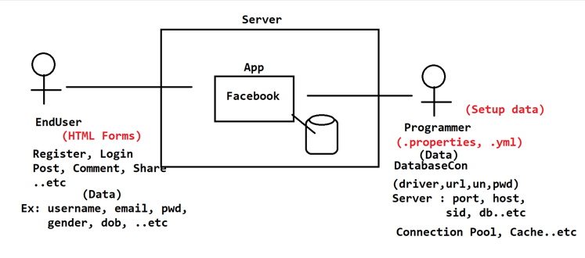
# we can use the following symbols (period., dash -, underscore _)
** keys are case sensitive ** if the keys is invalid and over the String type it will print as other error.
We can load the multiple properties file using the @propertySoruces syntax is like componentScans.
Similarly we can use the @comopnentScans to scan multiple packages.

====== 05 Jan 2024 ==========
- Autowiring (If there are two classes and we want to link them then it called autowiring.)
it is process of linking the object based on association mapping. @autowired annotation is used.
Container always create the child object first.
There is one independent and dependent bean. And the dependent class have the object of independent as dependency.
There is an important property of the auto-wiring required (default true) property.
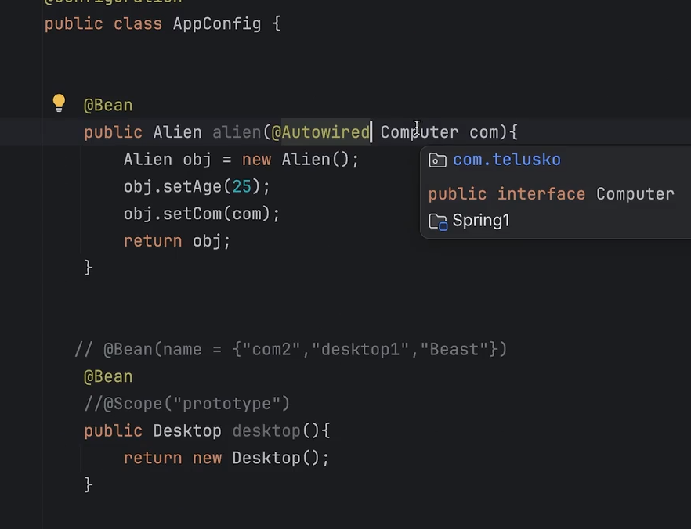

====== 06 Jan 2024 ==========

- Spring Life Cycle Methods
*If a method is called by container/runtime in between Object creation and destroy.
Like we have the init() and destroy() method in Servlets.
In Spring framework we have init and destroy method but the both are the optional.
We can implement them in the three ways.
i) XML configuration .. I.e <bean id=”student” class=”com.i2c.Student” init-method=”” destry-method=” ”>
- Create the two objects with any name you wish. The container does not close the resources use registerShutDOwnhook method to close at the same time with abstrcatApplicationConatex or use close method.
ii) Life Cycle interfaces ( InitializingBean init method – afterPropertiesSet) && dispiableBean destroy method)
iii) JSAR Annotation (@postcontruct and @predestroy) for this add JSR 250 dependency.
----
- @Primary
- @Qualifer
- JSR Annotations(Java Specification Request)
- @PostContruct:: This annotation is applied to a method to indicate that it should be
invoked after all dependency injection is complete.
- @PreDestroy:: This is applied to a method to indicate that it should be invoked before
the bean is removed from the Spring context, i.e. just before it’s destroyed.
Why we need java configuration?
Ans: If a class(Spring Bean) is per-defined then we can not use Annotation Configuration.
** In above case we go for Java Configuration. Even we can configure multiple beans(objects) using Java Configuration, where annotation Config supports only one Bean(object) Configuration.
-----------------Java Configuration Steps-------------------
1. Define one public class with any name
2. Apply @Configuration annotation over class
3. For one object = define one method
public <className> <objectName>() {}
ReturnType methodName

4. Add @Bean over method.
---
What is the mean of @Configuration and @Bean?
A) @Configuration says "Hey! I'm a Config File, not a simple java class" to Spring Container.

@Bean is used to define a single bean method within a configuration class, and is typically used for third-party or non-Spring classes. @Component is used to mark a class as a component, and is typically used for classes that you create yourself and that have a simple initialization process.
@Component –> Used for Programmer defined class
@Bean –> Mainly for per-defined (Supports both)
Q) Can we use Java Configuration for both pre-defined and use-defined (programmer-defined) classes? If Yes, then why Annotation Configuration?
A) We can write Java Config Code for a programmer-defined class. But code becomes lengthy, execution is bit slow compared to annotation.
Q) What is the use of @Bean if we use new keyword and set method to create full object in Java Config?
A) This object is not a local scope object, created inside Spring container with scope singleton and accessible in project(any where). Yes we are writing the code but the object managing, creation and calling will be handled by Spring.
Important: Do we need to provide @ComponentScan/basePackage for Java Config? A) No. it is required only for Annotation Config.
- Type of Configuration in Spring Framework
- XML Configuration
- Annotation Configuration
- Java Configuration (@Bean & @Configuration) we have the dependency but we need to tell the
container please maintain its life cycle.
- Spring Bean Life Cycle (When Bean is created, How long it is present in container).
Container provide a s cope to every bean based on the configuration.
- Singleton (default): For every bean this is default scope. One Object is created per configuration
It returns single object even if we access it multiple times. The same instance is shared by all the clients.
- Prototype: Every-time new object when we access then object.
- Request: (Web App Only) Container creates new object when a New Request comes to server, maintained until response.
- Session: (Web App Only) Container creates object when new session is created [Login-Logout] and object is removed when session is Destroyed (ses.invalidate()).
We can change the scope if we required.
Application: In application scope (also known as global scope), a single instance of the bean is created for the entire web application context
Spring XML Configuration:
<bean id="" class="" scope="singleton or prototype"> </bean>
*) Spring AnnotationConfiguration:
@Component
@Scope("____")
class ____{
}

*) Spring Java Configuration:
@Configuration
public class ____{
@Bean
@Scope("___")
public <className> <obj>(){}
}
Q) Can two objects have same hashcode in Java?
A) Yes Possible, if hashCode() and equals() method is overridden and if both are having same data
-Difference between the singleton (Eager loading) vs prototype (lazy Loading)
We can make the singleton session which is by default to lazy laoding. For this we have to use the @Lazy annotation. For Xml make the lazy tag to true.

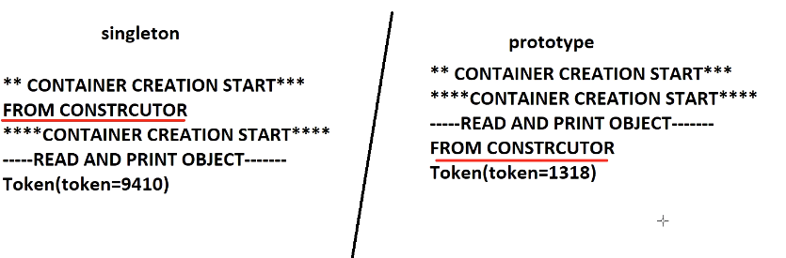

- LMI(Look- up Method Injection) When the scope of child is prototype and Parent is singleton.
There are three ways to solve this problem.
1. Use the applicationContext (not recommended) – (violating the rules)
2. Use The BeanFactory Class (not recommended) – (eager loading)
3. Use the @Lookup Method (Create one public method and use annotation over)

** Class should not be public and lookup method should not be the private/static
What is Circular dependency if two classes are connected using ReferenceType (HAS-A) Relation
then objects are created using default constructors first and linked using set methods one after another.
Such process is called as CD and handled by Spring container.

** DO NOT OVERRIDE ** toString() method in Both classes.
if we do, then toString() methods are called in loop from both classes
then results : Exception in thread "main" java.lang.StackOverflowError.

====== 07 Jan 2024 ==========
--- Spring Boot ---

- Spring Boot mainly provide Auto-Configurations. Its is Spring Based Framework. (Project) and for every concept it provides the ready made code. (Spring Starters). Every project has the parent project in the POM file (The dependencies they have simplified).Bases on the statrers provided in the POM.xml file, boot provide the configuration, for example if we provide the web starter it will provide the tomcat configuration to run our applcaiton, if we provide the JPA starter it manage the connection pool required for our application. Features
* Embedded database *Embedded Servers *No XML Configuration
Spring boot is a project. (Same as there concept of inheritance concept)
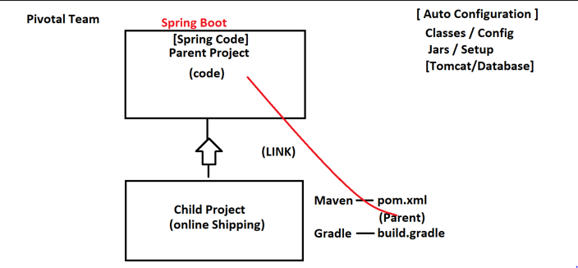

- Spring Boot starters ~ (spring-boot-starter-*)
It is a JAR File contains common code exist at parent project.
- Spring boot has provided support to work with External Servers and databases too.
- Why application.properties file in spring boot.
Snapshot is a project under development.
- What is Group Id: (jar folder name)
- Artifact Id: (Project Name)
- Version: (version)
- Package-name (This is same as base-package)
*************** -jar(build code) name will be:: artifactId-version *************
-Spring Boot container name: AnnotationConfigApplicationContext
* Creates the Container.
* Which scan all the classes in base-package or sub-package and creates the object
* Provide the data
* link the objects (Autowiring) based by using the @componentScan.
File structure of the Spring Boot Application.
- Starter Class (Which creates the container)
- application.properties file (To provide the input to the container objects)
- pom.xml for dependencies (build tag is used to compile, build, jar, deploy….)
@SpringBootApplication = @Configuration(For java based) + @Enable (this tell the spring boot to guess the how you want to confgure spring based, when we added the dependencies.)
In application.properties file all the keys are variables internally.
Raghu Sir, Email Reply:
That is supported naming convention. It is called as camel case to kebab Case.
For example driverClassName in Kebab Case is –> driver-class-name

========= 08 Jan 2024 ==========

- Runners: To execute a logic one time while starting the application (after creating the container)
There are two ways. Command Line Runner (Since 1.0) and Application runners(1.3)
1. We need to define one class that should implement interface CommandLineRunner (CLR) (I) or AR
2. We need to override abstract method run() and define our logic.
3. Main class/Starter class, after creating container, executing all runners in order.
4. We can define multiple runners, which are executed in NameBased (A-Z) Order.
5. We can provide our own execution order using annotation @Order(_).Lowest value is executed first.
6. If we did not specify any Order then executed at last.
To understand the runners consider the Customer Application.

======== 09 Jan 2024 ==========
Spring Boot application VS yml Files
- Properties file in Spring Boot: @value is used to load the values from properties file. If we have n-variables then use N- number of @value annotation.
***********************************************************************************
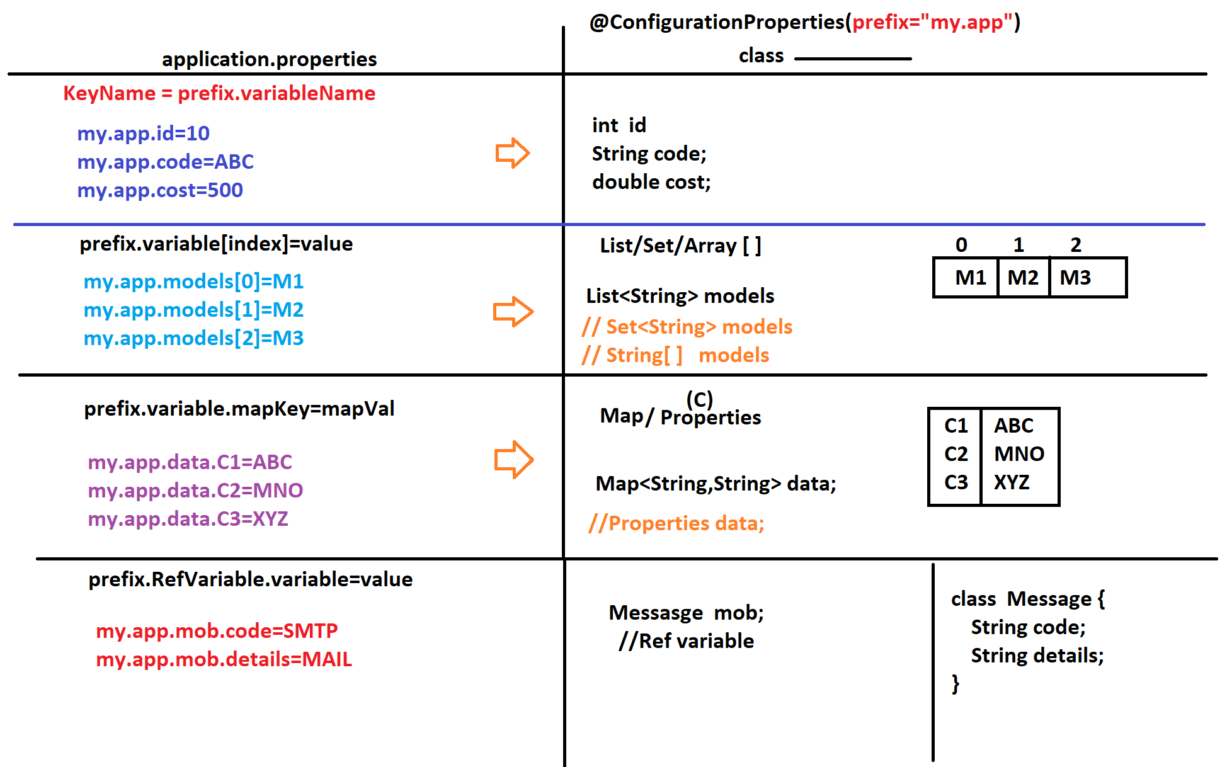

***********************************************************************************

We can use single annotation @ConfigurationProperties to load the values from properties file but using some common prefix remaining the variable name. The key name will be prefix.vaiableName i.e (com.app.host=host)
1. Must provide one common prefix for key name.
2. Same prefix must be matched while loading keys in class
3. key name and variable name must be matching.
4. Must generate set/get methods.
- The following possibilities can be in a class (Primitive, Non-Primitive, Reference-Type)
- YAML (Yet Another Markup Language) (application.yml)
It is another way for writing in the key-value in spring-boot. YAML files are fast in execution.
We don't write duplicated prefixes.(snakeyaml-1.30.jar) is used to read the properties.
It Supports the single file for multiple profiles.
Rules for writing the YML file
1. Use Symbol colon (:) in the place of dot(.) and equals(=)
2. After every colon (new level) change line for next level.
3. We need to provide spaces for every new level (not for 1st level)
4. Space count must match proper indentation for the given level
5. Must provide colon and space before value.
*) if we do not follow space rules or any other then Spring Boot throws the following exception
(Snake YML Exception): ScannerException
Q) What is both file having same key name and different values?
A) Always Spring Container takes value from application.properties with high priority.

======== 10 Jan 2024 ==========
- What is meant by Environment?
A machine where application is running is called environment.
- What is meant by profiles?
Maintaining the different properties/.yml file for different environment. i.e (DEV, QA, STG...)
There are two possibilities to provide the application properties.
- Config Map or Config Server. (Outside the project)
- Within the project (Application.properties)
What is the meaning of profiles?
Maintaining the different properties file for different environment is called profiling.
Name Rule: application-{profile-name}.properties
We have to write the different profiles. i.e (dev-qa-uat-prod)
We have to active the profiles using the bellow command.
1) Activate: (CMD) –spring.profiles.active={profile-name}
2) Using the jar file (java -jar jarFileName)
- application.message can be used to set the message of environment.
The default properties file always loaded.
What is profiles Fall back? If you didn’t specific any key then it will load from the default Profile.
--spring.profiles.active=Prod, QA in this case qa profile overrides prod profile key=values

Maven Commands: Clean + install

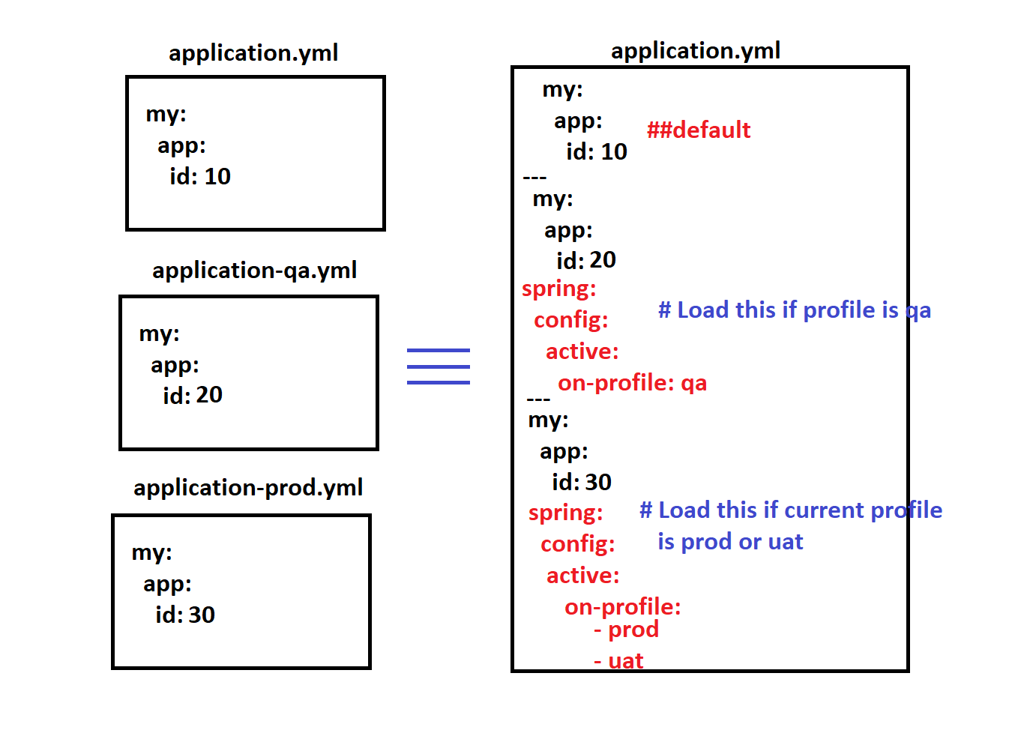
- We can manage multiple profiles using the YML file but we have to separate these configuration using the three dashes(---).
if we don't mentioned any profile first one will be taken as default profile.

) If we want to create any Bean/Object or execute any logic on profile based then use this @Profile("") annotation. For we want to execute the logic on default profile we have to write DEFAULT keyword
*) This annotation says: do not execute logic in every Environment. We can find which profile is activated using the environment interface.

Spring Data JPA
ORM is concept and Hibernate is the implementation.
Java--------Converted>----------- SQL ----------Execute>------------ Database
- What is difference b/w JDBC API and ORM and mapping rule?
1. JDBC API given by Java, used to perform database Operations.
2. JDBC works mainly on SQL concept. SQL contains all primitive data.
3. Even we have data in Object, should be converted into primitives then set to SQL.
4. ORM says perform the JDBC operation by using object concept.(OOP’S)
1 Class→ 1 Table
1 Variable→ 1 Field
1 Object→ 1 Row
5. JPA is given by sun/oracle to perform the database operations using the ORM concept.
JPA has different vendor (Eclipse link, IBATES, Hibernate)
- Some important annotations which are used in JPA
1. @Entity 2.@Table 3.@Id (To tell the primary key in the table) 4.@Column
- Q) What is the diff b/w ORM, JPA and Hibernate?
ORM – Theory/Concept
JPA – API (set of classes, interfaces, Enum, Annotations)..etc that follows ORM Concept
Hibernate – Implements ORM/JPA. It is JPA Vendor.
- ORM Properties
1. (platform) dialect: It is a class, that generates SQL query when we perform operation Ex: Oracle10gDialect, MySQL8Dialect,..etc (To generate the query)
=> All these dialects are present in package: org.hibernate.dialect
dialect is class which generates the SQL query while preforming the db operations.
2- hbm2ddl(Hibernate mapping to DDL mapping) For ddl’s
-> create: A new table will be created when we start application (if old table is present, drop table )
-> update: A new table will be created if table is not present if old table is present, then use same table
-> *** validate: JPA/Hibernate does nothing, No tables are created/dropped. Programmer has create/alter/drop.. Which is default.
-> create-drop>Create a New table -Perform Operations >Drop table while stopping app.(Used testing)
3 - Show-sql: To view Query (dialect generates class and to view the query show use the show_sql: true) default is false which will show the queries on console. And it is Vendor Specific.
JPA Standards means JPA Annotation
EntityManager(I) Session(I)
persist() --save()
merge() -- update()
remove() --delete()
find() --get()
Why we move to JPA with Hibernate? Please don’t provide the code template again and again. So boilerplate code has been removed. Using the dynamic proxy class [Design Pattern].
Entity | Entity
Persistence.xml | Use Application.properties / application.yml
Operation code | Use the dynamic proxy.

Q) What is Spring Boot – Data JPA and how it is Different from Hibernate?
A) In JPA with Hibernate programmer has to write code for Operations.
If we use Spring Boot – Data JPA then Operations code is generated.
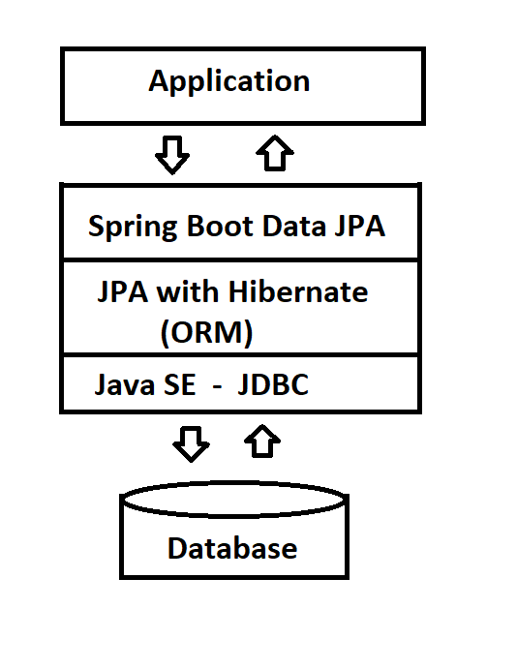
-> Data JPA also given code for
1. CRUD Operations
2. Pagination
3. Sort
4. Custom Query (JPQL/HQL)
-> Delete Query
-> Update Query
-> JOINS Select

*************************************************************

*) If we use Spring Boot - Data JPA, we need to define 2 main files for coding, those are:
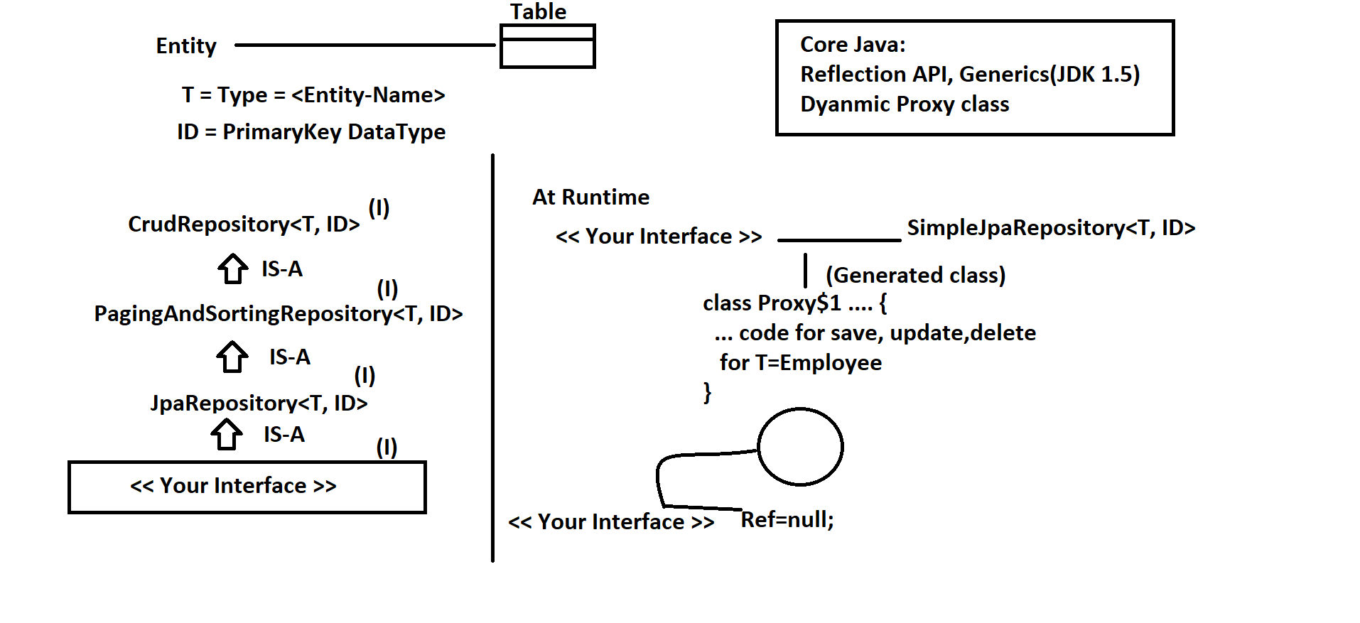
1. Entity class (same as JPA)
2. Repository interface (A class is generated at runtime)

How to work with Spring Data JPA
We Have to write the one Interface by extending the below repository.
* CurdRepositry
* PaggingAndSorting
* JPARepositry
there is one one implementation available
SimpleJpaRepositry<T,ID> it is still
UN-complete then the by using the proxy design pattern one full implementation will be created.
T→ Entity Class | ID → Primary Key
<<Your Interface> + Implementation class = Full implementation

======== 15 Jan 2024 ==========

CrudRepositary Repository

CrudRepositary: Create → Read →Update →Delete
In CrudRepositary the Save Method behaves like insert and update. This is the default behavior given by the CrudRepositary interface.→This method first executes SELECT query, if query returns matching results based on ID(PK) then execute UPDATE else INSERT.
Why SaveAll() method? (Network calls)
*** There is no UPDATE method given by CrudRepositary. We have only save method.

Paging And Sorting Repository

Data JPA also comes with two extra method with paging and sorting.
Sorting:

*) We can see some sample Sorting SQLs as given below:
1. single column Sorting - ASC
select * from booktab order by bcost; //default is ASC
select * from booktab order by bcost ASC;
2. single column Sorting - DESC
select * from booktab order by bcost DESC;
3. multi-column Sorting - sam type (ASC/DESC)
select * from booktab order by bcost ASC, bname ASC;
select * from booktab order by bcost DESC, bname DESC;
4. multi-column Sorting - mixed type(ASC + DESC)

Pagination: the index starts from Zero. It uses the limit concept [ select * from card limit 0,3]
********************************************************
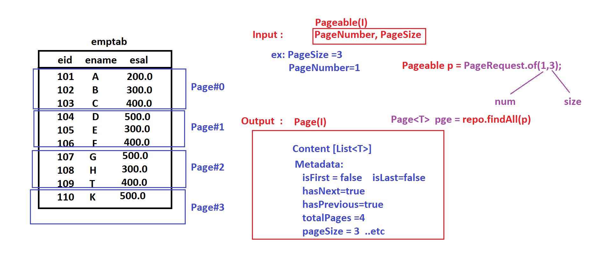

*******************************************************************************

======== 21 Jan 2024 ==========

@Temopral:-
This annotation is used for date. Don’t change at db side do configuration at code level.
@Temporal(TemporalType.DATE)
@Column(name="pmfgdte")
private Date mfgDate; //date
Custom Query:-
We can write our own query in JPA using(JPQL/HQL-SQL) for this purpose we have to use @Query annotation over the method. We can’t perform the INSERT operation using custom query.
JPQL - HQL [Java Persistency Query Language - Hibernate Query Language]
is query language, it is used to define query (SELECT, UPDATE and DELETE)
which is database independent. We have to use the class attribute as column name and Class name as database name.
How it works. JPQL / HQL → Dialect → SQL of given DB.
@Note:-
For * result set will be list of that class object → List<Employee> select e from Employee e
For single value result set will be List of that type. → List<String> select e.name from Employee e
For more than one value result will List of object →List<object> select e.name,e.id from Employee e
@Note:- Query Implementation is given by Dynamic Proxy class.

Collections Mapping Concept in JPA Repository

Why JPA Repository...
*) Supports ALL JPA Operations,
1. Collections Mapping (Collections with Primitives)
List<String>, Set<Integer>
2. Association Mapping (1...1/1...*/*...1/*....*)
3. Custom Query Language (SELECT/NON-SELECT -- UPDATE and DELETE)
[We want to define our own SQL/HQL query]
4. Joins: Fetch data from multiple tables using one SELECT SQL.
5. Date/Time, LOBs(Large OBjects-BLOB/CLOB)
*********************
** If we create a collection in our entity class this will be a new Table in which will be linked using the primary key. One is called as primary table (Parent) and other is secondary (Child) table.
** Supported Collections are * List * Set * Map
** The child table can have 2-3 columns in case of List & Map the column count will be 3 and in case of set there will be 2 column.

** Collections are two types 1) Indexed Base 2) Non-indexed Base

For every collection we need to define the @ElementCollection for collection @TableCollection and @Columns annotation.

@orderColumn will be required for List. (This is for the against which index what value is stored)

Understand the following Example

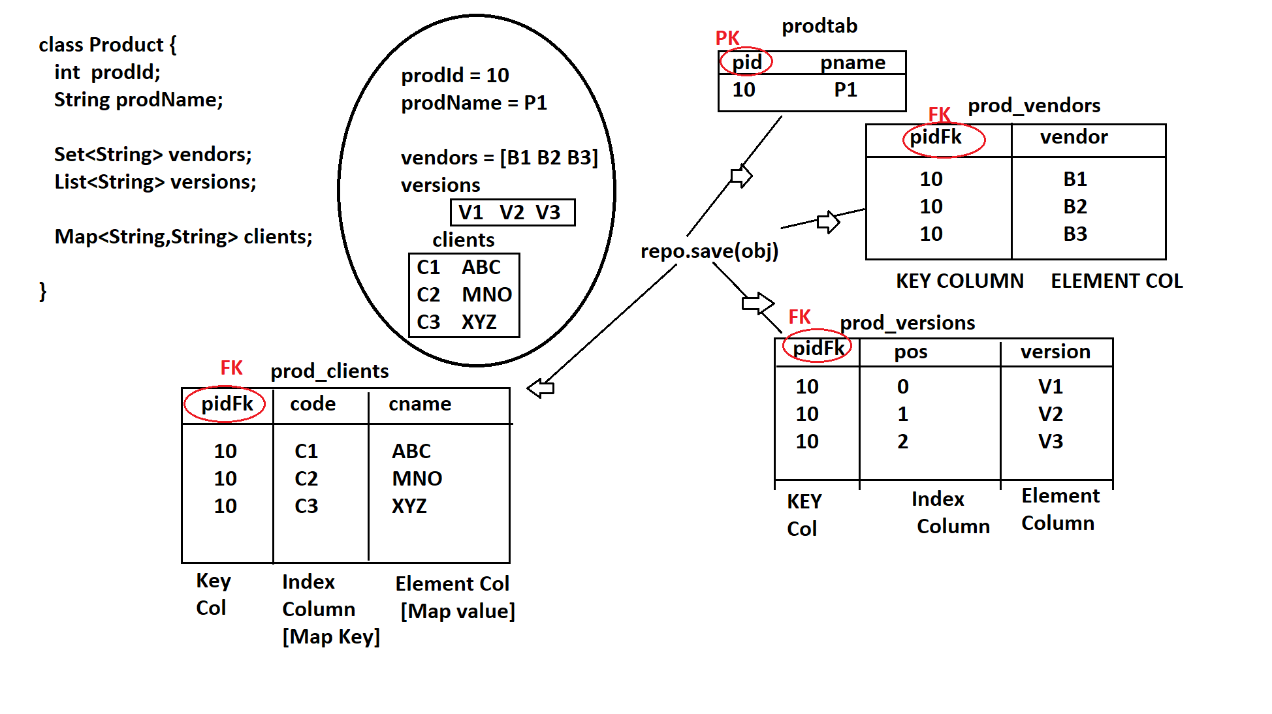

Association Mapping [HAS-A]

Two entities can be linked using Association Mapping
Multiplicity:- The connectivity level between the two entities.

1**1 1**M M**1 M**M

If there exists 1** M & M**1 then use → M**M relationship.

** Hint~ Add Foreign key column at many side.
In case of 1**1 use the M**1 with unique because it doesn’t allow duplicates.
Understand the below diagram.
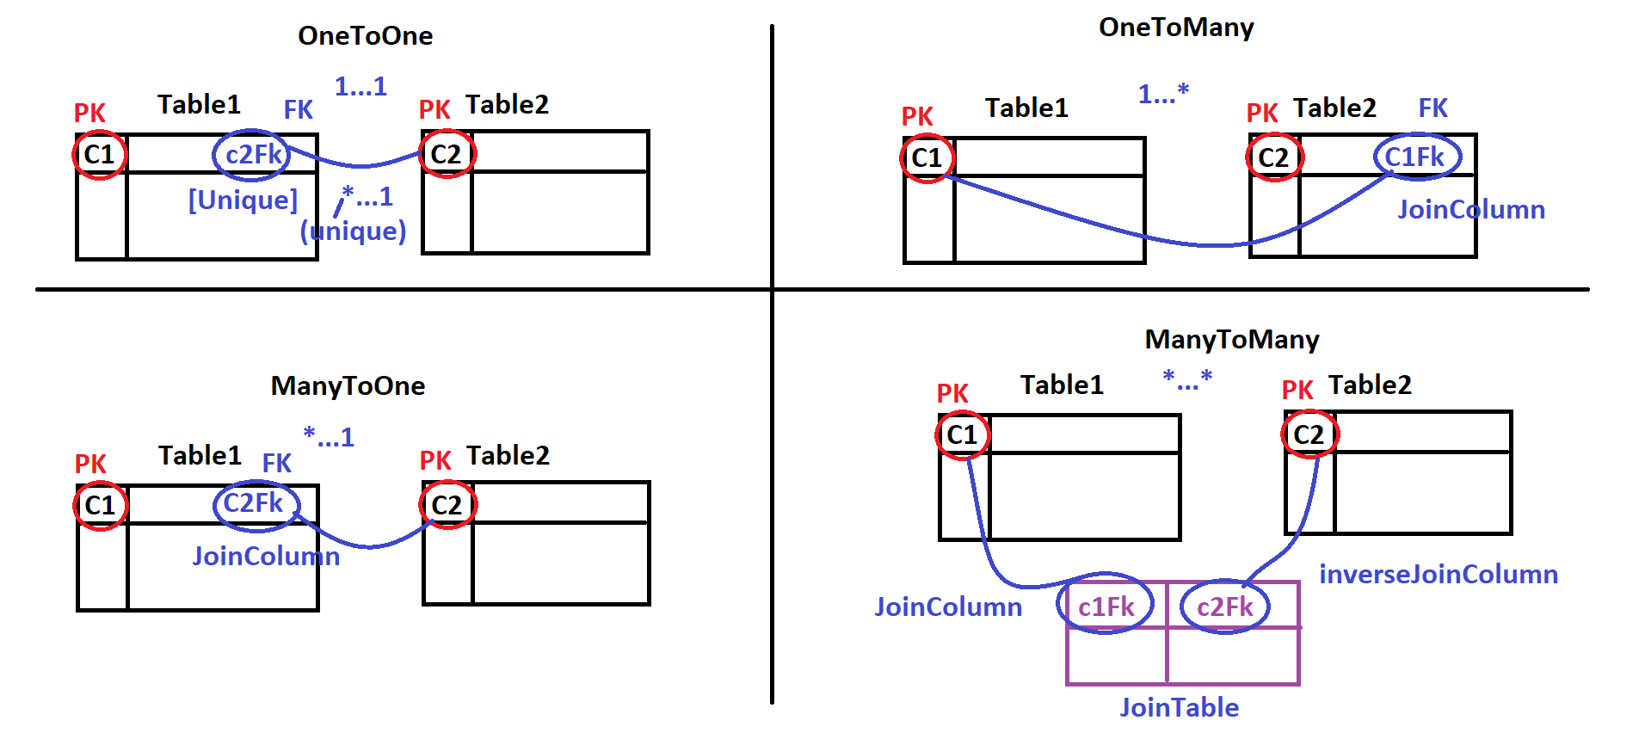

Multiplicity is divided into the two categories.
Collection Type → (When child is not single)
Non-Collection Type → (When child is Singleton)
********************************************************************************

Multiplicity Rules:-
- Define Two entity classes.
- Apply Has-A Relation. (Create a variable)
- Check for collection type. (If child is many)
- Apply multiplicity annotation
- if there is M**M create one extra table (Join Table/linked Table)
One to One Relationship
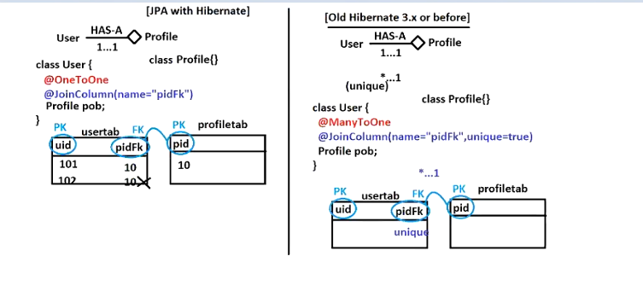

Many to Many Relationship
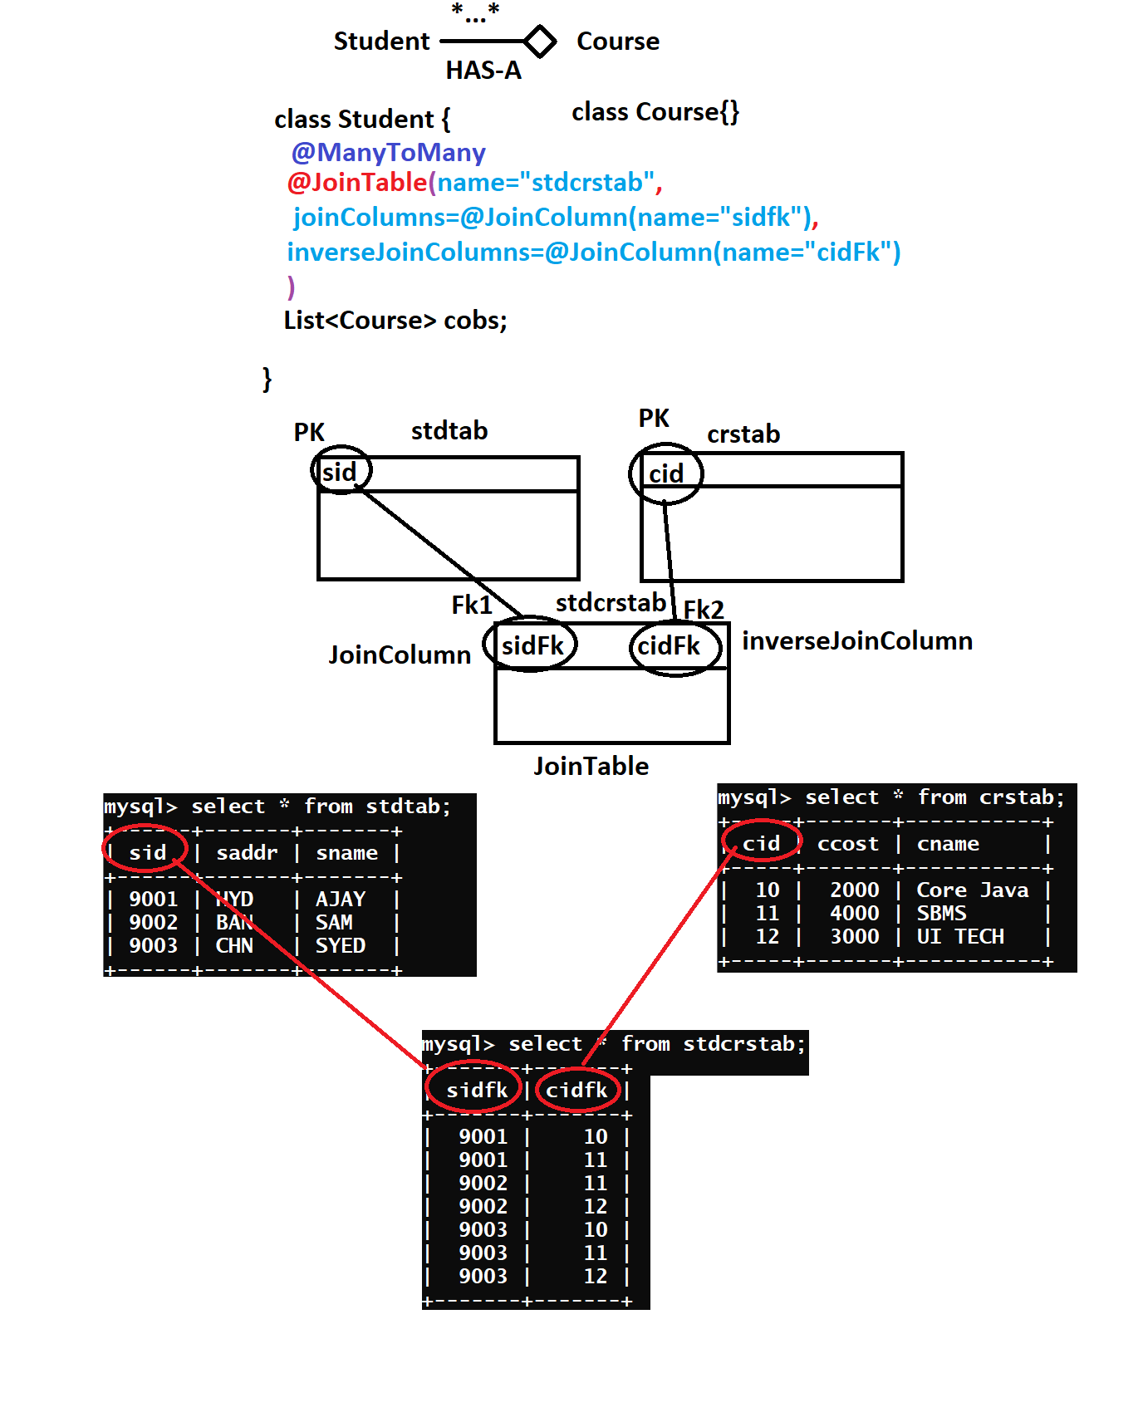

Passing parameters:- The input that we pass at runtime is called parameter.
There are two types of parameters
- positional SELECT... where eid=?1 or ename=?2 and esal=?3 [Method Parameter position]
- named (recommended when there are more parameters) SELECT ..where eid=:a or ename=:b and esal=:sal [Method Parameter name]
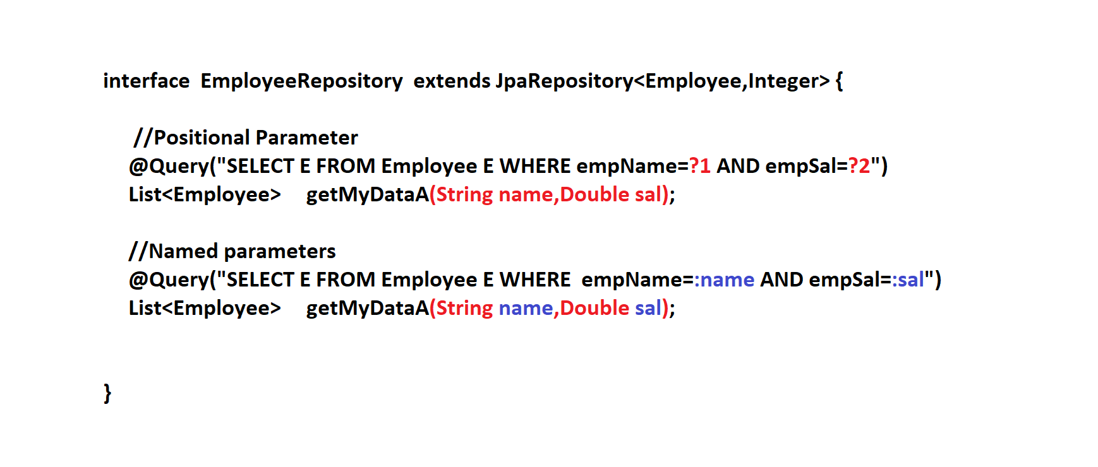

Use of @param in passing parameters
@Query("Select bookId from Book where author=:name")
List<String> fetchBookByAuthor(@Param(value = "name") String author);
we can use the @param if we want to use the different name in named parameter.

Data JPA Joins
SQL Joins:-
Joins are used to fetch the data from two/multiple tables.
** There are the following joins which are supported by data JPA.
- Inner join (Join) → Query will fetch the connected rows.
- Out Join (Of types 3)
|Left Outer Join → Left Join → All rows from left table and connected rows.
| Right Out Join → Right Join → All rows from right table and connected row.
| Full Outer Join → Full Join → All rows from both table (Connected & Non Connected)
Connected Rows | Non Connected Row
A row in parent table is connected with child table is called connected rows.

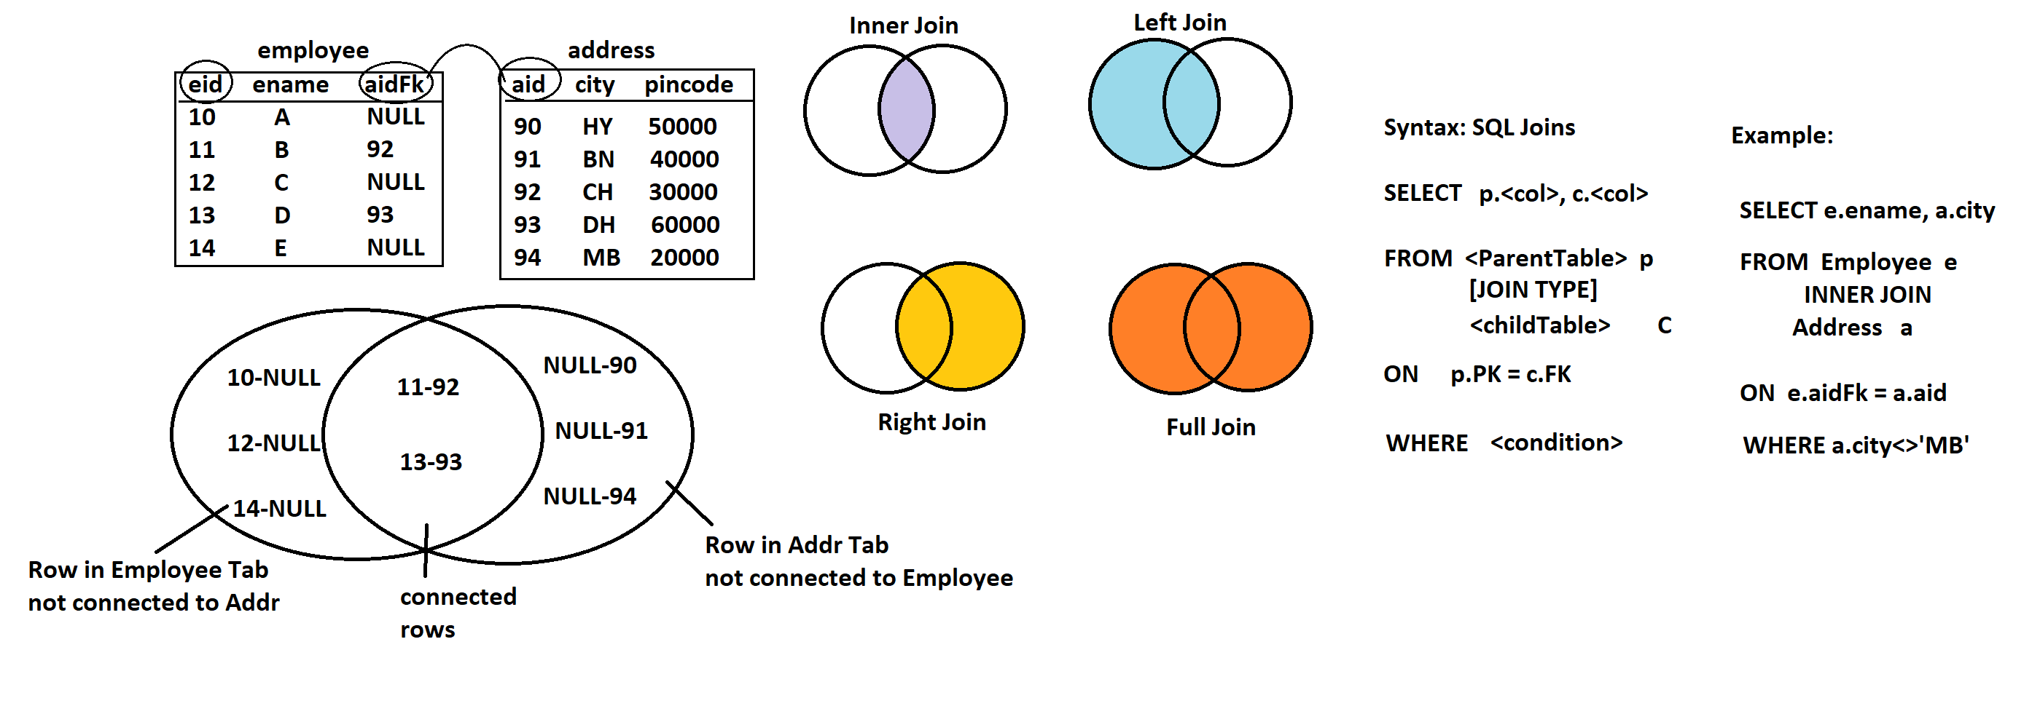
Syntax: - In JPQL(HQL) we use the child class reference. Though you write the JPQL HQL finally the dialect will convert into the database dependent joins query. The on condition will be added by dialect.
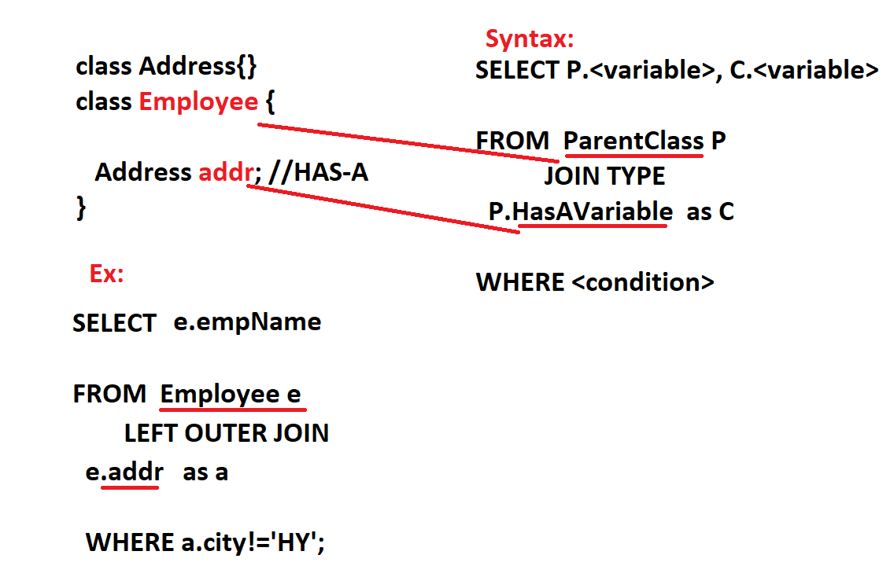

find By:-
- This is a new way of writing query. No Need to write manual JPQL/HQL or SQL query.
- Just define abstract method using "findBy" that generates SELECT SQL query at runtime
findByVaribalenameKeyword (Datatype variable) → default keyword will be Is or Equals. ** By keyword & variable recommended to be uppercase (Camel Case ). Variable name can be anything.
JPA uses the concept of DSL (Domain Specific language)
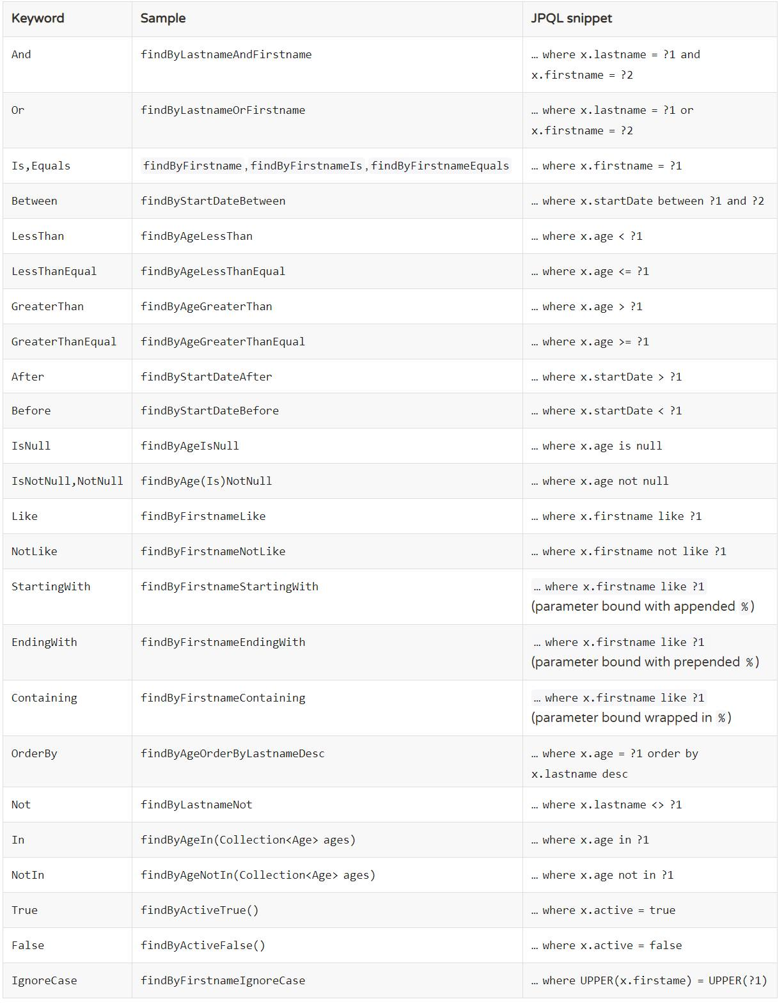

Complex data can be stored in as file in database. There are two types.
- BLOBS ((Binary large objects) PDF, WORD, Images)
- CLOBS ((Character large objects) Lengthy Objects, Notes….)
BLOB → @Lob byte[] (Byte array) use the annotation Definition=”BLOB” if exception occurs
CLOB → @Lob char[] (Character array) use the annotation Definition=”TEXT” if exception occurs
Now a days cloud buckets are used to store the lengthy data.. AWS..
Native Query

For this we have to use the native query we have to tell the dialect I’m giving you the pure SQL query, use the @Query(value=”Pure SQL Query”,nativeQuery=”True”).
** Native-Queries are faster in execution but Database dependent.

Custom Update and Delete

We can write our custom update and delete method for this we have to use the total 03 annotation.
By default @Query behaves like insert operation. WE DON’T HAVE CUSTOM INSERT.
- @Modeifying to ensure that its not simple insert (It is either for update Or Delete operation)
- @Transactional
- @Query
** If we miss anyone annotation it will through the exception.
What is transactional management:- All the changes should be commit or rollback, used for avoiding the data inconsistency. In JDBC we use autoCommit(false) → rollback→ commit
In Spring JPA we have to use one annotation @Tranasaction in Service layer.

Use of @Transactional annotation?
The @Transactional annotation in Spring, particularly in the context of Spring Data JPA, is used to define the scope of a database transaction. Transactions are used to ensure the consistency, isolation, and atomicity of multiple database operations. When a method annotated with @Transactional is invoked, Spring starts a transaction, and if the method completes without any exceptions, the transaction is committed. If an exception occurs, the transaction is rolled back.

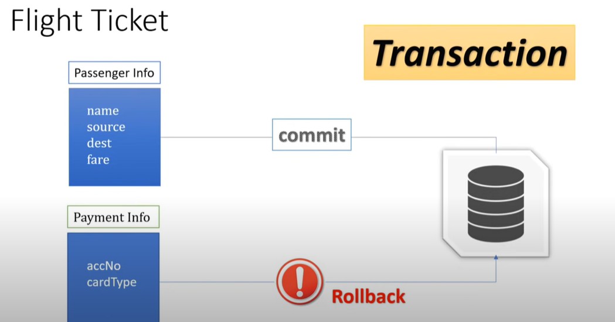
* Atomicity
* Integrity
* Roll back on runtime excep.

@Note:- If you’re dealing with transactional management always throw runtime expectation as it will discard the checked exception if occurred or create your own exception that must be extend the runtime
** If we want to the query in proper sql syantax we need to add the following property.
Spring.jpa.properties.hibernate.format_sql=true
@DyanamicUpdate | DyanamicInsert
@DynamicInsert annotation ensures that Hibernate uses only the given columns in the SQL statement that it generates for the create of an entity.
@DynamicUpdate annotation ensures that Hibernate uses only the modified columns in the SQL statement that it generates for the update of an entity.
The @JsonFormat annotation is part of the Jackson library, which is a popular JSON-processing library in Java. This annotation allows you to control the serialization and deserialization of date and time values when converting Java objects to JSON and vice versa.

What is Buffer?
When we execute the query it gets stored in area before committing the required changes to database this area is known as buffer.

Generators:-
Are used to generate by primary key. The generation type SEQUENCE may not be supported by some of the databases.

SEQUENCE | If DB supported then use the sequence to generate the Primary key. A sequence is data base object which is used to generate the series of unique number. (Oracle)
IDENTITY | AUTO-INCREMENT
TABLE | Storing the primary key as table. This strategy can be used in environments where other strategies are not feasible
AUTO | Choose one of the matching from list.

-----
What is data JPA?
JPA stands for java persistence api which is used to persist the data between the java objects and relation database. JPA does not perform any operation its self.
- Data JPA provides the ready made method for CRUD operations.
- It enables the database auditing with the minimal configuration.
- We can also write the custom query easily just providing the method signature. And its implementation will be provided by the proxy internally.
Question: Who the hibernate is different from Spring data jpa?
In hibernate if we want to persist the object we need to create the entityManagerFactory. Then from enitityMangerFacotry we need to creae the entity manager then we need to begin the transaction and after that we persist the entity to the database and close the object. But in spring data jap we just need to write the two entities 1 entity class 2. Interface the implementation will be provided by the proxy classes.

What is Spring MVC?
21-Feburary-2024
MVC: Design Pattern which is used to decoupling the view logic and processing logic separately by exchanging the data (Model)
M = Model (Data/Object holds data) – Your actual entity which you’re going to save in DB.
V = View (UI/HTML/JSP/JSF/Thyme-leaf..) [Display Result] – Whatever we want to show end-user.
C = Controller (Class) [Request Processing Logic]
Before this we used the JSP & Servlets for developing the web technology in which there is combine front and back-end code.
Model are the POJOS or data objects which are transferred between the controller and view.
View is the interface of our application which receives the data and present to the end user.
Controller are used to handle the incoming HTTP request which do the process of data and return the view.
Benefits:-
=> It is used to develop web application in standard.
=> By using this we can d-couple Request processing logic and Display code.
=> Before this we used Servlets and JSP in which there is lot of dependencies in this approach.
=> If we move from one UI to another UI there is no need to change the controller code.

What is data rendering? Replace the expression with data is called data rendering. Go to model search the key and replace the data.
A requests can be made using three ways.
- Using Links
- By entering the URL
- Submit Form.
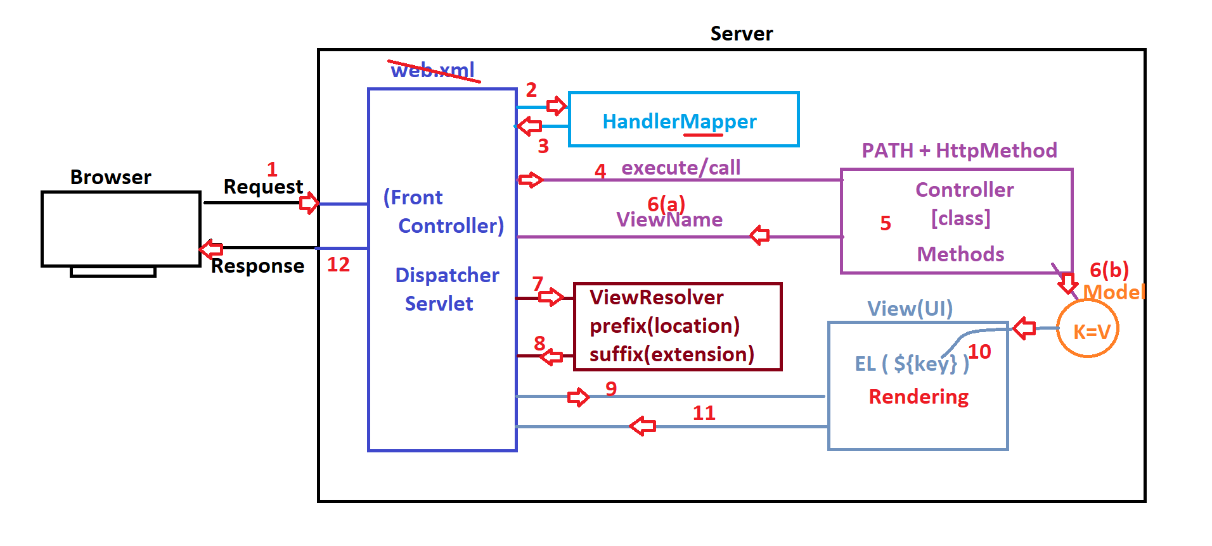

- DispatcherServlet is a pre-defined Servlet, given by Spring Web F/w. It is like Front Controller.
- Handler-mapper is MAP, contains Info "FOR WHICH REQUEST WHERE TO GO"
- FC will call/execute Controller#method which process the request and returns View Name (ex: Home, Login, Profile) without any extension and location details and also data if exist stored in Model (K=V)
- *) FC takes help of ViewResolver that gives File Location (prefix) and
- File extension (suffix) and finally returns View-Page.
ViewPage = prefix + viewName + suffix
= /mypages/ Home.jsp

- *) Finally View(UI) Page reads data from Model (if exist) using
- Expression Language (EL : ${key} ) [Data Rendering]
Code: Welcome to User ${user Name}
Ex: Welcome to User SAJID
- *) HTML output will be returned to FC and there to browser as Response.
- ) IN Spring F/w all components must be defined by Programmer, IN spring Boot, DispatcherServlet, ViewResolver and Handler Mapper are auto-configured. Only work on Model, View and Controller ***.
===========================HandlerMapper===========================
KEY VALUE
PATH + HttpMethod Controller#method
-------------------------------------------------------------------
/emp/save + POST EmployeeController#saveEmp()

- Spring Boot comes with the three embedded server (Apache Tomcat* Default *, JBOSS Undertow, Eclipse Jetty) with default port 8080.
- To work with JSP View, we need to add: Tomcat-Embedded-JASPER. For JSP we have to manually add the dependency and in case of Servlets the Catalina comes as default with tomcat that’s why we don’t need to add this dependency.
- Package Format must be.war (Web Archive). But we can even choose .jar or .war If we choose "Embedded Server". For any UI technology we have to add equivalent dependency.
** We have to define the ** Controller, ** View Pages, ** Properties File.

How tomcat works..

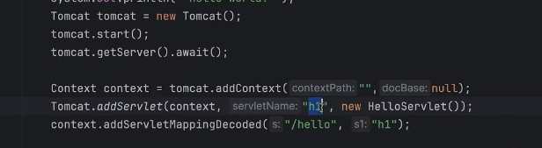

Whenever we used the external tomcat we have to use the @webservlet annotation. Our tomcat can only run the servlet that’s why the JSP page gets converted into the servlet..

Why we need Model?
Model is used to sharing the data from controller to UI.
To work with MVC we need to create the following folder structure
Create Folder System as

|-src
|- main
|- webapp
|- WEB-INF
|- mypages
Difference b/w GET and Post?
GET: Fetch Resource from server to client.
POST: Send/create new Resource from client to server.
URL: The url is case sensitive.
Exchange data in between client and (Controller) server.
Three is three ways to send data between view and controller.
- Model → is used to send the data from controller to view. Its scope is request scope. In case of object use the variable name for specific value. I.e (employee.id)
- Form/@Model Attribute→ is used to send data from view to controller using request body.
- RequestParam → is used to send data from view to controller using URL.
We can use the expression language to read the data at UI level.
@Note: Model internally uses the map to store the data . (key: String,Value: Collection)
Once response given to the UI will be cleared (Store data until response)

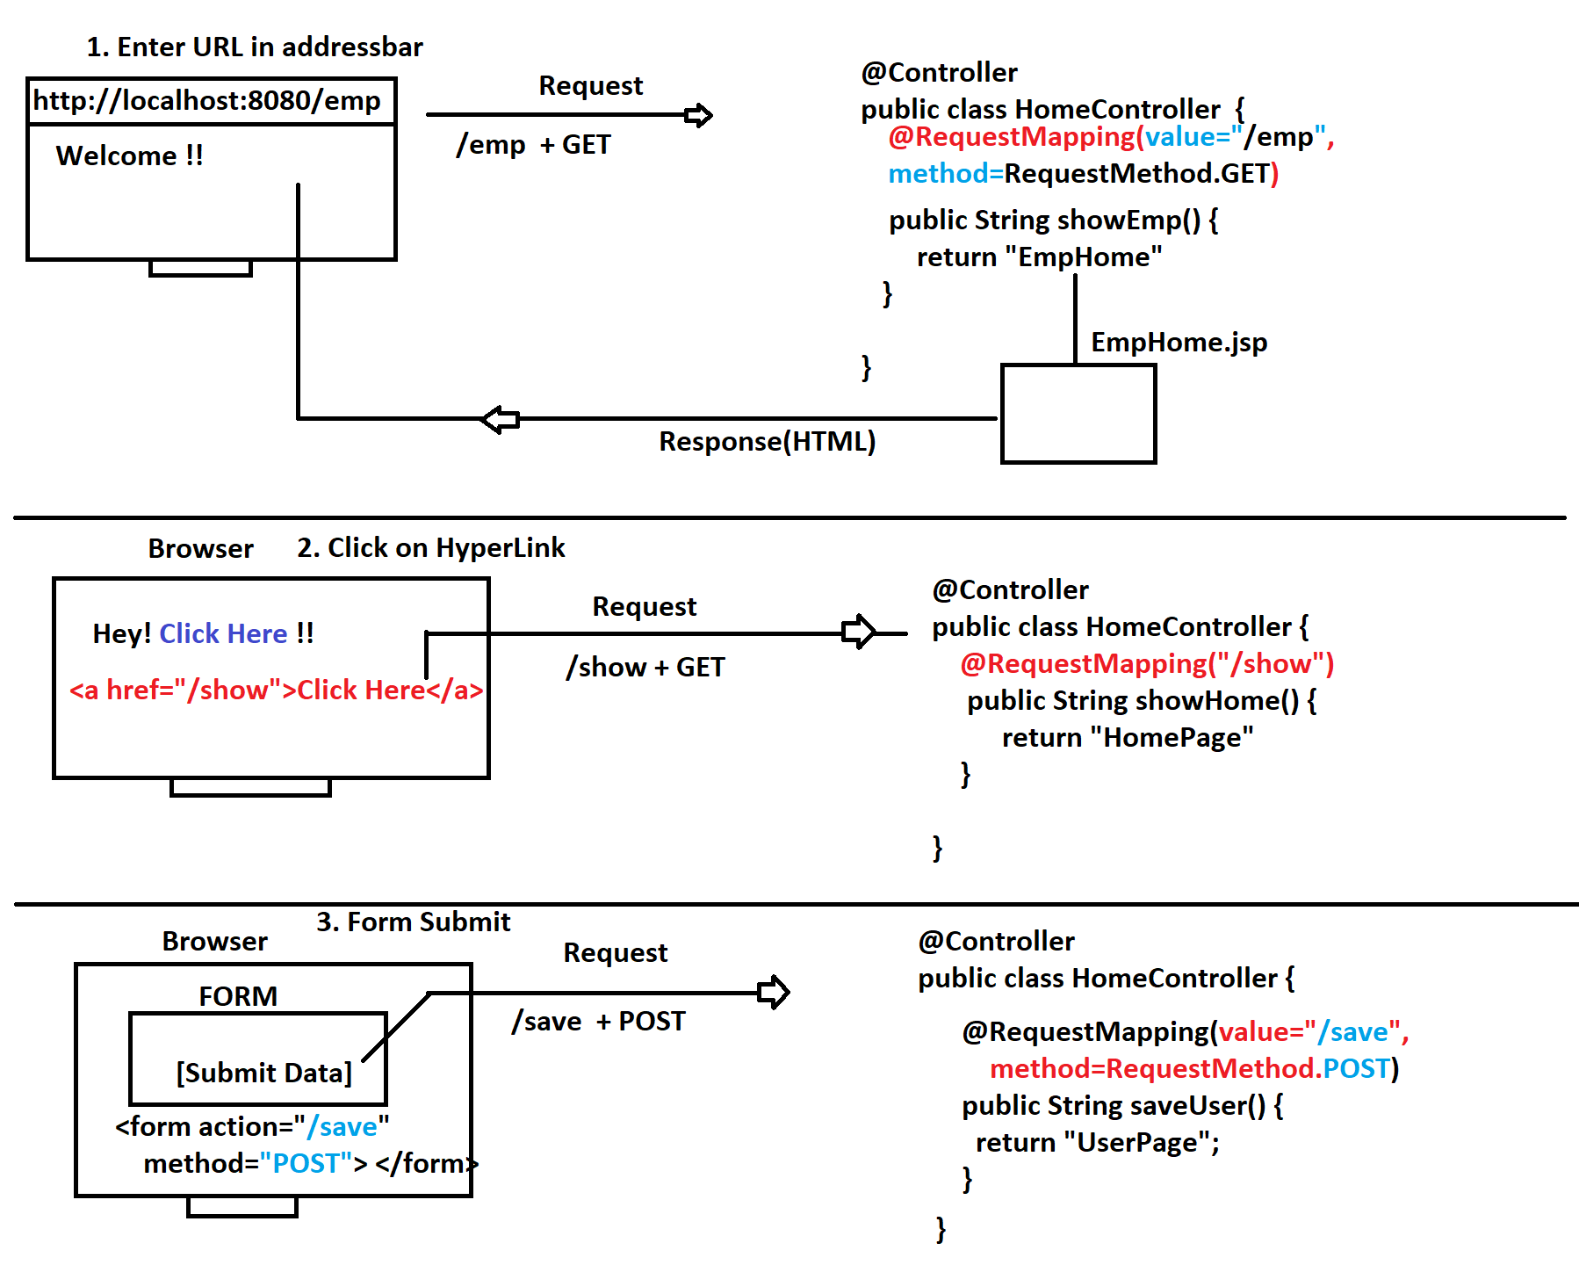
***************************** ! Why we need tomcat JSPER ! ************************

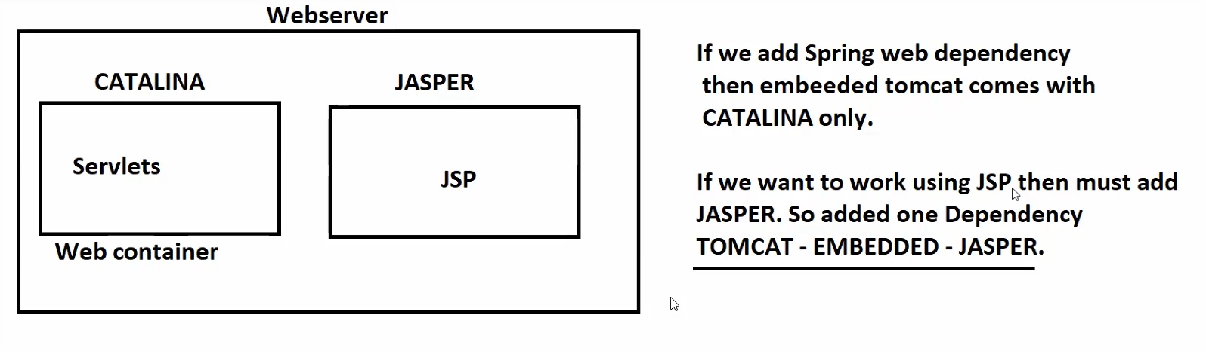

Use of EL:
${key} for full object we can extract the specific value using ${key.classVaribleName}
Model Attribute:- [Form Object]
To collect end-user data, we use HTML Forms (Collection of Inputs)
Register Form, Login Form, Equerry Form, Payment Form, Feedback Form..etc
Spring container convert the one form into the one form object (Java Class camelCaseRule).
There will be three steps:-
- Read parameters
- Parse if required
- Set the value.
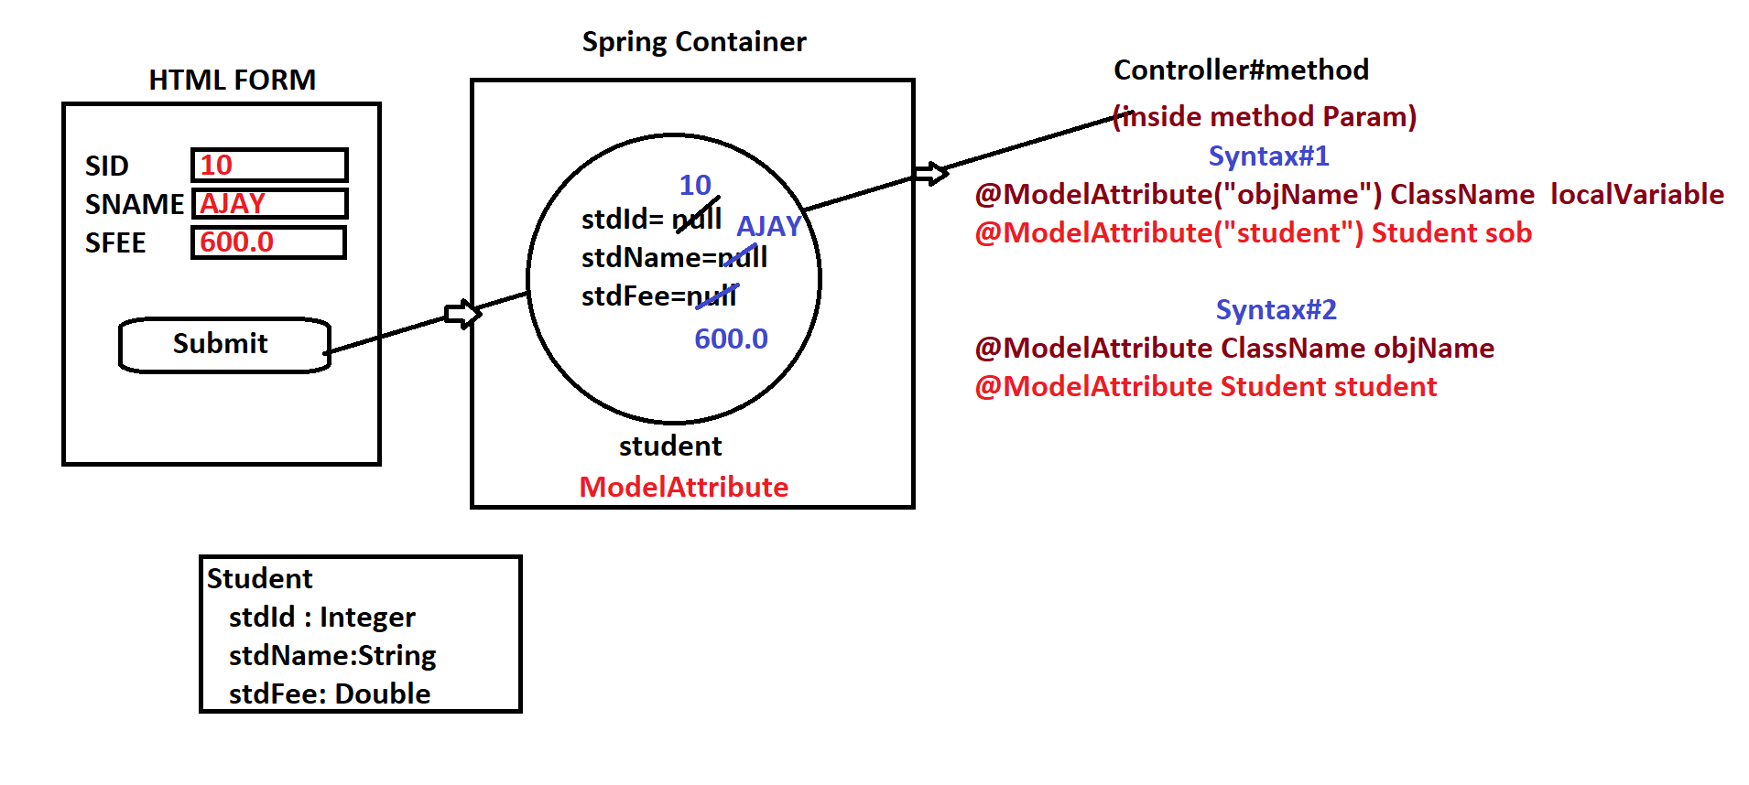
Programmer need to define one Model/Bean class
→ 1 Form = 1 class
→ 1 Input = 1 variable with set/get
→ Input Name === variableName

Request Parameter:
This annotation can be used if we want to pass the data via URL.
Passing input to Controller#methods (application) to execute a task.
*) Form Data is stored at application, but parameters are not recomanded.
*) Parameters are for input to process.
*) By default all the parameters are mandatory. We can make it optional and also can set the default value.
@Note: No need to follow the order while sending the parameters.

In Servelets | In Spring MVC
Request.getParameter(“eid”);  Integer.parseInt(“eid”) | @RequestParameter DataType varible  To read we have to pass in method parameter.

What is Redirect.
Dispatch (Moving) from one controller method to another controller method in the same request is called redirect. For example after student registration we want to send an email...
Syntax: redirect: controllerPath(URL) i.e redirect:all

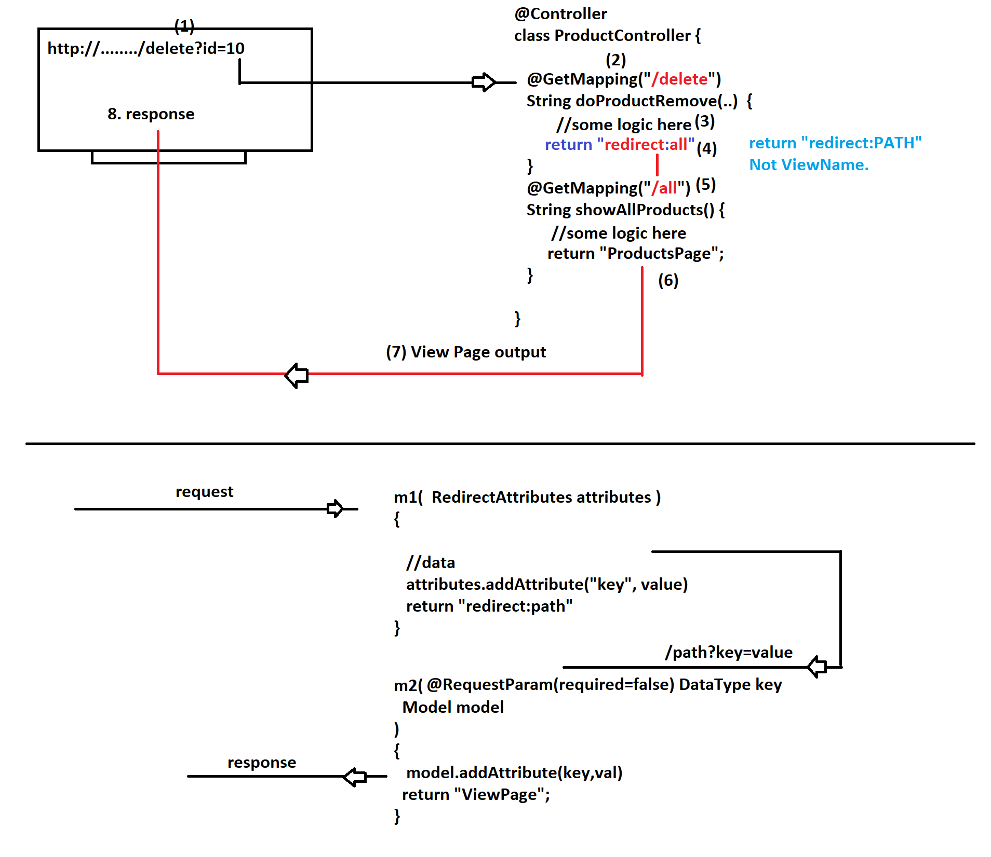

Model VS RedirectAttaributes
Model: To send data from Controller#mehod to View Page RedirectAttribute: TO send data from Controller#method to another #method while redirect.

Suppose w want to send some data from one controller to another controller for this we have to use the @RedicrectAttaribute annotation. But read them as OPTIONAL because they may or may not come. Some time we can call the redirected method it will show the error because the attributes are by default are mandatory.

Thymeleaf

*) It is HTML based Java UI Technology.
*) It is a light weight UI concept.
-> No internal conversions like JSP
-> File format is pure HTML with Dynamic Tags
-> Only Dynamic Tags are converted into Java Code
-> Easy to define files
-> Supports all concepts like
Dynamic Form, Links (CSS/JS/Images), all HTML concepts...etc

-> Spring Intgeration supports default prefix (templates folder)
and default suffix .html by adding dependency "Thymeleaf"

-> We need to link with Thymeleaf NameSpace server at HTML tag level
xmlns:th="https://www.thymeleaf.org/"

-> We can use [[]] to print data at WebPage or use th:text=""
-> We need to use '@' symbol to indicate PATH/URL?localtion
ex: @{/employee/save}
@{/css/mydata.css}

To work with the thymleaf we have to add a dependency in pom.xml.
For this we have to use the thyme-leaf sever path. xmlns:th="https://www.thymeleaf.org/"
The tag information is defined in this name-space server.

Some important points about thyme-leaf are:
1. Symbol $ indicates Model Memory (read data from Model)
2. Symbol @ indicates location/PATH/URL/Address
3. Symbol * indicates Link/Point to Form Input for Bi-directional.

Bi-directional form submission typically refers to a scenario where data is displayed in a form for editing, and upon submission, the edited data is sent back to the server for processing

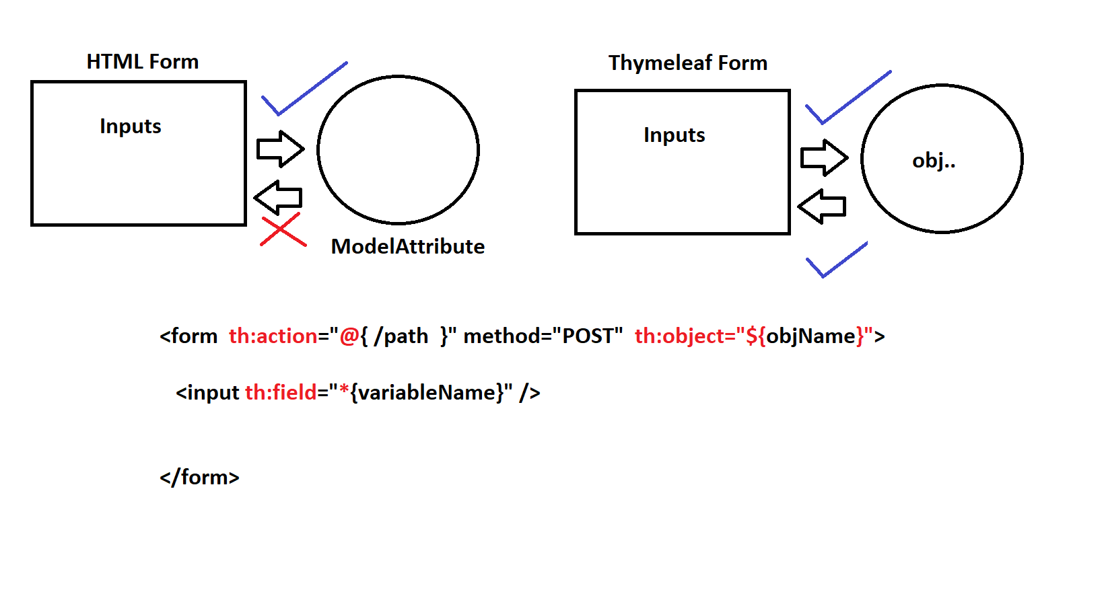

A complete Crud Application

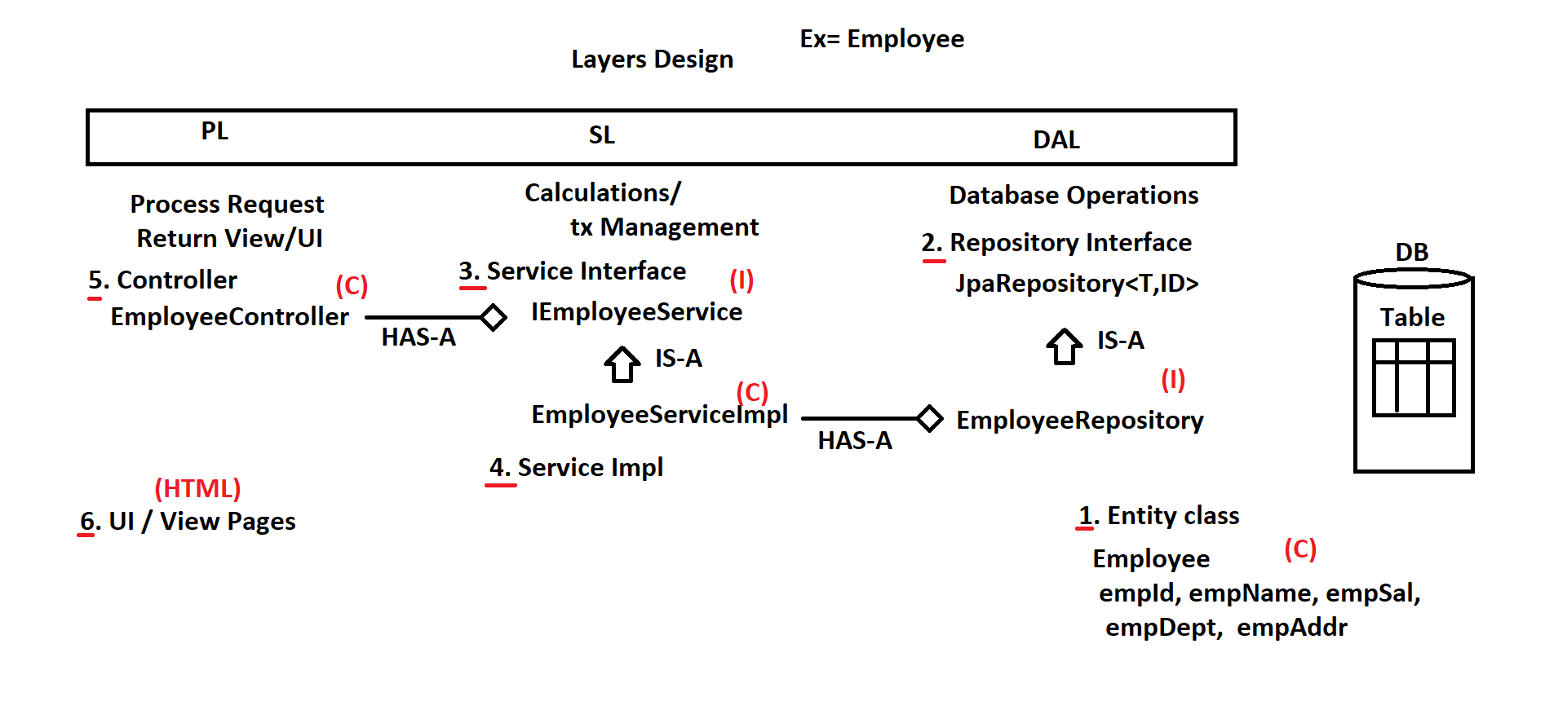

What is data base auditing?
It is detection of actions performed by the user. Spring provide the callBackListener. We have to enable it for detection. For example just like we have the SVN. For this we have to create the separate class that have the object for which detection is required. Use as generics for re-use.
@EntityListeners(value=AuditingEntityListener)
@JsonProperty(value = "userId",required = true)
@JsonIgnoreProperties(ignoreUnknown = true)
@EnableJpaAuditing()
Web Services:
We can develop standalone application using Spring MVC. But we have to integrate the application’s in real time. (Web returns page what if we need only data)
Linking two or more application using HTTP protocol using global format (every language can understand) by using the integration layer. (IL layer) which will be linked with SL (Service layer)
There are two types of global format 1) XML 2) JSON (which is faster)
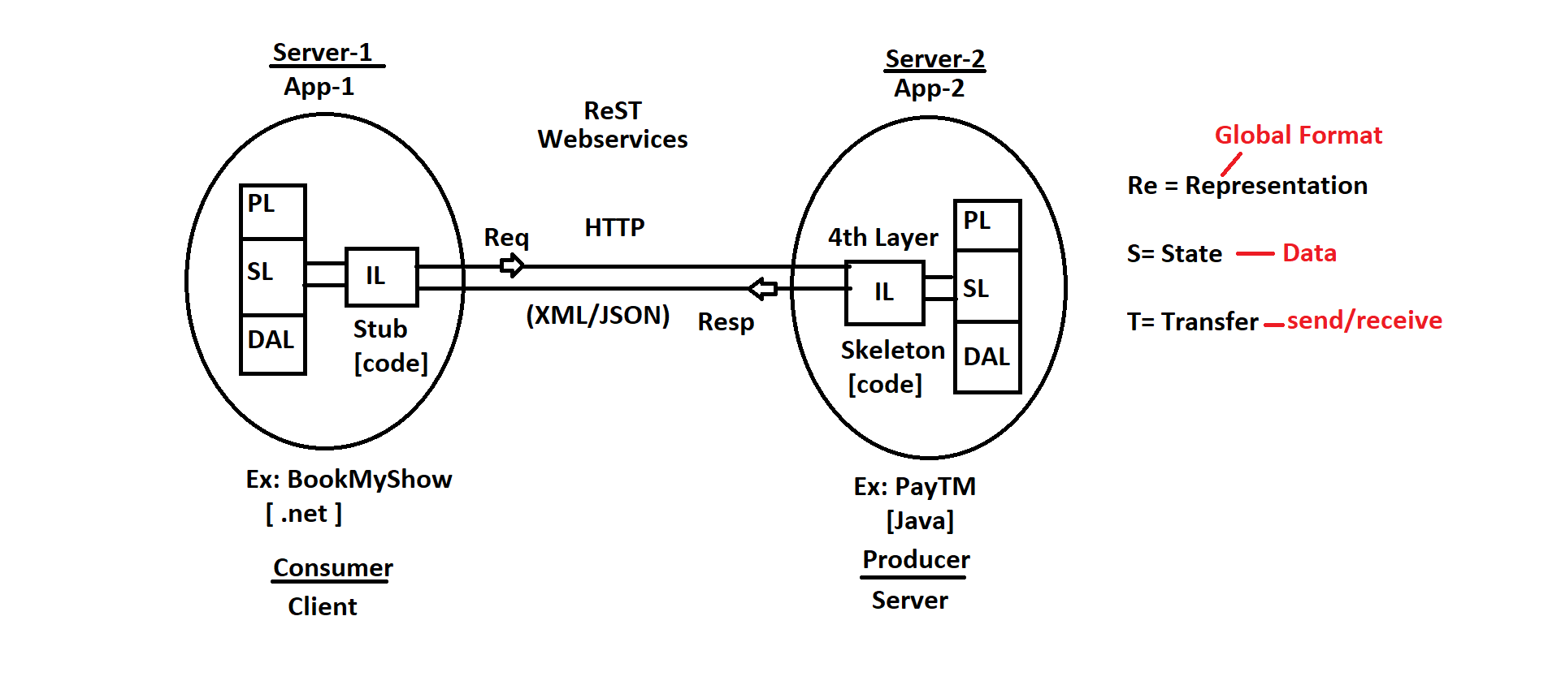

One application is called Consumer(Client) which uses the services and other is called Producer(Server) @Note: Don’t get confused both applications are running at server side
Consumer is called Stub and producer is called Skeleton.
Rest API :- Exchange of data using the HTTP protocol and the global data format using the client server architecture is called rest/rest-full API.
How data conversion take place.
In XML we have JXAB in which marshaling and UN-mershelling.
In JSON (JACKSON API) we have serializing and de-serilizing
HTTP protocol is which used to connect the application running on two different server.
Q) Can we use POST for Partial update? or to fetch data?
A) YES. But not recommended. Both Producer and Consumer should follow HTTP Standards.
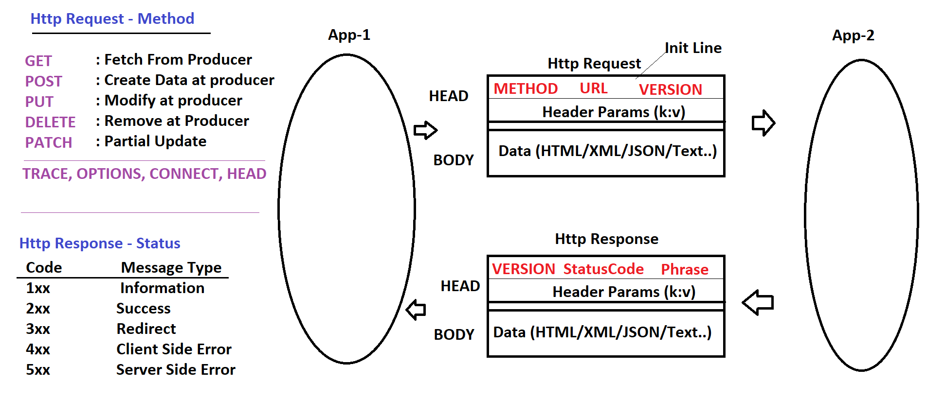

Stub is which makes the HTTP request and Skeleton is which process the request and gives response.
Stub → RestTemplate Skeleton → @RestController
Web Service Architecture
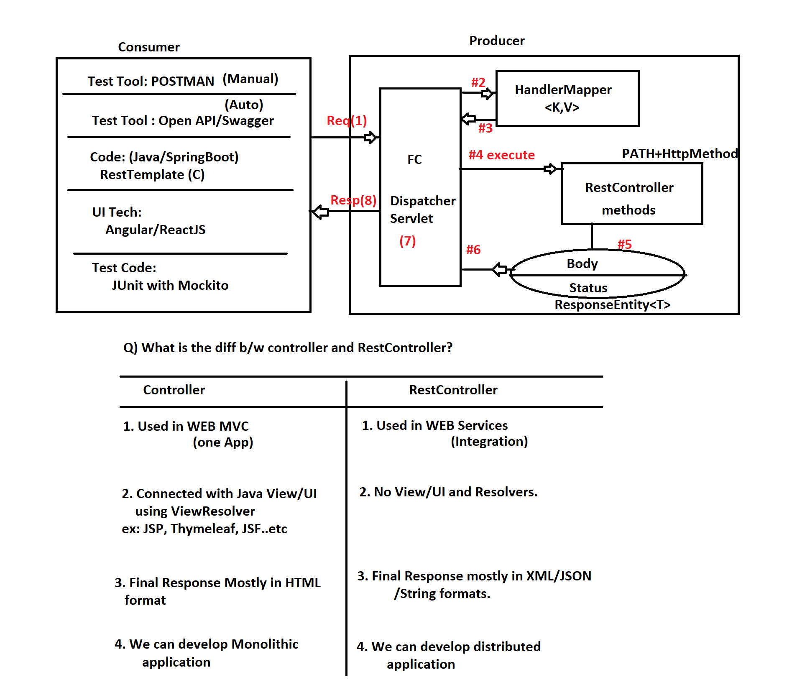

In Spring Framework, the @Controller and @RestController annotations are used to define controller classes that handle HTTP requests.

Some Important information about rest-full API’s .
RestController → @Controller + ResponseBody
- Client → XML/JSON→ Http Request Data → @RequestBody Object → Input
- Output Object → @ResponseBody → XML/JSON → Http Response Data → Client
- We have major two things HTTP method and URL for which java has a java-method.
- We have to use the same web dependency based on annotation it will decide.
- @Nullable is a indication annotation to Programmer saying that value can be null also. You will not get any NullPointerException
- ResponseEntity<T> contains 3 things mainly
Response Body (can be null),
Response Headers (can be null)
and HttpStatus (must be given) which is enum.
- JACKSON API : Open Source Java API used to convert Object to JSON and JSON to Object.
- When we add Spring Web Dependency by default this is also added into project.
- Content type tells the producer application that i have some JSON or XML data.
If the method param is non-string then use the @RequestBody.
If we want to work with XML we have to add JACKSON-DataFormat dependency and pass the header param accept:application/XML (Hey! Server give me data as XML).This the only when you have to get response as XML. Will receive 406 if dependency is missing.
- Q) What is the diff b/w 406 and 415 Error codes?
A) 415 - Unsupported Media-Type. If Request Body contains XML and Unable to Convert to Object format then This error code occurs. 406 - Not Acceptable. If Requested for "XML Response"(Response Body Expecting XML) But unable to convert then This error code occurs.
Media Type Annotations.
@RequestBody (Request Method Param)
@ResponseObject only for Object not for primitive.

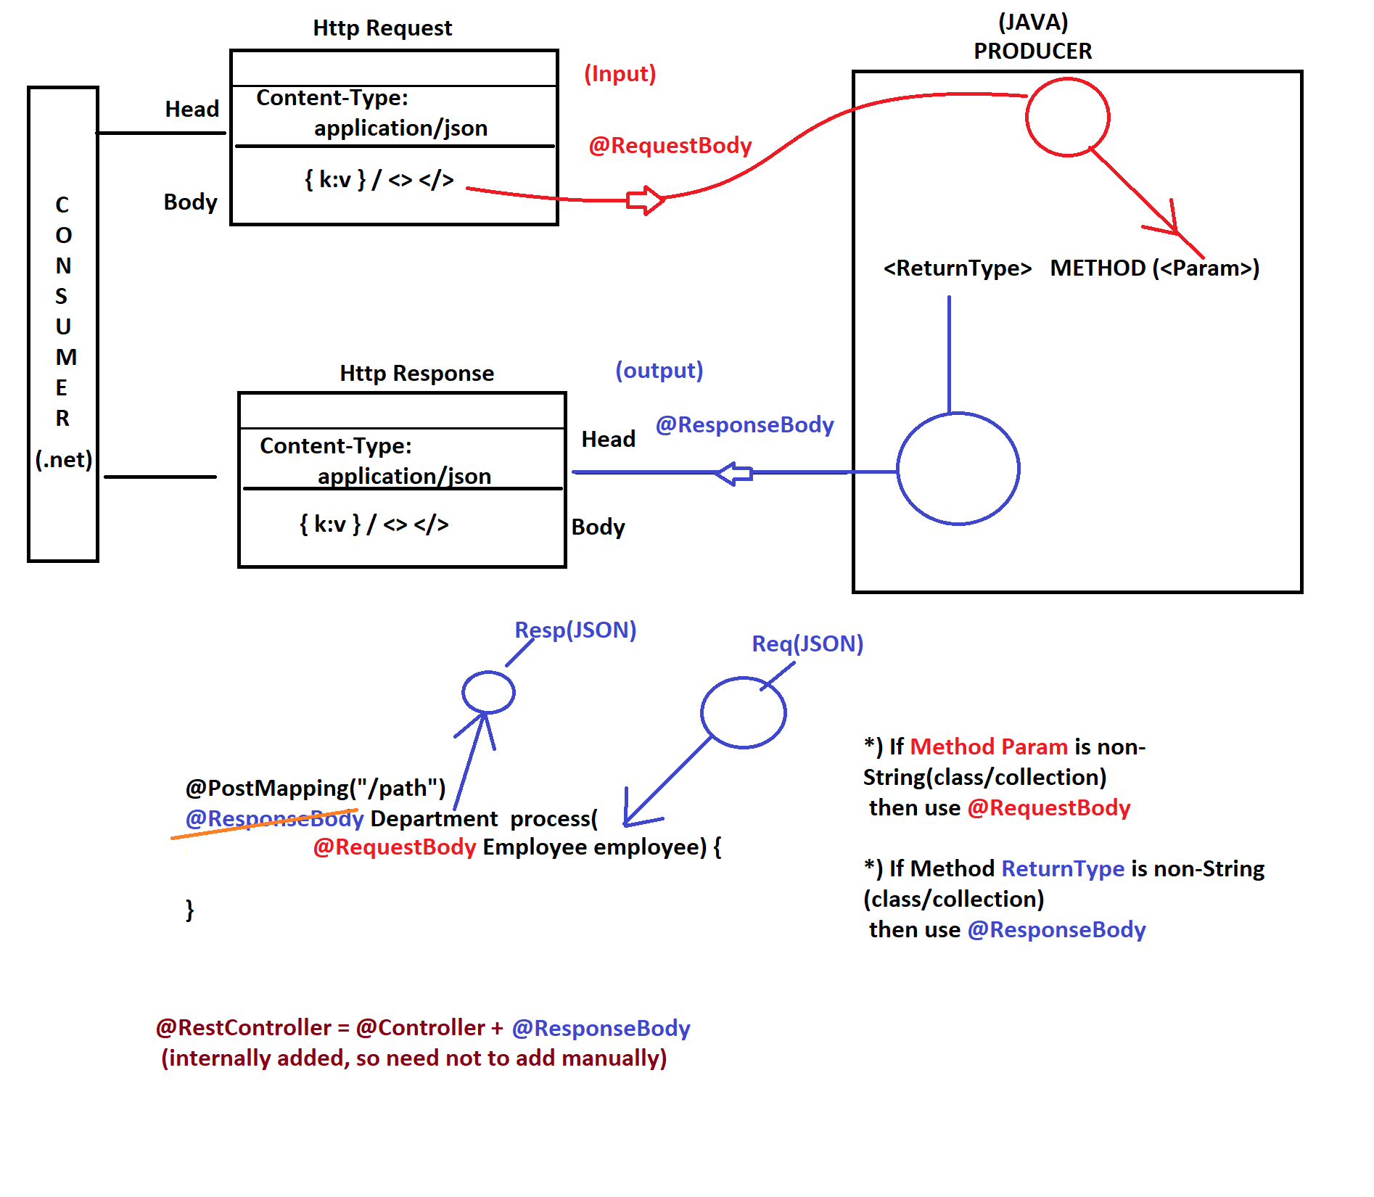

--Annotations used in Spring Boot ReST Producer--------
- @RestController
- @RequestMapping("/path")
- @GetMapping("/path")
- @PostMapping("/path")
- @PutMapping("/path")
- @DeleteMapping("/path")
- @PatchMapping("/path")
- @PathVariable
- @RequestHeader
- @RequestBody
- @ResponseBody (The spring framework by default uses the JACKSON Api for JSON. For xml we have to use the jackson xml for xml.
@Note we can restrict the spring framework the he can only uses / consumes the json/xml for this we to use the two annotations attributes. Produces,consumes
Why we need swagger?
Swagger allows us to describe the structure of our api’s to the end user.( Mainly front team)
We have to provide the swagger document which says what is the URL, method and parameters, what is the input and output but not the internal logic. We have one time configuration for this some. abstraction information.
We have two documentation tool. 1) Swagger Dependency (Swagger fox, Swagger-ui) 2) Open API
Some important points about the swagger.
@Apiignore which is used to discard the controller method to be shown on docket.
@ApiOperation which is used to set the description on the docket screen.
ApiInfo to change the description of the docket screen .
spring.mvc.pathmatch.matching-strategy=ANT_PATH_MATCHER
How to configure?
- Create one configuration class
- create the docket object docket→select→api(controller_path)→path(common_Api_path)→build →apiInfo(if need to change)
@Bean
public Docket configureDocket() {
return new Docket(DocumentationType.SWAGGER_2)
.select()
.apis(RequestHandlerSelectors.basePackage("com.app.raghu.rest"))
.paths(PathSelectors.regex("/v1/api.*"))
.build()
apiInfo(apiInfo()); }
Open API: (Swagger 3.0)
For this we have to add only open-api dependency. It has inbuilt mechanism which will hunt the class which are annotated with @RestController and make the part of docket screen. By using the component scan. We can change the description of the docket screen using one annotation called.
@OpenApiDefination and some important annotations are @operation @ApiResponse
How to configure?
- Need to add the open api dependency
- hit the following URL (htpp://localhost:9090/swagger-ui/index.html
Q) What are possible ReturnTypes for RestController method?
A) We can provide Return Types like:
-> A Direct Type: String, ClassType, CollectionType
-> ResponseEntity with Type: ResponseEntity<String>, ResponseEntity<ClassType>, ResponseEntity<CollectionType> -> Runtime DataType : ResponseEntity<?>
*) If We use ResponseEntity then we can decide HttpStatus and Body
with our custom header params.
If we just return a Direct Type that indicates only Response Body.

What is Hibernate Validation API.
Hibernate Validator API:-
*) JPA with Hibernate has provided Validation annotation APIwhich is integrated with Spring boot even. (Bcoz Entity class is from JPA with Hibernate.)

*) or add Validation using Spring Starter.

<dependency>
<groupId>org.springframework.boot</groupId>
<artifactId>spring-boot-starter-validation</artifactId>
</dependency>

VALIDATIONS:
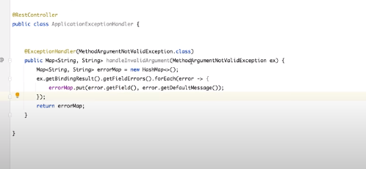

===For Any Type===================
@NotNull(message="Employee name must not be null")

==For String type===================
@Size(min=3,max=6,message="Employee Name must be in 3-6 chars")

@Pattern(regexp="SAT[A-Z]*")

=========Number type========================
@Min(value=3,message="EmpSal minimum nuber is 3")
@Max(4)

===Boolean type===========
@AssertTrue
private boolean isEnabled;
@AssertFalse
private boolean isFinished;

===Date Type==========
@Past
@NotNull
private Date date1;
@Future
private Date date2;

What is wildcard?
Type decider at runtime. Based on execution flow.
Hibernate validator api is used to add some constraint over the fields. For this we have to add validator starter. Annotation used @valid

How to handle the exceptions

Global Exception handler
define one class
@RestControllerAdvice // this annotation shows when ever there is any exception in the controller please come here.

=====================================================================
Custom Exception handler

*) We can define one class annotated with @RestControllerAdvice
when any exception is occured in application while processing
request by RestController and did not handled or re-thrown
then here Exception type is matched with @ExceptionHandler. And in the catch block of the controller we have to re throw the exception.

Finaly Response is given back to FC.

*) Bean class
package com.app.raghu.bean;

import lombok.AllArgsConstructor;
import lombok.Data;
import lombok.NoArgsConstructor;

@Data
@NoArgsConstructor
@AllArgsConstructor
public class ErrorMessage {
private String message;
private String module;
private String code;
private String date;
}
*) RestControllerAdvice
@RestControllerAdvice
public class CustomExceptionHandler {
@ExceptionHandler(StudentNotFoundException.class)
public ResponseEntity<String> showStudentNotFound(
StudentNotFoundException snfe)
{
return new ResponseEntity<String>(snfe.getMessage(), HttpStatus.INTERNAL_SERVER_ERROR);}*/
@ExceptionHandler(StudentNotFoundException.class)
public ResponseEntity<ErrorMessage> showStudentNotFound( StudentNotFoundException snfe) {return new ResponseEntity<ErrorMessage>(new ErrorMessage(snfe.getMessage(), STUDENT", "NOT FOUND", new Date().toString()HttpStatus.INTERNAL_SERVER_ERROR); }}

Spring Boot actuators:
Spring boot actuator is used to monitor at different level.

Consumer Application using Spring Boot Rest

RestTemplate:- it is a pre-defined class given by Spring REST that is used to make HTTP calls (request) and get response into ResponseEntity, String, ClassType, Collection. Methods are available for making the HTTP method. Exchange method is a universal method available to make. But it is recommended for PUT and DELETE only.
How to implement the service to consume the service.
- Create the rest template object (Using the java based configuration)
- Provide the URL.
- Create the request header (Body+Header)
- Make a call and get the response.
@Note:- For request param we have to us the map and url will be like that (Base_URL\\ ?courseid=2)
and for the path variable we have to use like that. Base_URL/2

Connection Pooling
These are the temporary between the server and databases.
Pool is the similar class type objects. Group of connection objects used between the sever and the database, in case of multiple Query request are by the server. Then create the pool of connection while starting the server. With details like minimum connection, idea connection, timeout.

Example Appache Data base Connection Pooling (DBCP) , Tomcat Connection Pool. Hikiri ** (which is much faster). Connection pool will never execute the query it transfer the query to the database.
*** Based on the Java version there are different dependencies.
** Previously tomcat is being used.
** Hikcari is the class
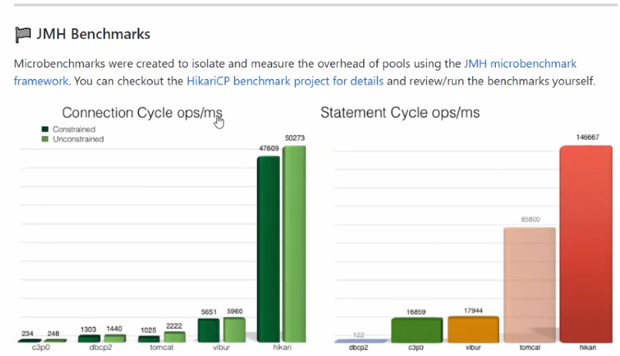

Spring Cache
We need to enable the caching using the @EnableCache and @cacheable(cachename=”name”)
By default the spring boot uses the ConcurrentHashMap as a cache mechanism.
CachePut: to inform the cache to do the needful before saving. While create and update the item.
cache(key=”#cahceName.key”)
cacheConfig is used to define the cache as globaly. Then after that we no need to define again and again.
cahceEvict(key=”#id”) need to remove the cached data.
Connection Pool and cache concept in Spring boot:-
Pool and cache exist at server side both or used to reduce some burden. Pool has connection reduces the connection formation time and cahce reduces the round trip to the database.
1. Pool : Group of same class Type objects.
Ex: String Constant Pool: All String Objects only.
Employee Pool: Employee Objects
Connection Pool: All Connection Objects
String Constant Pool: All String Objects.
2. Cache : Group of same/different class type objects.
Ex: Employee objs + product objs ..etc
Connection Pool:-
Group of Connection Objects used between server and database. in case of multiple Query request are made by server with one connection it will be very slow in execution (you may get timout message) Then create One Pool of Connections while starting server. With details like Min connection, ideal connections, timeout,..etc
Spring Boot uses HikariCP as the default connection pool, due to its remarkable performance and enterprise-ready features
@Note:- We don’t have to configure anything for this. HikariConfig class is used to define the configuration for the connection pool.
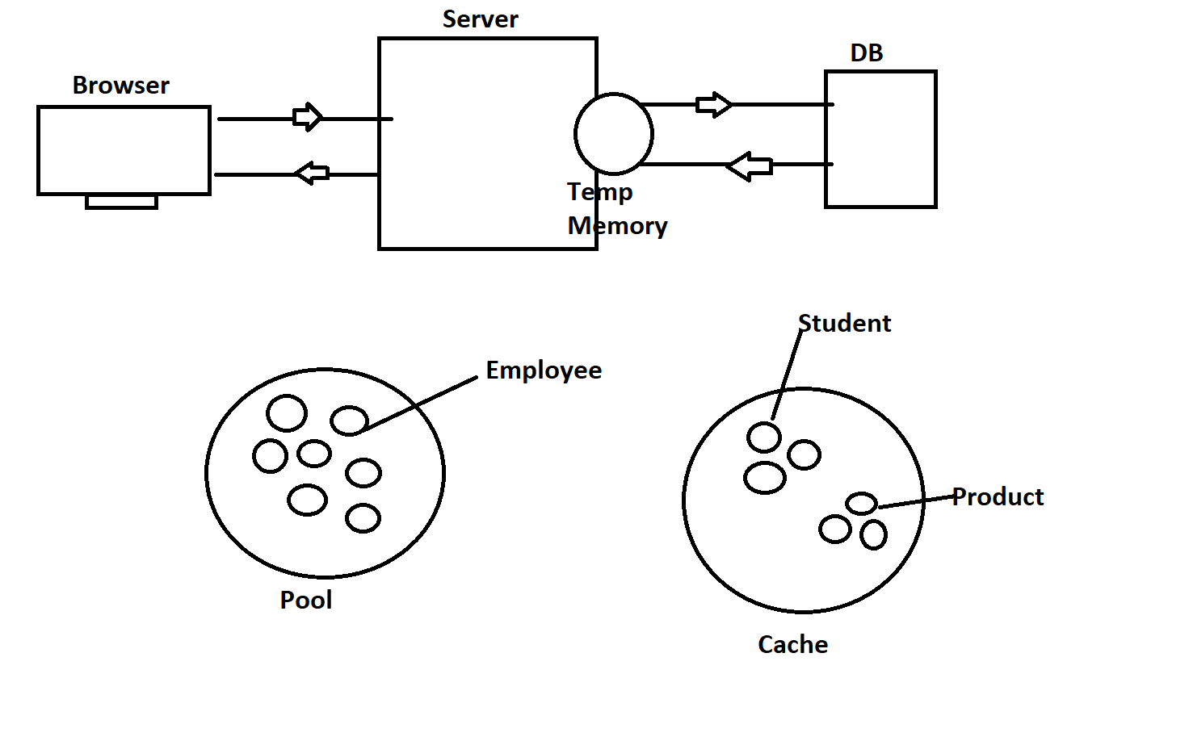

Spring Boot Security
Spring boot security provides the highly customized authentication and access control framework. And many developers prefer to use the existing solutions rather than re-inventing the wheel.
Spring Security is also know as JAAS: Java Authentication and Authorization Service.
In simple is a way of Implementing Login and Logout concept for our application.
Authentication: Validating User login details (username, password)
1. InMemoryAuthentication --> Store user details at RAM (temp)
2. JdbcAuthentication --> Store user details at Database
Ex: Works based on SQLs internally.
3. Custom UserDetailsService --> Store user details at Database
Ex: Uses ORM concept (Data JPA) internally.
Authorization: Validate User role(Authority) to access any resource (PATH)
1. permitAll : Url/path can be accessed by every one (No Security required)
ex: /welcome, /index, /contactUs, /aboutUs ..etc
2. authenticated : Url/path can be accessed by Login Users (can have any role)
ex: /myProfile, /settings, /logout ..etc
3. hasAuthority : Url/path can be accessed by Login User with Matching Role
ex: SAM (ADMIN) -> /viewEmployees
AJAY (CUSTOMER) -> /viewContracts

*) Authorization/Authority says who can do what.
Ex:
in Bank Application
SAM --> Manager --> Approve Loan -> /approveLoan
AJAY --> Customer --> View His Balance -> /showBal
..etc
==Example============================================================
*) /findBranch --> Everyone can use this service (no Security required)

.antMatchers("/findBranch").permitAll()

*) /login -> Everyone can access login (no Security required)

.antMatchers("/login").permitAll()

*) /profile -> User can access only after login (Login first)

.antMatchers("/profile").authenticated()

*) /changePwd -> User can access only after login (no role required)

.antMatchers("/changePwd").authenticated()

*) /applyLeave --> After Login with Role EMPLOYEE
/approveLeave -> After Login with Role MANAGER

.antMatchers("/applyLeave").hasAuthority("EMPLOYEE")
.antMatchers("/approveLeave").hasAuthority("MANAGER")

Even Manager can apply for leave on behalf of Employee
.antMatchers("/applyLeave").hasAnyAuthority("EMPLOYEE", "MANAGER")

*) 10 URLs, in that 4 are configured using antMatchers,
remaining (196 URLs) can be indicated using

.antMatchers("/showA","/find").permitAll()
.antMatchers("/viewData","/info").hasAuthority("MANAGER") instead we can use theanyRequest()

.anyRequest().authenticated()
******************
Ref Website: https://spring.io/guides/gs/securing-web/
Security Implementation Steps:
1. Add Dependency : Spring Security, thymeleaf-extras-springsecurity5
2. Define one Security Configuration class with 2 Beans 1 is for Authentication and 2nd is for Authorization. Apply the @EnableWebSecurity
@EnableWebSecurity Activates Security Concepts (Login, Form validation, Session management, Logout Config)

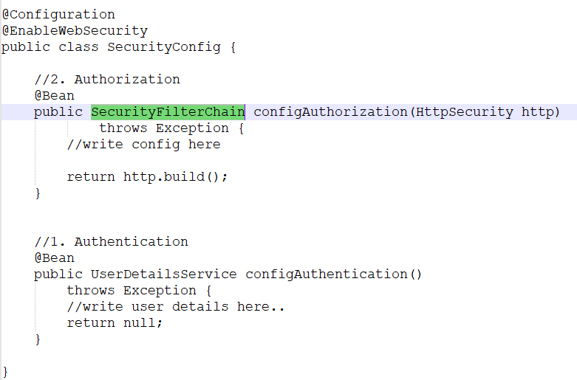
Define two beans(methods)
Authentication To holds UserDetailsService(I) InMemoryUserDetailsManager(Impl class)
Stores User, password, authority

Authorization To hold URL Access Details (antMatchers)
+ Login Form Details + Logout Details
above details can be hold using SecurityFilterChain(I)
Impl class DefaultSecurityFilterChain©
***************
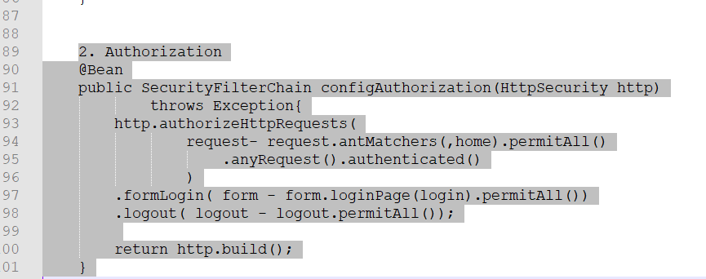
Password Encoder It is recomanded to store password in database
after encoding.

We must specify any one PasswordEncoder in application.
or else specify default ie withDefaultPasswordEncoder()
ie do nothing no encoding.
There is s password encoder BcryptPasswordEncoder

Spring Security Using JDBC API
Spring Security : JDBC Authentication

*) Store user details inside database as a table.
*) Spring boot starter JDBC Dependency need to be added in project
[pom.xml]

*) Spring boot 2.6.x we need to define queires manually for
creating table, insert user, select users..etc

*) In Latest version of Spring boot , queries are pre-defined
for user operations (save/insert, select..etc)

*) BCryptPasswordEncoder is used to convert user password into
unreadable format before stroing in database table.

For JDBC we have to use the JdbcUserDetailsManager

********************* Spring AOP *********************

ASPECT: Aspect is a class which provided additional services to our project.
Advice : A method inside the aspect class.
Point Cut: It is an expression it can never tell what advice. Your are selected for which will decide the advice.
Joint Point: Connecting the method with advice.
Target: It is the actual Object.
Weaving: it is the process of mixing the target and advice.

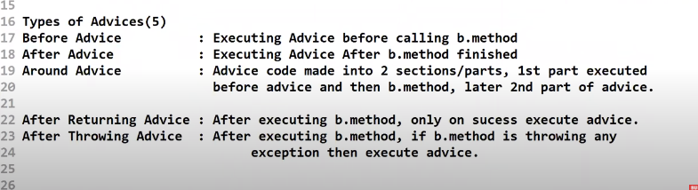
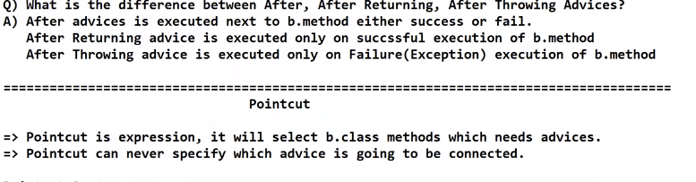
@EnableAspectAutoProxy
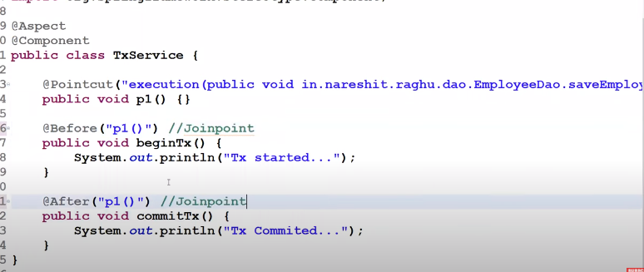
Micro-services

Monolithic Application process.

- Development: Writing application using IDE
- Compile: Convert .java -> .class
- *Build Creating .jar/.war files
- Test: Execute Unit Test cases
- *Deploy : Place .war file inside server and start server
- *Instance : Application in running state
- Load: No.of Request currently handling by Instance
- *Load Factor: 0<LF<1 | CurrentLoad/MaxLoad ( CR/TNR)
- Scale: Improve Resource capacity to work faster and better
*1) Horizontal Scaling: Creating Multiple Instances
Ex: Servers running apps
2) Vertical Scaling: Extend Resource capacity
Ex: Database Instances

- Monitor: Performance (health, Beans, cache..etc)
+ Log Files data
What is LoadBalancer Server and cluster?
By default one Instance max load capacity is 200.If no of request so, if No of Requests are increased then one instance may not be enough we need to have multiple instances created (ie called as Cluster/AutoScaling Group). To control the inputs and distributing in equal manner (round robin) LBS is used.

Monolithic Application
If an application has multiple services and deployed a single (.jar/.war) file it is called monolithic application.

Drawback:

- If we do any modification is done we need to rebuild the cluster. (entire rework)
- If any service is failed internally throwing some exception then it may lead to have unsuccessful deployment.
- If we increase the number of modules then it will effect a lot the pipeline time (compile, build, scaling time…..)
- because of cluster memory is allocated but only few services are used effectively. In an application some modules are effectively used . Some operations are not being used effectively.
Advantages.
Easy to code.
Easy to build as one war file.
easy to create the pipeline.
Easy to monitor (As one logs file).
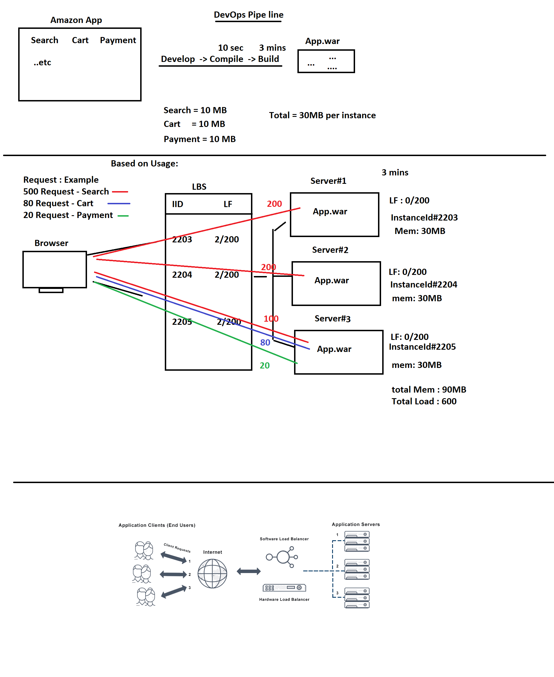

Micro-services structure
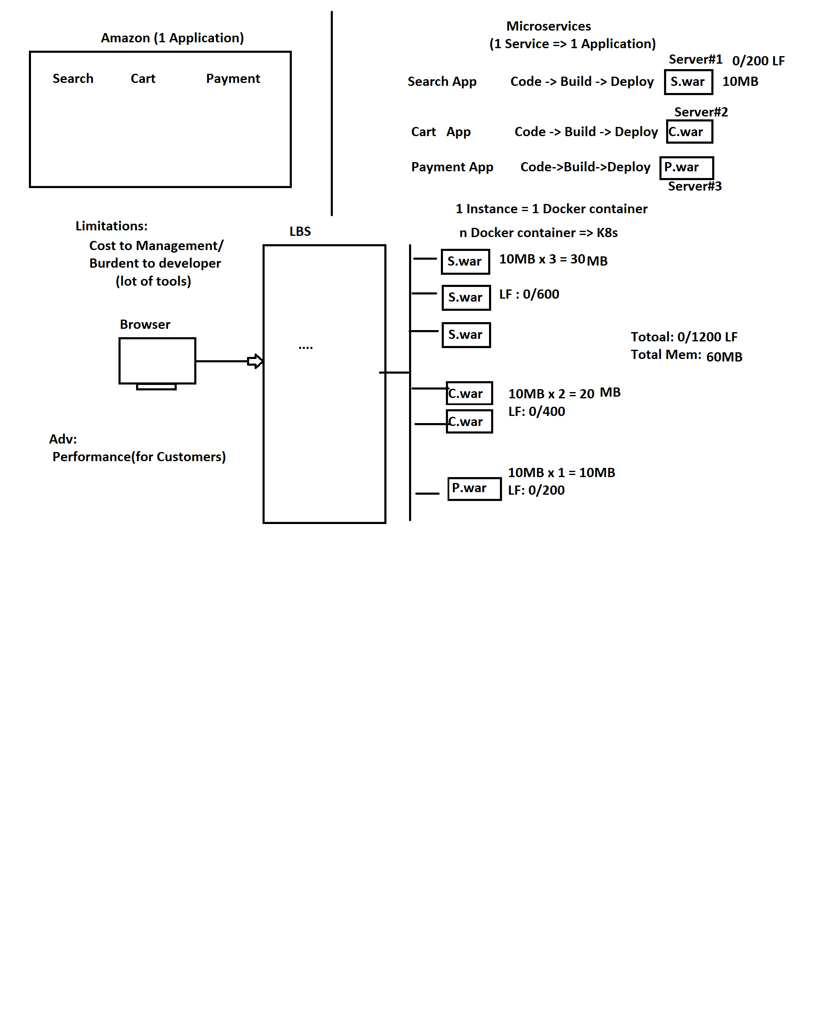
What is micro services?
** Creating each service as one application.
Independent deploy-able component is called Micro services. Distributed application.
** Loosely coupled Services linked (Deployed and linked) in parallel. If one service is failed it’ll not effect other services. Failure rate is much lesser. Recommended port for MS is 8761.
Micro Services: It is a Design, to develop large scale applications in parallel and even deploy.

+-------------------------------------+
| Theory Programming |
+ -------------------------------------+
OOPs java
ORM JPA with Hibernate
DI Spring Core
Micro-services Spring Cloud
-------------------------------------------
What is Spring Cloud: It is next level API of Spring Boot, which is used to
Develop MS# based applications.

Q) What is Cloud Computing?
A) IaaS, PaaS, SaaS ..etc Using Environment from others (service providers) to deploy our application on rental basis..etc
Cloud Providers: AWS, AZURE, GCP
*******************************************************
Q) How Spring Cloud is different from Cloud Computing?
A) Spring Cloud is Java API (classes, interface, enum and annotations) It is used to develop (write code and build) MS# applications. Once development is done, then MS# can be deployed to Cloud Computing Environments.

Drawback:
Development is headache.
Cast to management and monitoring.
Every instance is called a docker container. Creating those many containers we need Docker and k8s.

---------------------------- Implementation ---------------------------
1. Every MS# is implemented using Spring REST (in case of Java)

2. Register and Discovery Server will store MS# details
-> MS# name [Service Id]
-> no.of Instances(No.of times one Service is Running)
-> their IP and PORT details
-> Load Factor details
..etc

+---------------------------Ex:Register--------------------------------+
ServiceId InstanceId HOST PORT LF
+----------------------------------------------------------------------+
CART-MS CART-001 192.168.0.1 9090 0/200
CART-MS CART-002 192.168.0.3 9090 0/200
CART-MS CART-003 192.168.0.6 9090 0/200
SEARCH-MS SEARCH-352 192.168.10.1 8080 0/200
SEARCH-MS SEARCH-342 192.168.10.2 8080 0/200
SEARCH-MS SEARCH-211 192.168.10.3 8080 0/200
+----------------------------------------------------------------------+
*) Spring Cloud Netflix Eureka Server is a Register and Discovery Server.
How can we take the help of a Eureka Server,
–> Eureka Stores MS# details.
-> It will never makes any HTTP call to any MS#
-> Every MS# needs to register with Eureka Server(Provide MS# details to Eureka)
-> One MS# can get details of another MS# from Eureka (ie called as
Discovery, or fetch details)

3) Spring Cloud Config [git-Vendor]
MS# can have some common properties which is stored in Git Hub and can be loaded using Spring Cloud Config server.
OR
Every MS# (it is Spring Rest Application) contains properties/yml
files. In these files some/all key-val are common (duplicated). Don’t write in each micro services.

Define such duplicate key-vals only one time using ConfigServer
and share them to all MS# at runtime.

4. Spring Cloud Admin Server: [Actuator]
It is a monitering service for MS# cluster.
Like: no.of instances running, down, beans created, cache enabled?
Environment key-val, heap details, threads information, request details, scheduling details..etc. We can change the LOG level..
A person setting in front of Camera.
5. Spring Cloud API Gateway : [Cloud Gateway]
It is like a single Entry and Exit point to MS# applications. We expose only one IP and PORT ie Gateway details.
For a Request made by client, Gateway gets details from Eureka Server
and executes MS#, return results(Response) to Client.

6. MS# inter communication: / Intra Communication
one MS# wants to send/receive data to/from another MS#. These are used to link one MS# to other MS#.

DiscoveryClient + RestTemplate (Legacy)
LoadBalancerClient + RestTemplate (new)
Open Feign*** | FeignClient (AbstractClient) [It’ll choose the MS with less load]
7. Message Queue: (Apache Kafka)
We can integrate our MS# Environment with other 3rd party services
to exchange data in continious flow. Is it also possible to use to communicate the one MS# with other MS#.
8. Reactive API for MS# design (Spring Webflux + Spring Data Mongo)
We can use NoSQL Database (ie MongoDB --which stores JSON Data)
and use Spring Webflux inplace of Spring REST.
9. Distributed Tracing: [Sleuth and Zipkin]
We can find no. of MS# executed for a single request and their
paths/execution flow also time taken by each MS# + overall
It is also monitoring type service. Sleuth is generating all the details. And zip-kin is the display service.

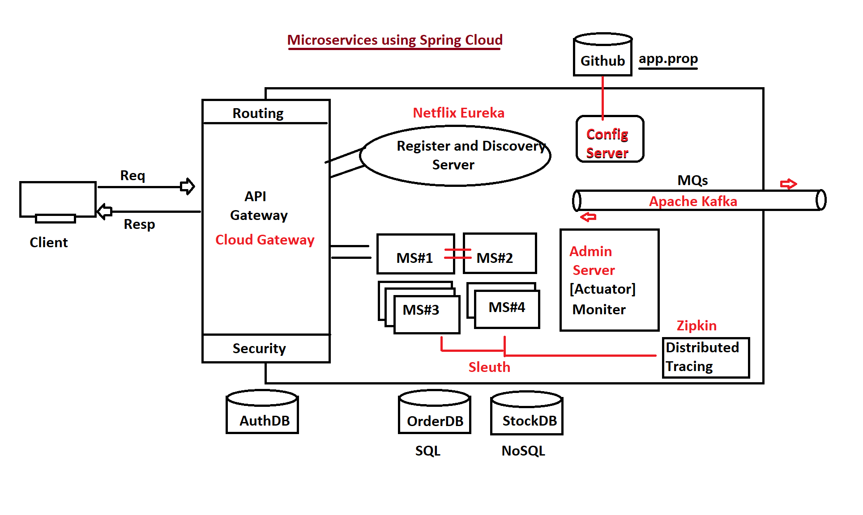
Bill Of material [Dependency Management]
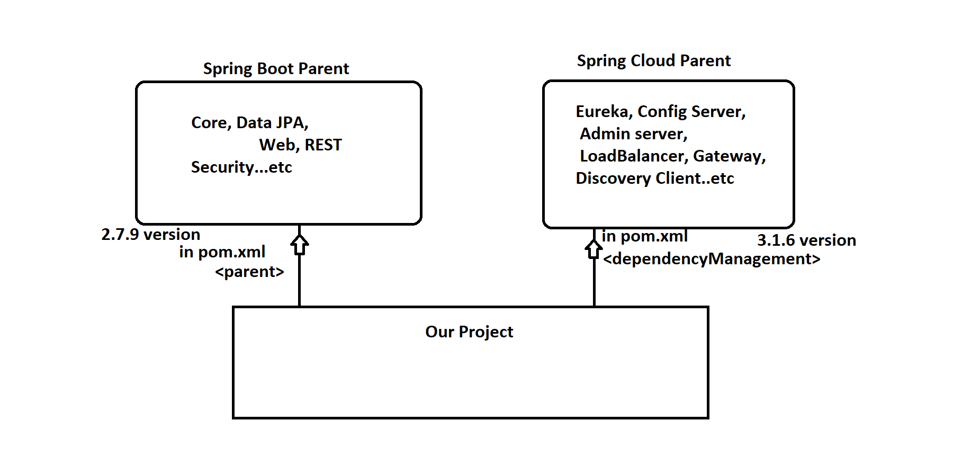

---------------------------------------------Eureka Server---------------------------------
ServiceId InstanceID IP PORT LF
------------------------------------------------------------------------------------------------
Cart-Service CRT-885604 172.16.12.10 8080 0/200
Cart-Service CRT-885885 172.16.12.11 8080 0/200
Cart-Service CRT-987456 172.16.12.12 8080 0/200
Cart-Service CRT-225563 172.16.12.13 8080 0/200
------------------------------------------------------------------------------------------------

ServiceId : project Name (spring.application.name)
InstanceId : A unique Random number/ Manual Id for each instance given
IP/PORT : Location and Port
LF:Load Factor.. CurrentNoOfReq/MaxNoOfRequest

=> application.properties
#Cart MS# app port number
server.port=9090

#ServiceId
spring.application.name=CART-SERVICE

#InstanceId (optional incase of 1 Instance)
#eureka.instance.instance-id=CRT-88560
eureka.instance.instance-id=${spring.application.name}:${random.value}
# Enable Register and Fetch with eureka server
#eureka.client.register-with-eureka=true
#eureka.client.fetch-registry=true

Note:
1. Every MS# is connected with Spring Cloud that is giving register and fetch-registery as true by default. So reducing work to MS# dev.

2. But, For Eureka also Spring Cloud is providing register and fetch-registery as TRUE We need to change it to false, else unknown instance is created which has no meaning and no use. Just memory waste.

Micro-services Inter Communication

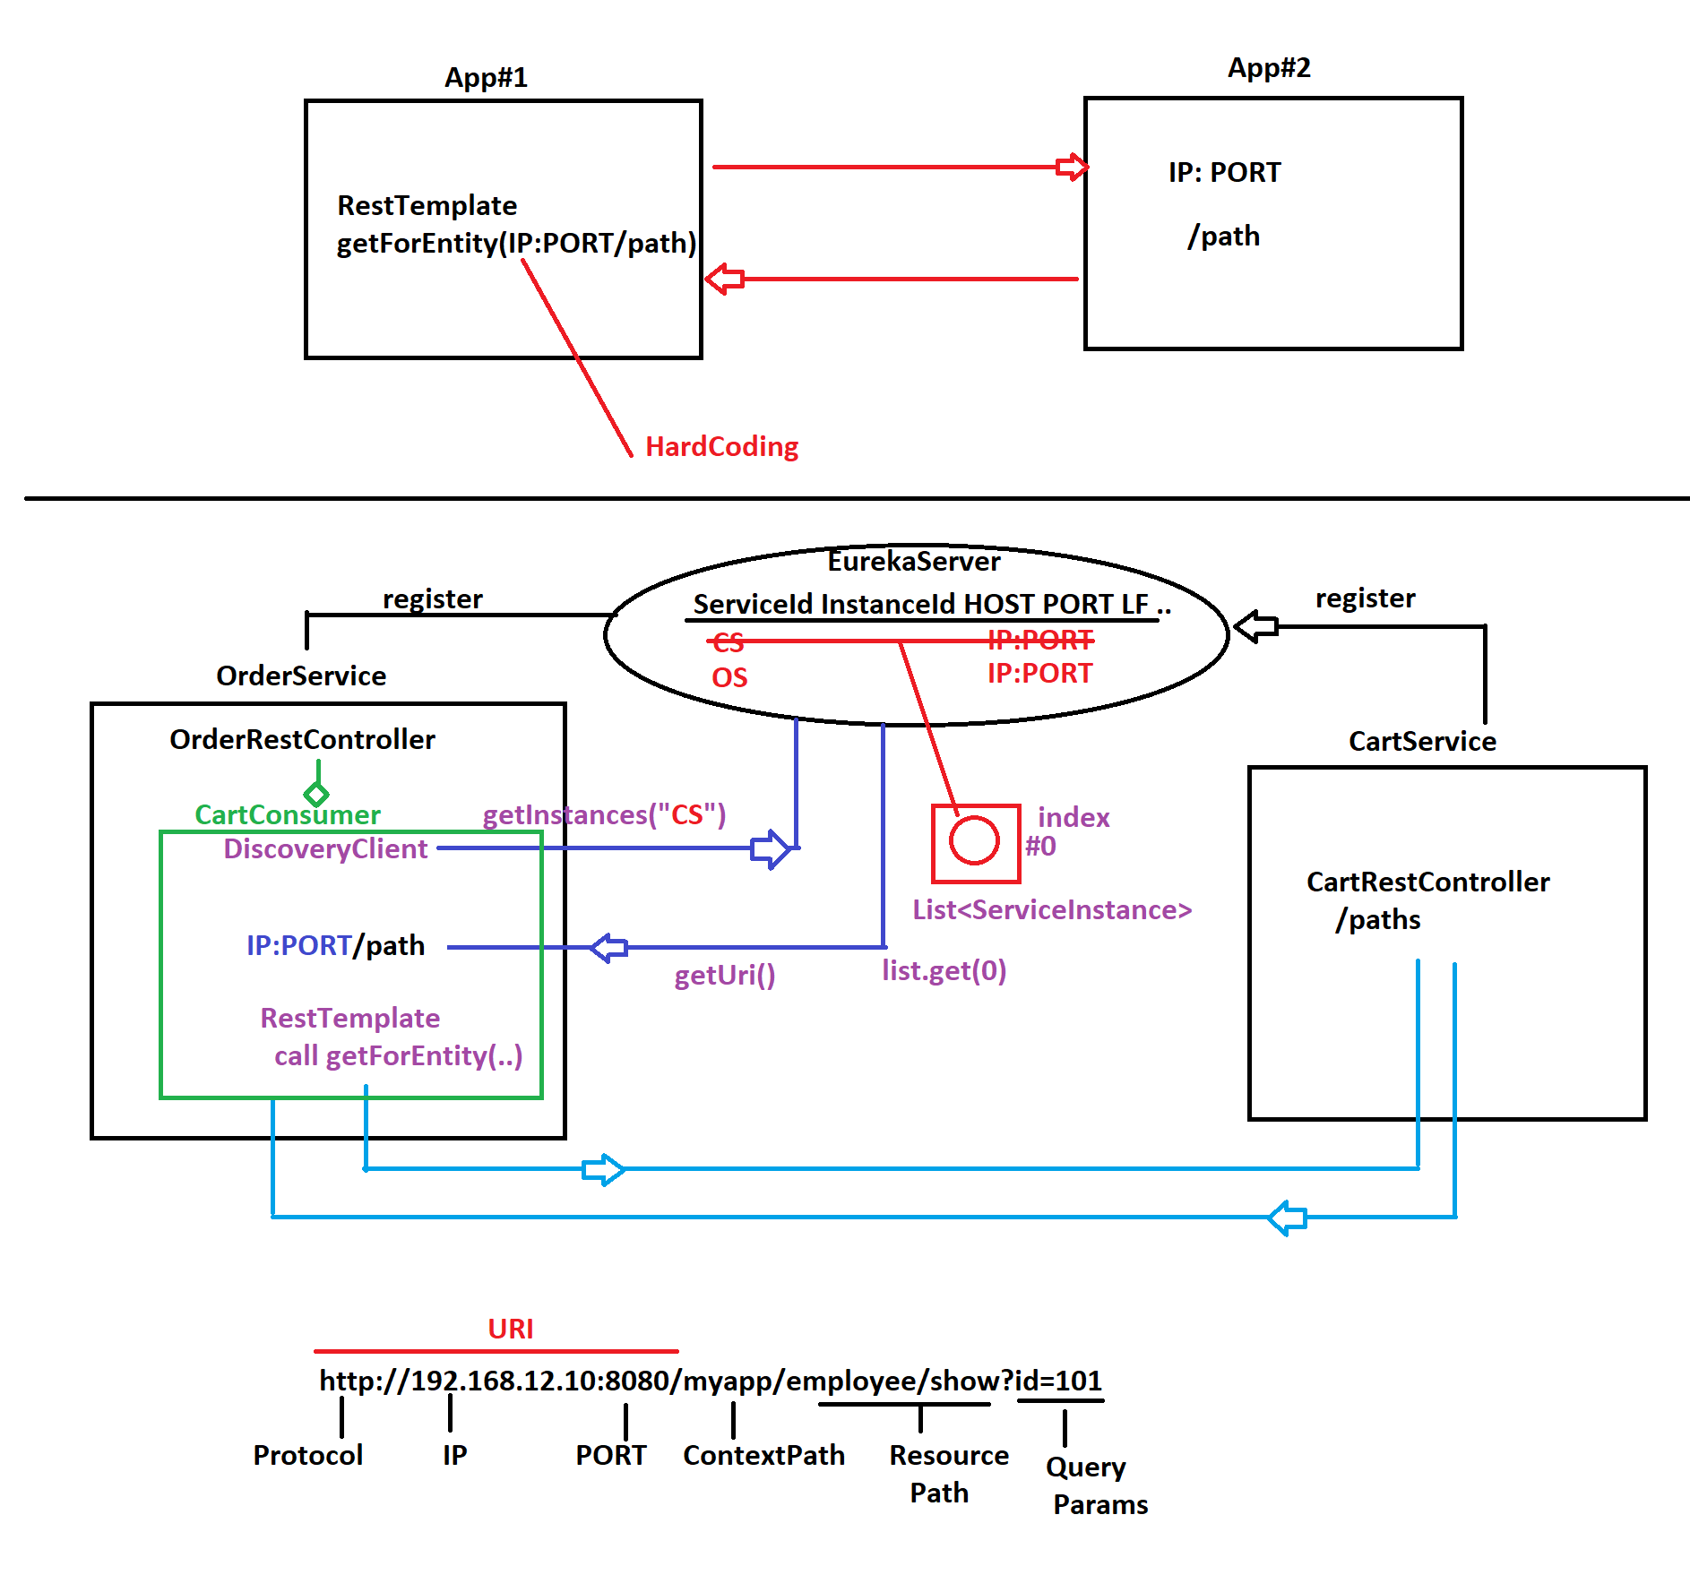

If two application are running on different servers and we want to communicate we can use the REST Template. But it is NOT Recommended in MS#.
DicoveryClient is not making the request to the other MS it is just

DiscoveryClinet.getInsances(String ServiceId)
DiscoveryClient(I)
getInstances(String serviceId):List<ServiceInstance>

- Above Interface is used to make call to Eureka Server, NOT to MS# apps.
- This is used to get MS# Details I.e called as ServiceInstance() by using MS# name ie ServiceId from Eureka.
- It returns All MS# Instances as a List<ServiceInstance>
- Why List? Bcoz MS# can be running multiple times.
- But, Here we running MS# only 1 time. So, directly using index#0 ServiceInstance.
- We can read URI ( IP:PORT ) from ServiceInstance then append Path.
Use RestTemplate to make HTTP Call 2nd MS#.
- That gets Response connect with current MS# Response and return.
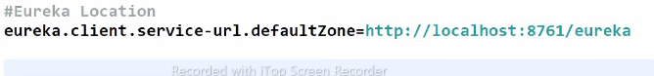

LoadBalacerClient(I) 2nd Client

- one MS# wants to connect with another MS# ie called as Intra Communication
- In this case we consider them as Provider-Client MS#s
- ClientSide LoadBalacing:
Consumer MS#/Client MS# has to choose one instance (not List) from Eureka Server which has less load factor.

- DiscoveryClient gets List<ServiceInstance> where as LoadBalacerClient gets only single ServiceInstance (even if multiple instances running for serviceId)
- Everytime consumer gets different producer instance. It follows Round Robin Method, LoadBalacerClient returns based on Less LoadFactor from Eureka Server.
- LoadBalancerClient(I) impl class is BlockingLoadBalancerClient©

Open Feign Client

DiscoveryClient : It is Legacy Client, It gets List<ServiceInstance> from eureka Server, based on ServiceId.
2. LoadBalacerClient: Spring Cloud LoadBalancer (old name Ribbon -- Removed)
It gets ServiceInstance from eureka based on LoadFactors. It follows Round Robin Concept.

3. ***OpenFeign : Feign Client
>> It is also called as Abstract Client
>> Here, code is generated at runtime which is similer to LoadBalacerClient.
>> We need to define Consumer code as a interface (not as a class).

---At Consumer MS# only -----------------------
Step#1 Add Open Feign Dependency

<dependency>
<groupId>org.springframework.cloud</groupId>
<artifactId>spring-cloud-starter-openfeign</artifactId>
</dependency>

Step#2 At main class : @EnableFeignClients

Step#3 Define Consumer interface that reflects Producer RestController

>> Define one public interface with annotation @FeignClient("ServiceId")
ServiceId of Producer MS# (or MS# which you want to connect)
>> Define one abstract method that matches to Prouder RestController method
[ReturnType, Parameter, HttpMethod, Path]

>>** We can define any interface name and any method name.

Config Server [For Common Properties][8888]
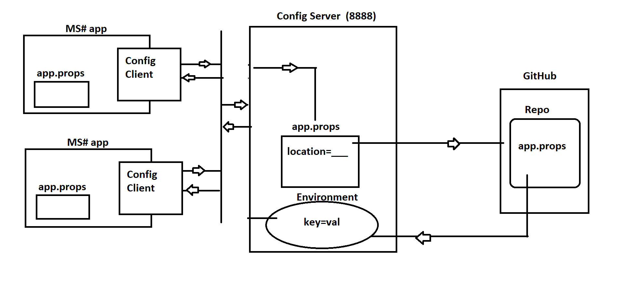

For config server in micro services we need to define the the location of the config server where the micro services can find the config-server path to fetch the common properties.
#Locate Config Server
spring.config.import=optional:configserver:http://localhost:8888
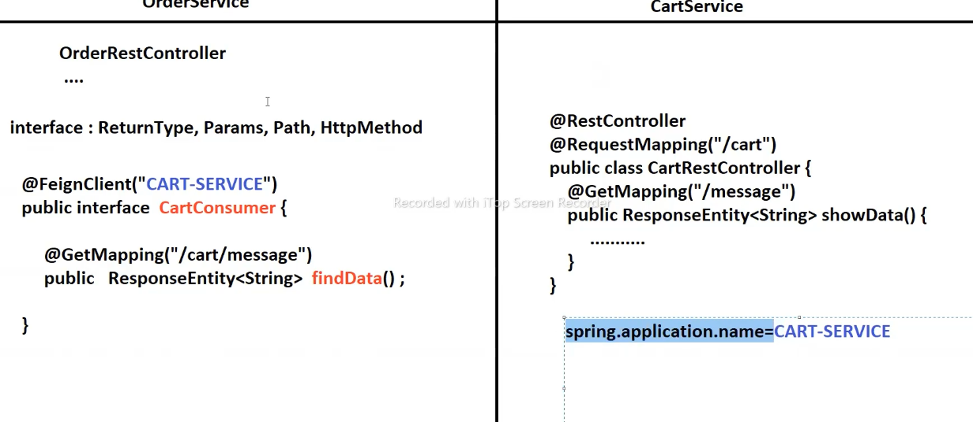

Problem with Config Server:
Every time when there is change in the common properties MS will not fetch that updated one.
You need to add acctuator dependency and activate it. Then we don’t need to restart it.

=======================================================================
Actuator + Admin Server(UI)
========================================================================
*) These are pre-defined Endpoint services.

*) There can be multiple MS# running at different places with multiple instances
monitering all MS# application can be done using Actuator + Admin (Client/Server)

*) We monitering MS# applications details like:
Beans, Cache, Health, no.of instances, Environment, ConfigurationProperties,
Heap, Threads, Scheduling, Cache..etc

Actuators: [Spring Boot Actuator]
Actuators are the collection of production ready endpoints (web Services).
Admin Server: It is central server that reads all MS# actuator and place them at single place. But for each micro server we need to admin client in each MS#. For Server we need to add the Server dependency. For client side the we need to add the client dependency.
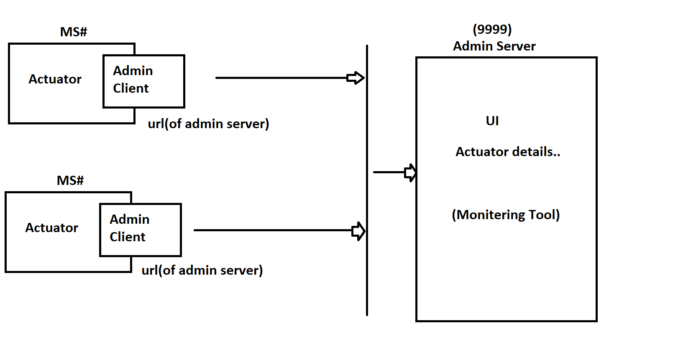

*******************************************************************************
Message QS(MQS)

To send data from Producer to Consumer (App/Machine/Server) in continioues flow, using one Message Broker/MOM/Mediator s/w.
*) MOM : Message Oriented Middle-ware
# Browser-Server Concept:
If Browser makes request then Server will process it and returns response.

# MQ Concept : one time connection is created between producer-Broker-Consumer, then Producer will send message and consumer will read message.

Communication:
Two Types:
peer to peer (P2P) – one producer one consumer
Pub Sub - one producer multiple consumer.
ActiveMQ|JMS Limitations:
1. It is single MOM / Broker software
2. Fail of Delivery of messages (rate of fail) bit high in case of server down
3. No Load Management (No LoadBalancer or multi node Broker/cluster)
So, in case of no.of Producers or Consumers are increased then it is a issue.
4. This is Protocol dependent (TCP)
5. JMS works for Java Applications only (Both producer and consumer)

*******************************************************************************

Important Links:
Pre-defined Key (https://docs.spring.io/spring-boot/docs/current/reference/html/application-properties.html#appendix.application-properties)
Rest Template:-
https://docs.spring.io/spring-framework/docs/current/javadoc-api/org/springframework/web/client/RestTemplate.html
Hikari Pool:-
https://github.com/brettwooldridge/HikariCP
Best Practices for application
https://github.com/Java-Techie-jt/springboot-best-practices

Best Practices:
- Always try from child to very next level parent.
- Port for one System / OS: 0-65535
- 0-1024 are called as Reserved port numbers. HTTP - 80
- Oracle/Jenkins/Tomcat - 8080
- 3. Use for coding : 6000 to 9999.
- Its good approach to use the base URL. i.e Request-mapping
- Even we can use PATH/URL as '/' (root / welcome page URL)
- if you don’t specify any port default is 80. or in place of local-host you can use.
- Within the same layer use the IS-A relation and in b/w the use HAS-A relation.
- We can use the JPA- Streamer to write the SQL query using the streams API.
- Spring boot select the equivalent versioned dependencies.

Best Practices for Spring boot Application
- Proper Packaging style (if you not define the proper packaging style the container will not scan your component. In this we have to used the @ComponentScan annotation explicitly.
- Use spring boot starters.
- Use the lombok
- Use the controller for routing (information)
- Use Service for business logic.
- Use the sonar Lit plugin to show the code smell and you can fix at the time of development. Which helps use to improve the quality issues.
- Always use the optional class if the return type is a single object.
- Object Mapper class can be used to convert the object to JSON as String

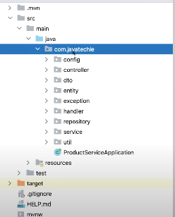

Java Techie Notes:
ACID properties:-
A→ Atomicity→ Either all or none.
C→Consistency → Before begin and after committing the transaction the sum of values should be same. ATM wali example.
I →Isolation →if there are the multiple transaction running parallel the failure of one should not impact other.
D→Durability →refer the persistence of committed transaction.
We can run n number of task without blocking the main thread. It gives the notification to the main thread.
How to create the string as primary key
@GeneratedValue(generator = "uuid2")
@GenericGenerator(name = "uuid2",strategy = "org.hibernate.id.UUIDGenerator")
Regular expression:-
[A-Za-z0-9\\.\\,\\.\\s]{3,34} allow A-Z/a-z/0-9/.,and Space
@JSONInclude to ignore the values if its empty.
If you want to group by the object then we can use the streams.
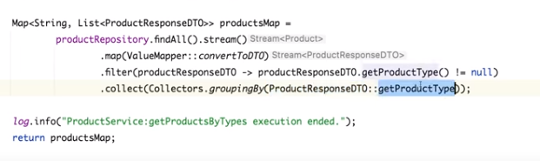

Functional interfaces: The interface which have only one abstract method is called.

JSON WEB TOKENS
There are two types of authentication
(1) Stateful Authentication (Session Management)
It will create on HTTP Session at Server side when client is successfully authenticated one session id is provided and sent to client using response as one Cookie. Client machine from next to on-wards submits the cookie to server then server verifies and provides services until logout. On logout the session will be invalided (Destroyed). Mostly Used in Web Applications.
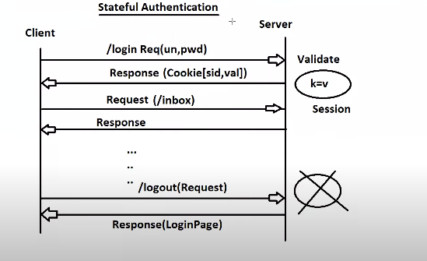

(2) Stateless Authentication
In this case no memory is allocated at the server Side. One token is generated at the server which is not in readable format. The next time when the client is making the request he need to send the token along with request. The secret key is maintained at server side, The Server validate the request using a secret key for creation and generating. Token is valid for period of time (No Logout Concept). Used in horizontal scaling (Micro-Services)
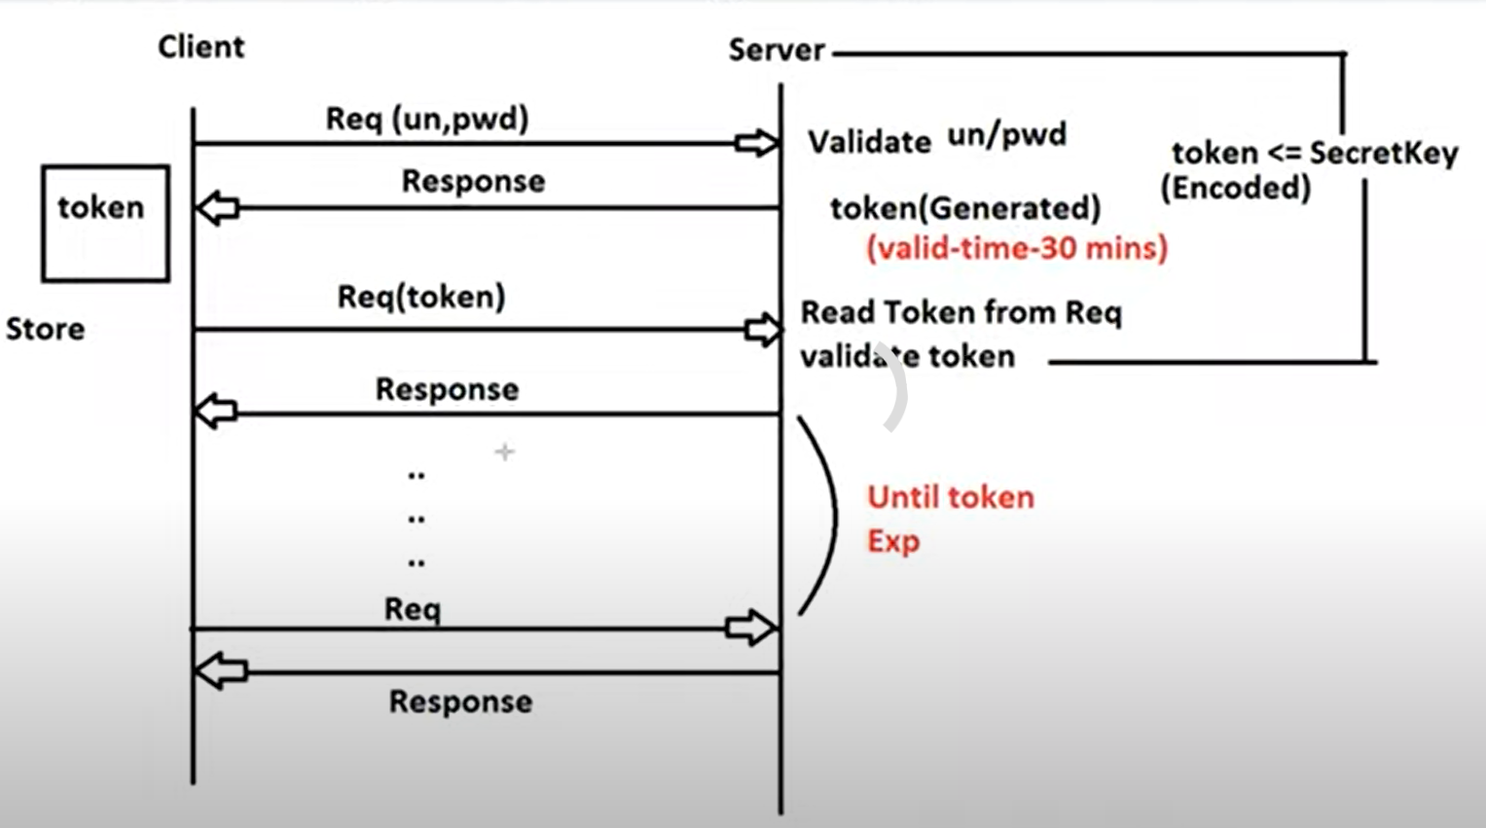
Web Services Authentication. (Service to Server)
Horizontal Scaling
resources grant access (Open Authorization Oauth) (Login with Facebook)
Oauth is similar to JWT with slightly modifcation.
Web Services (Server to Server)
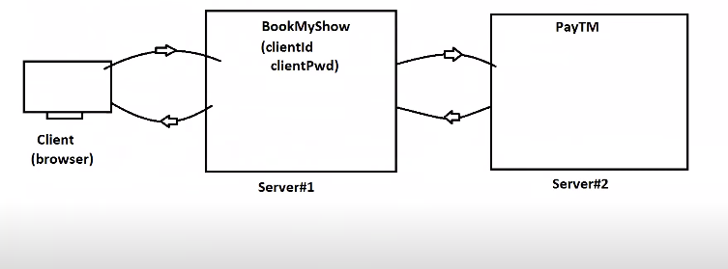
*************************************************
Horizontal Scaling (Micro-Services)
What is scaling? Running the same application on different server (App- Instance) when the load increases. Creating Session at multiples sever is not a good approach. (Think what if Stateful 🤔)
No matter where the token is generated you can use that token to access the resources as code is same.
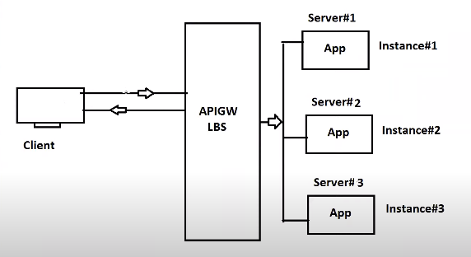

APIGW
(API Gateway)
LBS
Load Balance Sever

Vertical Scaling: Improving the CUP and RAM is called vertical scaling.
Drawback
- Token must be validated on each request. How many time you send the request it’ll be validated.
- Token not to be shared with others.
Security is also having some limitations. 😂
JWT is the open source Api that generates the token based on the client. Its stateless authentication. https://jwt.io/
**** If you’re using the older version you need to add the jxb dependency
Why JWT?
If we want to use the token based authentication then we use the TOKEN. Stateless Authentication. Its is JSON format. We have to use the jjwt. If the verision is not 8 we have to use the JAXB dependency.
The JSON Web token consist of three parts.
* Header Contains the JWT specification Information.
* Payload ( Client Id, Client Name,provider name,expDate….)
* Signature → Base64Encoded (header) + Base64Encoded(payload) and signed with secret Key
Format
xxxxxxxxxxxxxxxxxxxxxxx.yyyyyyyyyyyyyyyyyyyy.zzzzzzzzzzzzzzzzzzzzzzzzzzzzzzzz
(Header
Header consist of two parts i) JWT Token ii) Signing Algorithm
Hash Based Message Authentication (HBMA)
Payload consist on Claims. For example how is using the token , provider name , how long it is valid etc… Id →clientId , Subject → client Name , isser → token provider,
issDate → when provided, expDate-→ how long it valid.
Signature Base64Encoded (header) + Base64Encoded(payload)

How JWT Works
Header Payload
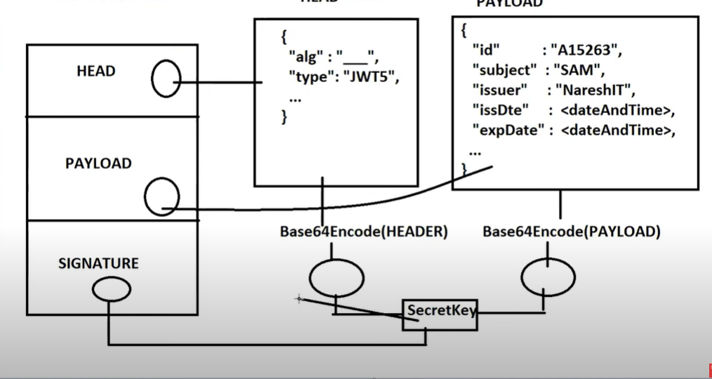

Sample Code For Generating the token
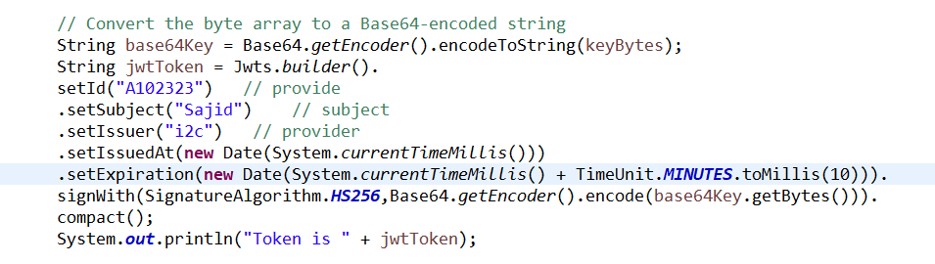
Claims the token (Parse The token)
At the time parsing only the signature is validated first if it is valid then go for payload and header.
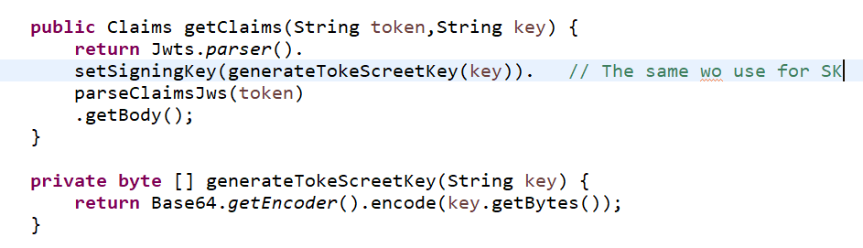
Code for parsing the token

Maven Overview
Our project needs jar without jars we can’t use the technologies. Hey! Programmer I will provide you dependencies from a Maven Repository. (Automated Process of Dependency Managment). It is dependency management tool. We can give the name of the final jar by using the tag <finalName>
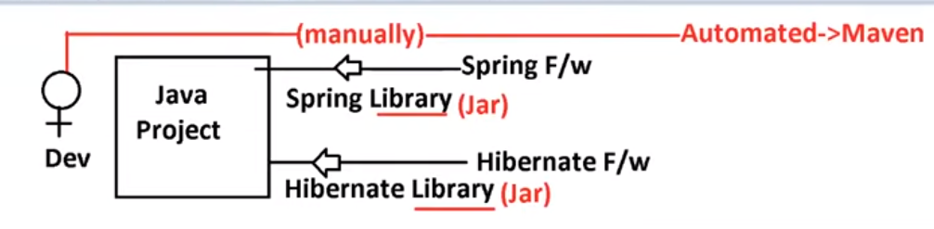
Source Code => .java
Compile file => .class
Build => .class → .jar/.war
How it works?
.m1 (main repository where all the jars are placed in well format)
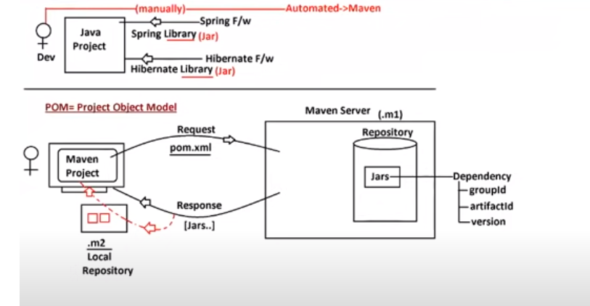
.

POM contains the following information.
- Parent project details
- Our project details
- properties (Key-value) -- For version management properties are recommended.
- Dependencies (*jars)
- Dependency management
- Plugins
Dependency Chain (Dependency Hierarchy)
If one jar is depending on the other jars maven says don’t worry I will provide you the current jar and its depending jar as well. It
Maven exclusion:-
It is the process of removing a particular jar from maven chain. For example if we deployed a spring boot application the tomcat server will come as default and you want to change it you can use the exclusion concept. We have to use the exclusions tag for this purpose. We can remove more than one jar also.
Maven Scope:-
when a jar should be used.
- compile (Default) jar is used at compile time
- runtime A jar is used only at runtime (for example a jar used in JDBC Programming)
- test A jar is used a
- provided A jar is given by Server / container.
- system This is used when we want to load a jar from our own system) for this scope we have to use on System Path Attribute as an extra.
Properties:- In maven properties concept is used to provide the version details.
** We can add the java version which is actually a plugin as property.
** use failOnMissingWebXml tag in properties tag. We can use this is if we didn’t want to use web.xml
Define your own tag and use.
<Properties>
<key> value</key>
</Properties>
How to use:
${key}
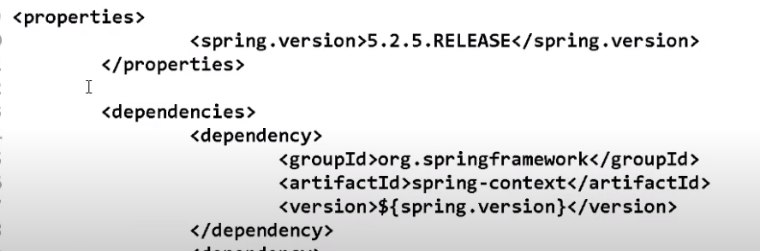
Dependencies Management:- (We manually handled the version)
BOM (Bill OF materials)
The spring says I have all possibilities jar you don’t have to handled the jars.
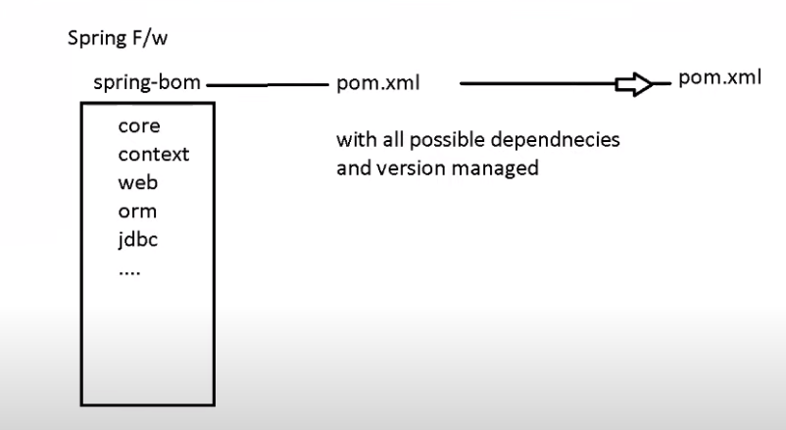
It is just like Has A Relation

If we add the any.BOM we have to use the dependencyManagement tag along with scope import.

Design Patterns
They are four types of design patterns.
- Creational Design Pattern (A way to create the objects)
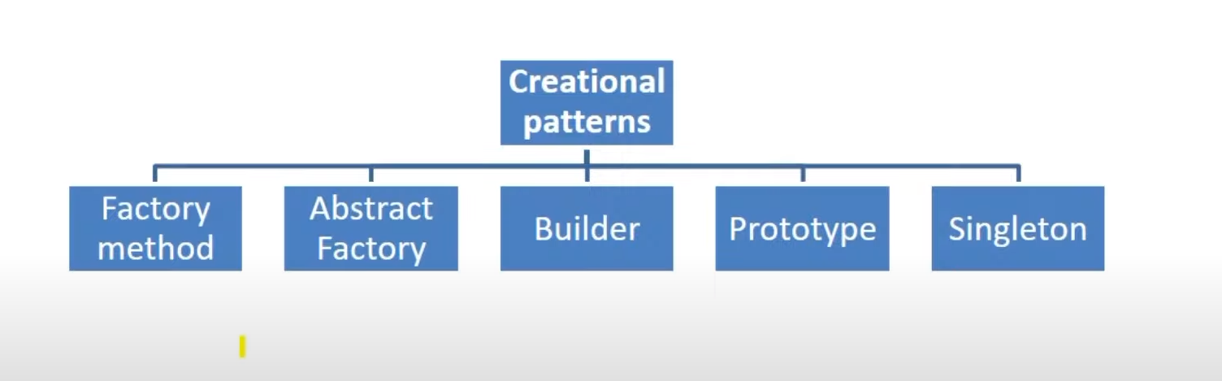
Q) What do we need Design pattern?
A) As Design Patterns are well documented and understood by software architects, designers and developers, then their application within a specific solution. Patterns give a software developer an array of tried and tested solutions to common problems, thus reducing the technical risk to the project by not having to employ a new and untested design, thus saving time and effort during the implementation stage of the software development life cycle.
Q) What Is Factory Pattern?
In the Factory pattern, we don't expose the creation logic to the client and refer the created object using a standard interface. It’s also called virtual constructor (As we don’t know how to create the object).
Steps:
1) create main class which call factory class.
2) Factory class returns required class instance.
Q) What Is Abstract Factory Pattern?
This factory is also called as factory of factories. Abstract Factory lets a class returns a factory of classes. So, this is the reason that Abstract Factory Pattern is one level higher than the Factory Pattern. The Abstract Factory Design Pattern is used to provide an interface for creating families of related or dependent objects without specifying their concrete classes.
An Abstract Factory Pattern is also known as Kit.
Steps:
1) create main class which call factory of factory class.
2) Factory of factory / factory Producer creates instance of factory class.
3) Factory class returns required class instance
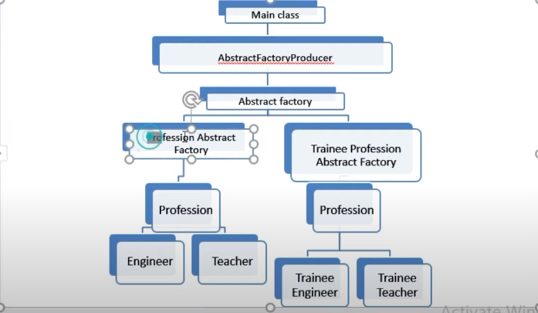

Q) What Is Singleton Design Pattern? (Eager, Lazy, Synchronized, double locking which saves..)
Singleton pattern is one of the simplest design patterns in Java. This pattern involves a single class which is responsible to create an object while making sure that only single object gets created. This class provides a way to access its only object which can be accessed directly without need to instantiate the object of the class.
Q) What Is Prototype Design Pattern?
Prototype design pattern comes into the picture when you want to create the object from existing object and its creation is vary costly.
* What if there are some fields which are private.
* The client should have the proper knowledge of the obejcts.

Q) What Is Builder Design Pattern?
Builder Pattern refers to approach that focuses on constructing a complex object from simple objects using step-by-step approach. Major roles used in this design patterns are : Complex Object / Final Product –
e.g. house – complex object which we will generate with builder design pattern Builder – abstract class / interface that defines all ways to create the product. It also has getFinalProduct method that will finally return complex object. ConcreteBuilder – multiple Builder Impls that will give different final objects which are complex to design, Director: Controls complex object creation. It has 2 main goals : 1st to call appropriate concrete builder class to create correct complex object. 2nd to return that complex object.

=====================Aspect oriented Programming==========================
cross cutting concerns
Join point (when you want to do something)
Advice (action/what)
Aspect : A class where you put all the cross cutting concerns.
Target (hero a main character)
Weaving (How it happening In spring it happens at runtime)
Proxy( The double on the target with the proxy)
point cut( expression)
Syntax
execution (return type class-name.method-name(args))

========================================================================
Spring Questions
*Dependency injection
Linking the objects to the dependent class.
*Spring bean
The bean which is totally manged by Spring container is called IOC
*Setter VS Constructor Injection:
Partial injection is not possible with the help of constructor Injection. It creates always the new object while the setter injection modifies the existing object.
* @Required Annotation
The value for the following dependency is mandatory.
* @Validation
It is used for restricting the user inputs but your version should be higher =>4
* @pathvaribale and @RequestParam
@Request param reads the data from query string and @pathvaribale extrct the value from uri.
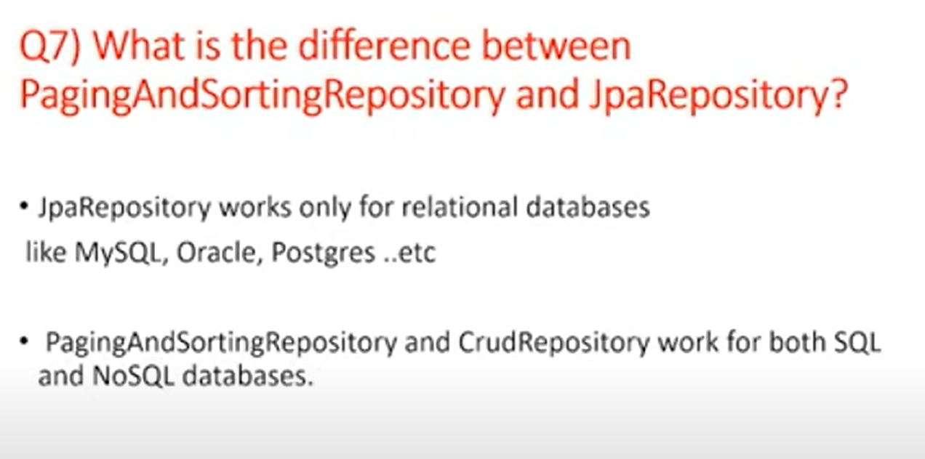

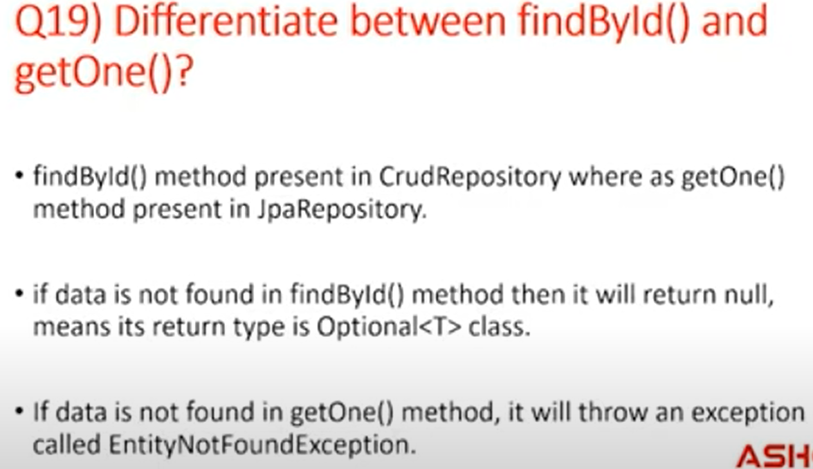

* What is SOLID principle
https://medium.com/@javatechie?p=ae96a48db97

Core Java Interview Questions:
Hashmap also perserve the order while hashtable doesn’t preserve the order.

Refer 162 to
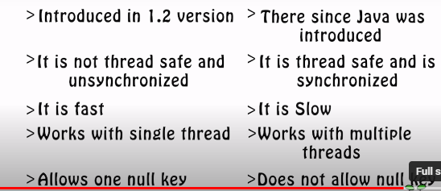
Design Patterns

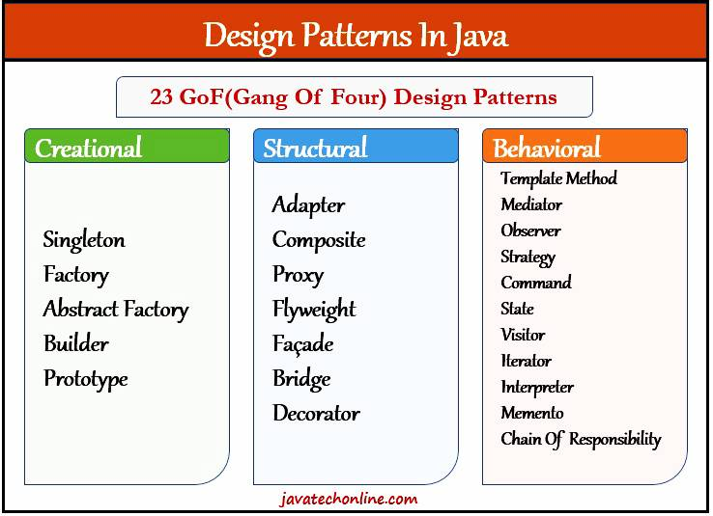
(Structural Design Patterns)
1 – Singleton Design Pattern
The singleton design pattern because we need the same state of the class.
* There is problem that when we use the static initialization process, the object is being created either we need the instance or not. (Eager Initialization)
* For this we go for the Lazy initialization. In this scenario the instance will only be available when you need it.
How to break the singleton design pattern
- Reflection API (in the private constructor throw an exception we can’t return the same instance because the constructor does not have any return type.)
- Cloning
Shallow Cloning:
  - Shallow cloning creates a new object and then copies the field values of the original object to the new object. However, if the field itself is a reference type, only the reference is copied, not the actual object it points to. This means both the original and cloned objects will share references to the same nested objects.
  - To perform shallow cloning in Java, you can implement the Cloneable interface and override the clone() method. The clone() method in Object class performs shallow cloning.
- Deep Cloning:
  - Deep cloning creates a new object and then recursively copies all the field values of the original object to the new object. If a field is a reference type, a new instance of that referenced object is created and assigned to the corresponding field in the cloned object. This ensures that changes made to nested objects in the cloned object do not affect the original object.
  - Deep cloning is not directly supported in Java by default. You need to implement it manually or use third-party libraries like Apache Commons Lang or Gson, which provide utility methods for deep cloning objects.
- Serialization (Override the readResolve to create the new object)
- Multi threading (Double checking looking)
Where to use.
- DB Connection
- Reading the properties file
- For some modules
- Logger
------------------------------------------------------
Builder Design Pattern:- (Creational Design Pattern)
Useful for creating complex objects with many parts.
Decorator Design Pattern:- (Strcutural Design Patterns)
This design pattern comes under the structural design pattern. In which we can add the additional behavior to the individual objects without effecting the other objects of the same class.
Observer Design Pattern:- (Behavioral Design Pattern)
If there is change in one object and you need to reflect it against many other objects we go for observer design pattern. For small scale application if we want to implement the event driven mechanism.
The Observer Design Pattern is a powerful way to create a one-to-many relationship between objects, ensuring that changes in one object are automatically propagated to all dependent objects.

************************************************************************
GraphQL:- is query language. It allows to client request for the data which he need. What you asked for nothing more. This can help prevent clients from over-fetching data
GraphQL is more flexible than REST, allowing clients to make changes on the client-side without requiring changes to the server. For example, if the design or data needs on the front end change, the back end doesn't need to be adjusted.
- You just need to annotate the @controller / enable the graphQL
- replace the @getMapping with @Querymapping and for argument use @Argument. And for updation/deletion/insertion we need to annotate with the @Muatation
- we need to define a file schema.graphqls with structure define the tyep tag(with elements for double you need to define the float)
- no define the @qquerytag (as method name) query for updation.
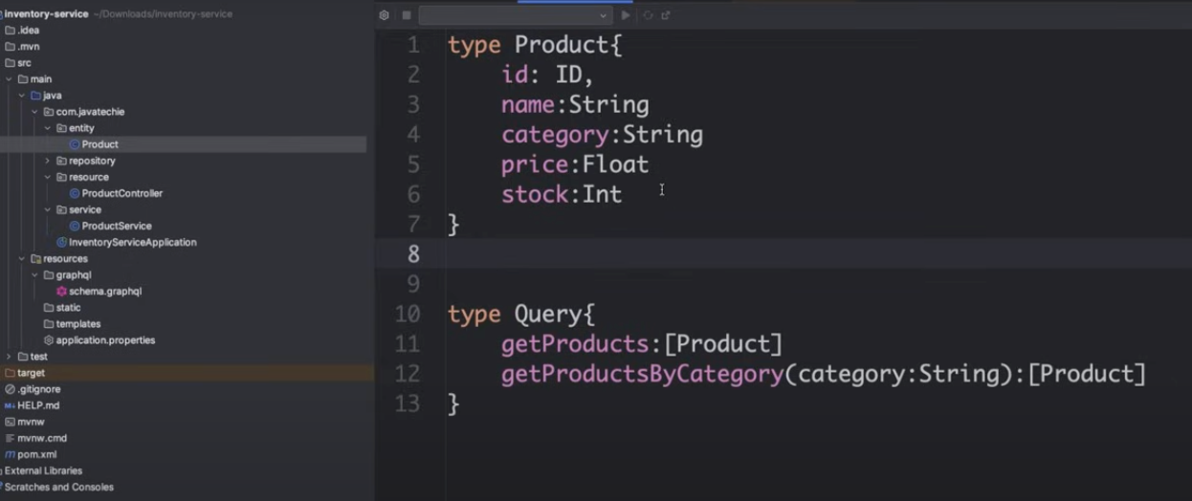

We can consider the example of inventary stok where updatation and new shippment example..
@Use @JSONInclude to include and exclude the value of JSON output.
Topic: Exception Handling mechanism in Spring Boot..
Spring boot the default mechanism of handling the exception. It also provide the annotations to handle and customize the handling mechanism like @ExceptionHandling and @controllerAdvice.

