**COMM646  
Assignment (200 points)**

**Part 1 (100 points)**

**Practice with jQuery Selectors and Commands**

In this assignment you will practice working with jQuery selectors and commands. You will use a basic version of the Vecta Corp website to select elements and then apply jQuery commands to those elements. To get started, open the vectacorp project folder within Brackets and complete the following steps using jQuery only:

**General**

1. Find the jQuery library, download it, and reference it from within the Vecta Corp. web page. Do not use the CDN, use the downloadable library.
2. Create a document ready function within an embedded script block in your web page. This is where you’ll write your code.

**The Headings**

1. Select the <h2> elements within the <section> and <aside> tags and apply a CSS solid, black, 1px border to them.
2. Select the <h2> elements within the <section> and <aside> tags and apply a color of #CC1C0D to them.
3. Select the <h2> elements within the <section> and <aside> tags and apply a padding of 3px to the top and bottom and 20px to the left side.
4. Select the <h2> elements within the <section> and <aside> tags and apply a border radius of 5px to the top right and bottom left corners only.
5. Select the <h2> elements within the <section> and <aside> tags and apply a background color of #DFE3E6.

**The Navigation Menu**

1. Programmatically add the class “navigation” to each of the 5 navigation menu items.
2. Select the navigation classes and apply a CSS solid, #929CA4, 1px border to them.
3. Select the navigation classes and apply a color of #CC1C0D to them.
4. Select the navigation classes and apply a padding of 3px to the top and bottom and 20px to the left side.
5. Select the navigation classes and apply a background color of #DFE3E6.

**Main Content**

1. Programmatically remove the vprospect, vconvert, and vretain classes from the <p> tags in the main <section> tag.
2. Programmatically add the text “Chevy Dealers Association” after the word “President” in the client testimonials section. Make sure to programmatically add a line break after the word “President” so that the new text you’re adding is placed directly underneath.
3. Programmatically wrap the testimonial verbiage with a <q> tag.
4. Programmatically italicize the testimonial verbiage.
5. Programmatically replace the bolded Vecta Corporation text in the opening paragraph with a hyperlinked version of the text. The link should go directly to http://www.vectacorp.com.

**Part 2 (100 points)**

**A jQuery Image Selection Slideshow (10 points)**

In this part of the assignment you will create an image selection slideshow using jQuery. The image below outlines what the final result should look like. To receive maximum points on this part of the assignment, be sure to take the following into account:

1. The slideshow must have a minimum of 5 images.
2. Add a numeric paging widget underneath the images. Make sure to stylize them using jQuery so that the selected image is clearly differentiated from the non-selected images.
3. Only one image will fade into view at a time. Depending on the number selected in the paging widget, the image that represents that number should fade into view. Make sure to take advantage of jQuery effects for this fade into view.  
     
   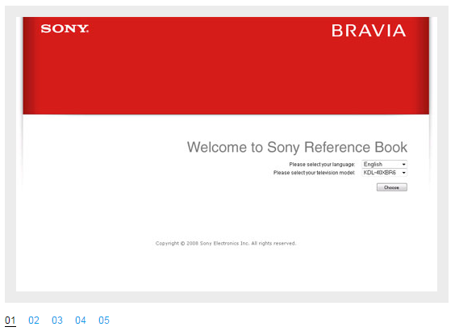

**A jQuery Tabbed Menu Bar (10 points)**

In this part of the assignment you will create a tabbed menu and associated panels using jQuery. The image below outlines what the final result should look similar to. To receive maximum points on this part of the assignment, be sure to take the following into account:

1. The tabbed menu must have a minimum of 3 tabs with 3 associated panels.
2. Each tab should show its respective panel when clicked and moused over. Add CSS styling to your tab menu, tabs, and panels so that it’s aesthetically pleasing.  
     
   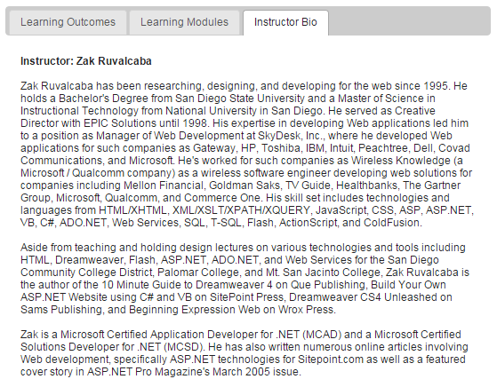

**A jQuery Accordion (10 points)**

In this part of the assignment you will create an accordion using jQuery. The image below outlines what the final result should look similar to. To receive maximum points on this part of the assignment, be sure to take the following into account:

1. The accordion must have a minimum of 3 headings and associated panels for each heading.
2. Next to the text for each heading should be a plus icon. You can use an actual icon image or just use text if you prefer. When an accordion panel is open, the icon should change just as it does in the image below. The heading style should also change including shape and color as it does in the image below.
3. The panels should animate into view when their respective headings are clicked.   
     
   