Marketplace
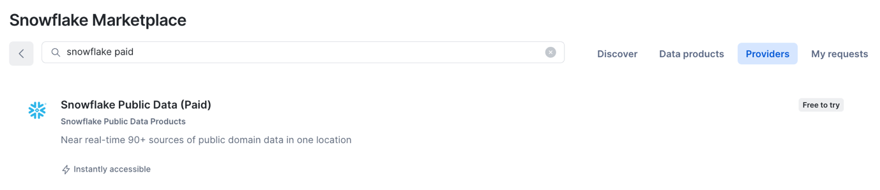
Type snowflake paid into the search bar
You should then select this one and click on the Try Now
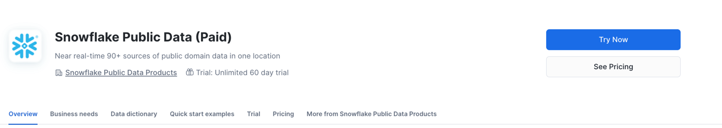

Type in your details
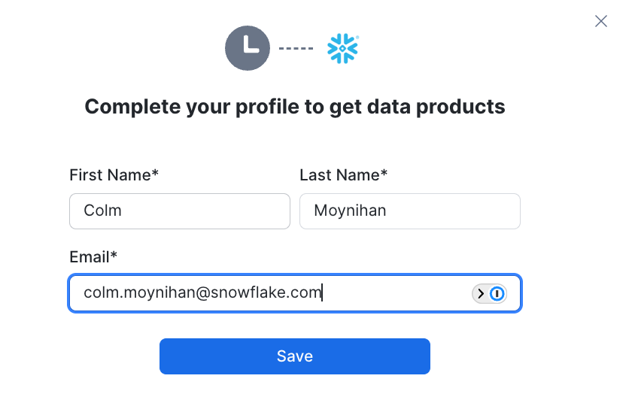
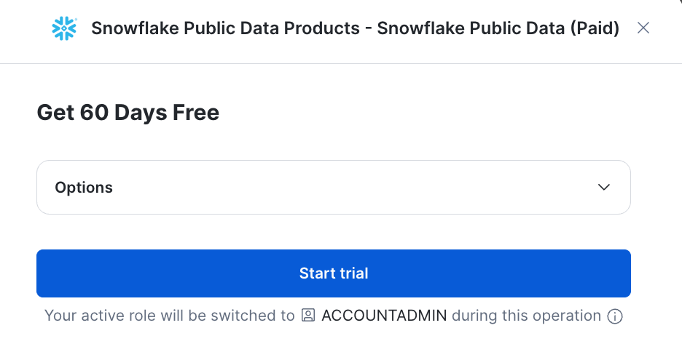
Click on Start trial
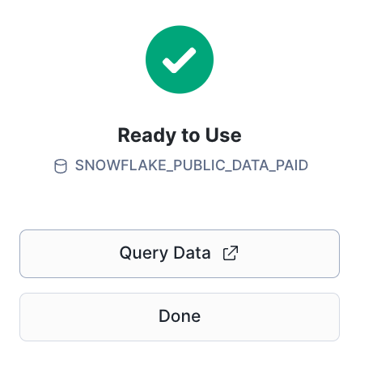
Now its ready to use
Click on Query Data
You should see this under
Databases under SNOWFLAKE_PUBLIC_DATA_PAID
Under PUBLIC_DATA
