Goto Workspaces and select
Git workspace
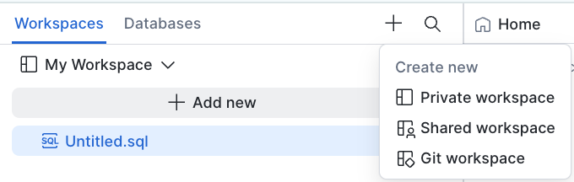

Then create workspace from Git repository
URL = https://github.com/sfc-gh-cmoynihan/holly-labs
Workspace name = holly-labs
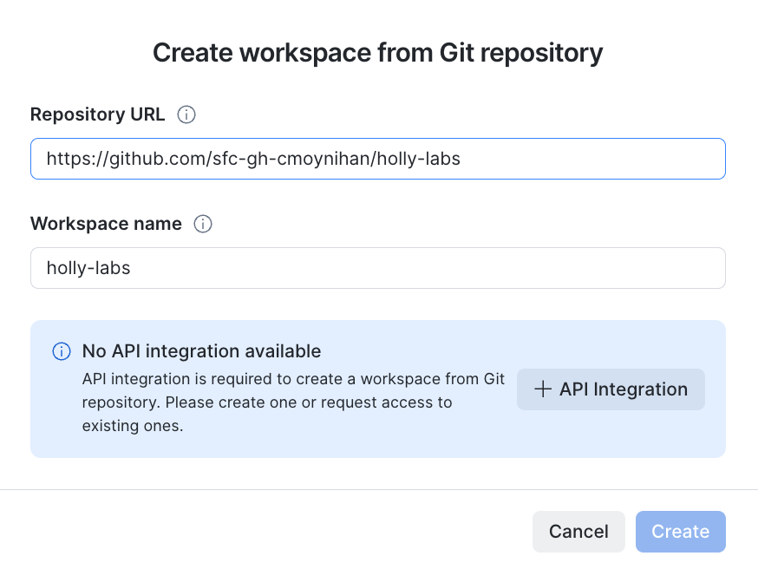
Add an + API Integration as follows
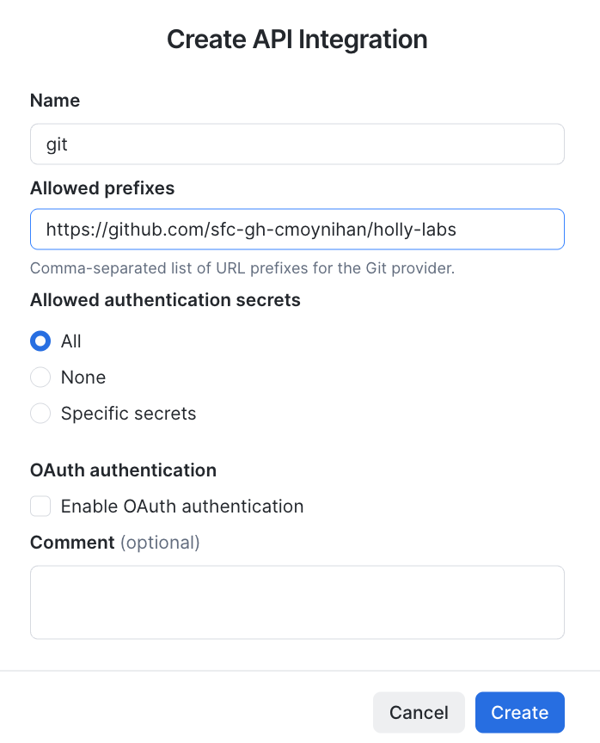
Then you should see this
