**Install Python 3.8**

<https://www.python.org/ftp/python/3.8.0/python-3.8.0.exe>

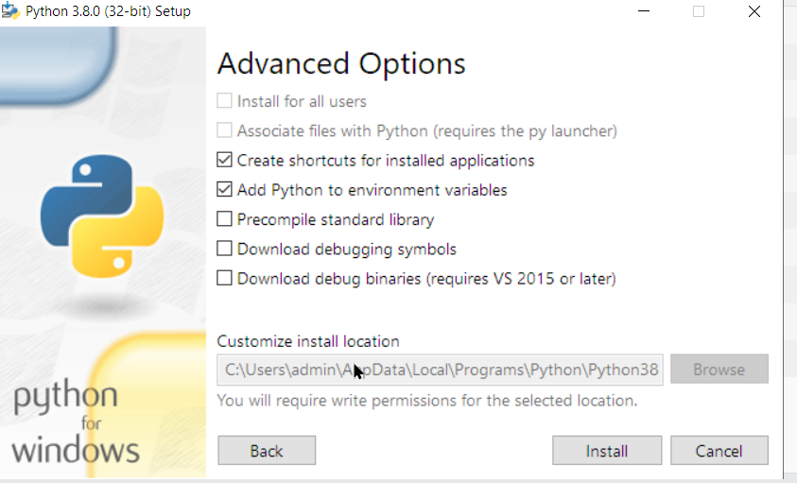

Go to github repo and download requirements.txt

Create a Project folder in your windows (any drive/name)

$ cd [your folder name]

$ python -m venv snowpark

$ .\snowpark\Scripts\activate

Copy following to a requirements.txt file

scikit-learn==1.0.2

notebook

pandas

numpy

pyarrow==6.0.0

matplotlib

seaborn

ipykernel

snowflake-snowpark-python

$ pip install -r requirements.txt

$ python -m ipykernel install --user --name=snowpark

All set, no need to download and install anaconda.

**Using Anaconda** (no need to complete this if you have setup the environment using Python)

Steps here - <https://docs.snowflake.com/en/developer-guide/snowpark/python/setup.html>

Miniconda installer

<https://repo.anaconda.com/miniconda/Miniconda3-py38_4.12.0-Windows-x86_64.exe>

Download the Lab source code

<https://github.com/Snowflake-Labs/sfguide-getting-started-snowpark-python/archive/refs/heads/main.zip>

cd to Customer -Churn-Prediction folder

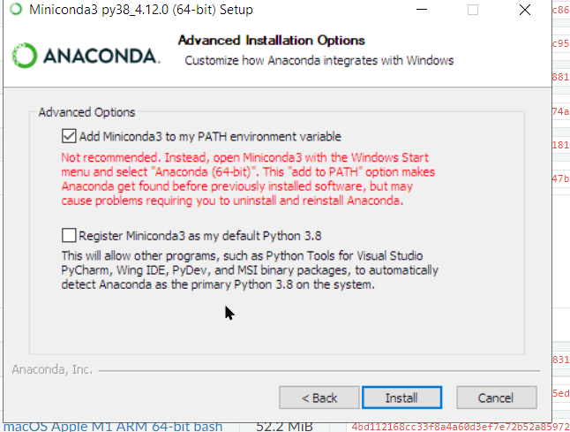

conda env create -f jupyter_env.yml

