MISSION REPORT
Operation Halftime Stampede
Falcon Football Academy — Halftime Snack Preorder
To: Baba | From: Your problem-solver on this mission

Mission Briefing
Every Saturday at halftime, all 60 players rush the snack table at the same time. Last week it went wrong: a shin pad ended up in the drinks box, two players ended up hurt in the crush, and one player missed the second-half kickoff because he was still stuck in the crowd. I was sent to figure out what's really going wrong, break the mess into pieces, and build something that fixes it. Here's what I found, and what I built.

1. What is the real problem — snacks, queue, or something else?
It's not the snacks. There's enough food and drink for everyone. It's not really "the queue" either, because a queue means people are waiting in an orderly line — what's actually happening is a crowd, not a queue.
The real problem is that two things are being forced to happen in the same 5-10 minute window, at the same table, for 60 people at once:
- Deciding — “what snack and drink do I want?”
- Collecting — actually getting the bag into your hands.
When decision-making and hand-out happen at the same time and place, every player becomes a mini traffic jam at the table, and the whole thing turns into a crowd instead of a line. That's the real problem: a timing and design problem, not a food problem.

2. The three biggest causes of the halftime chaos
- Decisions happen under time pressure, at the table. Every player has to choose their snack and drink in the same rushed minute everyone else is choosing theirs, which is slow by nature and jams up the one table.
- There's no system for who gets what. Nothing is sorted, named, or set aside ahead of time, so staff have to figure out each order live while a crowd builds behind that player.
- One pickup point, one tiny time window, no order to it. 60 players and one table in about 10 minutes, with no lineup or spacing, is exactly the setup that causes crowding, pushing, and injuries like the shin pad and the stuck player.

3. Who is affected, and what does each person need?
Who | The mess, from their side | What they actually need
Players | Crowd around one table, pushing to grab a bag before the whistle; risk of getting stepped on or hurt. | Grab their own bag fast, with zero decision-making in the moment, and get back onto the pitch on time.
Coaches | A player still at the snack table when the second half kicks off; can't fully use the substitution. | Every player back in position within the break, with no fights or injuries to manage.
Parents / snack volunteers | 60 kids asking 'what do you have?' at once, no way to know who already got a bag. | A simple list of who ordered what, so handing out bags is just matching a name, not taking an order.
Injured players (e.g. shin-pad incident) | Physically caught in the crush, at real risk of injury from the crowd. | No crowd to be caught in — an orderly, spread-out pickup instead of a scramble.

4. How the app fixes one problem — and one thing that could still go wrong

What it fixes
The app moves the “deciding” step out of halftime entirely. Players (or their parents) preorder their snack and drink any time before the match, on a Preorder tab. By halftime, there is nothing left to decide — every bag already has a name, a snack, and a drink attached to it. Staff open the Halftime Pickup tab, which lists every order sorted alphabetically with a search box, and hand out bags by matching a name, not by taking an order. That directly removes cause #1 (decisions under time pressure) and cause #2 (no system for who gets what), which are the two causes that actually create the crowd.

What could still go wrong
This version stores orders in the browser's local storage on one device, so it works great on a single tablet at the snack table — but it isn't shared automatically between devices yet. If a parent preorders from their phone at home and the snack table is using a different tablet, that order won't show up there unless it's the same device or a shared backend is added. There's also no rule yet for a player who shows up without preordering at all — that player would still need an on-the-spot decision. Both are the natural next step: a shared online order list, plus a clearly marked “walk-up” lane so late orders don't slow down everyone who planned ahead.

The App: Halftime Snack Preorder
A simple two-tab web app, built to run on any device with no installation:
- Preorder tab — player name, team, one snack (banana, orange slices, granola bar, apple), one drink (water, electrolyte drink, juice box), and an optional allergy note.
- Halftime Pickup tab — every order sorted alphabetically, a search box to jump to a name, a “Grab bag” button to mark it collected, a live count of bags remaining, and a reset button for the next Saturday.
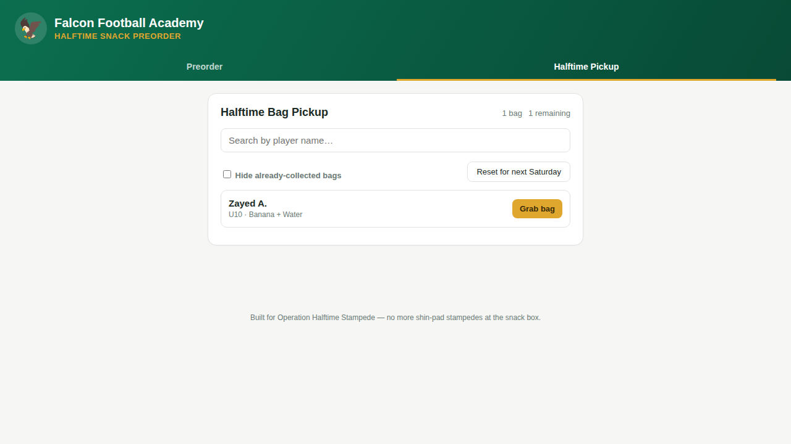
The Halftime Pickup screen during testing: one bag reserved for Zayed A. (U10, banana + water), ready to grab with no queue.

Design decisions — why I built it this way

Why preorder instead of a faster on-the-spot system (like more staff or more tables)?
More staff or more tables would only make the crowd bigger in more places — it doesn't remove the actual bottleneck, which is 60 people deciding at once. Preordering removes the decision from halftime completely, so more staff or tables aren't even needed to fix the core problem.

Why is it two tabs instead of one screen?
Preordering and pickup happen at completely different times (days before vs. during the match) and by different people (players/parents vs. staff at the table). Splitting them into two tabs keeps each screen focused on exactly what that person needs to do, and keeps the on-field staff screen fast and simple during the actual rush.

Why alphabetical order with search instead of a simple list?
With 60 names, scrolling a random list under time pressure is exactly the kind of slow, stressful lookup that caused the original stampede. Sorting alphabetically and adding search means staff can find any player in seconds, even if the whole squad has preordered.

Why local storage instead of a real database?
The mission asked for a simple app to prove the idea and test it — local storage needs no server, no login, and no setup, so it can be tested and used immediately on one device. It's also the most honest choice: it makes the one real limitation (orders not syncing across devices) obvious and easy to explain, rather than hiding it behind infrastructure I'd have to fake.

Why only 4 snacks and 3 drinks, not a big menu?
Fewer choices means faster preordering and a simpler pickup list. A big menu adds decision time back in — just earlier — and made the bag-matching step at the table more error-prone for no real benefit.

Deliverables
- Working app: “halftime-snack-preorder” (built with Claude), committed to the team repository.
- Answer deck (PowerPoint) covering these same four questions for a quick presentation.
- This mission report.

Mission status: chaos diagnosed, root cause isolated, working fix built and tested. Ready for review, Baba.

