**Project Title**

Hotel reservation service

**Authors**

Saeed Darabie

khalid aziz

**Abstract**

when you want to book a hotel you need many things to do with it, ex car rent, airline ticket,etc. I thought of a service based solution to solve

it.

when I use web service I can book a hotel and call another company (car rent) for example. My solutions is different from other solutions because we can automated many services together

**Proposed Architecture**

My system will consist of **3** *service providers.* The first provider hosts **m** *Web services. But replace patient with hotel*

clients. Below is a description of each entity in the system:

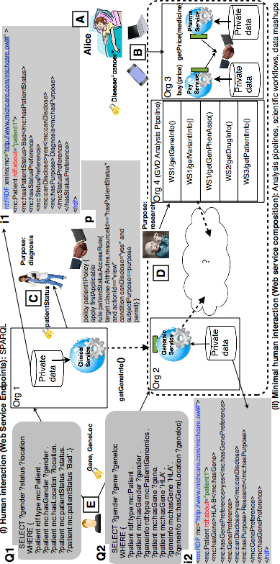

**Client**

My client will be a Web application that invokes service operations

**Service Providers**

Service provider 1 will host two services

Service 1: will do book hotel by invoking Service 2

Service 2: will read data from a file based data repository, then parse the retrieved data or do something else

Service 3: will do search hotel by id

Service 4: will do car rent by invoking Service 5

Service 5: will read data from a file based data repository, then parse the retrieved data or do something else

Service 6: will do search car by id

**Enabling Technologies**

**Client**

**Programming language: jsp**

**Service provider**

**implementation style (SOAP)**

**programming language**

**Web Server**

**data layer (file based repository)**

**this how service inter act and web service composition:**

